AHP Super Decision Model

Pizza Shop U.S. Market share

By: Jason Shipley

9/15/02

The Super Decisions program can be used to make decisions, but as demonstrated in class, it can also be used to predict. As assigned the Super Decisions program will be used to predict the market share of well know U.S. Pizza Shops.

For this model I chose to analyze nationally established pizza companies that are present in the Pittsburgh area. Because they are in the Pittsburgh area, I am familiar with the organization and have tried the product of each company.

To begin the model, 5 categories were created: 1. Alternatives, lists all of the companies to be compared for market share. 2. Advertising, compares the properties of advertising that are essential for attracting customers. 3. Food, compares the product that the companies are selling. 4. Company, compares the overall management and operation of the company as a business. 5. Miscellaneous, compares and attribute that did not fit into the other categories.

The most important elements under each category can be seen in each cluster. See Figure 1.

Figure 1
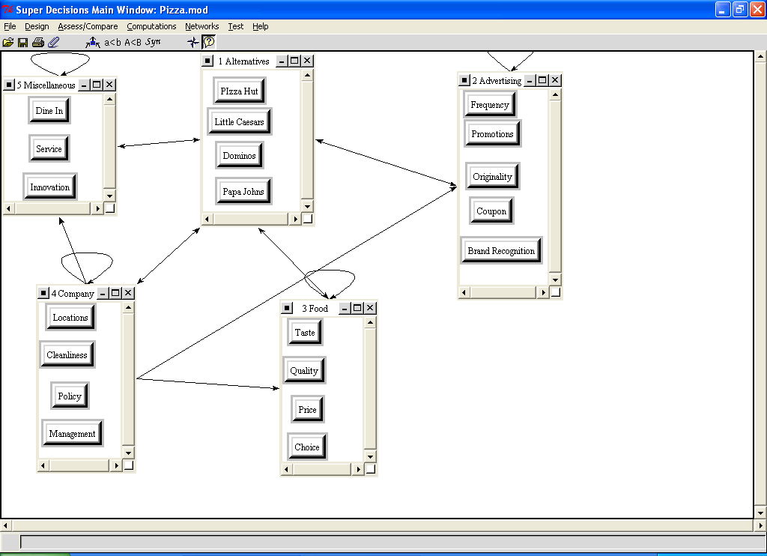

In general I felt that every element had effect within each cluster. The are some elements that I felt affected nodes in other clusters.

Management affects Innovation, Frequency, Promotion, Originality, Coupon, Price, and Choice. See Figure 2.
Figure 2.
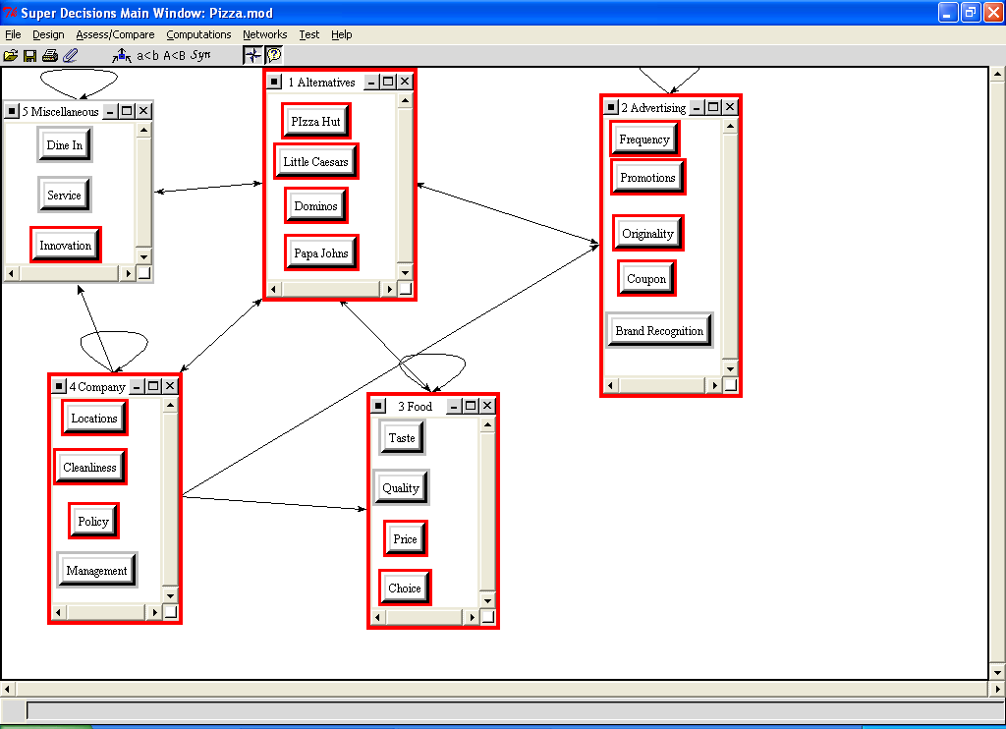

Locations affects Brand Recognition. See Figure 3.

Figure 3.
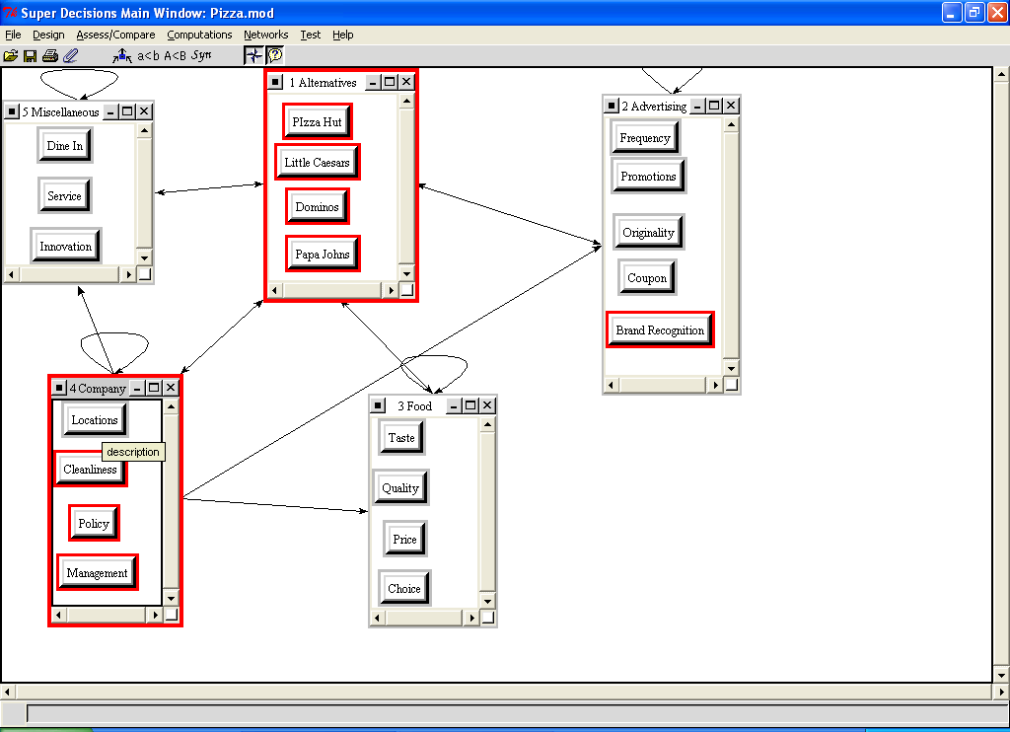

The highest weighted node for the model is the taste of the food at .132. The next highest is Quality at .084. See Figure 4.

Figure 4.
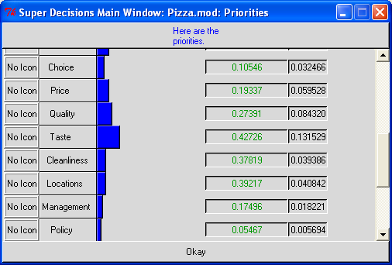

After Synthesizing the model the market share for each company came out as Pizza Hut 46.1%, Dominos 27.9%, Papa Johns 13.0%, and Little Caesars 12.9%. See Figure 5.

Figure 5.
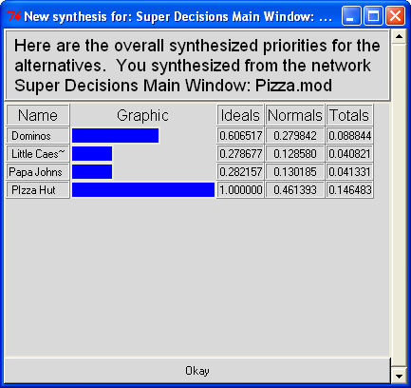

From the US Business Reporter, http://www.activemedia-guide.com/pizzarest_mrkt.htm, the 2000 US pizza shop market share was obtained. In the analysis all four of the analyzed companies are represented, but the category of other held over 54% of the companies. This 54% most likely represents local pizza shops or mom and pop operations. As 54% of the total companies are not represented in my model, it makes sense to compensate for this when reporting my percentages to better match this report. See Figure 6.

Figure 6.
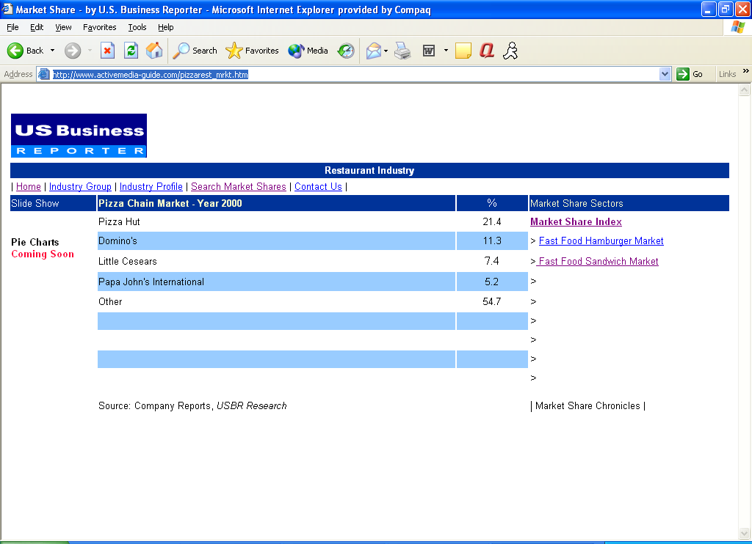

To compensate for the lack of 54% in my model, I multiplied by .46. See Table 1.

Table 1.
Company | Model Market Share | Multiplied By | Market Share Not Acct For | Result
Pizza Hut | .46 | X | .45 | 20.7%
Dominos | .28 | X | .45 | 12.6%
Papa Johns | .13 | X | .45 | 5.85%
Little Caesars | .12 | X | .45 | 5.76%

Roz Note: This was an original way to do it, convert from model results to market share data. Better to do as follows:

MktShr Rel.MktShr
21.4 | 0.472406
11.3 | 0.249448
5.2 | 0.11479
7.4 | 0.163355
45.3

Model results: Actual Rel Mkt Shr from data
.46 .472
.28 .249
.13 .115
.12 .163

As you can see from the Result column in Table 1, the relative market share found by the Super Decisions model match well for Pizza Hut (21.4% to 20.7%) and Dominos (12.6% to 11.3%), but are not as good for Little Caesars. Little Caesars probably came out lower because they are not well represented in the Pittsburgh area. Apparently they are more popular outside of the Pittsburgh area.

