Nicole Passarella
BQOM 2521
September 29, 2021
Assignment 3: US Activated Carbon Manufacturer Market Share Model
In this report I will discuss the market share model prepared for the US activated carbon manufacturers. Activated carbon is manufactured from raw materials like coal, coconut shell, and wood. These raw materials are thermally or chemically activated to create a porous product that can remove contaminants through a process known as adsorption. In the US, there are three companies who hold most of the industry market share. They are Calgon Carbon, a Kuraray Company, Cabot Corporation, and Ingevity Corporation.
Calgon Carbon is headquartered in Moon Township, PA with two manufacturing plants also located in the Pittsburgh, PA area. The company predominately produces re-agglomerated coal based activated carbon and has been producing activated carbon products for over 75 years. Recently, in March 2018, Calgon Carbon was acquired by Kuraray Co, and joined with Kuraray’s activated carbon division. Calgon Carbon manufactures a wide variety of carbon products that are regularly used in air, water, and other specialty purification applications. Calgon Carbon is the only activated carbon manufacturing company, who can also manufacturer their own carbon vessels to sell to customers or leas to customers on a service basis.
Cabot Corporation is headquartered in Boston and was founded in 1882. The company manufacturers a diverse range of products that includes activated carbon. In 2012, Cabot merged with the activated carbon manufacturer Norit (Rodriguez, p.30). Cabot produces predominantly coal-based carbons for air, water, and other specialty purification applications. They also have a fleet of carbon vessel equipment that they offer to customers. However, this equipment is not manufactured in house, and they must outsource the purchase of equipment.
Ingevity Corporation is headquartered in North Charleston, SC and produces a variety of chemicals, as well as a focused line of wood based activated carbons. While Ingevity participates in multiple markets like drinking water, they have focused their expertise on carbons for the automotive industry. Ingevity has strong IP in the automotive industry that they leverage when others try to compete in this segment of the industry.
There are also a handful of other smaller companies who participate in the US activated carbon market. However, individually they do not control a large portion of the market. In most cases, these competitors participate in the drinking water, food & beverage industry, and the industrial market. However, they struggle to compete with the larger industry players, as the dominant companies in the industry have a vast amount of knowledge and expertise that many customers require.
As seen in figure 1, the market share model built consists of four clusters. One for the alternatives, and three additional that encompass the applicable criteria. Specifically, the criteria clusters are, Customer Experience, Customer Segments, and Product and Service.
Figure 1: Market Share Model
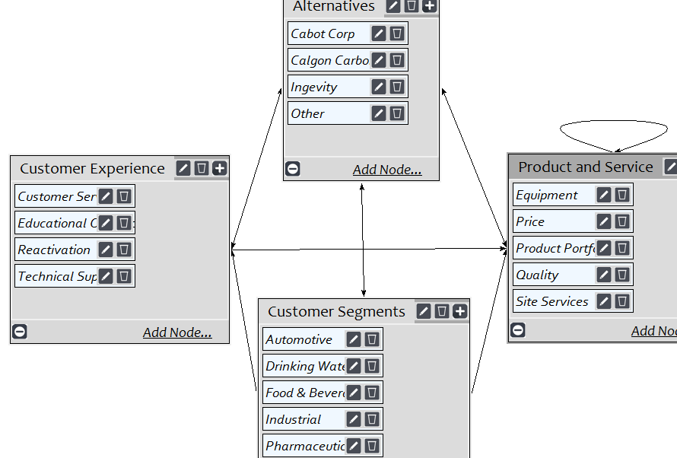
Before explaining what connections were made in the model, I want to elaborate on some of the above criteria nodes most individuals outside the industry may not be familiar with. First, educational outreach is related to how the company educates the industry on activated carbon. This can involve the water associations a company is involved in, trade shows attended, or the presence of educational webinars hosted in combination with educational webinars available on YouTube. Second is reactivation, which is the ability to use high kiln temperatures, ~1800 deg F, to drive off the adsorbed contaminants and create a new product. The reactivated carbon can be placed into a pool of product that can be used in non-potable applications like wastewater treatment. Alternatively, customers using larger volumes of carbon can elect to have product custom reactivated and sent back to them for re-use in their application. Reactivation is an attractive option to companies because it is a greener and typically more economical alternative to disposing of the spent carbon. Additionally, if reactivated carbon can be used in a customer’s process, then it can provide cost savings in comparison to a virgin activated carbon product. Third is technical support that encompasses the company’s ability to support various testing and analysis in their R&D lab, as well as provide customers with application support. Application support can be recommending the appropriate product and equipment for their application or troubleshooting the problem at hand. Site Services from the Product and Services Cluster is a company’s ability to offer on-site exchange services for a customer’s granular activated carbon filtration system. On site services allows the company to provide the customer a turnkey solution for their carbon treatment system.
The Customer Segments cluster includes the application areas where activated carbon is used. The automotive segment uses carbon to limit car emissions, as well as in a car’s battery technology. Drinking Water encompasses both municipalities and small point of use (Brita) and point of entry (whole house filter) segments. Food & Beverage covers beverage companies who use activated carbon to produce a food grade product like beer, soda, and bottled water. Industrial customers use activated carbon to remove contaminants from air and wastewater, as well as in specialty applications like purification of natural gas and chemicals. Lastly, the pharmaceutical industry utilizes activated carbon in desiccant packs to control moisture and in poison control to treat ingested toxins.
Now, I will shift to discussing the clusters and associated connections. Once the four clusters were created, I connected the alternatives cluster to the three criteria clusters. Then, all criteria clusters were connected back to the alternatives. Following this step, I identified the relationships between the clusters and within clusters as necessary. The customer segments cluster was the primary cluster to identify connections with. This is because a company’s product and service offering influence a customer’s purchase choice.
Within the customer segment cluster, I started with Automotive and made connections to Customer Service, Price, and Quality nodes since these all influence this customer segment’s purchase decision. I followed this method for each subsequent customer segment node. In figure 2, you can see the connections made to encompass what influences the Industrial segment node’s purchasing decision. For each other criteria node I evaluated if any connections were necessary across criteria. I determined that price was influenced by a company’s product portfolio, quality, and site services offering. This connection is represented by the self-loop on the Product and Service cluster as seen in figure 2 below.

Figure 2: Industrial Segment Connections
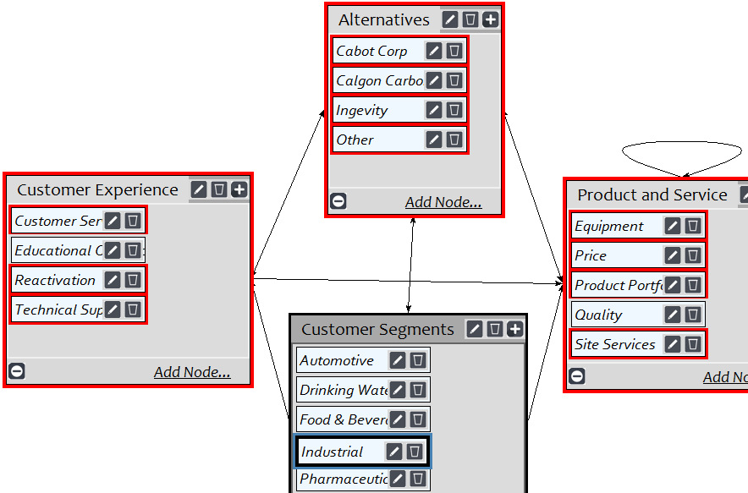
After the network connections were complete, I moved to the judgments tab to make all necessary pairwise judgements. An example judgement is shown in figure 3 below. In each judgement, I ensured the inconsistency was within acceptable an levels.
Figure 3: Pairwise Judgement
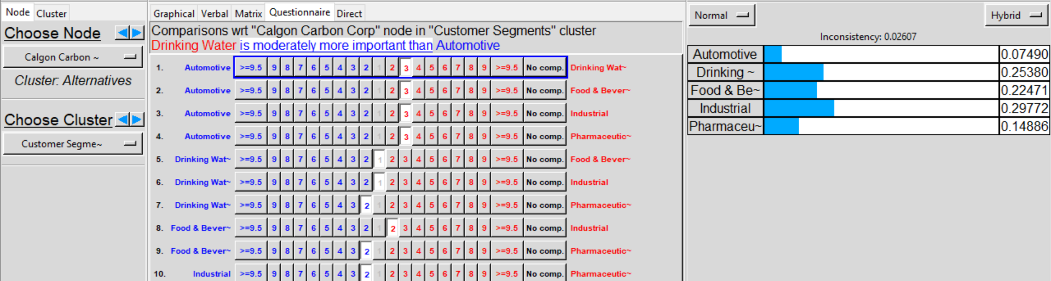

Following the completion of all judgements, the model was synthesized and produced the results seen in figure 4. In addition to reviewing the final synthesized results, I also wanted to discuss the priority of criteria nodes by segment. First, regarding the customer segments cluster, industrial is the top priority followed by drinking water, food & beverage, pharmaceutical, and automotive (Table 1). I agree with these priorities, as the industrial and drinking water segments are the top revenue generators for the company followed by the rest of the industry segments.
In the product and service priorities (Table 2), it is logical that price is the largest priority followed by product quality, product portfolio, and the rest. Finally, in the customer experience segment (Table 3), reactivation followed by customer service and technical support are also logical rankings. Reactivation is attractive for reduces a company’s footprint along with cost savings. Effective customer and technical support are critical to many customers who may have experienced an upset at their plant, and they need immediate responses from the company for product supply and troubleshooting.
Figure 4: Synthesized Results
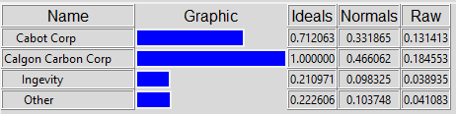
Table 1: Customer Segments Priority | Normalized By Cluster | Limiting
Automotive | 0.09597 | 0.012668
Drinking Water | 0.26559 | 0.035057
Food & Beverage | 0.2253 | 0.029739
Industrial | 0.26893 | 0.035498
Pharmaceutical | 0.14419 | 0.019033

Table 2: Product and Service Priority | Normalized By Cluster | Limiting
Equipment | 0.09853 | 0.029168
Price | 0.5218 | 0.154467
Product Portfolio | 0.11641 | 0.034462
Quality | 0.1545 | 0.045736
Site Services | 0.10876 | 0.032195

Table 3: Customer Experience Priority | Normalized By Cluster | Limiting
Customer Service | 0.28935 | 0.050923
Educational Outreach | 0.11112 | 0.019557
Reactivation | 0.34172 | 0.06014
Technical Support | 0.25781 | 0.045373

Table 4 below shows the comparison of the Market Share Model versus the Actual Market Share results. Following this table is the Compatibility Index result in Table 5.
Table 4: Model versus Actual Market Share Comparison
US Activated Carbon Manufacturers
 | Actual  Mkt Share | Model  Mkt Share
Calgon Carbon | 47.4% | 46.6%
Cabot | 33.9% | 33.2%
Ingevity | 8.3% | 9.8%
Other | 10.4% | 10.4%

Table 5: Compatibility Index Results
RESULTS
Number of Alternatives | 4
Sum of Matrix | 16.101492
Compatibility Index | 1.0063432

Overall, the model performed well shown by the compatibility index of 1.01. This index result indicates that the ANP Market Share Model results are close to the actual market share in the industry. I believe this model performed well because I have been working in this industry for the past seven years and was able to apply my market knowledge to the model. I have a strong understanding on what the above stated customer segments care about when they are deciding on what company to work with, as well as the strengths and weaknesses of each major company in the industry.

References
Rodriguez, A. (2020, May). Activated Carbon Manufacturing. IBIS World. Retrieved September
24, 2021, from https://my-ibisworld-com.pitt.idm.oclc.org/us/en/industry-specialized/od4484/about.

