Rob Byrnes
Decision Making in a Complex Environment
October 15, 2012
ANP – Final Project Report

Introduction/Background

All companies must make decisions about how their firms should be run. One such decision is which markets should be entered. In an ideal situation there would be sufficient resources to successfully move into all markets immediately. More often the markets must be prioritized based on the needs of the individual company. In my company we are looking to expand into new markets. There are many new markets we look into but only a select few can be chosen each year. Right now we are in the stages of budgeting for 2013 growth. This model will be used to help predict the success of each potential market. The final decision will be made by directors within the company from each of the major departments.
Dominion Retail is a major player in the deregulated energy markets in the northeast regions of the United States. Energy Deregulation is used to introduce competition into the electric and gas industry by allowing consumers to decide from whom they buy their power. Before energy deregulation, you were forced to buy your energy from the local utility company. The rates were regulated and you had no control over pricing because the utility owns a monopoly on the wires or pipelines used to transport gas to the individual consumers. In deregulated markets the utility still provides the same service of transporting the gas or electricity, but consumer can chose who supplies the gas or electricity itself. Dominion is a company which supplies gas and electricity to end consumers with a focus on residential and small commercial businesses. Typical consumer markets will offer both gas and electricity which presents an opportunity to cross-sell. As a publicly traded company the most important factor in making decisions on market entry is long term profitability which rewards shareholders. Dominion’s competitive strategy is to be a low cost supplier. We seek to offer consistent low cost alternatives for a customer’s energy needs.
When a market first opens there is a low level of competition and most suppliers will offer a price which is lower than the current price offered by the utility. The utility price is referred to as the tariff rate. The utility cannot make a profit on the sale of the gas or electricity. Profits can only be obtained through the pipelines and transmission wires. The tariff rate is designed to match the actual cost the utility spent to acquire the gas or electricity. Since profits cannot be obtained there is no incentive for a utility to maximize their energy purchasing. Whatever the costs are they must be approved by government regulatory bodies and are passed back to the consumer. A retail supplier, such as Dominion, maximizes their efficiency to obtain power at lower costs than the utility. A portion of the savings is passed on to the consumer, thereby creating an incentive for both supplier and consumer to participate in the market.

Ultimate goal

The ultimate goal is to select the best market to enter for long term profitability.

Main Model

With the objective of finding the best market to sell our products for long term profitability, the model includes the benefits, opportunities, costs, and risks (BOCR Model) involved in making this decision. In order to evaluate the alternatives, a BOCR model was developed with the following parts:
- Alternatives: American Electric Power (AEP), Philadelphia Electric Company (PECO), and Potomac Edison Power Company (PEPCO)
- Strategic criteria: defined by market Share, Reputation, Profits, and Growth Potential. Reputation is further refined to Investors, Customers, and Employees.

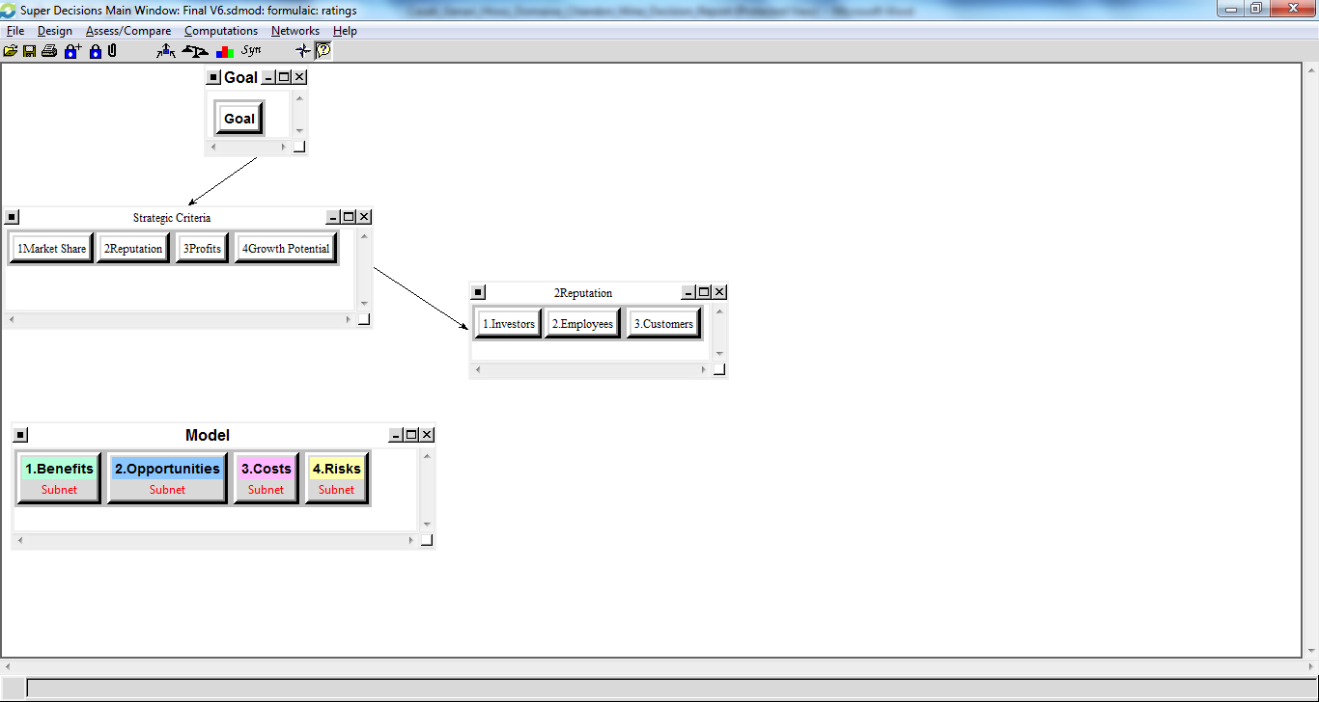

Alternatives

American Electric Power (AEP)

AEP is an electric utility located in Ohio. The electric market in Ohio is somewhere Dominion has experience which means the costs associated with IT programming, training employees, and marketing will be lower. AEP has a very large customer base of approximately 1.5 million customers. The large customer base presents a tremendous opportunity for growth. AEP service territory overlaps with the Columbia Gas of Ohio market. This overlap is significant since Dominion has a long standing presence in the Columbia gas market place. The territory overlap allows Dominion to utilize its current customer base and reputation resulting in higher sales for AEP. The name recognition and ability to cross sell are strong positive factors. AEP has relatively little competition today with only 9 other suppliers listed in the market which are mostly small regional companies. The utility pricing is about average for the AEP territory compared to other markets. The price stability is somewhat understood and reasonably predictable. Both pricing and stability present moderate but manageable risks.

Philadelphia Electric Company (PECO)

PECO is an electric and gas utility located in Pennsylvania in and around the Philadelphia area. Dominion has vast experience in the Pennsylvania market and is currently a supplier in the PECO electric territory. The PECO territory has approximately 500,000 customers for gas service. Dominion’s existing presence in the electric market is extremely advantageous. In a market where gas and electric are controlled by the same utility cross-sell opportunity is at its highest. Customers are familiar with Dominion as their PECO electric supplier which could make it easier to sell Dominion as the gas supplier. There are 22 competitors listed in the market with some larger national and multinational companies. The competitive nature is not ideal but the market is not fully matured which leaves substantial market growth potential. The pricing for the PECO gas market is not ideal and is somewhat of a liability. Similarly the price stability could be much stronger and presents another significant risk.

Potomac Edison Power Company (PEPCO)

PEPCO is an electric utility located in Maryland serving approximately 530,000 customers. Dominion does not have a strong brand presence in this market. Dominion is currently a supplier in the neighboring Baltimore Gas and Electric market within Maryland which may lend some credibility. There is no opportunity to cross-sell with gas service at this time. Dominion does not have any current gas supply contracts in the state of Maryland. The opportunity to enter additional markets in Maryland is not attractive at this time and is not currently being considered. Competition in this market consists of 30 suppliers with the majority being small regional companies. Some large national and multinational companies have already entered the market which presents a more mature market. There is still substantial opportunity for the PEPCO market. Pricing is currently tremendously attractive in the market and price stability is extremely stable and predictable.

Strategic Criteria

To evaluate the strategic criteria, a ratings table was used. The main influence on the decision is the profits (66.1%). In order to maximize long term shareholder value profits must be attained. In this model, there is no reason to enter a market without the expectation of profitability. Dominion cares about its reputation in the industry. The ultimate decision must improve the reputation of the company. Reputation is spit into investors, employees, and customers. Combining the three aspects of reputation influences the decision by 16.6%. The most significant reputation to maintain is that of the investor. Entry into a market should improve the reputation of the company in the eyes of the investor since the investor is the ultimate decision maker with the power to select new management if necessary. Growth potential (10.9%) is the future ability of a market to expand. The ability to reach to new customers within a market helps to make it more attractive. Market share (6.2%) is the least influential strategic criteria. Market Share is the total available market that can be attained through a successful campaign. Overall this is a strategic decision that is based upon financial and competitive criteria.

The priority of the BOCR for this decision shows the most important merit to be opportunity (42.3%). There is no certainty that entry into a market will be a success and the upside potential of a market is most influential. Risks (28.3%) must be properly considered when making the decision. Failure in a market entry can have a strong negative influence on profits and the reputation with investors. Benefits (21.1%) and Costs (8.2%) are the least significant. Costs especially are low since as a large corporation with significant funding, failure in one market will not sink the entire company.

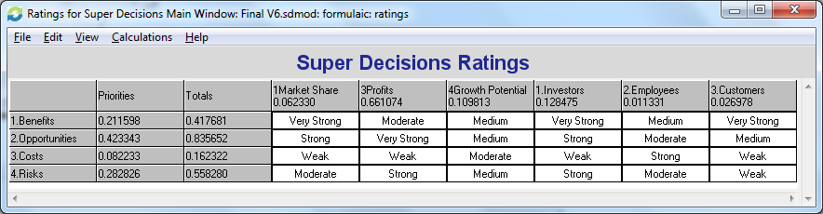

BOCR Model

BOCR Criteria and Sub-Criteria
Benefits | Opportunities
Economic | Economic
Financial | Financial
Reputation
Competitive | Competitive
Customers | Financial
Marketing | Marketing
Costs | Risks
Economic | Economic
Financial | Financial
 | Reputation
 | Competitive
 | Financial
 | Marketing

- Benefits Subnet - Economic
  - Alternatives
  - Financial
Growth is the potential benefit for the overall company when entering a market and is the most important criterion. The question behind growth is how much the market can improve the financial standing of the company. Growth influences the reputation of being a good investment. Price Stability refers to how the utility determines its tariff pricing. A utility will often elect to change pricing monthly, quarterly, or annually and with varying degrees of predictability and transparency. There are marketing strategies to effectively sell for any type of frequency. Predictability and transparency of the pricing models impact the success or failure of a market entry. Profit Margin refers to the attractiveness of pricing under current market conditions. Future pricing is unknown. Profit Margin and Price Stability are used in conjunction.
  - Reputation
Being viewed a good investment is the most important Node in the Reputation cluster. Markets which will improve the standing of the company with investors are highly desirable. Being trustworthy in the eye of the customer is also important. Trust can be earned over time by repeatedly saving customers money. Trust is more likely to occur in markets where Dominion already has some level of brand recognition. Trust and good will are desirable since both can positively influence profit margins in a territory. In this model, when customers view the company as being trustworthy the result is good will. That good will then influences being a good investment. From the perspective of an investor, good will is a strong benefit within the market. Pride is the employee’s feeling of entering a market. Employees may feel that entering a market is disreputable if certain characteristics of a market are being unfairly exploited. The model does not provide substantial weight to the employee’s feeling of pride.
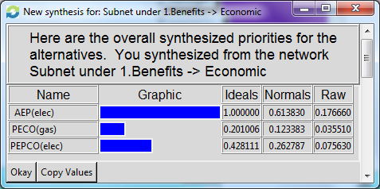
- Benefits Subnet - Competitive
  - Alternative
  - Customers
Under the benefits subnet, the First Mover has the strongest competitive influence for customers. Early entry into a market is highly sought after since customers are more easily obtained. When a market is not overly competitive the majority of customers will be on the utility tariff rate. This is advantageous since it is easier to market to a large group of customers since it is well known what their price is. The second benefit of a market is the ability to build loyalty with a customer once a customer has been signed up. Building loyalty is important to maintaining a good reputation within a market. The opportunity to be the First Mover goes hand in hand with the ability to build loyalty.
  - Marketing
The most influential benefit from a marketing perspective is the ability to cross-sell. Cross-selling allows the company to utilize its current customer base and increase revenue per customer. The company already has a track record and a level of understanding of the customer in markets where cross-selling is available. The ability to cross sell is related to building loyalty in a market. The existing loyalty is what makes cross selling easier and thus more attractive within a specific market. Often entry into a new market will result in some amount of free publicity. Communities will be excited about the potential to be saving money. Publicity can come in the way of local television news station segments, articles in the paper, or community awareness campaigns. In more mature and competitive markets the opportunity of free publicity is lower since the majority of consumers in the area are already familiar with their options. The publicity benefits the company by lowering the costs of marketing and increasing customer awareness. When the local newspaper runs an article that Dominion’s new price is a good one there is typically a large influx of new enrollments. While it is possible for free press to occur in more mature markets, it is unpredictable and sporadic and as such not being considered as part of this model. In a mature market a short term increase can occur but the impact is not as influential as in a new market.

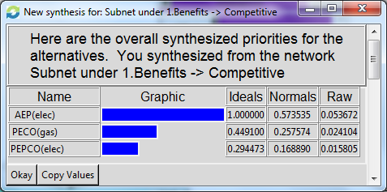
- Opportunities Subnet - Economic
  - Alternative
  - Financial
Growth is the most influential opportunity. Some markets have the opportunity to significantly improve the finances of the company while others can add only marginally. Price Stability presents an opportunity to utilize specific strategies to maximize profits from the predictability and transparency of the utility pricing model. Profit margin represents the opportunity to improve financially through pricing under current market conditions.
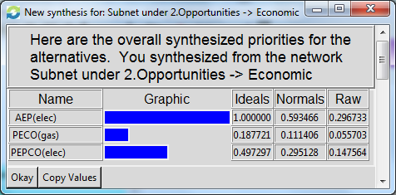
- Opportunities Subnet - Competitive
  - Alternative
  - Financial
From a competitive perspective the Growth Reduction opportunity is the ability of a market to be rapidly and successfully entered thereby reducing the attractiveness of the market to competitors. Many companies approach new markets in a similar manner. There can be an opportunity to capture enough of a market to reduce the attractiveness for a competitor. Competitors often elect to avoid a crowded market. Entering the market early and successfully enrolling a large number of customers removes those customers from consideration for a competitor. Growth reduction is influenced by the opportunity to be a first mover into a market. Profit Margin is the opportunity to offer pricing that would reduce the attractiveness of competitors. Through various hedging strategies a supplier may be able to offer exceptional value to customers. If a competitor knows they cannot compete with an available offer the market becomes less attractive. Additionally providing exceptional value to customers through attractive profits margins will influence growth reduction.
  - Marketing
The opportunity to cross-sell in a market represents a significant opportunity. Markets where cross-selling is available are more attractive than markets without. First Mover is an opportunity to enter into a market while there are still many new customers available. Being the first mover into a market represents the largest competitive opportunity. Obtaining new customers is preferred to attempting to take them from a competitor. Competitors have been known to build cancellation fees into their contracts which can make markets more challenging when not being the first mover. Free publicity is the opportunity for local television, newspapers, and communities to present our products to create a buzz.

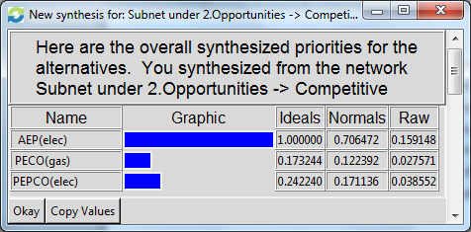
- Costs Subnet - Economic
  - Alternative
  - Financial
The costs of entering a market are determined by three factors required to enter any new market. The first is Employee training cost. Employees must be trained to handle the nuances of each new market. A market that is similar to another the company has experience in will result in lower costs. The majority of employees are hired on a temporary basis resulting in a low importance being placed on employee training. Due the nature of temporary employment Dominion has existing training procedures that can be adapted to other markets as well as a qualified full time training staff. IT Programming is the costs associated with building databases and transactional systems to handle the new market. The most widely accepted industry practice utilizes Electronic Data Interchange for exchanging transactional information between supplier and utility company. Some utilities do not follow these practices and elect to develop their own systems which results in additional cost. IT programming related to connecting with customers is already in use. The costs required for each potential market are essentially the same and not relevant to the model. Marketing costs are how much the company anticipates would be required to attract new customers. Markets where Dominion has brand awareness have preferred lower marketing costs.

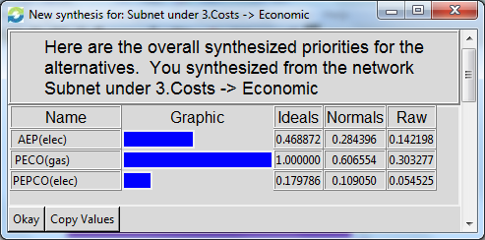
- Risks Subnet - Economic
  - Alternative
  - Financial
The entry into a new market requires risk that the market may never materialize. The lack of growth means the market has somehow changed and is not able to generate the profits that we originally expected. Stranded Costs refer to the financial losses that would be associated with the Cost subnet. Once the expenses of employee training, IT programming, and Marketing have be spent they cannot be regained. Stranded costs and lack of both influence Dominion being perceived as a bad investment.
  - Reputation
When Dominion enters a market the investors have an expectation of profits and growth. Not being able to meet those expectations can results in investors labeling the company as a bad investment.

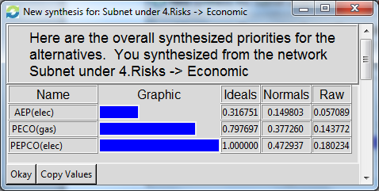
- Risks Subnet - Competitive
  - Alternative
  - Financial
Financial risks for the competitive subnet consist of Growth and Profit Margin. The same approaches Dominion would utilize as an opportunity could be completed by a competitor first. A competitor may be able to exploit the market resulting in an unattractive financial situation.
  - Marketing
Marketing risks include First Mover, Free Publicity, and Market Saturation. First Mover risk would occur when Dominion expects to be into the market based on current conditions but another competitor is able to get there first. Free publicity risk would be if entry in the market is not met with the anticipated level of publicity. Lack of free publicity would increase the costs required to be successful. Finally market saturation risk can occur when there are too many competitors working the same market at the same time. The customer can be bombarded with advertisements that dilute the effectiveness of marketing campaigns.

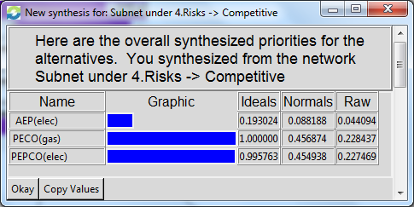

Overall Synthesized Results

The overall synthesis results below show the best option is to enter the AEP market. I used the multiplicative standard formula for the short term model. With a market size of 1.5 million AEP is three times the size of the other options. The Benefit and Opportunity of entering the AEP market is overwhelmingly positive. The potential upside for the AEP market is exceptional and there is a high likelihood of cross selling with the Columbia of Ohio gas market. AEP is the strong front runner in current market discussions. The market size and potential for significant growth cannot be underestimated. Though AEP has the lowest rating for risk the opportunity is sufficient to justify the higher risks. AEP is in fact the first market entry planned with initial expansion activities already beginning. PEPCO comes in as the second option and PECO gas is only slightly attractive at this time.
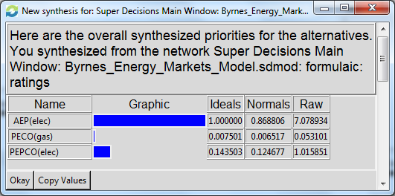

Determining the best option for the long term term I used the additive (negative) standard formula. The results still overwhelmingly point to AEP as the best option for the reasons described in the short term model. There is a significant decline to PEPCO. PEPCO went from 12% in the short term model to -3% in the long term model. This is reasonable based on the attractiveness of the PEPCO pricing and stability. PEPCO presents a minor opportunity for consistent level of profitability. PECO is still the least attractive market to enter and looks significantly worse in the long term model. Both PEPCO and PECO serve comparatively small markets which limits the potential financial impact

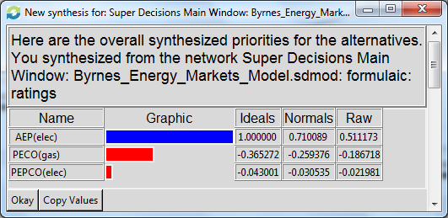

Sensitivity Analysis for BOCR Model – Benefits

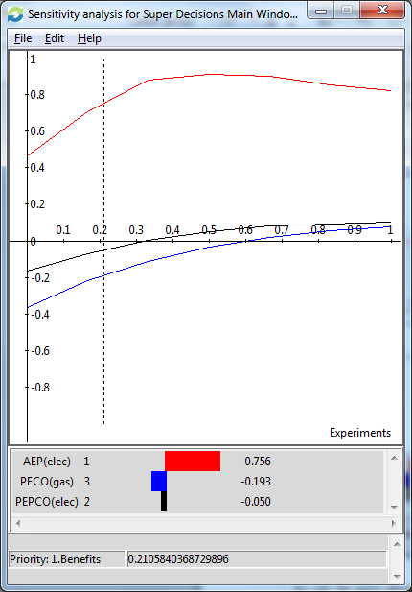
As can be seen above from the sensitivity analysis focus on Benefits, AEP has a dominant position over the other alternatives at every point of the priority range with a wide gap of advantage.

Sensitivity Analysis for BOCR Model – Opportunities

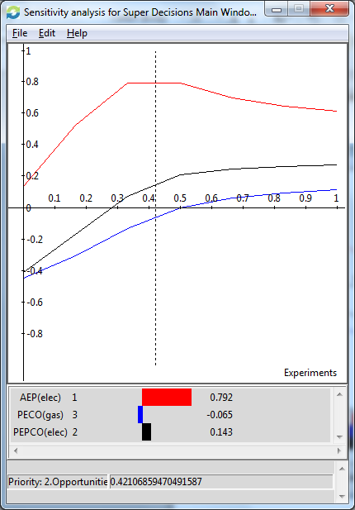
As can be seen above from the sensitivity analysis focus on Opportunities, AEP has a dominant position over the other alternatives at the current priority of 42%. However, as opportunity becomes more important both PECO and PEPCO begin to close the gap around 50%.

Sensitivity Analysis for BOCR Model – Costs

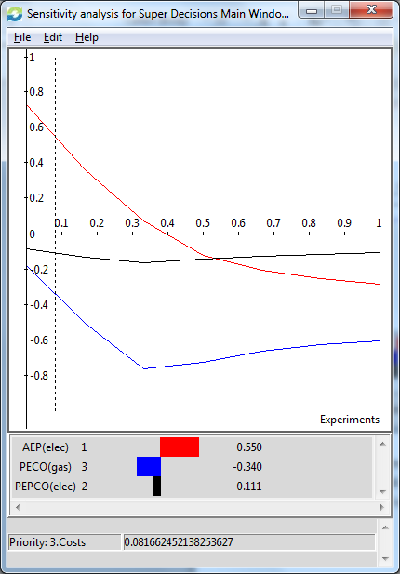
As can be seen above from the sensitivity analysis focus on Costs, AEP has a dominant position over the other alternatives at the current priority of 8%. However, as opportunity becomes more important both PECO and PEPCO begin to close the gap and around 53% PEPCO becomes the best alternative. I can understand why AEP would become a less attractive alternative as the priority of Costs increases. As the Cost priority increases, the opportunity priority with the overwhelming position of AEP becomes less influential. Cost is the only BOCR decision merit where AEP was not the best alternative. This leaves comparing PEPCO to PEGO gas. The industry standard technology is Electronic Data Interchange (EDI) which both AEP and PEPCO use. PECO gas has elected to utilize extensible markup language (XML). Using XML is why PECO gas is ranked significantly lower than the other alternatives for IT programming in the model. Synthesizing of the Costs subnet shows PECO gas as a better alternative than PEPCO. PEPC, however, exhibits an advantage over PECO in the other merits which influences PEPCO becoming the best alternative when cost receives an increasing priority. Looking at opportunity first, since it is the highest priority, PEPCO exhibits a lasting advantage over PECO gas. PEPCO also has higher rating than PECO gas under Benefits. While the market sizes of PECO and PEPCO are similar the pricing opportunity for PECO is more attractive opportunity. Overall though PECO gas in the best alternative within the Cost merit, the strength of PEPCO in the overall model makes is the best alternative as priority of cost increases.

Sensitivity Analysis for BOCR Model – Risks

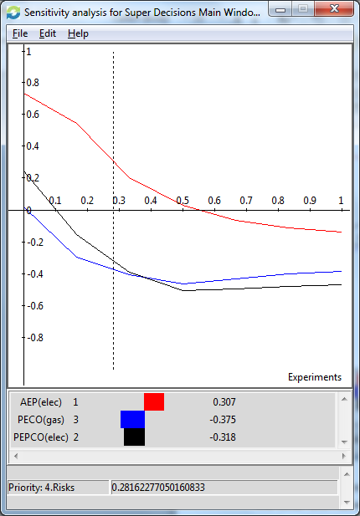
As can be seen above from the sensitivity analysis focus on Benefits, AEP has a dominant position over the other alternatives at the current priority of 28%. Around 38% PECO gas becomes the second best alterative instead of PEPCO. Both PECO gas and PEPCO remain far below AEP.

