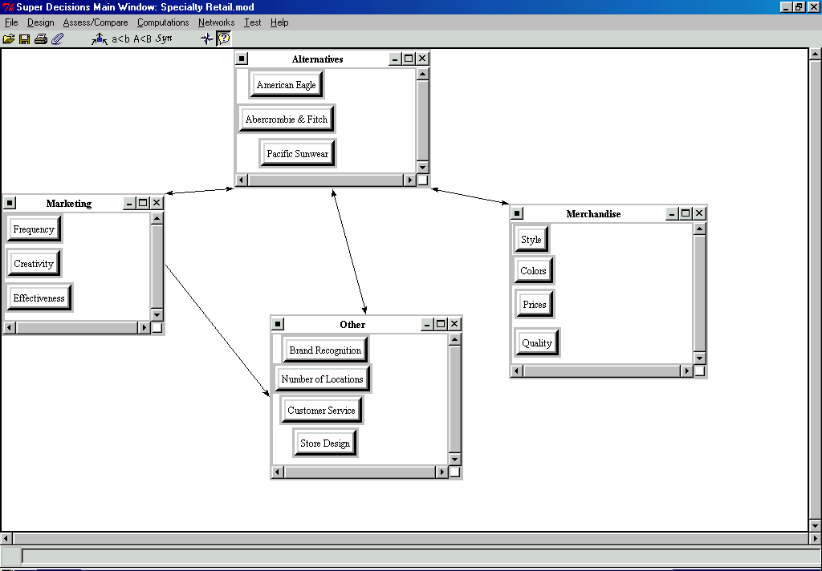
Mike Mathias
Decision Making
Assignment 2

The market share example I created corresponds to my current employer. I work for American Eagle Outfitters and decided to provide an example including AE and two of our major competitors, Abercrombie & Fitch and Pacific Sunwear. Below, you can see the clusters and nodes that I believe to be the major factors in estimating the market share of these three competitors.

The model on diskette will provide the detail of the comparisons and the results of the matrices. The synthesized results can be seen on the next page.

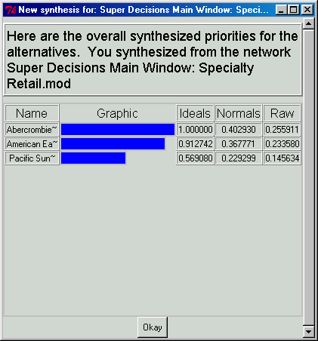
I used fiscal 2001 sales volume to compute the dollar market share associated between these three companies. They were as follows:
AE: Sales of $1,371,899,000; relative market share of 40.1%
Abercrombie: Sales of $1,364,853,000; relative market share of 39.9%
Pacific Sunwear: Sales of 684,800,000; relative market share of 20.0%

You can see from the synthesized results that my model was fairly close to the actual shares; 36.8% for AE vs. actual of 40.1%; 40.3% for Abercrombie vs. actual of 39.9%; 22.9% for PacSun vs. actual of 20.0%.

SEE DISKETTE FOR OTHER MODEL DETAIL.

