Jacklyn Wise L3 Assignment 3/26/2018

For this assignment, the market share of gaming systems is investigated. The alternatives for this model include:
- Nintendo Switch
- PlayStation 4
- Xbox One
The criteria have been clustered as the following:
- Revenue:
  - Price
- Customer Experience
  - Ease of Use – How easy is the system to use?
  - More than Games – Can the system handle more than just games? (Can it play DVDs, search online, stream shows, etc.?)
  - Versatility – Can the system be played away from a television source?
  - Breadth of target Audience – Is the gaming system targeted for a wide or narrow audience?
- Features:
  - Graphics
  - Motion Controls
  - Number of Games – number of games available to play on the system
  - Variety of Games – is there a variety of games available to play on the system

The first step was organizing the criteria and alternatives into a network and make connections. (See screenshot on next page).

Special Connections:
- Nintendo Switch: connected to all other nodes, except “More than Games.” Nintendo switch does not have the ability to be more than games aka play DVDs.
- PlayStation 4 & Xbox One: connected to all other nodes, except “Versatility” and “Breadth of Target Audience.” PlayStation 4 & Xbox One are not able to be played away from a television source, and targets a specific audience of young adults.
- Breadth of Target Audience: connected to “Ease of Use” and “Versatility.” The easier the system is to use, the more likely older and younger audiences are to play. Versatility also targets a younger audience because you can take the game with you in the car or on the airplane away from the television source
- Price: connected to all nodes except “ease of use” and “breadth of target audience” because these nodes are not something a customer necessarily pays for when considering a gaming system.

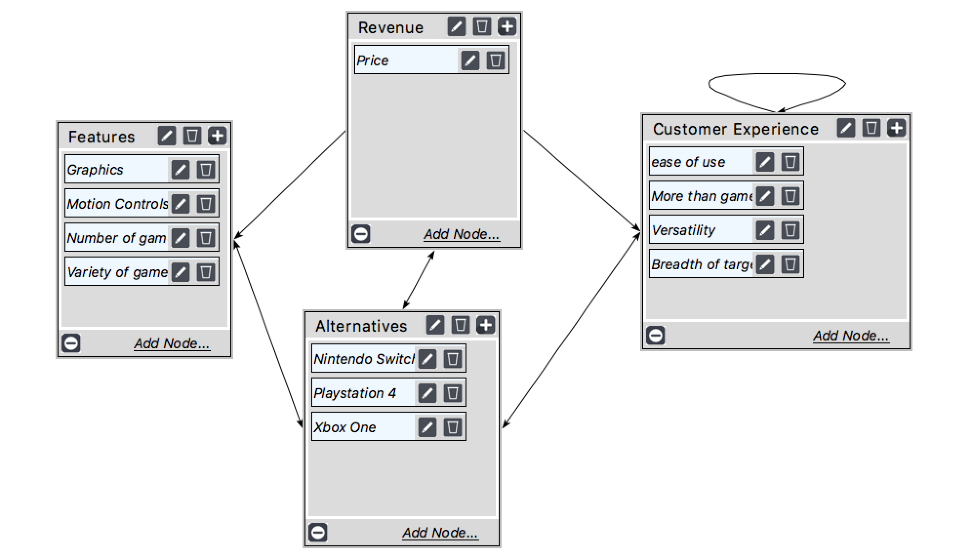

Judgements:

The next phase of the model is to start with the judgments of the clusters and then move on to the pair-wise comparison judgements of the nodes. (See the model Wise_MarketShare.sdmod for details).
Unweighted Super Matrix
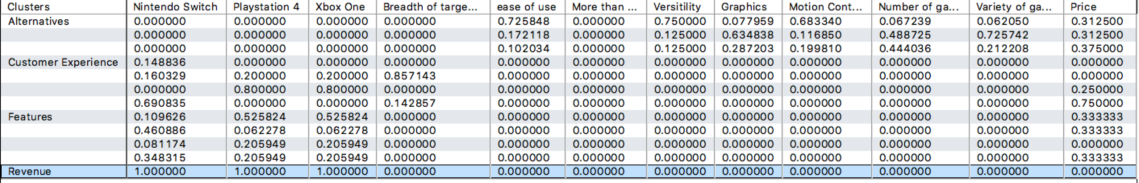
Weighted Super Matrix
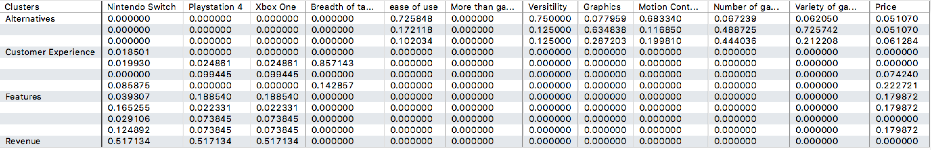

Some of the key differences between the alternatives is that the Nintendo Switch has a broad target audience, has motion control capability and is versatile, but is limited in the number of and variety of games available for the system. The Xbox One system has better graphics than the Nintendo Switch, but has a smaller amount/variety of games available than PlayStation 4. PlayStation 4 has the best graphics out of all of the systems, which is a key parameter when determining a gaming system. PlayStation 4 also has more games with more variety available to consumers. Xbox nor PlayStation 4 have motion control capability or are versatile, but they are able to be used more than gaming system, they can play DVDs and stream better quality movies/shows. After making the comparisons, the full model was synthesized with the following results, PlayStation 4 at 44.5%, followed by Nintendo Switch at 29.3% and Xbox One at 26.3%. (See screen shot below)
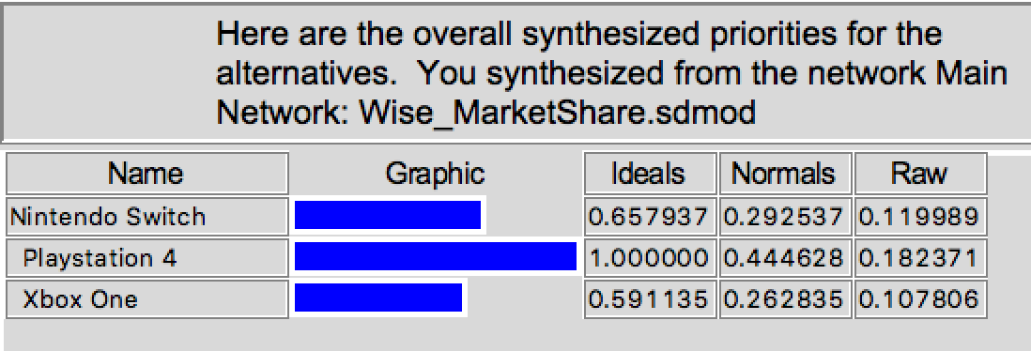

Comparison of the model to actual Market Share Data:

Data of 2017 Market Share for Video Game Systems was obtained from the Statista Website:

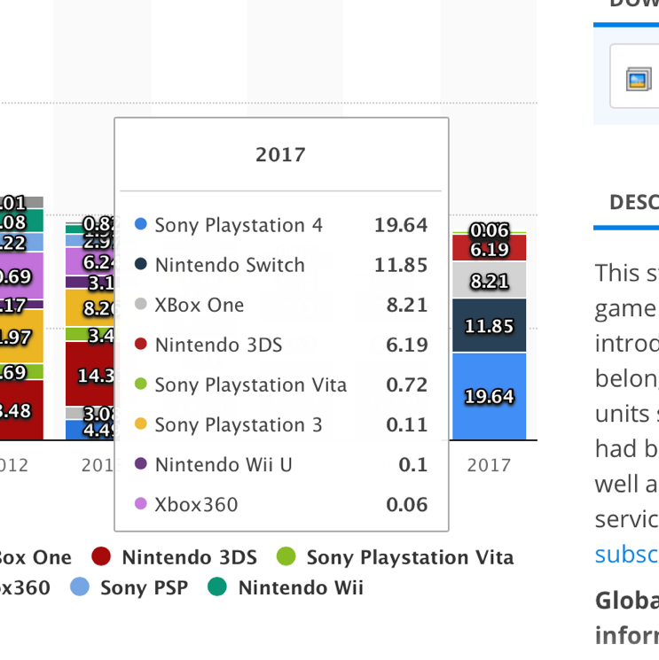
https://www.statista.com/statistics/276768/global-unit-sales-of-video-game-consoles/
Using the Compatibility Index Excel Calculator, the normal priorities from the Super Decisions Model were used to compare with the Market Share Data. According to the Statista website, PlayStation 4 held 19.64% of the Actual Relative Market Share, followed by Nintendo Switch at 11.85% and then Xbox One at 8.21%. The normalized values resulted in the following values:
System | Normalized Actual Values
Nintendo Switch | 0.29849
PlayStation 4 | 0.49471
Xbox One | 0.20680

From the Calculator, the Saaty Compatibility index is 1.022 which is very close to 1 and therefore, we are able to say that the model is close to the actual relative market share.

