- INTRODUCTION:

I decided to estimate the market share for US mobile telephone carriers by subscriptions. The major companies were considered: AT&T, T-mobile and Verizon. The aspects that I considered to estimate the market share were the following:

- Price of 4G plan;
- Maximum number of phones allowed;
- Price of tablet plan;
- Overall Coverage;
- Rural Coverage;
- Advertising budget;
- Early termination fee;
- Help and Support:

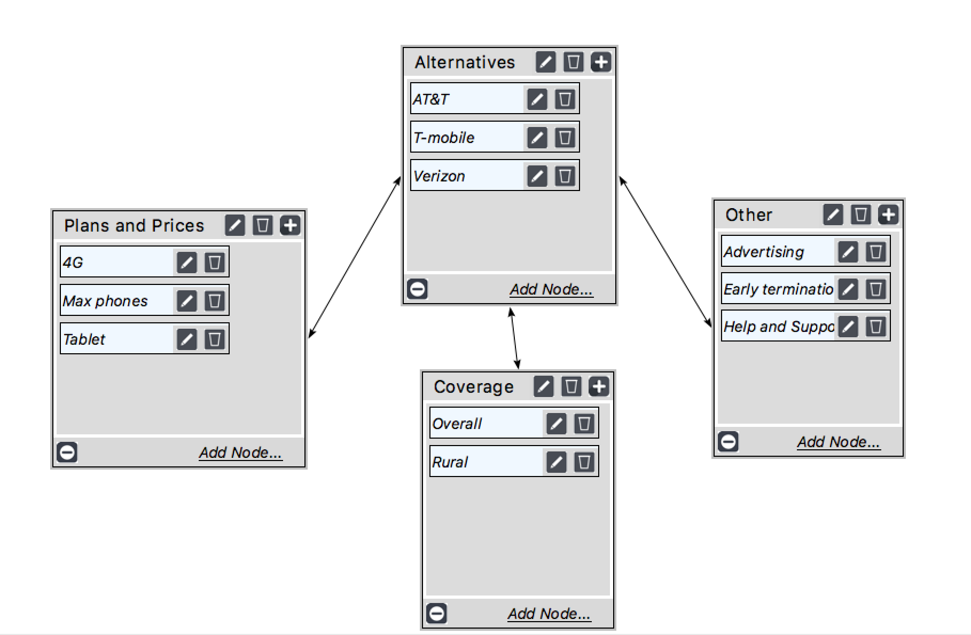

- JUDGEMENTS:

The judgements were made based on the differences in the plans offered by each of the companies. In terms of overage coverage both AT&T and Verizon are pretty similar, and both of them are considerably better than T-mobile.

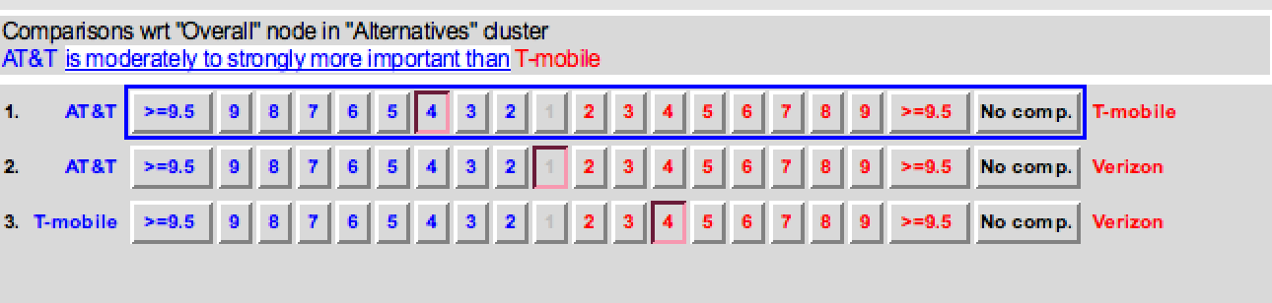

Considering Rural Coverage, Verizon is the best, AT&T is a little behind Verizon and both companies are considerably better than T-mobile.

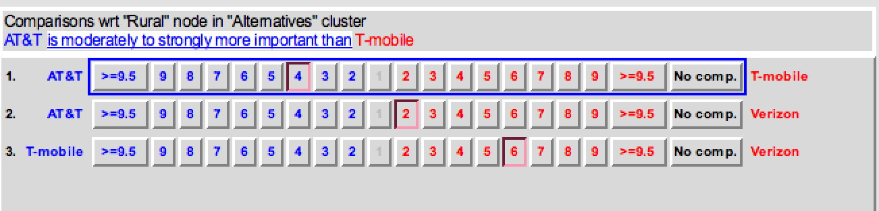

In terms of Advertising Budget, AT&T is the company with the highest budget, followed by Verizon and T-mobile stays in the last place.

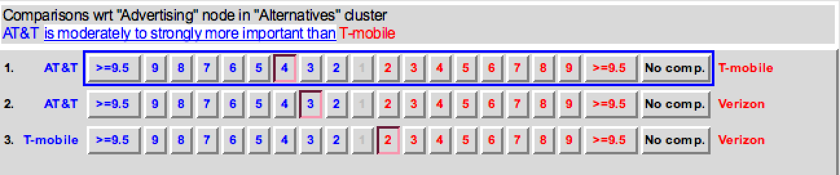

In terms of early termination fee, T-mobile charges the lowest fee, followed by AT&T and Verizon. Verizon’s early termination fee is also the highest in relative terms (by comparing the relationship between the early termination fee and the price of the 4G plan).

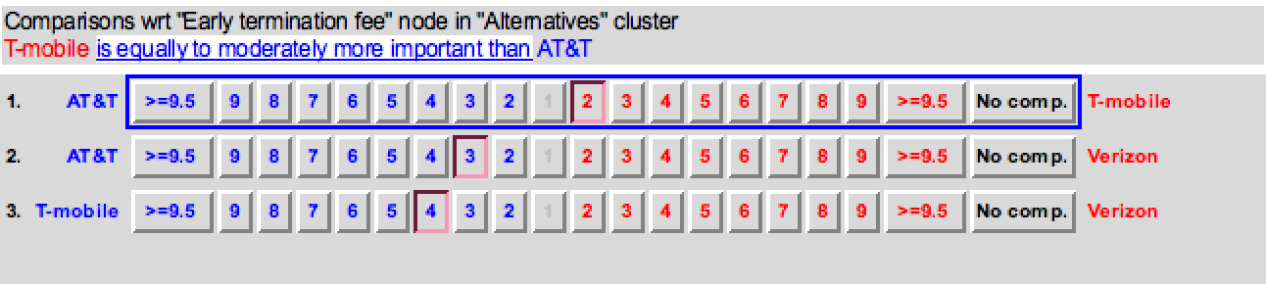

When it comes to Help and Support, Verizon is by far the best, followed by T-mobile and AT&T is the worst.

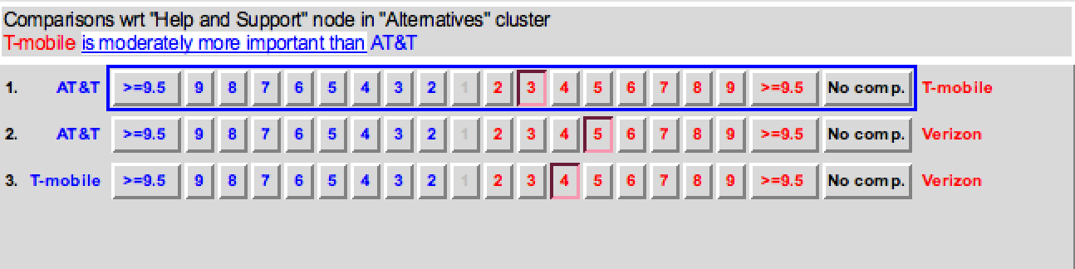

In terms of the 4G plan, T-mobile has a slightly better price than AT&T and Verizon, whose prices are pretty much the same.

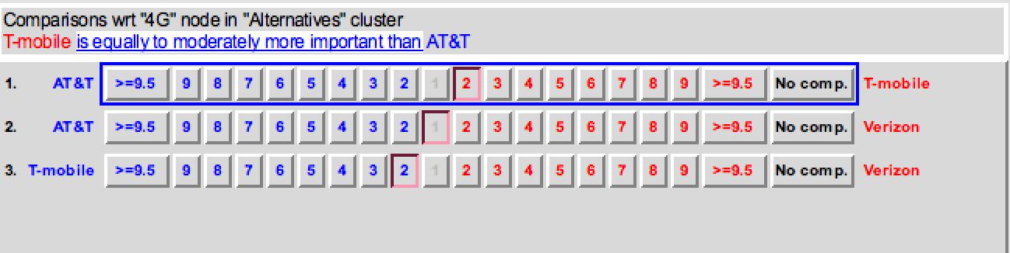

In terms of the maximum number of phone per plan, both AT&T and Verizon allow up to 10 phones per plan, while T-mobile only allows 5 phones per plan. Besides that, the monthly fee per plan that AT&T charges is lower than the monthly fee that Verizon charges.

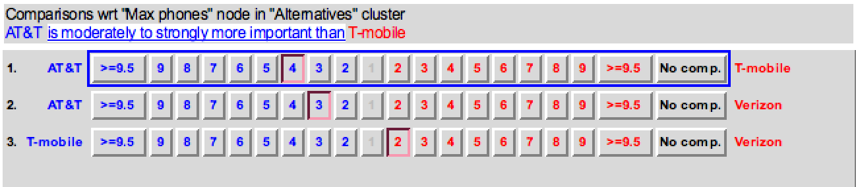

When it comes to data plans for Tablets, both AT&T and Verizon offer very similar services for the same price, while T-mobile charges a much higher price.

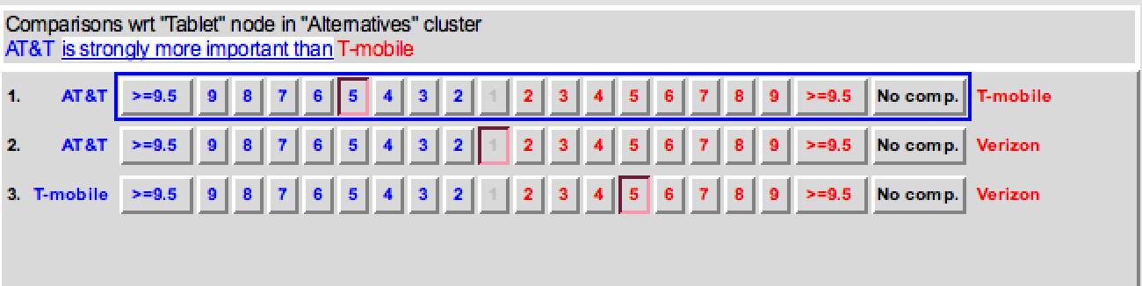

03. RESULTS:

By considering these factors to calculate the relative dominance of each of the companies in the cell phone market of the United States, the following results were obtained:

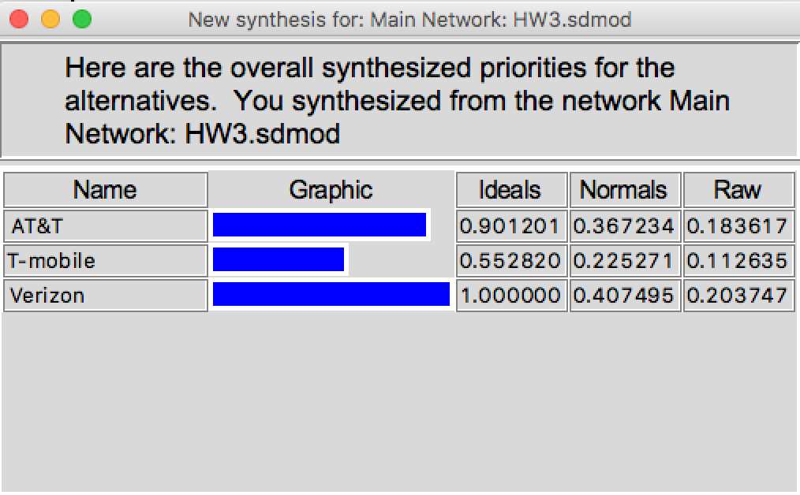

By searching on Google, the results obtained for the market share of these three companies were the following: (https://www.statista.com/statistics/199359/market-share-of-wireless-carriers-in-the-us-by-subscriptions/)

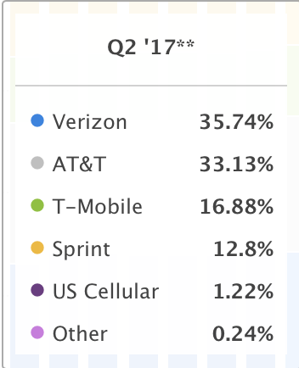

- COMPATIBILITY INDEX:

By comparing the results obtained through the ANP model and the actual values in the Compatibility Index Template, the value obtained was very close to 1. This means that the model proposed seems to accurately predict the most important factors that customers take into consideration when deciding about which plan to subscribe for their mobile phones.

