Determining the Market Share of Top Toy Retailers

SUMMARY:
Author: Rebecca Rothman
Synthesis Formula: No formula necessary for simple network
Super Decisions File Name: Super Decisions Toy Market Share Model.mod
Type of Structure: Simple Network

I. The ANP Main Network
Two clusters have been included to find out the market share of the top toy retailers. These are product and store characteristics. These clusters have different characteristics or nodes. In the product cluster, we have three elements: distribution of toys, purchasing power and variety of toys. In the store characteristics cluster, we also have three elements: price, number of stores and hours of operation. The simple network is shown in the screen shot below.

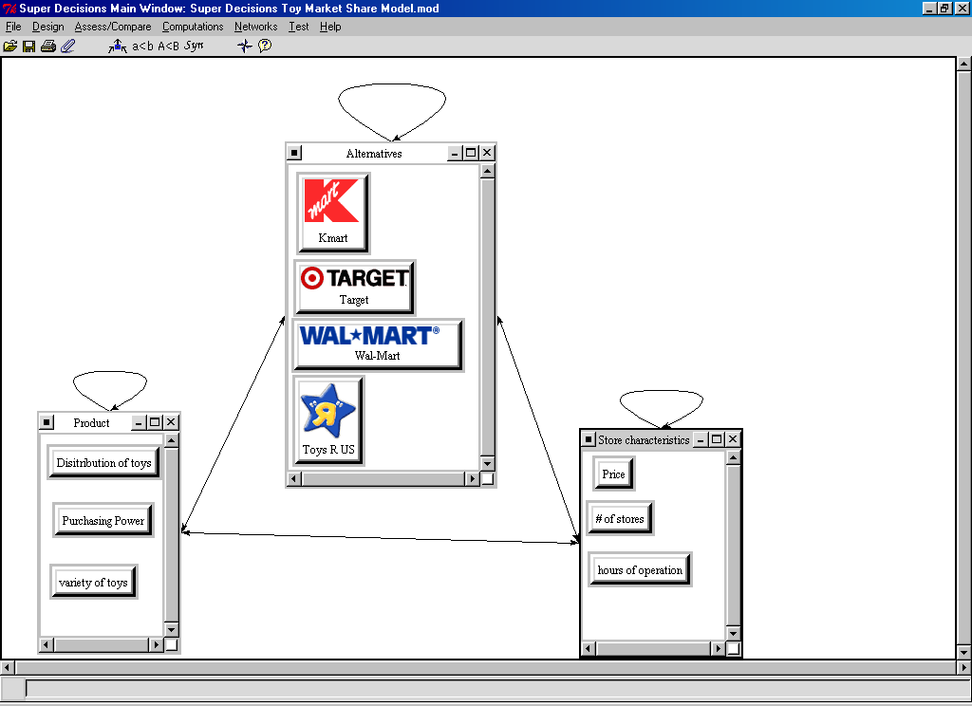

II. Overall Outcome
Pair-wise comparisons were done between all of the clusters and all of the nodes in order to calculate market share. According to the results, Wal-Mart has the largest market share among the alternatives with 39.8%, Toys R US has the second largest market share with 33% followed by K-Mart with 15.1% and Target with 12%.

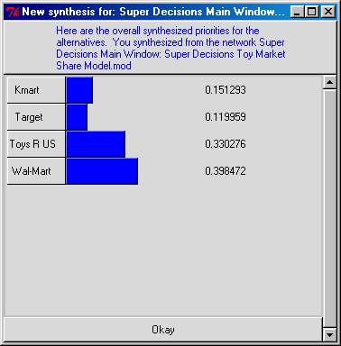

Real world results were obtained from the following link:
www.toy-tia.org/industry/statistics/topretailers.html

And show:
Rank | Store name | Percent | Super Decisions Rank
1 | Wal-Mart | 19% | 1
2 | Toys R US | 16.5% | 2
3 | K-Mart | 7.4% | 3
4 | Target | 7.2% | 4
 | Other | 5.9 | Not included

