Determining Whether the NFL Should Modify Its Regular Season to 18 Games

Shannon Harris and Paul Matthews
10/17/2011

Table of Contents
Introduction 2
Model 3
Strategic Objectives 4
Criteria Definitions 5
Benefits 5
Opportunities 5
Costs 7
Risks 8
Results 9
Criteria Results 9
Ratings Model 10
Top-Level Results 11
Sensitivity Analysis 12
Conclusion 13

Introduction
The National Football League (NFL) currently operates a 16 game regular season with a 4 game pre-season. A major point of contention in the recently settled NFL labor dispute and lockout was the proposal by NFL commissioner Roger Goodell to extend the regular season to 18 games while shortening the pre-season to 2 games. This course of action was met with both praise and condemnation from both sides of the labor dispute. In general, owners supported the proposal to extend the regular season and shorten the preseason while players strongly opposed the plan citing increased risk of injury during regular season games. The NFL’s customers (i.e. fans) largely supported the proposal to extend the regular season.
Under the current NFL schedule, 4 preseason games precede a 16 game regular season containing 1 bye week. Preseason games are treated as exhibition and do not count towards a team’s final record and likelihood of making the playoffs. During preseason games, most players on the starting lineup see limited playing time while the coaches try to evaluate personnel and determine which players will make the 53 man roster for the start of the regular season. Season ticket holders are forced to purchase preseason tickets at face value as part of their overall package and generally receive less value for their money, as preseason games are not as exciting as regular season games.
Under the proposed schedule, 2 preseason games will precede an 18 game regular season containing 2 bye weeks. The argument is that the total number of games will remain the same for players while increasing the value of the games played for the fans. An additional bye week is meant to give players more time to rest and heal from injuries during the season and negate the physical toll of playing 2 more regular season games vs. preseason games.

Model
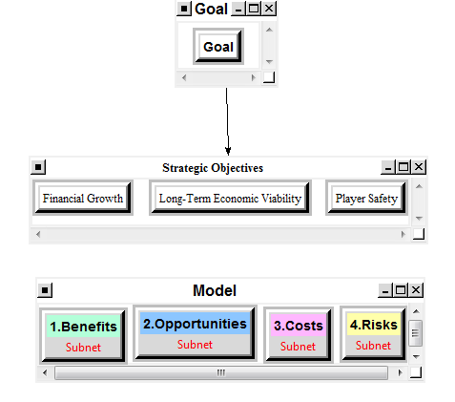
The model created to determine which alternative the NFL should choose was setup by creating a goal node linked to the 3 strategic Objectives. A cluster containing the Benefits, Opportunities, Costs, and Risks (BOCR) criteria was created. Each BOCR is a subnet. The first level of each subnet contains a cluster with control criteria. Each control criteria is then given a priority based upon a decision network within the node. Below are the descriptions of the Strategic Criteria, Benefits, Opportunities, Costs, and Risks, and the nodes that are contained below each control criteria.
BENEFITS:
Control Criteria | Nodes in Decision Network
Economic
 | Merchandise Sold at Games
 | Tickets
 | TV Rights
 | Bar and Restaurant Sales
Social
 | Fan Satisfaction
 | League Popularity

OPPORTUNITIES:
Control Criteria | Nodes in Decision Network
Institutional
 | Additional Bye Week
 | Decreased OTA and Training
 | Increased Competitiveness
 | Minor League
 | Modify IR Terms
Social
 | International Games
 | Increased Benefits for Retired Players

COSTS:
Control Criteria | Nodes in Decision Network
Economic
 | Increased Roster
 | Pay Players for Additional Games
Social
 | Competitive Attrition
 | Complexion of Season
 | Variance Between Statistics

RISKS:
Control Criteria | Nodes in Decision Network
Economic
 | Decreased Profit Margin per Game
 | Negative Returns for Bad Seasons
Social
 | Evaluation of New Players
 | Longer Disappointing Seasons
 | Player Injury

Strategic Objectives
The strategic objectives for the NFL in making the decision to keep the current schedule or adjust to a new schedule are Financial Growth, Long-Term Economic Viability, and Player Safety. When considered appropriately, these three objectives will help influence a decision that considers all stakeholders. All stakeholders have an interest in the NFL continuing to grow financially and on a path that ensures long-term sustainability as well as short-term. Player safety is also a concern for all involved since without healthy players, the NFL cannot continue to be the competitive sport it currently is, which would be a detriment to all involved.

Criteria Definitions

Benefits
The economic benefits of extending the regular season of the NFL are numerous. The NFL generated over $9 billion of revenue in its 2010 season. This revenue came from several streams, of which ticket sales, merchandise sales, and TV broadcasting rights were the most significant. Increasing the number of regular season games will allow each of these revenue streams to grow. In addition to the NFL’s direct revenue, there are many economic benefits for the cities hosting NFL teams as bar, restaurant, hotel, and parking revenues are enhanced by the additional regular season games.
The social benefits of an 18 game regular season include increased fan satisfaction and league popularity. Fans will benefit from having more competitive games during the season and ticket holders will feel they are receiving a higher value product for their money. League popularity will increase as more games are broadcast nationally.

Opportunities
The institutional opportunities within the NFL of extending the regular season revolve around giving teams additional leeway in managing their rosters and players additional opportunities to increase skills and decrease unnecessary strenuous training while increasing the competitiveness of the league. Currently NFL teams are limited to a 53 man roster and have strict terms on placing players on injured reserve (not counted towards the 53 man limit). Under the current rules, if a player is placed on injured reserve he is effectively out for the remainder of the season. For this reason, teams hesitate to place players on injured reserve when there is a marginal chance that they may recover in time to play at some point in the season. If the league were to extend the season, the opportunity for injured players to return to action is greater and therefore the terms of injured reserve should be modified to reflect this new dynamic. Under an 18 game regular season, injured reserve status could be limited to a predetermined number of games rather than default for the entire season thus giving teams more opportunity to fill their 53 man roster with healthy players while not eliminating the chance that an injured player could return to action. To further increase the attractiveness of modified injured reserve terms and allow players additional time to rest and recover during the season, an additional bye week could be granted to every team. Also, to decrease risk of injury prior to the season starting rules could be created to limit the use of organized team activities (OTA) and strenuous training camps. Many veteran players see OTA and training camps as a greater risk of injury rather than an opportunity to improve for the season.
One criticism of shortening the preseason from 4 to 2 games is that it denies players the opportunity to earn a spot on the roster by demonstrating their abilities in a game time situation. To help develop and discover players that are ready to play in the NFL, the league has an opportunity to create a minor league version of the NFL that will be used similar to baseball’s farm system to find and develop new talent. This will take emphasis away from needing to evaluate players by only a handful of preseason games.
A dynamic of the NFL season in its current form is that certain teams inevitably will secure playoff spots before the last weeks of the season while other teams will fall far out of contention by the end of the season. This dynamic leads to competitive attrition around the league as these teams who have already determined their post season fate will begin to rest players and deliver lackluster performances in the final games of the regular season. Extending the regular season by 2 games effectively increases the likelihood of this competitive attrition affecting the outcome of games at the end of the season. An opportunity for the league to combat this phenomenon within an 18 game season would be to schedule divisional match-up games in the final weeks of the regular season. Intra-divisional games have a greater bearing on a team’s playoff standing than inter-divisional games do, therefore these games are more likely to be competitive late in the season. Also, divisional rivalries run deep and spur competitiveness among teams, players, and fans.
The social opportunities of extending the NFL regular season include extending the fan base of the NFL to a more international market and increasing benefits for retired players. Currently, there is one scheduled international regular season game a year. This game has been played at Wembley Stadium in London, England annually since 2007. These games, known as the International Series, are slated to expand in the next several years as the NFL’s international popularity grows. The addition of 2 regular season games for the NFL would certainly afford more teams the opportunity to play a game internationally and in new locations. The International Series has had great success in drawing in new fans from foreign markets and is a tremendous opportunity for the league to generate new revenues and bolster its long term economic viability. Also, the additional revenues generated by an 18 game regular season could be partially allocated to improve benefits for retired players.

Costs
The economics costs for extending the regular season to include 2 of the currently slated preseason games fall primarily on the owners since players would have to be compensated for the additional games, and coaches are requesting larger roster sizes so they can be better prepared for potential injures. Compensation for players covers a broad range from approximately $300,000 to $30 million dollars. The cost of paying for the additional 1 or 2 games (depending on the creation of an additional bye week) could cost owners a significant amount of money. The current roster size is 53 players with 45 players dressed per week. Coaches are looking for a roster of 58 with 53 players dressed per week. The cost of the additional 5 players per roster even at the league minimum would be significant.
A current issue in the NFL season is the lack of competitiveness at the end of the season. Often teams know whether or not they will earn a playoff berth before the final two games and may choose to bench starters and not play as competitively. This competitive attrition could only be exacerbated by the extension of the season. This would make the additional games unattractive to fans, and is detrimental to the league’s reputation. Additionally, if players are injured because of the additional games the final games could end up being a game of attrition instead of a game of skill. The final games could potentially be played by the players who were lucky enough not to get injured earlier in the season and teams would not be able to play at full competitive capacity.
A big part of any sports league is the tracking of player stats. In football these include stats for undefeated seasons, longest starts in a game, most passing yards, most rushing yards, etc. If the football season is extended, it will reduce the integrity of the stats when compared to prior seasons. While this is a social risk, it has been dealt with in the past in football and in several other sports. The current 16 game format was modified as early as 1990 and prior to 1978 teams played a 14 game season.

Risks
The economic risks of the new schedule include a decreased profit margin per game and the risk of negative returns for bad seasons. Since owners will be spending more on increased rosters and increased cost per player and fans will be paying the same per game, the fans will need to respond positively to the new schedule by showing up to the additional games, buying more games, watching the games more on TV, etc. If this doesn’t occur, there is a risk of decreased profit margin per game. Also, teams that are bad in previous seasons often have difficulty producing sell-out crowds and selling merchandise for the subsequent seasons. If there is more money invested in making the season longer, the negative return if fans fail to participate the next season will be greater.
The social risks of adapting a new schedule are the lack of time to evaluate new players, longer disappointing seasons, and risk of player injury. Currently the preseason is used as a mechanism for coaches and owners to evaluate new players and adjust their rosters down to 53 players. Performance in the pre-season games is the best way for them to evaluate players since there is no Minor League Football. Reducing the evaluation time could introduce issues in putting together solid team rosters before the beginning of the season.
Along with teams who know they will earn a playoff berth before the end of the season, there are also teams who start out bad, and progress badly throughout the season. This presents itself as a social risk since fans will have to see their team potentially lose 2 additional games. This could decrease fan satisfaction and be detrimental to the league. The additional two games also increase the opportunities for player injury. Player head trauma and other long-term injuries are already a concern in the current schedule. There is no additional risk factor in the additional two games, but the additional intense activity could have negative long-term effects on players’ bodies and potentially reduce the amount of time a player can participate in the league.

Results

Criteria Results
For each of the BOCR subnets, the decision networks were built and pair-wise comparisons made for each connection. After each subnet was synthesized, the following results were found for the preferred alternative.

BENEFITS:
Alternative | Ideals | Normals | Raw
Keep Current Schedule (4-Pre; 16-Regular) | .263276 | .208407 | .263276
New Schedule (2-Pre; 18-Regular) | 1.000000 | .791593 | 1.000000

OPPORTUNITIES:
Alternative | Ideals | Normals | Raw
Keep Current Schedule (4-Pre; 16-Regular) | .616201 | .381265 | .616201
New Schedule (2-Pre; 18-Regular) | 1.000000 | .618735 | 1.000000

COSTS:
Alternative | Ideals | Normals | Raw
Keep Current Schedule (4-Pre; 16-Regular) | 0.363524 | 0.266606 | 0.357143
New Schedule (2-Pre; 18-Regular) | 1.000000 | 0.733394 | 0.982446

RISKS:
Alternative | Ideals | Normals | Raw
Keep Current Schedule (4-Pre; 16-Regular) | 0.208566 | 0.172573 | 0.208566
New Schedule (2-Pre; 18-Regular) | 1.000000 | 0.827427 | 1.000000

Ratings Model
The New Schedule proved to be the best in both benefits and opportunities but also to be the most costly and risky. A ratings model was then developed based upon the New Schedule; below are the priorities that were assigned after the ratings were completed.
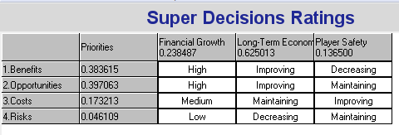

Top-Level Results
The final synthesis at the top-level model gives the below results. Long-Term Viability is the highest weighted priority, followed by Financial Growth and Player Safety. The New Schedule is most preferable when using the additive formula (long-term result), but the Current Schedule is the most preferable using the multiplicative formula. In the long-term, switching the new schedule would be best due to the potential of increased financial growth from television rights and fan participation. In the short-term, the current model has proven to be successful and sustainable while not increasing the risks and costs of the NFL.
OVERALL RESULT:
Name | Normalized By Cluster | Limiting
Financial Growth | 0.23849 | 0.238487
Long-Term Economic Viability | 0.62501 | 0.625013
Player Safety | 0.13650 | 0.136500
Additive Formula
Alternative | Ideals | Normals | Raw
Keep Current Schedule (4-Pre; 16-Regular) | 0.485808 | 0.326966 | 0.274189
New Schedule (2-Pre; 18-Regular) | 1.000000 | 0.673034 | 0.564397
Multiplicative Formula
Alternative | Ideals | Normals | Raw
Keep Current Schedule (4-Pre; 16-Regular) | 1.000000 | 0.681499 | 2.177944
New Schedule (2-Pre; 18-Regular) | 0.467353 | 0.318501 | 1.017868

Sensitivity Analysis
Sensitivity Analysis was performed on the result based upon the additive formula. When comparing the alternatives under the Benefits subnet, the New Schedule is always preferred, and increases in preference as the current schedule decreases. The New schedule is also always preferable when performing sensitivity for Opportunities. At a weight of .2 the two reach a steady state, but with the new schedule still being the preferred.
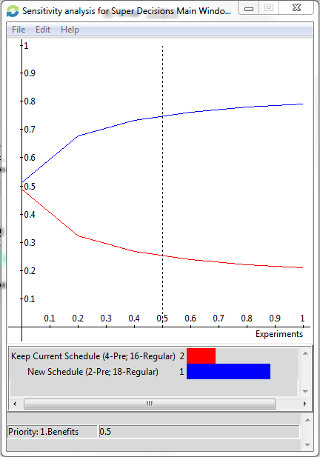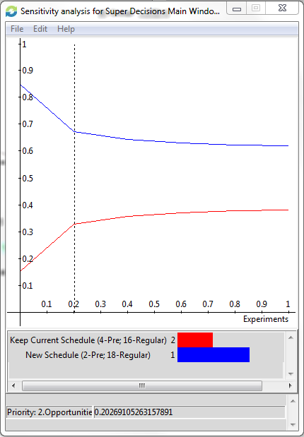
Sensitivity has a different trend from the perspective of costs and risks. For Cost, the new schedule is only preferable up until a weight of approximately .5. After this mark, the current schedule is preferred at an increased weight. Similarly for Risks, the new schedule is preferable up until a weight of 1.5 when the current schedule becomes preferable. This result also helps explain the difference in conclusions between the multiplicative and additive formulas.
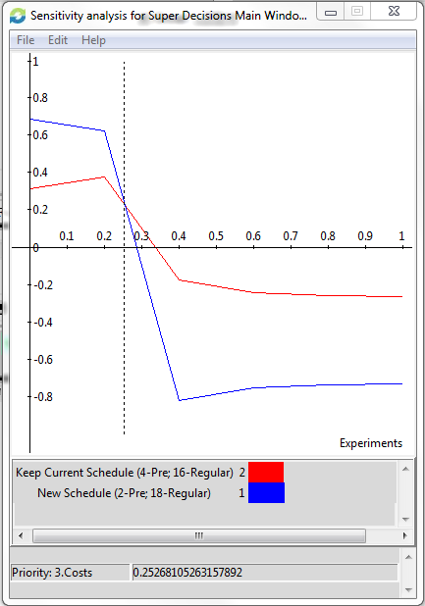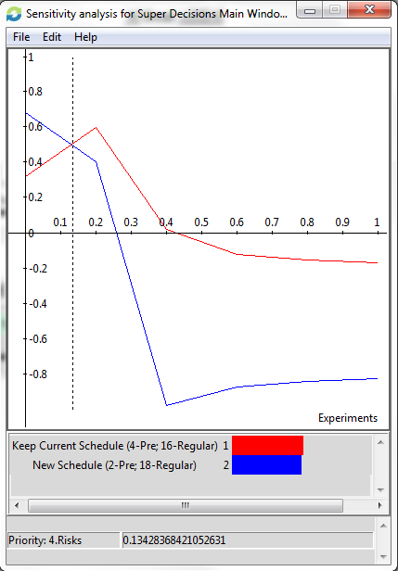

Conclusion
Our model concludes that the NFL will fulfill its strategic objectives in the long-term by updating the current schedule to include 2 pre-season games followed by 18 regular season games. With the current weights of our model the additional costs and risks of the new schedule outweigh the benefits and opportunities with respect to achieving the strategic objectives in the short-term. Interestingly, in the final collective bargaining agreement it was agreed to maintain the current 16 game format for the next ten years.

