Corey Filburn & Alexander Rascoe
BQOM 2521 – Decision Making
BOCR Decision Model

Introduction

The high revenue sports of college athletics (football and men’s basketball) have become an increasingly large business. These sports often produce enough revenue to support entire athletic department budgets and provide funds for university facilities upgrades. Coaches and assistant coaches have seen their salaries increase exponentially and athletic directors have brokered new deals to move schools into more lucrative conferences. These conferences were once based on geographical regions and historic rivalries, but now they are determined by national television deals and improved brand exposure for the universities. While college sports have become big business, the student athletes who provide the on field entertainment, have been left out of the revenue earning equation. These athletes are generating advertising revenues through television exposure, bowl game revenues, and money generated on their likeness in video game and merchandise sales.

These factors have resulted in student athletes turning to alternative means to pay bills or have extra income that is not provided by the scholarships they receive. Student athletes have resorted to selling their equipment or autographs, which has led to numerous scandals. Most notably at The Ohio State University, several athletes sold jerseys and merchandise in exchange for money and tattoos. This resulted in severe sanctions against the school and these players losing their eligibility to play.

Another means of receiving revenue is in the form of lawsuits against the schools and the NCAA, on behalf of players, seeking to recover monies generated when their image and likeness was used in merchandise and video game sales. Most recently the NCAA settled a class action suit of several players including former UCLA basketball player Ed O’Bannon for use of their images in video games.

The time has come for universities to recognize that college athletics is a business and for the athletes to be compensated for the revenue they generate. But what is the best means of doing this? This study uses the ANP model and SuperDecisions software to determine the best method of payment for student athletes that will be beneficial for all parties involved.

Alternatives

The alternatives used in this model are as follows:
- Full Time Salary – this would involve providing players a full time salary with health benefits in addition to their scholarships.
- Stipend – this method involves paying student athletes a flat rate per semester to cover the costs of ancillary expenses not included in scholarships.
- Part Time Wage Pay – this would involve paying players according to the amount of hours they are practicing or playing but could not exceed 40 hours per week.
- Percentage of Revenues – this involves students receiving a percentage of the revenues generated to be divided amongst the players involved.

The Model:

BOCR Networks and Data

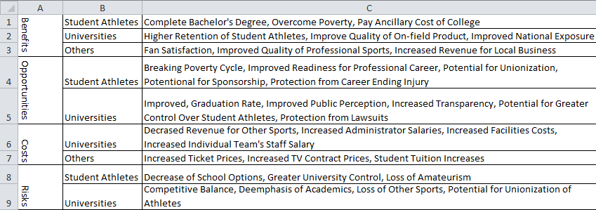
Figure 1: Clusters in the BOCR Network and Associated Criteria

Benefits:
Two groups who directly benefit from this pending change in athlete compensation are the students and the universities. The students will be more likely to complete their bachelor’s degree, overcome poverty and pay their additional costs incurred while they attend college when they are justly compensated.

Regarding the universities, players will not leave the university early in order to obtain a big money contract in a professional league and so university retention rates will increase. The players will be more competitive while playing because they are paid employees of the university and as a result, the sport will naturally become a better spectacle and the on-field product will improve. Additionally, because the players are playing better and staying for longer, the universities will be on the national stage, gaining exposure for the individual universities, and enticing college applicants to consider applying to their university.

There are several other categories that receive benefit from college athletes being paid and are grouped together under one category, other. This group includes fans who will be happier for the college players that they are receiving just compensation. The professional leagues will also benefit because the college leagues will effectively become a minor league, professional teams can watch the players grow for a 4 year period and make better decisions on draft day. Also, while players are staying for longer and fans are more satisfied, locally businesses surrounding the stadiums and universities will experience a boom in their revenue.

Opportunities:
Student athletes have a tremendous amount of opportunity to gain by being paid. They will be more likely to break the poverty cycle with increased income and they will be more ready to play in the professional leagues with additional years in the college system, As paid employees the students will have the opportunity to form a national union of athletes that can better protect player’s rights. The students will also be able to receive sponsorship contracts, which are more lucrative than professional sports contracts. Finally, they will have protection from career ending injuries because they will be able to receive some payment for their skill-set, instead of blowing out their knee during college and never making it to the professional leagues.

The universities will instantly see an increase in their graduation rates from the sports teams. They will have the opportunity to have their public perception enhanced as the nation will no longer believe the universities are endorsing slave labor in the form of not compensating players. They will have increased transparency as revenue numbers for individual programs will be openly available as well as the individual amount paid to each player. Universities will have greater control over student athletes as their employers and make the players more accountable for their actions. Finally they will be protected from class action lawsuits that attempt to gain compensation for the use of student athlete’s faces and names in video games.
Costs:
There are no costs to players so they were excluded from the costs subnet.

In making the decision to pay players, the university may have to divert funds from other sports and decrease their revenue, potentially preventing these teams from stepping on the field. The implication of paying athletes and making them employees of the university will require universities to expand their administrative staff. Additionally, these administrators will need more office space, which will cost the university more money. Also, running a team with paid employees will increase the responsibility of the current team’s staff and require more work hours. They will likely require raises to continue working.

While fans will certainly be pleased to see this system of injustice rectified, they will have to play a part in offsetting the cost and will see their ticket prices rise. The whole industry, including the broadcasting companies, will want a bigger piece of the pie and so TV contract prices will increase. Finally, student tuition will necessarily increase, again to offset the cost of the entertainment value provided by the athletes on the field.

Risks:
There are ofcourse risks associated with making the decision to pay athletes. There will be a decrease in the number of school options for student athletes coming out of high school as some universities will elect not to participate in the new system and as a result cut their programs. The students will become employees of the school and able to be fired for poor performance. The athletes will also lose their amateur status and while this might not appear at first glance to be risky, they will be excluded from developmental leagues that some athletes participate in during summers.

The universities in undertaking this change risk upsetting the competitive balance currently present within the NCAA affiliated leagues. Only the biggest schools will be able to pay their players. There will be a de-emphasis of academics as schools try to find loopholes to continue to put players on the field that will not be able to graduate but are considered employees. They will lose other sports due to funding cuts and the risk of player unionization may disrupt the status quo so much that it minimizes any potential positive outcome for the universities.
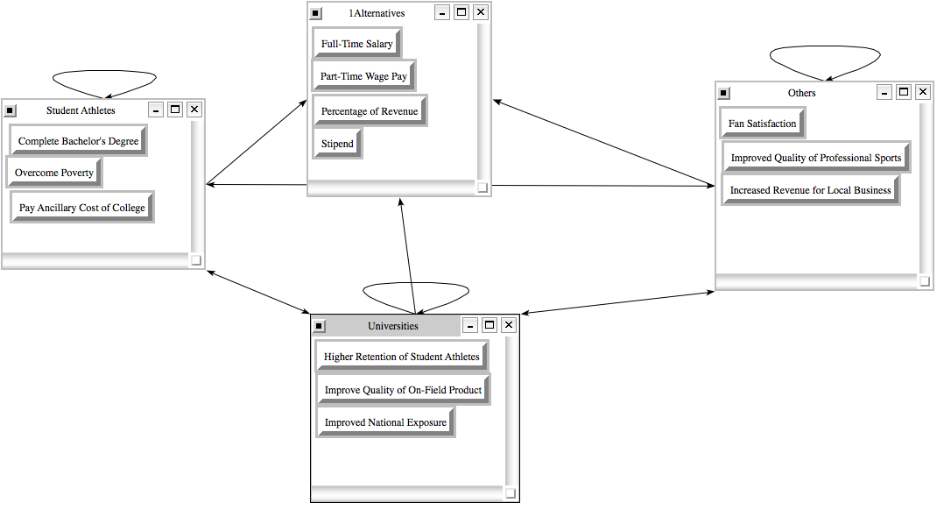
Figure 2: Benefits Subnetwork

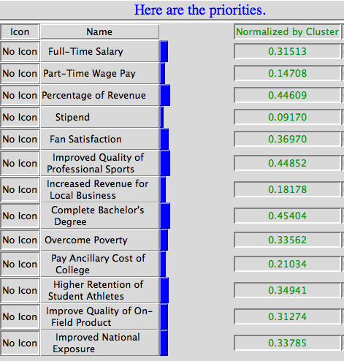
Figure 3: Benefits Priorities

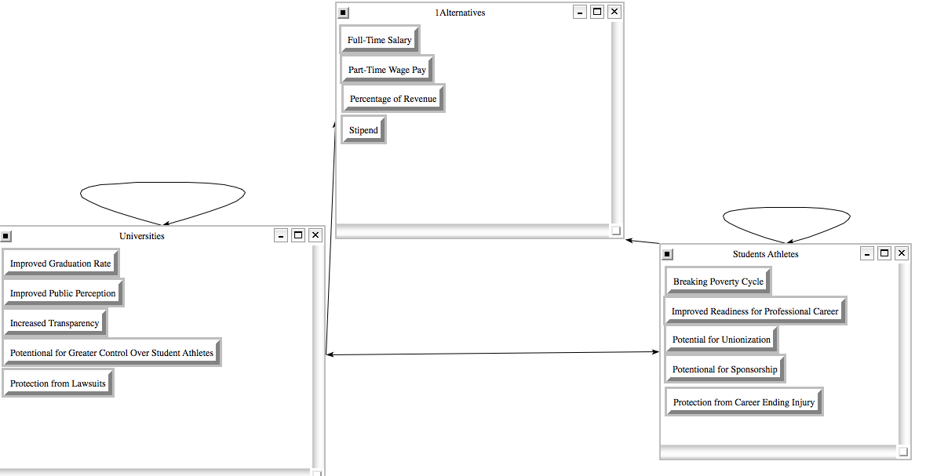
Figure 4: Opportunities Subnet

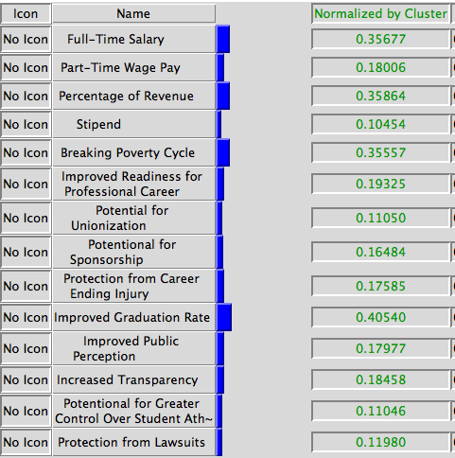
Figure 5: Opportunities Priorities

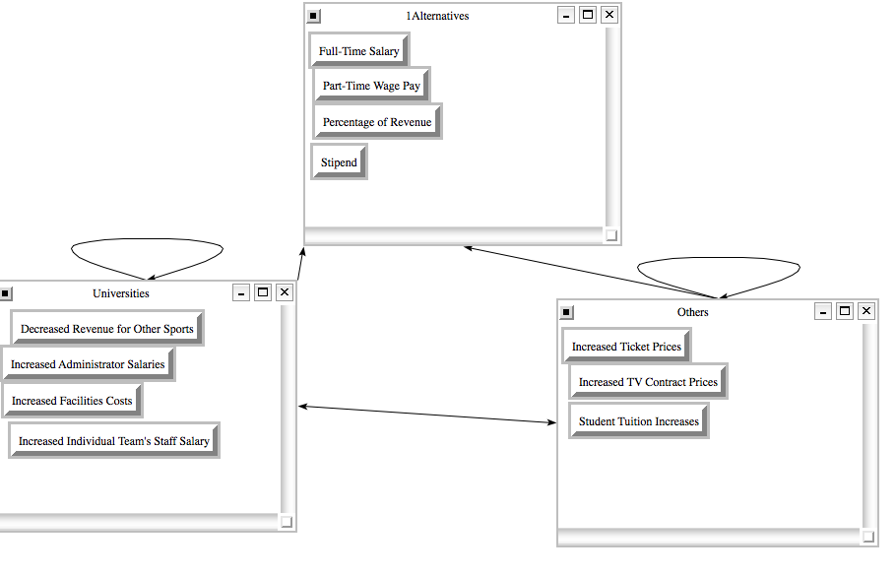
Figure 6: Costs Subnet

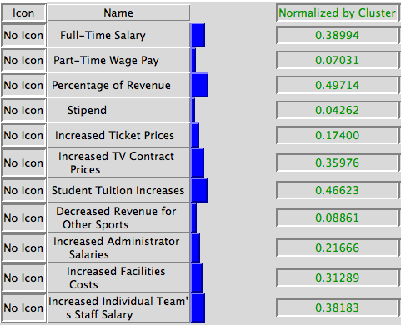
Figure 7: Costs Priorities

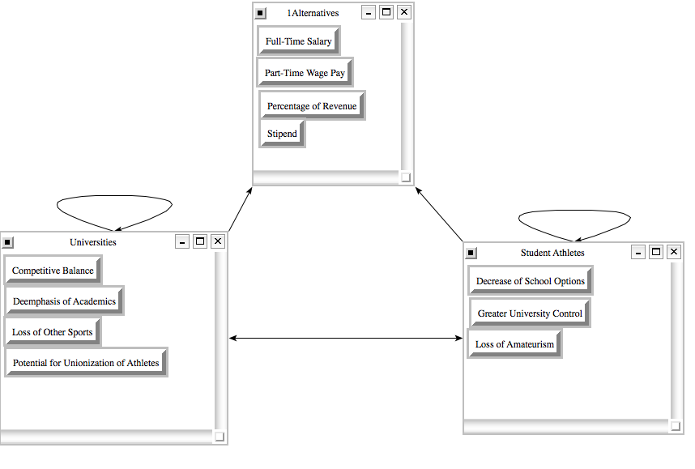
Figure 8: Risks Subnet

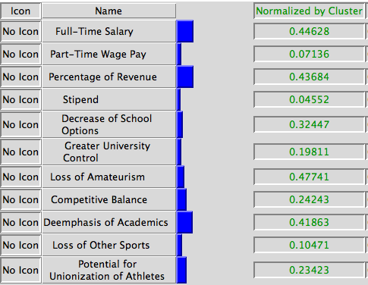
Figure 9: Risks Priorities

BOCR Results and Analysis

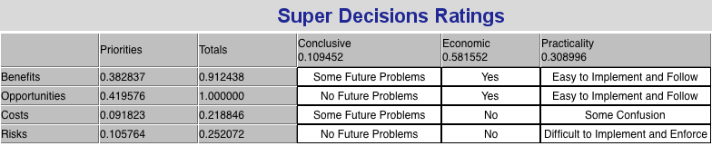
Figure 10: Strategic Criteria Ratings Scale

The economic strategic criterion was preferred to the others based on pairwise comparison and held the highest priority of 0.58. This criterion was preferred because universities and the NCAA have made college athletics big business and any solution for athlete compensation must give highest priority to economic considerations.
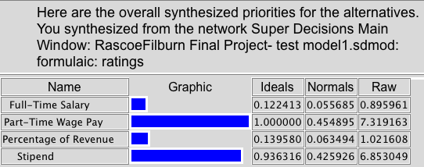
Figure 11: Multiplicative Synthesis (Best Short Term Solution)

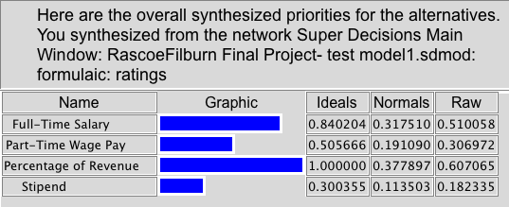
Figure 12: Additive Synthesis (Best Long Term Solution)

Conclusions to be Immediately Drawn:

The results of the additive and multiplicative synthesis differ slightly in their interpretation and the recommendations to be made. Based on the additive synthesis, the best long term solution for paying players would be using a percentage of revenue model, followed by a full-time salary model. In contrast, the multiplicative synthesis indicates the best short term solution would be to pay players a part-time salary followed by a stipend.

In terms of the projected values of each of these payment strategies and with preference given to the economic strategic criterion, this result makes the most sense. The percentage revenue model would incentivize players to perform and universities to have their best players on the field, who also bring in the most money for their institution. This however, comes at a substantial cost to the universities to implement and in the short-term, a hybrid strategy of a part-time salary transitioning to a percentage of revenue model makes sound economic sense.

