Decision Making in a Complex Environment

Determining Whether Pitt Should Build an On-Campus Football Stadium

Logan Baker
Patrick Kahle
April 23, 2013

Introduction

As Heinz Field begins to age, it is time for the athletic department and administrators at the University of Pittsburgh to begin considering options, specifically whether or not an on-campus football stadium should be constructed. It is important to evaluate all of the various factors associated with this decision to ensure the best path forward is ultimately chosen. To do so, a complex Benefits, Opportunities, Costs and Risks (BOCR) model has been developed. The model that has been developed for this decision applied criteria from four main areas of consideration: financial factors, fan satisfaction, University reputation, and logistics. Through the use of ANP and BOCR, various different subnets have been setup to evaluate the two alternatives: construct an on-campus football stadium or do not construct an on-campus football stadium. From there, the results of each BOCR were rated against the strategic criteria to provide the overall best short- and long-term decisions.

Alternatives

The decision that must be made is whether a new on-campus football stadium should be constructed, or whether it should not be constructed. Most avid Pitt football fans will quickly rattle off a number of advantages of an on-campus stadium. Some common points are an improved atmosphere, greater student attendance, easier accessibility, stimulation of the campus economy, and an overall better “fit” when compared to a pro football stadium miles from campus. But there are arguments against the on-campus stadium that the decision-makers must consider, two being the large cost of stadium construction and logistics nightmare with which the campus would be presented. Using a BOCR model to factor all criteria from the decision-maker point of view, we will determine the best path forward. The strategic criteria that were identified were football program success and health, growth of Oakland and the Pitt campus, reelection of the decision-makers, and University growth.

ANP Model

The model was created using the Analytic Network Process (ANP) to find a resolution to the issue described above: Determining whether or not Pitt should build an on-campus football stadium. See the top-level network below. Following the top-level model are the BOCR criteria subnetworks and the synthesis results, along with analysis. The subnetworks are presented in outline format. For details on subnetworks and node connections, please refer to the SuperDecisions file also included with this submission.
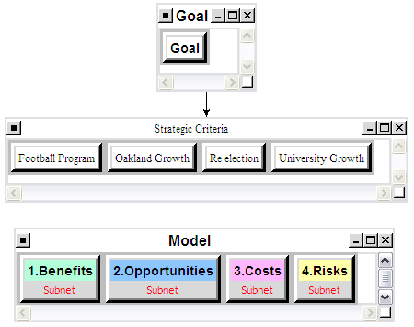
Top-Level Network

Benefits

The benefits of building a new stadium on campus are often presented by those students and fans that desire a more “traditional” game day atmosphere. Having a football stadium on campus would allow for easier access for students and would offer alumni and fans a chance to attend a football game while also being within walking distance of campus. It is also important to consider the financial impacts this would create for Oakland. Hosting 5-6 home games each fall would mean that potentially 50,000 people could be on or near campus on a Saturday. This would be great for restaurants, hotels, and merchandise vendors in Oakland.

It is also important to consider the impact an improved Game-Day atmosphere would have on the football program and University. Having a stadium in Oakland would likely create greater opportunity for Student to organize tailgates and a smaller, filled to capacity stadium would create more energy and excitement for the team. A new stadium on campus would also generate positive national attention for the University and could help attract more recruits and general students. The following table shows an outline of the Benefits Subnetwork that detailing all the benefits realized with the construction of a new stadium on campus.

Benefits Subnetwork
Financial Factors | In Stadium | Ticket Sales
Financial Factors | In Stadium | Concessions (stadium)
Financial Factors | In Stadium | Merchandise (stadium)
Financial Factors | On Campus | Parking (campus)
Financial Factors | On Campus | Apparel
Financial Factors | On Campus | Food
Financial Factors | City | Transportation
Financial Factors | City | Casino Revenue
Financial Factors | City | Parking (public)
Fan Satisfaction | Access to Stadium | Prox to campus bldgs, housing
Fan Satisfaction | Access to Stadium | Casual fan ease of access
Fan Satisfaction | Access to Stadium | Student ease of access
Fan Satisfaction | Game Day Environment | Tailgating
Fan Satisfaction | Game Day Environment | Pregame atmosphere
Fan Satisfaction | Game Day Environment | In-game atmosphere
Fan Satisfaction | Game Day Environment | Alumni presence
University Reputation | Fans | Alumni Support
University Reputation | Fans | Fan Support
University Reputation | Fans | National TV attention
University Reputation | Prospective Students | Prospective Student interest
University Reputation | Prospective Students | Prospective Recruit Interest
Logistics | Traffic Flow | Oakland Traffic
Logistics | Traffic Flow | Coordinating Shuttle Services
Logistics | Traffic Flow | Increased foot traffic
Logistics | Resident Burden | Reduced Resident Parking
Logistics | Resident Burden | Increased Noise
Logistics | Resident Burden | Oakland Crime

Benefits Synthesis Results: the benefits subnetwork favored the construction of an on-campus stadium.

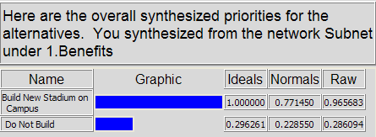

Opportunities

Building a new stadium would result in a tremendous cost for the University but also would create numerous opportunities. Financially, a new stadium would likely result in increases in ticket sales from current levels and multiple sold out games each year. Also, a new stadium would create the opportunity for the University to host concerts or other events in a setting larger than the Peterson Event Center. Opportunities also would exist for increases in student pride and prospective student applications; increases in alumni pride could coincide with increases in donations as well. To accommodate the thousands of people traveling to the new stadium in Oakland, an opportunity exists for the city to construct new roadways, exit ramps, and public transportation routes in order to improve traffic flow

The football program could garner more national expose with a new stadium and often the reputation of a program and the loyalty of the fan base factor into the decision of what bowl game a team will play in. Therefore, building a new stadium could in fact lead to invitations to more prestigious bowl games for the team. An overview of all potential opportunities considered in the model is presented below.

Opportunities Subnetwork
Financial Factors | Stadium | Increase Ticket Sales
Financial Factors | Stadium | Naming Rights
Financial Factors | Stadium | Sponsorships
Financial Factors | Stadium | Park/Concessions/Merch
Financial Factors | University | Host Concerts
Financial Factors | University | Increase Enrollment
Financial Factors | University | Campus Stores
Fan Satisfaction | Alumni/Fans | Alumni Pride
Fan Satisfaction | Alumni/Fans | Visits to Campus
Fan Satisfaction | Alumni/Fans | Donations
Fan Satisfaction | Students | Student Pride
Fan Satisfaction | Students | Team Support
Fan Satisfaction | Students | Game day Experience
University Reputation | Football | National Reputation
University Reputation | Football | Bowl Bids
University Reputation | Football | National TV Games
University Reputation | Football | Intimidating Environment
University Reputation | Football | Attract more recruits
University Reputation | University | Increase Applications
University Reputation | University | National Exposure
University Reputation | University | University Pride
Logistics | Transportation | New Exits/Roads in Oakland
Logistics | Transportation | Expand T Route to Oakland
Logistics | Oakland | New Hotels
Logistics | Oakland | New Businesses
Logistics | Oakland | Visual Appeal of Skyline
Logistics | Oakland | Increased Crime in Oakland

Opportunities Synthesis Results: opportunities subnetwork favored the construction of an on-campus stadium.

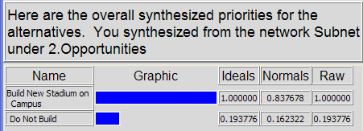

Costs

When considering the costs of building a new on-campus stadium in Oakland, the obvious factors are the financial ones. A large plot of land will need to be acquired, and that land will likely be expensive. On top of the land acquisition, the construction of the stadium will not be cheap, especially if the stadium is expected to approach the quality that the players and fans are accustomed to with a professional football venue such as Heinz Field.

In addition to the financial costs, we must pay attention to the benefits that the current arrangement at Heinz Field offers: the expansive territory for tailgating, the close proximity to local bars and shops and the casino, the spacious concourse, well-known concessions options, spacious bathrooms, and comfortable and roomy grandstand seating. These factors will all likely be changed for the worse in what would likely be a cramped and lower-budget on-campus stadium. The following table shows an outline of the Cost Subnetwork that accounts for all of the tradeoffs that would be made in the change to an on-campus stadium.

Cost Subnetwork
Financial Factors | Stadium | Concessions
Financial Factors | Stadium | Grandstand
Financial Factors | Stadium | Restrooms
Financial Factors | Stadium | Training Rooms
Financial Factors | Other | Promenade
Financial Factors | Other | Statues/Decoration
Fan Satisfaction | North Shore | Proximity to Bars/Casinos
Fan Satisfaction | North Shore | Tailgating
Fan Satisfaction | North Shore | Events
Fan Satisfaction | Heinz Field | Pro Football Facility
Fan Satisfaction | Heinz Field | Concessions
University Reputation | National | Share with Steelers
University Reputation | Prospective Students | State of the Art Facilities
University Reputation | Prospective Students | Pro Football Facility
Logistics | Traffic | Proximity to Highways
Logistics | Traffic | Alternate Routes
Logistics | Parking | Garage/Lot Quantity
Logistics | Parking | Proximity to Field

Costs Synthesis Results: the costs subnetwork showed high costs for not building an on-campus stadium.

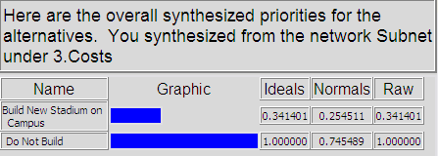

Risks

The Risks Subnetwork is added to account for the possible negatives that could occur if an on-campus football stadium were constructed. For instance, the athletic department could see decreases in ticket sales for a number of reasons. Perhaps more fans were loyal and comfortable with Heinz Field and do not want to renew season ticket reservations if games will be played in a different locale. Perhaps some donors will be so put off by the decision that they decide they do not care to donate money to the school any longer. These situations would conceivably be few and far between, but the risk still exists.

As for fan satisfaction, many people are perfectly content with spending their Saturdays on the North Shore tailgating and going to the local bars and the casino. They are at peace with the gameday atmosphere, and feel that there would be no improvements, or perhaps even a regression at an on-campus stadium. It’s very possible that recruits that could help the team win would rather play at Heinz Field than a bandbox in Oakland, and therefore decide to play football elsewhere. Considerations must also be made for the fan conduct that would occur on-campus. There is much greater potential for drunkenness, rioting, and excessive revelry and/or crime when students do not need to find transportation to and from football games. These risks are all factors that should be considered. The Risk Subnetwork with these and additional factors are outlined below.

Risks Subnetwork
Financial factors | Revenues | Ticket sales
Financial factors | Revenues | Concessions
Financial factors | Donations | Corporate
Financial factors | Donations | Alumni
Fan satisfaction | Gameday | Atmosphere
Fan satisfaction | Gameday | Tailgating
Fan satisfaction | Gameday | Fan Engagement
Fan satisfaction | Team Success | Bowl Games
Fan satisfaction | Team Success | National Ranking
Fan satisfaction | Team Success | Recruiting
University reputation | Crime | Violence
University reputation | Crime | Theft
University reputation | Crime | Disorderly Conduct
University reputation | Revelry | Rioting
University reputation | Revelry | Fires
University reputation | Revelry | Drunkenness
Logistics | Public transportation | Cleanliness
Logistics | Public transportation | Delay
Logistics | Public transportation | Overcrowding
Logistics | Traffic | Accidents
Logistics | Traffic | Gridlock
Logistics | Traffic | Alcohol-Related

Risks Synthesis Results: risk subnetwork showed large risks to not building on-campus stadium.

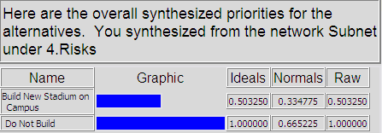

Ratings Model

A ratings system was implemented to compare the BOCR against the four strategic criteria: Football Program health, growth of Oakland, reelection of the decision-makers, and University growth. These were done based on the level of influence that the specific strategic criteria had on the alternative that was shown to have the top priority value for that particular item (i.e. Benefit, Opportunity, Cost, or Risk). In summary, Benefits and Opportunities were rated against each of the four strategic criteria with the decision to build in mind, because that was the alternative that had the highest ranking in those models. For the Costs and Risks, the decision in mind was the decision not to build. The table below summarizes the results.

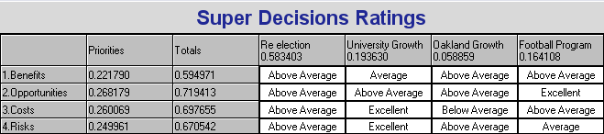

Overall Results

The following displays the overall results for the BOCR model based on the various criteria comparisons and ratings applied to the model.

Multiplicative: The multiplicative results, shown below, represent which alternative is best in the short-term. It was determined through the model that was developed that the decision to not build an on-campus stadium is the best choice with a priority of 99%.

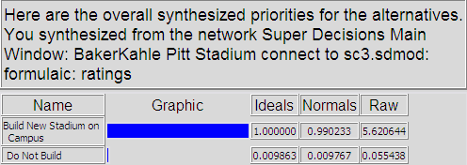

Additive: The additive results shown here represent the best alternative to be selected based more on the long-term net effects. This calculation shows that the decision to build the on-campus stadium is the best choice.

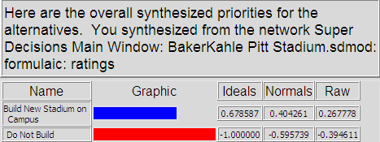

Sensitivity Analysis

The following sensitivity analyses graphs show the priority relationship for each alternative as the priority for the benefits, opportunities, costs, and risks change. Each one will be evaluated and discussed relative to the impact of a changing priority and it’s affect on the overall best alternative to choose.

Benefits and Opportunities
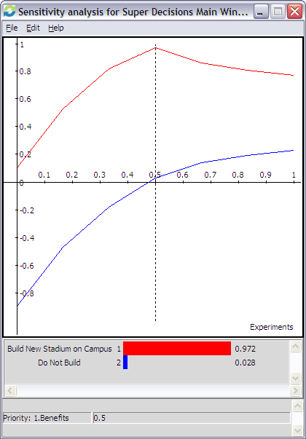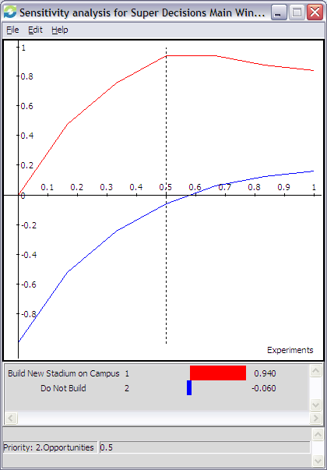

Costs and Risks
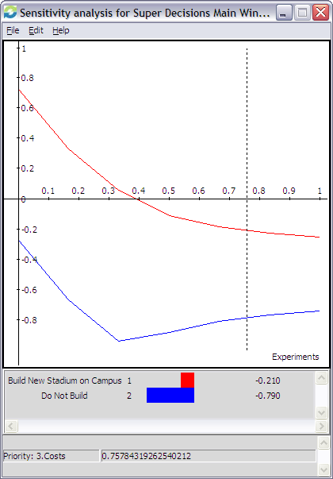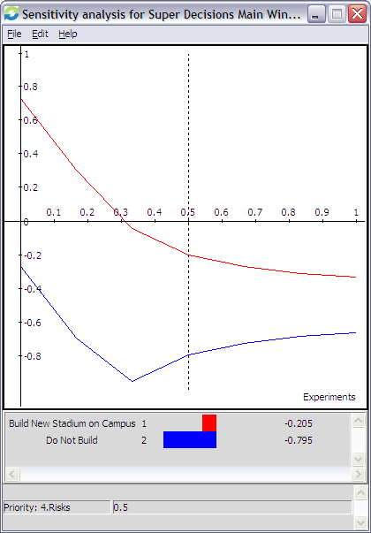

At any weight of benefits/opportunities, both benefits and opportunities factors heavily favor building a new on-campus football stadium. The same can be said for costs and risks; they were much higher for building than not building the stadium, favoring the decision to build.

Conclusion

In conclusion, the BOCR model that was developed shows that the best decision regarding the prospect of the on-campus football stadium is to build. Typically Universities are risk-averse and operate with heavy interest in long-term goals, so the decision the long-term decision favoring the option to build would be very influential on the decision-makers. It is important to keep in mind that such a decision is based on many factors that were likely unnoticed since a wider audience was not involved in the model development and ratings assignments.

