Should the NFL Add Games to Its Season?

Decision Making in a Complex Environment
Final Project
October 16, 2009

Aaron Bulkley
Tom Charley
Jonathan Hasson
The National Football League has been mulling around the decision of lengthening the regular season for a few years now. In the current situation, the NFL regular season is 16 games, and there are 4 preseason games that have no effect on the leagues standings. The NFL, including the owners and players, has come up with two other alternatives for adding games to the regular season. The first consists of shortening the preseason to 3 games and lengthening the regular season to 17 games, and the second consists of shortening the preseason to only 2 games and lengthening the regular season to 18 games.
Many NFL owners are in favor of lengthening the season because preseason games bring in considerably less revenue from ticket sales and television contracts. Furthermore, with the current Collective Bargaining Agreement, players are due 59.6% of all revenues in the form of salaries. An increased number in games will provide them with more revenues to make up for the salary expense.
The NFL as a whole will benefit from increased exposure and media coverage. The NFL is the most popular spot in the United States and will benefit from giving their customers what they want, more meaningful football.
The players will benefit from increased salaries from playing two more games and exposure that can lead to lucrative endorsement deals.
Deciding on a change in season length for the NFL is a good situation for using a complex Benefits, Opportunities, Costs, and Risks ratings model with the SuperDecisions software.
To make a decision on whether the NFL should change their season length, we considered all relevant criteria. Thinking about this, we decided on 4 top-level strategic criteria:

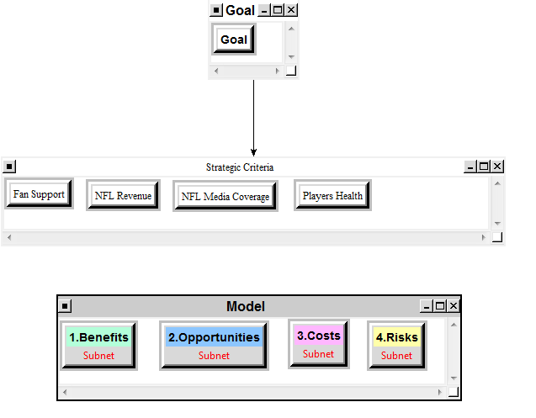
- NFL Revenue: Revenue production is a major driving force in the decision to extend the regular season. Owners and players could see increased cash flow from these extra games.
- Fan Support: Considering the popularity of the NFL in the US, the extended season would most likely be widely accepted by the fans of the league.
- NFL Media Coverage: Media coverage is a huge part of the NFL business model. From network contracts to new outlet coverage, added regular season games would have ramifications across a wide spectrum of media outlets.
- Players Health: In preseason games, the best players do not play a considerable amount of time because the games do not count for regular season standings and the high possibility of injury that comes with the game of football. Extending the season would mean that the star players, arguably the most valuable asset of the league, would be put at risk of injury for a considerably higher amount of time. Injuries of key players would undoubtedly increase.

Since it was a BOCR model, we have control criteria and subcriteria for Benefits, Opportunities, Costs, and Risks:
For Benefits:
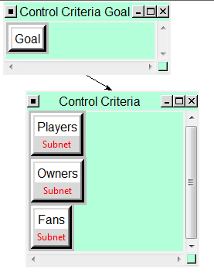

Subnet for Control Criteria:
Players Owners
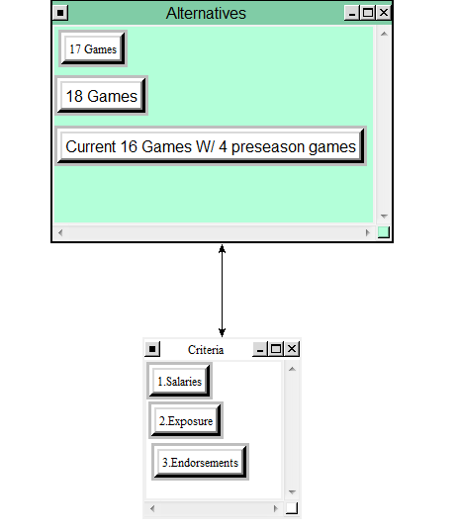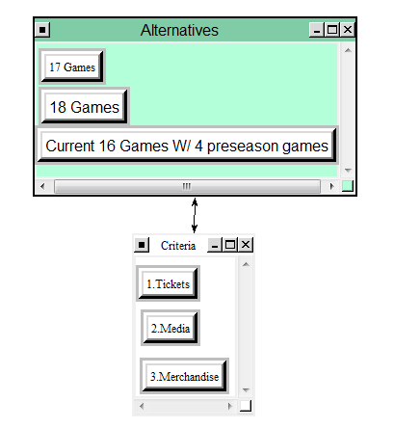
Fans
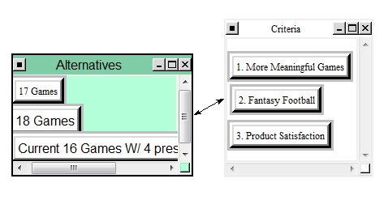

For Opportunities:
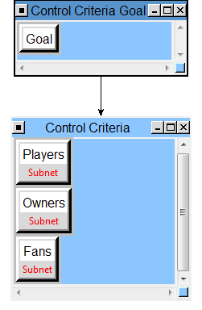
Subnet for Control Criteria:
Players Owners
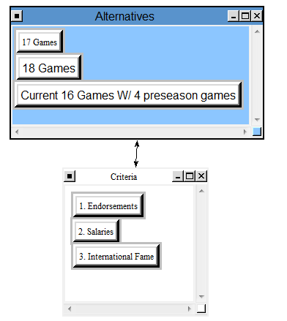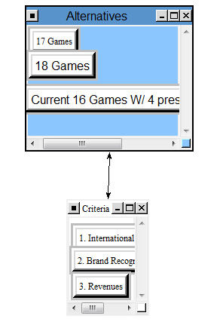

Fans
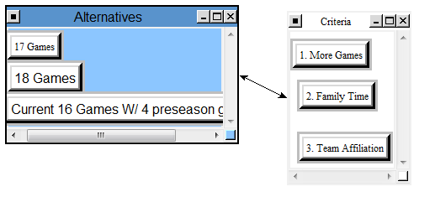
For Costs:
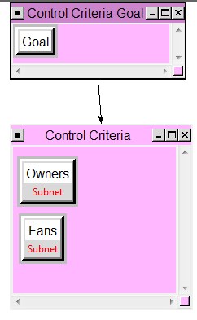

Subnet for Control Criteria:
Owners Fans
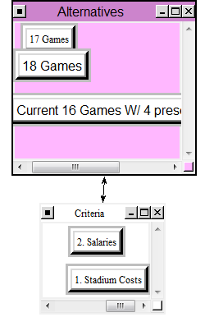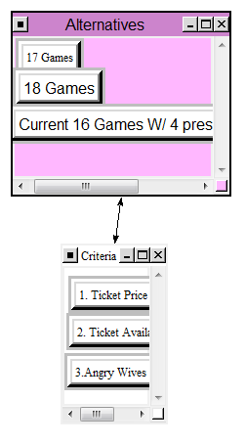

For Risks:
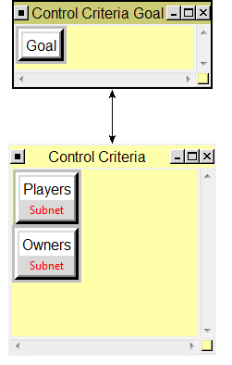

Subnet for Control Criteria:
Players Owners
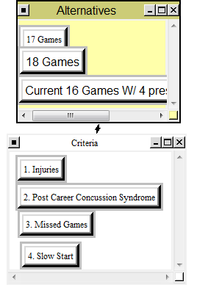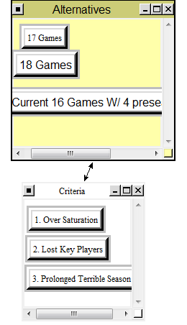

After setting up the BOCR model we made the pair wise comparisons for the criteria and sub criteria.
Benefits

Alternative Rankings
Graphic | Alternatives | Total | Normal | Ideal | Ranking
 | 17 Games | 0.3466 | 0.2273 | 0.3466 | 2
 | 18 Games | 1.0000 | 0.6558 | 1.0000 | 1
 | Current 16 Games W/ 4 preseason games | 0.1783 | 0.1169 | 0.1783 | 3

How the alternatives fed forward
17 Games | Total Priority | Rank
Fans | 0.1068 | 2
Owners | 0.1163 | 2
Players | 0.1140 | 2

18 Games | Total Priority | Rank
Fans | 0.3375 | 1
Owners | 0.3202 | 1
Players | 0.3295 | 1

Current 16 Games W/ 4 preseason games | Total Priority | Rank
Fans | 0.0557 | 3
Owners | 0.0635 | 3
Players | 0.0566 | 3

Opportunities:

Alternative Rankings
Graphic | Alternatives | Total | Normal | Ideal | Ranking
 | 17 Games | 0.5000 | 0.2857 | 0.5000 | 2
 | 18 Games | 1.0000 | 0.5714 | 1.0000 | 1
 | Current 16 Games W/ 4 preseason games | 0.2500 | 0.1429 | 0.2500 | 3

How the alternatives fed forward
17 Games | Total Priority | Rank
Fans | 0.1429 | 2
Owners | 0.1429 | 2
Players | 0.1429 | 2

18 Games | Total Priority | Rank
Fans | 0.2857 | 1
Owners | 0.2857 | 1
Players | 0.2857 | 1

Current 16 Games W/ 4 preseason games | Total Priority | Rank
Fans | 0.0714 | 3
Owners | 0.0714 | 3
Players | 0.0714 | 3

Costs:

Alternative Rankings
Graphic | Alternatives | Total | Normal | Ideal | Ranking
 | 17 Games | 0.4368 | 0.2467 | 0.4368 | 2
 | 18 Games | 1.0000 | 0.5648 | 1.0000 | 1
 | Current 16 Games W/ 4 preseason games | 0.3338 | 0.1885 | 0.3338 | 3

How the alternatives fed forward

17 Games | Total Priority | Rank
Fans | 0.1136 | 3
Owners | 0.1293 | 2

18 Games | Total Priority | Rank
Fans | 0.2481 | 1
Owners | 0.3034 | 1

Current 16 Games W/ 4 preseason games | Total Priority | Rank
Fans | 0.1383 | 2
Owners | 0.0673 | 3

Risks:

Alternative Rankings
Graphic | Alternatives | Total | Normal | Ideal | Ranking
 | 17 Games | 0.4766 | 0.2770 | 0.4766 | 2
 | 18 Games | 1.0000 | 0.5813 | 1.0000 | 1
 | Current 16 Games W/ 4 preseason games | 0.2438 | 0.1417 | 0.2438 | 3

How the alternatives fed forward
17 Games | Total Priority | Rank
Owners | 0.1294 | 2
Players | 0.1429 | 2

18 Games | Total Priority | Rank
Owners | 0.3010 | 1
Players | 0.2857 | 1

Current 16 Games W/ 4 preseason games | Total Priority | Rank
Owners | 0.0696 | 3
Players | 0.0714 | 3

After the BOCR was done, we did the ratings for the strategic criteria. The rating matrix can be seen below:

Ratings matrix
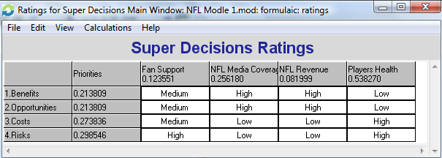
After we finished our BOCR model we combined the BOCR using the additive and multiplicative formulas. Synthesizing the data provides us with the results of our model:
Additive Formula:
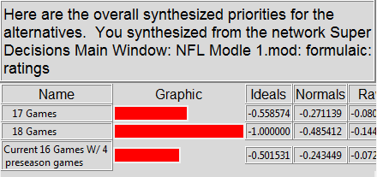
So it seems that, since additive formula represents the best alternative for the long-term, the current 16 game schedule is the best alternative.

Multiplicative:
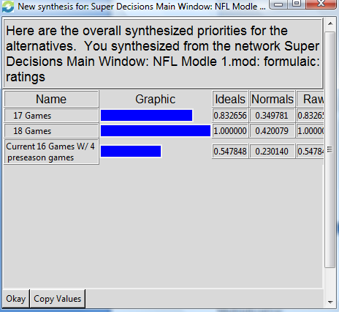
Multiplicative says that the extension to the 18 game schedule is the best alternative by far, with staying at the current 16 game season not looking like a good alternative at all.

SENSITIVITY:

Benefits:

As the importance of benefits increases, the extension to the 18 game season becomes the best alternative. This is due to the fact of increases revenues for the owners and the league as a whole and increased salary for the players and increased enjoyment for the fans.

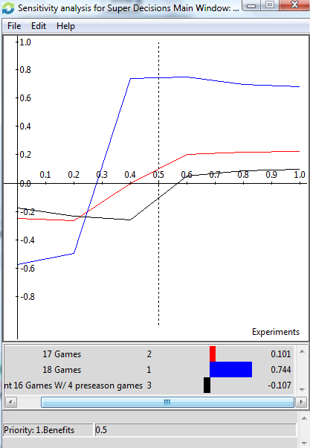

Opportunities:
The extension of the regular season to 18 games should be chosen as the importance of opportunities increases. Opportunities for exposure, media coverage, player recognition all increase with more games.
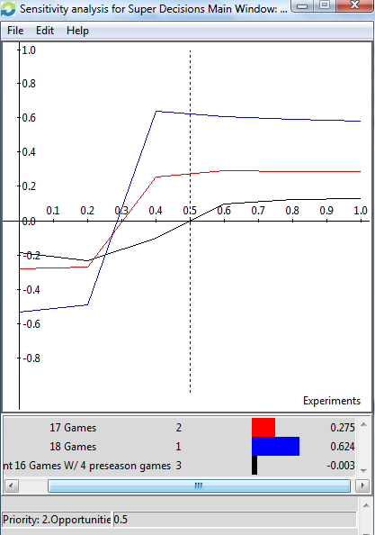

Costs:
As the importance of costs increase, staying at the current 16 game schedule seems to be the best alternative. This makes sense because, as you add games, the league as a whole will encounter more costs in the form of operating costs, liability, and salary costs.
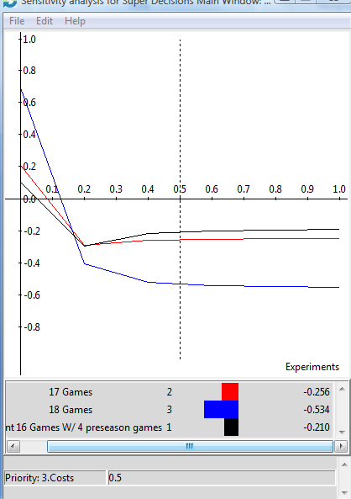

Risks:
As risk increases in importance staying at the current 16 game schedule is also the best alternative because the risk of injury to the players remains at a lower level, and the risk would increase with an increase in regular season games.
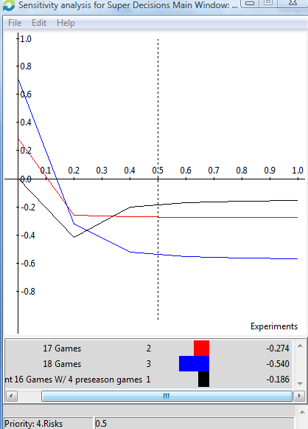

Conclusion:
From the analysis we obtained from the model, it seems that in the short-term the best alternative would be to extend the regular season of the NFL to 18 games. In the long run, staying at the current 16 game schedule was the best alternative. We feel that it may still be in the best interest of the NFL to keep their season at the current 16 games, even though we feel that the NFL will eventually make the decision to extend the regular season for the revenue benefit. It is a players’ league, and the league has changed the rules in recent years to protect the players, and we feel that extending the season would be retroactive to any headway the league has made to prevent injuries and protect the players.

http://www.denverpost.com/sports/ci_10310155
http://sportsillustrated.cnn.com/2008/writers/ross_tucker/08/21/schedule/index.html

