Final Project: Should the Pirates owners invest profits into the team?

Tom Glaser
Nathan Mancine

October 19, 2009

Decision Making In Complex Environments (BQOM 2521)

Background

The Pittsburgh Pirates are a major league baseball team with a rich history. The organization was home to numerous famous players such as Manny Sanguillen, Willie Stargell, Bill Mazeroski, Honus Wager, Andy Van Slyke and the great Roberto Clemente. The Pittsburgh Pirates were also World Series Champions in 1909, 1925, 1960, 1971, and 1979. That strong baseball heritage is quickly being overtaken by a new Pirate stereotype, “Losers.” The famous Pirate players listed above are as old as the World Series Championships themselves. It has been thirty years since a World Series Championship, and seventeen years since they had a winning a record. The Pirates have been receiving negative attention and publicity for years with regards to trading away their best players for “no-namers” or “has beens.” Fans have been left with a bad taste in their mouths from watching losing baseball while paying eight dollars for a beer and six dollars for nachos. This distaste can be clearly viewed by looking at the attendance numbers. The Pirates draw 60% of other average MLB teams in attendance numbers each year. The fans seem to be tired of paying to watch a glorified minor league team riding on the achievements of the past. A key statistic with a possible correlation to team record could be the Pirates’ extremely low payroll. The Pirates’ payroll is near the bottom of the league (49 million compared to the average of 80 million per team).

These issues have led us to ask the question “Should the Pirates’ owners invest profits into the team?” Our model will attempt to answer this question from the Pirates’ owner’s perspective. We will build the model with the owner’s interests and priorities in mind. Hopefully this model can help make sense of the issue of why the Pirates lose and why the Pirates’ owners seem to damn the team year after year.

Alternatives

- Re-invest money into the team.
  - Used to retain quality players
  - Pay management staff and current players adequately
  - Purchasing/trading for capable players who are able to contribute
- Continue to put money into the owner’s pockets.
  - This alternative will continue the status quo

Strategic Criteria

Our Strategic Criteria consist of four main topics:

Entertainment: This idea engulfs any and all persons to whom the Pirates Organization could provide entertainment. This encompasses the team itself, pierogi races, hot dog cannons, and fireworks for attendees at the games. Entertainment also includes television viewers, the community that is affected by the organization, and even in-town guests for concerts or all-star games being held at the Pirates’ venue.

Fans: This topic includes the Pirates’ direct fan base. These individuals could be radio listeners, television viewers, or game-attending fans (including season ticket holders).

Profits: This is the most complex topic. Not only are the profits from merchandise, concession, and ticket revenues important, but there is also a gray area, “Revenue Sharing.” Revenue Sharing is a policy that was established by Major League Baseball to share the profits of large markets with smaller markets. Major League Baseball (MLB) does not have a salary cap. The lack of a salary cap would enable teams in New York with a large market to generate more revenue and pay higher salaries for the best players. Teams in small markets such as Pittsburgh or Tampa Bay would be destined to fail due to lack of potential revenue because of a smaller and more finite fan base. Therefore, teams in large markets are forced to share some of their larger revenue with the smaller market teams in order to level the playing field.

Retention: The idea is focused on two main areas. The first of these is to physically retain the Pirates within the city of Pittsburgh. The second of these is to retain the current fan base.

Project Model with Goal, Strategic Criteria, and BOCR
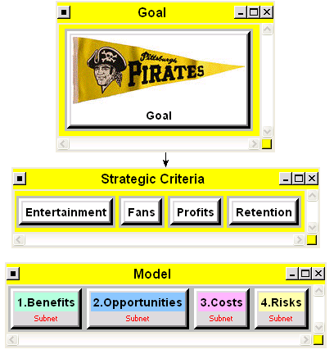

Setting Up the BOCR Model & Control Criteria

Under our Benefits, Opportunities, Cost, and Risks model we used two major Control Criteria; Economic and Social. We used these two Control Criteria for each of the four components. We also used a universal comparison and rating system for Economic and Social Control Criteria. The detailed breakdown of the Control Criteria is as follows:

- Economic
  - League
    - This category envelopes all monetary drivers in MLB. These topics are Revenue Sharing, Rivalries and Television Exposure. The main driver in this category is Revenue Sharing. Revenue Sharing can actually reward losing teams and punish consistently winning and profitable organizations.
  - Internal Organization
    - This area encompasses all economic choices and decisions. This can include advertising, marketing and promotions. The Internal Organization would also include the management that makes the day-to-day decisions. These day-to-day activities include managing the current roster of players while also managing the team’s future; their minor league system of players.
  - Fan interest
    - This idea attempts to engulf the economic implications of the fans. The fans have a trickledown effect on the organization’s revenues. Fans are responsible for ticket purchases, buying team merchandise and concession items at games, not to mention the buzz (aka word of mouth), excitement and passion for the organization.
- Social
  - City Development
    - City Development category attempts to capture the social impact of the Pirates Organization. Business Growth and Economic well-being, although economic in nature, has a strong social impact. Housing the Pirates in Pittsburgh has a direct impact on jobs, new job growth and tax revenue. Jobs and tax revenue have a direct impact on County and City Welfare Programs.
  - Charitable
    - The Pirates conduct numerous charitable events and donate to disadvantaged organizations. The Pirates also give tickets to organizations in order to provide children with the opportunity to enjoy baseball. This support to the local community develops goodwill between the city, social classes and the organization.
  - Community
    - In regards to social impact, the Pirates Organization depends and relies on press coverage from the local community media such as the Pittsburgh Post Gazette and Fox Sports Network. This community press coverage spurs fan interest and fan loyalty. However, this area can also negatively impact the community. If the press coverage is continually negative, it could potentially dissuade fan growth and result in a negative view of the organization by the community at large.

The following picture depicts the control criteria and linkages that were setup within in each of the BOCR of the model:
Control Criteria with Subnets
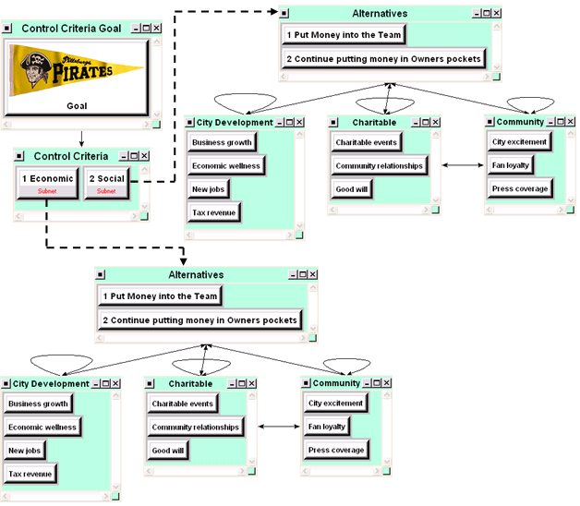

Results of the BOCR

Once the subnets within each of the BOCR (Economic and Social) were established and the links between the clusters and nodes were established (as shown above), we I scored each of the linked nodes against one another using the “Questionnaire” method. When the scoring was performed, we checked the consistency index each time to ensure that it was less than 0.1, and made adjustments where required. When the ratings of the 2 subnets within each BOCR were completed (Economic and Social), the BOCR subnets were synthesized. The results are as follows; the alternative with the higher percentage is highlighted in bold & italic:

Benefits:
- Put Money into the Team 46.4%
- Continue putting money in Owners pockets 53.6%
Opportunities:
- Put Money into the Team 51.0%
- Continue putting money in Owners pockets 49.0%
Costs:
- Put Money into the Team 71.5%
- Continue putting money in Owners pockets 28.5%
Risks:
- Put Money into the Team 59.3%
- Continue putting money in Owners pockets 40.7%

The Ratings Model

After each BOCR was synthesized to determine which of the alternatives scored higher, the Ratings model was used to generate the results for the entire model and determine which of the alternatives is optimal. With the Ratings model, the alternative with the higher score in each of the BOCR is rated against the strategic criteria of the model; Entertainment, Fans, Profits, and Retention. For example, under Benefits, “Continue putting money in Owners pockets” scored highest, therefore, in the Ratings model, the impact of that alternative is rated against the strategic criteria. The rating system that we used for each of the strategic criteria was a scale of 1-5, with 1 being the lowest and 5 being the highest. The resulting factors of the rankings and the completed rating matrix are as follows:

Rating System for the Ratings model
Rating Factor
- 0.147577
- 0.232364
- 0.382097
- 0.627223
- 1.000000

Completed Ratings Matrix
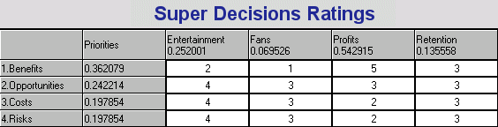

Analysis of the Ratings Model

Once the ratings matrix is complete, the last step is to synthesize the results. For this analysis, we used both the Multiplicative formula and the Additive formula for synthesizing the results. The Multiplicative formula (BO/CR) is equivalent to marginal cost/benefit analysis and is generally best for short term results. Additive formula (bB+oO-cC-rR ) is generally best for long term results. The synthesis for each formula is as follows:

Multiplicative Formula results
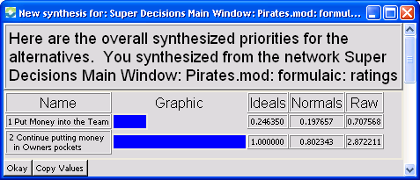

Additive Formula results
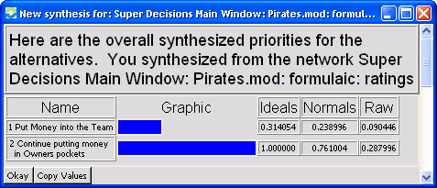

With both formulas, “Continue putting money in Owners pockets” was found to be the optimal solution by a large percentage. Upon reviewing each of the BOCR results, this solution is not surprising. While “Put Money into the Team” does present the most opportunities, it is also the most costly and most risky alternative for team ownership to consider. This makes sense, not just in baseball, but all professional sports because there are several examples of ownership groups that have invested heavily into the team and hired high priced talent and the team still did not achieve the desired results.

Sensitivity Analysis

Even though the resounding answer from the model was “Continue putting money in Owners pockets”, we performed a sensitivity analysis in an attempt to determine which criteria had the greatest impact on the final results. Because the end decision revolves around revenue, we focused this analysis on the Economic subnet. The factor within the Economic subnet that had the most impact on the final solution was Revenue Sharing. The following graphs show the sensitivity analysis for each of the BOCR with respect to Revenue Sharing:

Sensitivity Analysis: Benefits Sensitivity Analysis: Opportunities
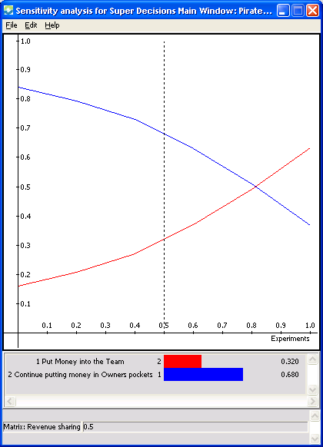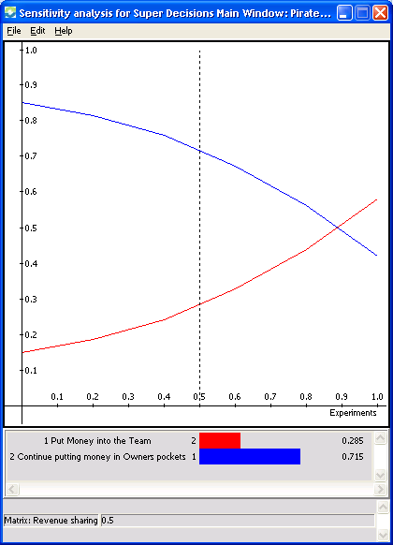

Sensitivity Analysis: Costs Sensitivity Analysis: Risks
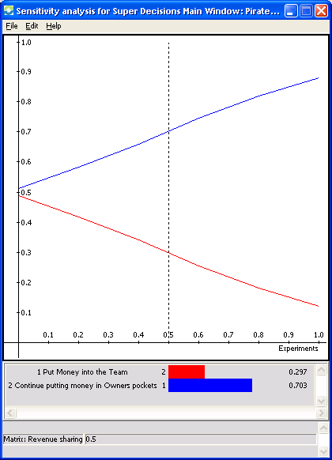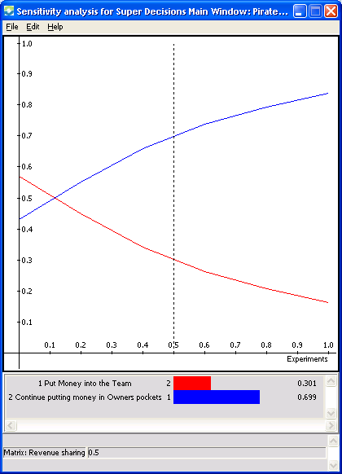

The results of this sensitivity analysis would be rather discouraging to fans of the Pirates. For Benefits and Opportunities, “Put Money into the Team” only becomes the better alternative when the impact of Revenue Sharing is set higher than 80%. For Costs and Risks, “Put Money into the Team” becomes the better alternative when the impact of Revenue Sharing is less than 10%. Basically, based on the model that we created, the only way for “Put Money into the Team” to become the best alternative is if Major League Baseball changes to Revenue Sharing program in a negative way for small market teams.

Conclusion

Like most fans of Pittsburgh sports, prior to this analysis, we felt that the owners of the Pirates were just being greedy and only cared about making money for themselves and not about putting a winning team on the field for the city. In going through the analysis, it became more and more apparent that owning a major league baseball team is no different than owning a large corporation in that, the goal is to establish and carryout a business model that makes money. Period. It is our opinion that the ownership if the Pirates have studied MLB’s Revenue Sharing system and have based their business plan and budget around it. Instead of focusing on the quality of play by the team, the whole business model and marketing focus of Pirates baseball is based on:
- What a great stadium PNC Park is
- All of the fun activities that occur before, during, and after the game
- Promotional give-aways like Sky Blast night and Bobble Head night

For the ownership to change their business model, it would require either a drastic change to the leagues profit sharing program, for attendance to drastically drop, a salary cap, or a combination of all three. A change to any of these factors would disrupt the Pirates’ current business model and would force them find an alternative way to remain profitable.

