BQOM 2521 Decision Making in a Complex Environment
Spring 2 - 2008
- Group Project -

Topic
Define the Best Location for the Olympic Games 2016
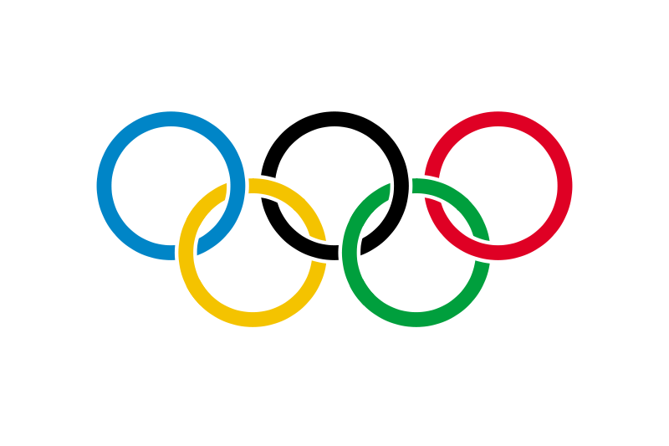
(CHICAGO, DOHA, PRAGUE or RIO DE JANEIRO)
- The ANP approach -

04/22/2008 Submit

Group:
Masamichi Yoda
Sattha Kohpisalsukwattana
Noriaki Obata
Table of Contents
Topic 3
Introduction 3
Background 3
What is Olympic game? 3
Where are candidate cities in 2016? 3
History of past host cities 4
Alternatives 4
The Model 5
1. RATINGS 5
NETWORK ANALYSIS: 8
2. BOCR Network 8
BENEFITS 9
COSTS 10
OPPORTUNITIES 11
RISKS 12
Results 14
Sensitivity Analysis 14
Benefits 14
Costs 15
Opportunities 15
Risks 16
Conclusion 16

Topic
Define the Best Location for the Olympic Games in summer 2016

Introduction
We build an Analytic Network Process (ANP) model using the SuperDecisions software. The objective of our analysis is to use the ANP to define the best location for Olympic Game in summer 2016. We will compare between the candidate cities and evaluate them along the dimensions as mentioned after in model section:
The evaluation is carried out using the Benefits, Costs, Opportunities and Risks (BCOR) model in the software. Finally, we will draw some conclusion resulting from the model.

Background

What is Olympic game?
The modern Olympics are a sports festival for world peace that started in 1896 in Athens, Greece. The game is an international multi-sport event subdivided into summer and winter sporting events. The summer and winter games are each held every four years (an Olympiad). Until 1992, they were both held in the same year. Since then, they have been separated two years apart.

Where are candidate cities in 2016?
The bidding process for the 2016 Summer Olympic Games was officially launched on May 16, 2007. The first step for each city was to submit an initial application to the International Olympic Committee (IOC) by September 13, 2007, confirming their intention to bid. Completed official bid files, containing answers to a 25-question IOC form, are to be submitted by each applicant city by January 14, 2008.
Cities are listed in order of drawing of lots:
Chicago, United States - Chicago 2016 Olympic bid
Prague, Czech Republic - Prague 2016 Olympic bid
Tokyo, Japan - Tokyo 2016 Olympic bid
Rio de Janeiro, Brazil - Rio de Janeiro 2016 Olympic bid
Baku, Azerbaijan - Baku 2016 Olympic bid
Doha, Qatar - Doha 2016 Olympic bid
Madrid, Spain - Madrid 2016 Olympic bid
The final candidate cities will be shortlisted in June 2008, and the final selection will be made by the full IOC membership on October 2, 2009, in Copenhagen, Denmark.

History of past host cities
Rotation is significantly affects the decision where the next Olympic Games will be held. Following chart shows the past host cities.
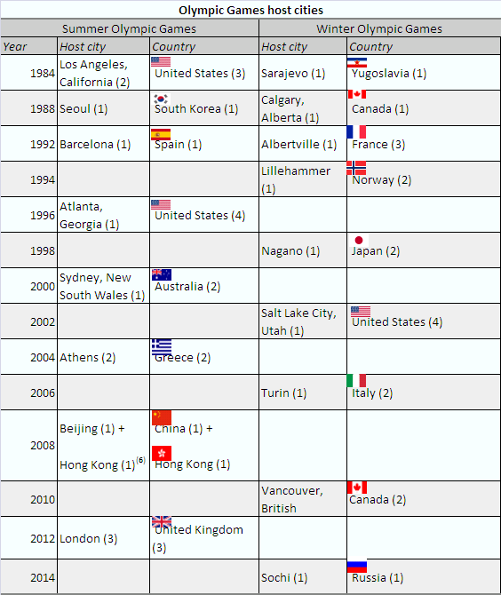

Alternatives
As stated above the IOC has seven choices for the host city of Summer Olympic Games in 2016. Because the rotation affects the decision making where the next place should be, we considered the recent host cities to exclude less possible cities as the next host city as mentioned following;
Tokyo: Since the 2008 Olympic Games will be held in Beijing, Tokyo has much less possibility because of its vicinity. It is located in the same East Asia region as Beijing.
Baku: Since conflicts have been continuing in this area, it may not be appropriate place to hold Olympic Games in this city. Security is important factor because Olympics are a sports festival for world peace that started in 1896 in Athens, Greece
Madrid: Since the 2012 Olympic Games will be held in London, Madrid has much less possibility to become a host city because of vicinity.

Based on the above reasons, we selected the following four cities as more possible candidates for the next Games in 2016.

- Alternative 1: Chicago (U.S)
- Alternative 2: Doha (UAE)
- Alternative 3: Prague(Czech)
- Alternative 4: Rio de Janeiro(Brazil)

The Model
1. RATINGS: To establish ratings scales and evaluate the importance of Benefits, Costs, Risks and Opportunities of the Decision Making Model, we developed a hierarchy of personal value criteria and sub-criteria. The model has 4 different strategic criteria. The strategic criteria are used to prioritize the BOCR as we recognize that in any decision there are multiple considerations that need to be taken into account when ascertaining the best solution to define the best place for Olympic Game must take into consideration its impact in:
1) Economic
2) Cultural
3) Political
Sub-criteria; Foreign Policy, Monetary Support, Relationship with IOC, Stability of Government Power
4) Social
Sub-criteria; Public Opinion, Rotation

Following picture shows overview of our entire model:

The results of the pair-wise comparisons between the criteria (sub-criteria) are shown below;
Subjective Value in Evaluating Merits

4.Social: 0.36
- Public Opinion: 0.09
- Rotation: 0.27
3.Political: 0.33
- Foreign Policy: 0.03
- Monetary Support: 0.09
- Relationship with IOC: 0.16
- Stability of Government Power: 0.05

2.Cultural: 0.08
1.Economic: 0.22

The priorities for ratings are below:
From these priorities, we could say “Rotation” and “Economic” have higher priority.
The assessment criteria used to determine the priorities of the BOCR merits are illustrated below.
As indicated above, 3 factors (Benefits, Costs and Opportunities) show high priorities. We satisfied with this output in that the input was carefully thought out. Also we believe intuitively that Olympic game brings host country to many aspects of benefits and opportunities with huge cost, but risk is very low. Therefore this output is totally matched our expectation. We explain our rating about each BOCR below;
Benefits could bring “very high” economic reward, “high” cultural aspects because of respect and pride their native culture, “high” monetary support from both government and sponsor, and “low” stability of government because Olympic game cannot keep the government stable; while Opportunities could bring “very high” economic with huge business chance, “high” friendly foreign policy to invite new business. In contrast to the above, Costs were “very highly” related to “Relationship with IOC”, also found to bring “high” economic expenditure, “low” cultural risk, and “low” public opinion; while Risks were found to bring “medium” economic risks, and related to rotation issues “highly”.

NETWORK ANALYSIS:
2. BOCR Network: The overall BOCR network is illustrated in a tree hierarchy format in figure below. The top level is a cluster that contains the Goal node. This cluster is connected to the second-level clusters that contain the BOCR nodes: Benefits, Opportunities, Costs and Risks.
Each subnet of Benefits, Opportunities, Cost and Risk were divided into:
- Economic
- Social
Benefits
Opportunities
Costs
Risks
Economic
Social
GOAL
Economic

Social
Economic

Social
Economic
Social
Clusters in the Decision Networks and Elements in the Clusters
BOCR | Control Criteria | Clusters | Elements in Clusters
Benefits | Economic | Infrastructure | 1 Accommodation 2 Internet 3 Stadium 4 Transportation
Benefits | Economic | Economic Growth | 1 Consumption 2 GDP 3 Income per capita 4 Job Opportunity
Benefits | Economic | Media | 1 Broad Media 2 Print Media 3 Sponsor
Benefits | Economic | Political | 1 Communities 2 Government
Benefits | Social | Security | 1 Doping 2 Safety 3 Terrorism
Benefits | Social | Culture | 1 Language 2 Strong Culture
Benefits | Social | Public Opinion | 1 Confidence 2 Environment 3 Rotation
Costs | Economic | Infrastructure | 1 Accommodation 2 Internet 3 Stadium 4 Transportation
Costs | Economic | Media | 1 Broad Media 2 Print Media 3 Sponsor
Costs | Economic | Financial | 1 Government 2 Monetary Support 3 Organizer
Costs | Social | Safety | 1 Community 2 Country
Costs | Social | Environment | 1 Natural 2 Residential
Costs | Social | Culture | 1 Fashion 2 Food 3 Language
Opportunities | Economic | Infrastructure | 1 Accommodation 2 Internet 3 Stadium 4 Transportation
Opportunities | Economic | Economic Growth | 1 Consumption 2 GDP 3 Job Opportunity
Opportunities | Economic | Cost | 1 Initial Investment 2 Maintenance
Opportunities | Social | Culture | 1 Globalization
Opportunities | Social | Market | 1 Market Character 2 Market Penetration 3 Awareness
Opportunities | Social | Public Opinion | 1 Safety 2 Environment
Risks | Economic | Infrastructure | 1 Accommodation 2 Internet 3 Stadium 4 Transportation
Risks | Economic | Economic Growth | 1 Consumption 2 GDP 3 Income per capita 4 Job Opportunity
Risks | Economic | Image | 1 Business 2 Sport 3 Travel
Risks | Economic | Finance | 1 Loss 2 Lack of cash flow 3 Loan
Risks | Social | Security | 1 Doping 2 Safety 3 Terrorism
Risks | Social | Public Opinion | 1 Confidence 2 Environment
All networks | Alternatives |  | 1 Chicago(U.S) 2 Doha(UAE) 3 Prague(Czech) 4 Rio de Janeiro(Brazil)
BENEFITS: The Benefits Criteria was developed to analyze the potential benefits the above- referenced four alternatives and encapsulate the Economic and Social control criteria.
Economic: The economic benefits are divided into Infrastructure, Economic Growth, Media, and Political
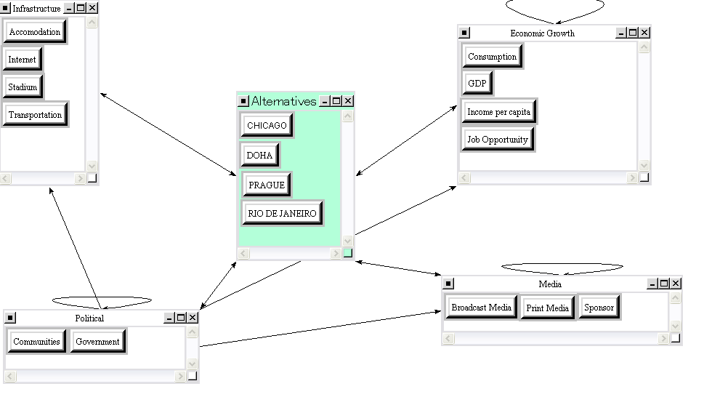
Social: The social benefits are divided into Security, Culture, and Public Opinion.
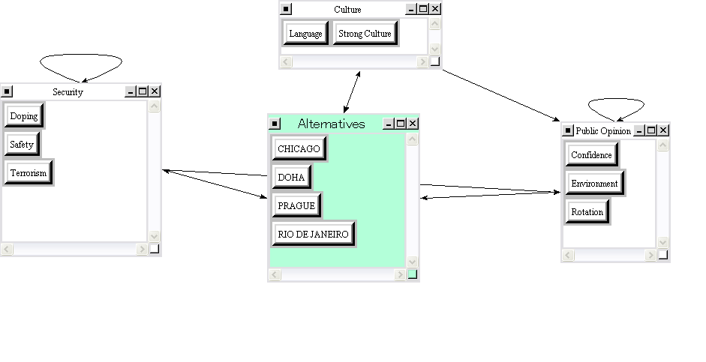

COSTS: The Cost Criteria was developed to analyze the possible costs and encapsulate the Economic and Social control criteria that would be available under each of the aforementioned 4 alternatives.
Economic: The economic costs are divided into Infrastructure, Media, and Financial.
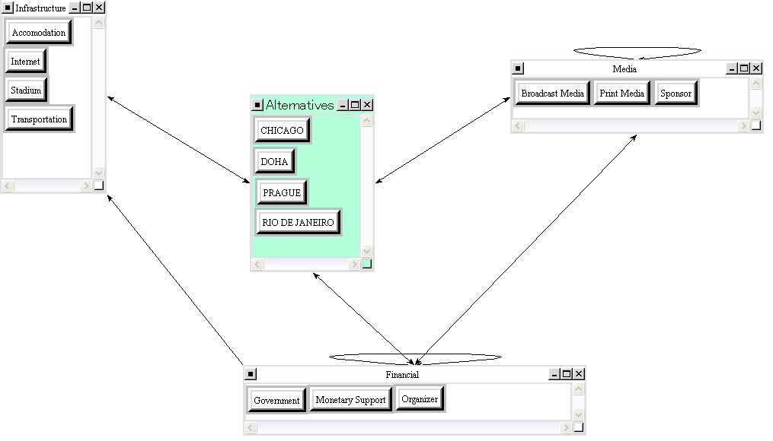
Social: The social costs are divided into Safety, Environment, and Culture.
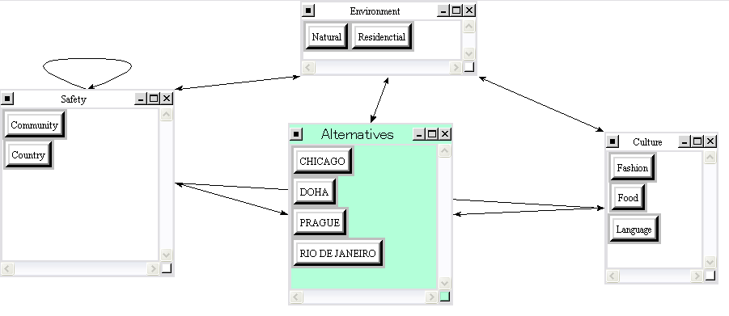

OPPORTUNITIES: The Opportunities Criteria was developed to analyze the possible opportunities and encapsulate the Economic and Social control criteria that would be available under each of the aforementioned 4 alternatives.
Economic: The economic opportunities are measured in terms of Infrastructure, Economic Growth, and Cost.
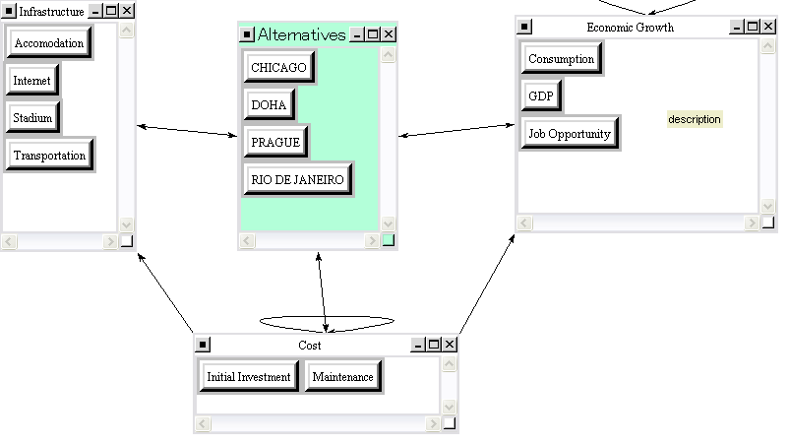
Social: The social opportunities are measured in terms of Market, Culture, and Public Opinion.
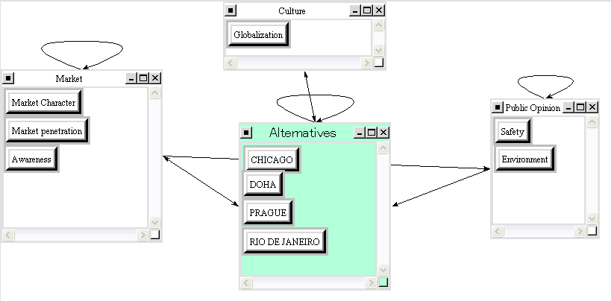
RISKS: The Risk Criteria was developed to analyze the possible risks and encapsulate the Economic and Social control criteria that would be available under each of the aforementioned 4 alternatives.
Economic: The economic risks are measured in terms of Infrastructure, Economic Growth, Finance and Image.
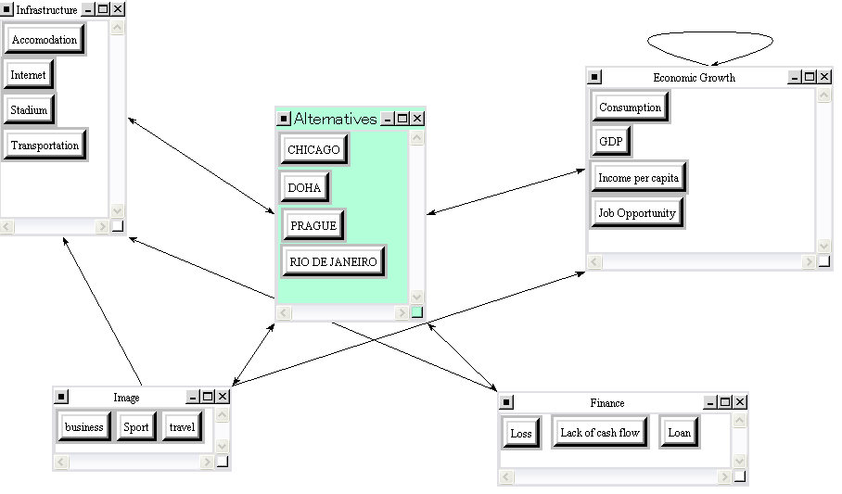
Social: The social risks are measured in terms of Security and Public Opinion.
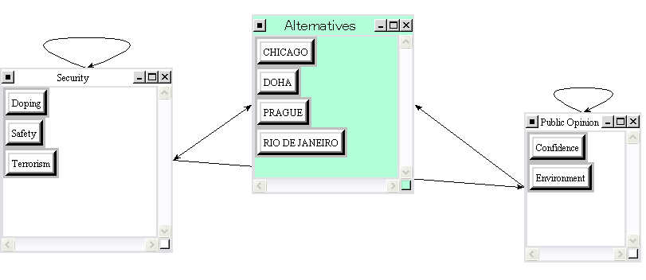

Benefits(+)
From Benefits point of view, Rio de Janeiro is highest priority, while Chicago, Doha and Prague are similar.

Costs(-)
From Costs point of view, Rio de Janeiro is worst. However second (Prague) and third (Chicago) are near thus RIO is not significantly higher than other cities.
Opportunites(+)
From Opportunities point of view, Rio de Janeiro is significantly higher than other 3 cities.

Risks(-)
From Risks point of view, Prague is highest, but Rio de Janeiro (second) looks almost same.

Results
According to our analysis, the best place for the Olympic Games 2016 is Rio De Janeiro. The second best place is Doha but its degree of priority is very far away from Rio De Janeiro. On the other hand, Chicago and Prague show negative priority.
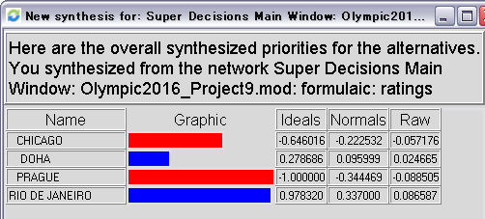

Sensitivity Analysis
The sensitivity analysis will consider the individual variables that are the Benefits, Costs, Opportunities and Risks. The results from analyzing the sensitivity graphs for each of the BOCR nodes are as follows:
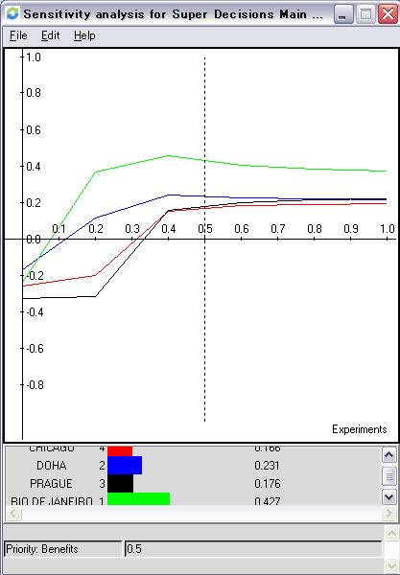

Benefits
- The degree of the priority of Benefits will not change the final outcome of the place for the Olympic Games 2016 and Rio de Janeiro is always the best place. Furthermore, Doha is always the second-ranked place.

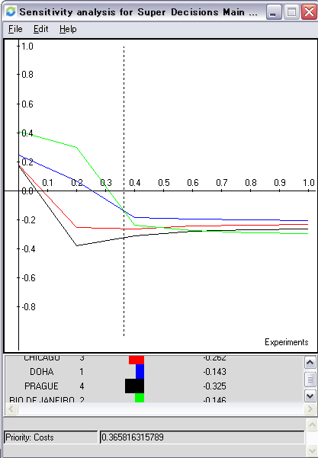

Costs
- As the priority of Costs increased, Doha becomes the best place for the Olympic Games 2016. Furthermore, Chicago becomes the second-ranked place.

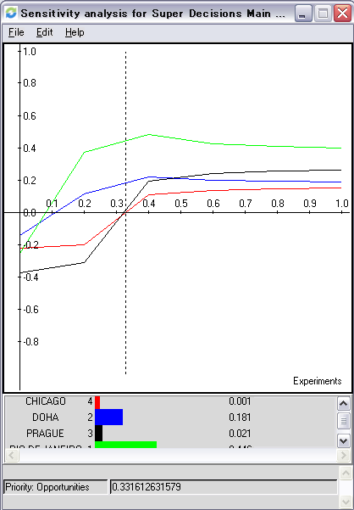

Opportunities
- The changes in the priority of opportunities will not change the final outcome for the best place of Olympic Games 2016. Rio de Janeiro is always the best place. Furthermore, Prague becomes the second-ranked place, when the priority of opportunities increases.

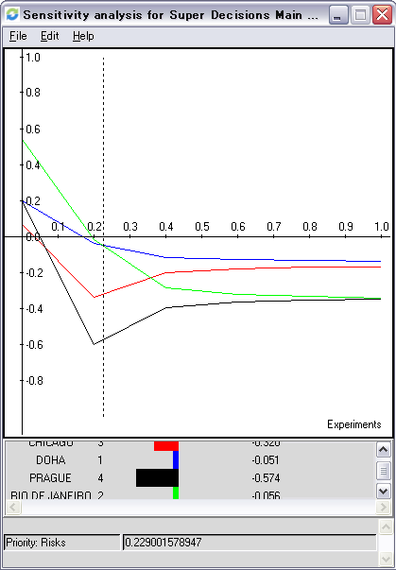
Risks
- As the priority of Risks increased, Doha becomes the best place for the Olympic Games 2016. Also, Chicago becomes the second-ranked place.

Conclusion
We use the ANP model to define the best location for Olympic Games 2016. The result is that Rio de Janeiro is the most suitable place for the Olympics 2016 in terms of benefits, costs, opportunities, and risks. There are several factors supporting this result. First of all, Rio de Janeiro, Brazil is the emerging country which would like to develop the country in the aspects of economic, social, and international affairs. It can improve more percentage than the developed country like US or DOHA. The Olympic Games will benefit Brazil’s economic. Moreover, the Olympic Games will activate the spirit in country. When the citizens in a country have strong confidence toward the same objective, that country can make significant change and development. Second, since the countries in the South America have not been the host for the previous Olympic Games, those countries have more possibility to be a host compared to the other candidates who were located in the continent that has already been the host for Olympic Games in the recent time, for example, US in north America, United Kingdom in Europe. Thus this is the good time for Brazil to be the host for Olympic game. Finally, Brazil has the potential to organize the Olympic Games and financial capability to build necessary infrastructure such as stadium, accommodation, transportation, and so on by financial aids from the Government. Furthermore, since Brazil is the big and highly potential market, it would be not difficult to find sponsors for the Olympic Games.

