Most Likely NFL Franchise to Move to Los Angeles

Presented by
Patrick Shedlock – pjs59@pitt.edu

Introduction
The National Football League has had a long history in Los Angeles. Unfortunately for LA, the history is dotted with NFL franchises coming and ultimately going. In 1946, the Cleveland Rams became the first NFL franchise to locate to Los Angeles becoming the Los Angeles Rams. In 1960, the Los Angeles Chargers were founded only to move to San Diego the following year. In 1982, the Oakland Raiders moved to Los Angeles only to return back to Oakland in 1994. And finally in 1995, the Los Angeles Rams left for St. Louis leaving LA without an NFL franchise for the first time in 50 years.
The lack of an NFL team in Los Angeles is an issue the league and the city have been working on to resolve since the Raiders left. Since that time, Los Angeles has been by far the largest U.S. market without an NFL team, currently making up the second largest media market in the United States. The main reason for prior NFL defections was due to lost revenue caused by TV blackouts in LA as a result of not filling the outdated 90,000 seat LA Coliseum. One key sticking point had been whether the Coliseum should be the primary venue for a new team, or whether a lower capacity NFL-specific stadium should be built in the area. In September of 2012, the city approved construction of a new 75,000 seat stadium as long as an NFL franchise agrees to move to Los Angeles. A BOCR model is applied in an effort to predict the most likely NFL franchise to relocate to LA.

Methodology Approach
The type of model that was conducted was one that helped predict the most likely outcome, which was the most likely NFL franchise to move to LA. Since this is a model of predicting an outcome, there is no decision maker. The key in getting an accurate result is to compare as many of the factors influencing this prediction as possible.
Alternatives
- Jacksonville Jaguars
- Oakland Raiders
- Buffalo Bills
- St. Louis Rams
- San Diego Chargers

Per extensive research conducted online about the topic at hand, these 5 cities were chosen as the alternatives for this model analysis due to the strong likeliness that they would relocate to another city if the right situation presented itself. The combination of poor management, lack of fan support, terrible on-field performance, coaching turnover, lack of city support, outdated stadiums and many other factors have made these the best 5 alternatives.
Control Criteria & Sub Criteria
As you see in the below table, each merit was analyzed by focusing on the economic and social control criteria. This allows for both a financial and non-financial approach to the prediction. The table also lists the clusters that were created within each subnet.
Important Factors of Influence
Underneath the clusters were many nodes of influential factors that were pairwise compared in order to establish priorities that would ultimately predict the most likely NFL franchise to move to LA. Some of the more important economic benefit factors were the lack of attendance, lack of merchandise sales, and lack of city support, franchise value and age of stadium. Comparing the current financial situations for each of these factors in each city, help determine what city has the most benefits. Social benefit factors included the amount of other city activities, whether there are other professional teams, lack of ownership stability and lack of relocation history. It would be more likely and beneficial to the franchise if there were other activities in the city, another franchise residing in the city, new ownership and past history of relocation. Below are the synthesized results for the benefits subnet.
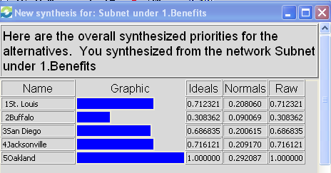
Some of the more important economic opportunities are ownership upside, the lack of future commitments to the city, the potential increase to the franchise value and resources devoted to other city efforts. The social opportunities of influence compared were whether the current roster had young talent with potential, whether there was prior history of success in the NFL, whether there was new ownership and what was the likeliness the fans would continue to support the team after relocation. The following synthesized results are for the opportunities subnet.
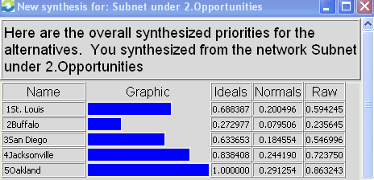
The economic costs that were taken into consideration was the length of the current stadium lease, the stadium rent, other fees, merchandise sales, stadium sales, local businesses relying on the team, jobs related to the franchise, moving expenses and player/front office salaries. These factors were extremely impactful for the model since there were some franchises with significant costs of relocating due to unpaid stadium rent and breaking their current lease agreements. Some social costs considered were the distance from LA, division realignment in the NFL, loss of current fan base and the media market size. Each has costs associated with them, some weighing more than others. Below are the synthesized results for costs.
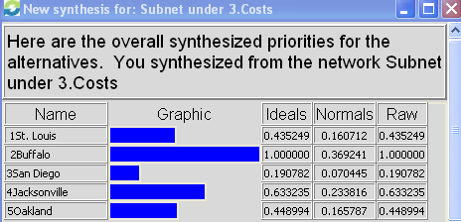
The economic risks considered were the lack of fan support and the lack of city support. These factors were analyzed with the thinking that if there was a tendency of not having support for a particular franchise would be costly in the long run. Social risks were the lack of playoff success carrying over to LA, the relocation history, future turnover in the front office and the likeliness that another franchise in the city will relocate. The synthesized results for risks are below.
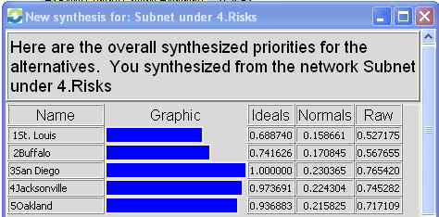
Strategic Criteria
- Lack of Team Profitability
- Lack of Fan Support
- Lack of Ownership Support
- Lack of Team Success
Below is the super decision rating table measuring the weights for the benefits, opportunities, costs and risks. As you can see the ratings yielded strong priorities for benefits, opportunities and costs; however; a low priority rating for risks.
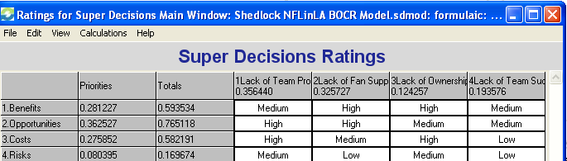
Overall Synthesized Model Results
The following are the overall model’s synthesized results for both the additive or long-term and the multiplicative or short-term views. As you can see both formulas favor the Oakland Raiders as being the most likely franchise to move to LA; followed by San Diego, St. Louis, Jacksonville and Buffalo.
Additive – Long Term
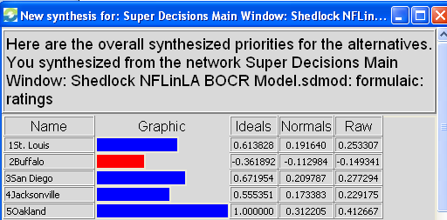

Multiplicative – Short Term
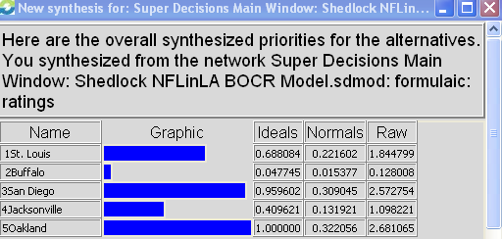
Conclusion
After conducting the robust BOCR model, it was unanimous that the most likely NFL franchise to move to LA is the Oakland Raiders. The favorable characteristics; such as a year-to-year lease agreement, old stadium, great fan base, short distance to LA, new ownership and ease of transition; shed a very positive light on Oakland being the most logical franchise to relocate to Los Angeles.

