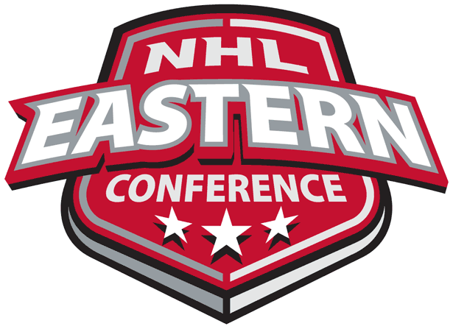
Predicting the NHL Eastern Conference Champion

University of Pittsburgh
Katz Graduate School of Business
Decision Making in a Complex Environment
Final ANP Project Report
4/23/2013
Brian Gosey & Steve Previs
This ANP model was created to predict the 2013 NHL Eastern Conference Champion. The eight qualifying teams were used as the alternatives and were compared based on the most important factors and data available. So who is predicted to win? Read on and find out…

The Purpose
The purpose of our model was to see if by using the Analytical Network Process (ANP) we could synthesize the appropriate data to determine which team would win the 2013 NHL Eastern Conference Championship. With ten games remaining in the season, the teams in the standings that were projected to be in the playoffs, that became our alternatives, were as follows:
- Pittsburgh Penguins
- Boston Bruins
- Montreal Canadiens
- Washington Capitals
- Toronto Maple Leafs
- Ottawa Senators
- New York Islanders
- New York Rangers
Elements Considered and Criteria Chosen
When considering the teams that are in the divisional playoffs, we tried to consider a variety of tangible and intangible factors for creating our inputs.
Performance -- A key component to the success of any team is their performance. Obviously, the teams that have played the best throughout the regular season are towards the top of the standings as the playoffs begin. Their performance is likely a very good indicator of how well the team will fare in the playoffs. Elements of our performance indicators were:
Win % - wins vs. losses for the regular season
Home Win % - wins at home during the regular season
Road Win % - wins on the road during the regular season
Goals Scored – total goals scored during the regular season
Goals Allowed – total goals allowed during the regular season
Critical Game Stats – This is a stat we synthesized from several statistics of goals scored per game (GPG), goals allowed per game (GA), penalty percentage (PP%) or how effective was the team scoring goals during the penalty minutes, penalty kill percentage (PK%) or how well effective the team is neutralizing opponents during penalty minutes.
When thinking about successful NHL teams often a dominant goalie comes to mind. A team with a very hot goalie can succeed on his great play for a length of time. In order to evaluate how good the goalies of a team are, we combined all of the playoff experience of the goalies on the team as well as the number of playoff wins for the goalies. We then were able to rank the goalie quality of the teams that made the playoffs.
Our performance component was meant to illustrate the overall quality of players on a specific team. Stats were essentially the only criteria we could use, as the shortened NHL season this year resulted in the cancelling of the All-Star game, which would have been a great indicator of star power on a given team.
Experience -- We felt that experience definitely plays a role in the success or failure of a team. We ranked teams based on their average experience in years for this reason. Head coach experience is also especially important in a playoff environment, so we used coach playoff appearances, number of wins and if the coach had ever won a Stanley Cup as our deciding factors. Additional factors applying to experience are if the team has won a Stanley Cup in the last five years or not, as this shows recent success and the likelihood of small roster turnover from that period of time. Also, we looked at playoff appearances from the last ten years as it shows both a level of expectation, which comes with successful experience, as well as a level of commitment from management that they are willing to use the resources needed to field a contending team each year. Quality depth throughout the bench can help any team compete at the highest level without having to rely significantly on just one or two players, especially if a player gets hurt and there is a huge production drop-off with the replacement player. This is why we included depth as a factor in our model under experience.
(Hot) Streak -- As the final weeks of any sporting season come to an end and the playoffs near, teams that are trending in the upward direction are often the ones that do well. This tapering effect, to use a swimmer’s term, is the proverbial trying to “catch lightning in a bottle.” Teams that are winning expect to win. Once a team makes the playoffs, they see that their hard work has paid off and they feel that they belong there. Our opinion is that a team making the playoffs frequently and in successive years has a great chance of performing well once in the playoff setting, as they can build on that previous success.
Home-Field Advantage – This factor is one of the more obvious in determining playoff success. A team that plays more games at home enjoys the comfort of being in their own building without having to travel. They can feed off the energy from their fans and enjoy the intimidation factor that their fans bring to the arena against the other team. We ranked these teams based on several criteria, such as how intimidating the arena is to play in for the visiting team, how well the team has played at home during the regular reason, and also how their current seeding could be used to secure further home-field advantage later in the playoffs.
Other -- We determined that there is also an element of “other,” or likely intangible factors that contribute to a team making a strong run at the end of a season. As we ran through past examples of winning teams, we felt that desire/motivation to win was one of the most important pieces to this element. Also, we felt a confident team could continue to play well in all playoff situations. There is a difference between confidence and desire/motivation so we kept the two separate. Another piece to this element is good luck and bad luck. Bad bounces and lucky shots are part of the game of hockey, and how teams respond to their fortune can affect the outcome of the playoffs. In addition, the luck of the draw can help one team draw an excellent head to head matchup versus another team. Luck also leads into our other subnet of a healthy team. Teams obviously don’t have a choice over whether their players are healthy or not, but this is a huge factor in determining whether regular season success can be continued. And with the health of a team comes the need to make late season acquisitions to fill the void of any injured or subpar players in order to make a championship run.
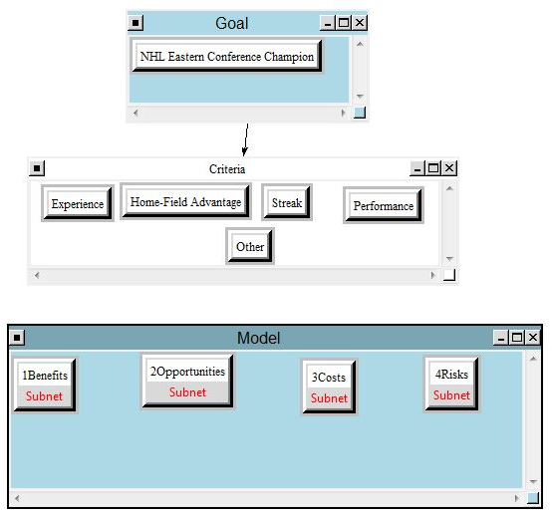
BOCR – Benefits Opportunities Costs Risks
Figure 1: Our ANP Model
As we developed our BOCR model, we placed each of the fitting criteria subnets under each of the Benefits, Opportunities, Costs, and Risks sections. Again, the criteria we decided upon were Experience, Home-Field Advantage, Streak, Performance, and Other.

Benefits Control Criteria:
Experience: Won Stanley Cup, Playoff Appearances, Depth, Experience of Team, Experience of Coach, Average Age of Team
Streak: Consecutive Playoff Appearances, End of Season Wins
Home-Field Advantage: Record at Home, Intimidation, Playoff Seeding
Performance: Regular Season Stats, Past Playoffs
Other: Motivation/Desire, Confidence
Opportunities Control Criteria:
Home-Field Advantage: Seeding
Streak: Continue End of Season Hot Streak
Other: Late Season Acquisitions, Healthy Team, Good Luck
Costs Control Criteria:
Experience: Won Stanley Cup, Playoff Appearances, Depth, Experience of Team, Experience of Coach, Average Age of Team
Streak: Consecutive Playoff Appearances, End of Season Wins
Home-Field Advantage: Record at Home, Intimidation, Playoff Seeding
Performance: Regular Season Stats, Past Playoffs
Other: Motivation/Desire, Confidence
Risks Control Criteria:
Home-field Advantage: Seeding
Streak: Continue End of Season Cold Streak
Other: No Late Season Roster Moves, Injuries, Bad Luck
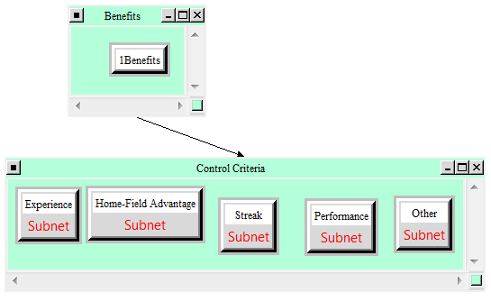

Figure 2: Example Subnet of the Control Criteria of Benefits

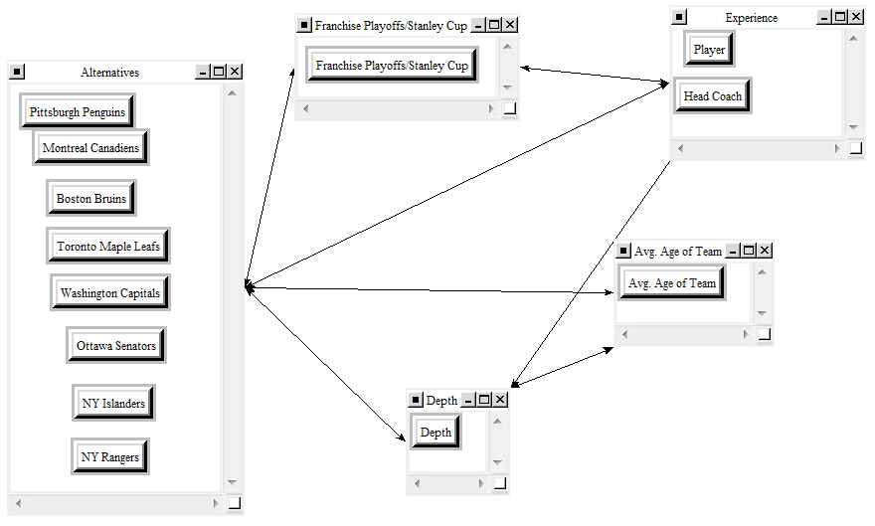
Figure 3: Alternatives and Individual Factors under Criteria

Model Results
After inputting all the data into each one of the criteria and sub criteria, we were able to pull results from the model and analyze and synthesize them to determine the model’s final outcome.
Criteria Priorities
Determining which criteria had the biggest influence on the model will proceed to affect all of the data we input into our model. A screen shot of our priorities can be seen on the next page. As illustrated, Experience was the criteria that held the highest weight (almost 53%) with Performance coming in second with a fairly strong weight as well (27%).

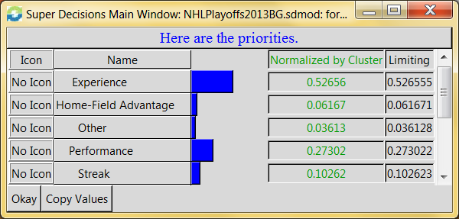
Rating Highest Priority Teams – BOCR to Criteria
Figure 4: Criteria Priorities
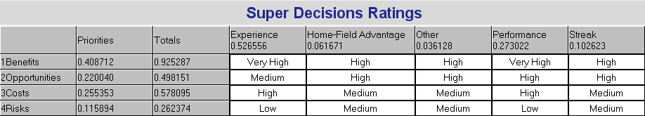
Shown below are the ratings that the highest priority team in each of the BOCR categories received when compared to our criteria. (Benefits = Pittsburgh Penguins, Costs = Toronto Maple Leafs, Opportunities = Pittsburgh Penguins, Risks = Pittsburgh Penguins)
Figure 5: BOCR - Criteria Ratings per Highest Priority Team

Synthesizing the Overall Data
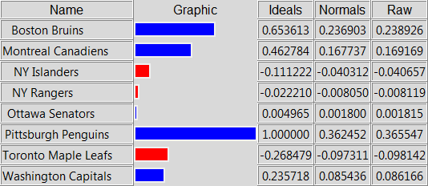
Finally, as can be seen below, is the overall synthesis of our model in terms of the Alternative (Team) weights. The Pittsburgh Penguins are in first, followed by the Boston Bruins and Montreal Canadiens.
Figure 6: Overall Model Synthesis

Sensitivity Analysis
On the following page is the sensitivity analysis for each of the four BOCR categories. Each of the colored lines illustrates a different team and where they will fall under each category. The individual BOCR priority is as found in the ratings. (Benefits = 0.41, Opportunities = 0.22, Costs = 0.255, Risks = 0.116) All of these graphs represent the priority of each team as priority of the BOCR category increases. For example, in the Benefits (top right) Sensitivity, none of the lines cross. This means that at every priority Benefits could be given, the teams will remain in the same order according to their own specific priority.
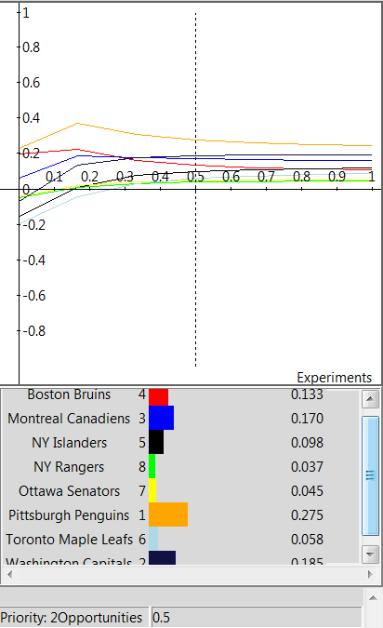

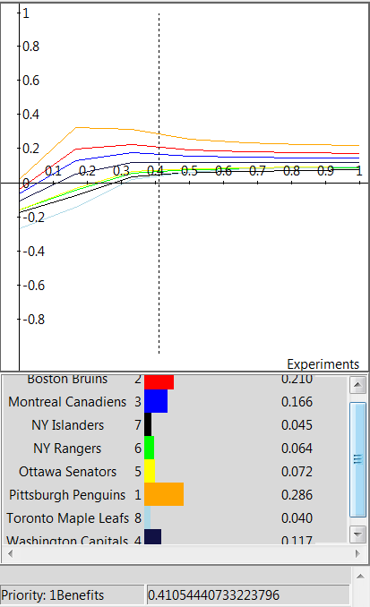

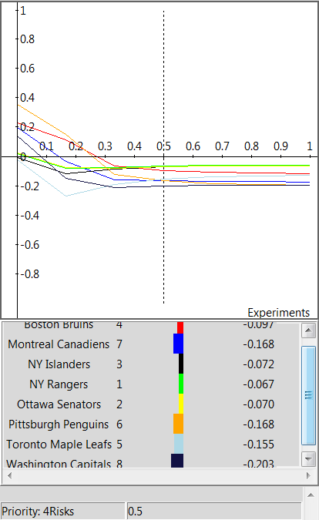
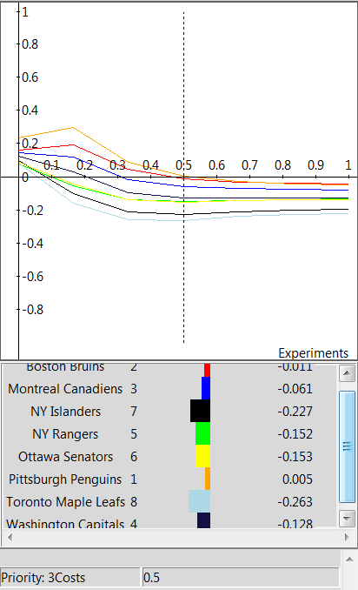

Conclusion
As shown previously in the overall model synthesis, the Pittsburgh Penguins are predicted to be the NHL Eastern Conference Champion. They are closely followed by the Boston Bruins and further by the Montreal Canadiens. The Pittsburgh Penguins have a great statistical team which is backed by superstar players and a lot of depth. They have players, a head coach, and a goalie with a Stanley Cup victory under their belt and have had plenty of playoff success in the recent past. They have been on a hot streak for the last part of the year and have only made their team stronger with recent player acquisitions. Their solid play at home is a huge plus, as they have secured the number one seed in the playoffs, which means home-field advantage throughout the playoffs. Because of the talent on their roster and their success so far this season, the team exhibits few downfalls (costs) and has set the sky as the limit. All of these things demonstrate why the Pittsburgh Penguins show such a high priority in our model and have been chosen to win the NHL Eastern Conference Championship.

