Justin Mikol
Decision Making: Final Project
October 15, 2012
The Franklin Regional Lacrosse Club
BACKGROUND
The Franklin Regional Lacrosse Club is a registered non-profit youth sports organization incorporated in the Commonwealth of Pennsylvania. Started in 1992, the club supports the lacrosse athletic program of the Franklin Regional School District located in Murrysville, PA. The club was officially incorporated a non-profit in 1998, and since that time, the club has undergone many changes.
The original goal of the club was to provide a setting for organized and officiated lacrosse games to be played with members of the Franklin Regional community. From its initial stages of only a single team with fifteen players, the club has since grown to include ten separate teams between middle school and high school programs. The combined enrollment of each of these programs is well over 120 player/participants. The original goal of the club has since been accomplished. We now engage in competitive play with schools from the surrounding Western Pennsylvanian area, and travel to numerous showcase tournaments outside our state boarders. Our players are actively recruited by collegiate programs and we have set the standard lacrosse organizations around the area.
With this tremendous growth throughout the past twenty years, it has been discussed at board meetings if the club is getting too big and should be broken down into separate business units. In an attempt to promote overall efficiency, the Board of Directors is debating the idea of three organizational results for governance of the club: 1) keep the status quo of the club and operate as usual; 2) de-centralize the teams into more manageable units but still keep close ties with the “parent” organization; and 3) completely separate all the entities into their own manageable distinct business units.
ISSUE
Should the Franklin Regional Lacrosse Club keep its current organizational structure, de-centralize, or separate completely?
ANALYSIS
A BOCR model was used in calculating the best outcome. The alternatives used for the model were 1)Status Quo; 2)De-Centralize; and 3)Separate Entities. The significance of these alternatives was explained above. The control criteria used to evaluate this model were: 1)Operating Efficiency; 2)Player Development; and 3)Long Term Sustainability. These are the main criteria that the Board of Directors is basing their decisions off of. Player development is crucial to these choices. To accompany this, the operating and managing efficiency of the club needs to determined with long term sustainability in mind.
The returned results were interesting. The synthesized results are as follows: 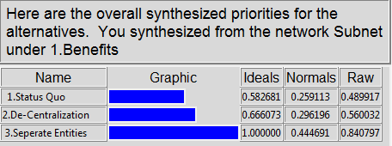
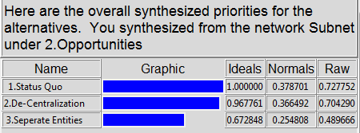
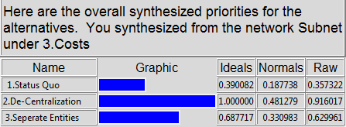
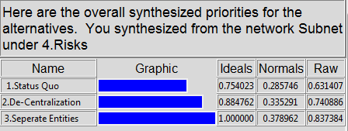

The synthesized results vary across each model. While the sensitivity remain similar.
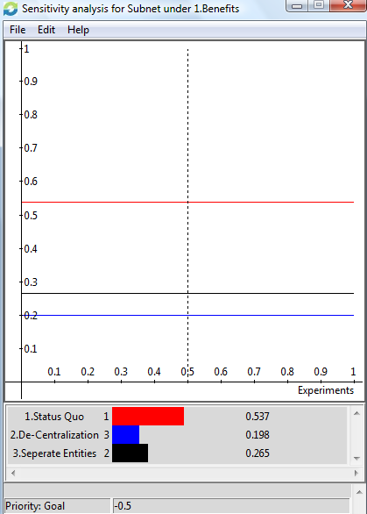
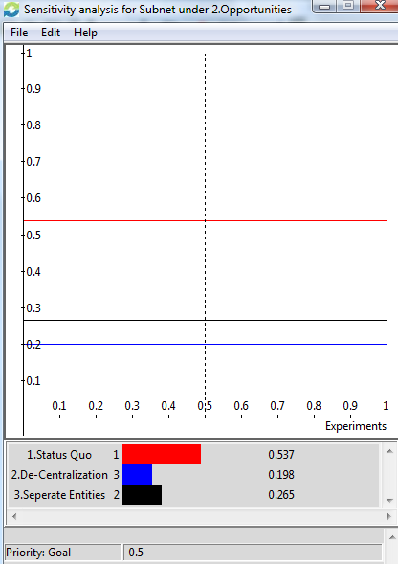
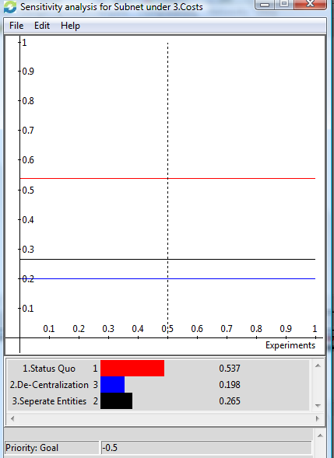
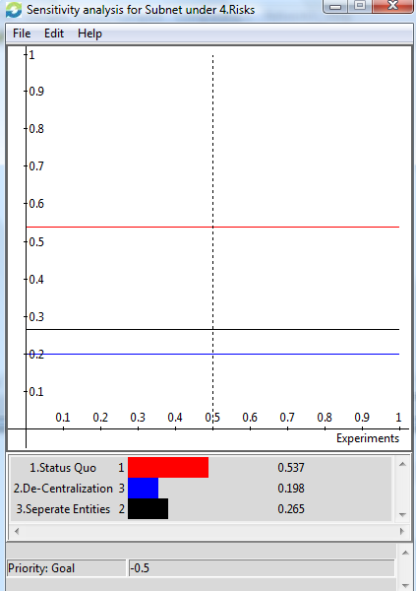

CONCLUSION
The overall ending synthesized results returned that “Status Quo” or keeping the club as is and in its current organizational position is the best choice. This is true for both the multiplicative (first image below) and additive/negative (second image below) synthesized results.
