Building a Super Conference – ACC Expansion Options

AUTHOR(S)
Douglas Wright
James Trenk
Nathan Krieger

INTRODUCTION
College athletics has always provided great competition between institutions on the fields and courts around the country. Winning collegiate teams have become a source of pride for the many students, alumni, and fans of the schools who demand increasing exposure of these events. As a result, there are more channels and online coverage of college sports than ever before. This results in some universities being able to realize a huge windfall in additional revenue into their athletic department budgets. Schools are constantly jockeying to improve their position and realize some of these additional revenues. This has led to a fierce competition that extends beyond the playing field and into the business of college athletics.

In order to realize the additional revenues that some of the schools have recently been able to achieve, a school needs to be a member of what is considered one of the major athletic conferences. Today, that currently includes the Atlantic Coast Conference (ACC), Big East, Big Ten, Big 12, Pac 12, and Southeastern Conference (SEC). While all are considered to be major athletic conferences, there are significant differences between the amounts of revenue that each generate. As the popularity of live college sports programming continues to grow, so has the revenue generated through the sale of the broadcasting rights for these events. As the conference’s television contracts expire, the networks have been bidding heavily against each other and have driven up the prices that they are willing to pay. The fact that these contracts are often long term deals, often 15-20 years or more means that once a new deal is signed it is often difficult to have that new contract redone until it expires, so it is imperative to get as much money as possible and try and outdo what the other conferences were able to achieve. One way, however, that the contract can be revisited and potentially redone is if the conference experiences any changes in membership.

These recent events have led to several of the more powerful conferences attempting to lure away members of other conferences in order to boost their content that they are able to provide to the networks and hopefully substantially increase their per school revenue. This has resulted in several of the conferences becoming unstable and their futures uncertain. Several schools in those conferences have been looking elsewhere to more stable conferences, while the weaker conferences are also looking to add new members to replace schools that were lost as well as additional, more high profile schools to try and stabilize their respective leagues.
Last month, it was announced that both Syracuse University and the University of Pittsburgh would be leaving the Big East Conference and joining the ACC. The two new additions would join Boston College, Clemson University, Duke University, Florida State University, Georgia Tech, University of Maryland, University of Miami, University of North Carolina, North Carolina State University, University of Virginia, Virginia Tech, and Wake Forest to put the conference at 14 schools. Many have speculated that the ultimate outcome of this conference realignment, as it has been termed, are 4 super conferences made up of approximately 16 teams each. If in fact that is the case and the 4 – 16 team conferences are the future, then the ACC can be expected to add 2 additional schools in order to be considered one of those super conferences and be able to experience the many financial, athletic, academic, and social benefits that it includes.

GOAL
To determine which two universities the ACC should invite into their conference as the 15th and 16th members

ALTERNATIVES
- Connecticut & Rutgers
- Connecticut & Texas
- Notre Dame & Connecticut
- Notre Dame & Rutgers
- Notre Dame & Texas
- Notre Dame & West Virginia
- Rutgers & Texas
- West Virginia & Connecticut
- West Virginia & Rutgers
- West Virginia & Texas
- Do Not Expand Further

The combination of potential candidates that could potentially be invited to the ACC is extremely large. There are several options that are more likely than others and we have decided to focus on a few of the more likely and often mentioned candidates to receive an invitation to the ACC. The schools that were considered in our analysis include University of Connecticut, Notre Dame University, Rutgers University, University of Texas, West Virginia University.

In order to determine which two of these universities the ACC should invite, we used a combination of the universities for our analysis and comparison. Thus the list of alternatives ultimately used in our analysis include the combinations mentioned above.

DECISION CRITERIA

Strategic Criteria
Grow Geographic Footprint - Any new additions should ideally include new areas in which the conference does not currently have a footprint. This would include new television markets and new recruiting territories for the schools and teams.
Improve Academic Reputation – While the reasons for expansion around the country are largely monetary, academics also play an important role to several of the conferences. The current ACC schools have a tremendous academic reputation, especially at the undergraduate level, and should look to maintain or enhance that reputation with any potential new members.
Improve Athletic Profile – Football is undoubtedly the main attraction that any new member can bring to the conference. Schools or universities with traditionally strong football programs would quickly move to the top of the candidate list. However, the overall strength of a school’s athletic department should not be discounted. The ACC has traditionally been strong in basketball as well as several Olympic sports including soccer and lacrosse and might be looking for schools that can provide competition and exposure to the conference for some of these “minor” sports.

Increase per School Revenue – Any new additions to the conference would have to at least pay for themselves and ideally be able to increase the per school payout that the conference is able to realize from television contracts and bowl revenues in order to be considered a viable expansion candidate. It does not make sense nor would the university president’s approve any member that decreases their share of conference revenue.

Increase Conference Exposure – Any new member to the conference should be able to add increased visibility to the conference through tournament appearances and high profile matchups.
Maintain Cultural Integrity – All ACC member schools are located on the east coast, hence the name of the conference. Additionally, the majority of the schools are smaller, private research universities, with a few exceptions. Potential new members should be similar to the existing members with respect to both location and structure in order to avoid any potential conflicts that may arise.

Stabilize Conference – As we have mentioned, some of the realignment occurred as a result of schools in unstable conferences looking to join more stable conferences. Any new member should help to stabilize the conference further and help to reduce the possibility of members wanting to exit the conference for a more perceived stable conference.

Control Criteria
Financial – The decision on which schools to invite to the conference has a number of financial aspects that need to be considered. This control criterion will be used to analyze and compare the various options and how they affect the conference financially.

Organizational – In addition to financial decisions, there are also aspects that surround the potential universities themselves in terms of what they represent both academically and athletically. This criterion will be used to analyze and compare the various options and their effect on the conference.
Social – Outside of the financial and organizational considerations that must be taken into account; there is also a social aspect that needs further investigation. This criterion will be used to analyze and compare the various options surrounding the fan bases and geographic considerations to the conference.

BOCR Model
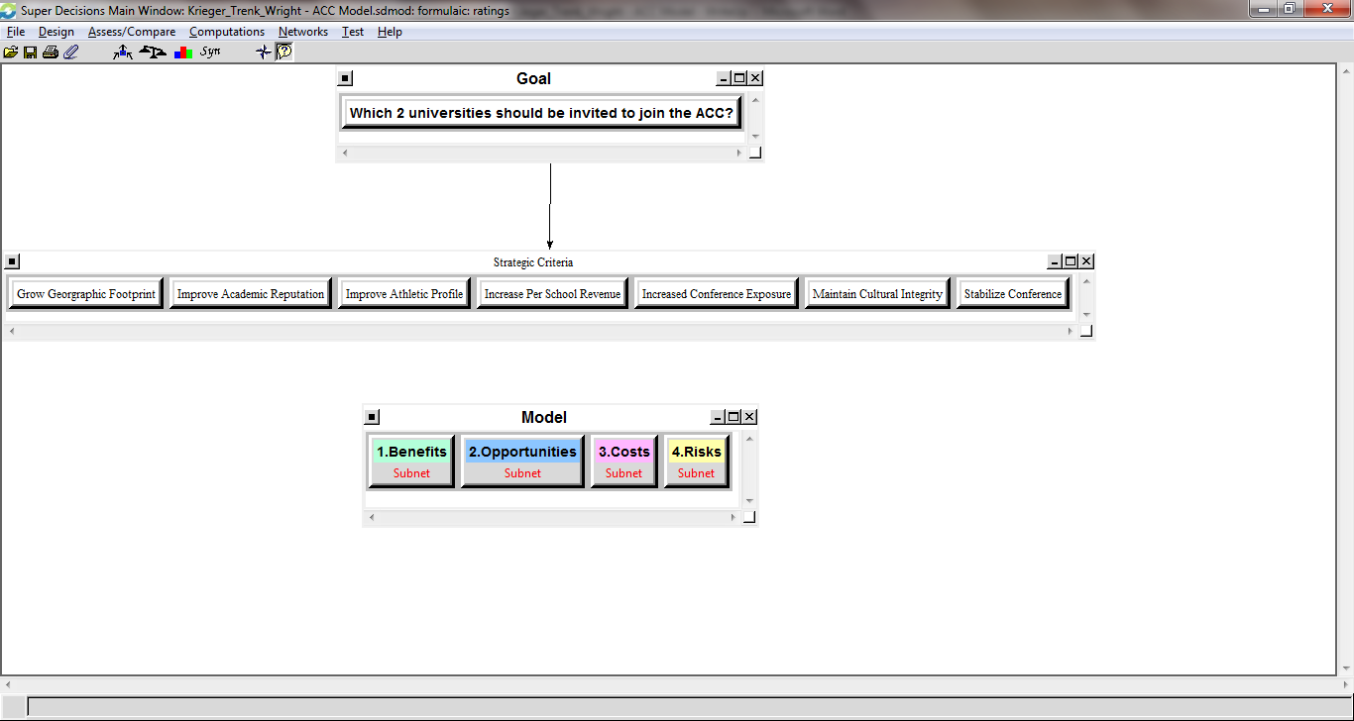

This screenshot shows how the model was structured with all of the strategic criteria connected to the goal of determining which 2 universities should be invited to join the ACC. Additionally, the Benefits, Opportunities, Costs, and Risks are each depicted as subnets and can be expanded to see the individual control criteria and decisions used in the comparisons.

Benefits
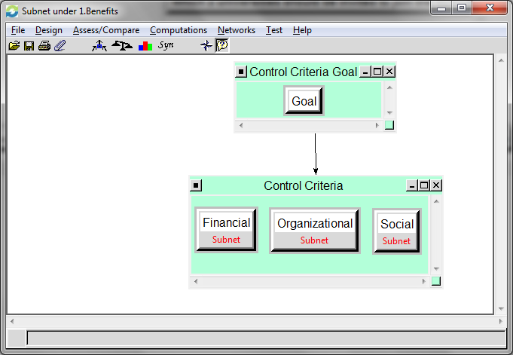

The benefits subnet contains all three of our control criteria; Financial, Organizational, and Social.

Financial
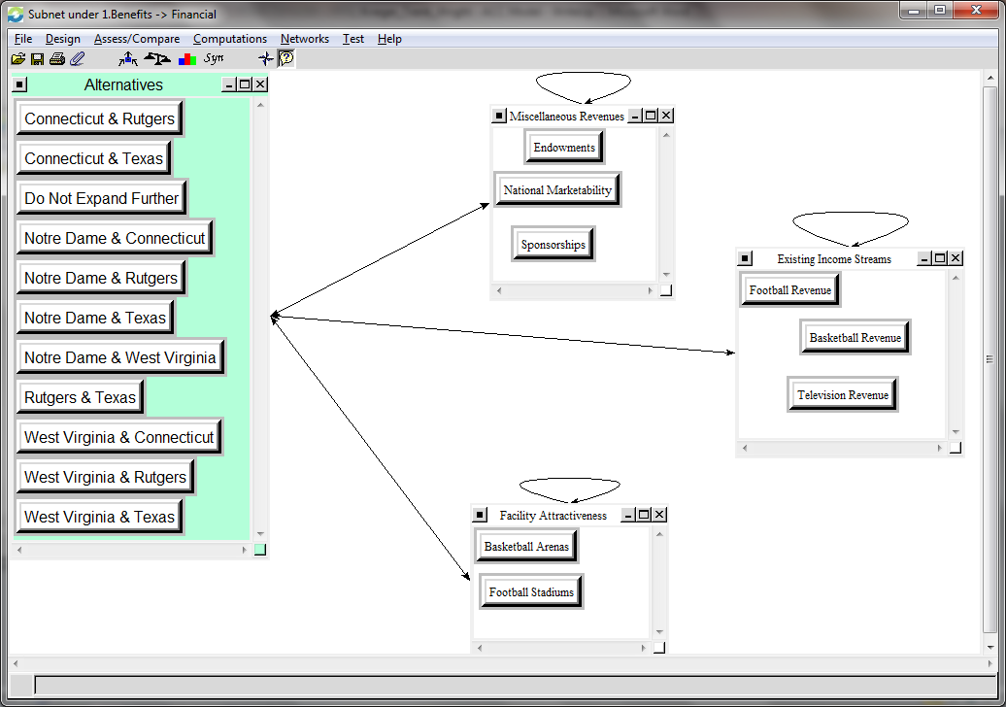

Making up the Financial Benefits subnet are a series of Clusters and Nodes that include:
- Miscellaneous Revenues
  - Endowments – used to compare how large a particular set of universities’ endowments are as this is an indicator of the wealth of a particular university and how they might be able to contribute to the conference.
  - National Marketability – how well-known is the university around the country, not just in the specific region in which it resides. This speaks to the demand that may be created to see this particular university participate in any number of athletic competitions.
  - Sponsorships – the likelihood that the university will be able to bring in additional sponsors which are headquartered or have a significant presence in their region.
- Existing Income Streams
  - Football Revenue – profitability of the university’s football program.
  - Basketball Revenue – profitability of the university’s basketball program.
  - Television Revenue – the amount of revenue that the university is able to generate through its television contracts.
- Facility Attractiveness
  - Basketball Arena – used to compare the condition of the university’s basketball arena. The status of the basketball arena can be an indicator of the university’s commitment to the program as well as how much income potential the program has through ticket sales, concessions, etc.
  - Football Stadium – used to compare the condition of the university’s football stadium. Again the status of the stadium can indicate commitment from the university as well as how much income the program can generate through ticket sales, seat licenses, donations, concessions, etc.

Organizational
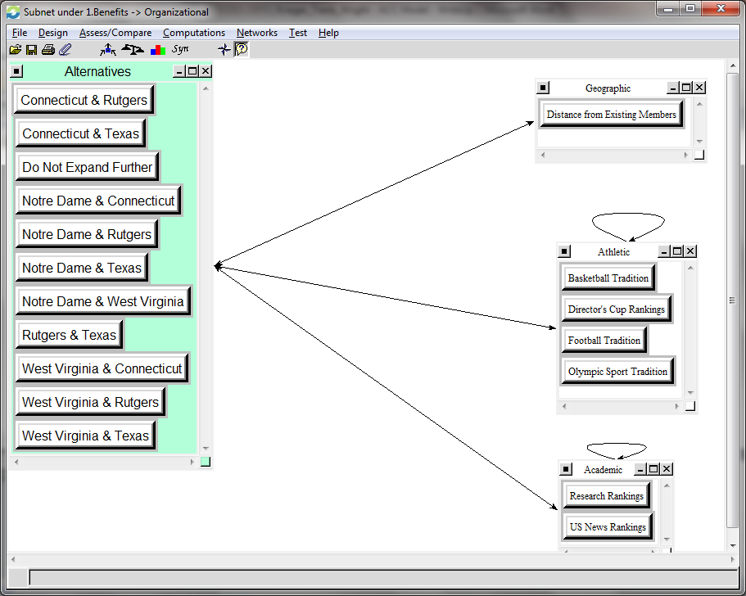
- Geographic
  - Distance from Existing Members – used to compare the distance that a university lies from the existing members of the conference. Institutions that are closer to the majority of the conference’s members are more preferable as it has the potential to significantly reduce travel expenses and the likelihood that fans will travel to the games.
- Athletic
  - Basketball Tradition – used to compare how tradition rich and historically successful the university has been in basketball. This includes a number of different factors such as overall wins, tournament appearances, championships, high-profile players, etc.
  - Director’s Cup Rankings – used to compare the overall strength and success of a university’s athletic program across all sports.
  - Football Tradition – used to compare the tradition and historical success of the university’s football team. Again, factors considered include the overall number of wins, bowls, championships, individual accolades, high-profile players, etc.
  - Olympic Sport Tradition – used to compare the traditional strength of a university’s minor sports, other than football and basketball. Taken into consideration, were overall wins, championships, players, etc.
- Academic
  - Research Rankings – used to compare the strength of an institution’s funding for research initiatives. The ability to procure grants and conduct high profile research is something that can bring positive exposure to both the university and the conference.
  - US News Rankings – used as a measure to compare the overall strength of a university’s academic profile. The majority of the ACC schools rate highly in the rankings and the conference would be looking for schools of a similar class.

Social
l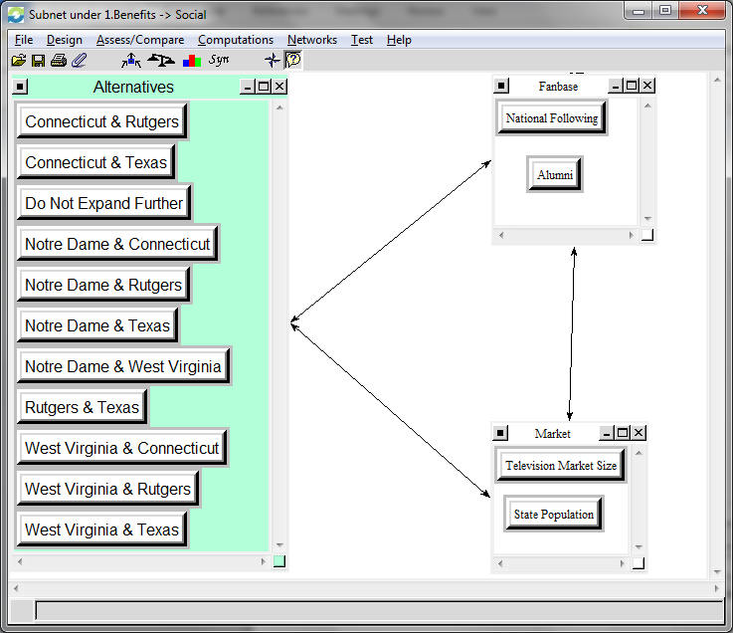
- Fan base
  - National Following – used to compare the popularity and notoriety of a university outside of its traditional geographic region.
  - Alumni – used to compare the number of alumni that exist for a university. The larger the alumni base, the larger the likely fan base as the majority of alumni should at least maintain some form of connection to their alma mater.
- Market
  - Television Market Size – used to compare the size of a university’s television markets and the major markets in which it resides. The ability to carry particular television markets increases the amount of money that a conference is likely to be able to get from a renegotiated television contract.
  - State Population – used to compare the size of the state’s population in which the university resides. The larger the state, the more potential fans that would be interested in attending and watching various athletic contests.

Opportunities
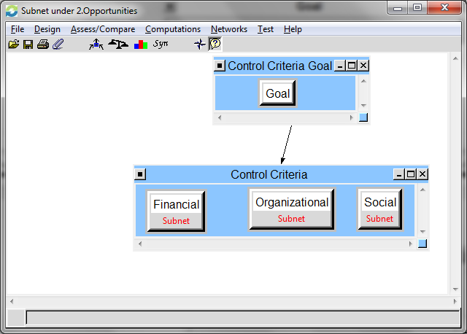

The Opportunities section contains all three of the control criteria; Financial, Organizational, and Social.

Financial
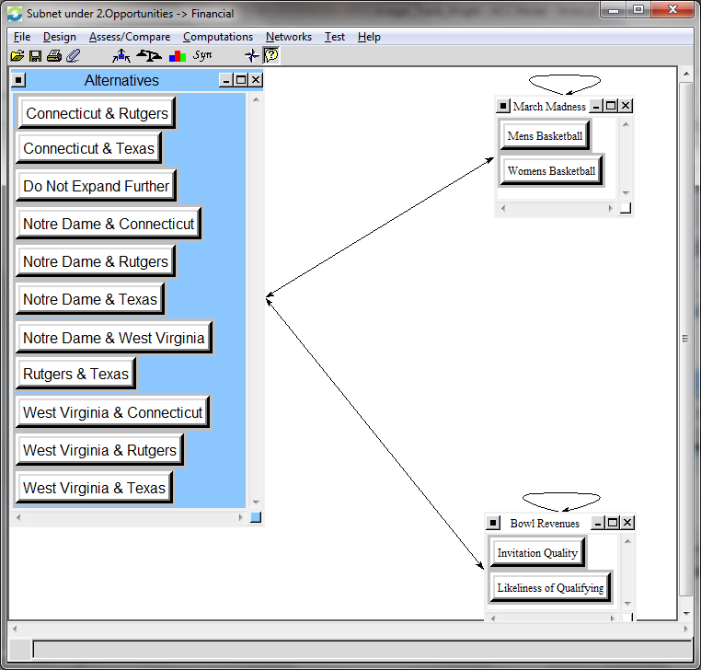

- March Madness
  - Men’s Basketball – used to compare the potential revenues that a university is likely to earn for participating in the annual basketball tournament.
  - Women’s Basketball – used to compare the potential revenues that a university is likely to earn for participating in the annual women’s basketball tournament.
- Bowl Revenues
  - Invitation Quality – used to compare the quality with which a university is perceived as a likely bowl participant. The larger bowls, which pay the most money, want matchups to include schools that traditionally travel well and spend money while attending the event.
  - Likeliness of Qualifying – used to compare how probable it is that a university will be able to achieve bowl eligibility and generate added revenue to the conference.

Organizational
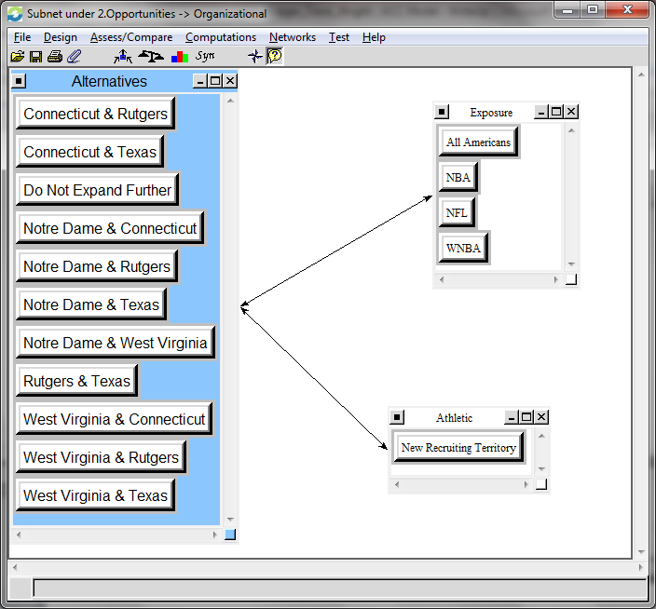

- Exposure
  - All Americans – the number and regularity with which a university produces all-American athletes.
  - NBA – the number and regularity with which a university is able to produce high profile athletes in the National Basketball Association.
  - NFL – the number and regularity with which a university is able to produce high profile athletes in the National Football League
  - WNBA – the number and regularity with which a university is able to produce high profile athletes in the Women’s National Basketball Association.
- Athletic
  - New Recruiting Territory – used to determine how traditionally rich the recruiting territory in and around the potential new candidates region. Territories which produce a significant portion of highly sought after recruits would be extremely important to a conference as it potentially can increase the success of its athletic teams.

Social
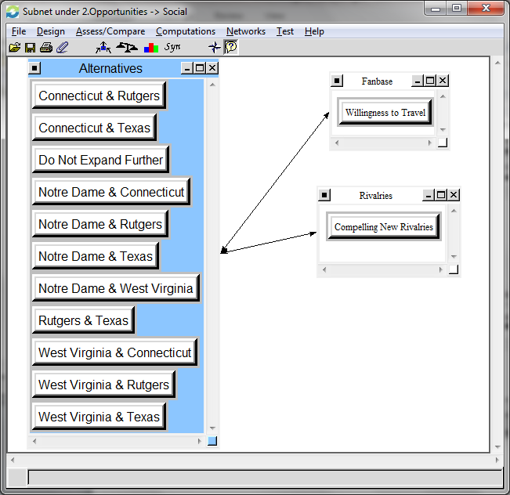

- Fan base
  - Willingness to Travel – used to determine how likely the fan base of a university is willing to travel to away athletic competitions. Fan bases that have larger groups willing to travel are more desirable to members of the conference as they will likely spend money in and around the area, which can provide a boost to the local economy.
- Rivalries
  - Compelling New Rivalries – Potential new rivalries that might be created as a result of an invitation should also be considered. New rivalries have the potential to provide excitement and exposure to the league, its fans, as well as the television audiences that would likely tune in.
Costs
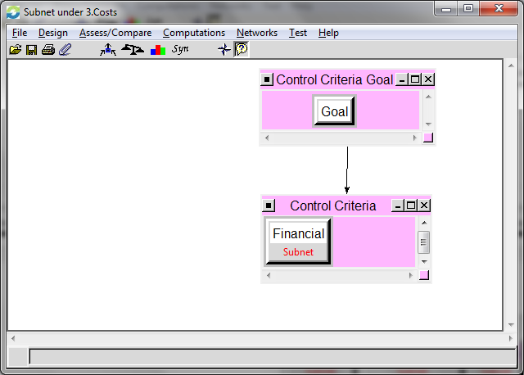

The Costs section only contains a financial component.

Financial
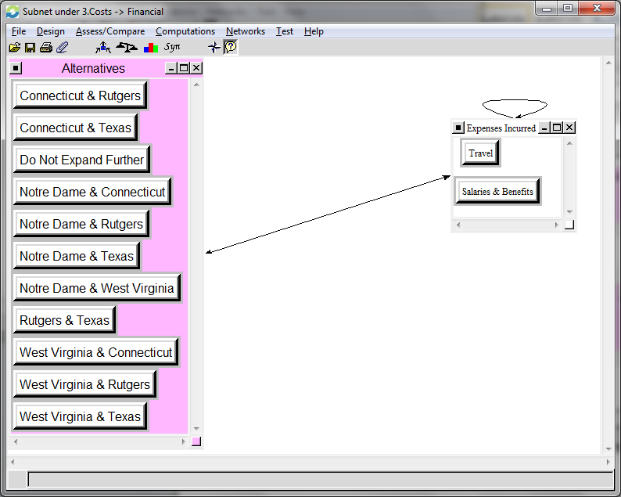

- Expenses Incurred
  - Travel – travel expenses can vary greatly depending on the part of the country with which a university is located. It is important to understand what the impact on travel would be to a university as many of the smaller sports would also have to travel. Longer distances would require air travel which generally is more expensive than other modes of transportation.
  - Salaries & Benefits

Risks
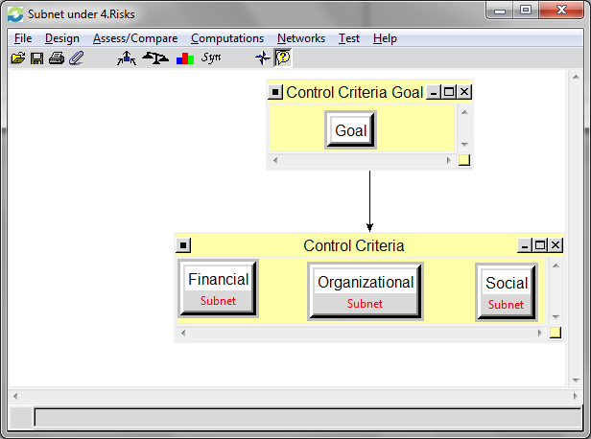
The Risks section also contains a Financial, Organizational, and Social component that were analyzed.

Financial
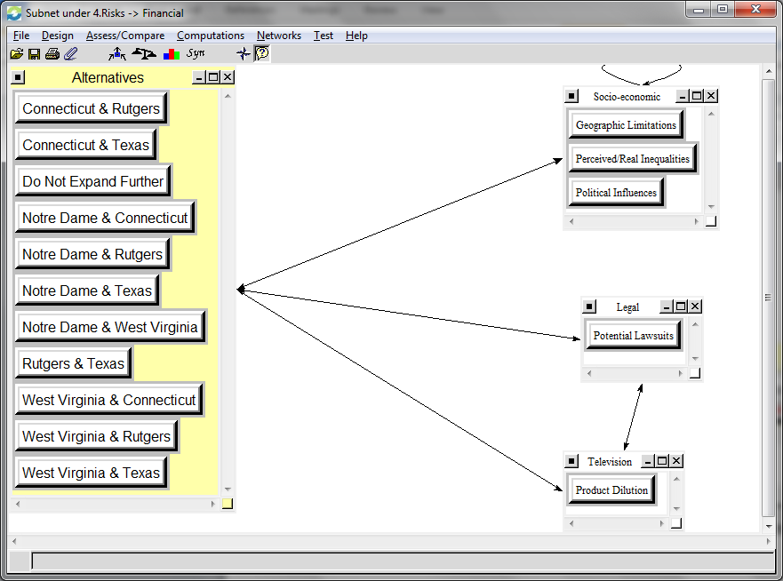

- Socio-economic
  - Geographic Limitations – used to compare any limitations that may exist as a result of a university’s geographic location. Consideration needs to be given for universities that may become a geographic outlier and the potential negative consequences which might result.
  - Perceived/Real Inequalities – used to compare any potential advantages or disadvantages that a new university might encounter as a result of becoming a member of the ACC in relation to the existing membership.
  - Political Influences – used to compare the likelihood that politicians may get involved in the realignment issues. Many of the universities are state institutions and many of the politicians have a vested interest in ensuring that the schools in their state not be adversely impacted.
- Legal
  - Potential Lawsuits – used to compare the likelihood that a lawsuit may be filed if a particular university is offered. Universities that already belong to a conference and want to exit to join a new conference are often required to pay an exit fee. In addition, if other members of the conference feel as though the loss of the university unfairly harms their conference or its ability to generate revenue it is possible that legal action may be taken. There is a precedent for this action which has been taken during several of the conference realignment events that have taken place in recent years.
- Television
  - Product Dilution – used to compare the likelihood of including universities that are in close proximity to one another. It is possible that a university includes the same television markets and set of population as an existing member. This would end up hurting the conference’s ability to generate additional revenue and would likely decrease the amount of revenue that is able to be distributed to each university.

Organizational
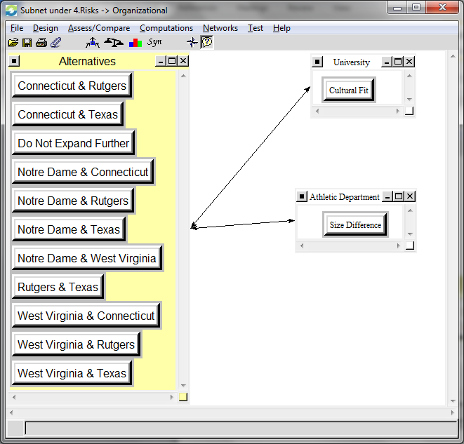

- University
  - Cultural Fit – the more stable conferences are often made up of like-minded universities that view things in a similar manner. This often includes how the university itself is structured. Within the ACC, the majority of the schools are private and have smaller enrollments. There are some exceptions, but any new university should ideally match the majority of the existing conference membership.
- Athletic Department
  - Size Difference – There can be large discrepancies in the number of athletic programs that a university sponsors as well as the budget that the athletic department has to work with. Ideally, new members should sponsor similar sports and have an athletic budget that compares favorably with the existing membership.

Social
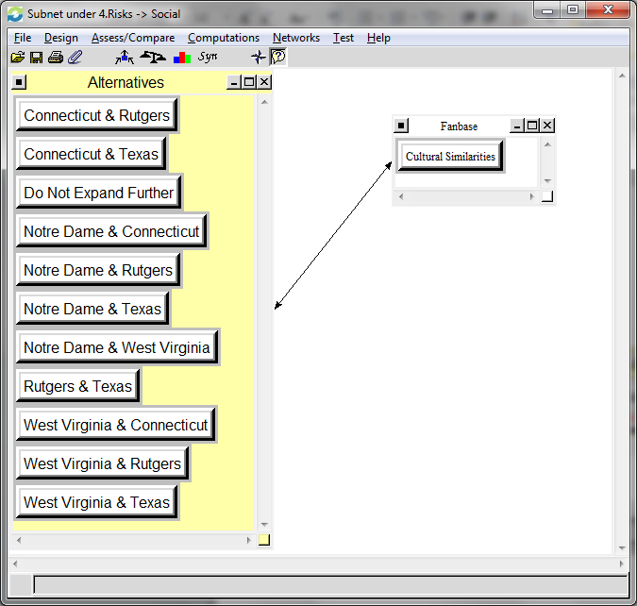
A single cluster and node were identified for the social risks.
- Fan base
  - Cultural Similarities – used to compare the cultural similarities between fan bases. It is possible that geographic areas throughout the country may possess significant cultural differences. If expansion into a new cultural area occurs it is possible to create some instability through these differences.

Synthesis
Benefits
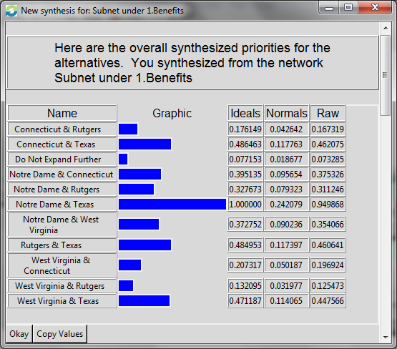

Once synthesized, the top alternative from the Benefits perspective is the Notre Dame & Texas combination, with Rutgers & Texas and Connecticut & Texas a distant second and third, respectively. This result can be expected as both schools are the two biggest schools in terms of popularity, tradition, and revenue generation that we analyzed. The Notre Dame & Texas combination was used for determining the ratings of the Benefits.

Opportunities
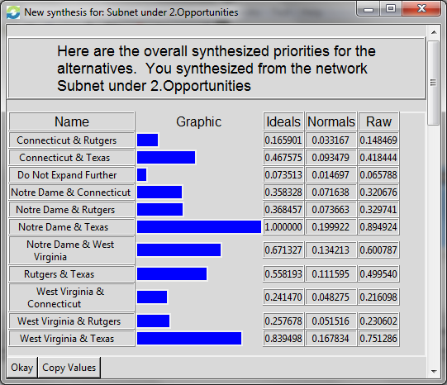
Upon completing the synthesis of the Opportunities criteria, we were able to determine that the Notre Dame & Texas combination was once again the top alternative. In second place was the West Virginia & Texas combination, followed by Notre Dame & West Virginia. We again utilized Notre Dame & Texas when evaluating the Opportunities portion of the ratings.

Costs
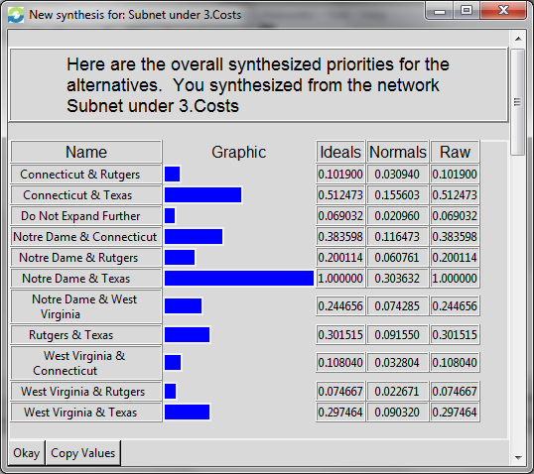

The Costs evaluation shows that the Notre Dame & Texas combination provides the largest potential costs, followed by Connecticut & Texas and Notre Dame & Connecticut. Notre Dame & Texas were used for evaluating the Cost ratings.

Risks
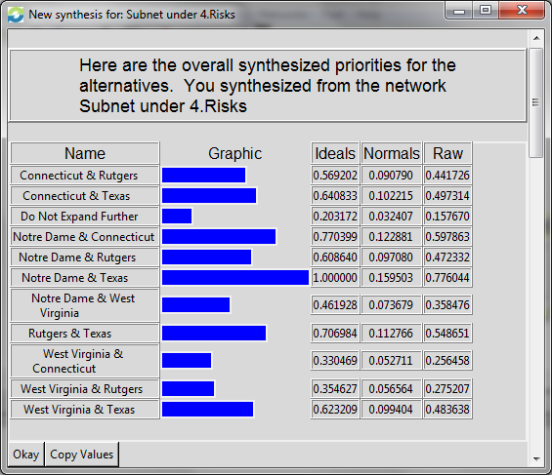

We concluded that Notre Dame & Texas provided the largest risks and used that alternative for evaluating the Risk ratings. Notre Dame & Connecticut and Rutgers & Texas wound up being the second and third riskiest options.

RATINGS

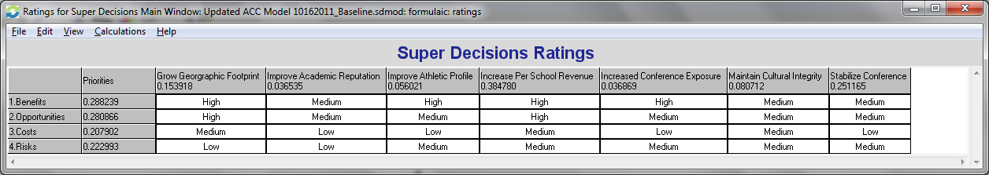

Notre Dame & Texas ended up being the top alternative for the Benefits, Opportunities, Costs, and Risks. This alternative was used to evaluate all ratings decisions. Additionally, for all of the Strategic Criteria that were evaluated, we utilized a Very High, High, Medium, Low, and Very Low scale.
Within the ratings, we can see that the Income Per School Revenue, Stability of the Conference, and Growth of the Geographic Footprint were the most heavily weighted of the Strategic Criteria evaluated. The rest of the Strategic Criteria carried significantly less weight than these top three.
Once all of the decisions were evaluated we determined that the Benefits alternative was the highest priority followed by Opportunities, Risk, and then Costs. With all of the Strategic Criteria rated and the alternatives prioritized we were able to calculate the optimal decision for the ACC in both the short and long term timeframes.

SENSITIVITY ANALYSIS

Benefits
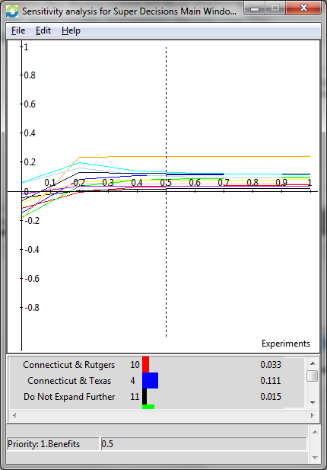

The sensitivity analysis of the Benefits illustrates that initially; West Virginia & Texas provides the most benefits. However, as the importance or priority of the benefits increases, then Texas & Notre Dame instead provide the most benefits to the conference.

Opportunities
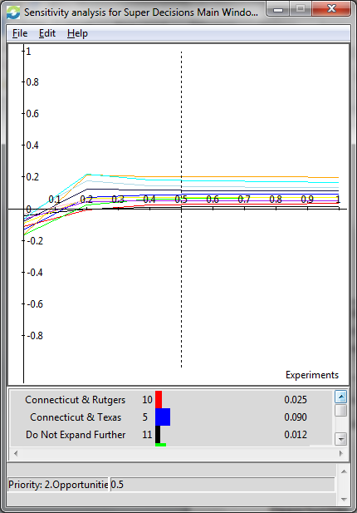

The sensitivity analysis of the Opportunities again illustrates that initially Texas & West Virginia provide the most opportunities. However, as the importance of Opportunities increases, then Texas & Notre Dame instead becomes the optimal choice.

Costs
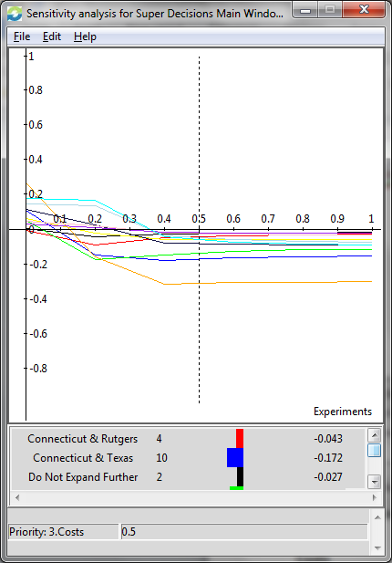
The sensitivity analysis for costs shows that initially, Texas & Notre Dame provide the least amount of costs, however as that importance increases it actually becomes the largest and most significant cost. West Virginia & Rutgers end up providing the least amount of costs to the conference as the level of importance increases.

Risks
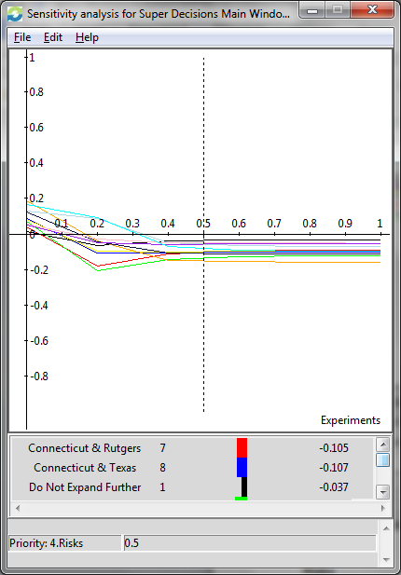

Initially, as the level of importance is low, the sensitivity analysis with respect to risks indicates that Texas & Notre Dame provide the least amount of risk. As that level of importance increases, however, Texas & Notre Dame end up becoming the riskiest, with Not Expanding Further providing the least amount of risk.

RESULTS
Multiplicative (Short Term)
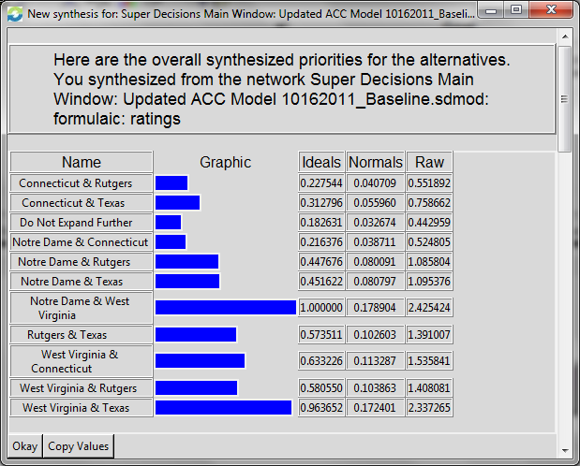
The multiplicative formula, to determine the short term decision, was first used to analyze our model. This formula determined that the best decision for the conference would be to add the Notre Dame & West Virginia combination. This outcome seems realistic and tends to make quite a bit of sense. The combination of Notre Dame and West Virginia has the potential to add significantly to a new television deal that the conference would probably be able to sign as well as contribute substantially to the athletic profile of the conference. In addition, Notre Dame is able to compensate with its outstanding academic reputation and national following for West Virginia’s short comings in those particular areas.

Additive (Long Term)
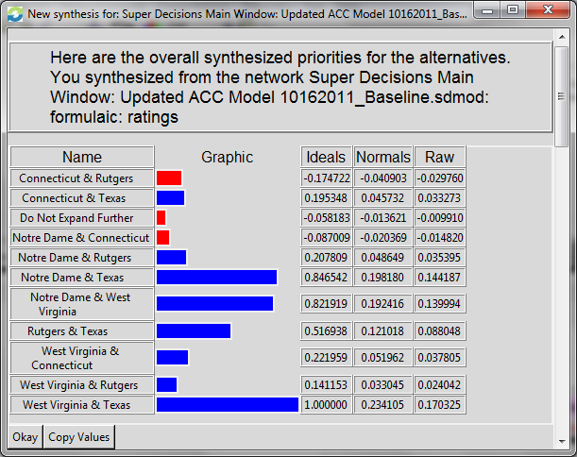

Using the additive formula, we were able to calculate what the best long term decision for the conference would be. Performing the synthesis, we were able to find that the decision to add West Virginia & Texas would be best for the conference. This result is a bit surprising and is not what we had initially anticipated. However, thinking about the strategic criteria, we can see that adding these two schools to the conference would provide a significant new market and geographic area along with a potentially lucrative new television contract due to both program’s recent athletic successes.

CONCLUSION
While the two formulas used in our analysis produced slightly different results (West Virginia & Texas versus Notre Dame & West Virginia), they are in fact used to predict the decisions over different periods of time. West Virginia, however, was included in both of the results and this tends to make logical sense. West Virginia by itself is not a very good expansion candidate due to its poor academic reputation, small state population and lack of significant television market. Alternatively, when paired with another university that is able to compensate for these deficiencies, WVU is then a viable consideration because of its terrific athletic profile and loyal fan base. This is exactly what we are seeing in our model. In the short term, pairing West Virginia with Notre Dame brings a national following along with terrific academics. In the short term this is probably the choice that is able to get the conference the most revenue in the shortest amount of time. The long run model instead shows that the ideal choice is West Virginia and Texas. Again, Texas is able to compensate for West Virginia by providing a large new geographic area with a large population as well as a good academic reputation. It is also quite possible that over time and with the assistance of the other conference members, West Virginia will be able to improve its academic reputation to become more acceptable and on par with the rest of the conference.

The events surrounding this latest round of conference realignment is occurring at a rapid pace, with new rumors about different schools defecting to other conferences happening on a daily basis. For this reason, we believe that the ACC will be required to make a decision in a relatively short period of time. In addition, we decided to look at which options are realistic and most likely to happen. As it stands today, it is undeniable that the Big East conference appears to be the most vulnerable. We have mentioned that the University of Pittsburgh along with Syracuse University have already announced their intentions of leaving the Big East to join the ACC. Additionally, several other Big East schools are being looked at as expansion candidates for a number of other conferences. For this reason, it is more likely that if extended an invitation, a school from this conference would be likely to accept. Also, the University of Notre Dame is currently an independent in football, meaning that their football program does not participate in an established league and instead creates its own schedule. For all other sports, Notre Dame participates in the Big East conference. If additional schools were to leave the conference, as has been speculated, then the conference itself may dissolve with Notre Dame looking for a conference to place its non-football athletic programs. It is also more likely that Notre Dame would be looking to place its football program into an established conference as the size of the new, larger conferences would prevent them from scheduling non-conference opponents towards the end of the season. This may prove to be an issue that Notre Dame would need to solve. For these reasons, we believe that if given the opportunity and thinking about what is best for the stability of the conference, it would be in the best interest of the university presidents to extend invitations to both the University of Notre Dame and West Virginia University to become the 15th and 16th members of the Atlantic Coast Conference.

