Should Pittsburgh Submit a Bid to Host the 2024 Summer Olympics?
Prepared for: Decision Making in a Complex Environment
Prepared by: Erica Jurkowski
Date: April 21, 2013

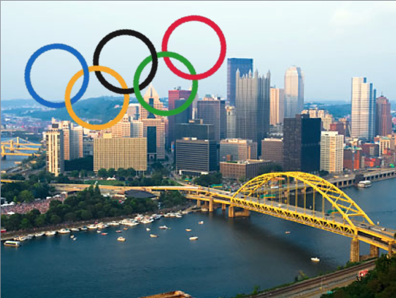

Table of Contents

Abstract………………………………………………………………………........ 2

Introduction……………………………………………………………………...... 2

Methodology…........................................................................................................ 3

Data……….............................................................................................................. 4

Analysis……............................................................................................................ 13

Conclusion…………………………………………………..……………………. 14

Bibliography……………………..……………………………………………….. 16

ABSTRACT
For this paper I evaluated whether Pittsburgh should submit a bid to host the 2024 Summer Olympics. I considered the benefits, opportunities, costs, and risks of alternative decisions before the games, during the games, and after he games. Of course, there are hundreds of obstacles sitting between today and Pittsburgh 2024. Primary among them include housing for 16,000 athletes and officials, facilities for tennis and aquatics and about $3 billion. However, hosting the Olympic Games can create numerous economic benefits the host city and country. The BOCR model and decision criteria suggested that Pittsburgh should “Go For Gold” and pursue a bid to host the games.
INTRODUCTION
The U.S. Olympic Committee is looking for cities interested in bidding for the 2024 Summer Games. Pittsburgh was among 35 U.S. cities to receive letters this February from the USOC to gauge interest in hosting the games. The committee will review bids in about two years and decide whether to recommend one to the International Olympic Committee, which is expected to choose a host city in 2017

In a statement, Mayor Ravenstahl said, “As our City grows and evolves, we welcome opportunities to tell our comeback story to the world. It wasn’t long ago that we hosted a safe and successful G20 Summit, and now, we may have the opportunity to bid for the 2024 Olympics…Pittsburgh should feel very proud and honored to have come this far. Certainly there would be extraordinary obstacles and challenges to meet in putting a bid together, and we will reach out to community members to gauge their interest.”

The obstacles we would face include estimates that it would cost $3 billion in operating costs to host the games. Further, the City must prepare to host the games in new stadiums and venues, house all the people in adequate hotels, transport everyone from one place to the next with a reliable mass transit system, and handle the high level of security needed at the games. An Olympic City needs 45,000 hotel rooms, a village for 16,500 athletes and officials, an international airport and a workforce of up to 200,000. Currently, Pittsburgh only has 24,000 hotels. We also don’t have a tennis stadium, an aquatics center for swimming and diving events, or a velodrome for cycling and a track-and-field stadium. The costs of these huge infrastructure expenses may be covered by raising taxes.

Sports Columnist John Mehno, “Pittsburgh doesn’t like to admit that certain things are beyond its grasp, but the Olympics might be too big. Let’s remember this is a city that had a crisis when a Pirates game, a concert and the Arts Festival all happened on the same Saturday.”

On the other end of the argument, according to the Post-Gazette, is that “We are a city and a region on the rise. Our cultural and educational assets earn national press. Our rivers and skyline are familiar coast to coast. Our neighborhoods are high-quality and affordable. Our health care is first-rate and accessible. Our corporations and foundations are devoted to the community. Our employment and economy are better than the nation's. Our population decline has stopped and, as everyone knows, we're a town that loves sports beyond belief.”

Research conducted in this area has indicated that a host country can earn up to 823 million dollars out of the visitors who may come to visit the host country within the first twenty days prior to the event and twenty days after the event. This is also topped up by some new businesses that may be created as direct result of the Olympics and this can bring about a total of 1.1 billion dollars. Other reasons for hosting the Olympics include: Pride in Pittsburgh and in the United States, international spotlight, new jobs, tourism, and city improvement. So the question remains, should Pittsburgh submit a bid to host the 2024 Olympics?

METHODOLOGY

I designed the model to predict the best decision for the city of Pittsburgh. It would only be in Pittsburgh’s best interest to submit a bid if actually hosting the Olympics is a good decision for the City. Therefore, in order to decide whether Pittsburgh should submit a bid to host the Olympics, I decided to look at the implications of what would happen if Pittsburgh’s bid were ultimately chosen. The City has two alternatives: Submit a bid or do not submit a bid.

For my analysis, I used the BOCR Model. The Benefits, Opportunities, Costs, Risks of hosting the Olympics vary greatly with respect to time. This is why I chose to break down the Control Criteria into 3 categories: Before Games, During Games, and After Games (with slight variations throughout the model).

The most commonly used Clusters for each Control Criteria are: Economic, Social, and Political. These were then broken down into multiple elements within the clusters. Details for the structure of the model can be found in the upcoming table labeled: Clusters in the Decision Networks and Elements in the Clusters. I made pairwase compairisons for the criteria and subcriteria.

Next, I created the Strategic Criteria, which include: Financial Viability, Economic Return, Infrastructure Requirements, and Olympic Legacy. The decision whether to submit a bid or not would likely be made by the mayor and a committee of respresentatives; however, they would mainly be acting with the city and the citizen’s best interests in mind. I kept this is mind when choosing the strategic criteria.

The next step was to create the ratings. I gave the greatest prioritity to Infrastructure Requirements because that appears to be the greatest problem that Pittsburgh will face.

Finally, I combinde the BOCR using the multiplicative and additive negative formulas to get the results.

DATA

Clusters in the Decision Networks and Elements in the Clusters
BOCR | Control  Criteria | Clusters | Elements in Clusters
Benefits | Before  Games | Economic | 1 Job Creation 2 Merchandise Revenue 3 Development of Infrastructure
Benefits | Before  Games | Social | 1 International Media Attention 2 Community Involvement 3 Volunteer Programs
Benefits | Before  Games | Political | 1 International Recognition 2 Environmental Awareness
Benefits | During  Games | Economic | 1 Job Creation 2 Ticket Revenue 3 Hotel Revenue 4 Transportation Revenue 5 Food Revenue 6 Merchandise Revenue 7 TV Revenue
Benefits | During  Games | Social | 1 Media Attention 2 “Home Advantage” of Athletes 3 Community Involvement 4 Volunteer Programs 5 Display of Local Culture 6 Diversity
Benefits | During  Games | Political | 1 International Recognition 2 Home Advantage” of Athletes
Benefits | After  Games | Economic | 1 Job Creation 2 Investment in Public Infrastrucure 3 Merchandise Revenue 4 Increased Tourism
Benefits | After  Games | Social | 1 Olympic Legacy 2 Sporting Venues
Benefits | After  Games | Politcal | 1 International Recognition 2 Olympic Legacy
Opportunities | During  Games | Economic | 1 Business development 2 Boost Economy
Opportunities | During  Games | Social | 1 National Pride 2 Local Pride 3 Increased Interest in Athletics
Opportunities | During  Games | Political | 1 Influence 2 Prestige of Country 3 Prestige of City
Opportunities | After  Games | Economic | 1 Tourism 2 Future Infrastructure Use 3 Future social housing 4 Future Transit Use
Opportunities | After  Games | Social | 1 National Pride 2 Local Pride 3 Increased Intrest in Athletics 4 Diversity
Opportunities | After  Games | Politcal | 1 Influence 2 Prestige of Country 3 Prestige of City
Costs | Before  Games | Events Costs | 1 Cost of bid 2 Promotion 3 Advertising 4 Opening/Closing Ceremony 5 Employee Salaries 6 Medical Services
Costs | Before  Games | Infrastructure | 1 Olympic Villiage 2 Sporting Venues 3 Housing 4 Mass Transit System 5 Renovation of Roads
Costs | Before  Games | Political | 1 Tax Raise 2 Use of resources 3 Olympic Committee 4 Neutrality
Costs | During  Games | Economic | 1 Insurance 2 Security 3 Employee Salaries
Costs | During  Games | Social | 1 Congestion externalities 2 Increased Traffic
Costs | During  Games | Policital | 1 Regulation 2 Neutrality
Costs | After  Games | Economic | 1 Maintenence of Infrastructure 2 Clean-up
Risks | Before  Games | Economic | 1 Displacement of homes/businesses 2 Disruption from Construction 3 Extreme Weather
Risks | Before  Games | Social | 1 Language Barriers 2 Extreme Weather
Risks | Before  Games | Political | 1 Voter Support 2 Culture Gap
Risks | During  Games | Economic | 1 Legal Liablity 2 Media Exposure 3 Safety 4 Extreme Weather
Risks | During  Games | Social | 1 Language Barriers 2 Public Criticism 3 Pandemic 4 Culture Gap 5 Extreme Weather
Risks | During  Games | Polical | 1 Terrosim 2 Public Criticism 3 Protesting 4 Voter Support
Risks | After  Games | Economic | 1 Financial defecit 2 Idle infrastructure 3 Excess housing 4 Unused Transit
Risks | After  Games | Policital | 1 Public Criticism 2 Voter Support 3 City debt
All networks | Alternatives |  | 1 Yes Bid 2 No Bid

Benefits, Opportunities, Costs and Risks Top-level Network
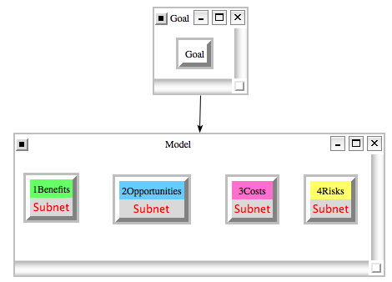

Next, I created the subnets, shown in the following graphic. For benefits the priorities were: before games 0.25 during games 0.50 and after games 0.25. I gave the highest priority to benefits during games because that is when most of the revenue and publicity comes. For opportunities the priorities were: during games 0.25 after games 0.75. I did not include opportunities before games because there wasn’t much of any. I ranked the priority for after games because that is when there are significant opportunities in the future for increased tourisms. For costs the priorities were: before games 0.50 during games 0.25 and after games 0.25. Before games had the greatest priority because that is when there are significant costs relating to infrastructure. For risks the priorities were: before games 0.25 during games 0.50 after games 0.25. Most of the risks comes during the games when there are thousands of extra people in the city.
Benefits (Top Left), Opportunities (Top Right), Costs (Bottom Left), and Risks (Bottom Right) Control Hierarchy Subnets
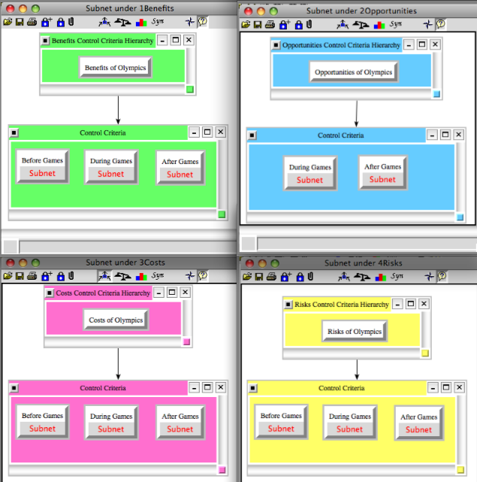

Decision Subnet for Benefits Before Games
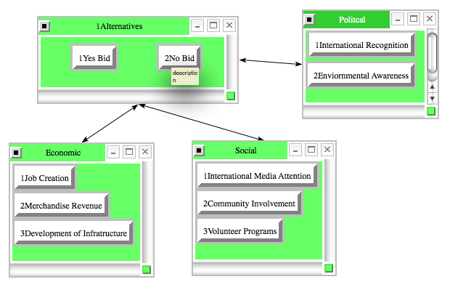
Decision Subnet for Benefits During Games
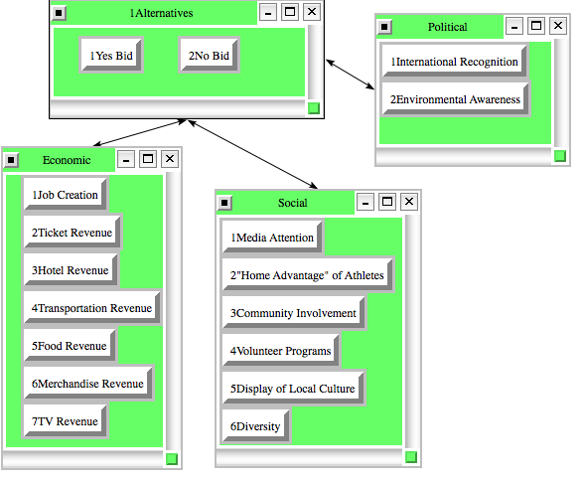

Decision Subnet for Benefits After Games
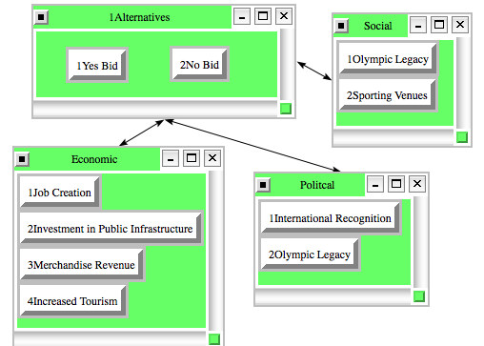

Decision Subnet for Opportunities During Games
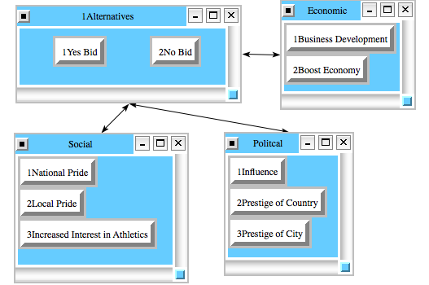

Decision Subnet for Opportunities After Games
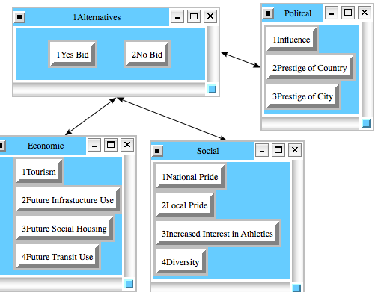
Decision Subnet for Costs Before Games
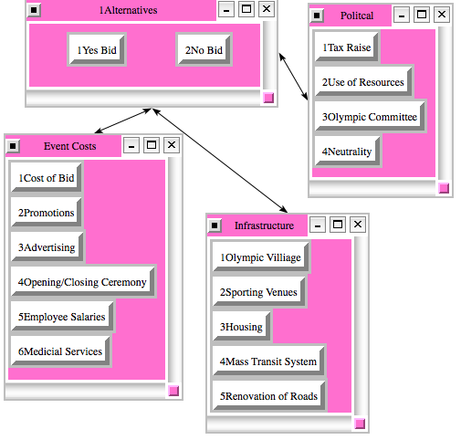

Decision Subnet for Costs During Games
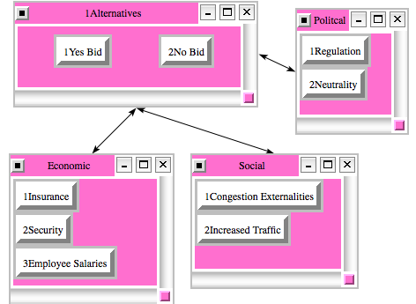

Decision Subnet for Costs After Games
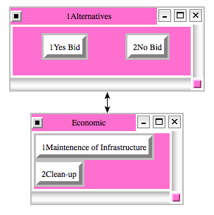

Decision Subnet for Risks Before Games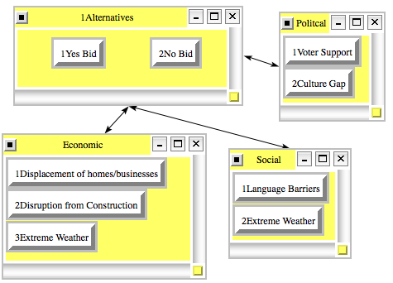

Decision Subnet for Risks During Games
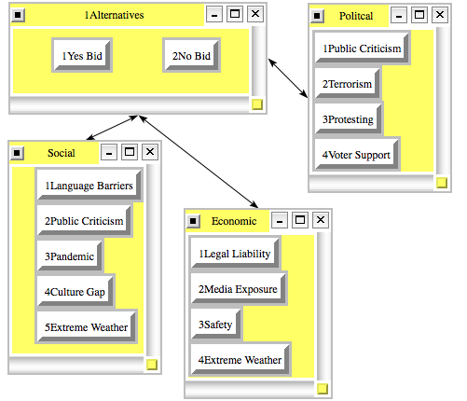

Decision Subnet for Risks After Games
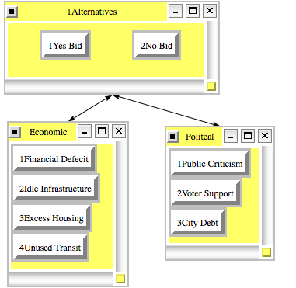

Results of Pairwise Compairisons for Benefits
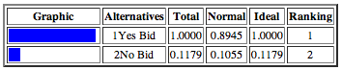
Results of Pairwise Compairisons for Opportunities
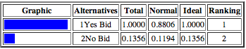
Results of Pairwise Compairisons for Costs
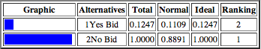
Results of Pairwise Compairisons for Risks
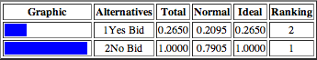

As exprected, the results (above) show that for benefits and opportunities, the best decision is to submit a bid. For costs and risks, the best decision is to not submit a bid.

Strategic Criteria
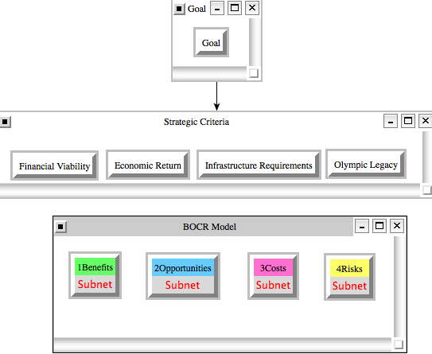

Priorities for Strategic Criteria:
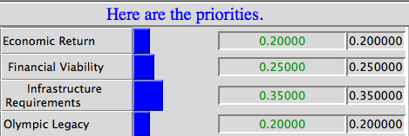

The table above shows the priorities given to the strategic criteria. I ranked the infrastructure requirements the highest because they are a huge obstacle Pittsburgh will face. It was the item of most concern indicated by city officials. Financial viability was next because the Olympic Games will cost over $3 Billion. This is a huge investment for the City. I ranked Economic return and Olympic legacy the lowest because although they are important, they are not going to be the deciding factors.

ANALYSIS
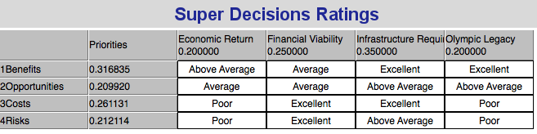

Multiplicative Results (Short-term)
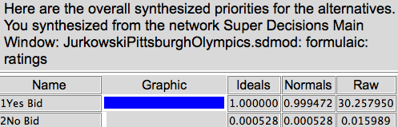

Additive Negative Results (Long-term)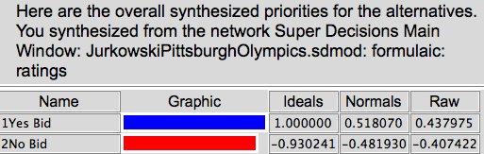

Both the multiplicative and additive negative results show that overwhelmingly Pittsburgh should submit a bid to host the 2024 Summer Olympics.

SENSITIVITY ANALYSIS

Benefits (Left) and Opportunies (Right)

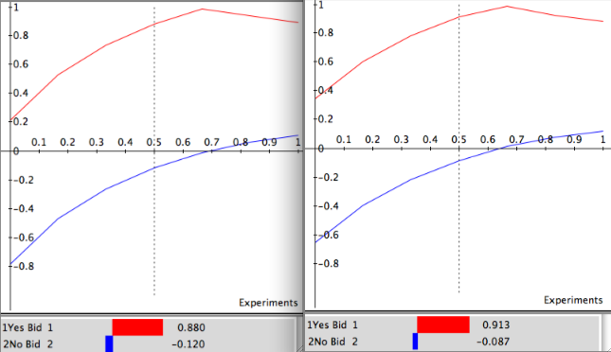

Costs (Left) and Risks (Right)
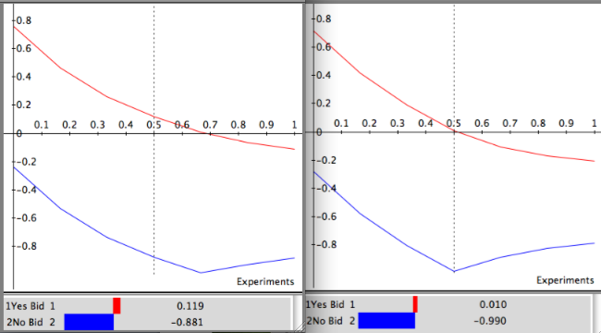
This sensitivity analysis demonstrates that “Yes Bid” is the best across the board for Opportunities and Risks and “No Bid” is the best decision for Costs and Risks because as I change the priority, the decision stays the same.

CONCLUSION

Hosting the Olympics can have numerous economic benefits to Pittsburgh, including the creation of approximately 77 thousand new jobs. In addition, Pittsburgh will have numerous facilities that will provide benefits decades after the Olympics. The Olympics will encourage Pittsburgh to expand some of their facilities and also inspire improvements of some of the infrastructural facilities. Further, we get the opportunity to market ourself to the world. This will go long way. Lastly, there are numerous community programs and groups that will come from such an event.

Pittsburgh has about two years to decide whether to bid for the games. Olympic Committee CEO Scott Blackmun wrote to Ravenstahl, “While the games require a formidable commitment, they also provide an unparalleled opportunity for a city to evolve and grow.” SuperDecisions agrees that Pittsburgh should “Go For Gold” by submitting a bid to host the 2024 Summer Olympic Games!

BIBLIOGRAPHY

Blazina, Ed. “Pittsburgh invited to consider playing host to 2024 Olympics.” Pittsburgh Post Gazette. 21 Feb 2013. Web. 20 April 2013.<://www.postgazette.com/stories/local/neighborhoods-city/pittsburgh-invited-to-consider-the-olympic-dream-676215/#ixzz2R5PzCtiO>

CBS Pittsburgh. “2024 Summer Olympics In Pittsburgh?” CBS Pittsburgh. 20 Feb 2013. Web. 20 April 2013.<http://pittsburgh.cbslocal.com/2013/02/20/2024-summer-olympics-in-pittsburgh/>

Mehno, John. “Sorry, yinz: No Pittsburgh Olympics.” Timesonline. 23 Feb 2013. Web. 20 April 2013.<http://www.timesonline.com/columnists/sports/john_mehno/mehno-sorry-yinz-no-pittsburgh-olympics/article_6f5e168c-3ac6-5857-a36fbc3f3cd41c45.html>

Smith, C. “Economic Benefits Of Hosting The Olympic Games”. Articlesbase. 23 Feb 2010. Web. 20 April 2013.<http://www.articlesbase.com/writing-articles/economic-benefits-of-hosting-the-olympic-games-1897436.html>

Togneri, C & Nixo, A. “Pittsburgh gets letter seeking interest in hosting 2024 Olympics.” TribLive. 20 Feb 2013. Web. 20 April 2013.<http://triblive.com/news/adminpage/3520415-74/pittsburgh-olympics-olympic#axzz2R6vBHrcF

