Drafting the Best Future NFL Quarterback
Decision Making in a Complex Environment
Final Project
Nick Besh
Steve Ellis
October 18, 2004

Anyone who has followed the NFL draft knows that drafting a Quarterback in the first round is a hit or miss proposition. Successful college prospects, many who are under classmen fail to go on and have the same success as professionals. There are the “cant-miss” prospects who do go one to become Pro Bowl QB’s, but just as many are total busts. It would appear as if the selection is nothing more than a crap-shoot. Drafting is all about priorities and alternatives. Given that, there must be a way to quantify all of the stats and “gut feelings” of players to select a future NFL star.
The description of the NFL draft problem would appear to be a perfect candidate for a complex ratings model using the SuperDecisions software. Analyzing the problem further lead us to our stated goal: Optimize a high selection in the NFL draft by drafting a solid contributor to your team, if not a Pro-Bowl caliber player while at the same time avoiding the selection of a player who can set your franchise back years. This is a critical decision that does not leave much room for error.
To achieve our goal, thorough research of all the criteria that would need to be considered when drafting a QB would need to be analyzed. This process led us to nine top level criteria:
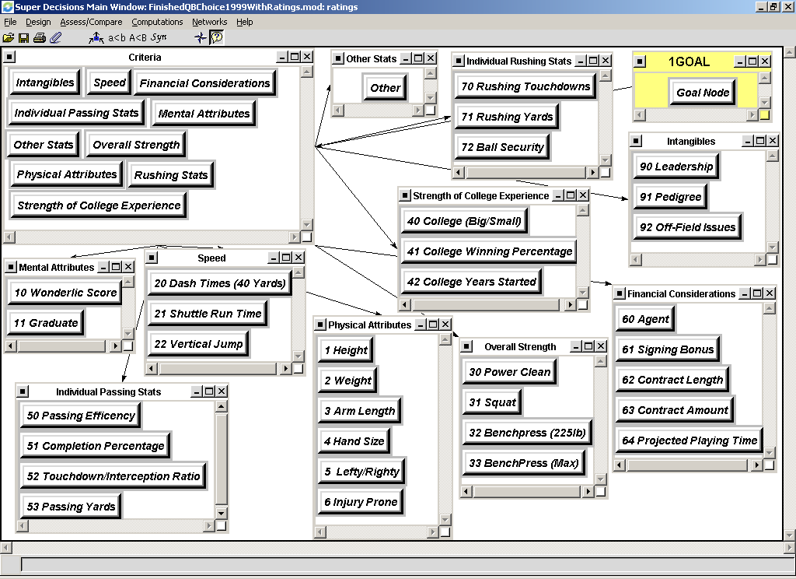

- Strength of college experience: Just how valuable was the players experience at this level to his future success?
- Sub Criteria: College (big/small), college winning percentage, college years started.
- Individual passing stats: Just how effective was the player at the QB position? What kind of results was he able to produce?
- Sub Criteria: Passing efficiency, completion percentage, touchdown to interception ratio, passing yards.
- Mental attributes: How did the player fare on the mental aptitude test and did he graduate?
- Sub Criteria: Wonderlic score, degree earned.
- Physical attributes: What kind of physical specimen is the player; does he have the physical size to succeed?
- Sub Criteria: Height, weight, arm length, hand size, lefty/righty, injury prone.
- Speed: Does the player have the speed and elusiveness to be successful?
- Sub Criteria: 40 yard dash time, shuttle run time, vertical jump.
- Overall strength: just how strong is this player in terms of both upper and lower body strength?
- Sub Criteria: Power clean, squat, number of repetitions of 225lbs on the bench press, maximum bench press.
- Intangibles: What other attributes does the player possess to separate himself from his peers?
- Sub Criteria: Leadership, pedigree, off-field issues
- Financial considerations: What kind of contract may this player command and how will his agent influence his decision to sign it?
- Sub Criteria: Agent, signing bonus, contract length, contract amount, projected playing time.
- Other stats: Are there any other factors that may be considered?
- Sub Criteria: Other

Once all the criteria and sub criteria have been built into the model and pairwise compared against one another, we can view the priorities of the criteria.
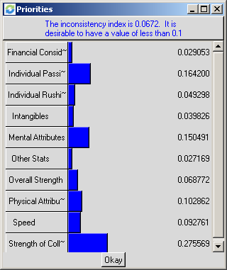
Here, strength of college, which encompasses the level of the program (and competition), how many wins the QB amasses, and how many games did the QB start is the greatest priority at 27.6%. This is followed by individual passing statistics and mental attributes. The next tier of priorities includes physical attributes, speed and overall strength.
To test our model, we decided to compare the results of the 1999 NFL draft to the actual performance of the 5 QB’s taken in the first round. Thus the alternatives for this model are as follows:
- 1st overall pick – Tim Couch – Cleveland
- 2nd overall pick – Donovan McNabb to Philadelphia.
- 3rd overall pick - Akili Smith - Cincinnati Bengals.
- 11th overall pick - Daunte Culpepper - Minnesota Vikings.
- 12th overall pick - Cade McNown - Chicago Bears.
Now it was time to build a ratings model to utilize our criteria to rate the players.
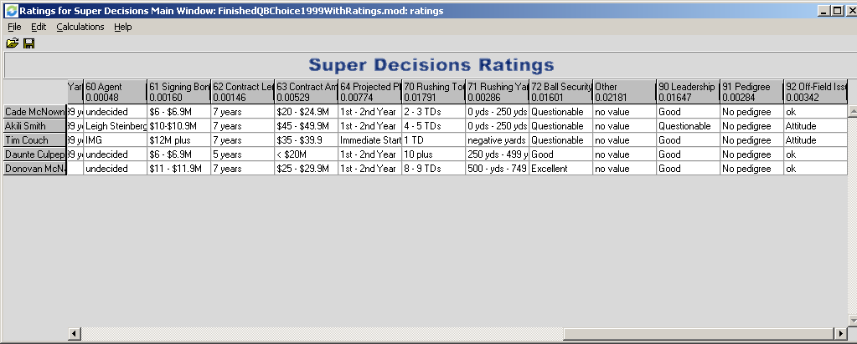
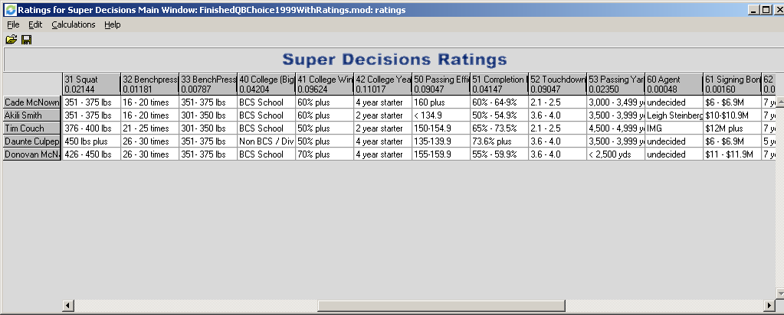
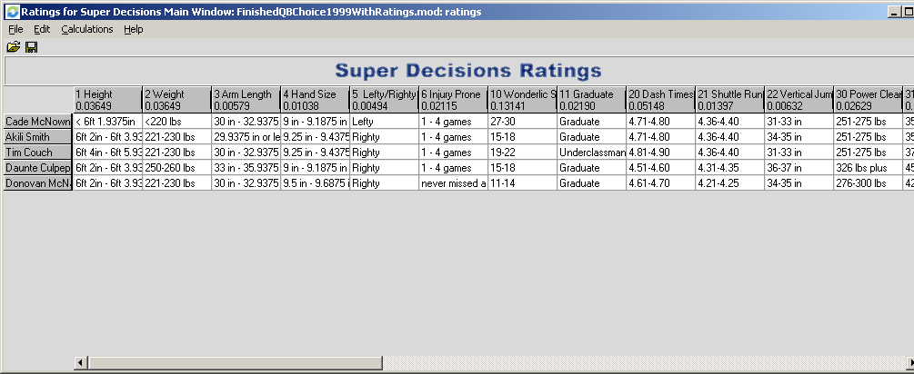
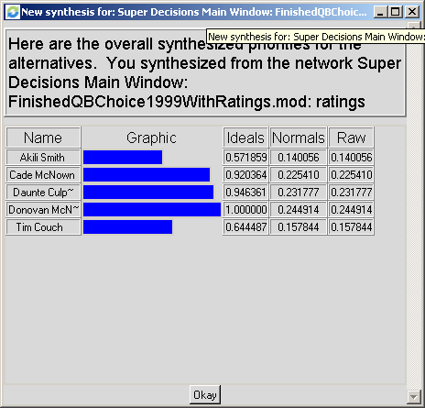
Synthesizing the data provides us with the results of our model:

Now let’s look back at what some of the experts said before the draft about each player selected:
- Tim Couch (Kentucky) widely considered a franchise quarterback…more mobile and athletic than Peyton Manning. Consensus #1 quarterback in the draft.
- Donovan McNabb (Syracuse) Great athlete but needs substantial work to convert from option QB to a pro style QB. Has all of the tools.
- Akili Smith (Oregon) Has all the physical tools to be a premier NFL quarterback. Regarded as the second best QB in the draft.
- Daunte Culpepper (Central Florida) Looks like a bigger Steve McNair with touch and accuracy; small school affiliation is a concern.
- Cade McNown (UCLA) Proven winner; definitely a big game QB. Looks like a young Phil Simms. Only average arm strength.
We can also look at the sensitivity of the criteria applied to the alternatives.
Sensitivity Analysis – 1999 Quarterbacks

Mental Attributes

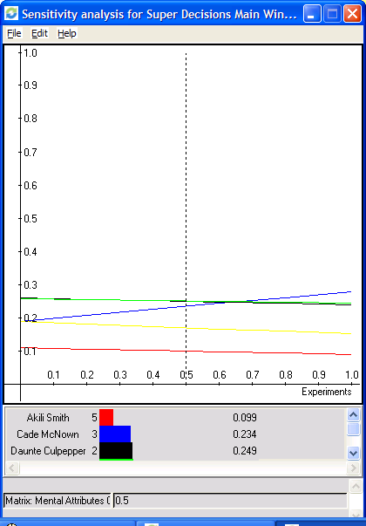

As you can see from this analysis as the mental attributes of the quarterback position become more important Cade McNown’s value as a potential draft pick increase.

Strength of College Experience

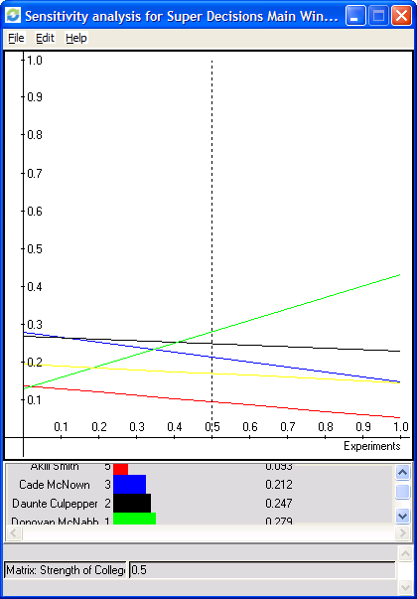

If the strength of the potential players college experience becomes more important Donovan McNabb becomes a more important player.

Physical Attributes

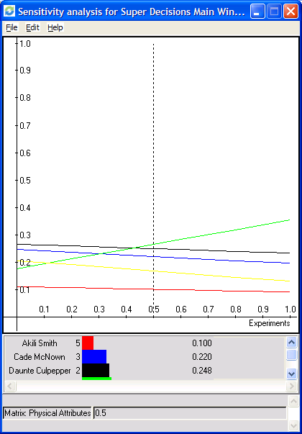

The sensitivity analysis shows that if the players physical attributes become the biggest indicator of which player you are projecting is the best; Donovan McNabb again is considered the best prospect.

Individual Passing Stats

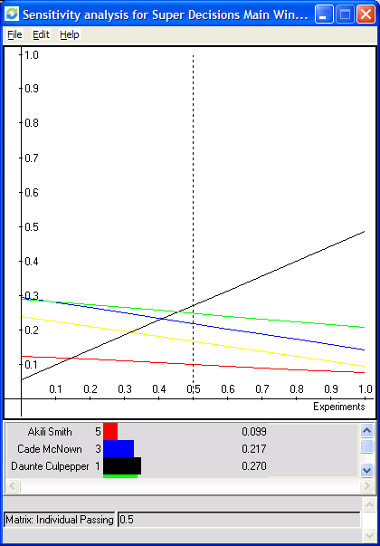

As passing efficiency and passing stats become more important in choosing a potential candidate, Daunte Culpepper becomes the quarterback that is most valuable.

Based on the expert evaluation of NFL General Managers and Coaches, the players were drafted in the proceeding order. Now let’s look at how these players faired:
Tim Couch:
- Played 5 yrs in Cleveland before being cut at the beginning of the 2004 training camp. He lost his job in 2003 to an undrafted journeyman, Kelly Holcomb. He started 62 games (out of 80) and threw for 11,131 yards, completing 59.8% of his passes with only 64 TDs and 67 career interceptions. He was cut again a couple of weeks later by the Green Bay Packers and it currently out of football.
Akili Smith:
- Played 4 yrs in Cincinnati before being cut in two training camps (Cin & Green Bay) in 2003. Started only 21 out of 64 games completing 48% of his passes for 2,122 yds. He threw 5 TDs and 13 Ints. Considered one of the biggest bust in the history of the NFL Draft (Ryan Leaf is the biggest).
Cade Mcnown:
- Started 2 years for the Bears before being cut after the 2000 season. Was a back up in Miami (01, 02) and in SF for (03). Passed for 3,111 yds completing 54% of his passes while throwing for 16 TDs and 19 Ints. Currently, out of football.
Daunte Culpepper:
- Has started 61 out of 83 games for the Vikings. He has completed 63% of his passes for 14,832 yards. He has thrown 98TDs and 64 Ints. He has gone to 2 Pro-Bowls and is considered one of the elite quarterbacks in the NFL.
Donovan Mcnabb:
- Has been to the Pro-Bowl 4 times and the Eagles are NFC East Powers. He has started 74 games, completed 58% of his passes for over 14,000 yds with 96 TDs and 50 Ints. He has also rushed for over 2,000 yards with 19 TDs. He is considered one of the best players in the NFL.
These are pretty amazing results. Our model predicted Donovan McNabb to be the best (24.5%), followed by Daunte Culpepper (23.2%) and Cade McNown (22.5%). These three were by fare the best performing QB’s out of the five alternatives.
Now let’s apply our model to the 2004 NFL draft. Once again, there were five QB’s taken in the first round and thus five alternatives.
- Eli Manning (Mississippi) No. 1 overall - N.Y Giants
- Philip Rivers (N.C. State) No. 4 overall – San Diego Chargers
- Ben Roethlisberger (Miami-Ohio) No. 11 overall – Pittsburgh Steelers
- J.T. Losman (Tulane) No. 22 overall – Buffalo Bills
Here are the results of the new synthesis:
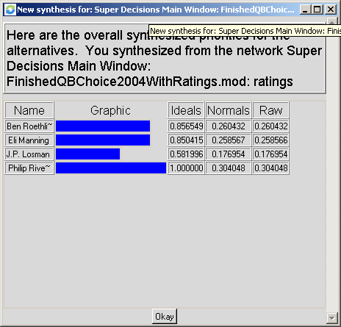

Sensitivity Analysis – 2004 Quarterbacks

Mental Attributes

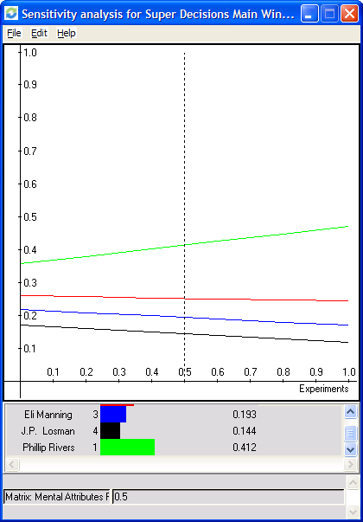

As mental attributes become more important Phillip Rivers starts out as the most important quarterback and increases the difference between number 1 and number 2 (Ben Roethlisberger).

Strength of College Experience

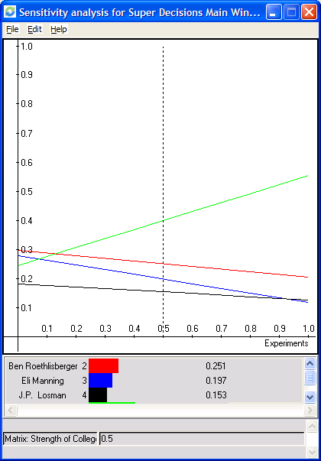

Phillip Rivers is considered the player to choose by a wide margin if strength of the college experience is considered the most important criteria.

Physical Attributes

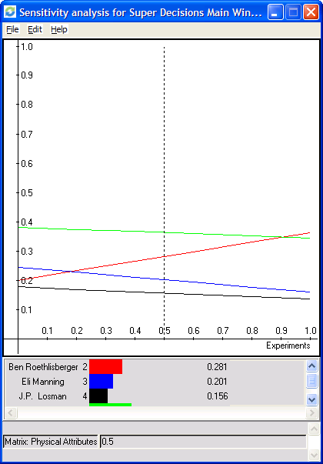

In this sensitivity analysis, Ben Roethlsiberger physical gifts become significantly more important.

Individual Passing Statistics

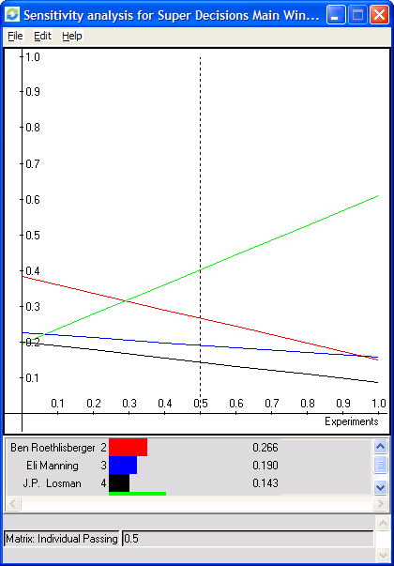

Because of his outstanding passing statistics Philip Rivers eventually overtakes Ben Roethlisberger in this category.

Based on the model it would appear the Steelers made a good pick in Ben Roethlisberger.

