Colin Macon
Final Report
DECISN MAKING COMPLX ENVRNMNT

Choices for a high-school basketball star:

Introduction

The goal of this work is to determine what the best option for a highly rated basketball player after high-school is. Using the BOCR model I created possible alternatives that were compared, ranked, and judged throughout the process. When this was completed, I found that the G-League was the best suited option to a player looking to enter the NBA Draft after being out of high-school for one year.

Alternatives/Background

The mix of high-school, collegiate, and professional sports is an interesting one especially when it comes to basketball. As it stands now high-school basketball players must be out of high-school for at least one year before declaring for the NBA draft. For this reason, many top prospects select a top collegiate basketball program to play and attend for one year. This has become known as “One and Done”. With this, these players are not allowed to accept any money other than their stipend and scholarship money as well as benefits that come from the university. These benefits include but are not limited to, free housing, meals, and sponsored team apparel. All of this sounds great, except these athletes are touted as being worth millions of dollars and may not collect any of it due to rules and regulations by the NCAA. This has created an assortment of options as of late. At some point in time in the NCAA, athletes will be able to get paid, but no one knows how much or how often. As for the other alternatives such as the G-League and overseas professional leagues. We are seeing more and more players choose this route every year. The conditions of both are very similar. You have a professional contract with the team you choose to sign to and then you are treated and become a real professional athlete. However, you must take care of things that would not have to if you went to college such as a tracking of income, other expenses, sponsorships, etc. Each alternative comes with a large number of characteristics which is perfect for our BOCR model.

Modeling

So, the time has come you are a top ranked athlete and have been told that you are going to be a top pick in the NBA draft when your time comes if you can keep playing at the high level that you do now. The only issue is you are not sure of which path to take and how to weigh the benefits, opportunities, costs, and risks.
Modeling Overview:

Alternatives:
College Full Ride
G-League
Overseas

Model
Benefits – The benefits that come with your choice in team
Opportunities - The opportunities that come with your choice in team
Costs - The costs that come with your choice in team
Risks - The risks that come with your choice in team

Strategic Criteria
Academics – you have a choice to continue your formal education
Likeness – one must weigh how a decision will impact your likeness of image
Draft – draft position is crucial and you would like to go higher rather than lower
Income – What does your income look like in each alternative

Connections were made where it was appropriate to do so as well as the completed comparisons for each

The ratings portion of this process was based on a Hi-Low scale

Modeling Outline:

First and foremost, we have the outline of our BOCR model in super decisions

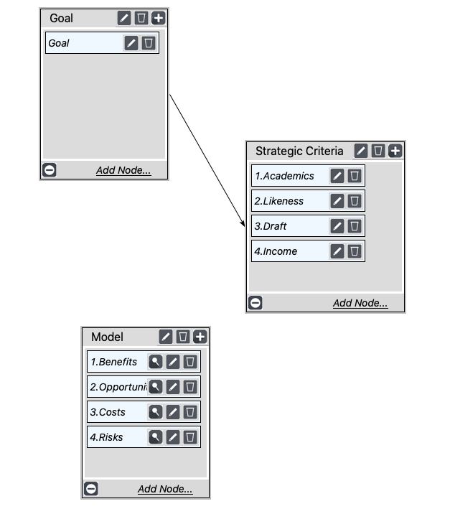

As you can see, we have our Goal, Strategic Criteria, and Model Node with a connection from the Goal -> Strategic Criteria

Next a subnet was created for each of the model criteria Benefits, Opportunities, Costs, and Risks. For each of these a subnet was created for those additional criteria of Finances, Organization, and Social. Below each outline of the network can be seen as well as the overall synthesized results per criteria.

Benefits Subnet:
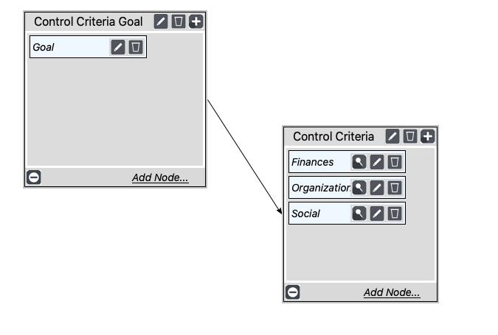
Benefits -> Finances Subnet:
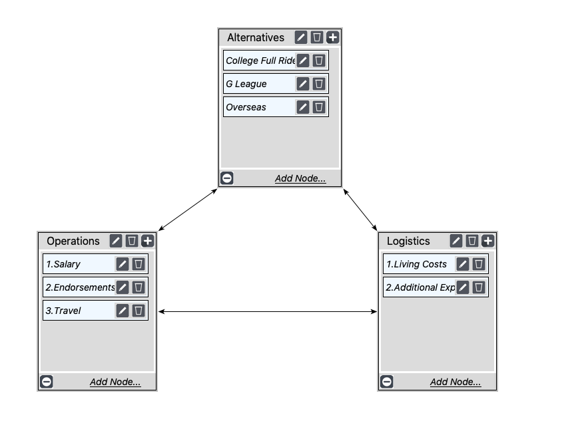

Benefits -> Organization Subnet:
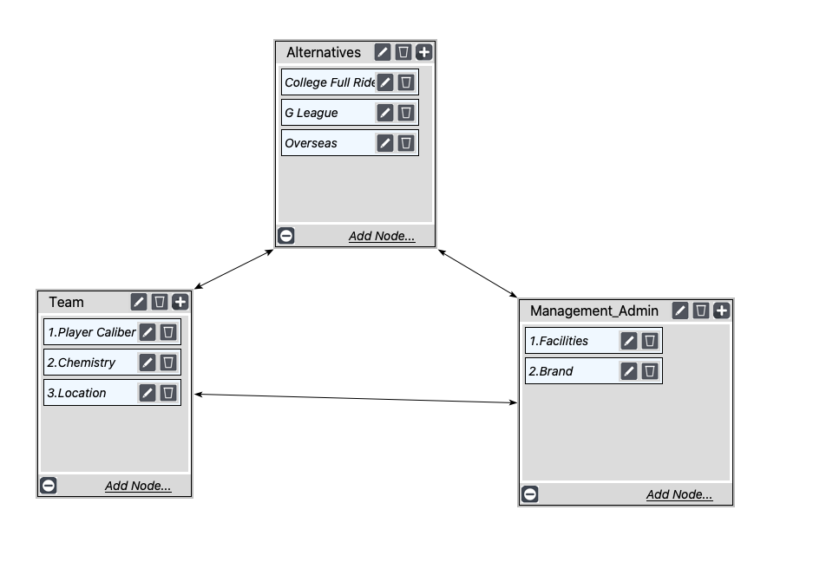

Benefits -> Social Subnet:

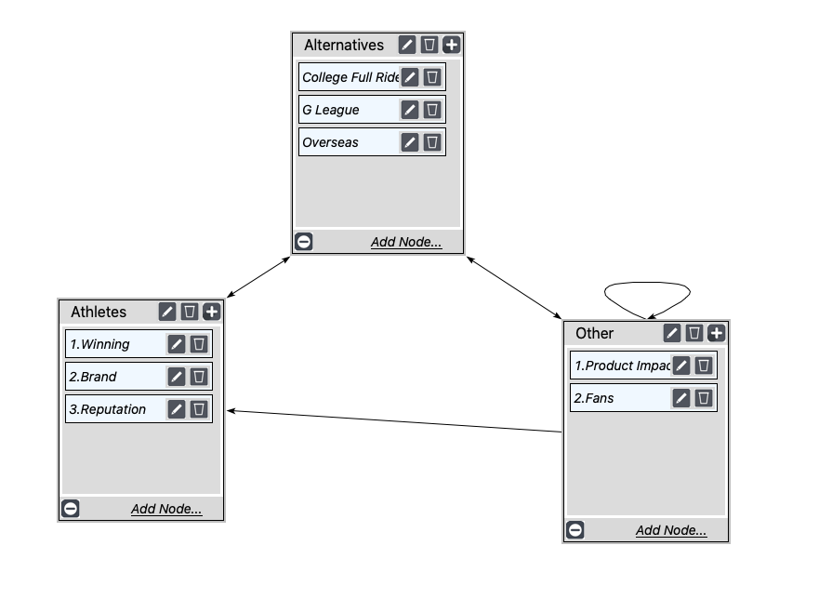

Benefits Results:
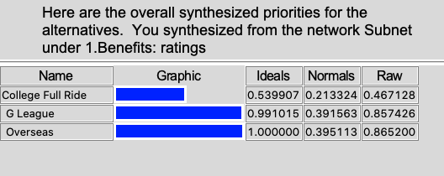

Using the benefits overall synthesized priorities we see that while G League and Overseas are very close. Overseas barely overtakes G League. With the two leagues being so similar as far as benefits are concerned this is interesting to see, but can be expected.

Opportunities Subnet:

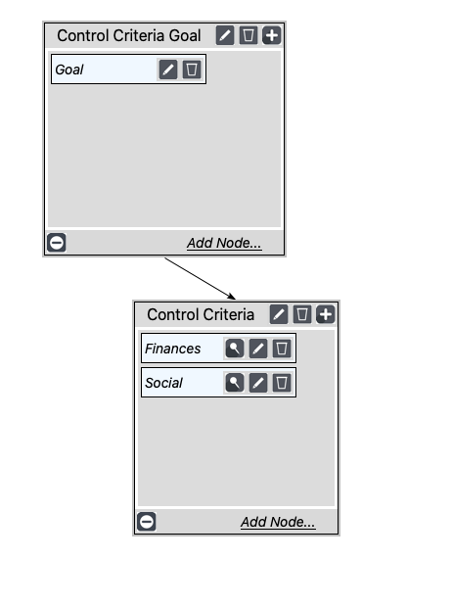

Opportunities -> Finances Subnet:
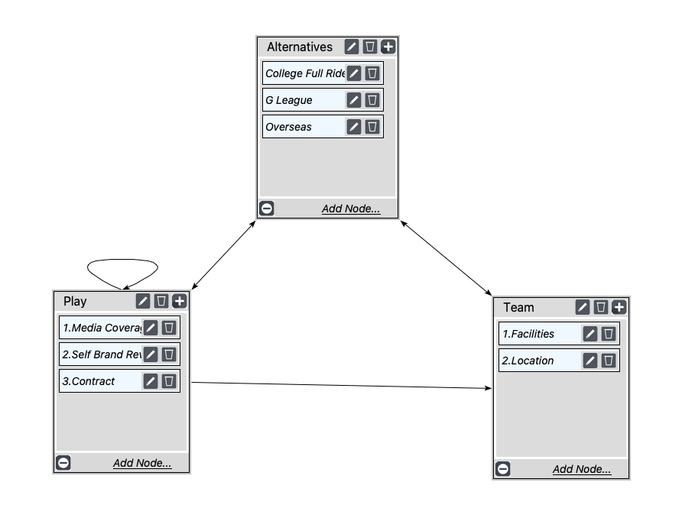

Opportunities -> Social Subnet:

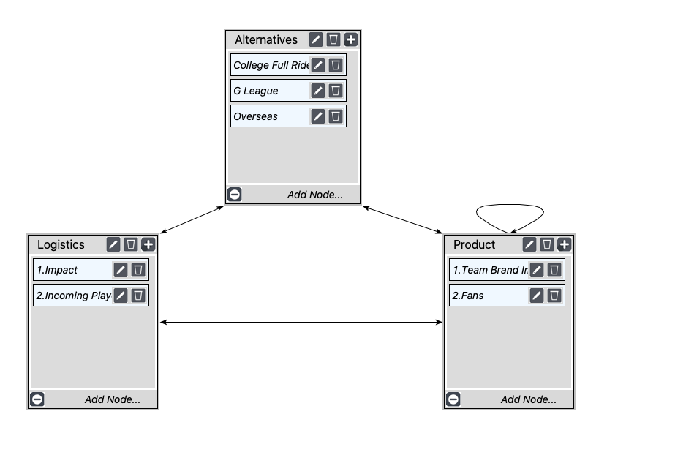

Opportunities Results:

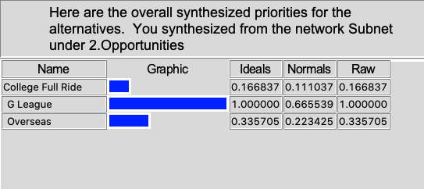

Using the opportunities overall synthesized priorities we see that the G League has the clear advantage. Whereas College and Overseas have a decent separation to each other, and are both very far behind G League. I would say that this set of results shows the clearest separation between one alternative and the other two.

Costs Subnet:

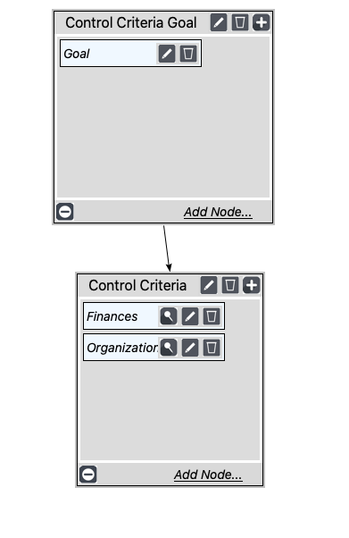

Costs -> Finances Subnet:
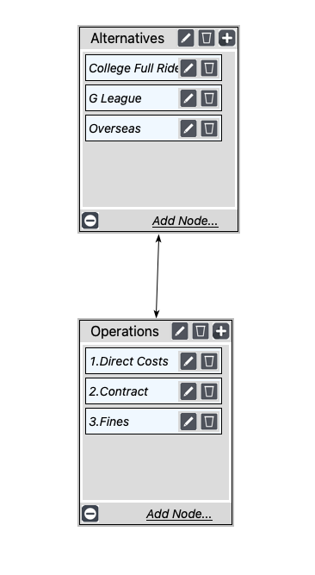

Costs -> Organization Subnet:

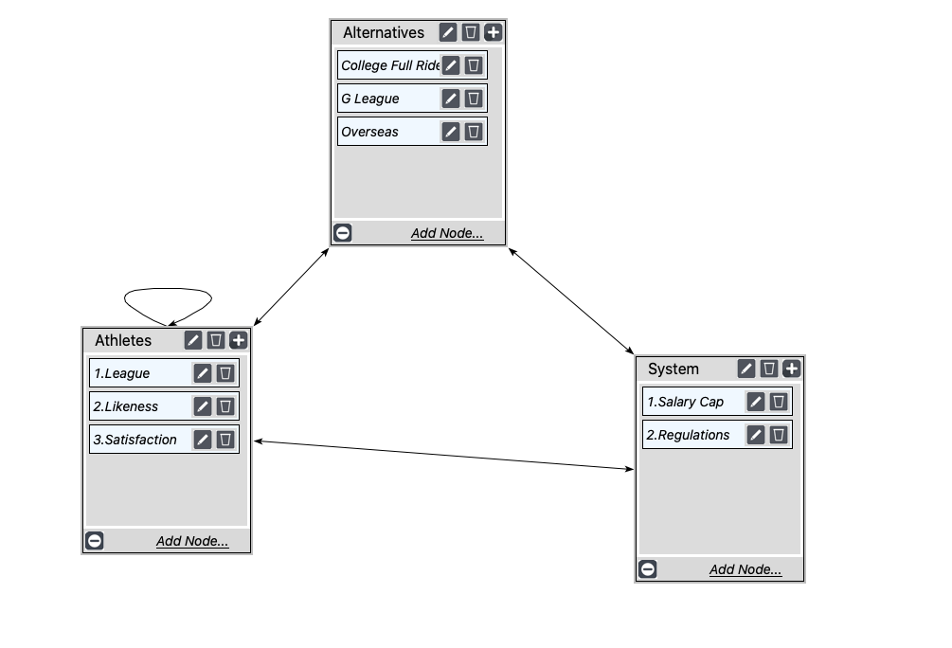

Costs Results:
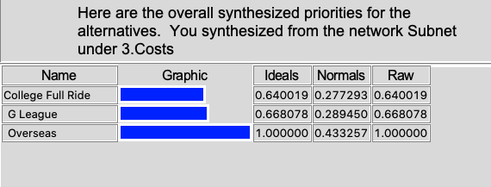

Using the costs overall synthesized priorities we see that Overseas has the ideal of 1 whereas both college and G league are very close to one another. This makes sense when we think about the costs that would incur with all three alternatives and the model reflected this as well.

Risks Subnet:

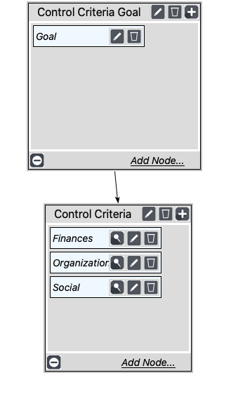

Risks -> Finances Subnet:
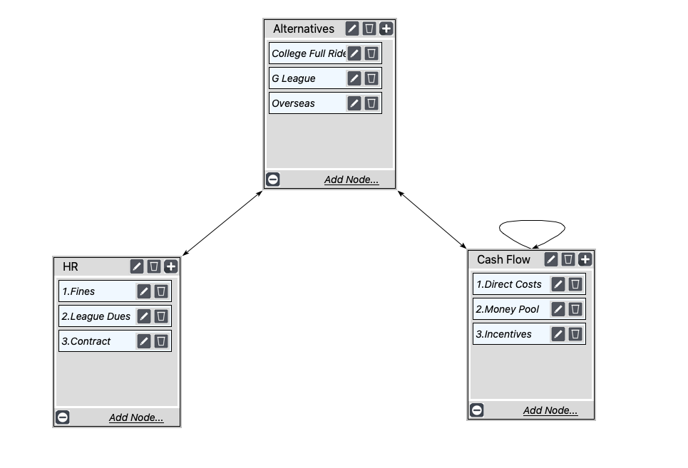

Risks -> Organization Subnet:

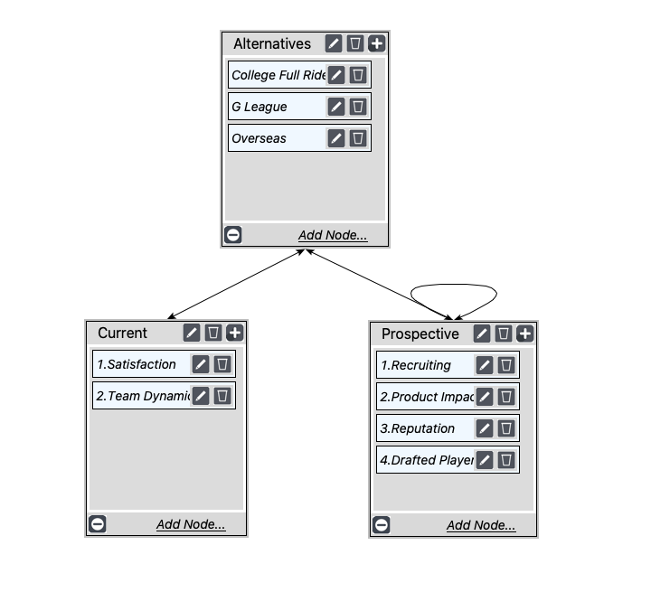
Risks -> Social Subnet:

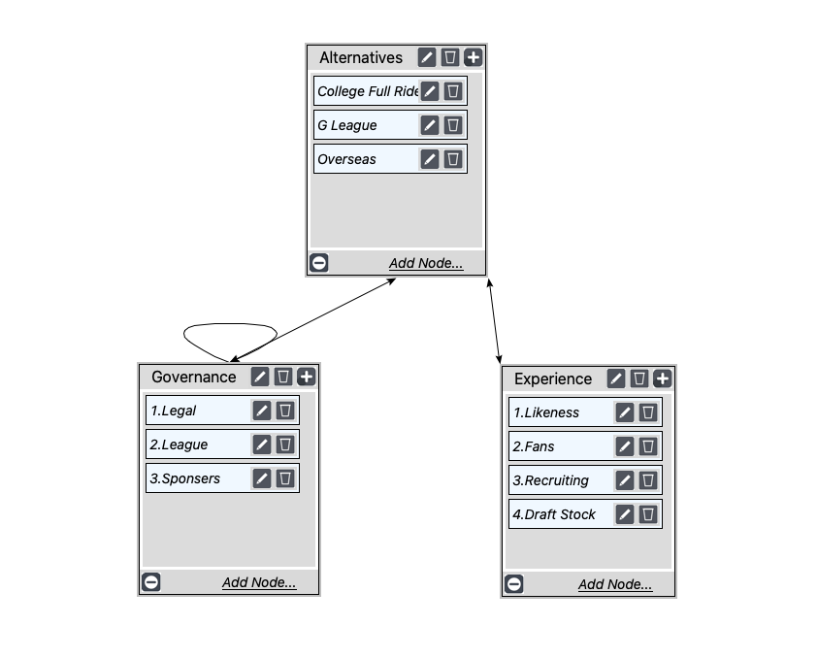

Risk Results:
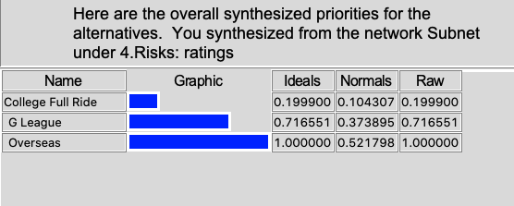

Using the ratings overall synthesized priorities we see that there is clear separation between the alternatives. Overseas is the obvious standout, but not too far ahead of G League relatively speaking. College is lacking behind, but this is not inconsistent with our other data at all.

Overall Analysis:

Ratings
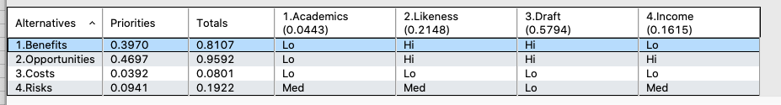

From the ratings we see that Draft (0.5794) is by far our leader while Academics (0.0443) is the least valued. This is very important with our alternatives as going to college is not looking to be a prime alternative at this point. Additionally, Opportunities (0.4697) shows to be the most important for alternatives. Both of these make sense if we are looking to get drafted highly.

Additive
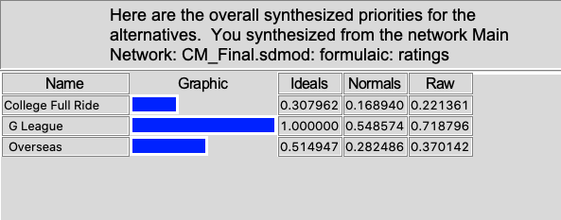

Multiplicative
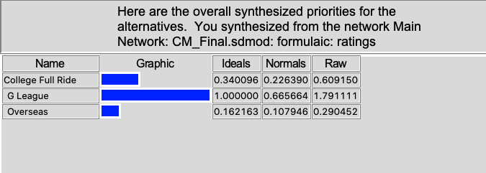
Using both Additive and Multiplicative we see that with “Ideals” of 1.0000xxxx “G League” is going to be our best alternative based on our overall model. I feel as though this is in-fact the best option due to the G-League allowing you to stay in the US, generate an income off your play and likeness, and give you prime availability to scouts for the NBA draft.

Sensitivities:

Finally, we have our sensitivities which are a key insight to our modeling. Something to note here is that benefits, costs, and risks all had reversals. From these reversals we see that with costs and risks those reversals occur between college and overseas rather early on in our graphs. This is with respect to the reversal that occurs in the benefits sensitivity between G League and Overseas, but this reversal occurs much later which is a better case scenario than the other two graphs in which a reversal is present.

Benefits Sensitivity Opportunities Sensitivity
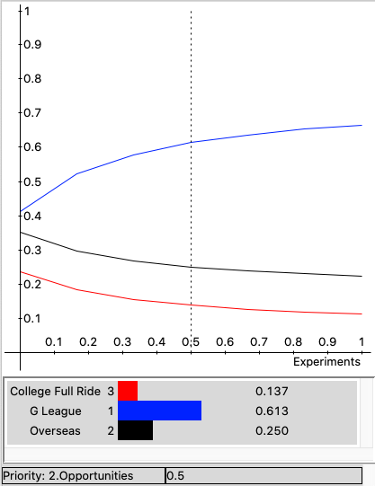
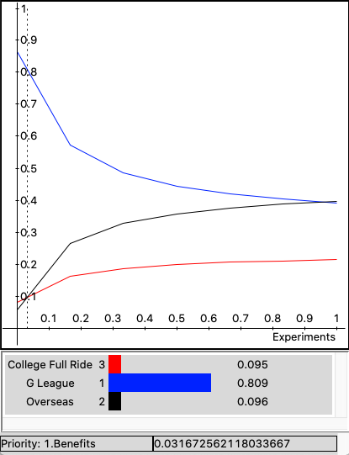

Costs Sensitivity Risks Sensitivity
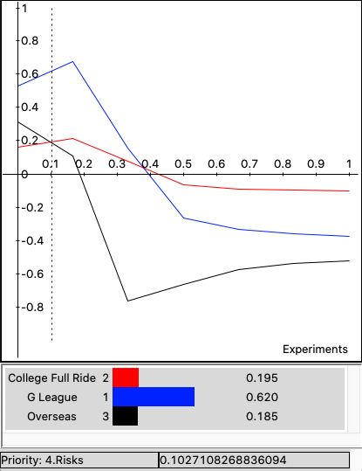
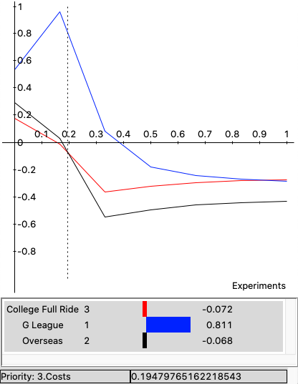

References:

Ravenelle, Anna. “NCAA Votes to Allow Paid Athlete Endorsements - What This Means.” CollegeVine, 25 Mar. 2020, blog.collegevine.com/ncaa-votes-to-allow-paid-athlete-endorsements/.
Teel, David. “Cost-of-Attendance Allowances for ACC Athletes Vary Widely.” Dailypress.com, Daily Press, 13 Aug. 2019, www.dailypress.com/sports/columns/david-teel/dp-teel-time-acc-cost-of-attendance-post.html.
“Meet Jalen Green, Isaiah Todd, Daishen Nix & Kai Sotto: The Newest NBA G League Prospects & Coach.” NBA G League, 10 June 2020, gleague.nba.com/news/meet-new-nba-g-league-prospects-and-coach/.
O'Donnell, Ricky. “How Elite High Schoolers Are Skipping College to Get to the NBA.” SBNation.com, SBNation.com, 8 Aug. 2019, www.sbnation.com/college-basketball/2019/8/8/20753788/nba-draft-college-basketball-recruiting-lamelo-ball-rj-hampton.
“The One-and-Done Dilemma: An NCAA Champion Feature.” NCAA.org - The Official Site of the NCAA, www.ncaa.org/static/champion/the-one-and-done-dilemma/.

