Evaluating Lease Renewal and Moving Scenarios

AUTHOR(S)
Courtney Kerler

INTRODUCTION
The Evaluating Lease Renewal or Moving Scenarios BOCR model was developed to aid my partner and I in preparing for our decision to renew our lease in our current apartment in Friendship or to begin the moving process by looking in our own neighborhood or other neighborhoods for apartments. We have received a notification from our current landlord that our decision must be made by May 1st on whether to renew and we would need to move out by July 31st 2013. The model was developed with four criteria: Safety, Location, Financial Obligation, and Efforts. After developing these four key criteria, I developed three alternatives: Renew Lease, Move within same neighborhood, and Move to new neighborhood.

Benefits | Opportunities | Costs | Risks
Safety | Safety | Financial Obligation | Safety
-Environmental | -Environmental | -Move in Costs | -Environmental
-Internal | -Internal | -Monthly Costs | -Internal (building)
Location | Location | Efforts | Financial Obligation
-Amenities | -Conveniences | -Time Requirements | -Potential Losses
-Position | -Commute |  | -Potential Pain/Suffering
Financial Obligation | Financial Obligation |  | Efforts
-Move In Costs | -Responsibilities |  | -Labor
-Monthly costs | -New costs |  | -Decision Making
Efforts | Efforts
-Time | -Physical
-Effort | -Decision Making

GOAL
To evaluate lease renewal and moving scenarios

ALTERNATIVES
- Renew Lease
- Move within the same neighborhood
- Move to new neighborhood
As a full time employee at WESCO Distribution, Inc. in Station Square, I want to be close to downtown for a short commute. As a part time MBA student, I also want to be close to Oakland to allow for easy commute. My partner is a PhD student at Duquesne, so further incentive to live near the East End of town, or at least on a direct busline to downtown as he takes the bus to and from school. I have limited my three alternatives to: Renew Lease (In Friendship), Move within same neighborhood (so as to assume that I know the area/commutes), and Move to new neighborhood (limited to Shadyside, Lawrenceville, or SouthSide).

DECISION CRITERIA
My strategic criteria were developed on a brainstorm between my partner and I. We examined various factors that would influence our decision making on whether or not to renew our lease in July. We brainstormed that our most important Strategic Criteria would involve the apartment’s Safety, Location, Financial Obligation, and Efforts.

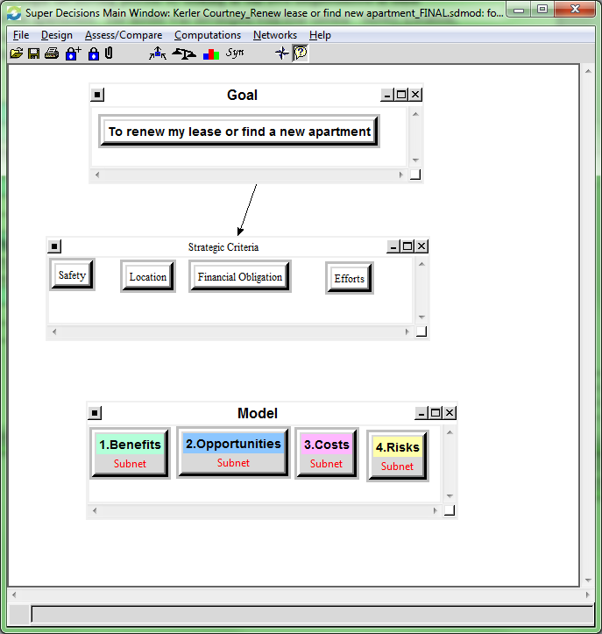

BOCR
The use of the BOCR method was extremely helpful in identifying the intensity and importance of each Strategic Criteria. As you can see below, Benefits and Risks ranked highest for us as far as importance. As you can also see, however, the Benefits we are willing to pay for will cost us “excellent” or EXTREMLY high Financial Obligations (or costs).

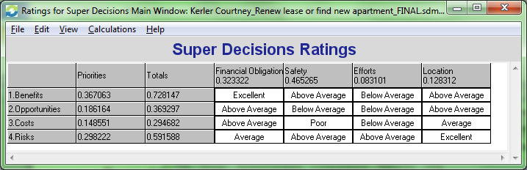

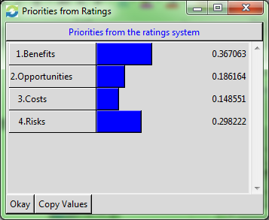

Networks:
Benefits
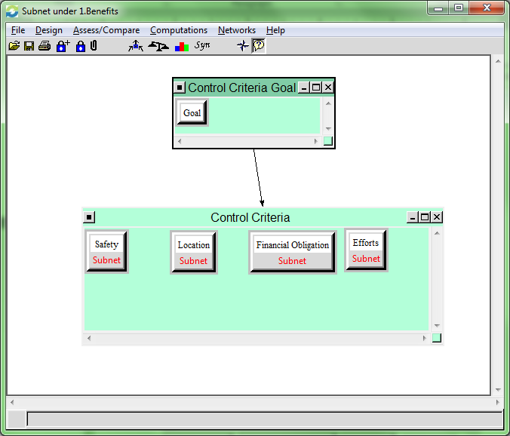

Benefits related to all of the strategic criteria involved in making the decision. Safety directly relates as a high priority we evaluated within the Benefits network. Location is also very important as a subnet because it will reflect on commutes, which can impact overall happiness from the standpoint of being in traffic and a vehicle for long periods of time and unpredictability of traffic patterns can lead to being late at work (thus causing additional grief!). Finding a lower cost apartment, or staying in our current apartment is another important benefit to examine from a Financial Obligation point of view. Freeing up the financial obligation of an apartment, could increase overall happiness and allow for additional cashflows to be allotted for various activities and special purchases that would be not be possible if we moved into a higher cost apartment.
I included Efforts in the Benefits examination because expending less effort on simply renewing my lease could free up additional time that I could be studying Dr. Saaty’s AHP and ANP models.

Let’s take a closer look at one of the Benefits subnets: Location

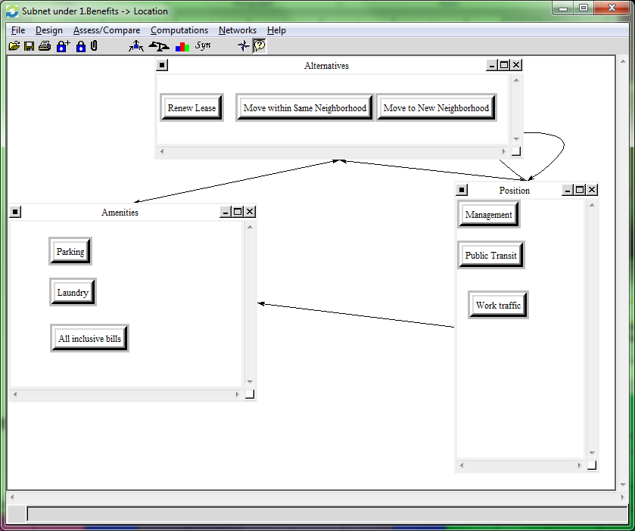

Within the Location Subnet of Benefits, you can see that my partner and I examined the Amenities and overall building Position/location clusters that the potential Alternatives could offer. Each of the Alternatives examined multiple criteria within those two clusters. More specifically: Is the management company respectable? Is Public Transit nearby? Will I encounter heavy traffic between 7-8am and 5-6pm during rush hours? Is there offstreet parking available with the apartment rental (paid or free)? Are laundry facilities on site? Are tenants responsible for additional bills such as Gas or Electric? All of these could be considered very useful benefits for each specific location. Of course, assumptions had to be made about the potential for moving. All assumptions were made indicating that the amenities listed would be sought after if we were to pursue finding another apartment within the same neighborhood or moving to a different neighborhood.
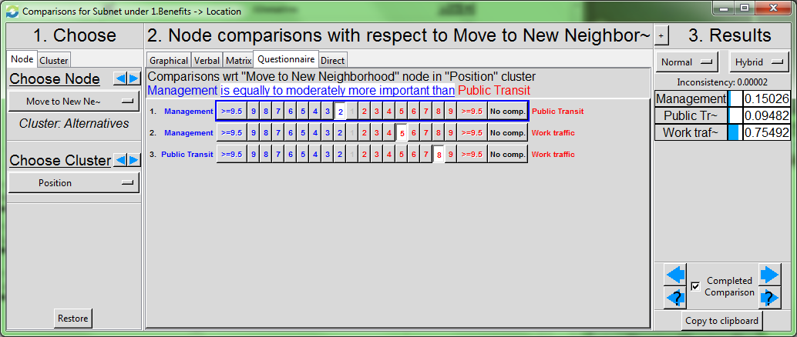

Here you can see some of my Node Comparisons for the Alternative Move to New Neighborhood within the Position cluster. You can see that we decided it is equally to moderately more important that we know the management company is dependable versus very close public transit. Although I discussed earlier that my Partner takes the bus to and from Duquesne University, we also have the possibility of carpooling if his schedule permits for early arrival on campus as a further tradeoff. Aggregate results indicate that my partner and I have rated Work Traffic much higher than knowing Management company or Public Transit.

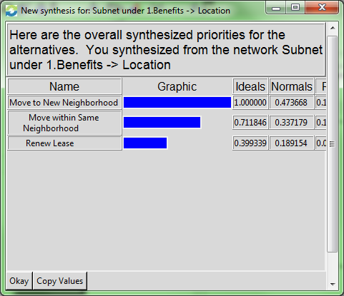

An Overall synthesis of my Benefits-> Location indicate that I should move to a new neighborhood.

Opportunities
The Opportunities control criteria examined all four Subnets and were assumed to refer to opportunities realized in a long term time frame. The Safety subnet examined clusters indicating Environmental and Internal nodes such as meeting new neighbors, realizing extra space in hallways for bicycle or grill storage, an improved electrical or structural conditions, and parking lot safety. The Location subnet examined Conveniences such as proximity to parks and safe biking areas and Commute opportunities such as new road discovery and Lessened Traffic. Financial Obligation subnet examined additional Responsibilities such as Inclusive Bills and Parking Pass and New Costs like building fees (an opportunity because it could lead to heightened building security). The Efforts Subnet examined clusters of Physical and Decision Making. My partner and I felt that expended Effort on Physical Packing and Organizing is viewed as a double win because of the Opportunity to exercise and organize and clean house simultaneously.

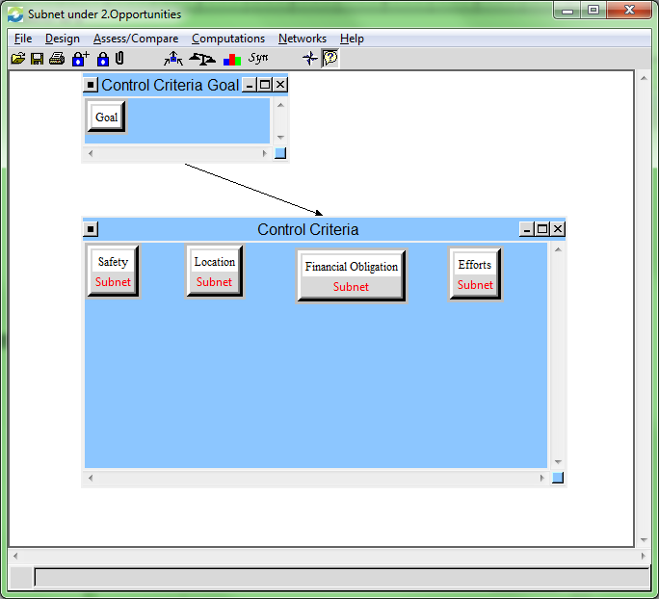

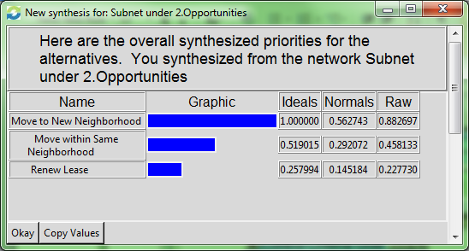

From the synthesized results Subnet of Opportunities indicate that moving to a New Neighborhood would provide the most opportunities at 56% in the long run. Moving within the Same Neighborhood would also produce some additional opportunities at 29% and Renewing my current lease would produce the fewest at only 14%.

Costs
The Costs Control Criteria Subnets include examination of Financial Obligation and Efforts. Under Financial Obligation I examined Move in Costs such as Renter’s Insurance, Security Deposit and moving costs and Monthly costs such as All Inclusive Bills and Parking Permits. Under the Efforts Subnet, I examined the many Time Requirements such as Searching Vacancies, Viewing Vacancies, and Decision Making that cost me time.

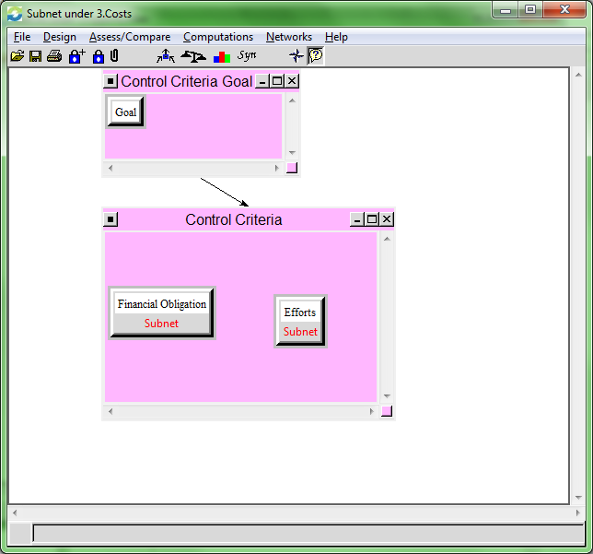

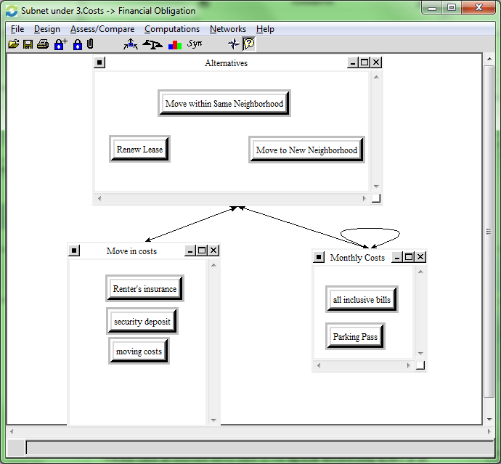

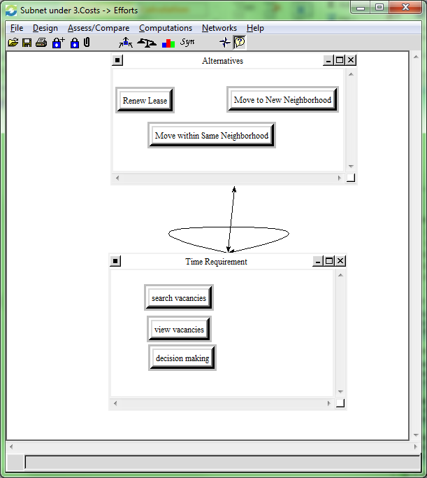

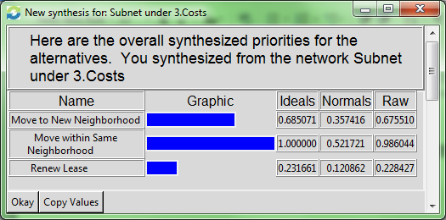

The Synthesis for Costs indicates that Moving within the same neighborhood (with pricey real estate and yet having to exert the time and effort associated with finding a new apartment) will cost me the most at 52%. Moving to another neighborhood will still cost considerably at 36% and Renew Lease will be the lowest cost at 12%.

Risks
The Risks Control Criteria examined Safety, Financial Obligation, and Efforts as Strategic Criteria. The Safety Subnet examined Environmental criteria such as Neighbors and Proximity to Crime as well as Internal (building) risks such as lack of Deadbolts, Window Latches, etc. The Financial Subnet examined Potential Pain/Suffering of having to deal with repairs, loss of valuables and Potential Financial Losses such as Security Deposit, Pet Deposit, etc. The Efforts subnet examined Decision Making risks such as Wasted Time and Scams and Labor Efforts risks such as Packing and Moving
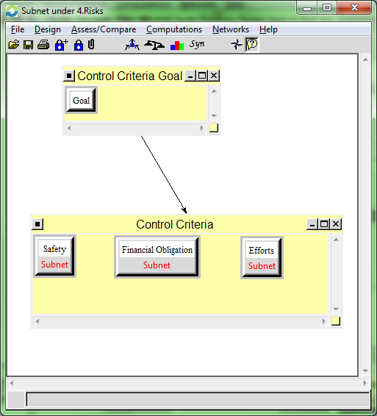

RATINGS
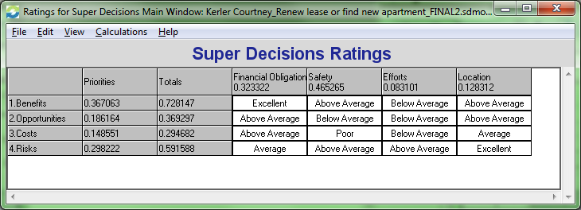

RESULTS
Benefits Synthesis
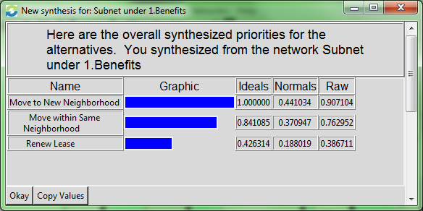

Opportunities Synthesis
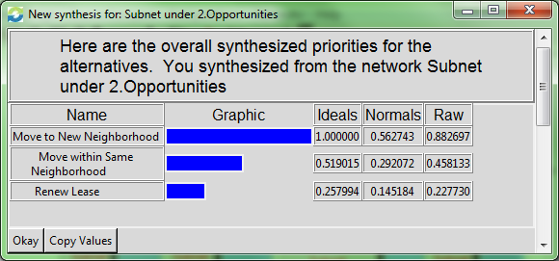

Costs Synthesis
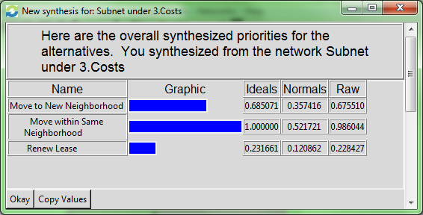

Risks Synthesis
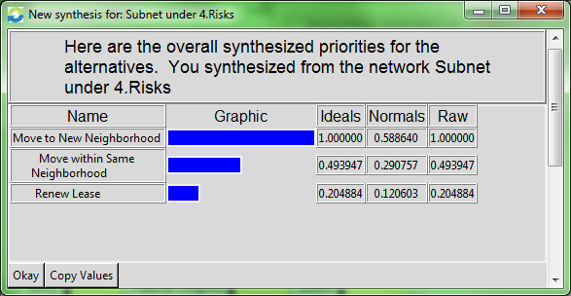

Whole Model Synthesis
Short Term Multiplicative Synthesis
As you can see the Short Term Multiplicative Synthesis indicates that Move to New Neighborhood. This seems normal because my results for Benefits, Opportunities and Risks all indicated the highest rating for Move to New Neighborhood. You can also see that all of them are great alternatives and is a very close race at 38% vs 35% vs 27%.
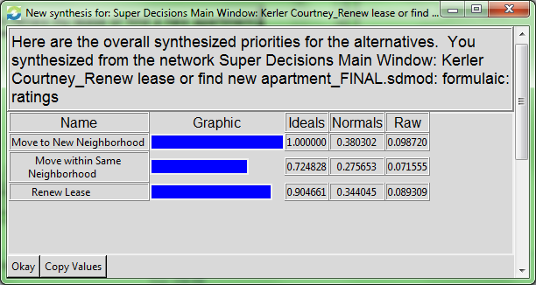

Long Term Additive Synthesis
As you can see, with the Long Term Synthesis, however, the priorities shift to indicate Renewing my Lease is best in the long term. I imagine this is because of the priorities of wasted time on searching for, setting appointments, and viewing apartments versus keeping my valuable time.

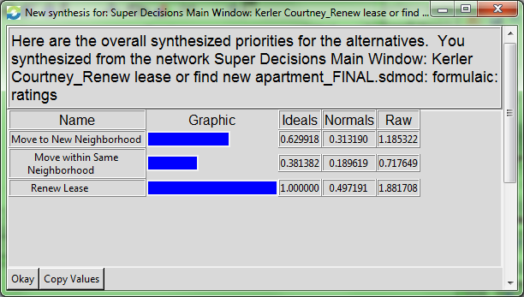

SENSITIVITY ANALYSIS

Benefits
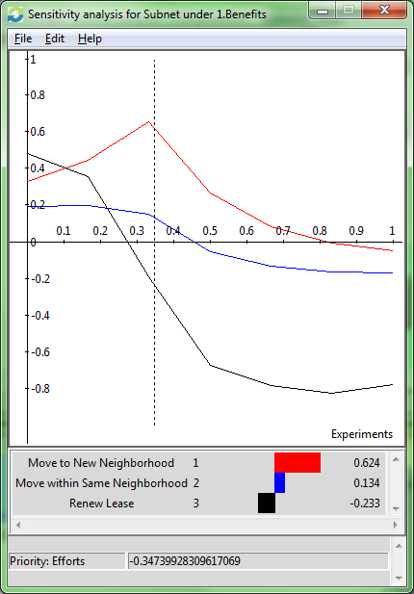

Opportunities
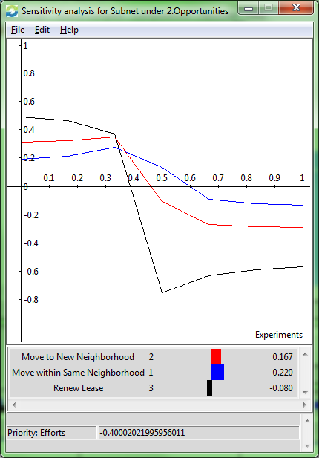

Costs
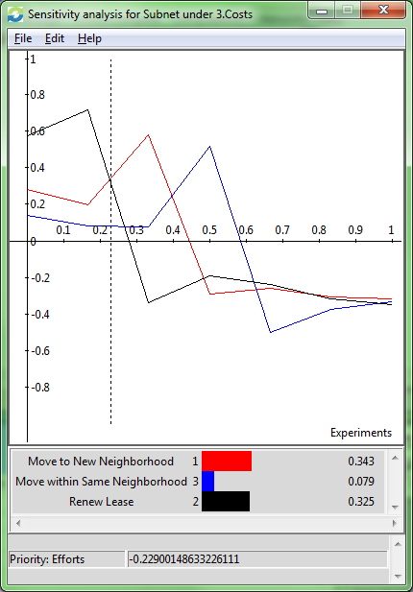

Risks
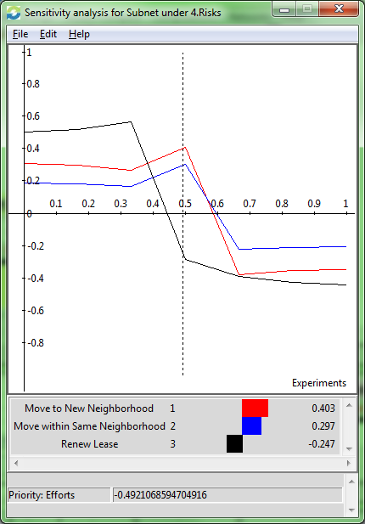

CONCLUSION
When analyzing the final goal section, both of the moving options seem to have very similar costs and risks sensitivities, as expected. A higher emphasis on Costs and Opportunities show that Move within Same Neighborhood would’ve prevailed as the best choice. However, as we can see, the overall emphasis on Benefits and Risks (as seen in the Super Decision Ratings above) and emphasis on Financial Obligation within all of the Subnets, has lead to the final best decision being…..

Move to New Neighborhood (Short term decision)!!!!


