Sarah Topper 3/5/2019
Assignment M2:C Relative Model of Personal Decision
Using the countertop decision from my personal decision summary, I built a relative model around the problem. My goal was to select the best countertop material. Criteria included cost, appearance, durability, and maintenance. While cost could in theory be broken down into material cost and installation cost, because butcherblock is the only alternative that has lower installation costs, I opted to roll them together.
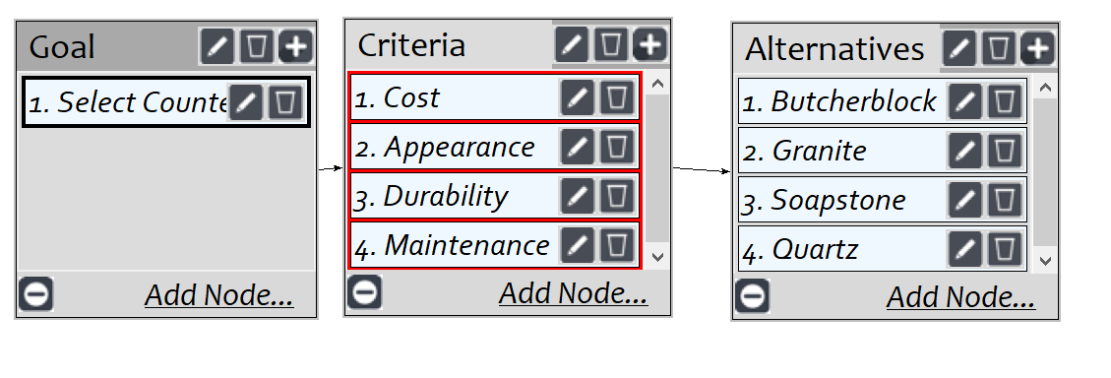
With the network built and connections made, I moved on to judgements for the “Select Countertop goal. The numbers below gave me an inconsistency rating of 0.07, which was acceptable.
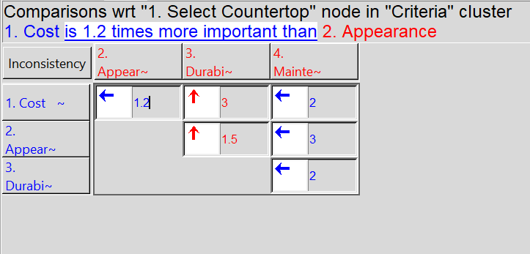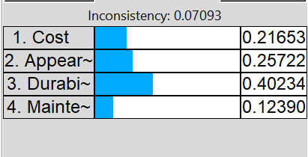
I made cost comparisons. . .
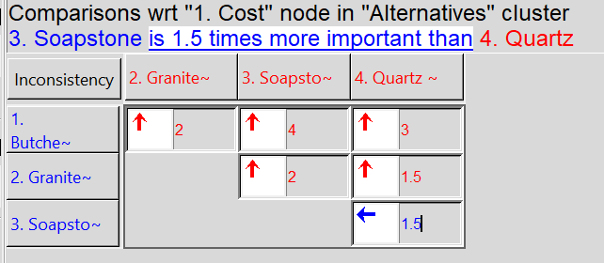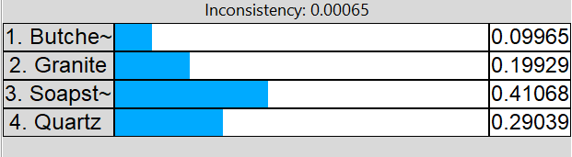

Appearance comparisons. . .
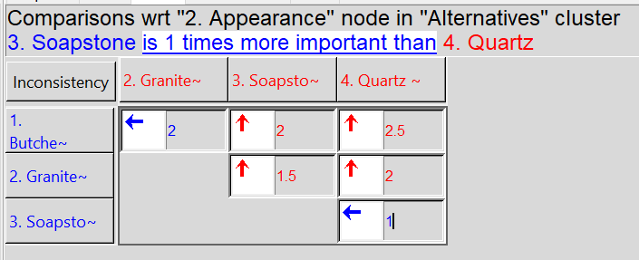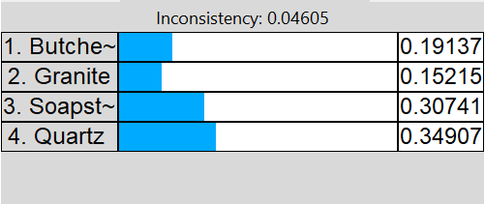
Durability comparisons. . .
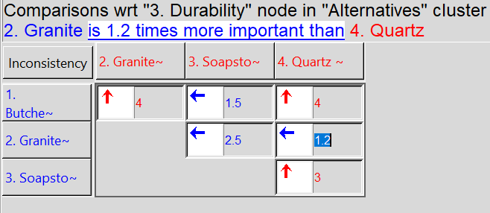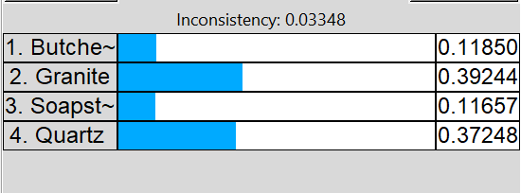
. . . and maintenance comparisons. For this item, I selected which was easier to maintain.
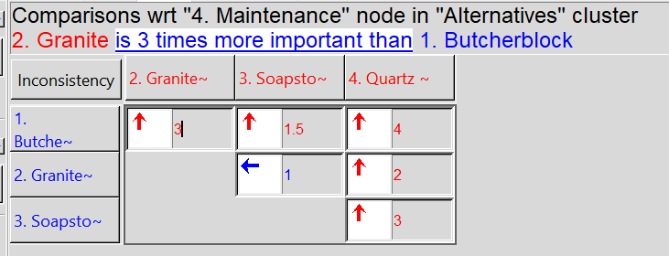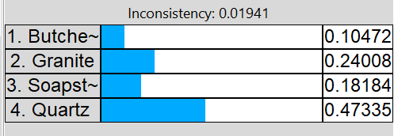
The results were not unexpected based on my previous thoughts on countertop materials. My first preference would be quartz, followed by granite, then soapstone, and finally butcher block.
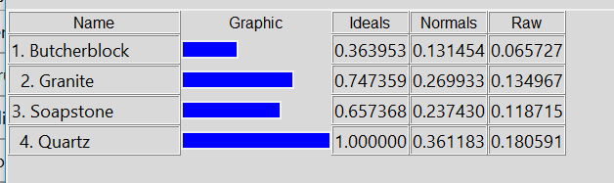

3/19/19
To convert to a ratings model, I first deleted the “Alternatives’ cluster from the network. I added a “Durability” cluster to incorporate three durability nodes, which I connected to the “Durability” criteria.
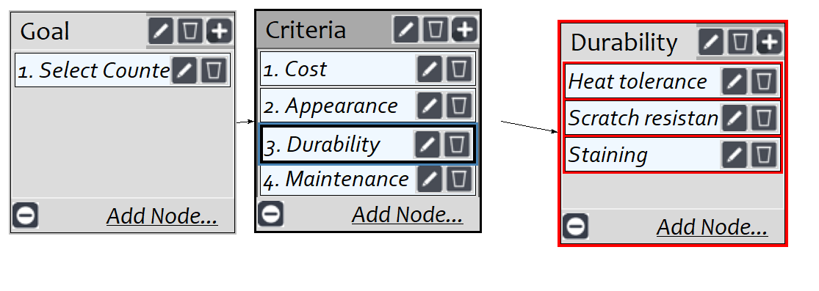
Under the “Judgments” tab, I made comparisons related to the new Durability criteria:
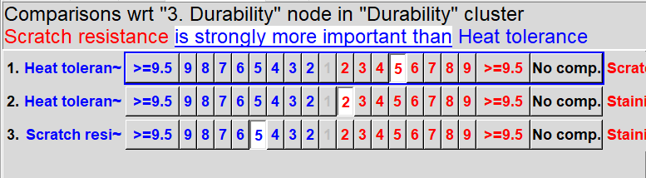
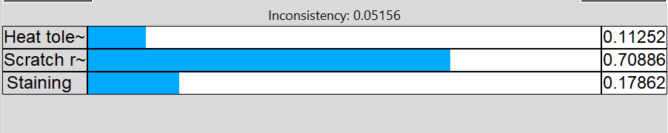
I really don’t want the countertops to scratch easily.

While I had judgements entered previously in the “select countertops” criteria, I double checked them and updated them to verify that by “maintenance” I meant “ease of maintenance.”
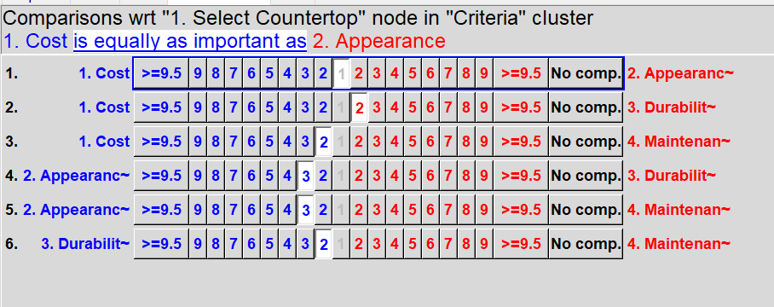
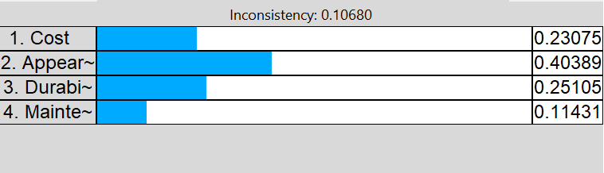
Under the “Ratings” tab, I selected my six bottom-level criteria:
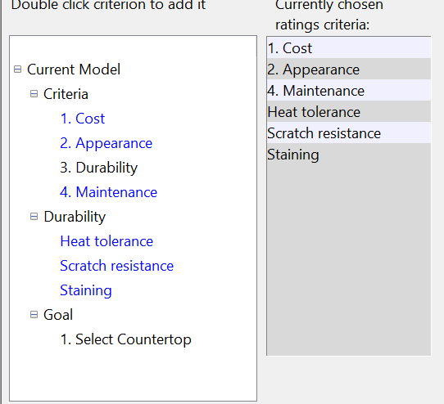

Then I added my four countertop alternatives. . .
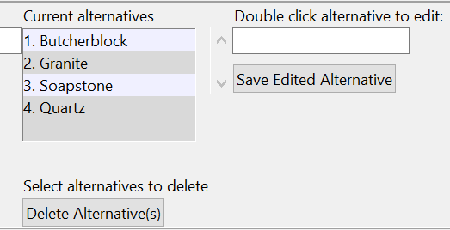
. . . and added scales for the criteria. For “Cost” I used numeric values and ranked them, with low cost being preferred to high cost.
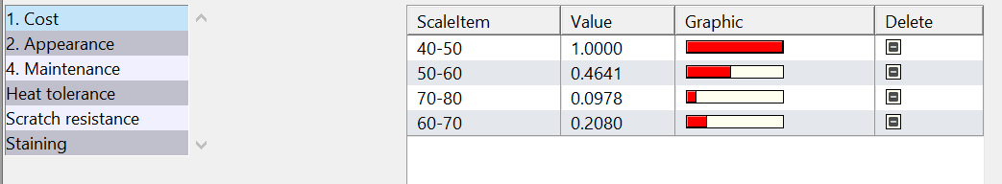
I assigned an excellent to poor scale to “Appearance”
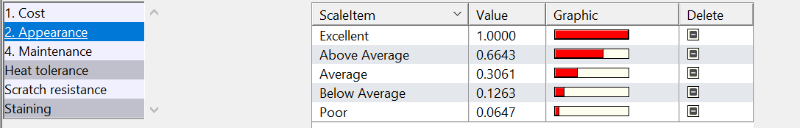
All other criteria were assigned a Hi/Med/Lo scale
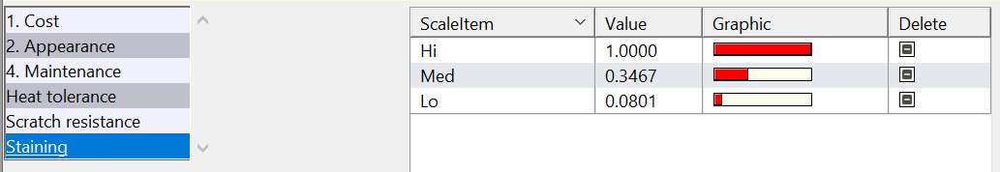
I moved to the Ratings table and assigned ratings to each alternative based on the criteria:
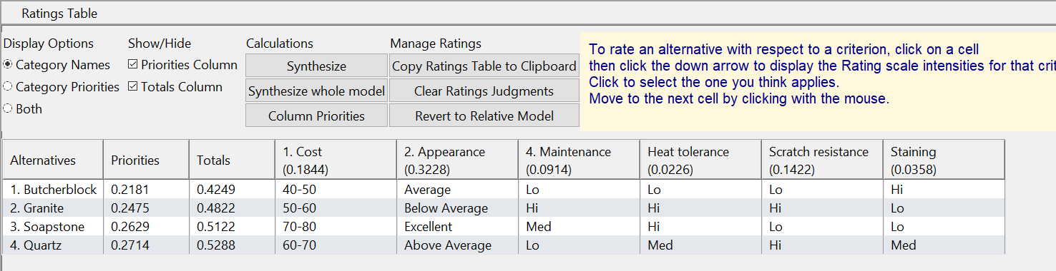
When that was completed, I synthesized the calculations and obtained the following results:
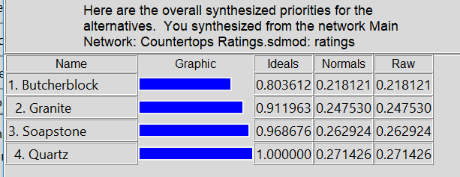
This confirmed my previous AHP model that quartz was preferred, though not by a wide margin.

ANP Model
To create an ANP model, I returned to the original AHP model and deleted the “Goal” node, then made connections between all alternatives and each criteria.
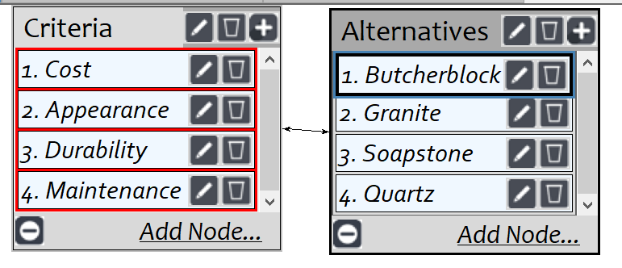
Under the “Judgements” tab, I made comparisons for each alterative, verifying that the inconsistencies were below 0.10 for each.

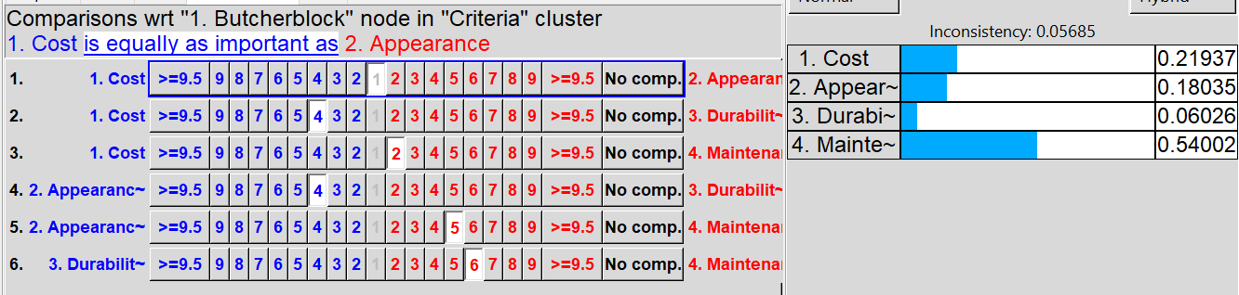
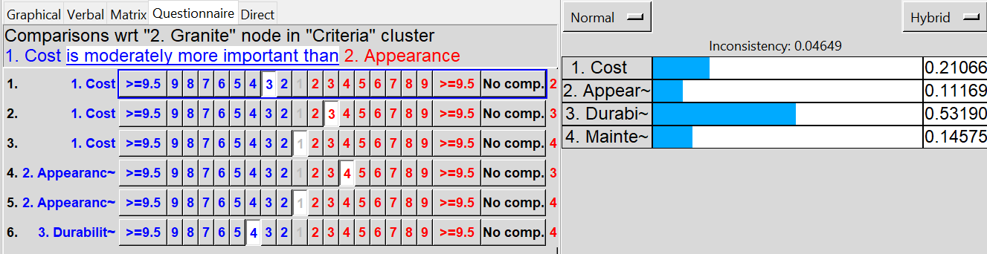
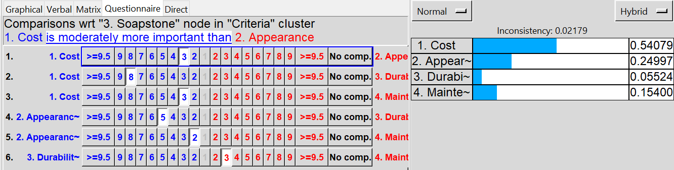
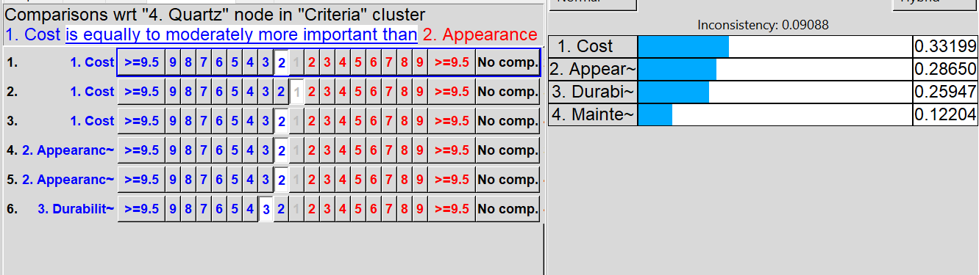
When I synthesized the model, I received the following results:
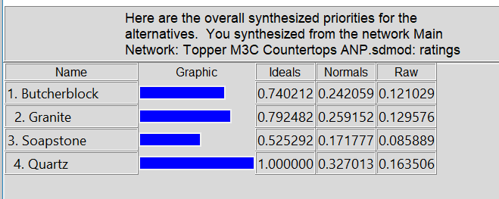
I found it interesting that in this case, while Quartz is still the frontrunner, Soapstone is the last choice rather than the 2nd.
I went back and reviewed the criteria node and saw that I’d been inconsistent in my comparisons. For example, while I rated soapstone as having a highest cost when entering judgements for soapstone, I had the judgements related to cost reversed later.
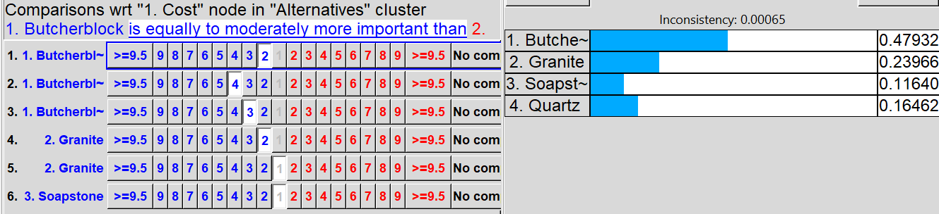
I reversed the cost ratings and checked the other criteria. The others still appeared correct. Resynthesizing the model gave:
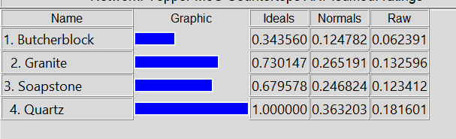
This still differed from the ratings model, but made more sense given what I know about the various materials and aligned with the results from the AHP model.
Checking the sensitivity model for cost, it showed soapstone becoming more preferred as cost sensitivity increased, which is the opposite of what I would expect.
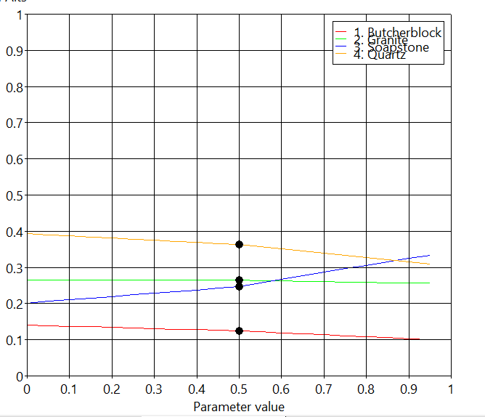
Other criteria follow a more expected sensitivity analysis. For example, durability:
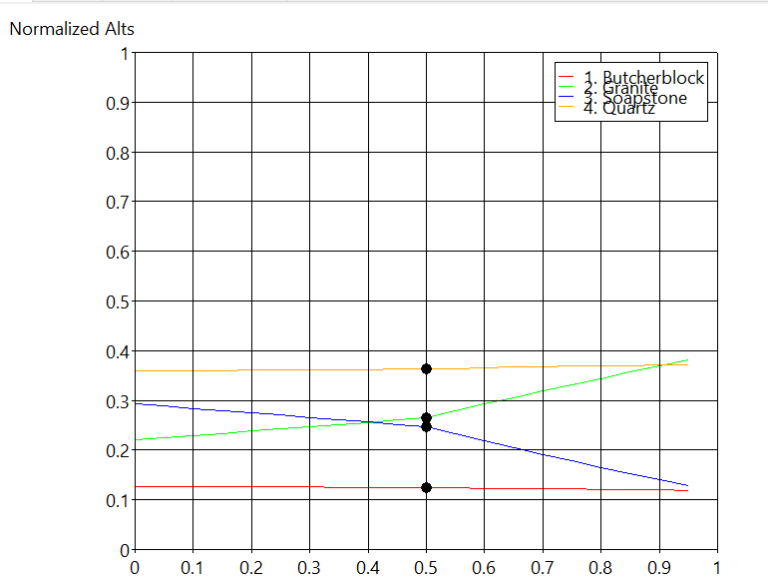

In comparing the different models for this particular decision, I found the ratings model to be the most intuitive to build and use. There is a limited list of alternatives, and I found it easier to rank the criteria based on scales rather than make direct comparisons of each criteria to the other. The greatest difficulty I have is in making the judgements – it is necessary to be internally consistent in saying, for example, that the absolute cost of a material is high, and that the high cost of the material is more important than the durability of the material. I recognize that in more complex systems where factors are influencing each other in complex ways, a network diagram will be more accurate and useful.

