Evan Fitzpatrick
Decision-Making in a Complex Environment
Assignment 2C: Personal Decision with SuperDecisions Software
Problem: Around my residence in the Shadyside/East Liberty area, there are several choices to grocery shop. I have been to all the various locations over the last couple of years, but have not quantified, based on my own criteria, which grocery store is the best to go to. The number of choices is a good problem to have.
Alternative Solutions Trader Joe’s, Target, Whole Foods, Aldi, Giant Eagle
Decision Criteria:
- Cost
- Quality
- Variety/Selection
- Parking
- Store Design
- Distance
The following screenshots outlay the problem, criteria, and alternatives solutions using the SuperDecisions software.
Weights of criteria. As shown below weights of the criteria reside substantially with cost. Some of the criteria have relatively miniscule weights but still factor into the decision.
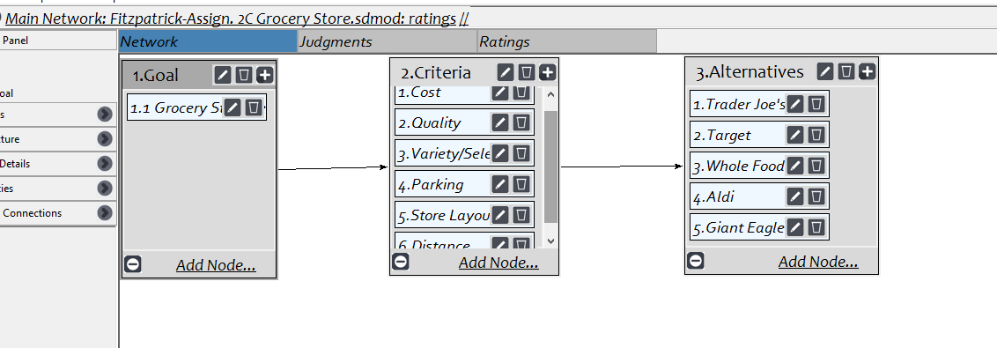
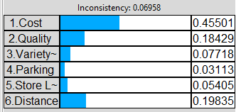
The subjective pairwise comparisons of the criteria are below.
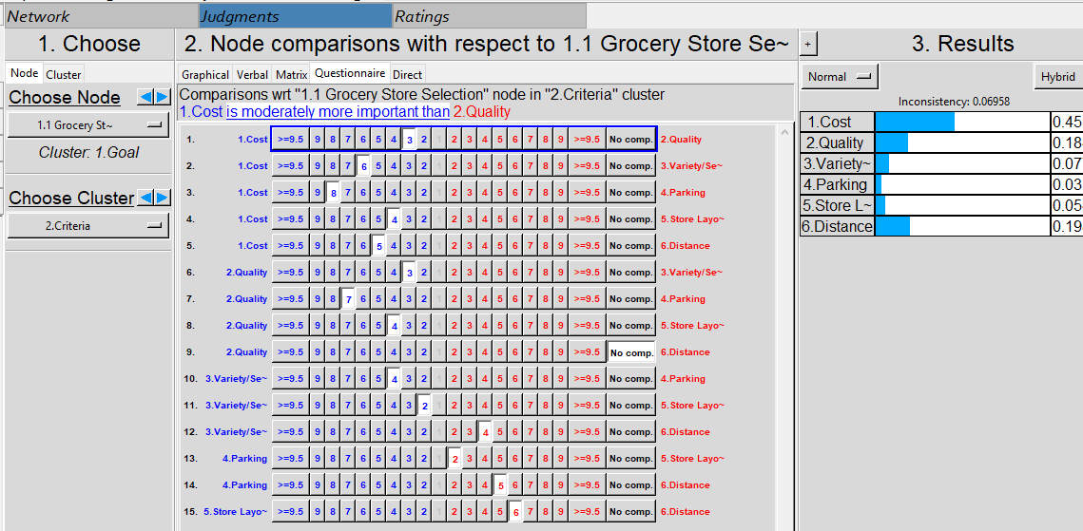

The subjective pairwise comparisons between the alternative solutions based on the criteria are below.
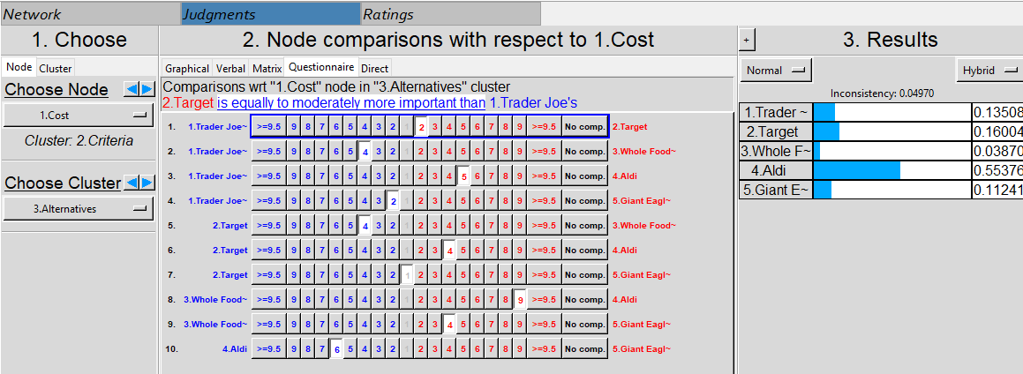
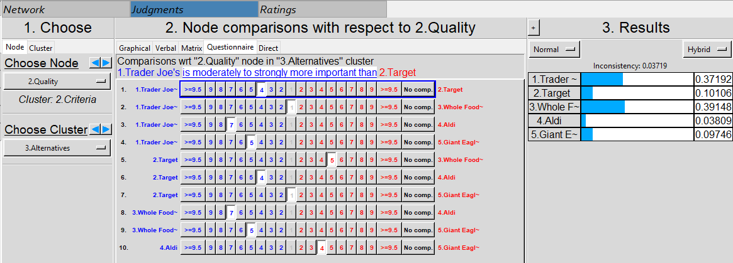
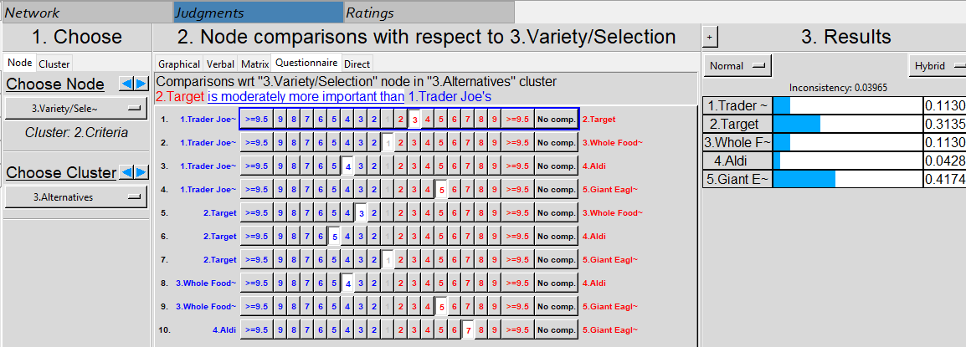
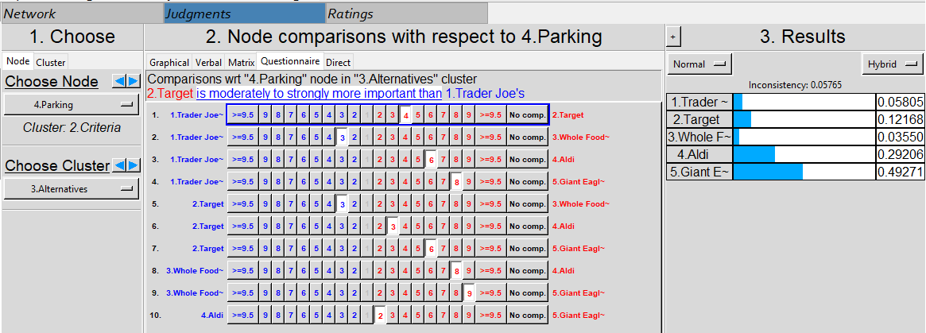
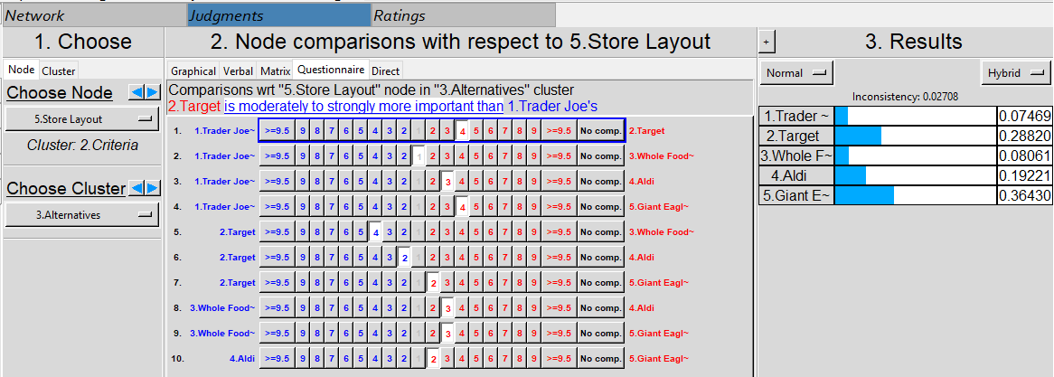
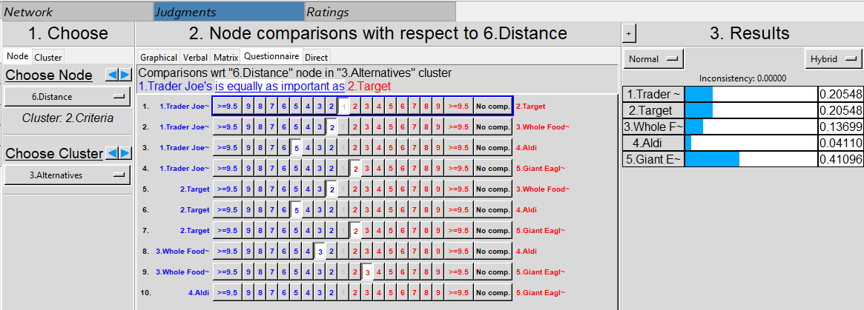
While not zero, the inconsistencies are reasonable to move forward with synthesizing the results.
Based on the pairwise inputs, the following results have been synthesized.
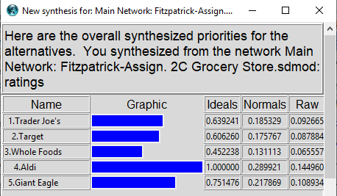

Sensitivity: Since cost had substantially the greatest impact on the decision, sensitivity analysis will be conducted to understand what weight of cost would garner a different outcome.
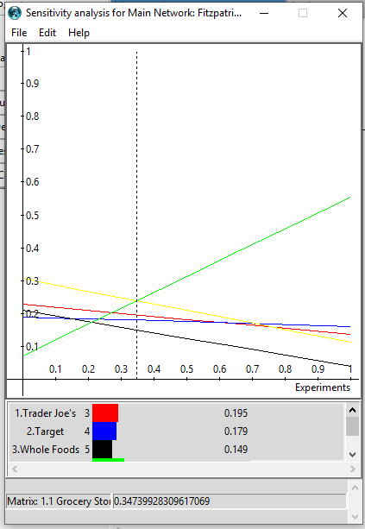
All other criteria equal, a decrease in the weight in cost of 35% would garner a different outcome in the decision. Perhaps this is a result of paying MBA tuition, and in the future may be less of a concern and place a greater weight on some of the other criteria (i.e. quality, selection). The remaining criteria require substantial increases in their importance to influence the decision outcome, but potentially cost would transfer all of its forfeited weight directly to quality or selection as stated above to bridge that gap.
Solution: Grocery shop at Aldi but monitor changing tastes due to financial situation that may impact the outcome. Perhaps there are other influences and values associated with this decision, since recently I have been shopping more frequently at Trader Joe’s, although my criteria above points to Aldi.
Assignment 3B: Conversion to Ratings Model
In order to translate the relative AHP model into a rating model, I removed the alternatives cluster from the model and created further sub-criteria for some of the criteria that can be further broken down into more specific influences as shown below.
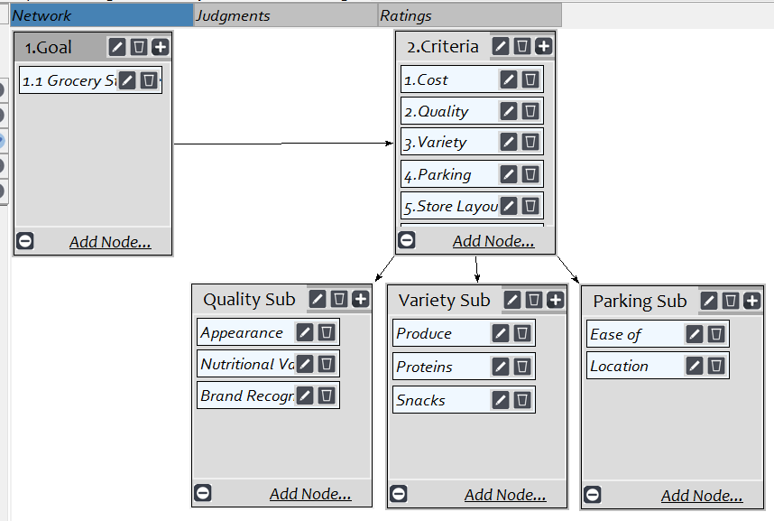
Each of the applicable criteria were then linked to the sub-criteria and each of the sub-criteria were then pairwise compared with the other sub-criteria in its respective node (i.e. Produce vs. Proteins vs. Snacks) under the “judgments” tab. An example is below.
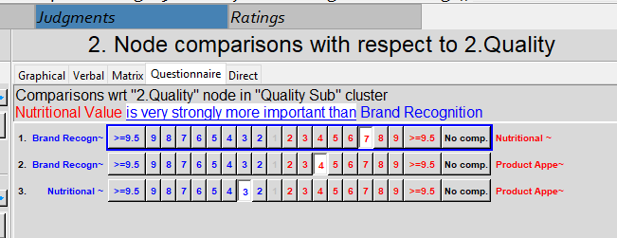
The “Ratings” tab is then utilized to choose the appropriate criteria and sub-criteria. Since Quality, Variety, and Parking have further sub-criteria, those sub-criteria are added to the ratings model. Cost, Store Layout, and Distance are not further expanded into sub-criteria, so they are included in the ratings model.
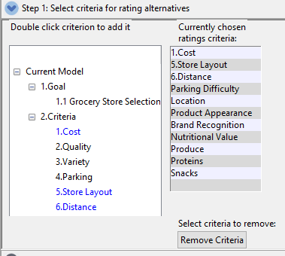
The five alternatives from the AHP model are then added as the alternatives for the ratings model.
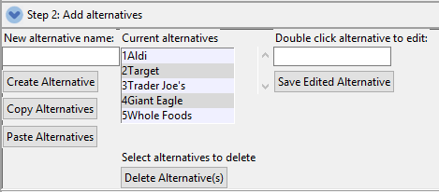
Each of the appropriate criteria and sub-criteria chosen is then assigned a ratings scale. Some are based on direct values, while others are based on 3-5 scale items. An example of each is below, wherein the scale ratings chosen are then pairwise compared to determine the relative importance of each. The highest rating receives a score of 1.000 decreasing towards zero by level of relative importance.

Example: Cost rankings (Preference in reverse order: Expensive, Above Average, Average, Below Average, Cheap)
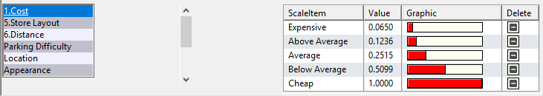
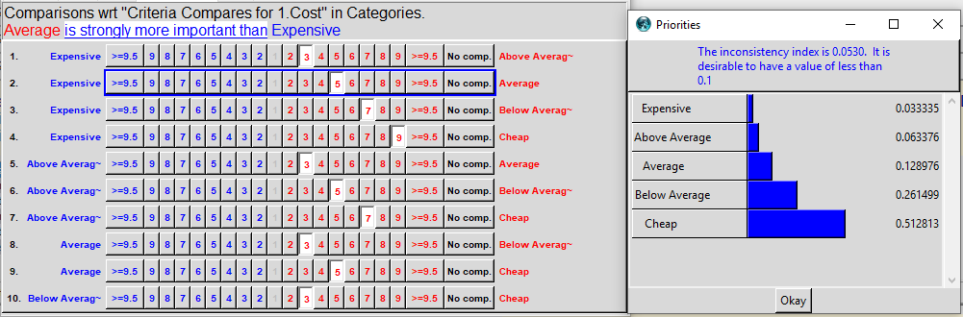
Example: Store Layout rankings (Excellent, Above Average, Average, Below Average, Poor)
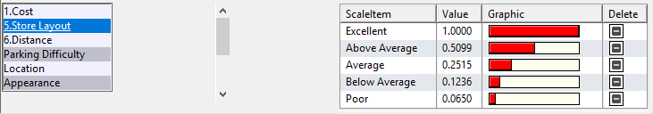
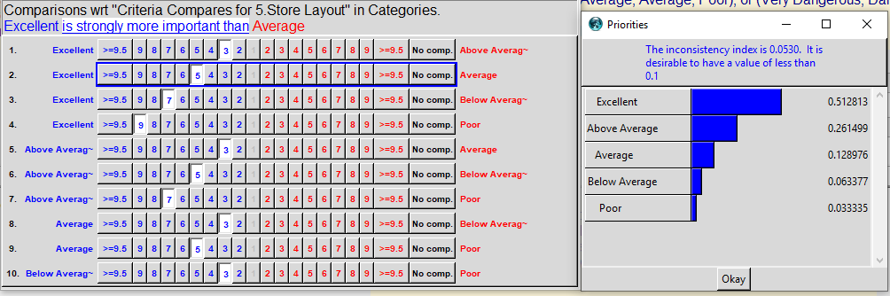
Example: Distance from store (Numerical ranges – 0.25 miles or less, 0.26-0.50, 0.50 or greater)
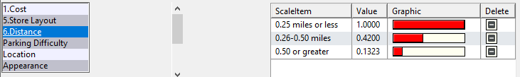

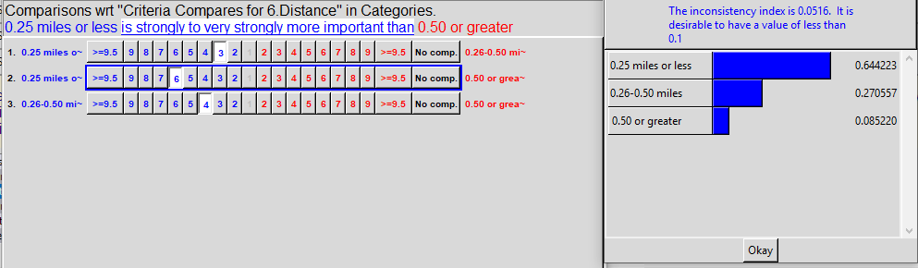

Now that the relative importance of the scale ratings is determined, the ratings scale for each alternative is matched up with each criterion in a matrix table subjectively. The completed table is below. At first glance, cost once again appears to be the greatest driver, with distance and nutritional value following.
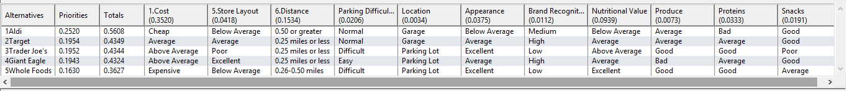
Synthesis: Based on the ratings above, the synthesized model once again points to Aldi as the preferred alternative. In this scenario, Target, Trader Joe’s, and Giant Eagle are practically identical alternatives. This is useful to keep in mind considering that Aldi is the only alternative which requires driving to the location.
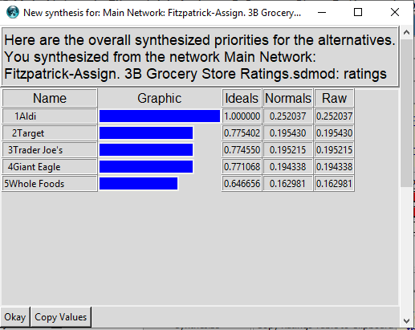

Comparison of AHP and Ratings Model: Pulling in the results of the AHP model below beside the ratings model results, Aldi is convincingly the chosen alternative. The importance of cost in the models in the first indication that this makes sense, with several other criteria that are relatively miniscule.
The AHP model provides more stark differences between the alternatives than the Ratings model. It is important to consider all the alternatives in this model because this is the choice on average given the importance of the criteria. The criteria themselves tend to change in any given situation (i.e. cooking for guests, dieting, availability of a vehicle). In either model, none of the alternatives are “no-go” if necessary, as their ideal value is reasonable comparable to Aldi. For the Ratings model, the cost rating for Aldi was “cheap”, but all other alternatives were “average” and above.

Assignment 3C – ANP Model Conversion and Comparison
The original AHP model will be converted to an ANP model below. The goal node is removed initially as displayed below.
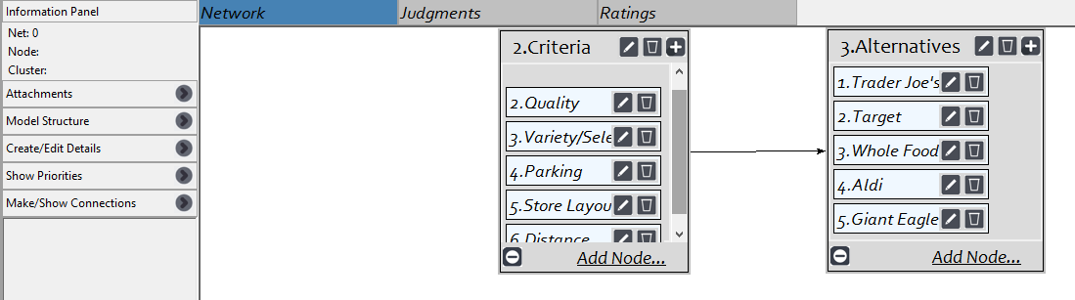
From there, each criterion is already individually linked to each alternative. Each alternative must also be linked to each criterion for feedback, as demonstrated below for “Quality”. Some of the criteria are also influenced by each other (Cost & Quality / Parking & Store Layout)
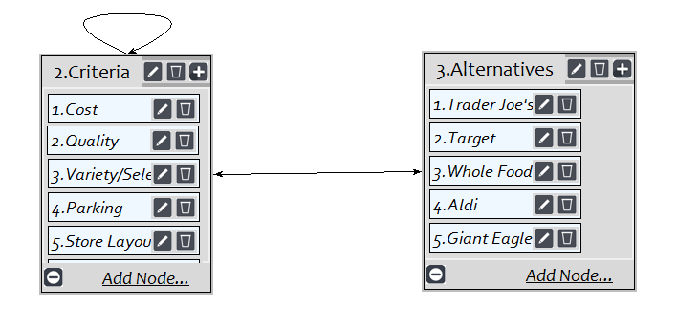
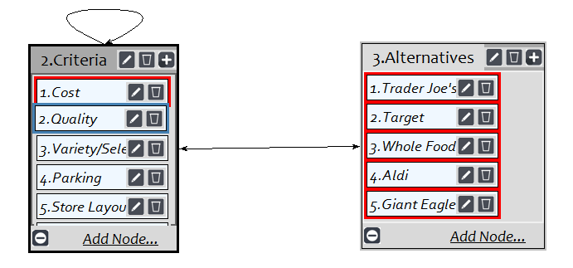
These links allow for a pairwise comparison of the criteria for each of the alternatives. An example is below.
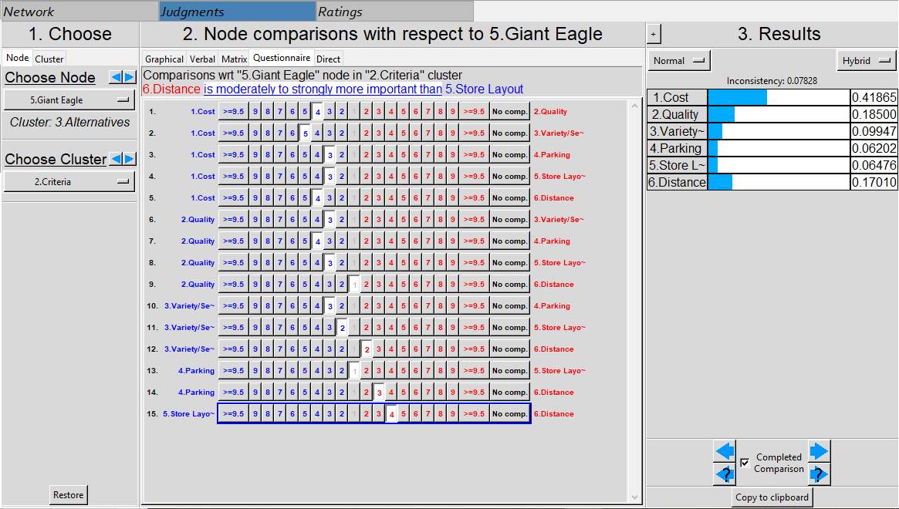
Synthesize: The values below provide a differing explanation to the AHP model and the Ratings model, with Giant Eagle being the preferred alternative. In this model, Aldi was the least preferred alternative.
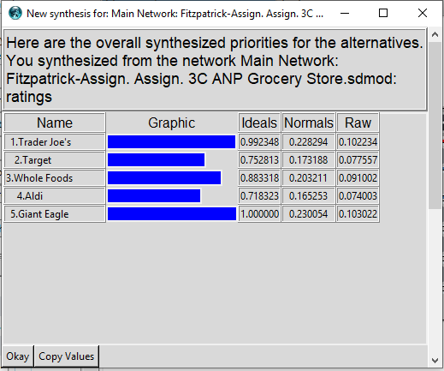
Comparing the three methods: The normalized values for each of the three methods are compared in the table below. The most interesting point in comparing the three models is that the ANP model generally reflected the other two methods before accounting for the influences between the criteria themselves. The connection between cost and quality had a substantial impact in altering the results. I can attribute this change to the idea that the two are directly correlated. One may be cost-conscious as displayed in the models but may be willing to pay for a corresponding increase in quality.
For how I approach this decision in everyday life, the ANP model appears to provide the results that best mirror my decision. I certainly enjoy the cost benefits of Aldi, but that typically requires more planning, and the convenience and quality of the other alternatives such as Giant Eagle and Trader Joe’s is what typically draws me there in the moment. Understanding the influences and feedback between the alternatives and criteria provided a more accurate depiction of the typical choices. It is worth noting again that a slight change in priorities based on certain situations could easily tip the scale to another alternative as they comparably close for the Ratings model and ANP.
 | AHP | Ratings | ANP
Trader Joe’s | 0.185329 | 0.195215 | 0.228294
Target | 0.175767 | 0.195430 | 0.173188
Whole Foods | 0.131113 | 0.162981 | 0.203211
Aldi | 0.289921 | 0.252037 | 0.165253
Giant Eagle | 0.217869 | 0.194338 | 0.230054

Sensitivity for ANP: Depiction of how close the alternatives are for cost and quality, which were the most impactful criteria. The sensitivity analysis is particularly useful because choosing a grocery store is an incremental, constant decision to make, unlike one-time purchases (i.e. buying a car), so sensitivity of the criteria may change frequently.
Cost:
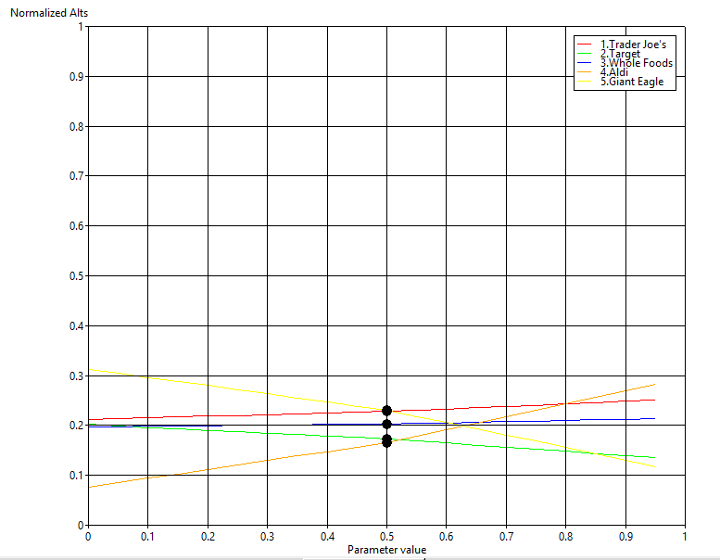
Quality:
