The personal choice I made was where to go on vacation. For this exercise, I considered 4 options that all appeal to me. The first option was a trip to Ocean City, the second a cruise, the third was an all-inclusive in the Caribbean and finally a trip overseas to Europe.
The criteria I evaluated the options on were Price, Travel, Entertainment, Relaxation, and Accommodations. The price evaluation looked at what I felt the overall price of the trip would be. The travel had two components to it, the first was the travel arrangements to get to the location and the second was the ability to move around once there. Entertainment was evaluated on the opportunity to find activities that would be interesting. The overseas trip has the highest entertainment value, while the all-inclusive / ocean city had the lowest entertainment options. The next criterion was the ability for the vacation to be relaxing compared to the others. I like to have a good balance between things to do and being able to relax. Finally, the accommodations of food and shelter were considered. This looked at food options, housing options, etc. while on the trip. The All-inclusive scored the best and the cruise scored the worst. The trip overseas and Ocean City were in the middle because I would expect accommodations there to be comparable.
AHP:
The original methodology used to evaluate this decision was an AHP model. The data was entered into SuperDecisions. The decision structure and the master matrix are shown below for the inputs. Once all the information was entered, the model was evaluated. Synthesizing the data, the trip to Ocean City ended up being the preferred choice.
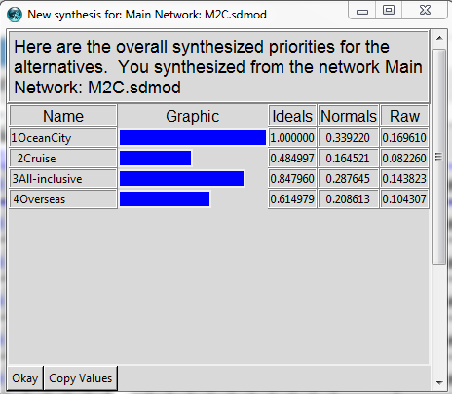

Ratings:
Looking at the decision a second time, a ratings model was used. In this scenario, the process model is simplified because the alternatives are not part of the process model, but each alternative is provided a rating. The process model and the rating matrix are shown in the appendix for review. Once the ratings were all entered, the model was synthesized providing the results below.
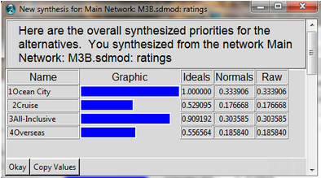
A point of note about the ratings model is that while they are good for making large comparisons, the details provided are limited by the rating models used. A rating scale with more options provides additional accuracy, but also takes more time to input and to evaluate differences. It is accuracy vs. speed tradeoff.
ANP:
Finally, the problem was evaluated again using an ANP model. In this structure, the goal cluster is removed and the process diagram updated to have the alternatives all feedback into the criteria. The updated process diagram is provided at the end of this document. Once the updated structure is completed, a comparison of each alternative and their criteria is provided. A sample comparison of the overseas alternative with respect to the criteria is also provided below. Once all the alternatives are entered, the model was synthesized providing these results:
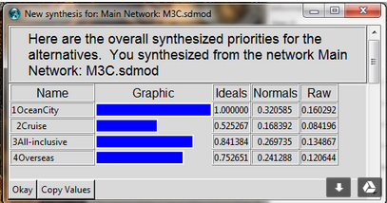
Comparison:
In review of the methodologies and the comparisons provided, the ranking has remained consistent for each of the options. It has rated Ocean City as the best option, followed by the All-Inclusive, an Overseas trip and finally rounded out with a Cruise. To go a little further into the evaluation, I compared the normalized data from each of the options which provided the following results:
Normal: | AHP | Ratings | ANP |  | Variation:
Ocean City | 0.33922 | 0.333906 | 0.320585 |  | 0.018635
Cruise | 0.164521 | 0.176668 | 0.168392 |  | 0.012147
All-Inclusive | 0.287645 | 0.303585 | 0.269735 |  | 0.03385
Overseas | 0.208613 | 0.18584 | 0.241288 |  | 0.055448

The evaluation is interesting because it mimics what the data above indicated; the cruise and the trip to Ocean City are firmly in the top and the bottom. The variation is around 5% of the normalized values, the All-inclusive and the overseas trip are not as hard set, seeing variation of up to 25% of the normalized values. (Note percentage based upon: variation / Max[Normalized Value]) This indicates that the methodology for these two may not have been as stable as the selections for the Ocean City and Cruise options. These values should be evaluated further to ensure that the ratings were valid and that assumptions made were correct.
The exercise was interesting because it demonstrated the differences in the methodologies and provided feedback regarding how the ratings, AHP and ANP models can all vary based upon the comparisons that were made. This strengthens the impact that it can be utilized in a comparative analysis, but cannot be utilized for an exact number. The scales and the relations are relative in these analyses.

Appendix:
Process Diagram and Master Matrix - AHP
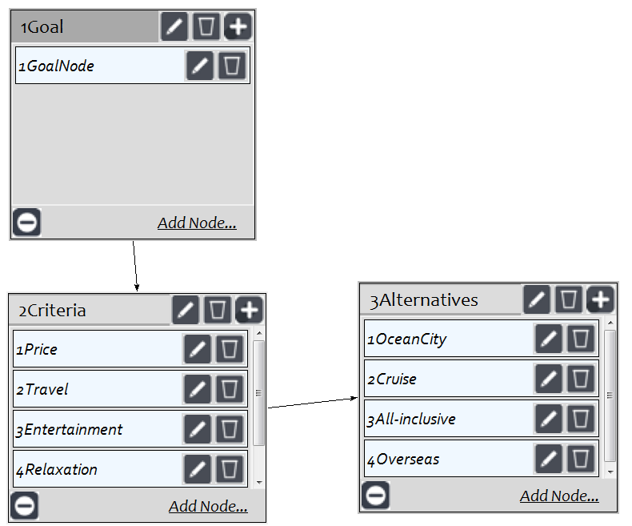

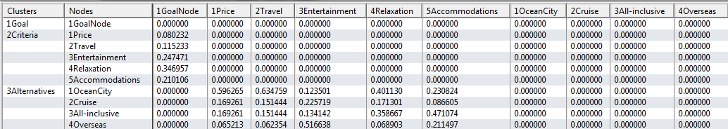

Process Diagram and Ratings Chart
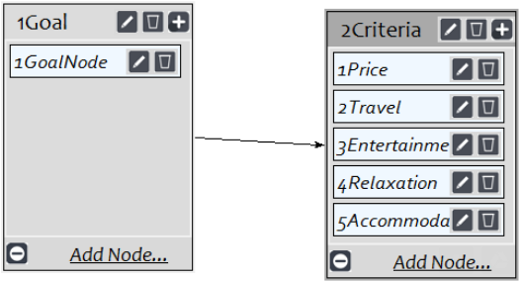
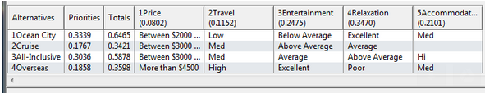

Process Diagram and Comparison Sample – ANP
