Sarah Topper 3/5/2019
Assignment M2:C Relative Model of Personal Decision
Using the countertop decision from my personal decision summary, I built a relative model around the problem. My goal was to select the best countertop material. Criteria included cost, appearance, durability, and maintenance. While cost could in theory be broken down into material cost and installation cost, because butcherblock is the only alternative that has lower installation costs, I opted to roll them together.
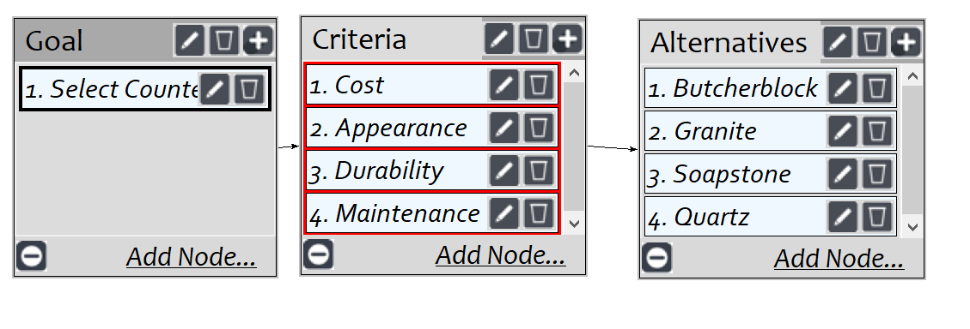
With the network built and connections made, I moved on to judgements for the “Select Countertop goal. The numbers below gave me an inconsistency rating of 0.07, which was acceptable.
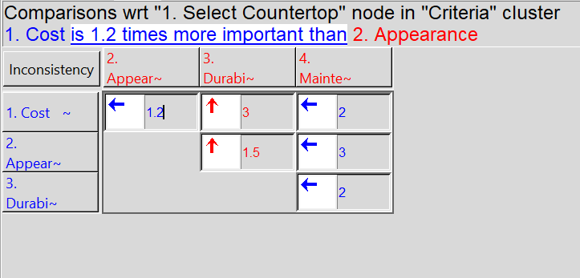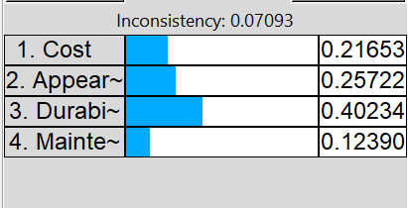
I made cost comparisons. . .
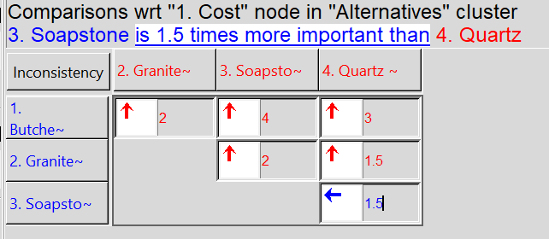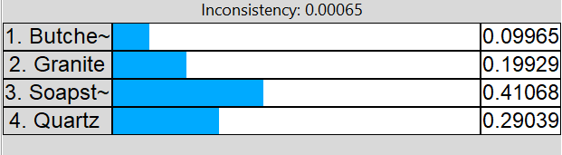

Appearance comparisons. . .
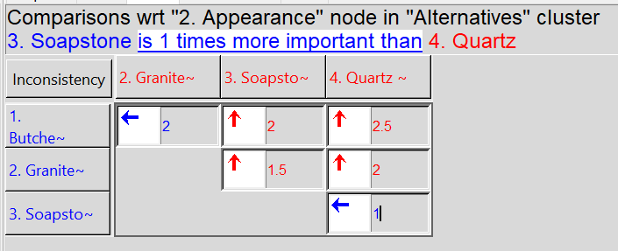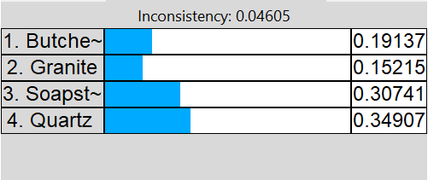
Durability comparisons. . .
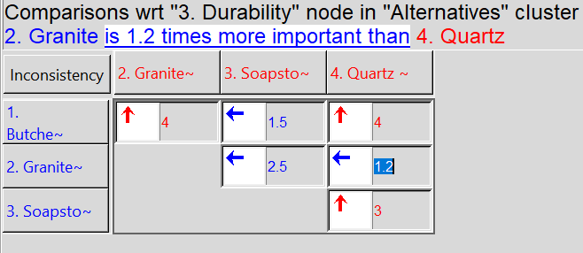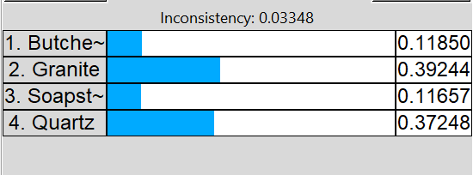
. . . and maintenance comparisons. For this item, I selected which was easier to maintain.
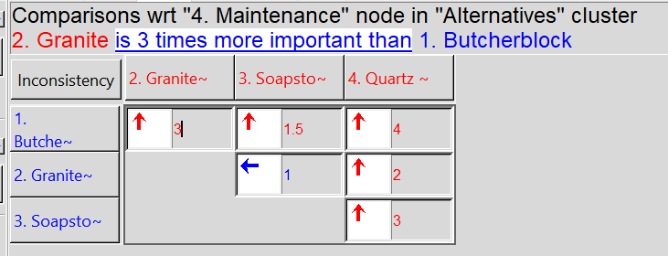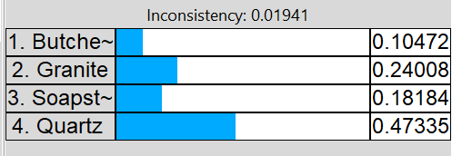
The results were not unexpected based on my previous thoughts on countertop materials. My first preference would be quartz, followed by granite, then soapstone, and finally butcher block.
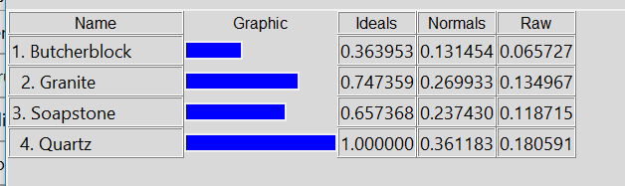

3/19/19
To convert to a ratings model, I first deleted the “Alternatives’ cluster from the network. I added a “Durability” cluster to incorporate three durability nodes, which I connected to the “Durability” criteria.
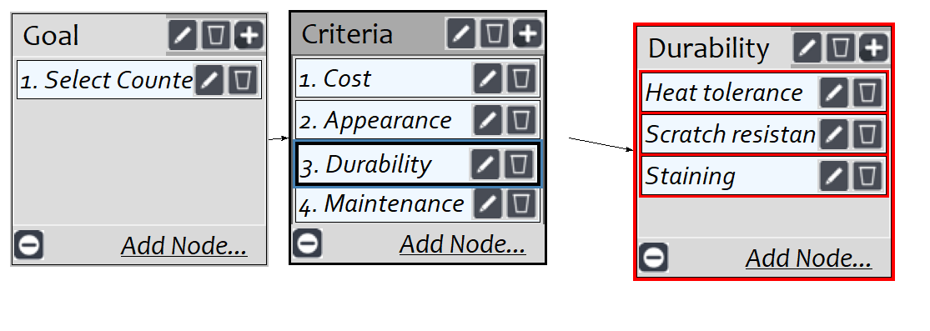
Under the “Judgments” tab, I made comparisons related to the new Durability criteria:
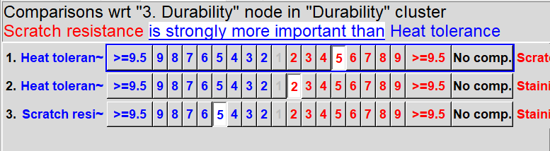
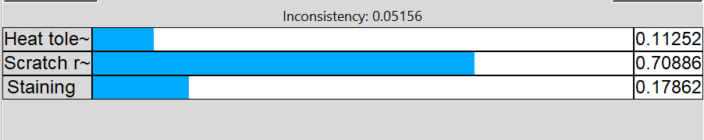
I really don’t want the countertops to scratch easily.

While I had judgements entered previously in the “select countertops” criteria, I double checked them and updated them to verify that by “maintenance” I meant “ease of maintenance.”
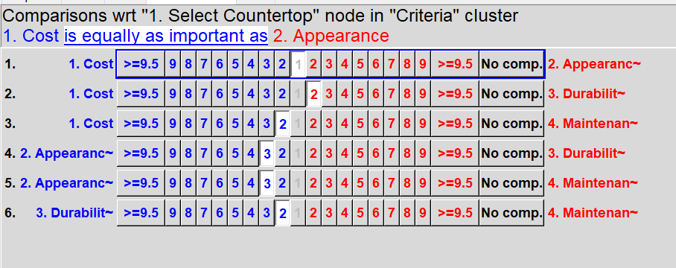
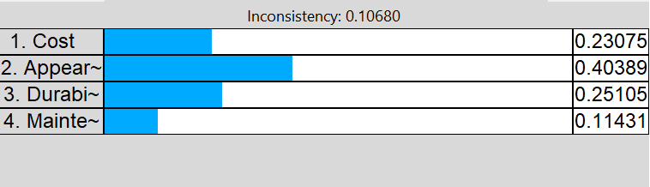
Under the “Ratings” tab, I selected my six bottom-level criteria:
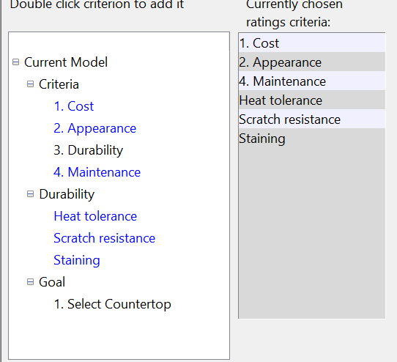

Then I added my four countertop alternatives. . .
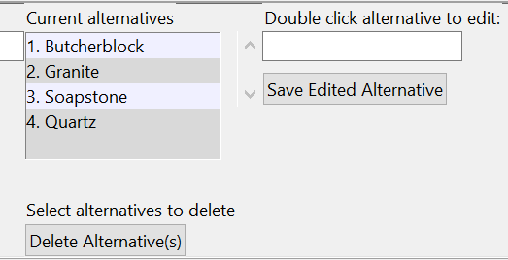
. . . and added scales for the criteria. For “Cost” I used numeric values and ranked them, with low cost being preferred to high cost.
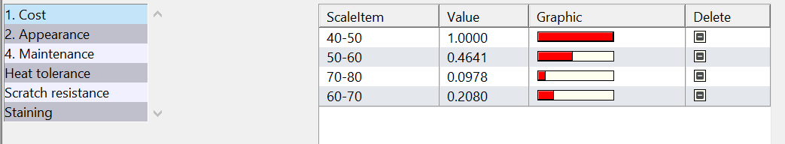
I assigned an excellent to poor scale to “Appearance”
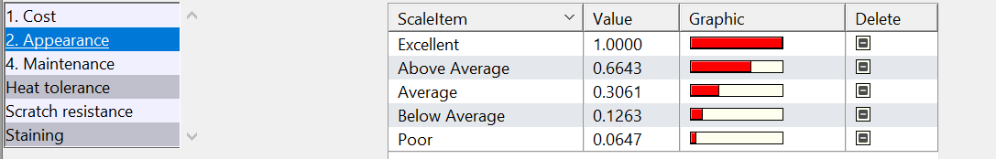
All other criteria were assigned a Hi/Med/Lo scale
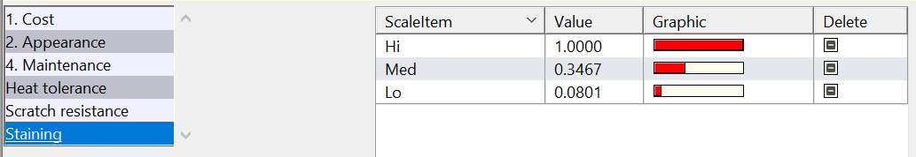
I moved to the Ratings table and assigned ratings to each alternative based on the criteria:
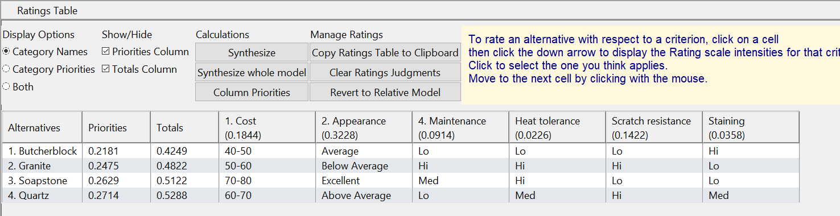
When that was completed, I synthesized the calculations and obtained the following results:
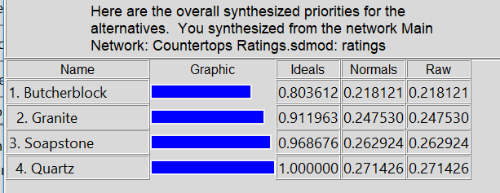
This confirmed my previous AHP model that quartz was preferred, though not by a wide margin.

