Mauriq Hill
Decisions in Complex Environments
Module 2/3

SuperDesions: Graduate School Selection

Clemson University:
- Growth: As a player, but not as an individual
- Soccer: Top 10 team in the country, in best conference for soccer (ACC)
- Cost: Offer 50% Scholarship
- Location: In South Carolina, close to home
- Education: Not a top 50 ranked MBA program
Georgia Southern University:
- Growth: Not as a player, but as an individual
- Soccer: Average college soccer team, not a great conference
- Cost: Full Scholarship
- Location: In Georgia (home state)
- Education: Not a ranked in the top 50 MBA programs (66?)
Radford University:
- Growth: Not as a player, but as an individual
- Soccer: Average college soccer team, not a great conference
- Cost: Full Scholarship
- Location: In Virginia, in rural area
- Education: Top 50 MBA program (46?)
University of Pittsburgh:
- Growth: As a player and as an individual
- Soccer: Average college soccer team, in best conference for soccer (ACC)
- Cost: Full Tuition minus Cost of Attendance
- Location: In Pittsburgh, but in a city
- Education: Top 50 MBA program (36?)

Profile Assumptions:

Relative Model Approach
Hierarchy:

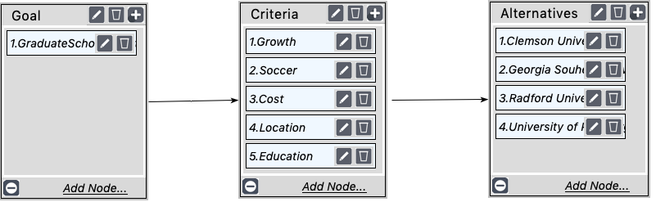

Significances of Criteria

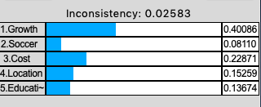

Synthesized Results:
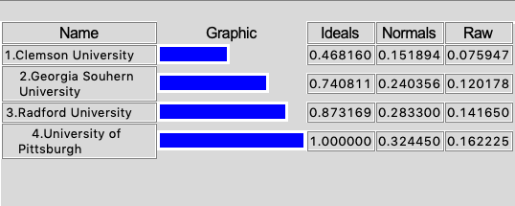
Graduate Selection in Respect to Growth:
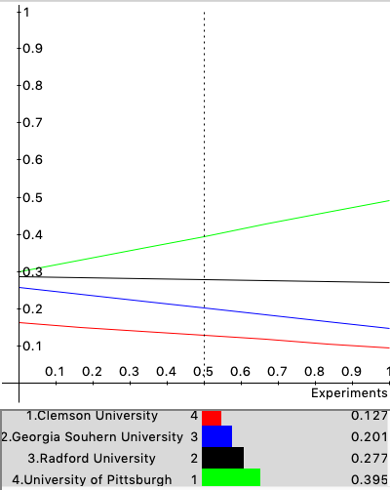

Graduate Selection in Respect to Location:

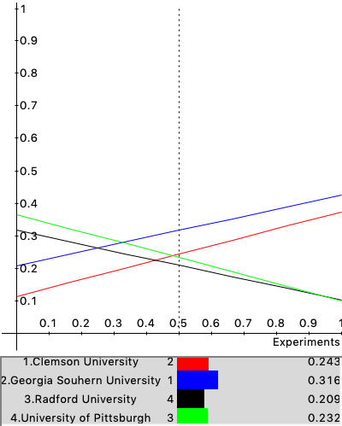

Graduate Selection in Respect to Cost:

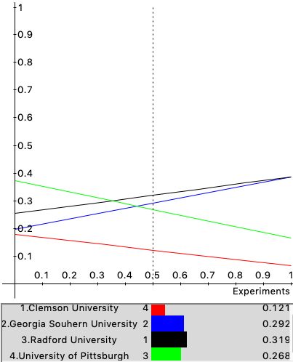

Graduated Selection in Respect to Education:

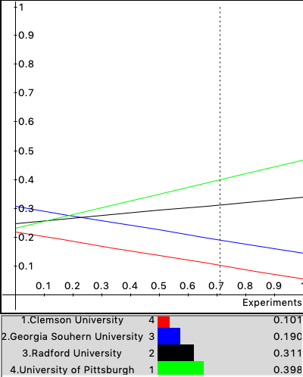

Graduate in Respect to Soccer:

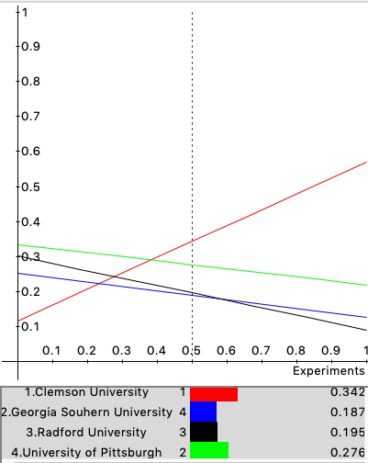

Rating Model

Transforming my Relative Model into a Rating Model:
- Step 1: Removed Alternative cluster
- Step 2: Created a sub criteria cluster for Growth node in Criteria cluster
- Step 3: Connected sub criteria Maturity and Experience with Growth criteria
- Step 4: Completed the pairwise comparison for the new sub criteria
- Step 5: Rating tab – defined all Alternatives, created a rating scale and rated all criteria and sub criteria base on alternative

Results:

When comparing the Relative Model and the Rating Model results together, there is not a big difference. Both models show that the biggest influence on the decision is the Growth criteria. University of Pittsburgh has remained the top decision for each model. Although not much has changed when I transformed the model into a Rating Model, in the synthesized results Georgia Southern University has become the next best decision.

In the Relative Model, Georgia Southern University was the third best choice. The reason I think Georgia Southern University and Radford University changed places within this model is because the Rating model uses degrees of variation when ranking criterion and those criteria have already been pairwise compared. Even though both the decision seem equal, since the Location criteria has a priority of 0.1089 and Education has a priority of 0.0976 this gives Georgia Southern University a minute edge when the results are synthesized.

Rating Scale

Network Diagram
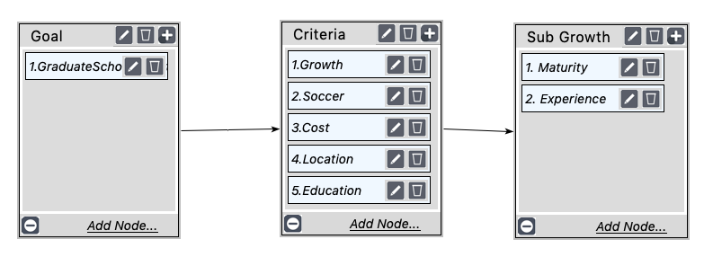

Synthesized Results:

Experience Sub Criteria Sensitivity:

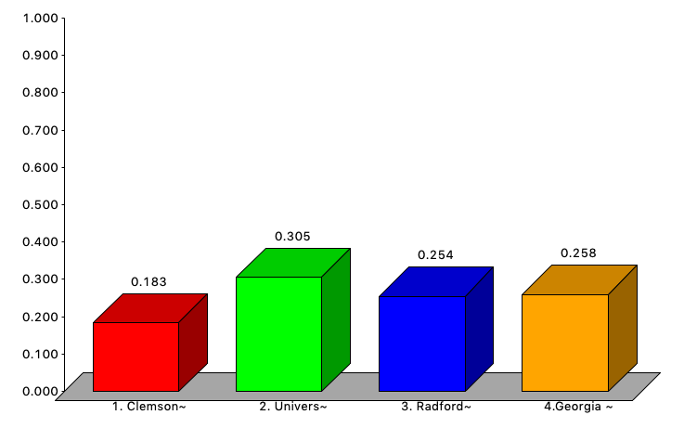

Maturity Sub Criteria Sensitivity:

Graduate Selection in respect to Growth with Sub-Criteria:

