Assignment 1 Review
Figure 1 outlines the AHP model developed using SuperDecisions Software for assignment 1. Figure 2 outlines the results.
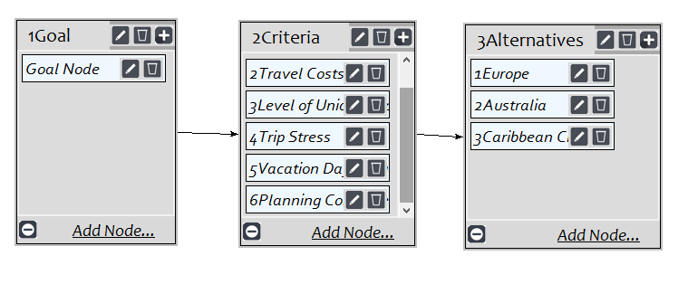
Figure 1: SuperDecisions Model Development for Summer Vacation
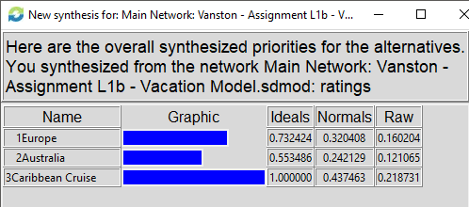
Figure 2 – Synthesized Priorities for the AHP Model

Ratings Model
The AHP model was modified to align with the ratings model approach. Two sub-criteria were added relating to the cost of the trip. This is shown in Figure 3.
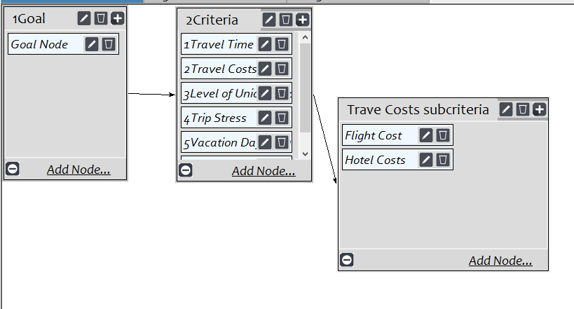
Figure 3 – Ratings Model Development
Figure 4 shows the lowest level of criteria for rating alternatives. Notice that criterion 2, Travel costs, is not shown in the ratings, but the sub-criteria of flight cost and hotel costs are shown. Figure 5 shows the alternatives. These are the same as the AHP model.
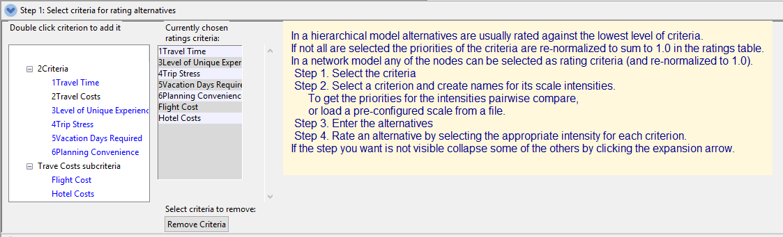
Figure 4 – Criteria for Ratings
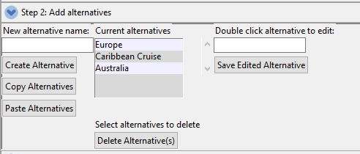
Figure 4 – Alternatives
Figures 5, 6, and 7 show examples of ratings developed for specific criteria. Figure 5 shows a criteria scale for travel time that was based on a quantative hour scale. Figure 6 shows a qualitative scale for the level of unique experiences criterion. Figure 7 shows a quantative scale for flight costs. All used the compare feature to develop relative rankings. Figure 8 shows a summary of the ratings.
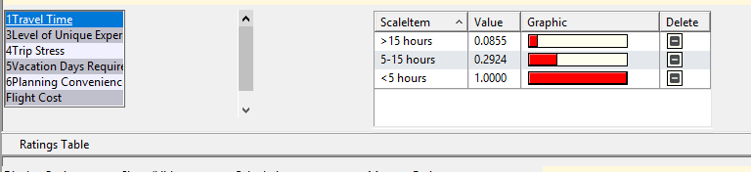
Figure 5 – Ratings for Travel Time

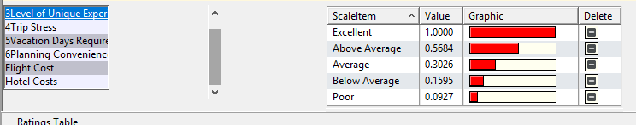
Figure 6 – Ratings for Level of Unique Experiences

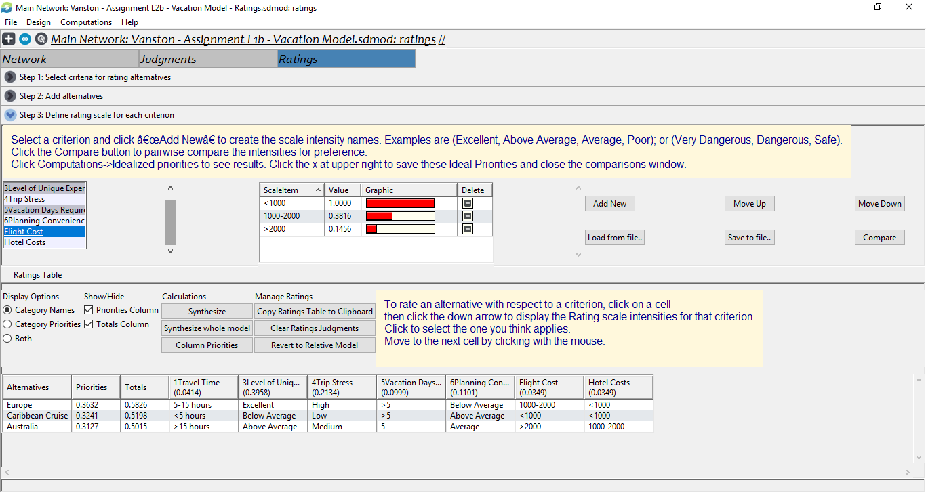
Figure 7 – Ratings for Flight Cost

Figure 8 – Ratings Summary

Results
Figure 9 shows the synthesized results.
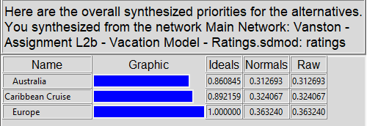
Figure 8 – Ratings Results
Model Comparison
Table 1 shows a comparison between the AHP and Ratings models based on normalized values. The highlighted values show the highest value from the model and the proposed selection. There was a large difference in the results. This could be attributed to a different numerical comparison tool provided by the ratings model. It may have been somewhat difficult to use pairwise compare two items that had numerical values such as travel time and flight costs. The ratings model allowed for this comparison.
Table 1 – Model Comparison
 | Model
Alternatives | AHP | Ratings
Australia | 0.242 | 0.313
Caribbean Cruise | 0.437 | 0.324
Europe | 0.320 | 0.363

