- ASSIGNMENT 1 RECAP:

The solution that I found using the AHP decision model with pairwise comparison was the following:

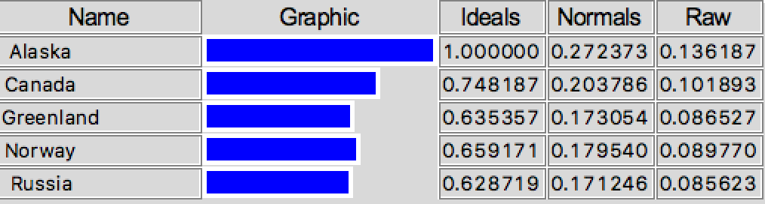

- RATINGS MODEL:

The screenshots below show how I built up the Ratings Model to decide about the best destination to see the Northern Lights during the winter.

The definition of the importance of each criteria remained the same for both the Pairwise and the Ratings models. The first step of the modification process was removing the choices from the Network Diagram and adding the information related to the choices in the Ratings tab. All the process can be seen in the screenshots below:

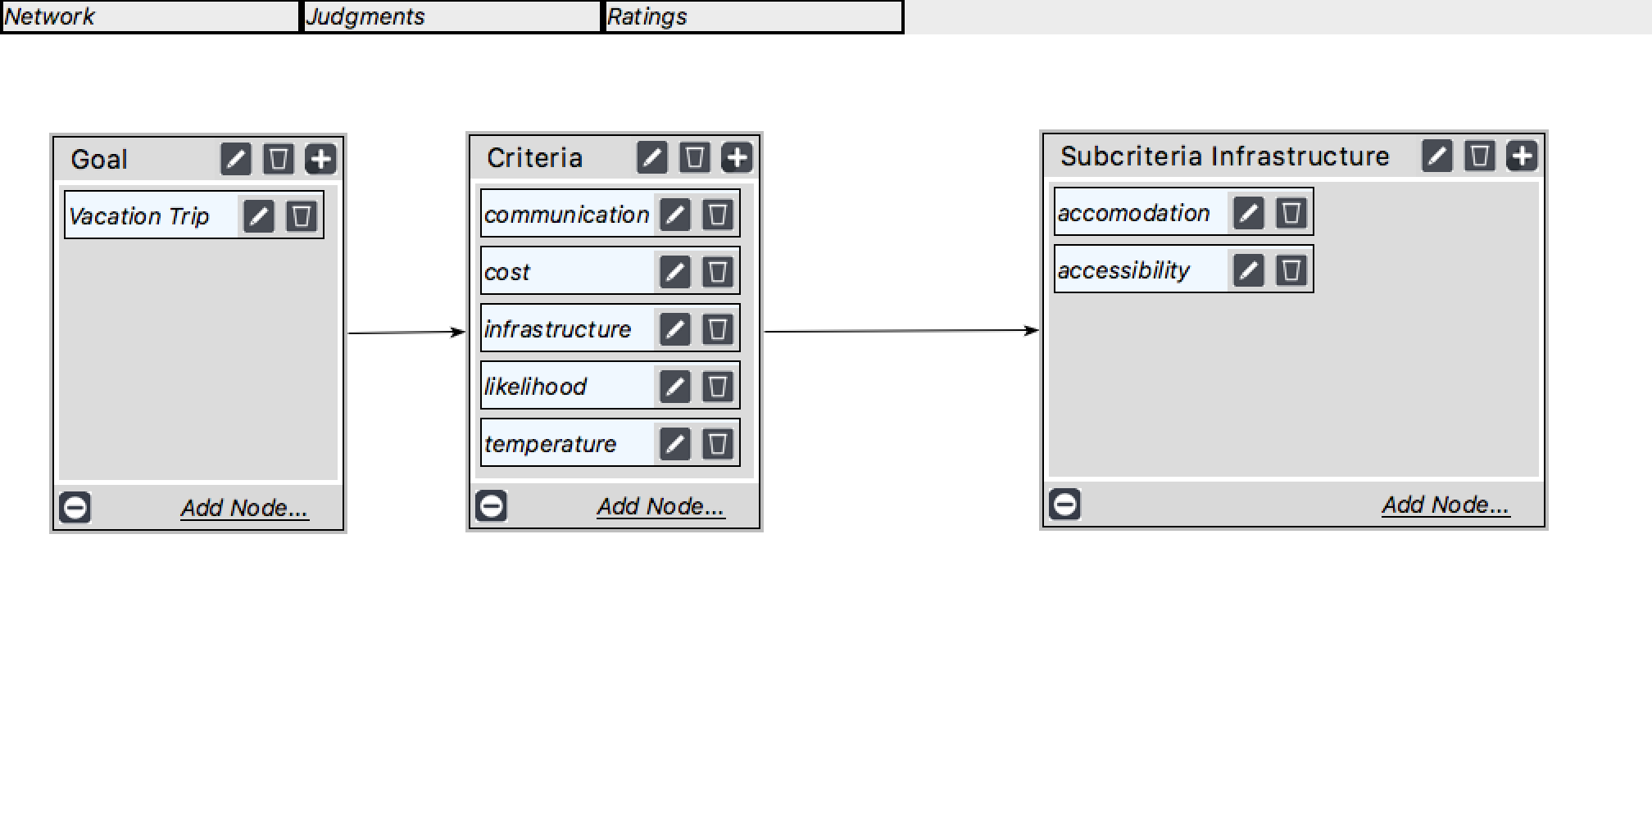

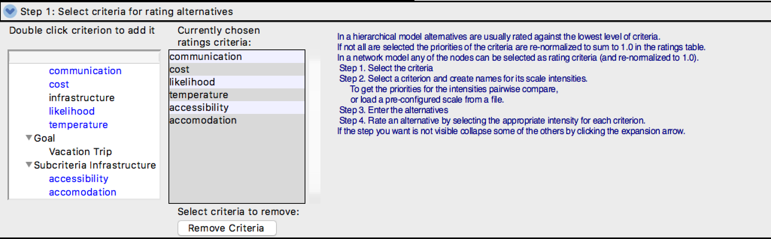

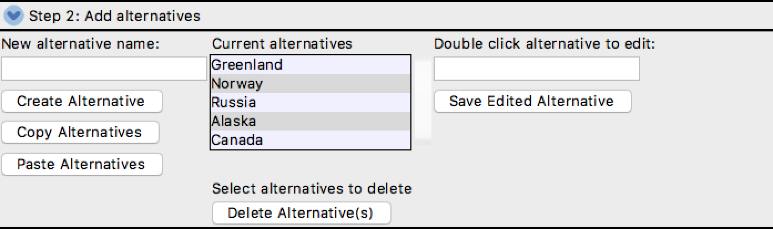

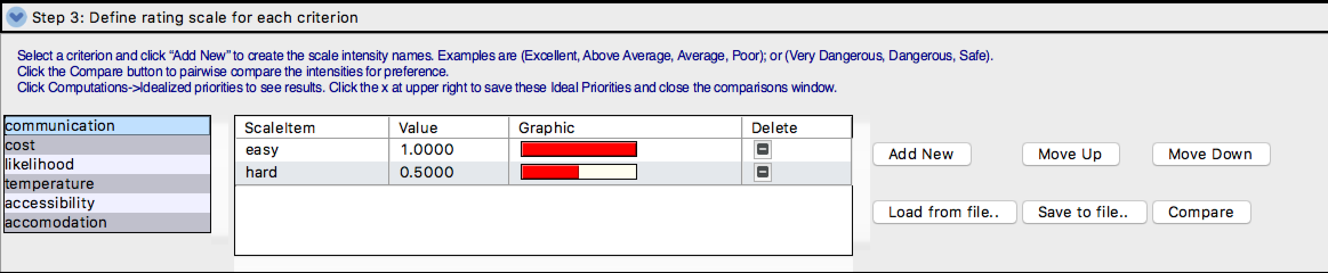

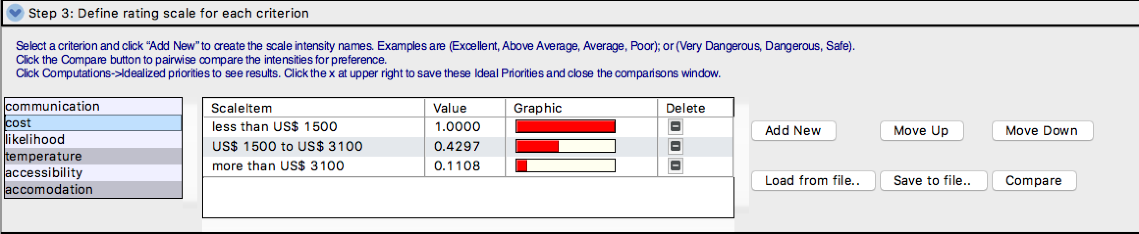

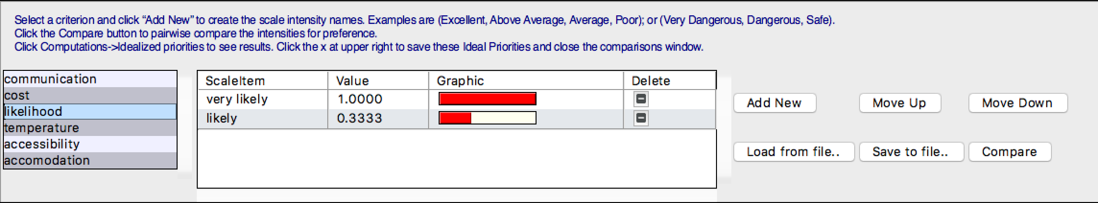

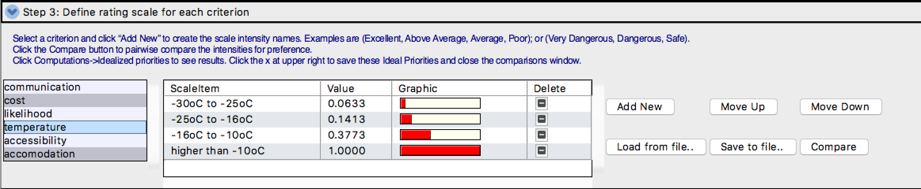

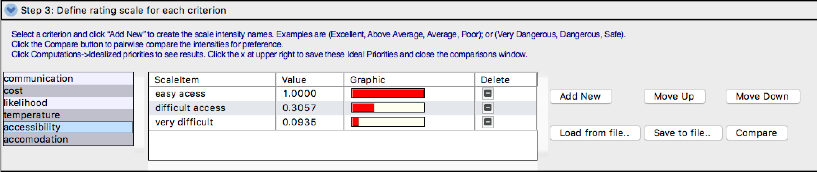

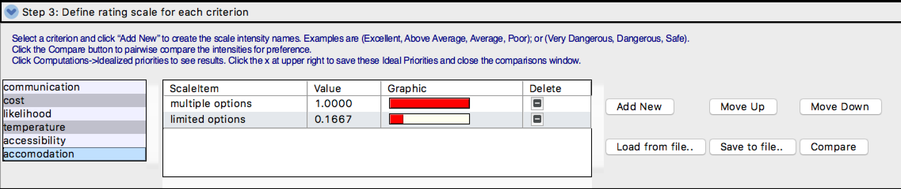
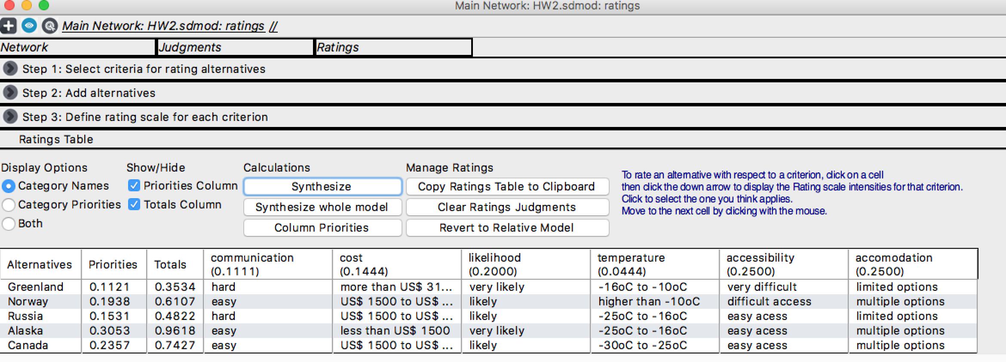

- RESULTS:

The results obtained are shown in the following table:

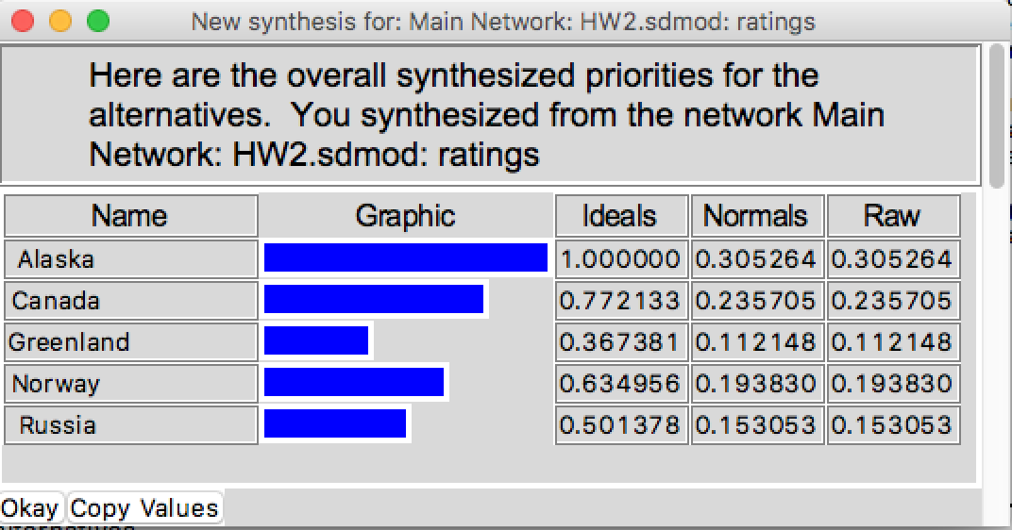

- MODEL COMPARISON:

Model | AHP (Pairwise Comparison) | Ratings
Alaska | 27.24% | 30.53%
Canada | 20.38% | 23.57%
Greenland | 17.31% | 11.21%
Norway | 17.95% | 19.38%
Russia | 17.12% | 15.31%

The table above shows that the two different methodologies produced very consistent results. In addition to the fact that the relative importance of each criterion remained the same (in spite of the fact that the ratings method divided the criterion infrastructure into two sub-criteria: accessibility and accommodation) in both approaches, both the pairwise comparison and the ratings methods were able to highlight the differences in the alternatives in a similar and consistent fashion.

