Decision Making in a Complex Environment

Choosing the Best Job

Steve Brady
Damon LaSalle
April 26, 2011

Table of Contents

page
1 Introduction 3
1.1 Alternatives 3
1.2 Strategic Criteria 3

2 ANP Model 4
2.1 BOCR 5
2.1.1 Benefits 10
2.1.2 Opportunities 14
2.1.3 Costs 19
2.1.4 Risks 23

3 Ratings Model 28
3.1 Overall Results 29
3.2 Sensitivity Analysis 31

4 Conclusion 34

1 Introduction

The decision that was selected for this project is choosing the best job. As an MBA student, it is important to evaluate all of the various factors and criteria associated with job options in order to select the best possible outcome. The model that has been developed for this project applied job criteria from four main areas of consideration: Company, Position, Benefits, and Logistics. Through the use of ANP and BOCR, various different subnets have been setup to evaluate the three different job alternatives based upon several different control criteria and pairwise comparisons. From there, the results of each BOCR were rated against the strategic criteria to provide the overall best decision, based on both the short term and the long term.

1.1 Alternatives

The jobs that were chosen for evaluation using the model were based on common positions occupied by MBA graduates in three different locations. Due to the nature of the model and the generality of the decision being evaluated, three hypothetical job scenarios were created for evaluation. The first job is a standard Engineering position in a small city area such as Pittsburgh. The job is held in a small company with low industry growth requiring daily commute via car. Further assumptions were made based on distance, time, etc. The second job considered was a Financial Analyst working in New York City. This job would require daily commute on mass transit, and is held in a medium sized company with high growth potential in a large city. Again, various assumptions were made. Finally, the third job considered as an alternative for the model is a general Consulting position. This job is held in a large company with average growth, and the logistics behind the job require that the employee travel to site via plane on a weekly basis.

1.2 Strategic Criteria

As mentioned earlier, the strategic criteria were chosen based on the various factors associated with the company, position, benefits (perks), and logistics. With regard to Company, factors such as size, culture, industry growth, and prestige were considered. Additionally, the details of the actual position, such as salary, title, advancement opportunity, and time requirement, were analyzed. Furthermore, the benefits package offered by the company was evaluated according to health insurance, retirement funds, professional development, and the availability of flextime. Finally, the travel logistics of the job were also considered, regarding commuting time/distance/method as well as any traveling associated with the job. These criteria, as shown in the model, were then evaluated using assumptions and hypothetical scenarios behind each of the three job options. More details on the specific sub-criteria considered for the BOCR will be discussed later in this report.

2 ANP Model

The model was created using the Analytic Network Process (ANP) to find a resolution to the issue described above: Choosing the best job. See the top-level network below:

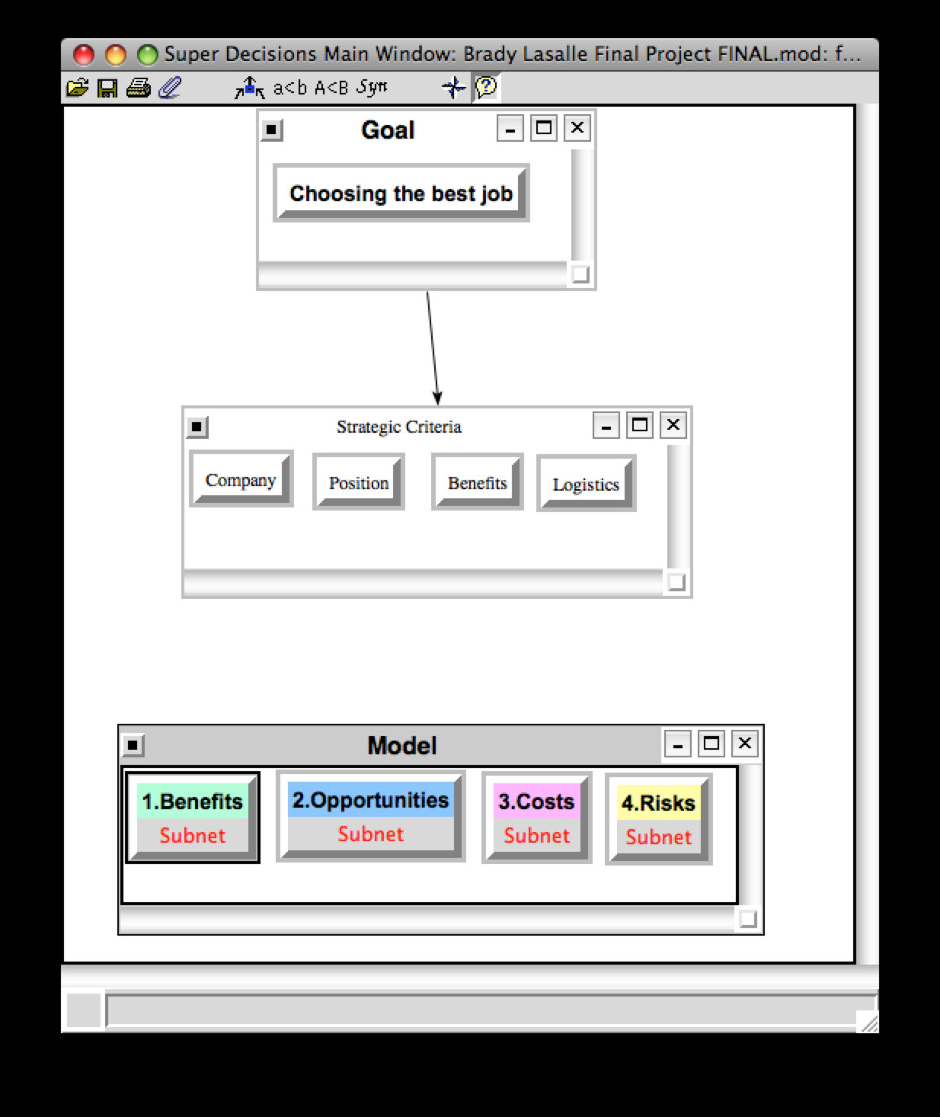

2.1 BOCR

In order to capture the full complexity of this decision, the BOCR model was used to establish the control criteria that applied specifically to the benefits, opportunities, costs, and risks associated with selecting a job. Through the use of subnets in each of the control criteria that applied, various sub-criteria were identified and compared to establish the overall priorities for each alternative relative to benefits, opportunities, costs, and risks. The displays below show the model section relative to the control criteria for each.
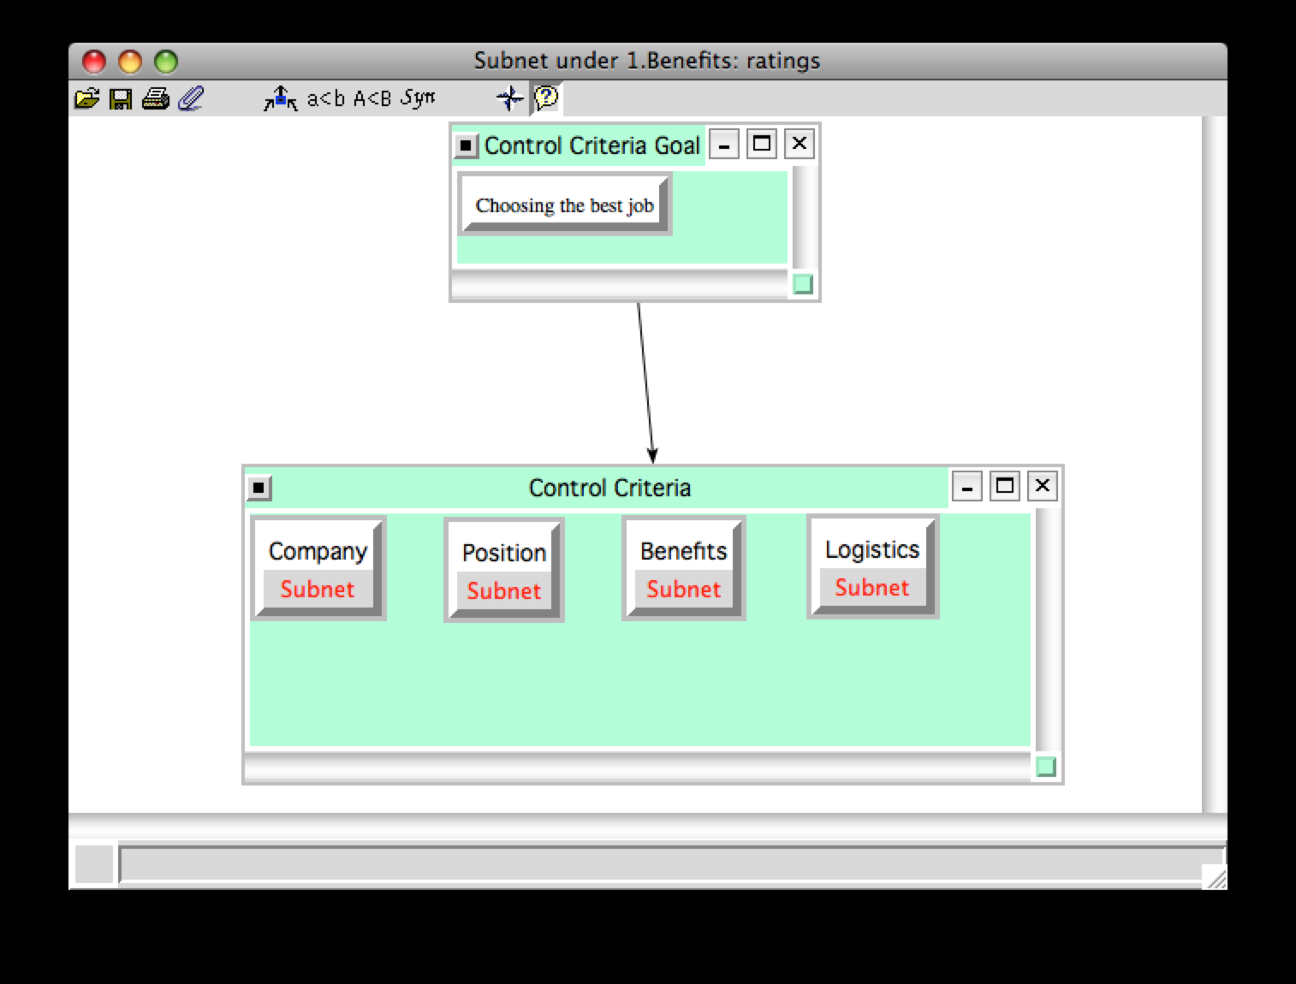

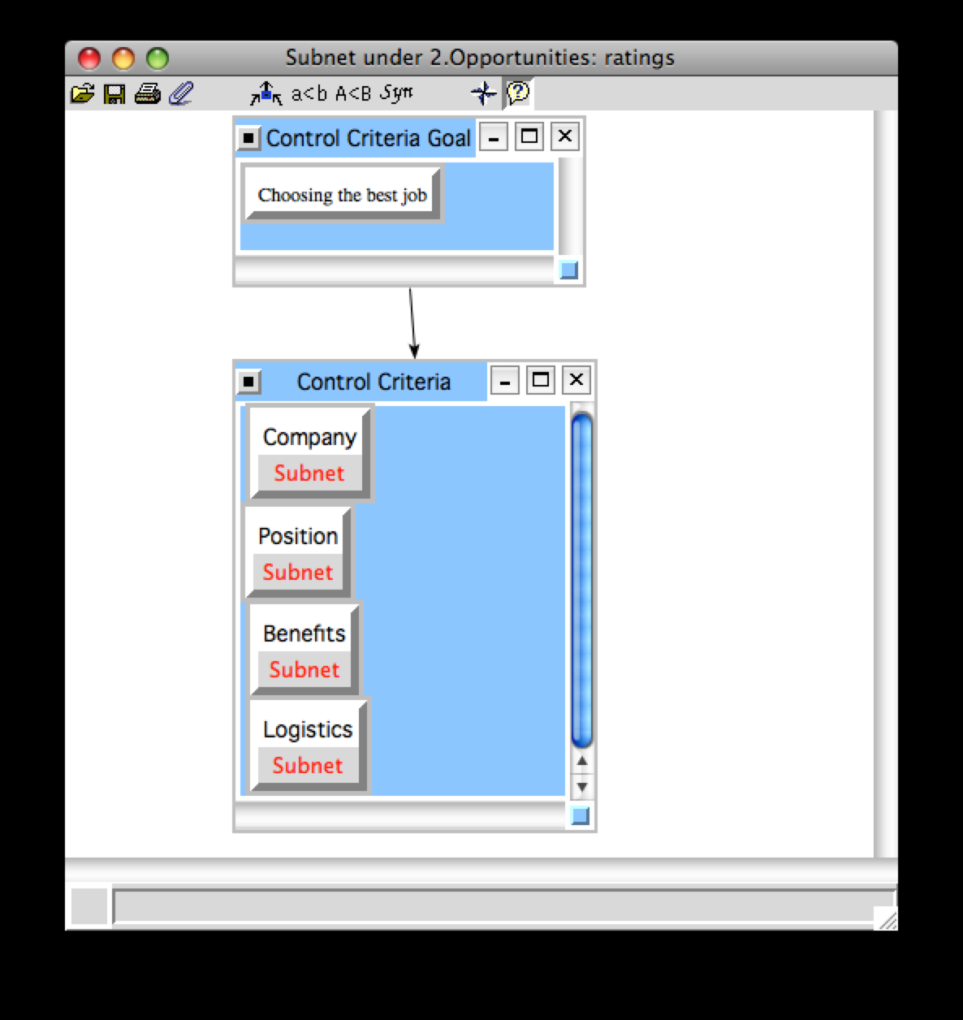

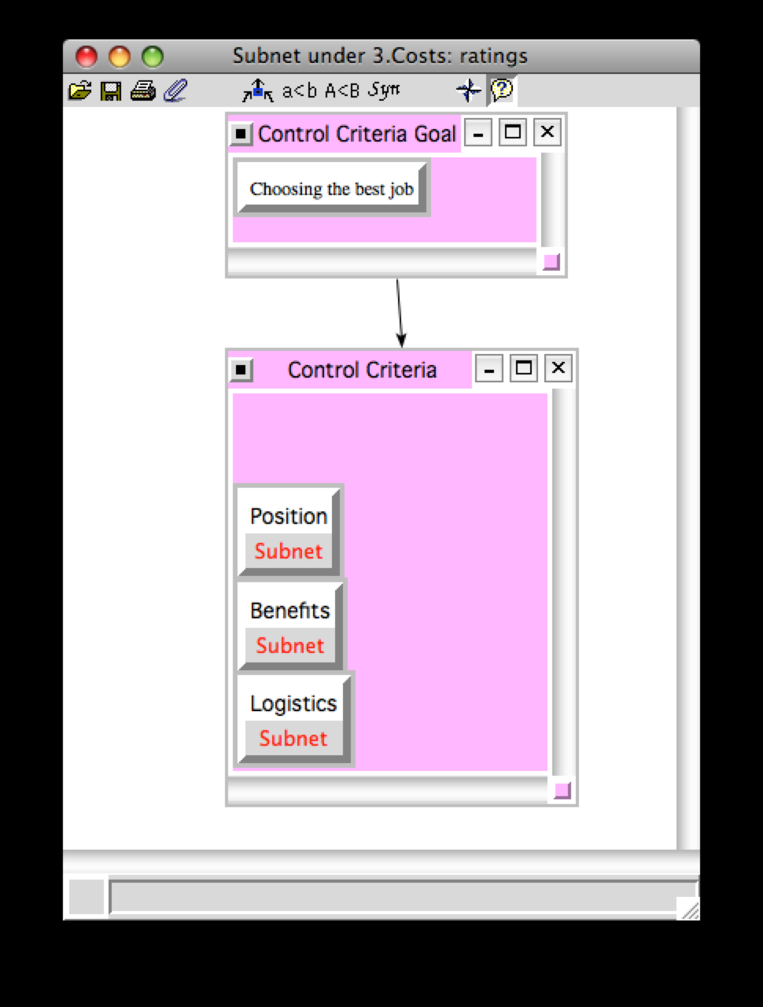

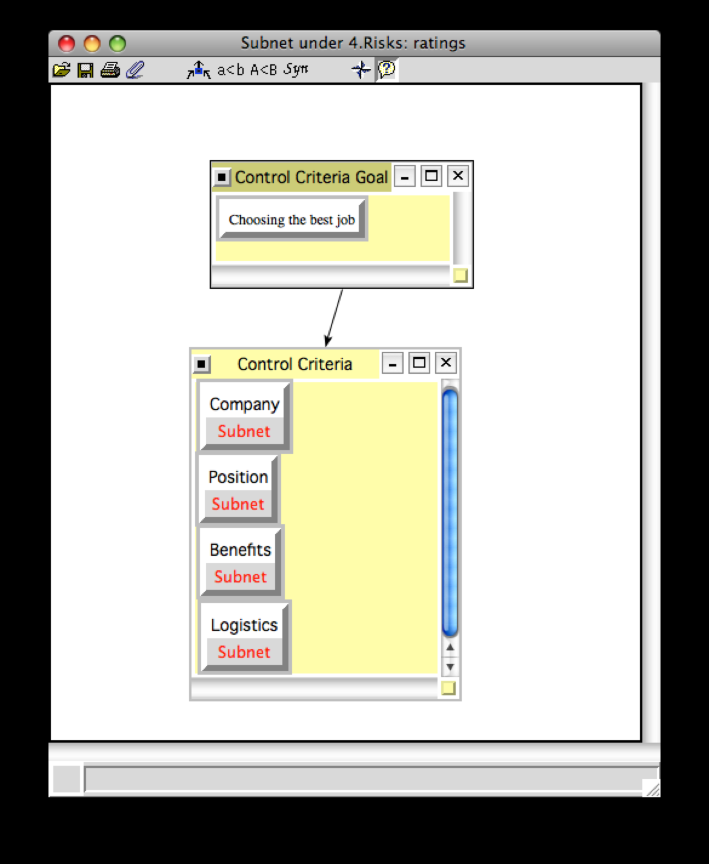

2.1.1 Benefits

The overall assumption for the way in which the model was created was that Benefits were to be evaluated and compared, and the sub-criteria chosen, according to the short term positives of the alternatives and job selection criteria. Details for each sub-criteria within each control criteria are detailed below.

Company. Company criteria deal with the overall status and characteristics of the company within which the specific job is held. With respect to benefits, the sub-criteria chosen to evaluate job selection were the Company Culture and Prestige. With regard to the culture, the priorities were given based on whether or not the company with which the position was held was accepting, creative, process driven, and/or hierarchical. With regard to the overall prestige of the company, the priorities with respect to benefits were chosen based on the companies position as either an industry leader, a major player, or a small player.
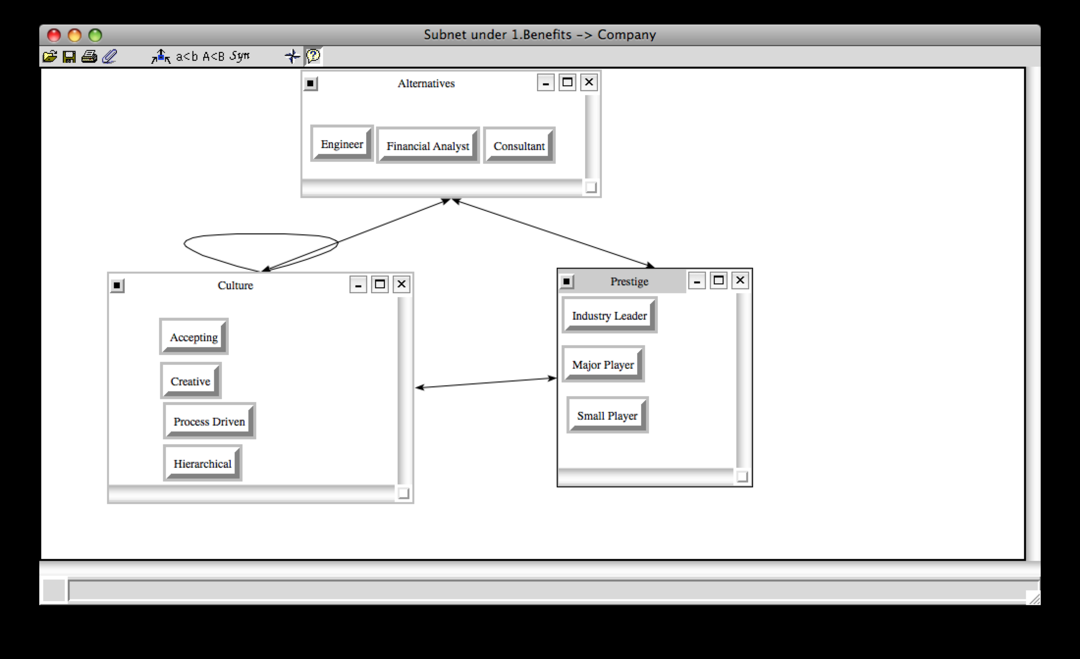

Position. Position is the criteria that deal with that actually characteristics and offerings of the job itself. The sub-criteria selected with respect to benefits that are related to the Position control criteria were the Salary and the actual Position category. Specifically, Salary was evaluated on whether it was above average for the actual position, the industry norm, or below the industry norm. With regard to the actual position, the levels of management, professional, and clerical were used to establish comparisons.
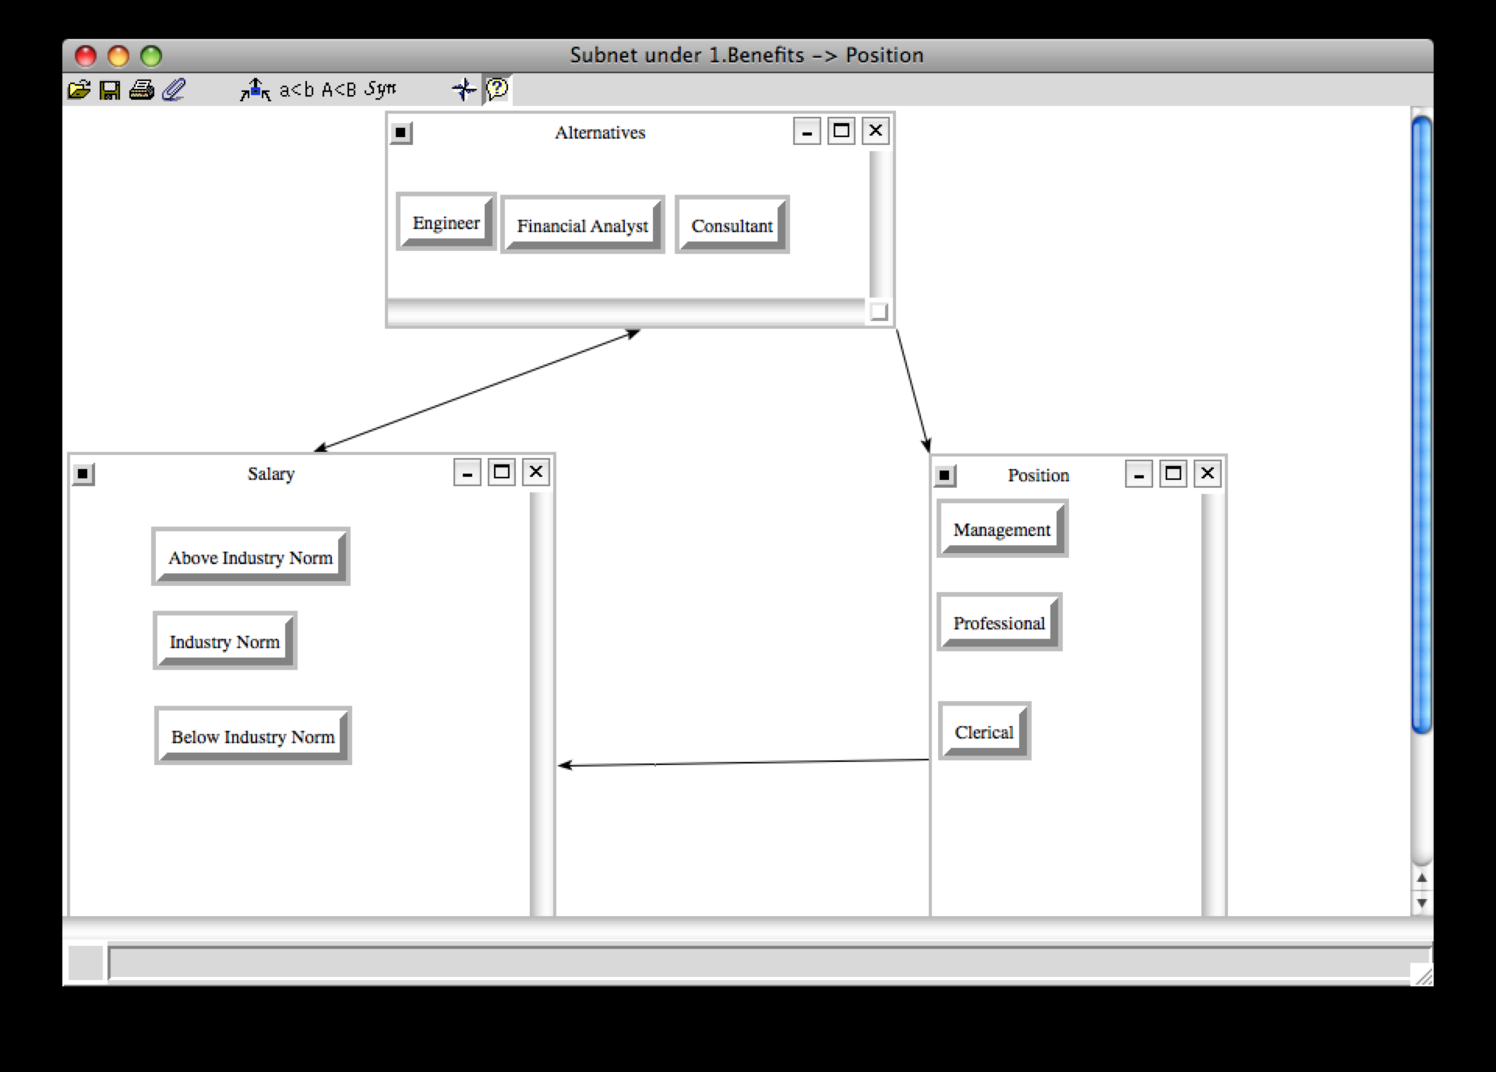

Benefits. As a clarification, benefits as a criteria, as stated earlier, refers to the perks offered with most positions within most companies, such as insurance coverage, retirement plans, etc.
With regard to the benefits portion of the model, the sub-criteria used to evaluate job benefits in the short term were flex-time and insurance. Specifically, the job was evaluated in regard to having a fixed number of hours that needed to be worked on a fixed schedule, or having a flexible time/hours policy. In addition, the level to which the insurance was covered by the company, if offered at all, was compared for each alternative.
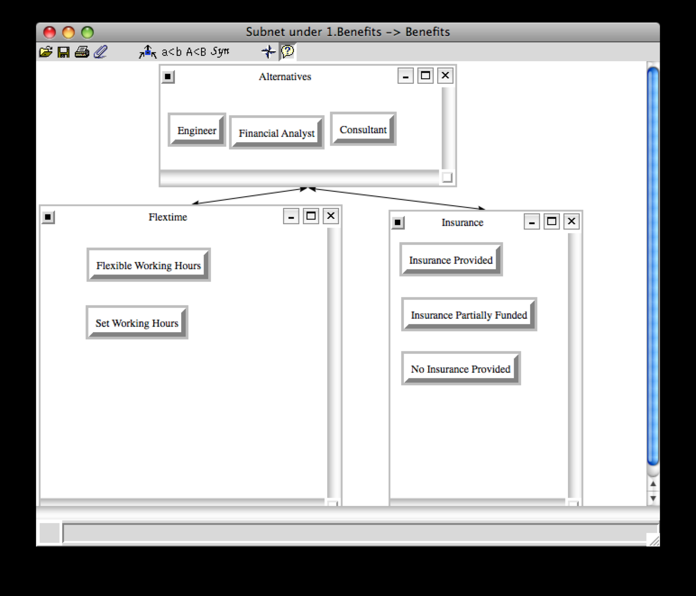

Logistics. Logistics is the criteria that deals with the various commuting and travel factors associated with the job that is being evaluated. From a benefits perspective, the sub-criteria used in comparing the alternatives with respect to job logistics in the short term were commuting time and commuting method. How long the average one-way commute (less than 30 minutes, between 30 and 60 minutes, or greater than 60 minutes) was compared for each. In addition, the method in which the commute was made (car, mass transit, walking/biking, and plane) was also compared. It is important to note that these ratings were based on the scenarios that were established for each of the three alternatives.
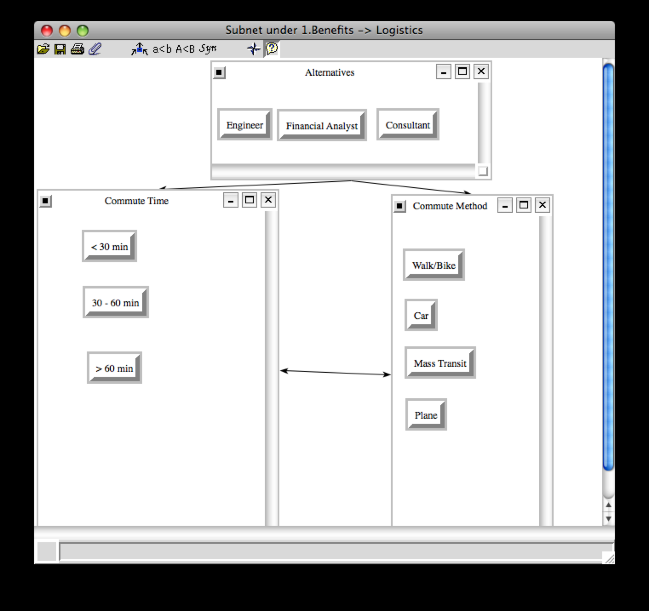

Synthesis Results. It can be seen below that the synthesis priorities of the job selection are best with the Consultant job, at ~50%, which makes it the top job choice in terms of benefits (short term gains). The financial analyst position would be the second best job with a priority of ~31%, while the Engineer would be the last pick (~19%) with respect to benefits. As a result of this synthesis, the ratings done in the final step of the model development with regard to benefits compared to the strategic criteria will be based on the characteristics associated with the Consultant.
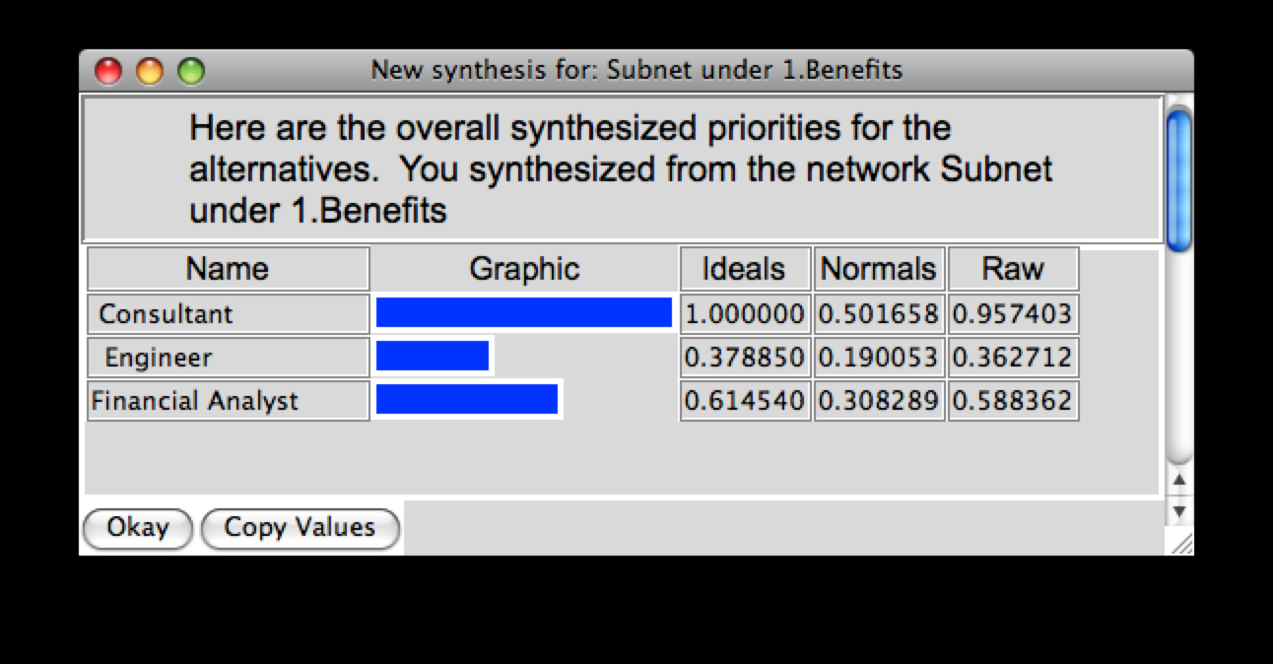

2.1.2 Opportunities

In developing and evaluating the Opportunities portion of the BOCR model, it was assumed that opportunities referred to the longer term positives related to the alternatives and job selection criteria. As a result, the sub-criteria were selected and compared with that in mind.

Company. Company criteria deal with the overall status and characteristics of the company within which the specific job is held. With respect to opportunities, the sub-criteria that were chosen are company size and industry growth. Specifically, the opportunities of having a small, medium, and large company were evaluated. In addition, the level of industry growth was measured and compared according to average growth along with above/below average growth.

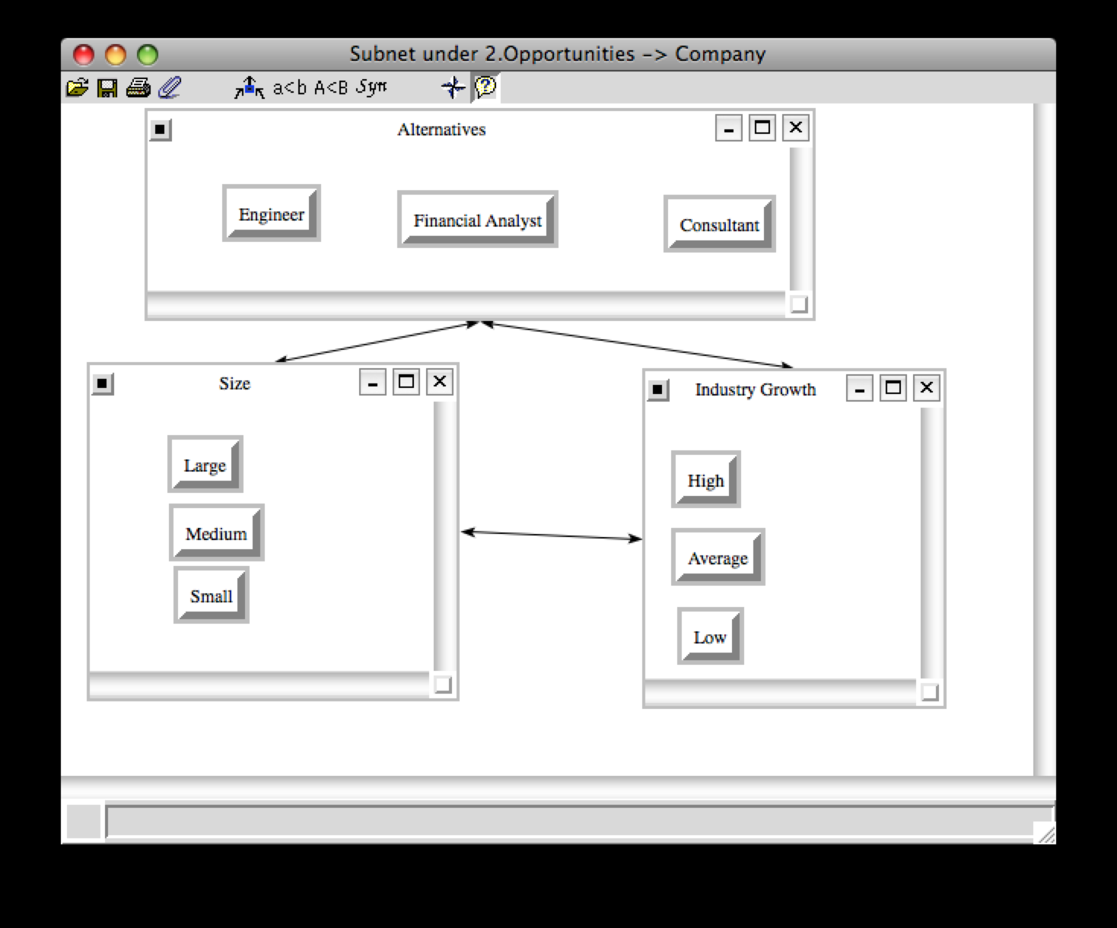

Position. Position is the criteria that deal with that actually characteristics and offerings of the job itself. The sub-criteria selected with respect to opportunities were advancement opportunity within the company as well as salary. For advancement, the comparisons were made based on the degree to which advancement within the company was known or structured; specifically, it was either clearly defined, potential exists, or totally unknown. With regard to salary, the offerings of straight raises, profit sharing, and stock options were analyzed relative to eachother as well as each alternative.
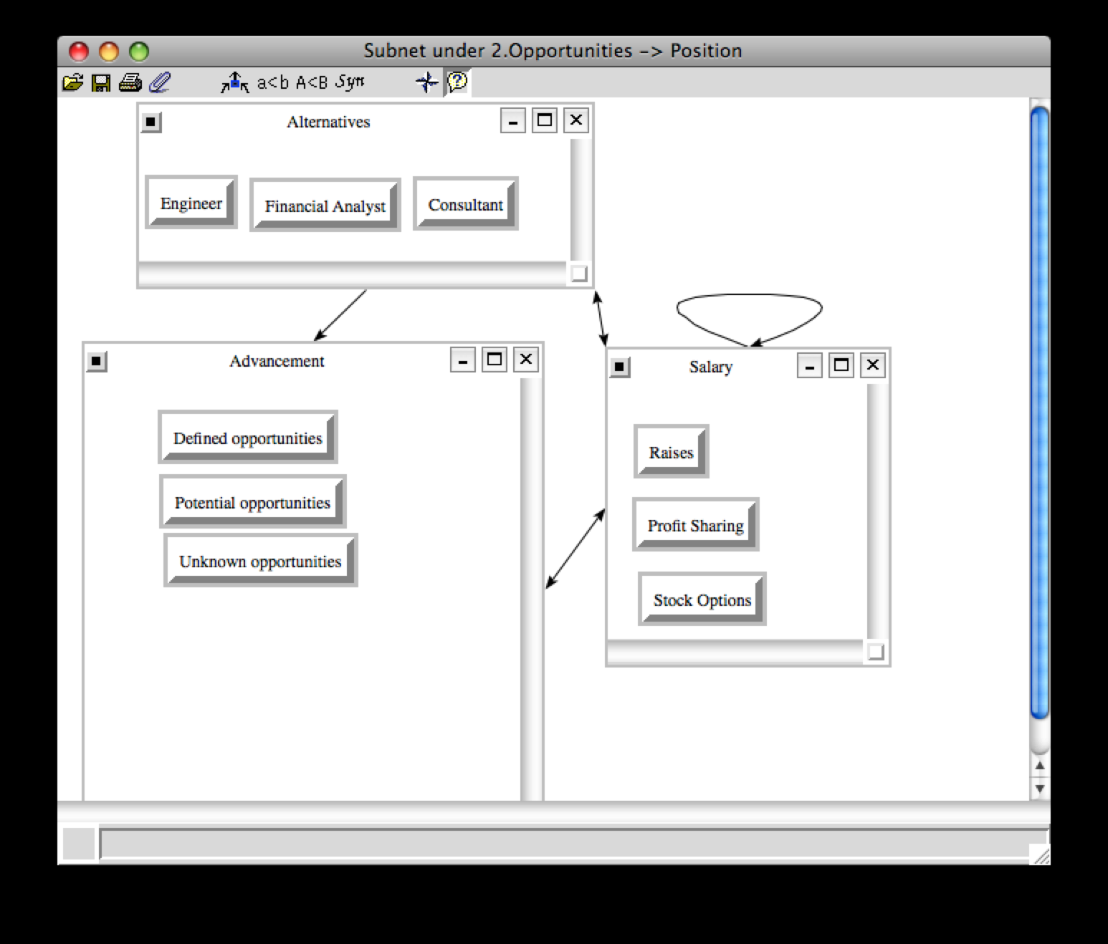

Benefits. As stated earlier, benefits as criteria refer to the perks offered with most positions within most companies, such as insurance coverage, retirement plans, etc.
With regard to the long-term positive opportunities, both culture and prestige were evaluated. The sub-criteria chosen for culture included accepting company culture, creativeness, hierarchical culture, or a process-driven culture. Again prestige was evaluated based on the degree to which the company is an industry leader, large player, or small player, and what is more desirable with regard to opportunities.
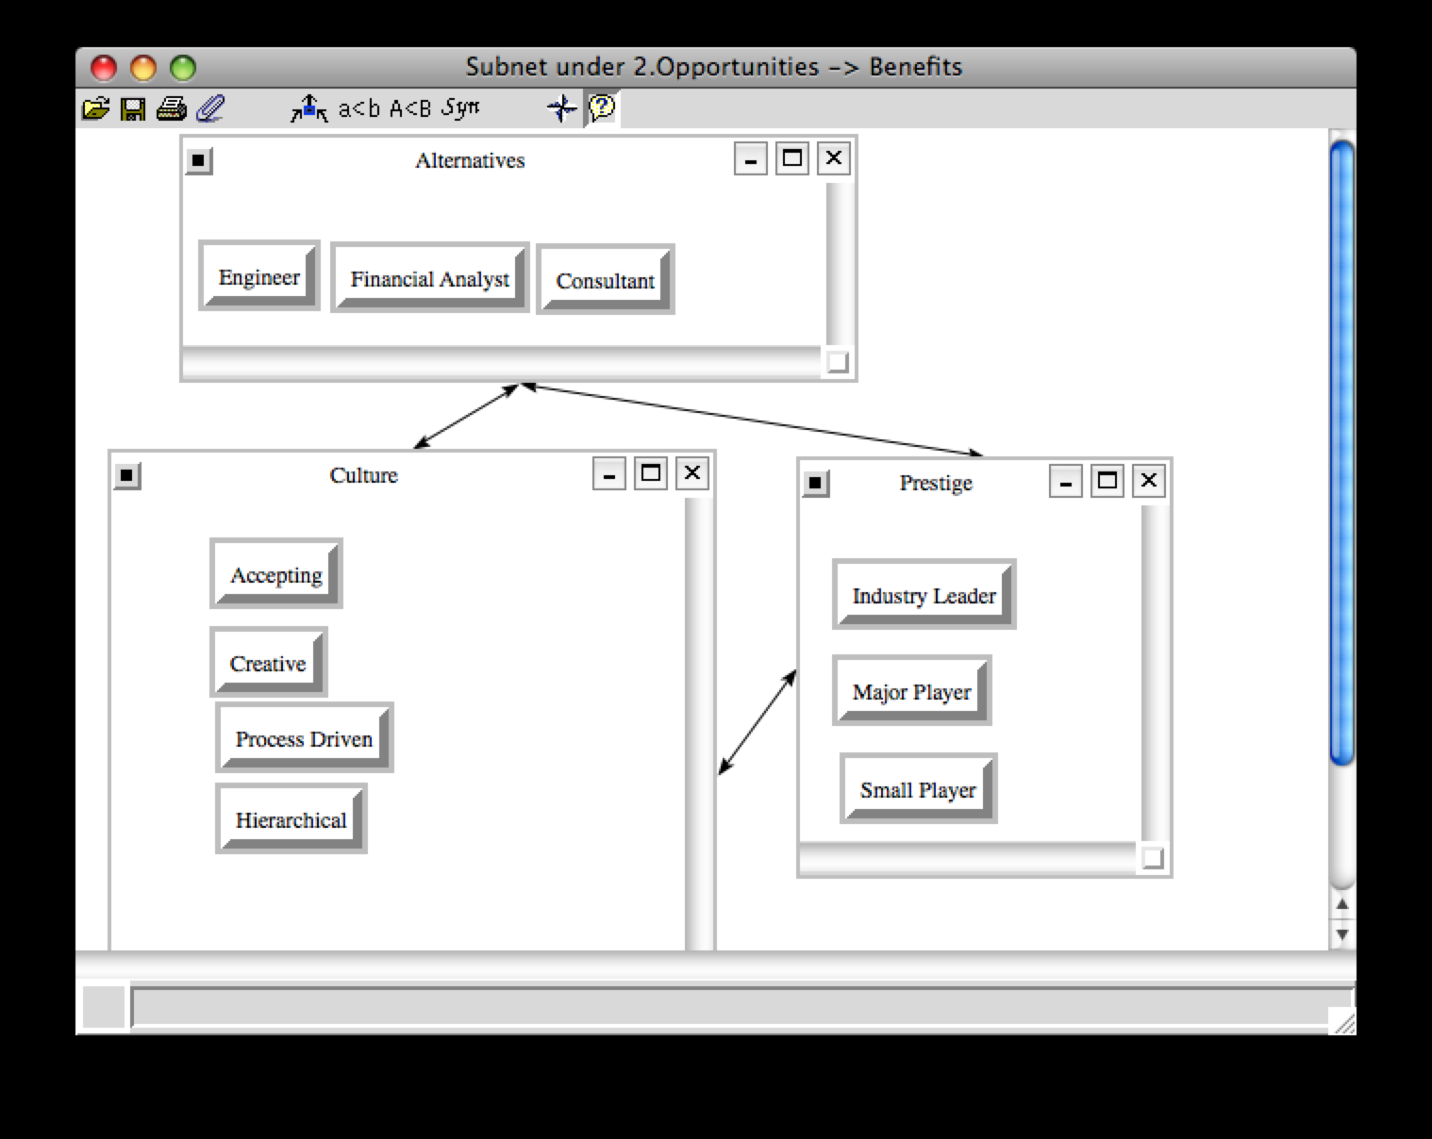

Logistics. Logistics is the criteria that deal with the various commuting and travel factors associated with the job that is being evaluated. From an opportunities standpoint, the longer-term sub-criteria identified were travel frequency and commuting distance. Travel frequency refers to any business travel required for the job, and was categorized by either daily, weekly, monthly, or rarely. Commuting distance was evaluated based on mileage of travel, and was chosen from either less than 10 miles, between 10 and 30 miles, and greater than 30 miles.
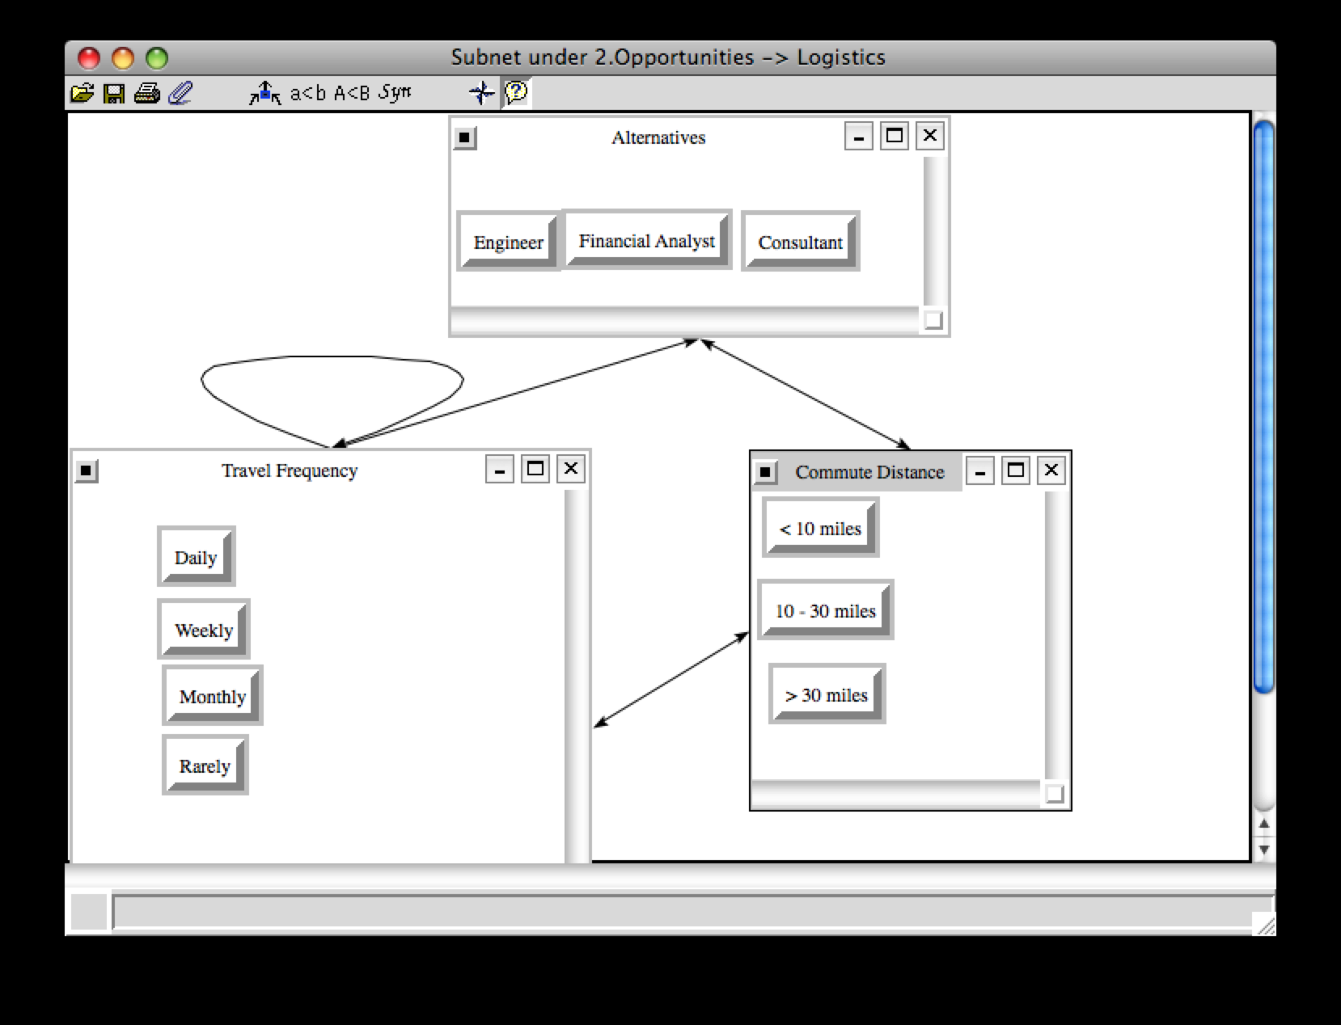

Synthesis Results. It can be seen below that the synthesis priorities of the job selection are best with the Consultant job, at ~47%, which makes it the top job choice in terms of opportunities (long term gains). The financial analyst position would be the second best job with a priority of ~34%, while the Engineer would be the last pick (~19%) with respect to opportunities. As a result of this synthesis, the ratings done in the final step of the model development with regard to opportunities compared to the strategic criteria will be based on the characteristics associated with the Consultant.

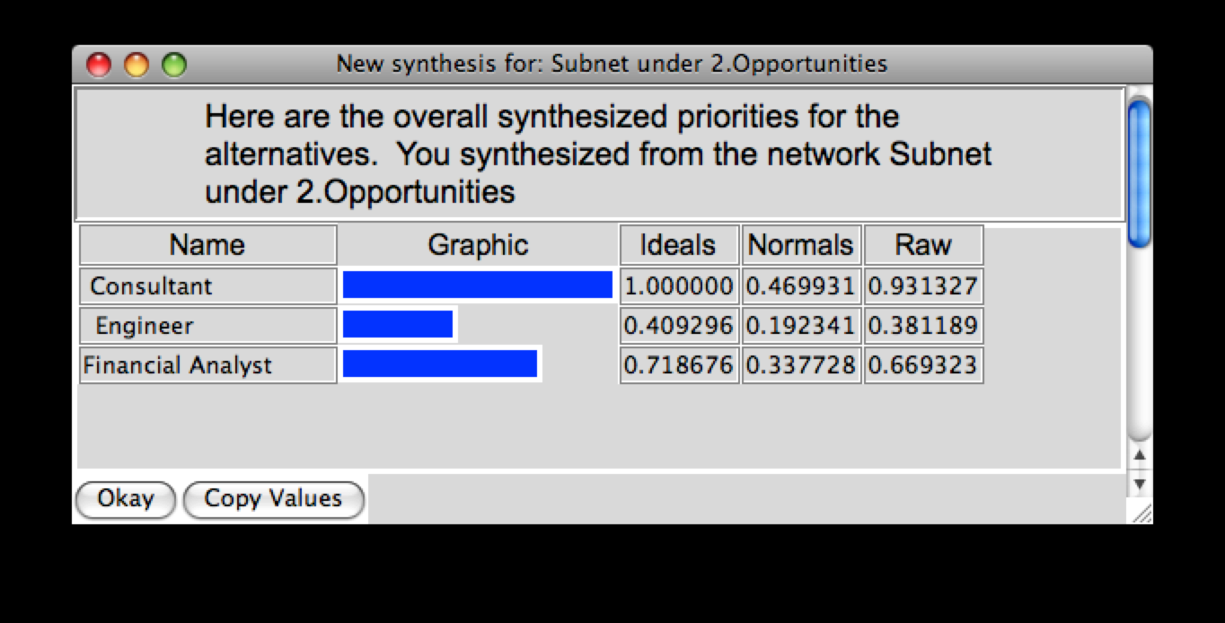

2.1.3 Costs

In developing and evaluating the Costs portion of the BOCR model, it was assumed that these referred to the short-term negative aspects related to the alternatives and control criteria. As a result, the sub-criteria were selected and compared accordingly. It is worth noting that the highest priority outcome of the synthesis results will be the alternative with the greatest short-term negative impact, and as a result, will be the least desirable. However, that alternative will still be the one used at the end to come up with ratings against each of the strategic criteria with regard to costs.

Position. Position is the criteria that deal with that actually characteristics and offerings of the job itself. The sub-criteria selected with respect to costs relative to the position control criteria is the time requirement associated with the job. This sub-criteria represents the time that a salaried employee works relative to a 40 hour week; specifically, 40 hours or less, between 40 and 50 hours/week, or more than 50 hours per week (on average).

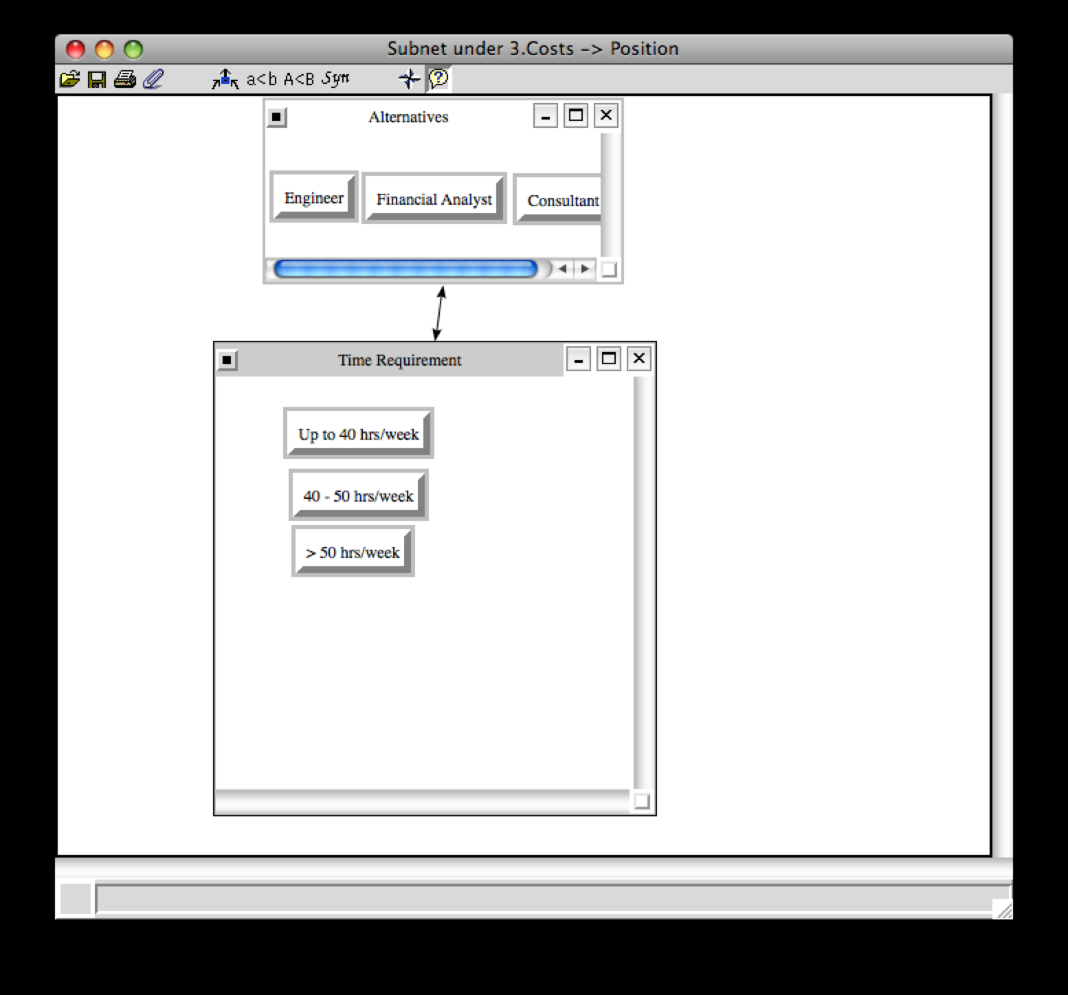

Benefits. Benefits as a control criterion refers to the perks offered with most positions within most companies, such as insurance coverage, retirement plans, etc.
With regard to the costs (short term negatives), the sub-criteria chosen for the model were insurance and professional development costs. For insurance, the comparisons were made based on the degree to which the company paid for health insurance, whether it be completely covered, partially paid for, or not paid for at all. In terms of professional development sub-criteria, the comparisons assumed that the company offered some type of development program, but the difference would be whether or not the employee had to pay.
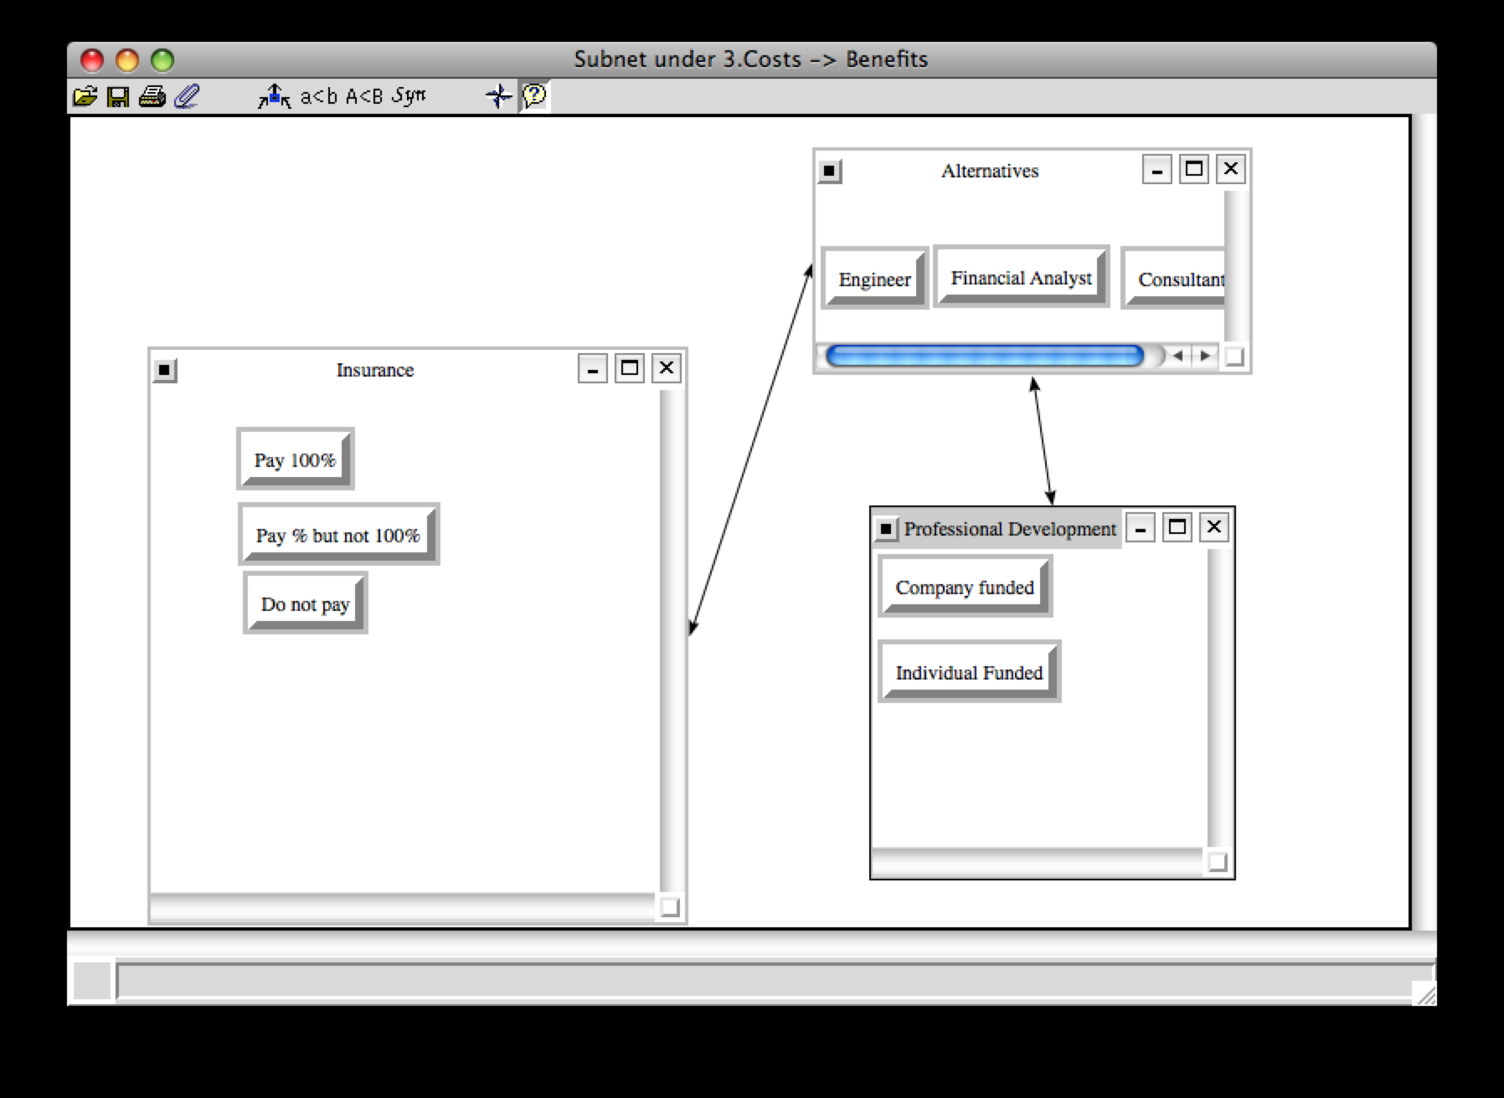

Logistics. Logistics deals with the various commuting and travel factors associated with the job that is being evaluated. From a costs perspective, it can be seen that this had the most complexity with regard to the following sub-criteria: Commuting time, commuting method, commuting distance, and travel frequency. Commuting time, again, was categorized as either less than 30 minutes, between 30 and 60 minutes, and greater than 60 minutes. The commuting method choices were bike/walking, car, mass transit, or plane. For commuting distance, the comparisons were based on either less than 10 miles, between 10 and 30 miles, and greater than 30 miles each way. Finally, the travel frequency was based on daily, weekly, monthly, or rarely occurring business travel.
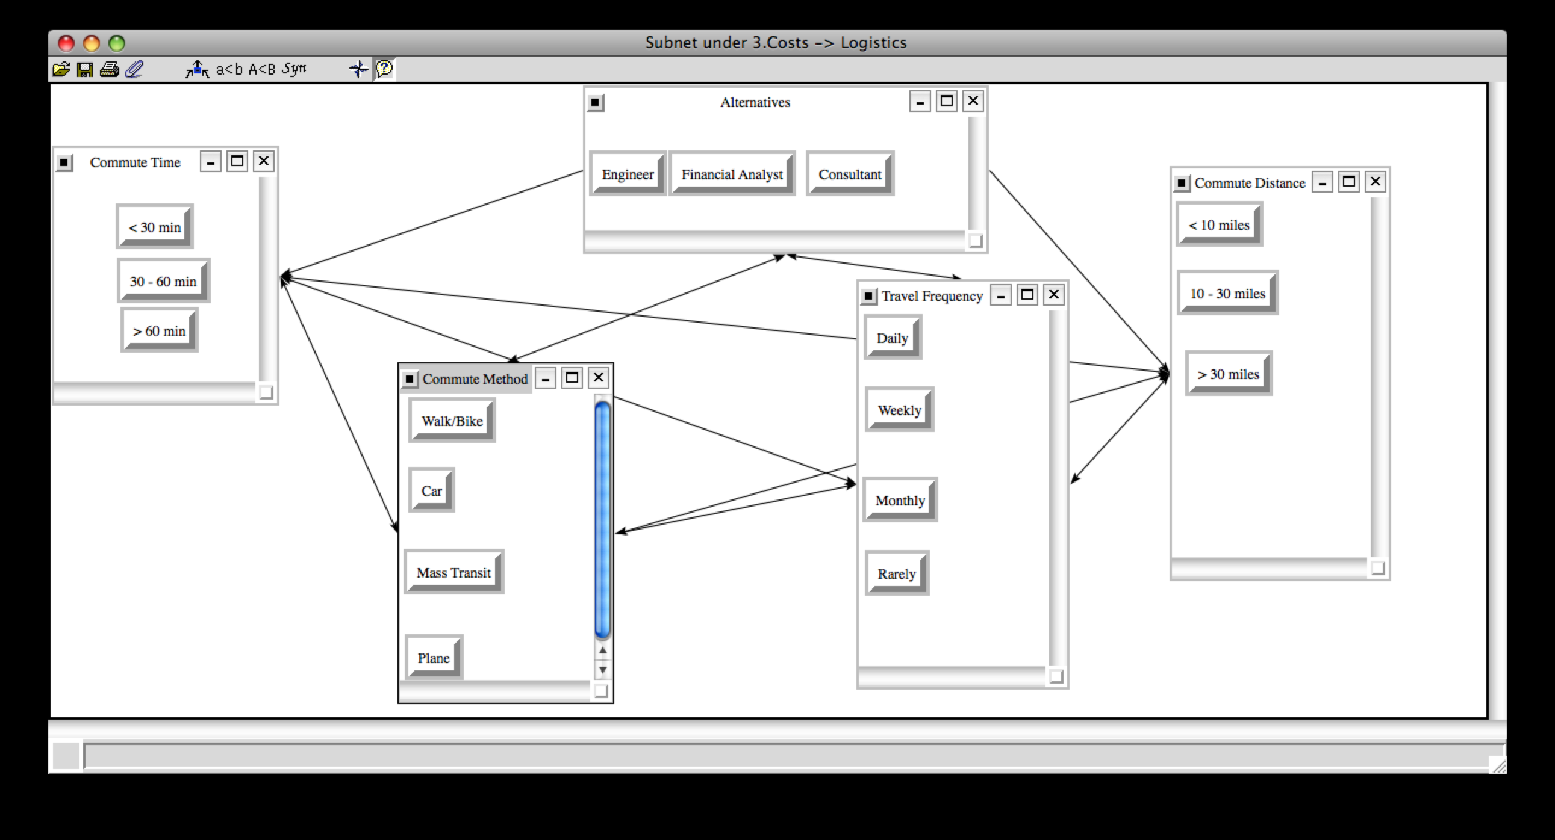

Synthesis Results. It can be seen below that the synthesis priorities of the job selection are greatest with the Financial Analyst job, at ~49%, meaning that it has the highest cost (short-term) impact. In reality, the ideal job to be chosen would be the one with the lowest cost priority, which is represented here by the Consultant with 23%. The Engineer falls in between the two with 28% priority. As a result of this synthesis, the ratings done in the final step of the model development with regard to costs compared to the strategic criteria will be based on the characteristics associated with the Financial Analyst. Again, while this seems counter-intuitive, the alternative with the greatest impact for the Benefit/Opportunities/Costs/Risks (albeit positive or negative impact) is the one that must be used.

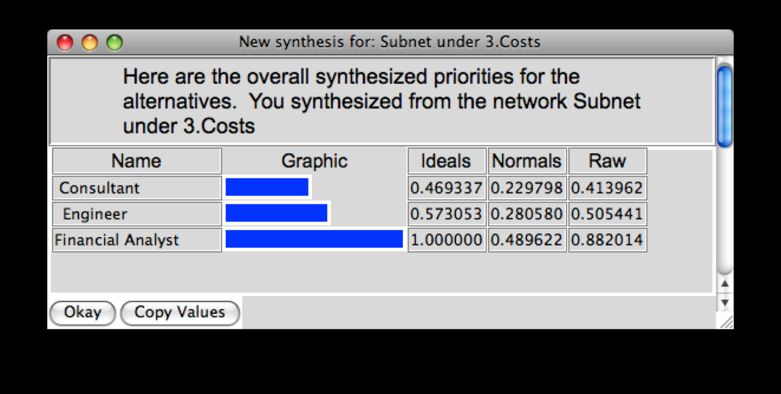

2.1.4 Risks

In developing and evaluating the Risks portion of the BOCR model, it was assumed that these referred to the more long-term negative aspects related to the alternatives and control criteria. As a result, the sub-criteria were selected and compared accordingly. It is worth noting that, similar to the cost section, the highest priority outcome of the synthesis results will be the alternative with the greatest long-term negative impact, and as a result, is the least desirable alternative. However, that alternative will still be the one used at the end to come up with ratings against each of the strategic criteria with regard to costs.

Company. Company criteria deal with the overall status and characteristics of the company within which the specific job is held. With respect to risks, the sub-criteria that were chosen are company size and industry growth. Specifically, the risks of being in a small, medium, and large company were evaluated. In addition, the level of industry growth was measured and compared according to average growth along with above/below average growth.

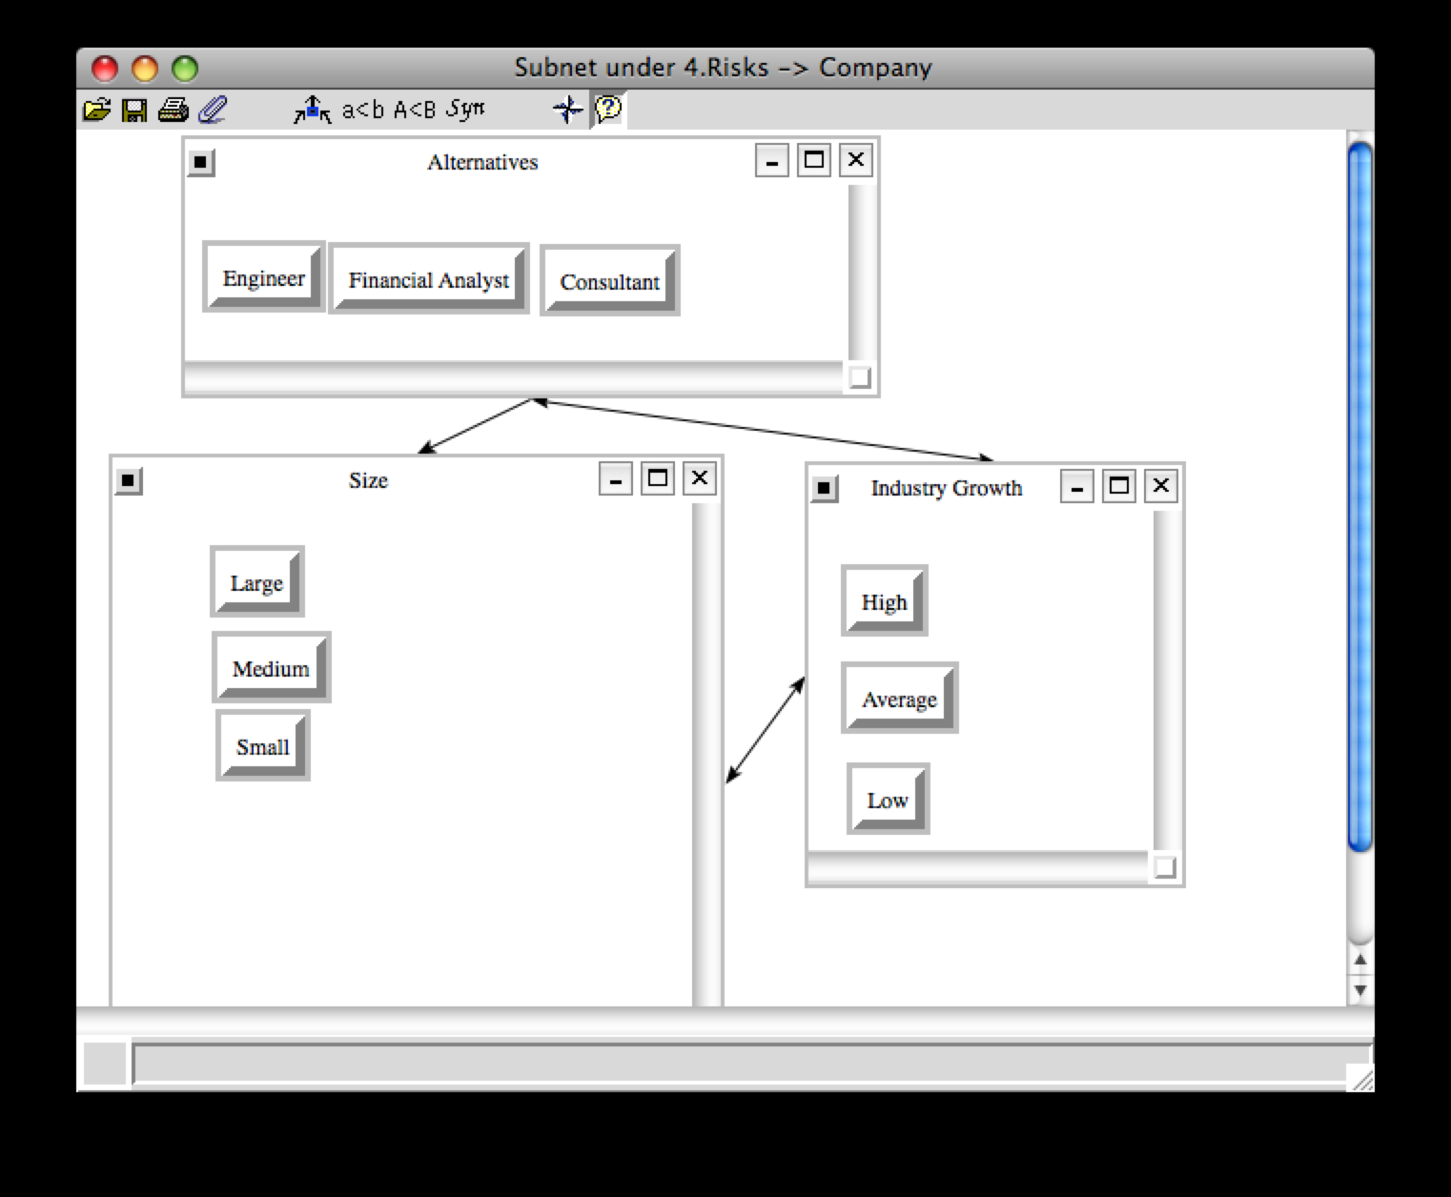

Position. Position is the criteria that deal with that actually characteristics and offerings of the job itself. The sub-criteria selected with respect to risks were advancement opportunity and time requirement. Again, the risks associated with defined advancement opportunity were evaluated against those with potential and unknown advancement opportunity. Also, the risks of working a job on average less than 40 hours/week, between 40 and 50 hours/week, and greater than 50 hours/week were analyzed.
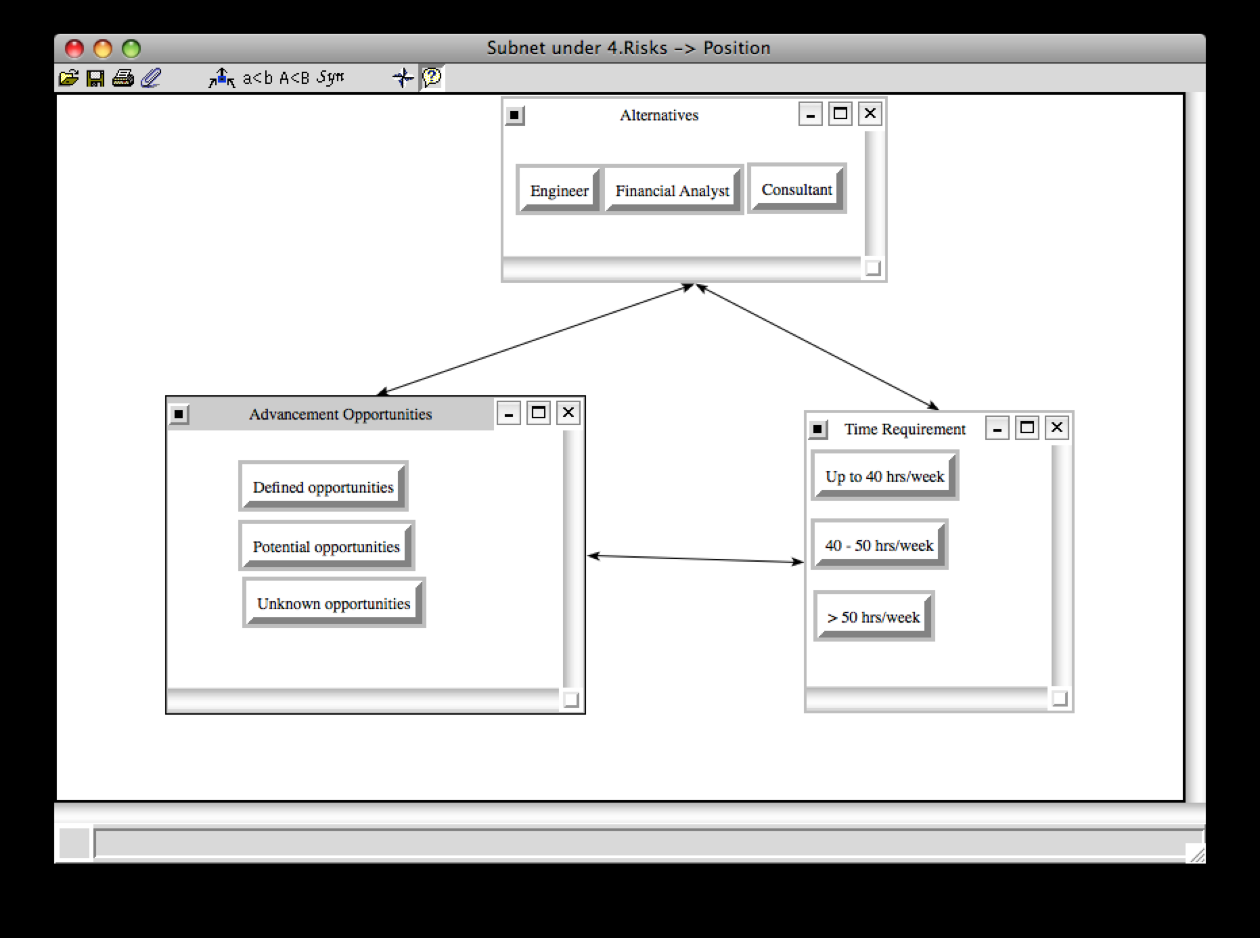

Benefits. Benefits refer to the perks offered with most positions within most companies, such as insurance coverage, retirement plans, etc. With regard to risks, the sub-criteria chosen based on their appropriateness were retirement offerings and professional development. The various choices for retirement sub-criteria were full pension, 401K with matching contributions, and no retirement plan offered at all. With regard to professional development, comparisons were made with respect to risks based on whether or not the company offered programs, and if it did, whether or not the company would fund participation in that program.
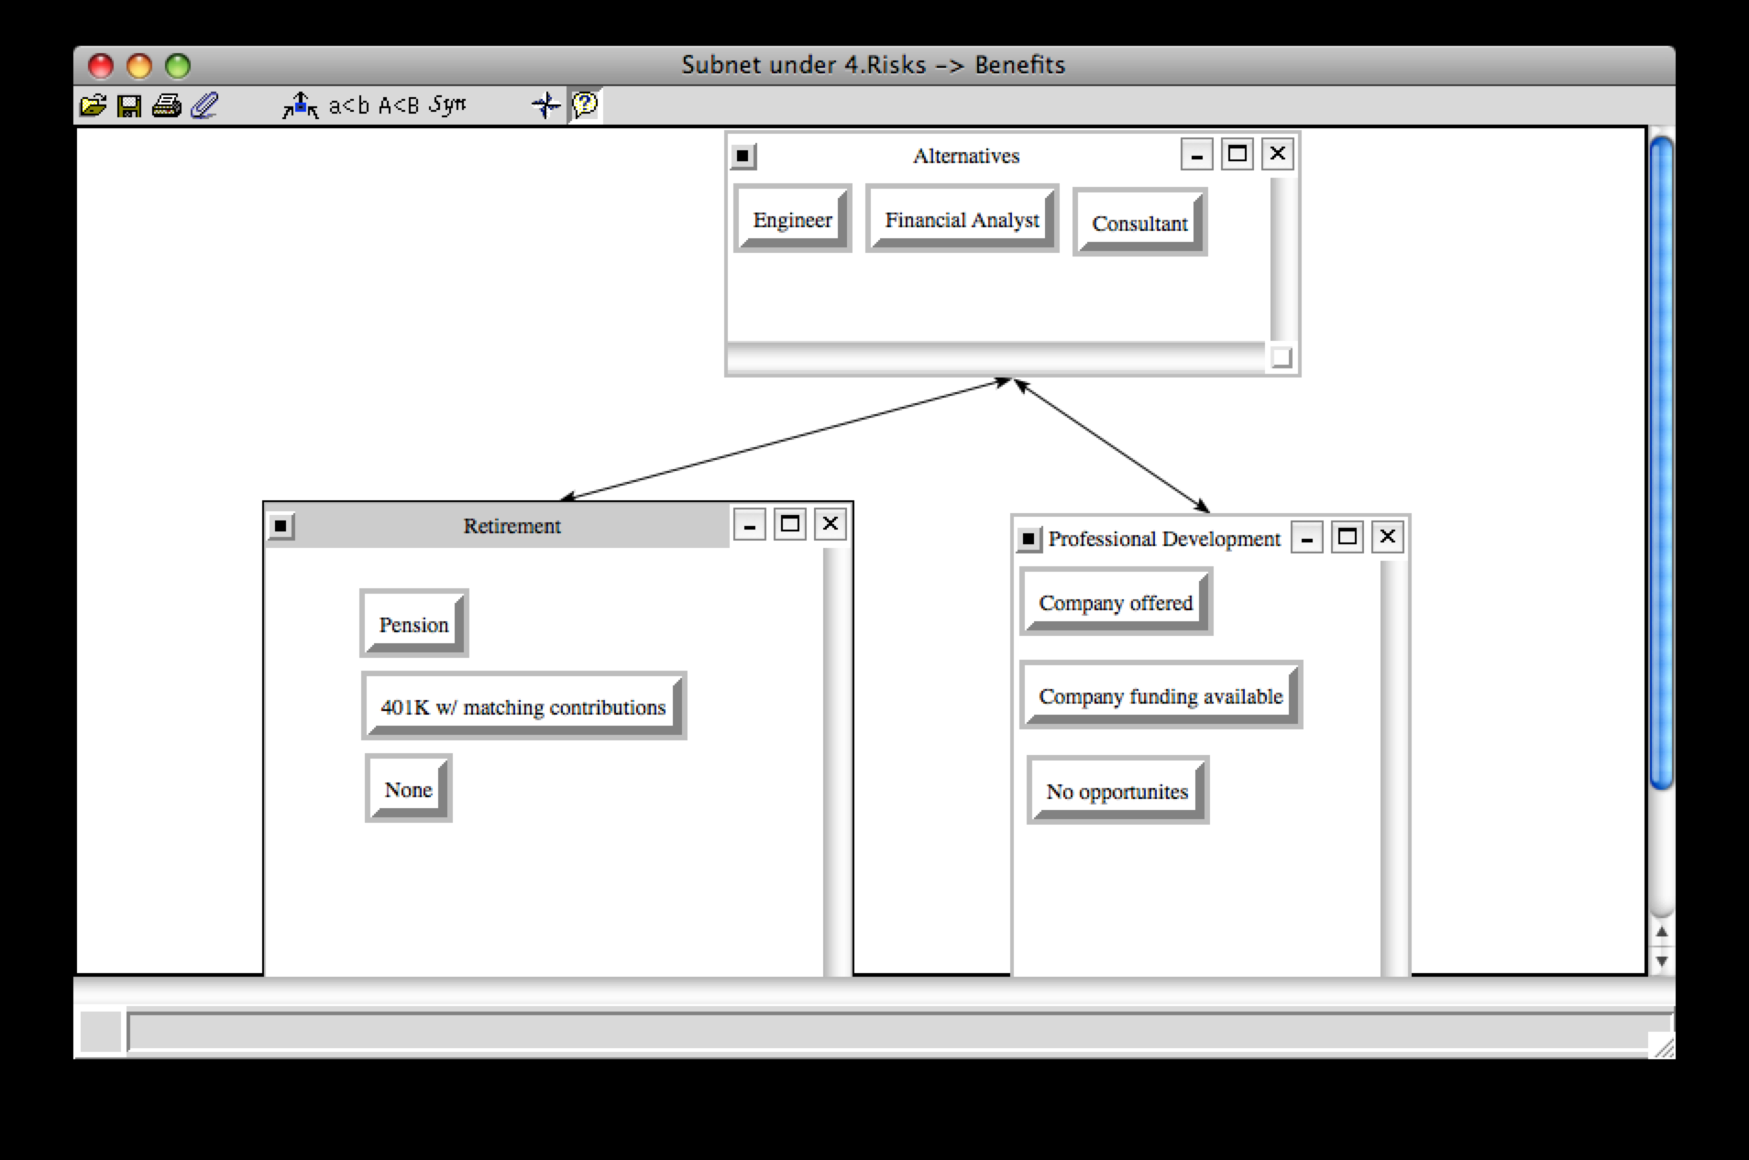

Logistics. Logistics is the criteria that deal with the various commuting and travel factors associated with the job that is being evaluated. From a risk standpoint, the sub-criteria evaluated were commuting method and distance. In the long run, comparisons were made for commuting method based on walking/biking, taking mass transit, driving, or flying. Commuting distance broke down into categories of less than 10 miles, between 10 and 30 miles, and greater than 30 miles each way.
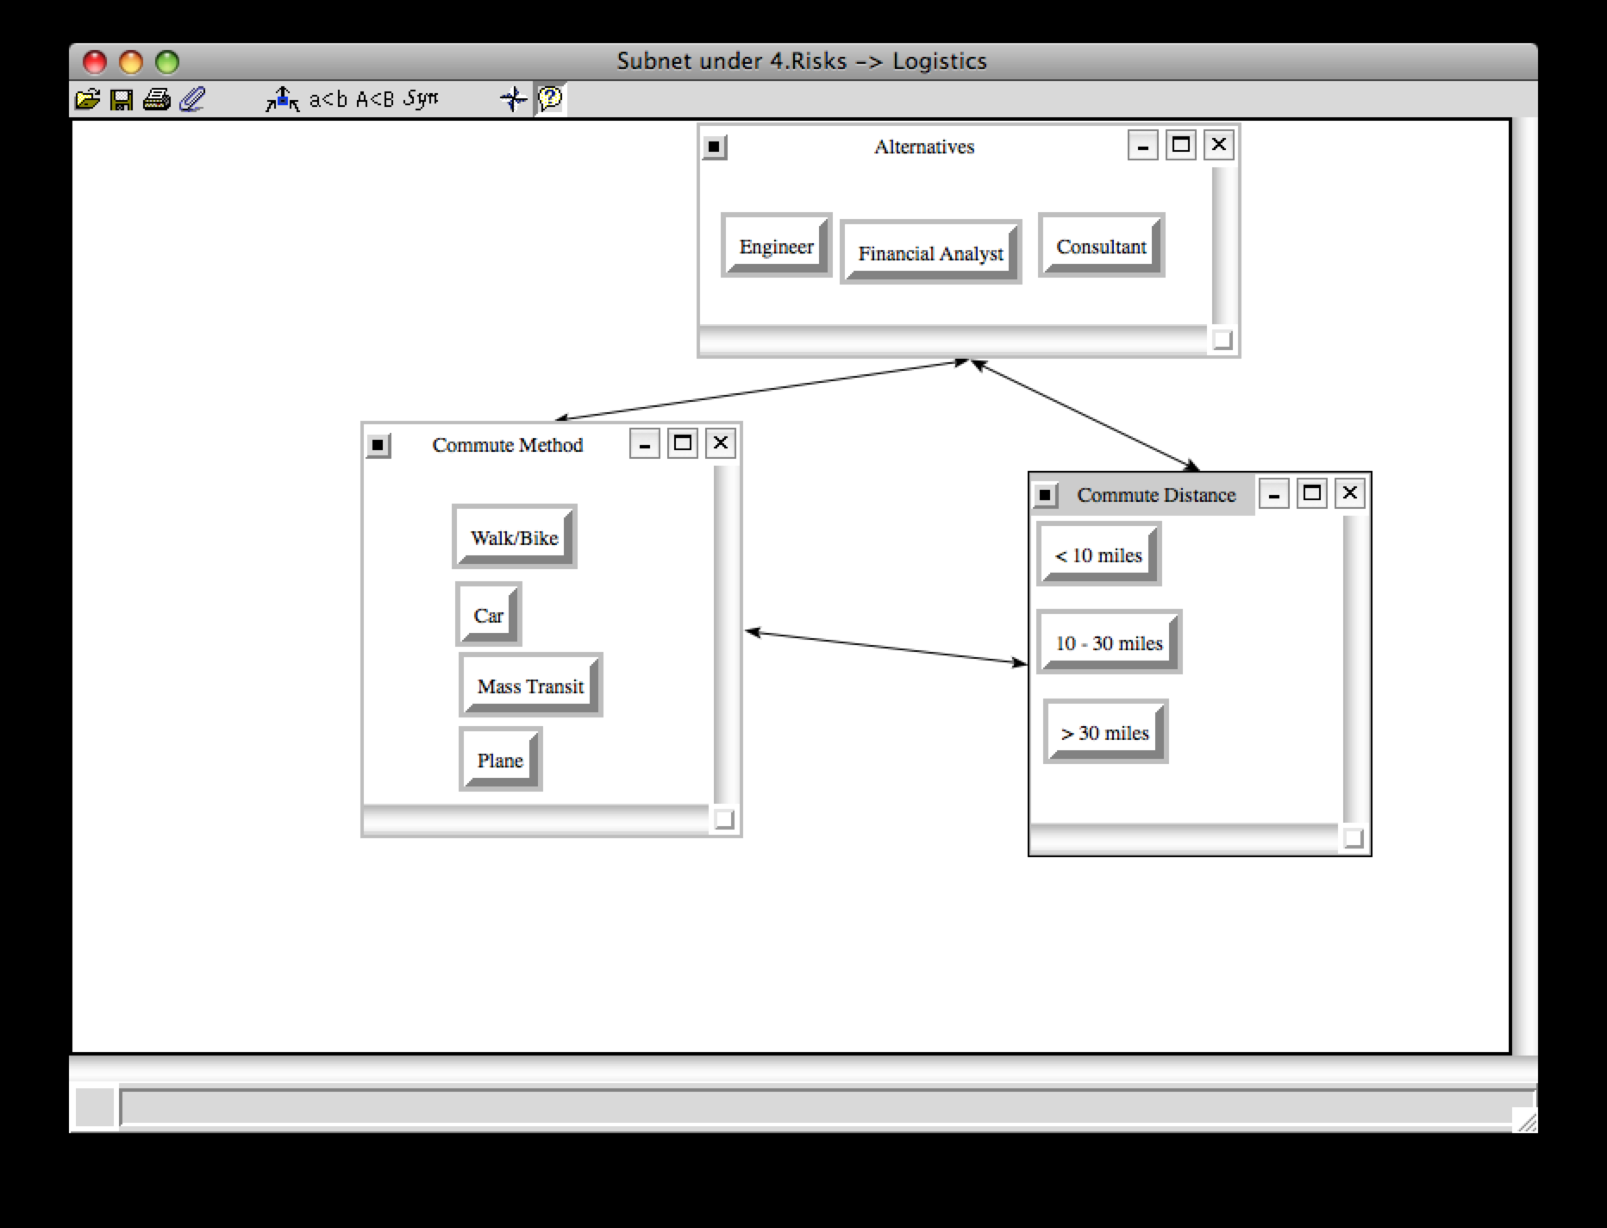

Synthesis Results. It can be seen below that the synthesis priorities of the job selection are greatest with the Consultant job, with an overwhelming ~61%, meaning that it has the highest risk (long-term) impact. Again, in reality the ideal job to be chosen according to the lowest risk would be the one with the lowest risk priority, which is represented here by the Engineer with 14%. The Financial Analyst has the middle priority with 25% priority. As a result of this synthesis, the ratings done in the final step of the model development with regard to risks compared to the strategic criteria will be based on the characteristics associated with the Consultant.

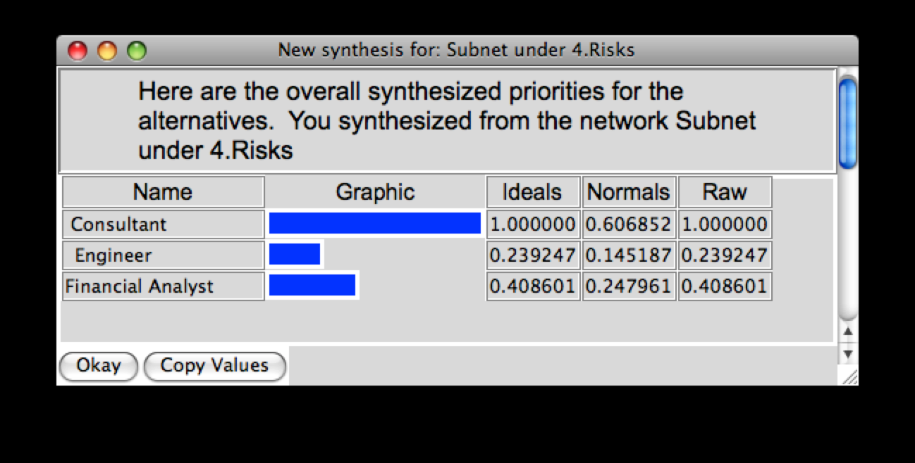

3 Ratings Model

We implemented a ratings system to compare the BOCR against our four strategic criteria: Company, Job, Benefits, and Logistics. These were done based on the level of influence that the specific strategic criteria had on the alternative that was shown to have the top priority value for that particular item (ie. Benefit, Opportunity, Cost, or Risk). In summary, Benefits, Opportunities, and Risks were all rated against each of the four strategic criteria against the characteristics of the Consultant job, because that was the alternative that had the highest ranking in each of those three models. For the Costs, however, the financial analysis job was used to develop the rankings. The table below summarizes the results.

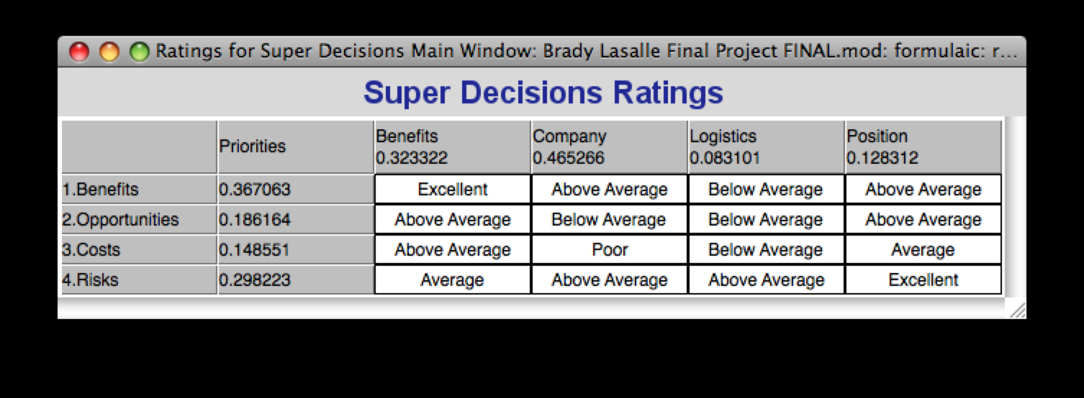

In addition, the table also lists the relative priorities for each of the four model components. As you can see the Benefits model results hold the highest priority with ~37%. From there, the Risks are the next highest with ~30%, followed by Opportunities and Costs with 18% and 15%, respectively. Furthermore, it can also be seen that the strategic criteria are prioritized as follows based on the ratings: Company (47%), Benefits (32%), Position (13%), and Logistics (8%).

3.1 Overall results

The following displays the overall results for the BOCR model based on the various criteria comparisons and ratings applied to the model.

Multiplicative. The multiplicative results, shown below, represent which alternative is best in the short run. It was determined through the model that was developed that the Consultant is the best choice with a priority of 49%. The Engineer (27%) and Financial Analyst (24%) were the 2nd and 3rd best choice, respectively.
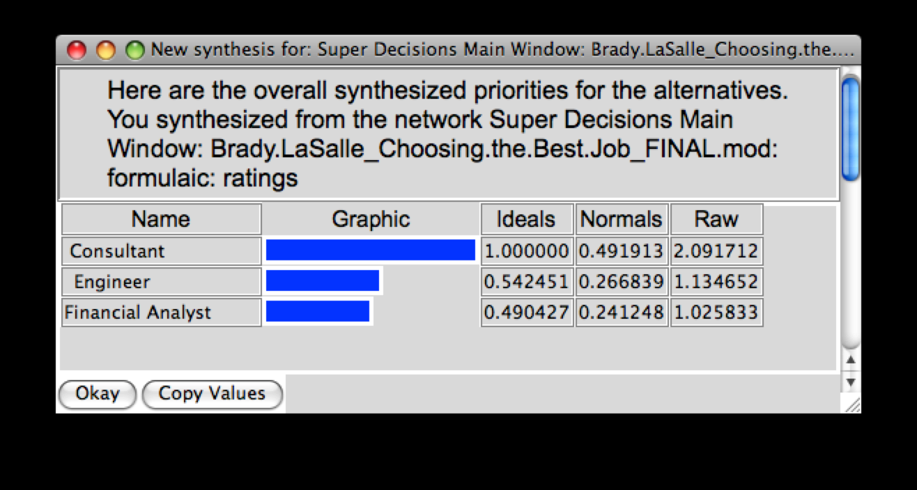

Additive. The additive results shown here represent the best alternative to be selected based more on the long-term net effects. Our model again shows that the Consultant is the best choice, with a priority of 50%. Coming in 2nd and 3rd best are the Financial Analyst and Engineer with 27% and 23%, respectively.
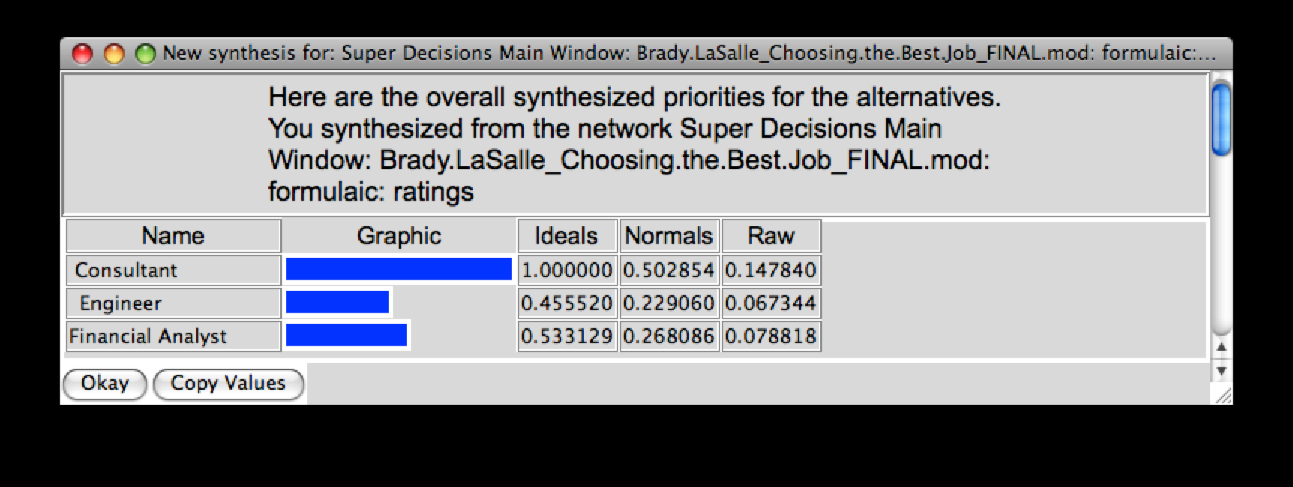

Based on the current priorities given for the BOCR model, it can be seen that the Consultant position would be the best alternative in both the short and long run; this is true by a fairly substantial margin. However, it can be seen that while the Engineer seems to be a more beneficial runner-up selection compared to the Financial Analyst in the short-run, the Financial Analyst position surpasses it in the long run.

3.2 Sensitivity Analysis

The following sensitivity analyses graphs show the priority relationship for each alternative as the priority for the benefits, opportunities, costs, and risks change. Each one will be evaluated and discussed relative to the impact of a changing priority and it’s affect on the overall best alternative to choose.

Benefits. It can be seen that, given the current priority for benefits (shown by the dotted line), that the highest priority (best choice) alternative is the consultant. While this remains true for any increase in benefits priority, it can be seen that the engineer becomes the more desirable alternative of the two at around 29% priority for benefits. Furthermore, at around 10%, the Consultant drops below the financial analyst and becomes the least desirable alternative.
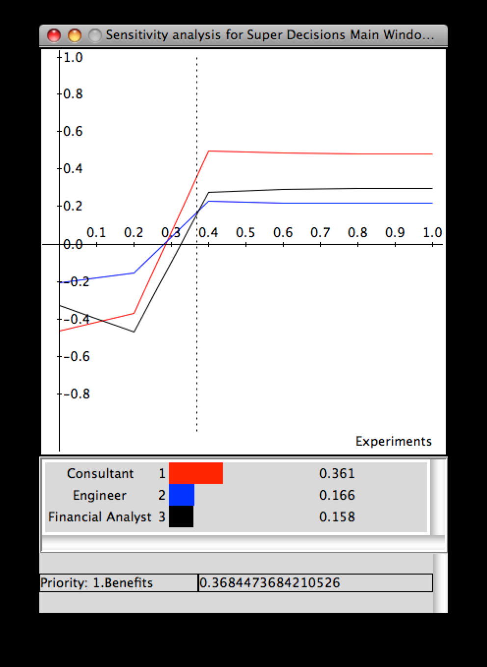

Opportunities. Based on the chart below, it can be seen that the Consultant position remains the top choice with regard to opportunities above an opportunities priority of 10%. However, below 10%, the top choice shifts from Consultant to Engineer.
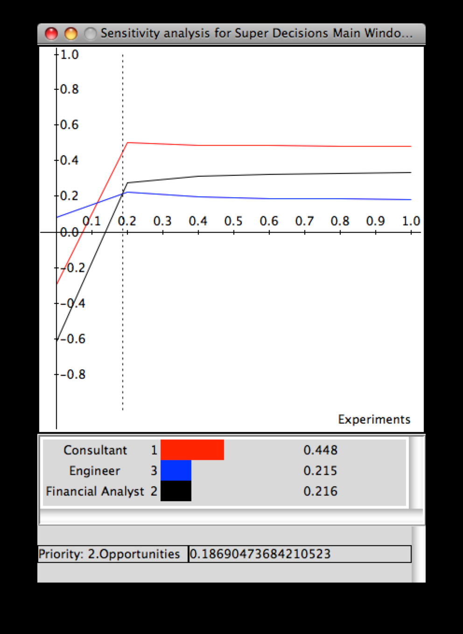

Costs. The sensitivity chart below shows that at the current priority level the engineering job ranks the highest in terms of costs, which makes it the least desirable. At the current priority, the Financial Analyst is the most desirable job because it has the lowest priority; however, below 10% the most desirable becomes the consultant, while above 39% yields the Engineer as the most desirable alternative with respect to costs.
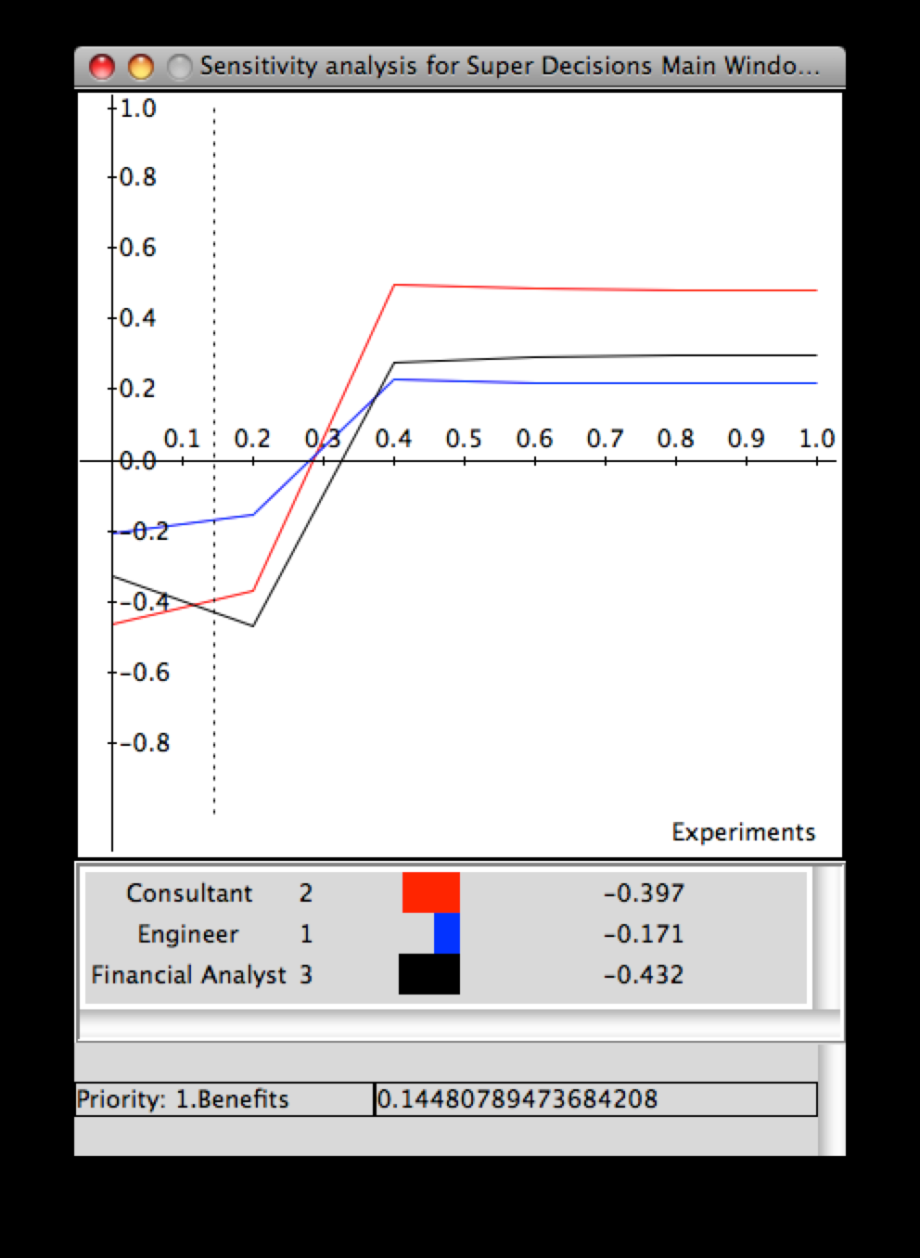

Risks. The consultant holds the highest priority (and thus, is the least desirable) while the Financial Analyst has the lowest priority (and is, thus, the best alternative relative to risks). However, from 35% to 40% risk priority, the Engineer becomes the least desirable while the Consultant becomes the most desirable.

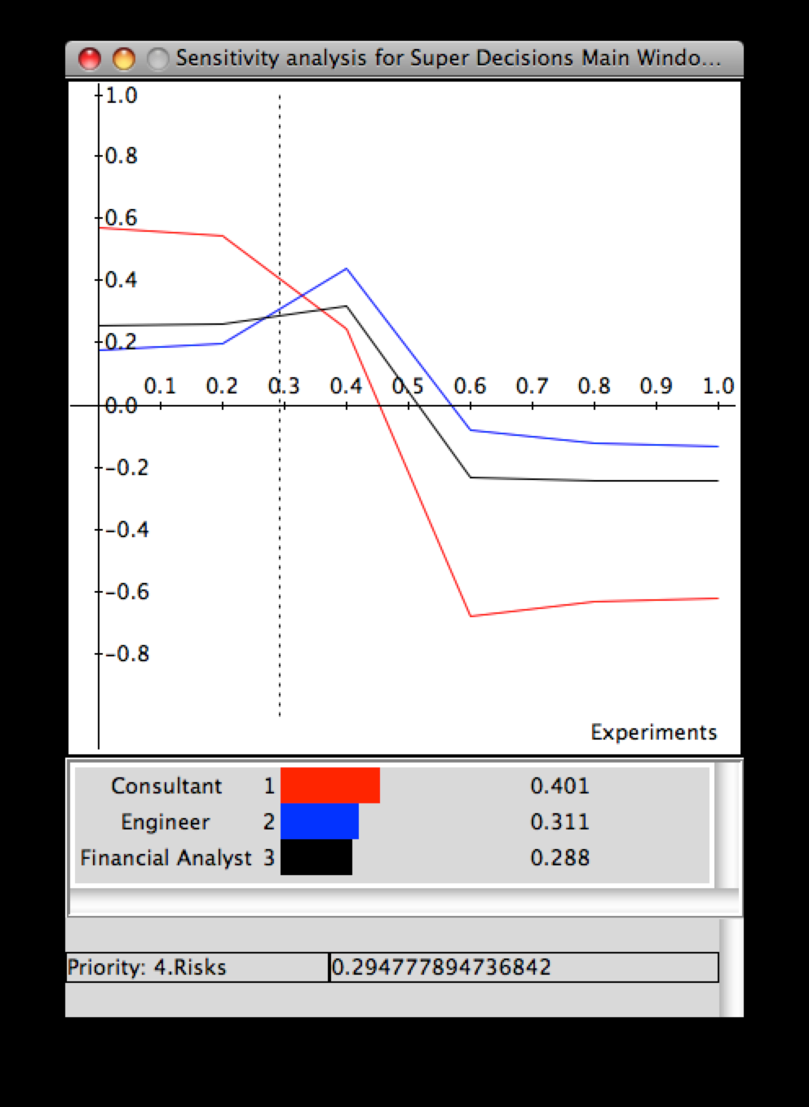

4 Conclusion

In conclusion, the BOCR model that was developed shows that the top choice in jobs out of the three alternatives considered was the consultant, both in the short run and in the long run. Even though the margin for this decision was fairly significant, the sensitivity analysis shows that a shift in priorities amongst the benefits, opportunities, costs, and/or risks could significantly alter the results. Furthermore, it is important to keep in mind that for a decision like this that is based so much on personal preference, that the same model used by someone with different tastes could easily have a different outcome, based on the differing comparison rankings that would be given to the various control criteria and sub-criteria.

