Renato Cozzarelli
Assignment 1B

The following report’s purpose is to walk through a decision problem, the criteria to make that decision, and the alternatives. It will outline the steps taken and contain screen shots from the SuperDecisions software which was used to model this problem. It will also include accuracy and sensitivity analysis as well as my prediction before running the model and then analysis of the results.
I just got engaged a few months ago and am trying to plan my wedding with my fiancée. The first big hurdle we must clear is to pick a venue to host our wedding reception. This is the decision problem I will attempt to solve. My goal is to pick the venue for us and our guests. We have done some initial research and have three venues types (alternatives) we found: Resort, Hotel, or Studio. We identified six criteria categories for judging a venue: cost, size of venue, food options, ease of access, housing, and atmosphere. The first two categories are self-explanatory. Food options rates the number of caterers available for us to choose. Some venues restrict what catering services can be used. Ease of access rates how many different ways guests can reach the venue (plane, bus, uber, drive, etc). The housing category estimates approximately how many guests can stay at the venue. Finally, atmosphere subjectively rates the venue for how it looks.

In the table below, are classifications and/or ratings we found from our research.

Categories | Resort | Hotel | Studio
Price (per 100 guests) | $30,000 | $15,000 | $6,000
Size | 400 | 300 | 200
Food Options | 1 | 6 | Any vendor
Ease of Access | Difficult | Easy | Easy
Housing | All | Half to Most | None
Atmosphere | Excellent | Good | Average
Table 1 Relevant ratings and ratings assigned based on research.
Using SuperDecisions software, the AHP model was created connecting the Goal (1) to the Criteria (6) to the Alternatives (3). Figure 1 shows a copy of this model. The atmosphere tab cannot be seen so it was shown on the side.

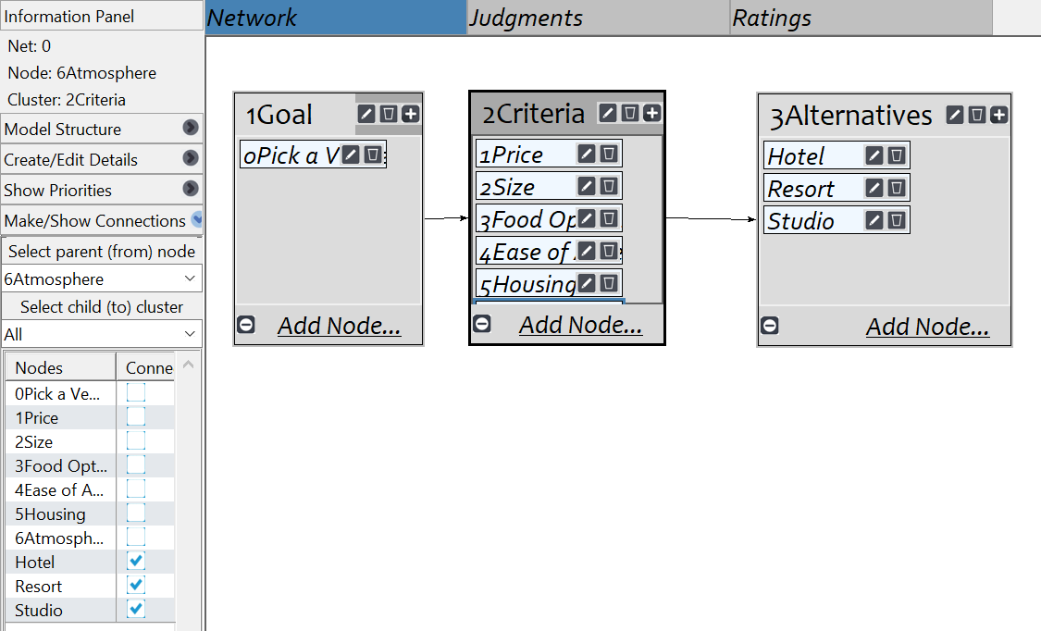
Figure 1 AHP Model showing link from goal to criteria to alternatives.

After properly linking my model, the next step was to make judgements on my criteria in order to establish the most important factors. I made these pairwise comparisons using the questionnaire tab which shows the results in Figure 2. Price and food are very important to us. We would like to bring in various types of food so the more caterer options we have the better. We also would like to keep the cost down. Ease of access for is also important since we will have a lot of guests from out of town. We would like them to have many options to get to the venue (plane, train, or uber) instead of being limited to having to drive their cars. Atmosphere is not very important to us because we believe we can make any place fun and exciting. We also do not plan to have a large wedding so the size of the venue is not as important to us. At this point, I also checked the inconsistency of my ratings. After some tweaking, I was able to get my inconsistency value below 0.1. The section was marked complete and I was ready to begin my criteria ratings for the alternatives.

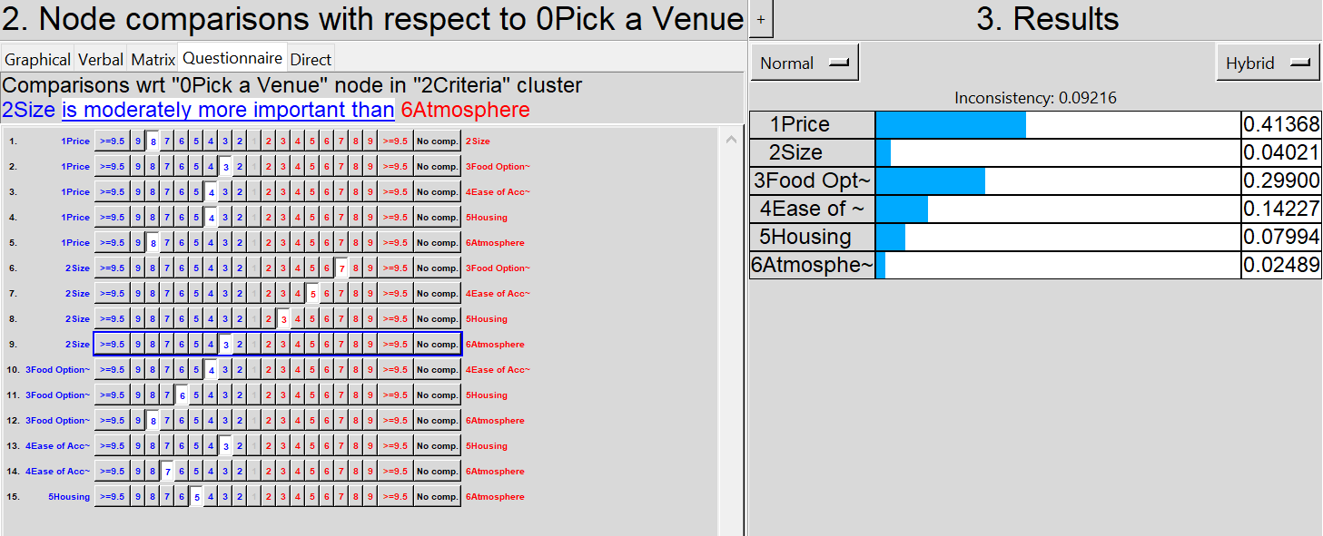
Figure 2 Judgements made on criteria and corresponding results.
For the first criteria, price, I used the costs listed in Table 1 and entered the direct values into the model. I also inverted the data as the cheapest venue is actually the most preferred instead of the most expensive. As expected the studio became the most preferred result. There is no inconsistency because the actual values were entered. The only error here would be due to our research. These results can be seen in Figure 3. The values entered were taken by dividing the cost of each alternative by the total cost of all alternatives.

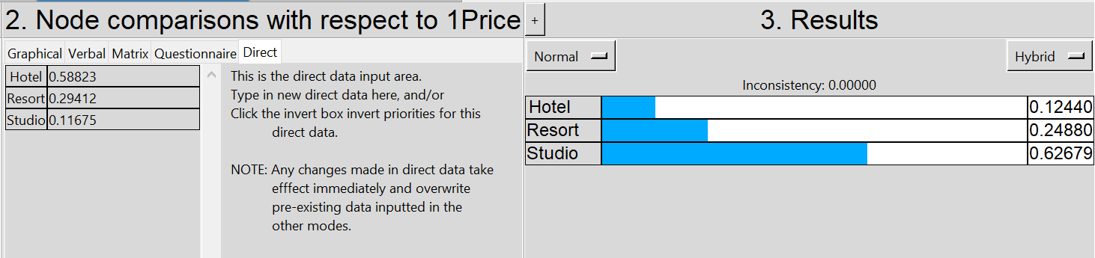
Figure 3 Judgement of alternatives based on price.
The next judgement was related to the size of the venue. We were able to locate approximately the maximum number of guests in these types of venues. Since we do not have a wedding guest list yet, a larger venue gives us the flexibility to add people as needed. In this case the questionnaire approach was used to relate the values to each other. The inconsistency result showed that the inputted data was acceptable and no tweaking was needed. These results can be seen in Figure 4.

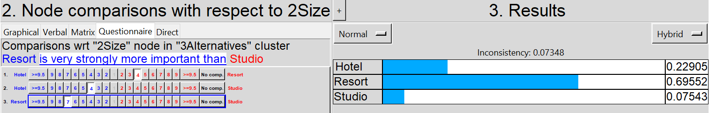
Figure 4 Judgement of alternatives based on size.
Figure 5 shows the judgment values obtained via questionnaire for the food options. Again, information comes from Table 1 which shows the studio has significantly more options since there are no restrictions relative to the other two alternatives. Since unlimited is obviously a much larger number relative to the other two, the comparison between hotel and resort only slightly leans towards the hotel.

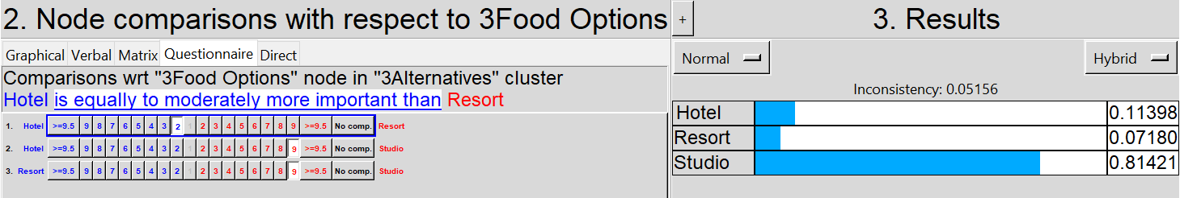
Figure 5 Judgement of alternatives based on food options.
The next judgement was relating to ease of access. All of the hotels and studios we are considering are located in Pittsburgh. This means that our guests have many different ways of getting to this place but pretty much all forms of transportation will get them close to the venue. The slight nod was given to the hotel since shuttles may be available which are not available for studios unless we paid for them. Results for this analysis can be seen in Figure 6.

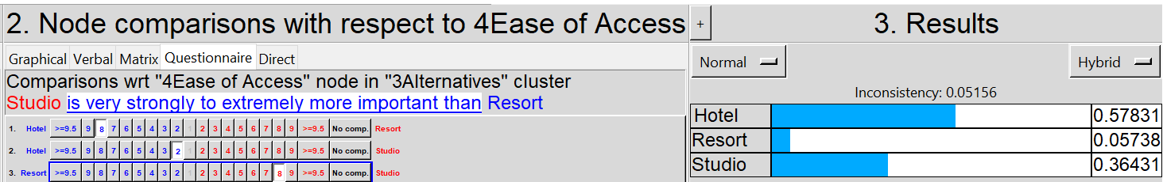
Figure 6 Judgement of alternatives based on ease of access.
Figure 7 shows the judgement results for our fifth criteria, housing for our guests. This evaluation shown in Table 1 is based on the assumption that if possible all guest would want to stay where our reception was held. This assumption leads to the ratings of how many of those guests could stay at the reception location. Since resorts are so large, they can guarantee housing all the guests, assuming there is no other large event that weekend. Hotels give wedding blocks, but some cap the number of rooms they will make available at the special rate and since they are located in the city, there is a chance all guests cannot stay there especially if the wedding guest list is large. For a studio venue, none of the guests can stay there as they have no housing accommodations.

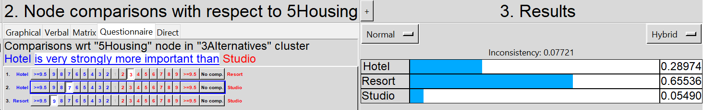
Figure 7 Judgement of alternatives based on housing.
Our last criteria judgement for alternatives was atmosphere. We rated resorts the best since not just where the reception was but the surroundings would make it the best. Hotels were slightly downgraded since when you leave the reception area, the décor and atmosphere significantly drops. Studios by far had the worst rating since it is the reception area and nothing else. These results are shown in Figure 8.

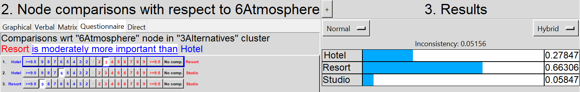
Figure 8 Judgement of alternatives based on atmosphere.
After completing this final step and verifying all the inconsistencies were less than 0.1, a sanity check was done to ensure that there were no errors. Upon completing this, it was now time to synthesize the data and view the results. These can be seen in Figure 9. These results were approximately what I expected due to the price difference and large variety in food options. Since the studios we are looking at are all easily accessible (our third highest priority), it is to be expected that these results would take place. I was surprised that despite the large difference in price, resorts came out slightly higher than hotels.

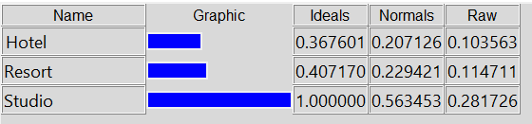
Figure 9 Final results for the decision on the type of venue to pick.
Of course, this analysis is based on our research which generalizes the information. Perhaps if we found a resort or hotel with a much lower price or willing to use any caterer, these results might be different. This is why the sensitivity analysis must be conducted. The results for all 6 can be seen below in Figures 10-15. This shows that as long as price and food remain the most important priorities and no changes are made to the ratings the studio will always be the way to go. The only way to change my choice would be to change the importance of one of the other four categories. This analysis will be more useful when we have actual costs and values for real places. It also shows that if for example all the costs of the venue were acceptable, and price is removed from the analysis, this model would have to be rerun and new results would have to be considered.

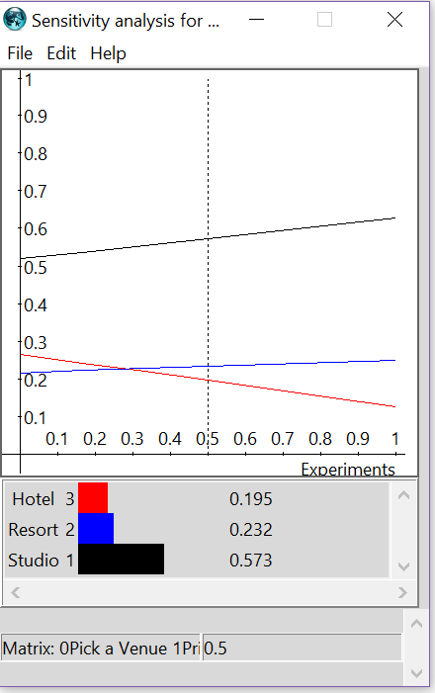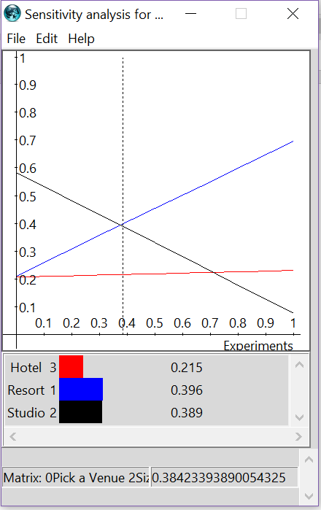
Figure 10. Sensitivity relative to price Figure 11. Sensitivity relative to size

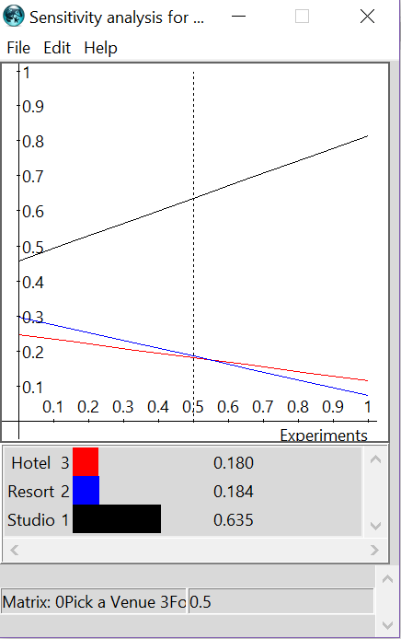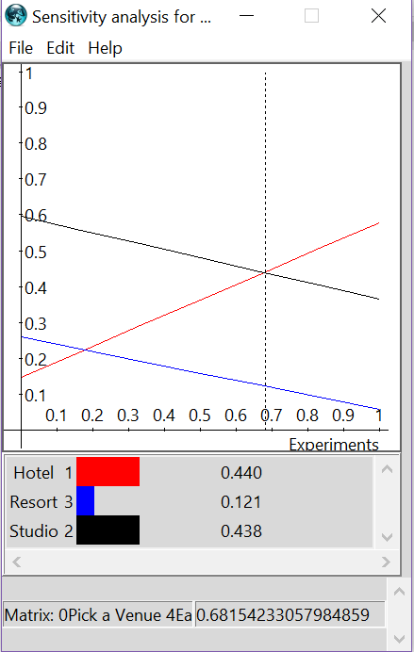
Figure 12. Sensitivity relative to food options Figure 13. Sensitivity relative to ease of access.

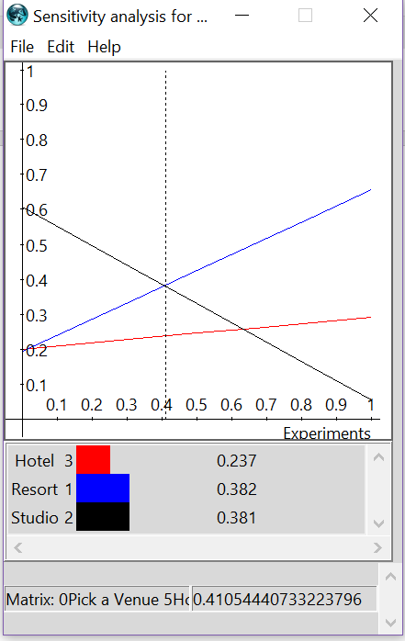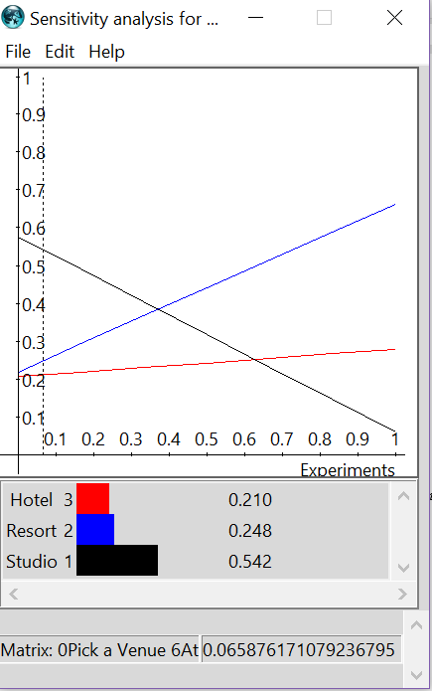
Figure 14. Sensitivity relative to housing Figure 15. Sensitivity relative to atmosphere

