- PROBLEM DEFINITION:

In order to see the Northern Lights in my next vacation, I have to decide which place among 5 different options (Alaska, Canada, Greenland, Norway and Russia) will provide me the best experience.

- CRITERIA DEFINITION:

The criteria that I used in this decision making process were the following:

- Likelihood of seeing the Northern Lights;
- Infrastructure;
- Cost;
- Communication;
- Temperature;

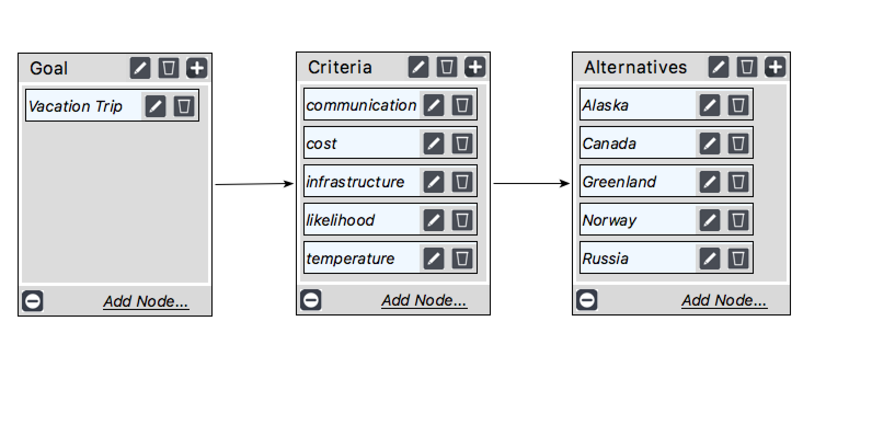

- JUDGMENTS:

  - Definition of the most important criteria:

The screenshot below shows the final priority scores for each of the criteria to be considered in my decision. I entered them using the Questionnaire form of the Superdecisions software. I only took the screenshot of the final result for the sake of brevity.
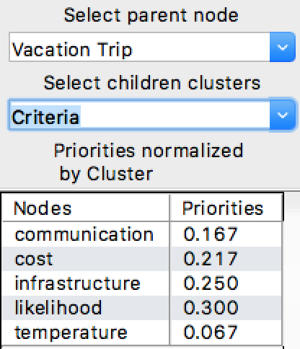

  - Classification of each vacation spot according to the criteria chosen:

The next step was classifying each different alternative according to the criteria chosen. Again, I am only reporting the screenshot with the final priority values for the sake of brevity.

    - Likelihood
The definition of the likelihood of seeing the Northern Lights during December and January was based on research on tourism and weather and climate websites.

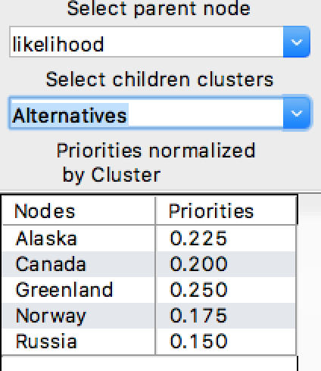

    - Infrastructure
The infrastructure scores for each location was obtained through research on specialized tourism websites. The scores were assigned to specific cities where tourists normally go to see the Aurora Borealis (even though I named the alternatives based on the country / state rather than the city).

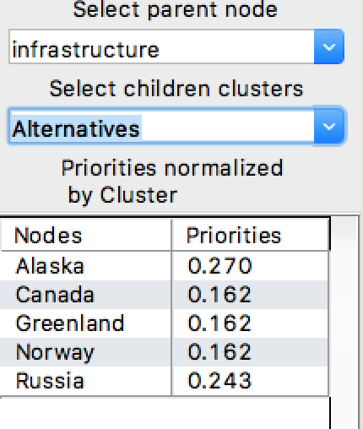

    - Cost

The cost of the stay was based on research on websites. I quoted each different location for the same period of time (December 18th , 2017 to January 6th, 2018) on Expedia and the priorities reflect the average cost for each of these locations.

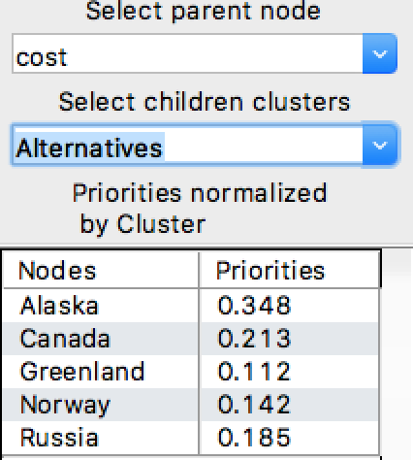

    - Communication

The communication criteria was based on my ability to communicate in each particular destination. Alaska and Canada received the highest scores. Norway was third because 90% of their population speaks English. Russia and Greenland received the lowest scores because there is an estimate that only 30% of the population of these regions speak English and they are probably concentrated in the most densely populated areas.

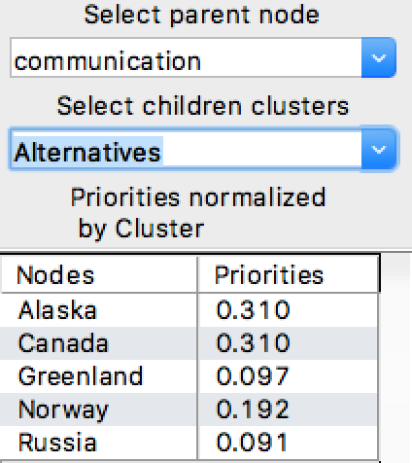

    - Temperature

In order to avoid severe cold, I ranked the least cold places based on the average low temperatures for the period of the trip. The final scores for the priorities are shown below:

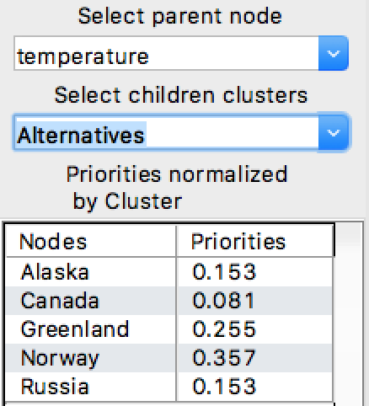

- INCONSISTENCY CHECK:

  - Criteria:

The screenshot below shows that Inconsistency is 0 for the criteria matrix, which is within the 10% margin that is allowed.

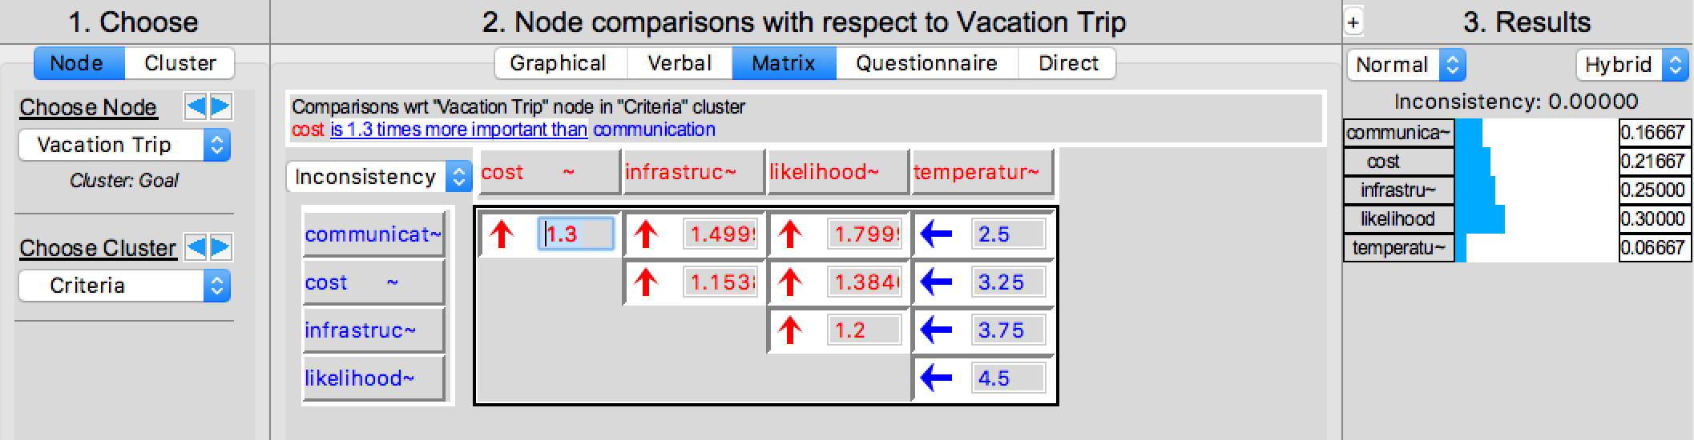

  - Location Evaluation:

When assigning scores for each different location for each criteria chosen, we couldn’t find any inconsistency problem. The highest value for inconsistency was 0.01593, which is way below the 10% threshold.

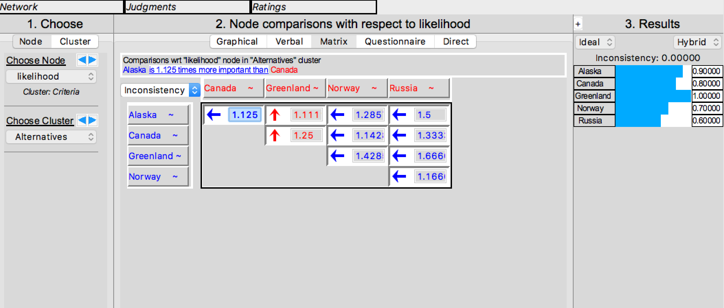

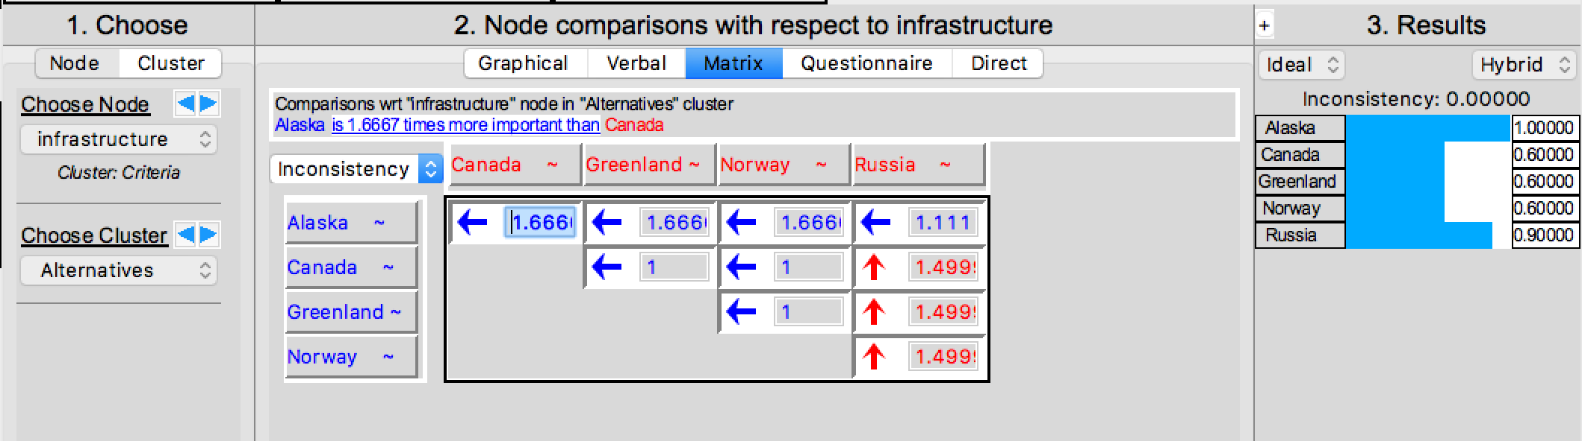

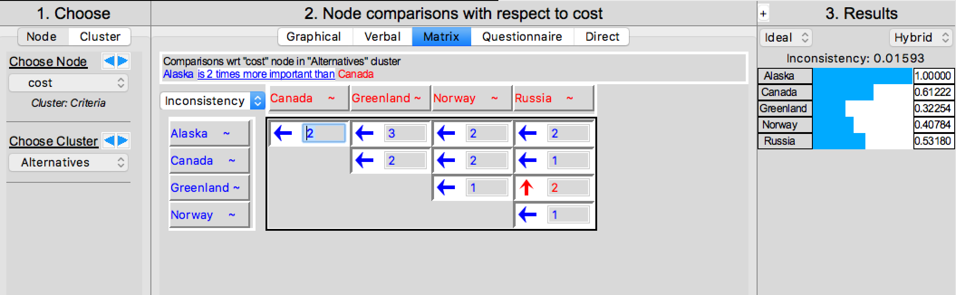

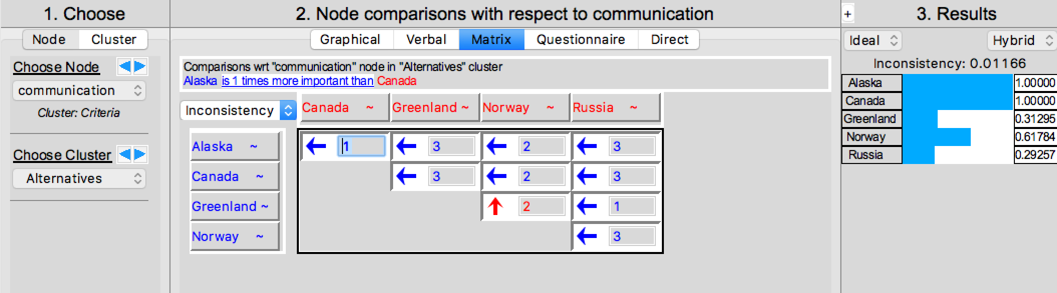

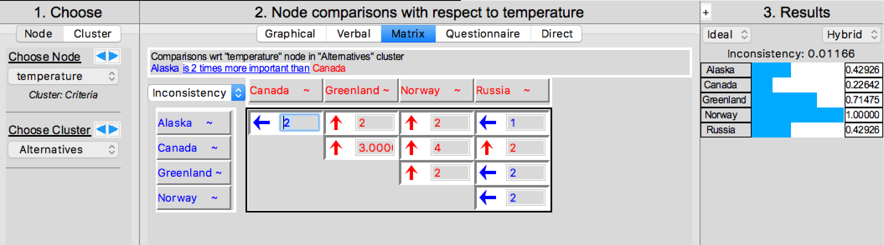

- RESULTS:

Based on the criteria defined and the rankings of each location, the following results were obtained:

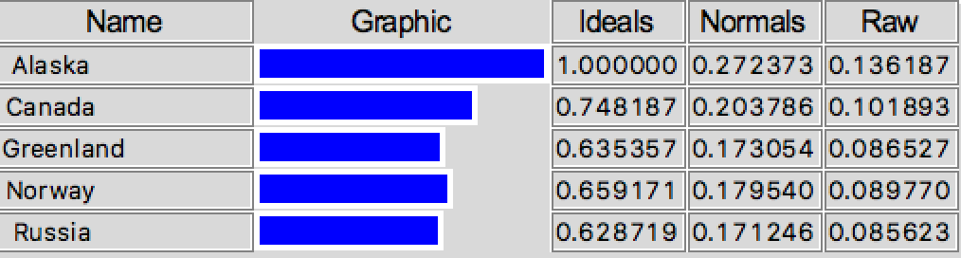

- SENSITIVIY ANALYSIS:

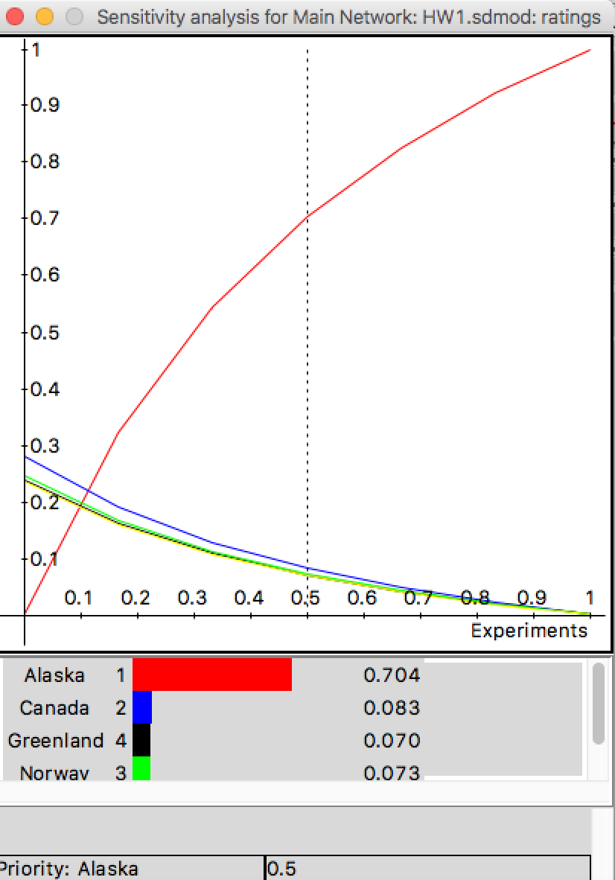

- LIKELIHOOD:

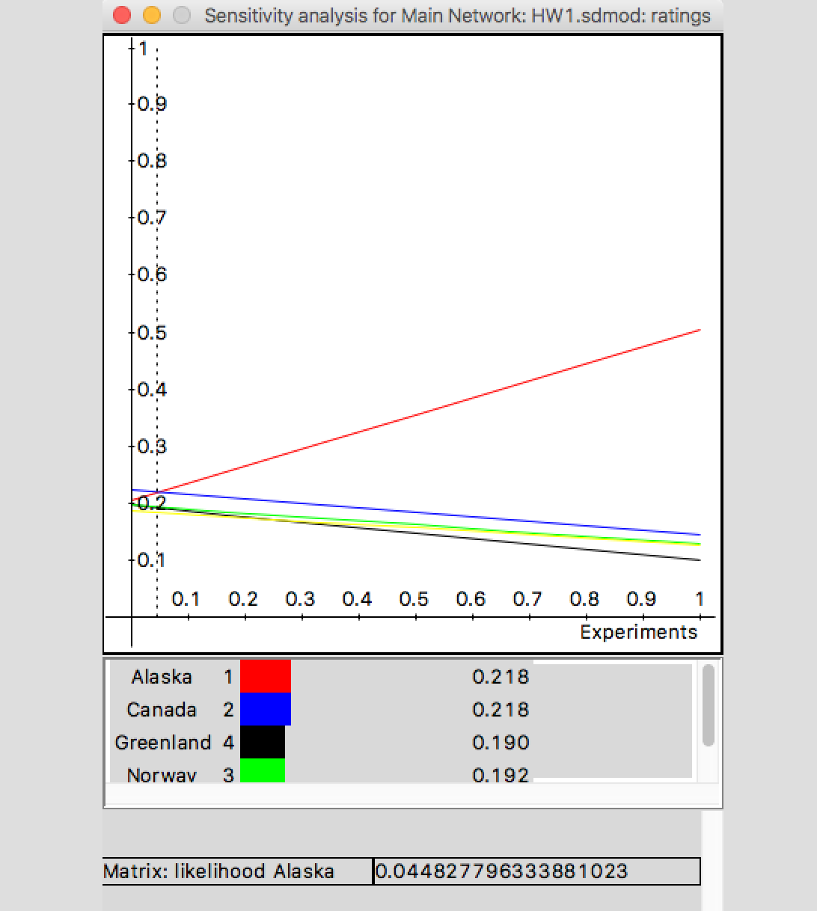

According to the plot above, as the likelihood of seeing the Northern lights increases, the attractiveness of Alaska also increases. In fact, Alaska is the best choice for pretty much the whole range of priority values for this criteria. However, if likelihood scores are lower than 4.5%, Canada becomes the most attractive alternative.
- COST:

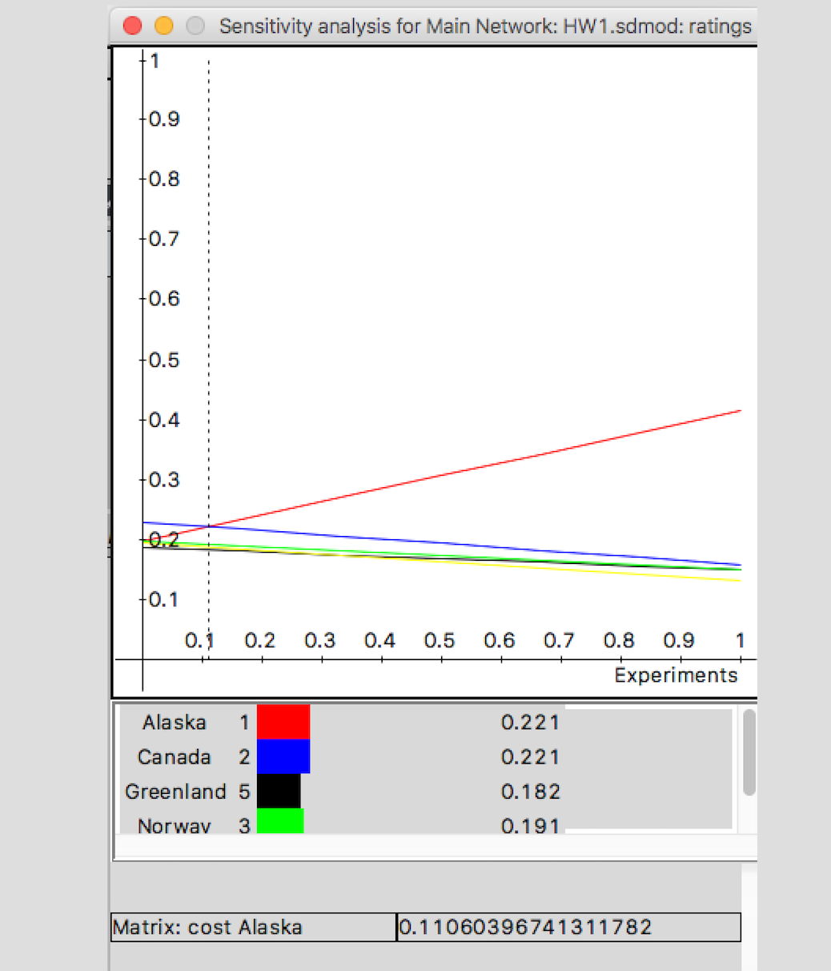

Alaska is also the most attractive choice over most of the priority scores for cost. The turning point is when Cost scores reaches 11%. At this point, Canada becomes the best choice.

- SENSITIVITY NODE ANALYSIS:

- COST:

It was easier for me to visualize the effects of each of the criteria in the decision outcome through the sensitivity node analysis. If cost were the only criteria to be considered, my ranking would be:

- Alaska
- Canada
- Russia
- Norway
- Greenland

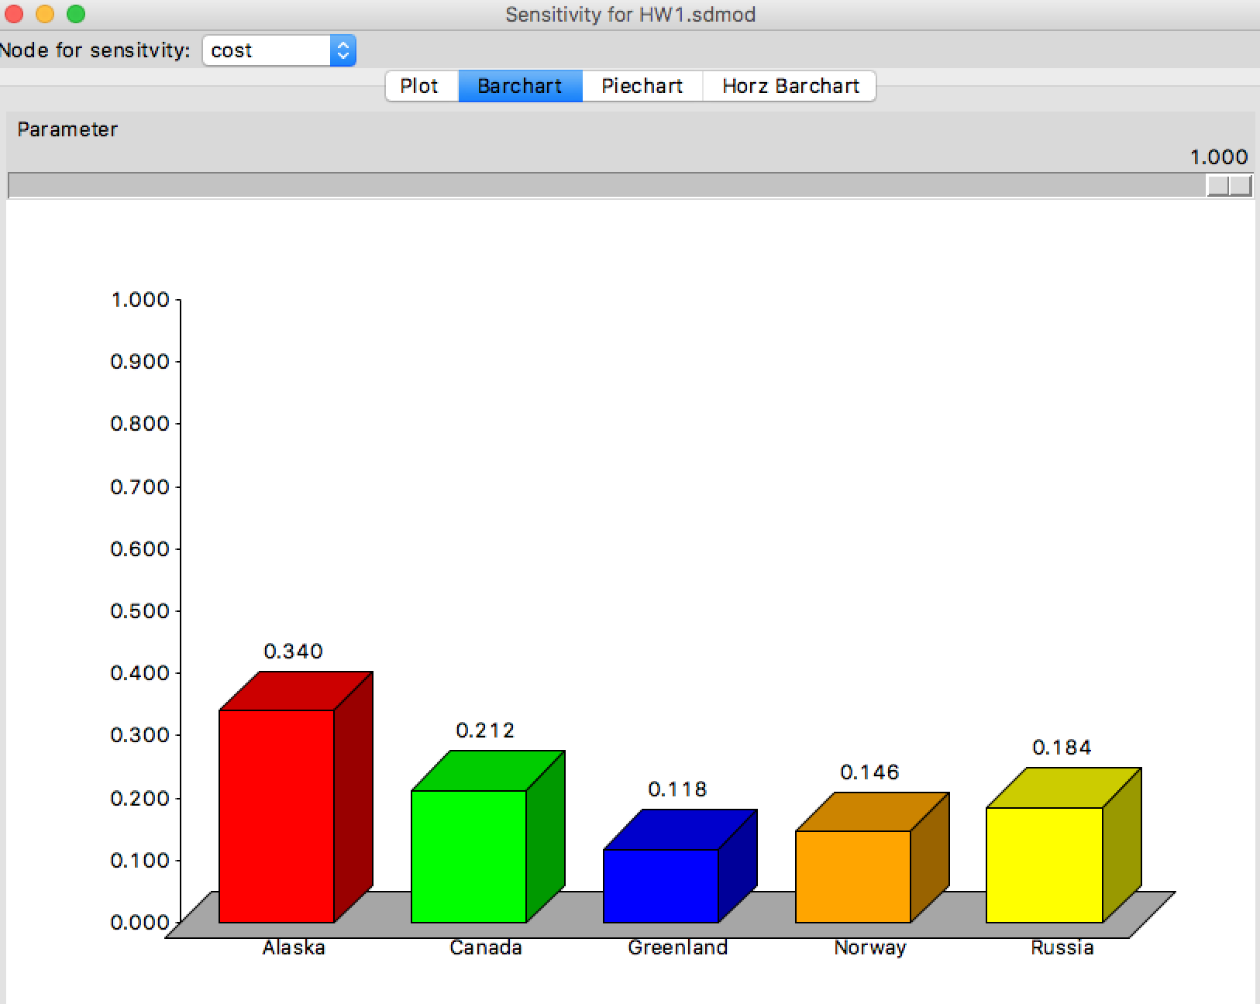

On the ther hand, if cost were not important at all, my ranking would be:

- Alaska
- Canada
- Greenland
- Norway
- Russia

This means that Alaska is still the best choice, even in a scenario where costs are not important. The other choices get relatively more attractive when money is not a constraint.

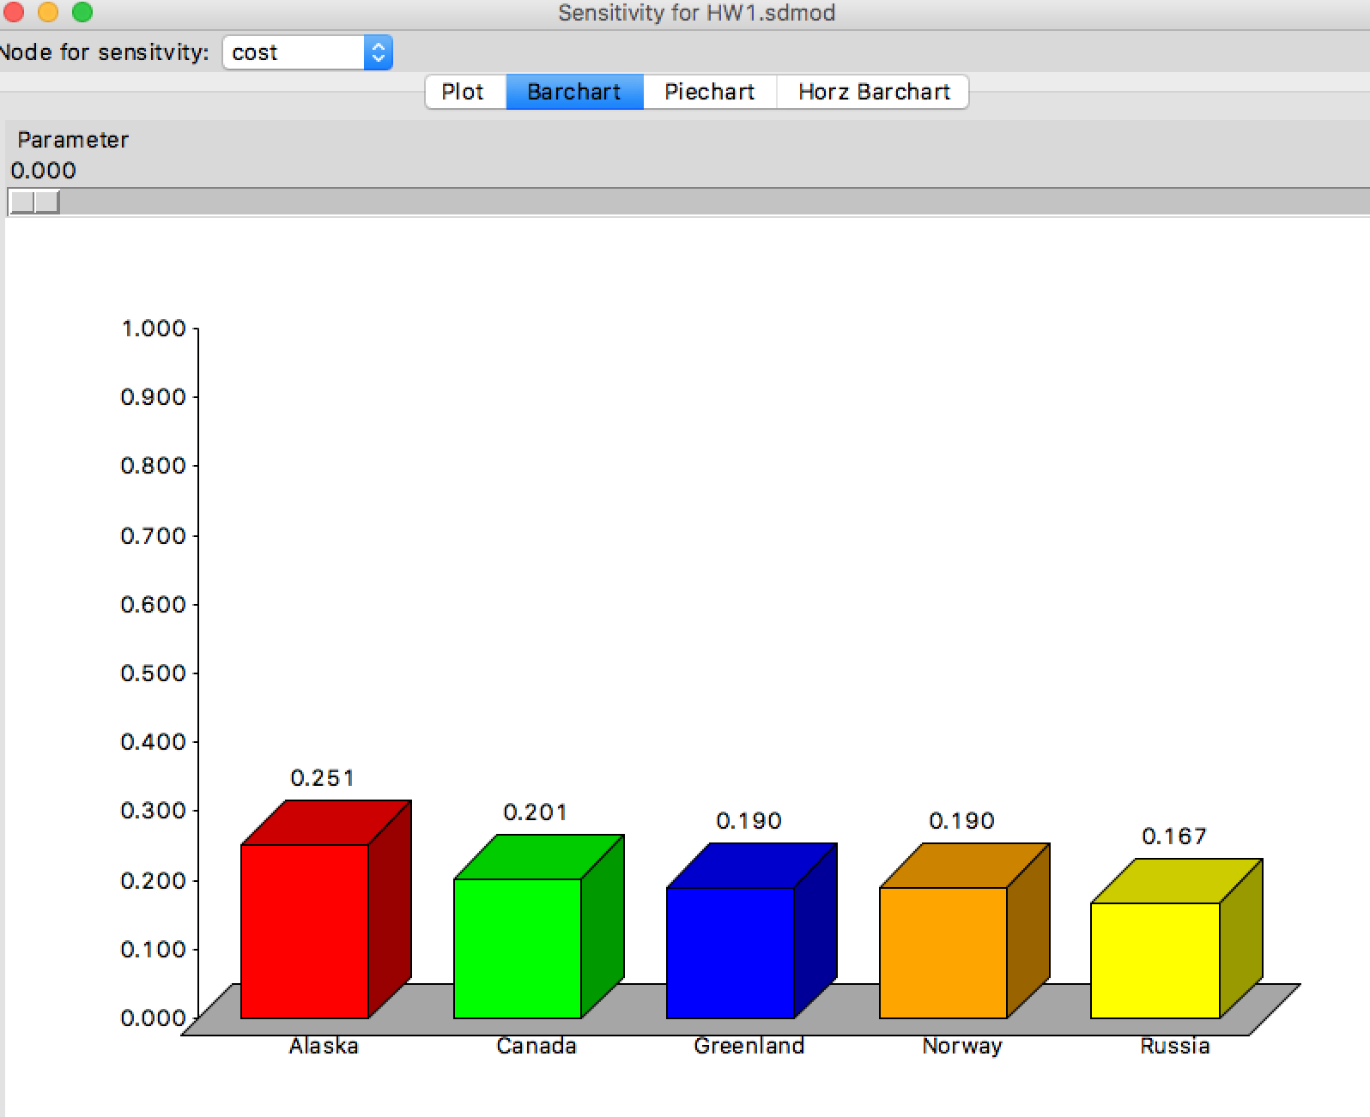

- COMMUNICATION:

If communication were the only criteria to be considered, Canada and Alaska would be by far the most attractive alternatives.

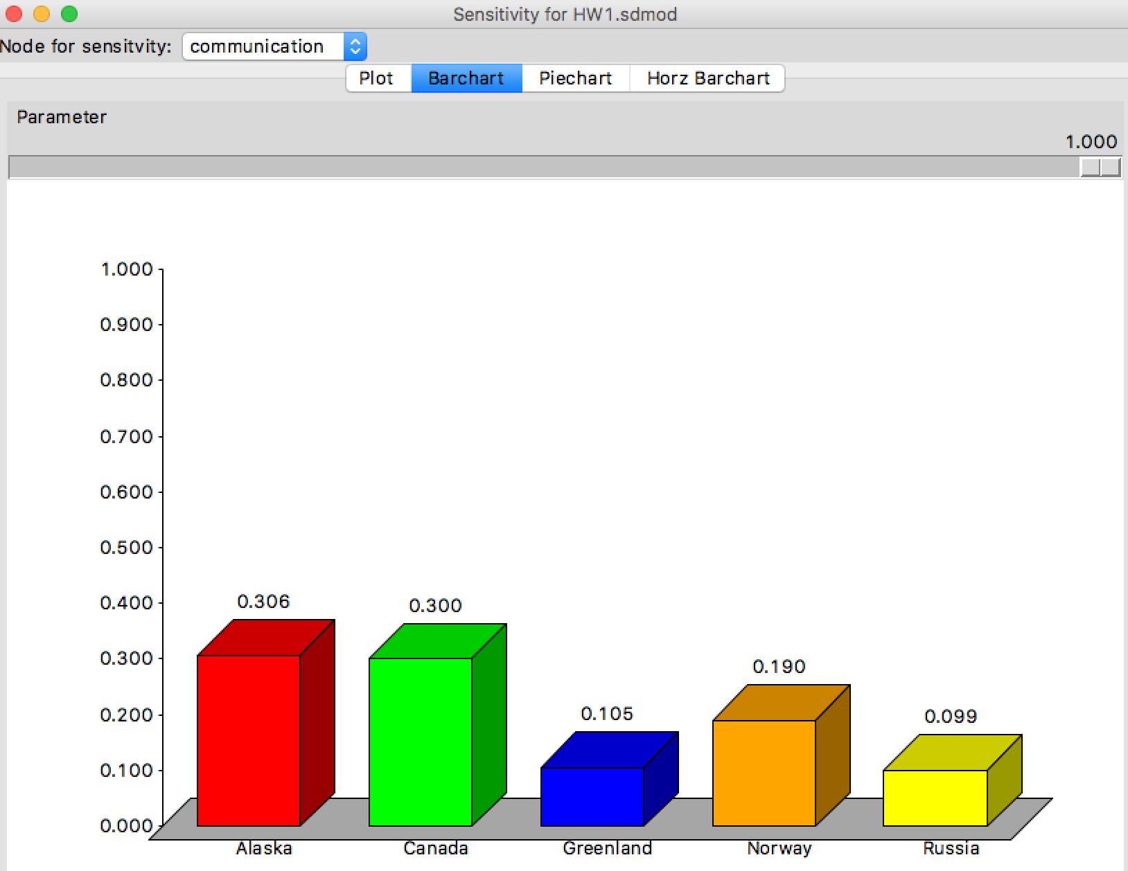

On the other hand, if communication were not important at all, both Greenland and Russia would be better options than Canada. A tourist guide could make the communication aspect of my trip completely irrelevant and then the final ranking would change considerably. Even so, Alaska remains as the best option.

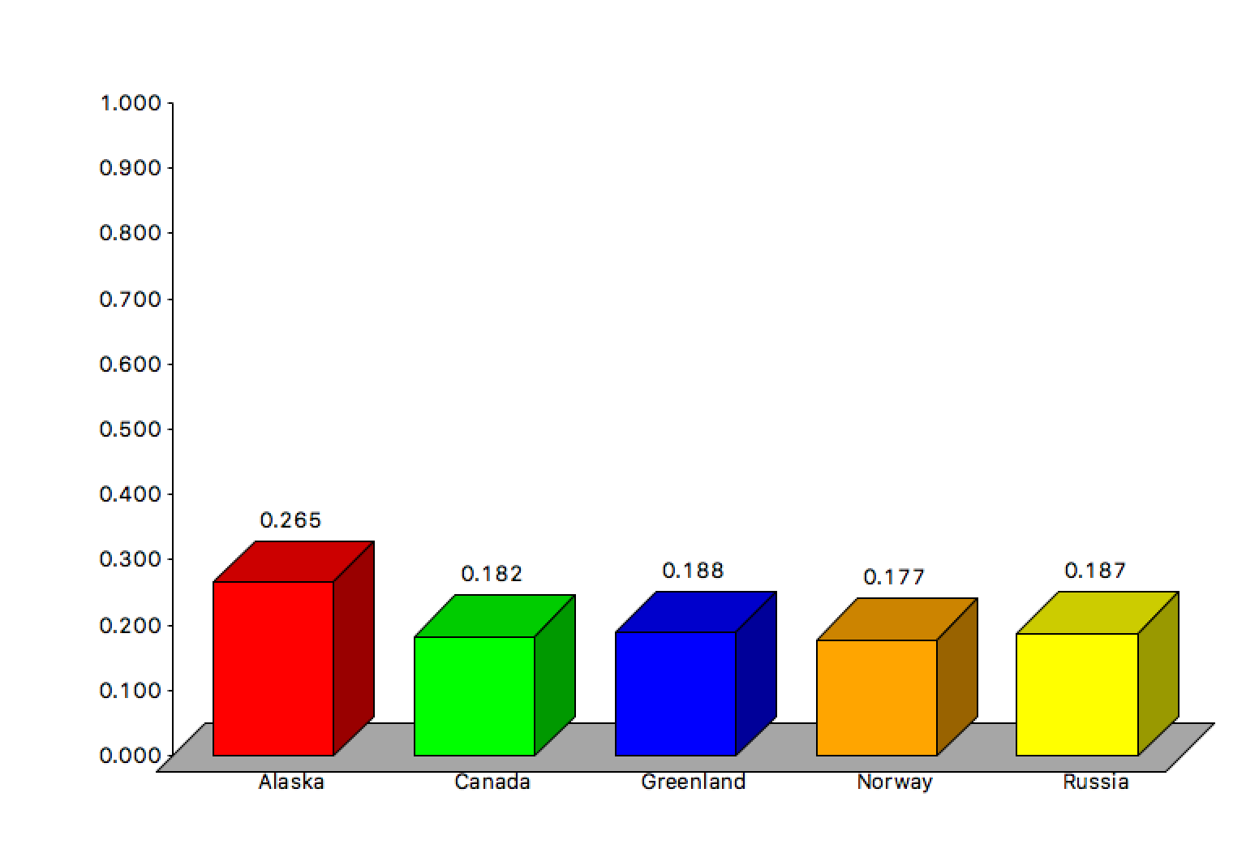

- INFRASTRUCTURE:

Again, Alaska is pretty robust with regard to infrastructure. This destination remains the most attractive whether infrastructure is an important criteria or not.

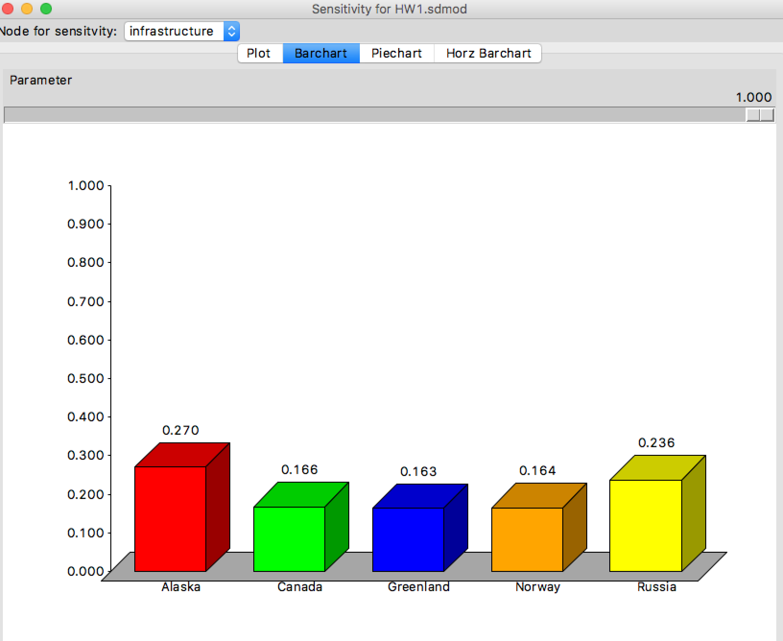

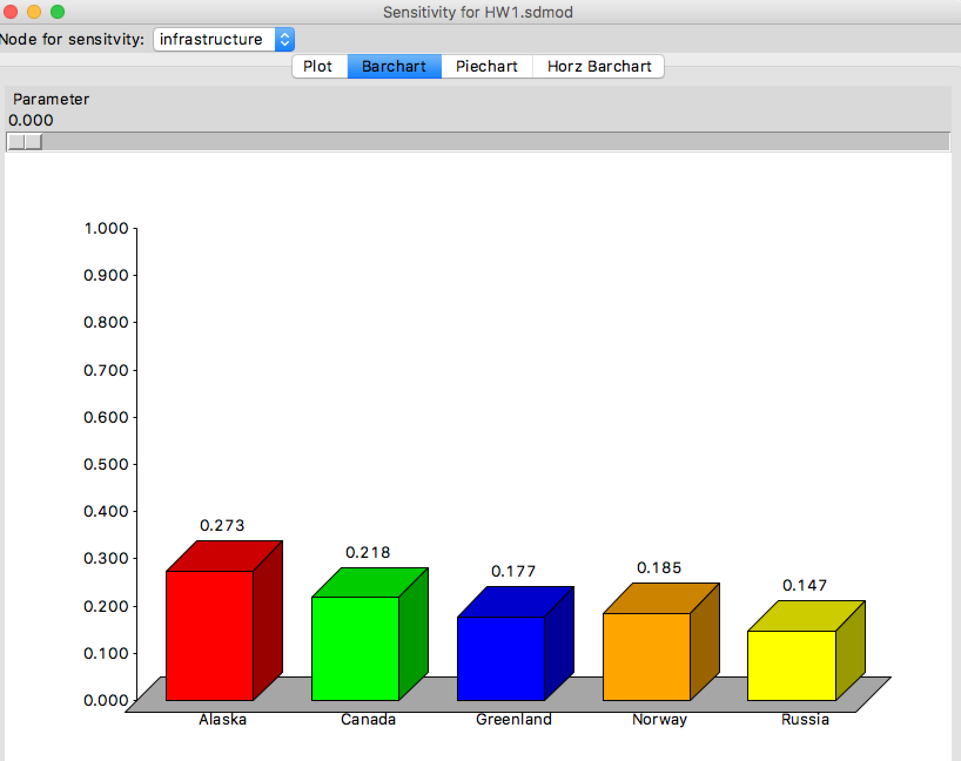

- TEMPERATURE:
If temperature were the only aspect to be considered, the ranking of the best choices would be completely different:

- Norway
- Greenland
- Alaska
- Russia
- Canada

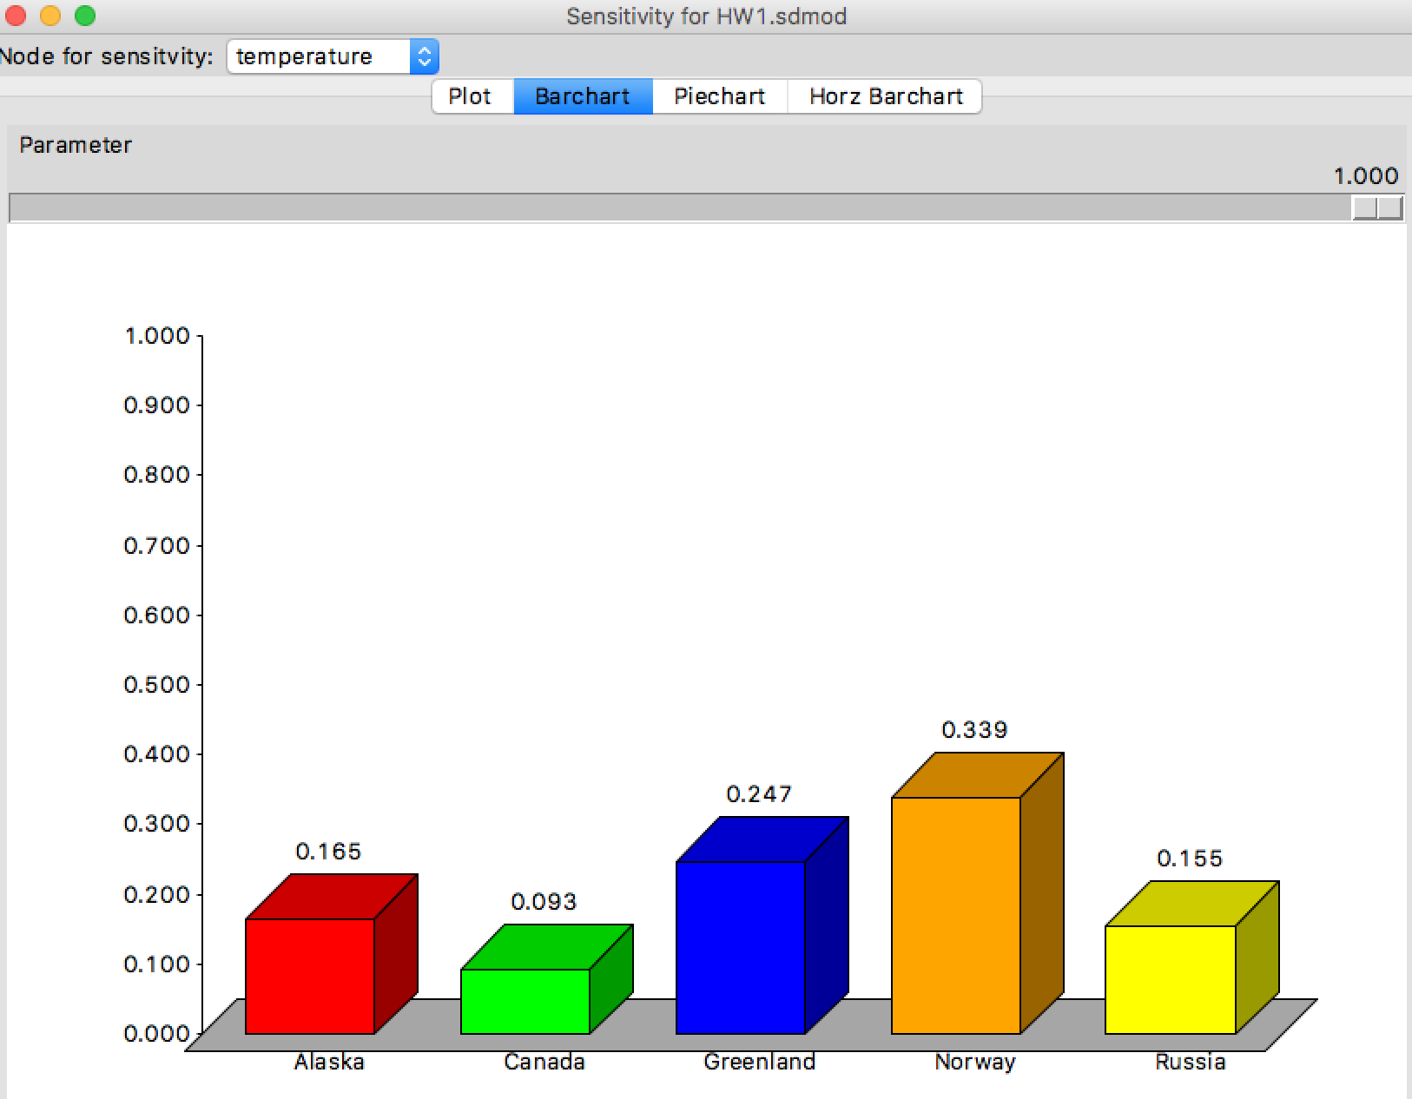

In case temperature is not important at all, then ranking changes completely:

- Alaska
- Canada
- Russia
- Greenland
- Norway

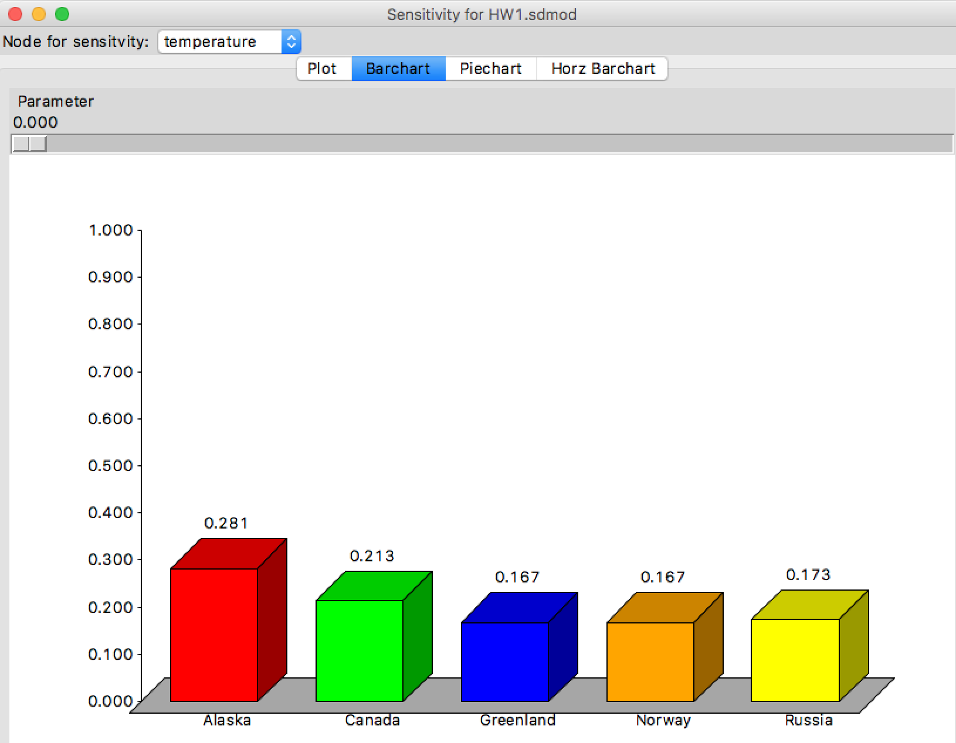

This means that unless temperature is a very important issue, Alaska is the best option for my trip.

- CONCLUSIONS:

The solution to the problem of deciding the best vacation spot for seeing the Northern Lights during the winter was given through the utilization of the Superdecisions software. The best choice was Alaska, and based on the sensitivity analysis that were performed, this choice is pretty robust.

