Introduction
My wife and I were recently confronted with the decision as to which type of child care program we were going to enroll our son, Patrick. When he was first born, we realized that waiting lists in Pittsburgh could be as long as three years. Just before his first birthday, we received a call from two different programs letting us know that there was an opening for him. Obviously, we did not want to pass up the opportunity to enroll him into a good program. However, each of the options were appealing in different ways. We ultimately chose to send him to the University Child Development Center (UCDC) because it felt like the best option. The goal of this assignment is to see if, by using AHP, we would have come to the same conclusion.

Alternatives
The three alternative all represented viable options. First, the University Child Development Center, affiliated with the University of Pittsburgh, was appealing because it provided consistent, accredited education to children up pre-kindergarten. It offered highly trained staff that were provided with training opportunities to continue their education. Unfortunately, it was expensive.
Second, Milestones Child Care was a privately owned program that had a solid reputation with over several decades of service. It was half a mile from our home, meaning my wife could pick Patrick up from school every day, and significantly cheaper than UCDC. Unfortunately, the teachers there did not have advanced degrees and they were not offered continuing educational opportunities.
Finally, my wife was considered homeschooling Patrick until she found a serious career opportunity. It was by far the cheapest option, as well as having no travel time. But, it meant my wife would need to provide full-time care.

Description of Criteria
The following criteria, shown in Figure 1, were used to evaluate each alternative:
- Travel distance: number of miles from home. Home was given a value of 0.01 miles sine the software did not allow for zero values. A greater distance was less desierable.
- Teacher education: highest level of the education that the teachers at each program had obtained. A higher level of education represented a better choice.
- Facility Quality: overall facility evaluation that included cleanliness, maintinance, size, and emenities (i.e play grounds, access to art supplies…etc).
- Cost: price of each program. A budget of $100 per month was agreed apon if we decided to home school Patrick. A higher cost was considered less desireable
- Teacher Training: evaluation of continuing education opportunities offered to the staff at the facilities.
- Class Size: the ratio of teacher to students in Patrick’s specific classroom.

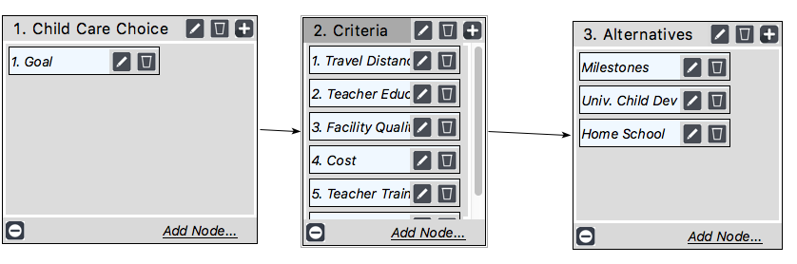
Figure 1. AHP Network Map

Judgements
Shown below, in Figure 2, are the pairwise criteria importance selections used in the analysis. The results of analysis show that we value teacher education first, followed by cost. Travel, facility and class size were considerably less important. The overall inconsistency of the pairwise comparisons, 0.074,
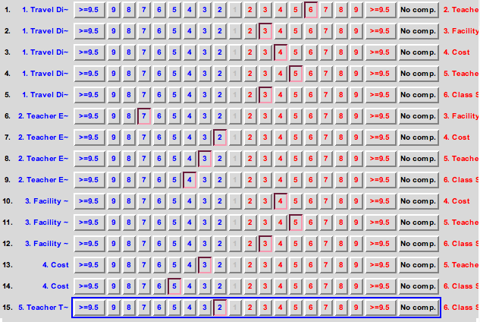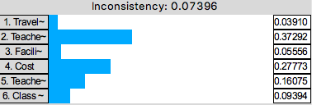
Figure 2. Pairwise Criteria Importance

Table 1 shows the results of the Inconsistency report. Since a value of 0.074 is less than 0.1, no further changes need to be made to the comparisons. However, note that if we wanted to reduce the value even further, we could make a few minor changes to rank 1 and 2.
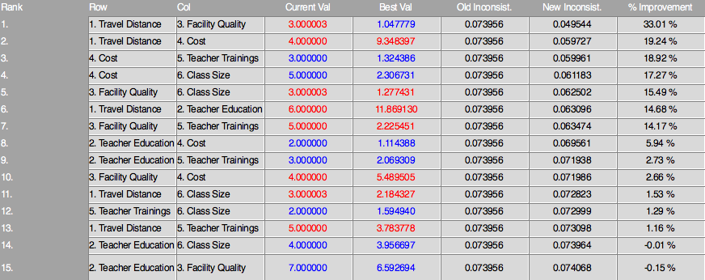
Table 1. Inconsistency Report

Teacher education was deemed to be highly important to my wife and I because we felt that someone with a better education would be able to identify important development milestones that Patrick was, or was not, achieving. While this is a general assumption and do not mean to assume that someone with a lower level of education cannot provide a quality education, for the purposes of this analysis, we argued that a higher level of education is more desirable. Since my wife has a Master’s degree she ranked higher that Milestones. UCDC beat home school since their specialty is early childhood education.
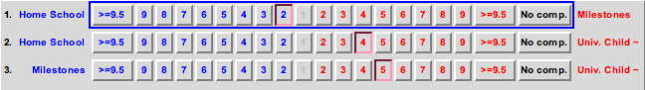
Figure 3. Teacher Education

The direct input was used for travel distance since the precise values were knows. The inverse was applied since a greater distance was less desirable.
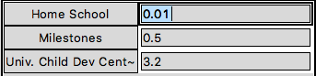
Figure 4. Travel Distance

The inputs for teacher trainings were selected based on the fact that my wife, as a licensed social worker, is required to complete continuing education courses to maintain her certification. Therefore, home school ranked higher than Milestones, slightly. UCDC beat Milestones significantly and home school slightly.
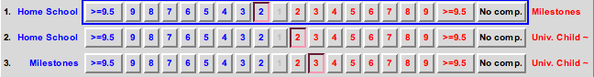
Figure 5. Teacher Trainings

The class size (ratio) value was known; home school was 1:1, Milestones was 8:1, and UCDC was 4:1.
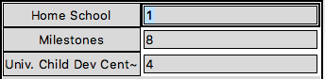
Figure 6. Class Size (Ratio)

For facility quality, we ranked UCDC the highest since they had the largest, and most well-funded program. Milestones beat home school since, while their facility was not nearly as large as UCDC, it was still more specific to early childhood education.
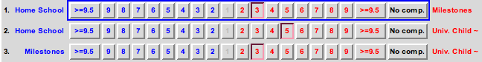
Figure 7. Facility Quality

Cost values were knows and directly input using the inverse selection since a higher cost was less desirable.
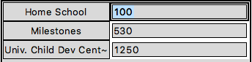
Figure 8. Cost

Results
Figure 9 shows the final results of the overall analysis. It indicates that home schooling Patrick would have been the best choice, based on the inputs discussed above, with UCDC being a very close alternative.
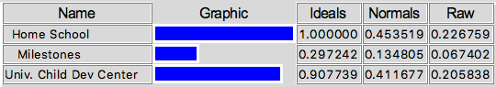
Figure 9. Overall Results

Shown in Figure 10 is the sensitivity analysis for the teacher education judgement. If the priority is set at 0.4, we can see that both home school and UCDC are weighted equally. Anything greater than 0.4 and UCDC becomes the better option.
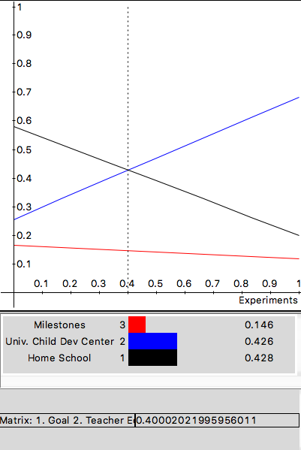
Figure 10. Sensitivity Analysis for Teacher Education

Regarding facility quality, shown in Figure 11, UCDC is the best choice across all priority values. At 0.37, home school and Milestones are the same.
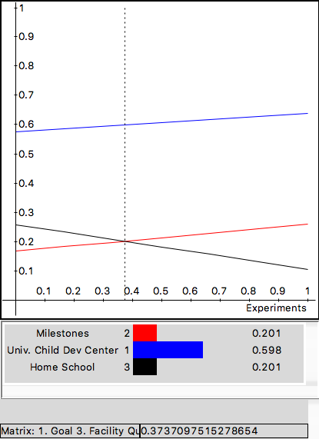
Figure 11. Sensitivity Analysis for Facility Quality

For class size, Figure 12, unless the priority is set extremely low, 0.02, home school is always the best choice. Milestones would never be an acceptable option, across all priority values.
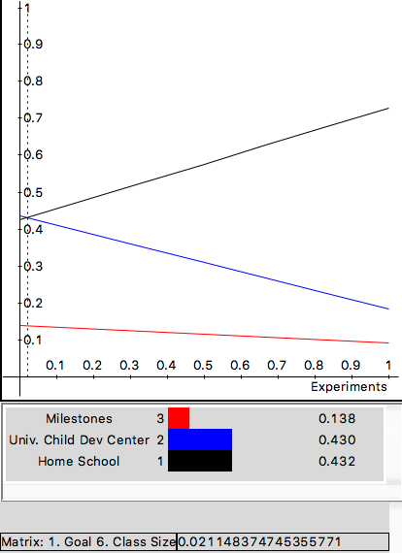
Figure 12. Sensitivity Analysis for Class Size (ratio)

Figure 13 shows that a priority of 0.23 makes UCDC and home schooling equality acceptable options. However, anything greater than that and home school becomes the best option. UCDC and Milestones are equal at a priority of 0.83.
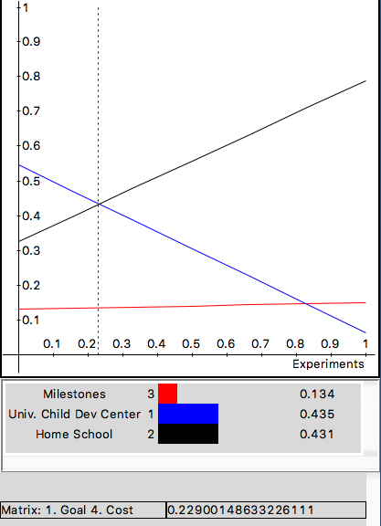
Figure 13. Sensitivity Analysis for Cost

Discussion
Prior to the AHP analysis, our decision to send Patrick to UCDC was made because both my wife and I had experiences at larger child care facilities and believed they provided good-quality educations. While cost certainly was a factor, we felt that UCDC was a safe and nurturing environment. In the back of my mind, I knew that my wife could provide him with an individualized experience that no one else could. However, one factor came to light that I did not consider when performing the AHP analysis
My wife and I believe that socialization is extremely important, which I did not account for in this analysis. Both Milestones and UCDC would provide more opportunities for Patrick to meet other children and adults, whereas home schooling would be more challenging to do this. Socialization is important to us because we want him to learn empathy, as well as the understanding that the world does not revolve around him (even if it does in our house).
Further, being a full-time mother and teach would be extremely challenging for my wife. Her mental health is important, as well as making sure she is happy. If she was responsible for Patrick’s full-time care and education, she would lose the ability to go to work and build a career for herself. Likewise, she would have time to socialize with people and engage in more intellectual conversations.

