In the following report, I will describe the decision problem I am trying to solve, the alternatives and my decision criteria. I’m going to outline each step I followed and I will express my opinion on the results.
I’m planning a trip to New Zealand and my decision problem is what travel mode to use best for exploring the country. My goal is to find the best transportation mode for traveling in New Zealand. There are different alternatives: We could either rent a car or a RV/Camper or travel by bus. Renting a car has a good comfort level, the price is about 2000 NZD (including stays in hostels). It is quite flexible to travel by car and travel speed is very fast. Renting a RV/Camper has a high comfort level, the price is a bout 4000 NZD (including fees for camping grounds). It is very flexible to travel by RV/camper and the travel speed is average. The comfort level for a bus is medium to low, the price is about 1000 NZD (including stays in hostels). Traveling by bus is very inflexible and the travel speed is slow.
Following the AHP model, the first step is to outline all influencing factors in a hierarchy that shows the connections. In this case, the influencing factors/ decision criteria are comfort, price, flexibility and travel speed of each alternative. Figure 1 shows the model including the hierarchy described above.
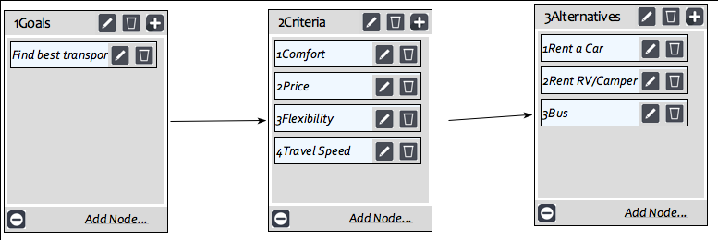
Figure 1: Model
The second step is to make pairwise comparisons/judgements to show the dominating factors. Firstly, I made a pairwise comparison for each criterion for the goal achievement. Figure 2 shows my judgment. Flexibility and comfort are more important to me than price and travel speed. As I want to get to know as much as possible of the country and the people, it is important to me to be very flexible. If I like a place or I find out about an interesting event, I want to be able to stay longer and not be constrained by a fixed schedule. Moreover, a trip to New Zealand is very exciting and I want to do a lot of activities. Thus, it is important to me to have a high level of comfort. After a very long day of hiking or scuba diving, I want to have a comfortable place to relax and prepare for another exciting day.
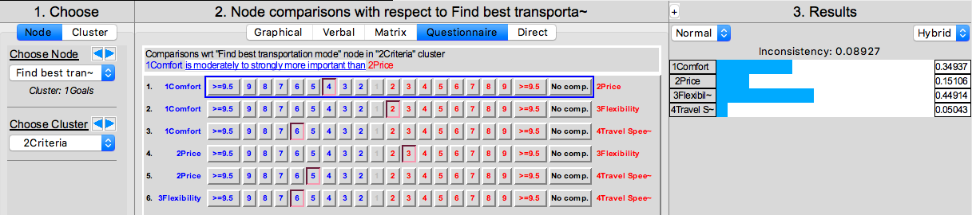
Figure 2: Judgement on Criteria
Secondly, I rated each criterion for the three different alternatives. Each rating will be explained shortly.
Figure 3 shows, that when looking at comfort, the RV/Camper is the most convenient option. The advantages are that I could keep my luggage in the RV and would not have to pack und unpack my backpack each time I get to a new hostel when traveling by car or bus. The bus is the most inconvenient option because private space in a bus while traveling is limited and long bus rides are exhausting.
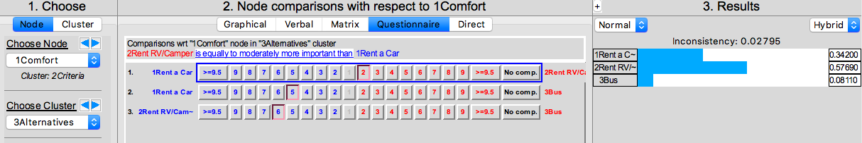
Figure 3: Judgement on Alternatives: Comfort
For making judgements concerning price (Figure 4), I switched to a direct comparison. Renting a RV/Camper and staying on camping grounds is four times as expensive as traveling by bus and staying in hotels. Renting a car is two times more expensive than traveling by bus. As the cheaper option is preferred, I used the “invert” option.
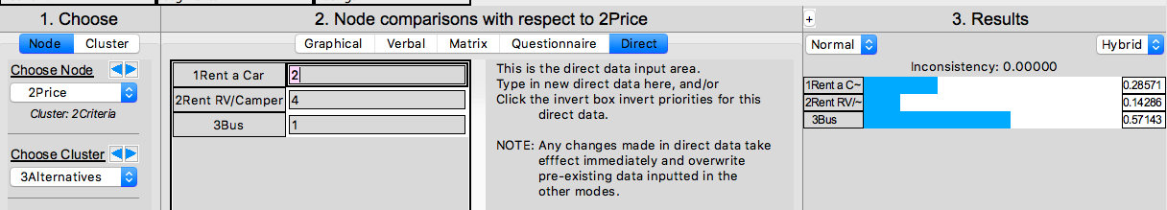
Figure 4: Judgement on Alternatives: Price
Considering flexibility (Figure 5), the RV/Camper is the best option. It is much easier to stay an additional night at a camping ground or cancel shortly on a camping ground than it is for cancelling or booking a hotel or hostel on short notice. Moreover, when traveling by bus, I would be limited to schedules and capacity of the buses.
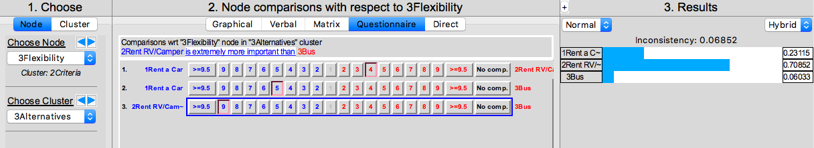
Figure 5: Judgement on Alternatives: Flexibility
The pairwise comparisons for travel speed (Figure 6) shows that the car is the best option. Buses are limited to schedules. Buses and RV’s/campers cannot go as fast as a car can go. In addition to that, there are some roads where campers and buses are not allowed.
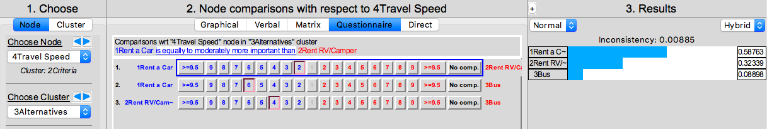
Figure 6: Judgement on Alternatives: Travel Speed
While making each pairwise comparison it is important to make sure that each judgement is consistent. The inconsistency value should ideally be below 0.1.
I pulled an inconsistency report (Figure 7) to improve the overall consistency.
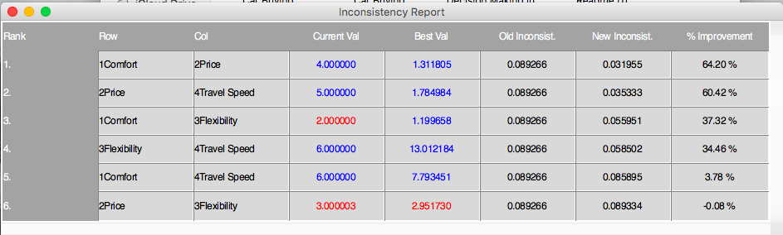
Figure 7: Inconsistency Report
After making a few comparisons more consistent, the new outcome is shown in Figure 8. The inconsistency is now 0.00119 compared to 0.08927 in the beginning.
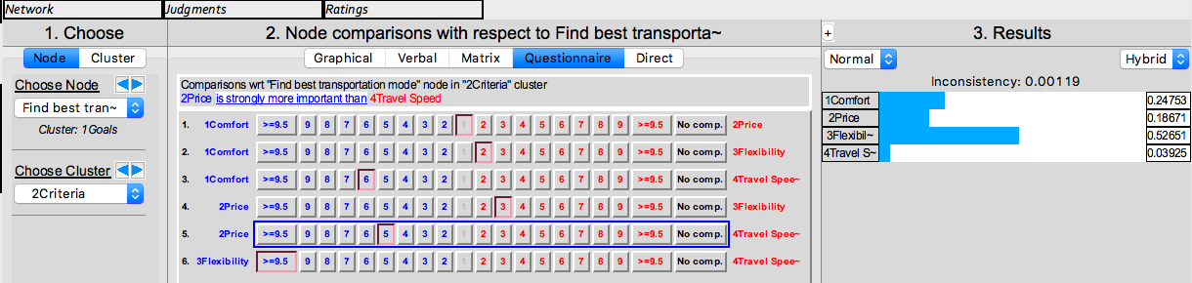
Figure 8: Judgement on Criteria - Version 2
The third step is to synthesize all judgement and find the alternative with the highest priority. Before synthesizing the results, it is important to make a sanity check to ensure that all comparisons are made. In this case, the sanity check is showing no errors (Figure 9).

Figure 9: Sanity Check Results
Figure 10 shows the final results. By synthesizing all judgements, it becomes clear that renting a RV/Camper is the best option for fulfilling the goal. The result shows 0.29 for renting a car, 0.56 for renting a RV/Camper and 0.15 for taking the bus.
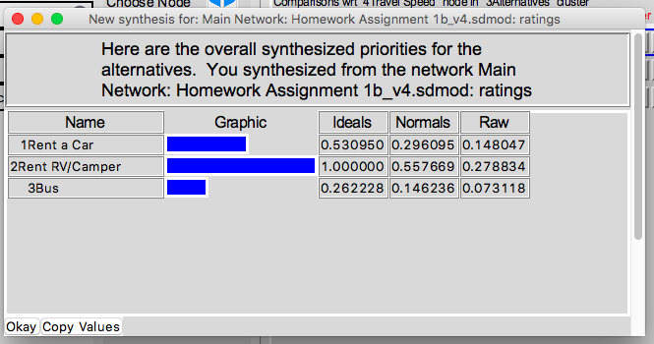
Figure 10: Final Results
My opinion about the results: The result is very helpful. I probably already knew in the back of my head that the bus is the most inconvenient way of traveling based on my personal preferences that I want to be flexible and have the chance to get some rest and privacy after long exhausting days. Thinking about it now, I could have added another criterion: privacy.
The result matched my initial opinion. Even though, I had the feeling that the bus was not my preferred option, it was not so easy to decide whether to rent a car or a RV/Camper is preferred. The tool helps to organize and structure the problem and provides a clear result. It helps to avoid misjudgments and eliminates biased ratings by showing inconsistency levels.

Figure 11 shows the sensitivity analysis for each criterion. This method helps to answer the following question: If the importance of the criteria changes, will the result change?
Changing the importance of the criteria comfort and flexibility will not change the result. If we change the actual priority of price in the model to almost 60%, the RV/Camper will not be the preferable solution anymore. If my priority is more than 60% for price, the bus will be the best option for traveling New Zealand.
If we change the actual priority of travel speed in the model to slightly more than 50%, the result will also change. If my priority is more than 50% for travel speed, the car will be the best solution for discovering New Zealand.
I think that this is a great tool to see how sensitive the different criteria are. If price or travel speed would become more important, the results would obviously change.
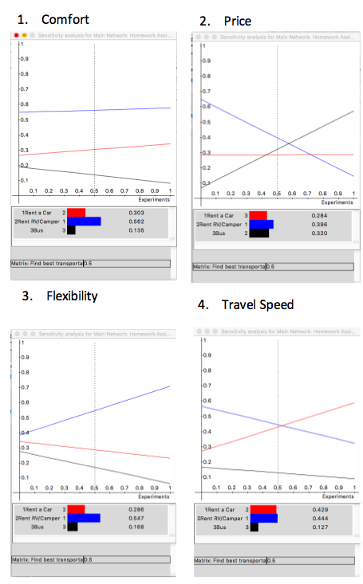
Figure 11: Sensitivity Analysis for each Criterion
Node sensitivity for Price (Figure 12):
At a parameter value of 1.00 for Price the cheapest option will clearly be the bus, while setting the parameter value for Price at 0, the best option will be the RV/camper.

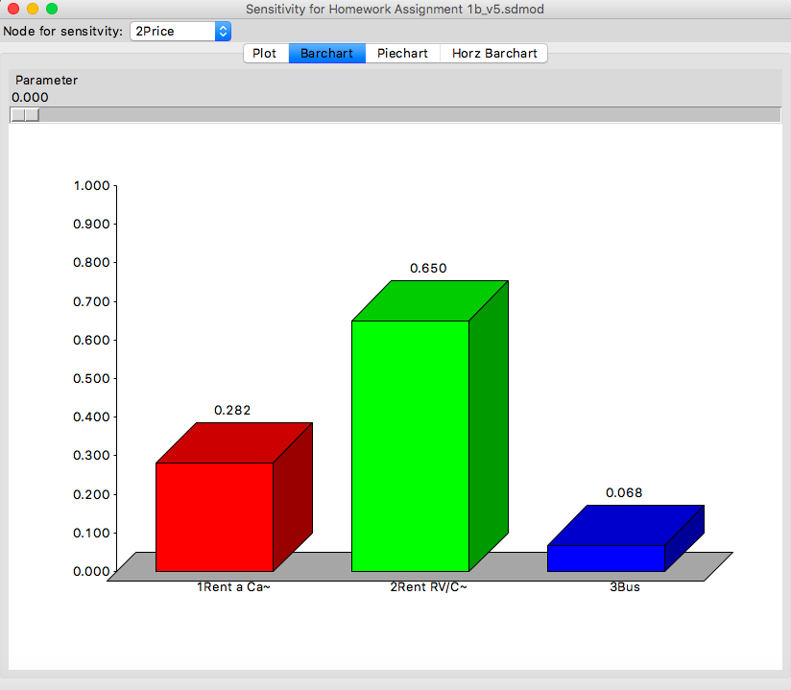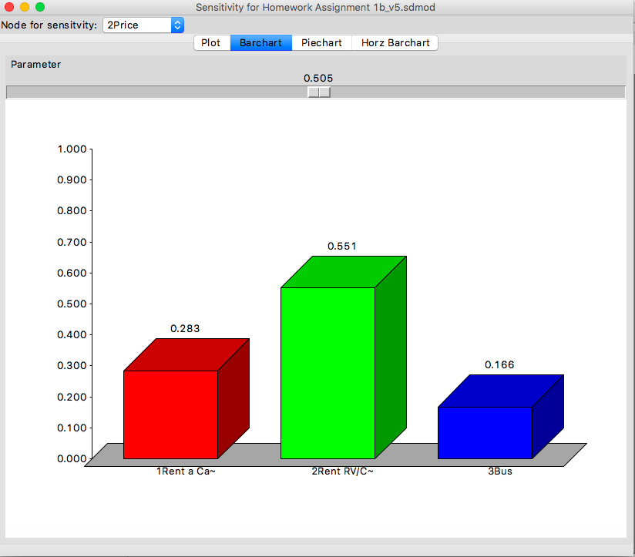
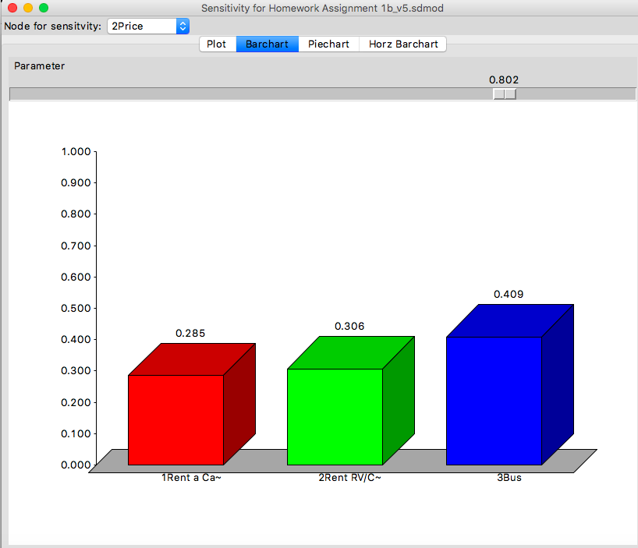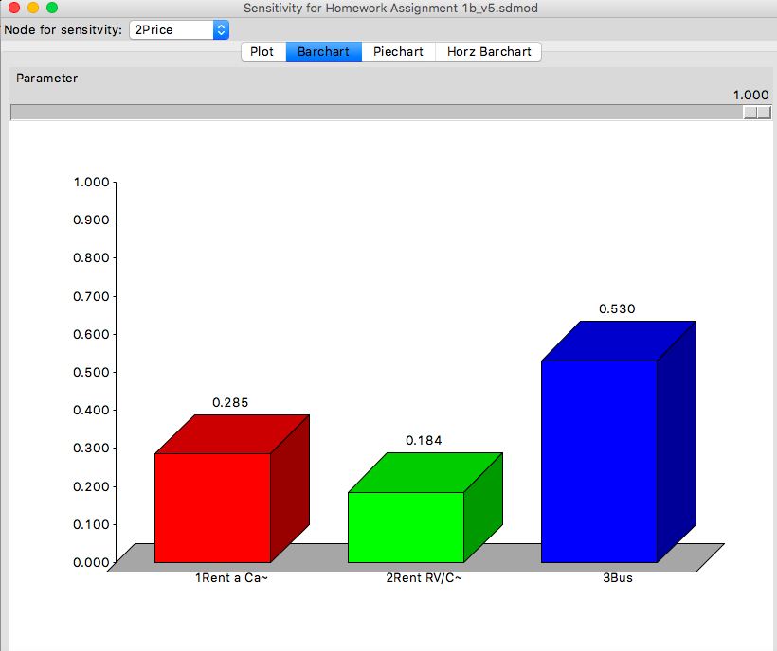
Figure 12: Node Sensitivity for Price

