Christian Miedel
Overview
Before I delve into my findings, the point of this project is very important, and very sensitive. There has been a long running and long standing question in the United States about the best educational methods for children. Some parents swear by the public school systems, some say that Home Schooling is the only way to protect your children, and some say that schooling should be done by the most highly trained, highly specialized people and that can only be accomplished through privatization. I will make no such argument through this paper. I will say straight up, I have no opinion in the matter, and attempted to approach this scenario from that point of view.
With this information forthwith, I will state my purpose in this research; to uncover weaknesses within each mindset. By analyzing the BCOR of each, the intent was to uncover problematic areas for each method and as such, offer insight to parents as to what to expect when choosing a schooling method for their children. Additionally, when ratings and pairwise comparisons are being made later, these decisions are coming from the education system in general. There are obviously exceptions to each and every case.
The Model
For the control Criteria of the model I chose Future, Personal, Social and Expenses, however, expenses were only really criteria for Costs. Each of the other three was present in Benefits, Opportunities, and Risks. These criteria were chosen because these are some of the areas most impacted by a school selection. Personal focused on the actual knowledge gained and the personal traits that are associated with the different schooling. Future was the impact that the different decisions had on goals and future prospects for students within each type of schooling. Social involved the different aspects of human interactions, extracurricular activities, etc. Expenses were primarily involved with physical costs and opportunity costs such as money and time. With these different criteria, I was able to formulate a model for determining strengths and weakness of each different school type.
Benefits
Instead of delving into the different nodes of each and every comparison (which would take an astronomical amount of time and explanation), the general ideology for each criteria will be explained. The clusters in the criteria categories do not change throughout the BCOR model, so instead of relisting them, I will only mark notable changes.
- Future- To examine the future benefits, we look into the different impact that each schooling technique has on the helpfulness within specific jobs or colleges. After some research, it seemed that colleges and universities seemed to put some emphasis on home schooled students, so this generally put home schooling slightly above public schooling with private school scoring the highest marks.
- Personal-For personal benefits, due to the more direct approaches that can be used for home schooling and because private schools can have teachers that are more specialized; home school and private school generally offered more personal benefits than public schools.
- Social-Socially, due to the large number of available people and activities, private and public schools offered the most opportunities socially. Here, home schooling naturally lacked due to the decrease in the number of students. Public schooling came up slightly higher than private as the population of students is generally more diverse and public schools put a large emphasis on extracurricular activities.
- Overall- Due to the very large differential in in social benefits, home schooling dropped significantly. This is an important thing to note and will be readdressed soon.

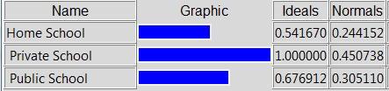

Opportunities
- Future-Slightly different than benefits, we look into the impact that different schooling has on the chances of landing a certain job or getting into a certain school. The results ended up being very similar to the benefits, as would be expected. The skills beneficial skills required are, after all, what recruiters and employers are looking for.
- Personal-The opportunities for the different subjects and different skills was generally higher at private schools because the depth of the subjects and the opportunity for different subjects is increased. While it is possible to teach students at home or even in public schools different, detailed subjects, parents are limited by their own person capabilities and public schools are forced into certain curriculum.
- Social-Socially, private school offered great opportunities because of the large potential for both life long and beneficial friends. While the same can be said for public school and home school to an extent (family did not count in this), private school has a better chance of pairing students with students that are of similar mindset. This can be less beneficial to overall experience, but does offer better opportunities to meet people that will work well with them.
- Overall-Overall, once again, because of the chances of life-long friendships and job and college opportunities, private school was determined to offer the most opportunities for students
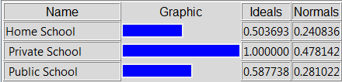.
Costs
- Expenses-Expenses were a very obvious category. For public schools, expenses are generally fixed, excluding food, regardless of attending or not (taxation). Home schooling however requires books and extra equipment to effectively teach, but the majority of these things can be acquired rather cheap. Private school however, requires tuition, which can be extremely expensive. Private school for this reason scored very highly in the region of expenses.
- Social-Social costs are those costs that are paid essentially by missing opportunities. Home schooling is naturally more susceptible to these pitfalls due to the lack of exposure. Private school also has some ability to fall into these costs, as class sizes can become very small and poorly socially diluted.
- Overall-Some parents may feel that social costs are more important while others may simply not be able to afford private school, meaning expenses are the only thing that matters. For this reason, equal weights were given as to not skew toward a certain direction. This resulted in close a running with private and home schooling.
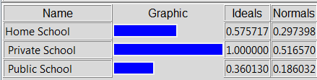
Risks
- Future-future risks were interesting because it required some node changing. Here, risks for the future were ending up in undesired colleges or jobs. As private schooling typically offers some more opportunities to explore regions of interest and home schooling allows for a curriculum to be built around the specific student, public school is truly limited because of the broad number of students that must be taught. For these reasons, public schooling scored a good bit higher in the category of future risk, as there is a better chance to miss a topic that could most interest a particular student, thus impacting their decisions on colleges and jobs.
- Personal-Here, instead of looking to where a student could end up in life, there was more of a focus on what a student learns. Again, public school is often limited, but in this particular situation, private schools lack in comparison to home schooling because students have chances to learn exactly what they are interested in. This offers the least risk to a person’s desires and therefore, came in at the lowest rank.
- Social-Socially, as before, there were friendships and aptitude. Generally, home schooling takes children away from the constant interaction with peers setting, making it riskier as far as social aptitude to homeschool. However, this removal also takes them away from negatively impacting peers. Public school does not. Here, the nodes of life long and beneficial friends became dangerous, small numbers, and bad crowd. Public school has the highest chances of introducing bad individuals thus making it the most socially risky.
- Overall-Because of the potential for life ruining interaction that can occur in some public schools (remember, this is not judgmental, simply explanative) public school has the most risks involved with private and home school coming in close to each other.
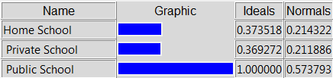
Strategic Criteria
When choosing strategic criteria to look for, I decided to choose criteria that most parents are interested in (again, all generalizations). For these four choices, I decided to on Opportunities for Success, Compatible Mate, Personal Happiness and Personal Fulfillment. While personal happiness and fulfillment are similar, I deemed them different enough that they merited separate classification.
When rating each model, I considered the likelihood of each scenario given BCOR. For example, taking the benefits given from each criterion, what is the extent to which a person would find themselves happy? Well, a person who has the knowledge that they desire and adequate skills to pursue their wants would be extremely happy. However, with this knowledge, there would be a need for fulfillment, not necessary complete fulfillment. Also, they would have opportunities for success that would be abounding and would have great chances to meet a compatible mate because they would have understanding of whom they would most desire.
Essentially, I would formulate a sentence similar to the ones above for each aspect of the BCOR and this is how I determined my ratings. The result is the following;
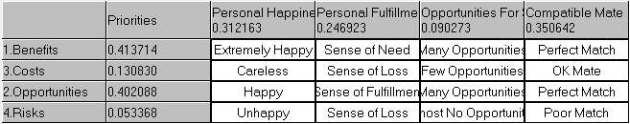
Sensitivity Results
The majority of the sensitivity results were uninteresting, but for risks and costs there are significant things to notice.
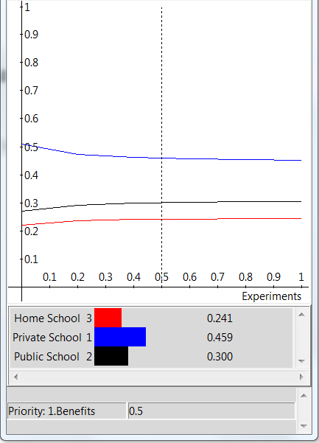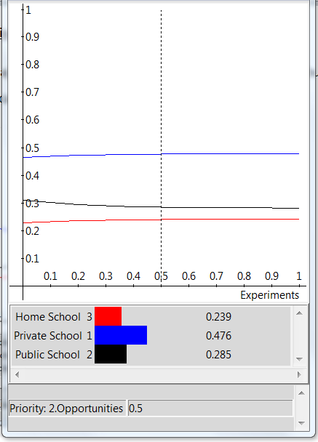
As is apparent from the sensitivity, very little changes in regards to preference as these variables change. While private schools get more beneficial as benefits become less prioritized, other alternatives drop slightly. This pattern is almost reversed for opportunities, but in general, the distributions of the alternatives remain fairly stable.
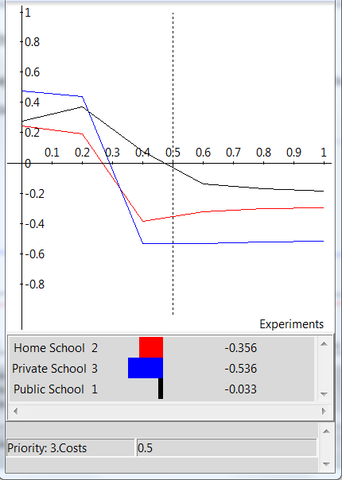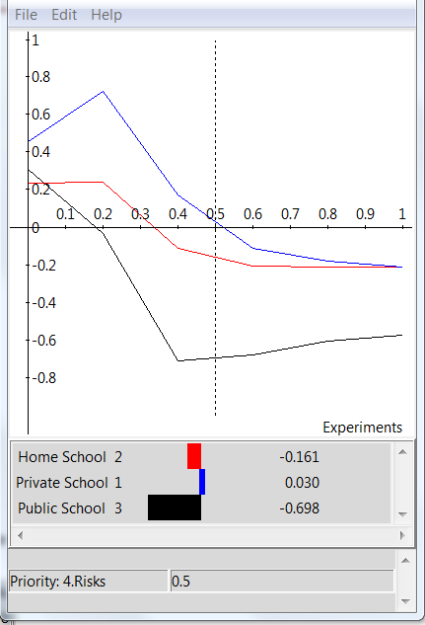
Here, when looking into costs and risks, the sensitivity becomes more interesting. For Costs, we see as they become more important, around 30%, private school drops to the lowest point. This is important because for families that have cost issues, it only takes a 30% importance to eliminate private school from the running. It’s also worth noting that homeschooling only becomes less costly than private schools when both of them are negative.
Looking at risks, we find very little risk puts public schools far into the negative. In fact, it only takes approximately 18% priority for public schools to be negative. This is important because when parents look into their specific situations, they may find that very little risk will eliminate public school as minimal risk can drastically affect the model’s results.
Result
After fully synthesizing the model, the following were the results: This result is using the Additive (negative) formula and is applicable for the short term.
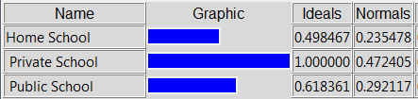
One thing to note would be that if the long term is considered utilizing the multiplicative formula, while private school is still the preferred method, we can see that homeschooling displaces public school.
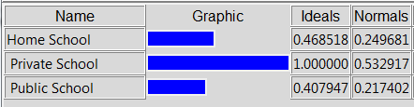

Discussion
From the above results we have a lot of information. For one, when looking into the priorities from the ratings column, we find that Risk, while extremely important all the time, is not necessarily a large priority. In general, these risks can be mitigated and monitored to ensure that they are minimized.
More on point is that for this model, the final result is not very important (thus the overwhelmingly small amount of space dedicated to the final result). Realistically, the sum of the parts is not the point and does not give extremely usable information. However, the individual parts of the BOCR are the real results. From these, we can take away some important information:
- Homeschool Students-Parents who decide to utilize homeschooling need to be aware of the social aspects that their children will be missing. The opportunities for sports, friends and extracurriculars will not be constantly available and they will have to go out of their way to make these things available. Additionally, it is important to make sure that while there is the ability to focus on your child’s needs, it is just as important to recognize your own weaknesses. There may be subjects that students need to know that parents are not extremely proficient in and there may be subjects students desire that parents do not know at all. One of the big benefits of home schooling is the flexibility afforded, so this needs to be remembered and utilized frequently.
- Private Schools-While private schools have a lot of positives in this model this is assuming that a good and well researched private school is available. Simply because a private school is available, does not mean it is necessarily good. One of the benefits of private schooling is that it is a choice to parents, meaning that they can decide for themselves if it will be a good place to learn. However, it must also be made aware of the extreme costs of attending such a school. The decisions cannot be made on a whim and students have to get something more for it. The best thing to take away from this model is that if private schools are not delivering what the model indicates, it may be time to look elsewhere.
- Public Schools-There are certain beneficial aspects to the public school systems that cannot be found elsewhere. For one, the public school systems give students a true feel for the outside world and the peers that they will encounter. This is why the model indicates that there may be benefits to communication skills in public schools. Home schooling and private schooling by default remove some of the interactions that are real and everywhere in the world and this can impact a person’s life. However, just as each option had its upsides in the model, each has its downsides. The real world can be a very dangerous place. Given that interactions can be anything in public schools, parents need to spend time teaching their children what to look out for and what to avoid. While parents cannot necessarily choose their children’s friends, they will always have the benefit of experience in recognizing when certain relationships could be detrimental. Parents need to be aware of what types of interactions are occurring around their children and react accordingly.
Final Thoughts
This model is really a foundation for parents to build off from. The benefit of this model is that it can be tweaked accordingly and manipulated for each parent’s desires. While I did my best to avoid inputting any of my personal opinions into the model, the model is ripe for them! This can be a real benefit and can be used by parents to focus in on their own attitudes, thus allowing them to mathematically see the results of their opinions.
Appendix
Entire Model
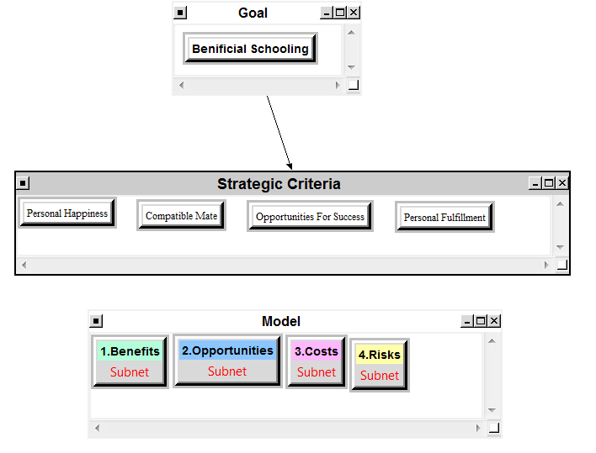

Showing Differences between Risks and Opportunities/Costs/Benefits
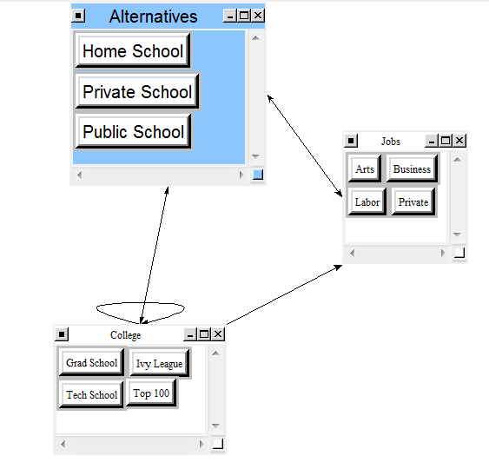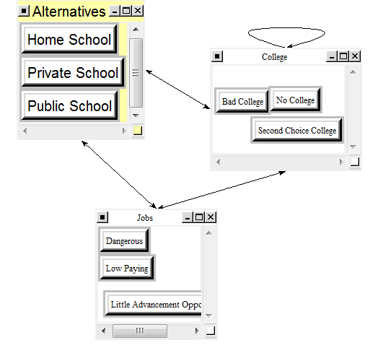
Future Opportunities Future Risks

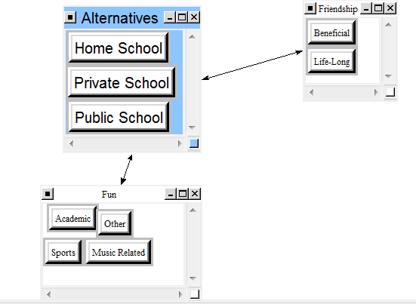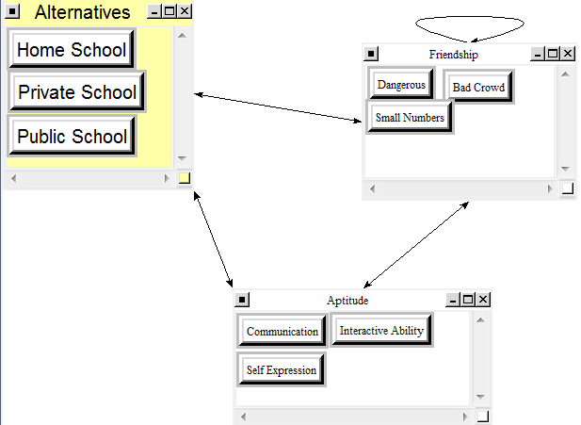
Social Opportunities Social Risks

