

ANP Model for Best Career Decision

Jessica Duda
Nicole Volpi

BQOM 2521 – Decision Making in a Complex Environment
Katz Graduate School of Business
University of Pittsburgh
Fall 2005

Overview:
The Best Career Decision model was developed to evaluate potential career choices. We chose this topic because we both plan to face this decision after completing our degree at Katz. The alternatives are (1) Stay at current job (2) Start a better job (3) Start a business. We determined that our current jobs, although less stressful and less time consuming, offer little growth opportunities and low happiness levels. Since we will be obtaining our MBAs, we felt that there would be a good chance that if we switched jobs, we would be able to get a “better” job based on our specific criteria. The last option of starting our own business is something both of us have thought about but are not sure if the risk is too great.

The alternatives were evaluated based on the following:

Table 1: BOCR Criteria and Sub-Criteria
Benefits | Opportunities
SOCIAL | SOCIAL
Family | Family
Friends | Friends
Personal | Personal
ECONOMIC | ECONOMIC
Current | Lifestyle
Future | Financial
Costs | Risks
SOCIAL | SOCIAL
Family | Family
Friends | Friends
Personal | Personal
ECONOMIC | ECONOMIC
Job | Competition
Personal | Employment Related
 | Personal

RATINGS:
A set of ratings for the overall significance of the Benefits, Opportunities, Costs, and Risks of the decision was developed. The strategic criteria are considered as Economic and Social. Ratings were given and prioritized with respect to the overall goal for each of the strategic criteria individually. The assessment criteria used to determine the priorities of the BOCR merits are shown below figure.

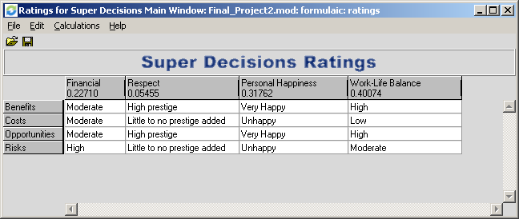

The priorities for ratings are below:
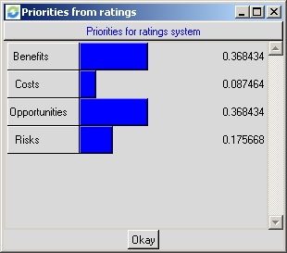

The benefits are high almost across the board considering the best-case scenario for each alternative. Benefits could bring moderately high financial reward, high prestige in regards to respect, very happy personal happiness, and high work-life balance – all in the case that the chosen alternative leads to success in both personal and work life. Costs for all alternatives relate to possible loss of one’s personal happiness, inadequate work-life balance, loss of one’s respect and finances. Considering opportunities, financial reward would be moderate, respect high prestige, personal happiness very happy, and work-life balance high. Risks have a significant high financial factor, possibility of little to no prestige added, unhappy personal happiness, and moderate work-life balance.

NETWORKS:
Benefits:
The Benefits Criteria (See Exhibits 2-4) was developed to analyze the potential benefits the three alternatives.

Social Benefits:
FAMILY: Family encompassed factors that would benefit one’s family, including time for family and money to support them, as determined by career decisions. Staying at our current jobs would allow more time for family, but would benefit low-to-moderately as far as money to support. Ideally, finding a new job would increase the monetary benefit but slightly decrease the benefit for time. Starting a business would possibly increase the monetary benefit greatly but would also decrease time for family greatly.

FRIENDS: Friends encompassed factors that would benefit the relations ship with one’s friends, including time available to spend with friends and earning the respect of friends, as determined by career decisions. Starting our own business would gain the most respect, followed by starting a better job. The time benefit is similar to the family time benefit, with staying at our current jobs allowing the most free-time to spend with friends.

PERSONAL: The personal cluster included workplace conflict, stress level and personal happiness. We determined that starting a better job would make us the most happy and staying in our current position would make us the least happy. Staying in our current position also would have the highest degree of workplace conflict, followed by starting a better job and starting a business. Starting a business would have the highest stress level, so that alternative was rated the lowest.
Economic Benefits:
CURRENT: The current benefits of each alternative are short-term earnings, employee benefits, and a level of growth opportunity. If you stay at your current job your short-term earnings and employee benefits will stay the same and your level for growth opportunity is the lowest out of the three alternatives. If you start a better job you have a high chance of having high short-term earnings, employee benefits, and a level of growth opportunity. If you start a new business your short-term earnings and employee benefits are low, but your level of growth is very high.

FUTURE: The future benefits of each alternative are long-term earnings, future employee benefits, long-term growth opportunity and security and stability. If you stay at your current job your long-term earnings and future employee benefits will stay the same and your long-term growth opportunity is the lowest out of the three alternatives. However, you job is highly secure and stable so that is a big benefit for staying your current job. If you start a better job you have a high chance of having higher long-term earnings, employee benefits, and future growth opportunity. The level of security and stability is slightly lower than staying at your current job. If you start a new business you have a better chance of long term earnings, benefits, and growth opportunity. The level of stability is shaky.

Opportunities:
The Opportunities Criteria (See Exhibits 5-7) was developed to analyze the possible opportunities that would come out of each alternative.

Social Opportunities:
FAMILY: Again, money to support and time for family were used to analyze the family criteria. Starting a business would give the least opportunity for spending time with family and the most opportunity to make more than enough money to support them. Staying at our current jobs would give the most opportunity to have a lot of time to spend with family and the least opportunity to make enough money to support them.

FRIENDS: Again, respect and time for friends were used to analyze the friends criteria. Starting a business would give the least opportunity for spending time with friends and the most opportunity to earn respect from them. Staying at our current jobs would give the most opportunity to have a lot of time to spend with friends and the least opportunity to earn respect from them.

PERSONAL: Lifestyle and personal happiness were used to analyze the personal criteria. The lifestyle node is used to include the opportunities beyond supporting families, such as the likeliness of having extra spending money for "luxury" items such as travel, shopping, etc. In our review, we found that with starting a business, we would have the highest likeliness of making enough money to not only support our families, but to have extra spending money for these types of things. But, due to the time and effort required to get to that level, starting a business did not rate as high for personal happiness. In this case, starting a better job ranked the highest, followed by starting a business and staying at our current jobs.

Economic Opportunities:
LIFESTYLE: The different lifestyle opportunities that are affected by each alternative are your lifestyle and the lifestyle of your family. The alternative that will increase the lifestyle opportunities for both yourself and your family is starting a better job because this will come with the most earnings right away. You have the opportunity to buy more of the things you want. If you chose to start a new business the lifestyle that you and your family are used to may be weakened because more time and money will be put into the new business. If you stay at your current job then your lifestyle will not change.

FINANCIAL: Each alternative comes with financial opportunities such as higher earnings, better benefits, and a better chance for a raise in earnings in the long run. If you start a better job you have a high chance of getting all three of these opportunities. If you start a business then you have the opportunity for better benefits and a raise in earnings in the future, but lower earnings are more likely in the short-run. Nothing will change if you stay at your current job.

Costs:
The costs network (See Exhibits 8-10) analyzes the costs associated with a career decision.

Social Costs:
FAMILY: Money to support and time for family were used to rate the cost of alternatives in relation to family. In regards to money to support, there was a moderate cost to staying at our current jobs, due to limited growth and advancement opportunities and a low cost for starting a better job since we think that switching jobs with our MBA will lead to a better salary. Although, in regards to time, there was a low cost to stay at our current jobs due to current work hours and a high cost for starting a business due to the amount of time needed for running the business.

FRIENDS: Respect and time for friends were used to rate the cost of alternatives in relation to friends. In regards to time, there was a low cost to stay at our current jobs due to current work hours and a high cost for starting a business due to the amount of time needed for running the business. In regards to respect, there was a low cost associated with starting a business, as we felt this was the best way to earn their respect.

PERSONAL: Personal costs involved include workplace conflict, stress level and personal happiness. In starting a business stress level would be big cost and workplace conflict would be a low cost. In staying at our current position, workplace conflict would be a high cost and stress level would be low. In starting a better job, personal happiness would be very low cost.

Economic Costs:
JOB: The economic costs involved in deciding on a career choice are supplies needed and miscellaneous expenses. When starting a business you will incur the most costs for supplies needed. Additional expenses also include utility bills and costs to hire employees to work at your business. When starting a better job your will have costs for supplies such as resume paper and transportation. Other costs include time away from your current job to interview. There are no job related costs incurred if you stay at your current job.

PERSONAL: The personal sub-criteria network evaluates the costs associated with a mortgage, car payment, and everyday necessities such as groceries. If you start a new business your earnings may drop and this will affect your personal spending. When starting a better job your earnings will go up and so your personal spending will go up and you will be able to afford more costly items. If you stay at your current job your costs will be unaffected.

Risks:
The risks network (See Exhibit 11-13) shows potential risks associated with a career choice.

Social Risks:
FAMILY: The alternatives include risk to your family members because, depending on the career choice, you risk the money used to support your family and the time you have available to spend with them. In regards to money to support, there was a low risk to staying at our current jobs, due to stability and a high risk for starting a business since there is much uncertainty. In regards to time, there was a low risk to stay at our current jobs since the current work environment allows for extra family time. There was a high risk for starting a business due to the amount of time needed for running the business.

FRIENDS: The alternatives include risk to your friends because, depending on the career choice, you risk losing their respect and the time you have available to spend with them. In regards to time, there was a low risk to stay at our current jobs due to current work hours and a high risk for starting a business due to the amount of time needed for running the business. In regards to respect, there was a low risk associated with starting a business, as we felt this was the best way to earn their respect.

PERSONAL: Personal risks involved include workplace lifestyle and personal happiness. In starting a business, although there was the most opportunity to do so, it is very risky in regards to lifestyle because there is no guarantee that the business will flourish enough to allow for extra spending. Another risk is personal happiness; no one wants to be at a job that they do not like. By making the switch to a better job, there is a better chance that we would like our jobs in comparison to staying at our current jobs. Also, by switching to a better job, there is a better chance that we would be happy in comparison to staying at our current job.

Economic Risks:
Competition: The alternatives include such issues as the potential risks associated with different forms of competition depending on which alternatives are chosen. One risk is competition from your co-workers. When you make a career choice to go to a higher powered job you run the risk of more co-workers competing for your raise, promotion, or entire position. The other risk is competition from businesses that are similar to the one you start. Although the risk of a similar business can be avoided by developing a unique idea, others may start up after they see the success of the idea. The alternative that has the lowest competition risk is staying at your current job, simply because you are aware of your surroundings and the workers are more content in their current positions.

EMPLOYMENT RELATED: A career change also comes with employment related risks such as job security and earnings. The career alternative that comes with the most risk is starting a new business. When starting a new business venture there is never a strong sense of job security and earnings certainty because the market is always changing. Starting a better job also comes with the added risk of low job security, depending on the company you are joining. If for any reason the company decides it needs to cut-back on employees you could be one of the first ones cut because you are new. It is less risky that you will have to worry about earnings, because one of the main reasons for getting a higher powered job is because it is accompanied by higher earnings. By staying at the current job you have a stronger sense of job security and you are secure that earnings level will not dwindle.

PERSONAL: Each career alternative comes with a different level of risk. When starting a new business you may need to re-mortgage your house for funding. Also there are many economic legal risks that need to be attended to. Starting a new job may have some legal risks involved if you have a stern contract to look over. Staying at your current job is secure and has fairly no risk on your personal assets.

Results:
Once the networks, sub-networks, clusters, and nodes were created, the relationship between each was determined and connections were made. In each network, the cluster comparisons were determined to be equal, meaning one cluster was not more important or significant in our decision than another. The node comparisons were really the important factors in determining the best alternative. Below are the results for each network and the top level.

Alternative Priorities for BOCR
Alternatives |  | Top Level | Benefits | Opportunities | Costs | Risks
Stay at current job | 0.202842 |  | 0.261061 | 0.154384 | 0.360100 | 0.384224
Start a better job | 0.456456 |  | 0.514572 | 0.495911 | 0.407935 | 0.417507
Start a business | 0.340702 |  | 0.224368 | 0.349705 | 0.231964 | 0.198269

As shown in the table directly above, the alternative of start a better job resulted in the highest priority level for Benefits, Opportunities, Costs and Risks. The rating appears to be accurate, because the lower the cost and risk associated with our alternatives, the more benefits and opportunities are found. The alternative for starting a business was rated the lowest for cost and risk, this makes sense because this alternative does have the highest cost and highest risk based on the criteria evaluated and described previously. Although staying at our current jobs has moderate cost and risk, the opportunity is extremely low compared to the other alternatives. According to the model, the best choice is starting a better job after graduating with a degree from Katz.

The results of this model were based off of personal criteria in regards to making a career decision. Social and economic factors were found to have influence on this decision. The best interpretation of this model would be that starting a better job would lead to more personal happiness, a good work-life balance, acceptable financial rewards and increased gain in respect. Staying at one’s current job, even though stable financially is not worth the personal dissatisfactions. Starting a business could bring high yields, but it is not worth the risk to the social and economic criteria discussed previously.

Exhibit 1: Top level Network
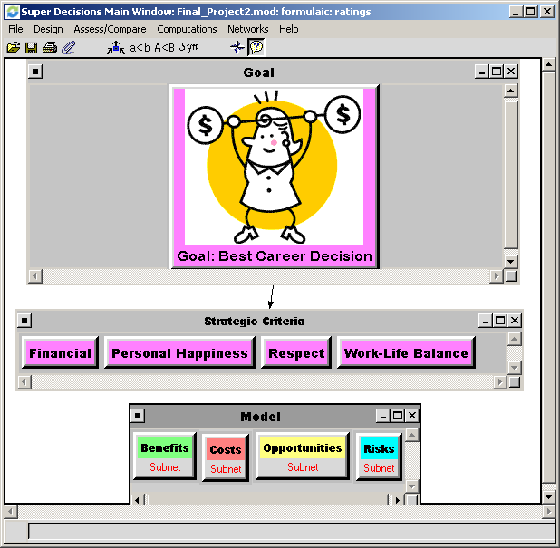

Exhibit 2: Benefits Sub-Network
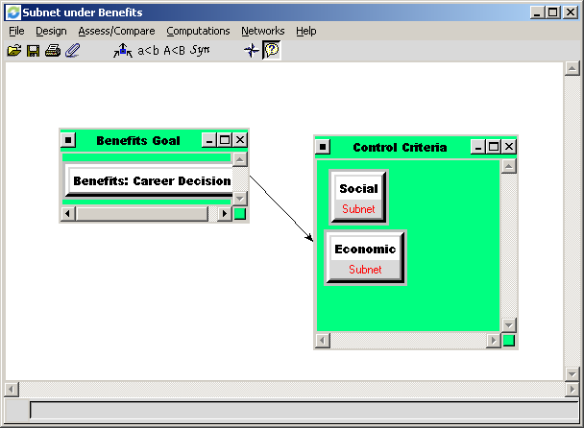

Exhibit 3: Social Benefits Sub-Network
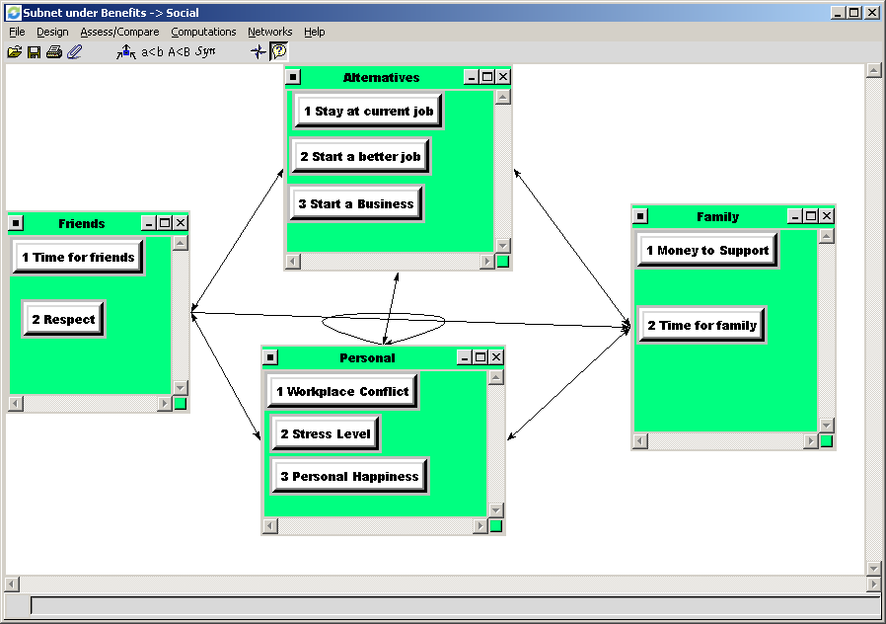

Exhibit 4: Economic Benefits Sub-Network
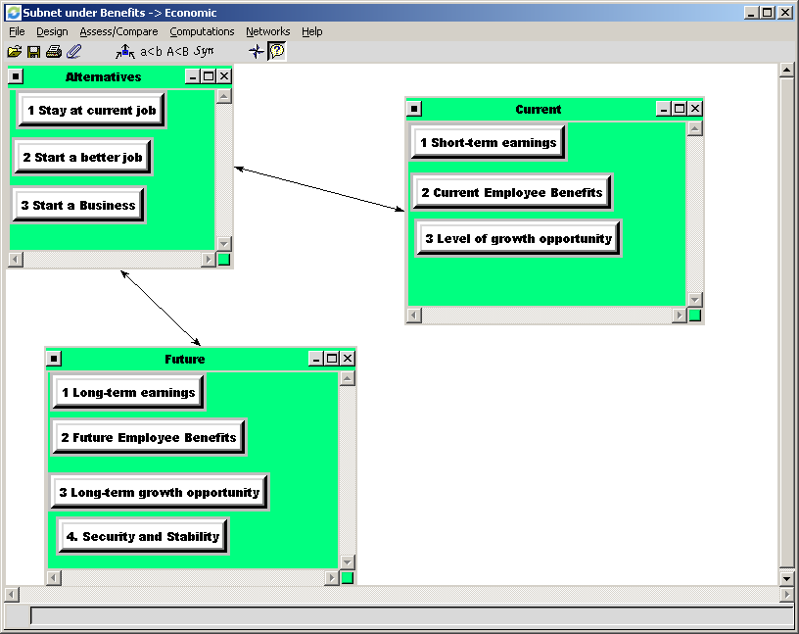

Exhibit 5: Opportunities Sub-Network
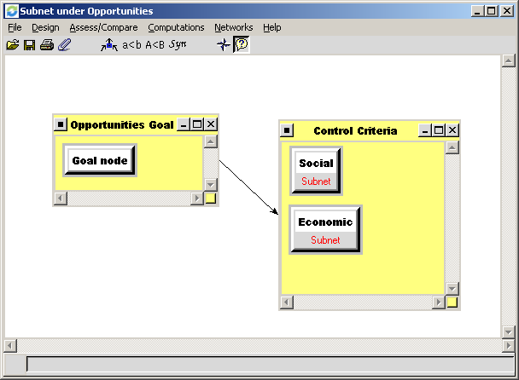

Exhibit 6: Social Opportunities Sub-Network
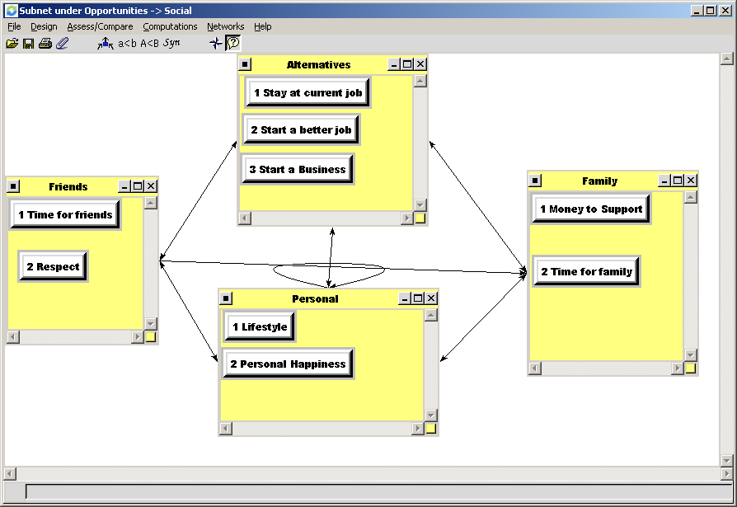

Exhibit 7: Economic Opportunities Sub-Network
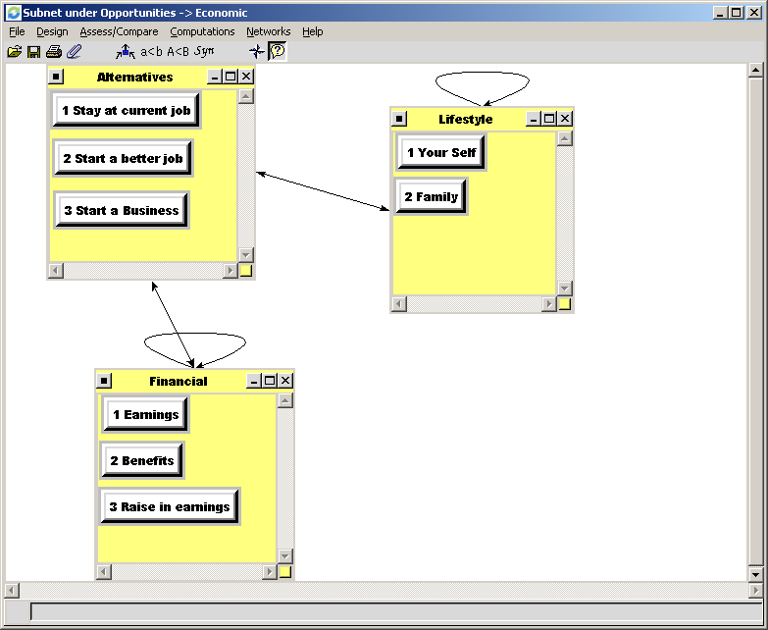

Exhibit 8: Costs Sub-Network
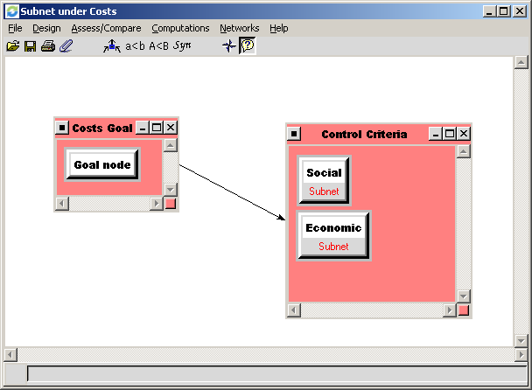

Exhibit 9: Social Costs Sub-Network
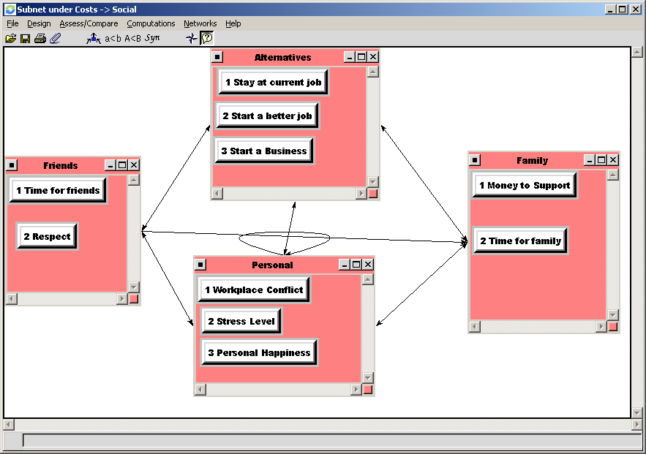

Exhibit 10: Economic Costs Sub-Netowrk
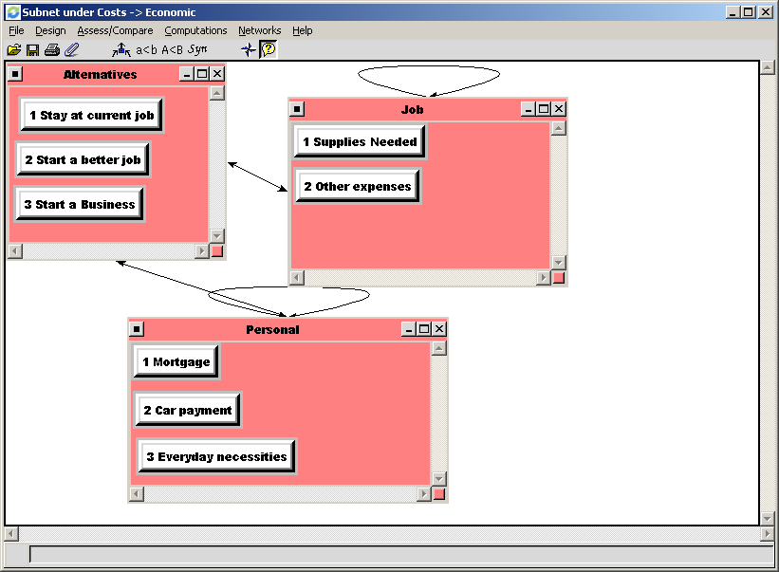

Exhibit 11: Risks Sub-Network
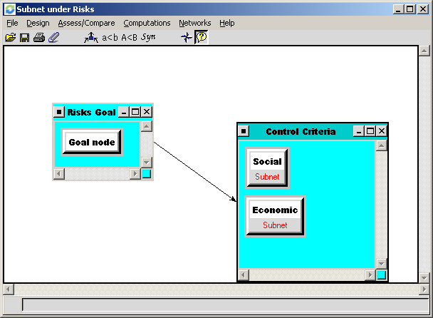

Exhibit 12: Social Risks Sub-Network
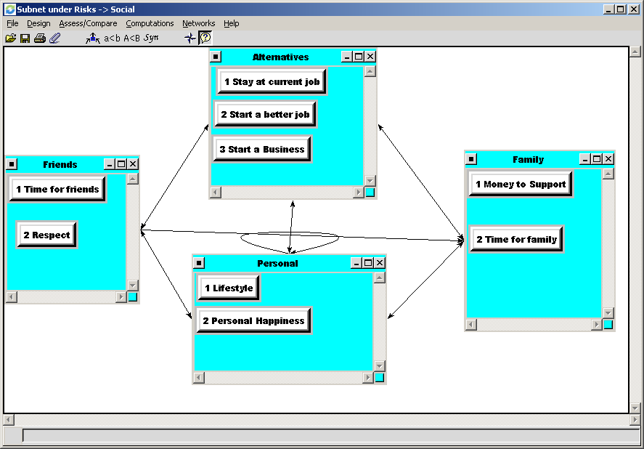

Exhibit 13: Economic Risks Sub-Network
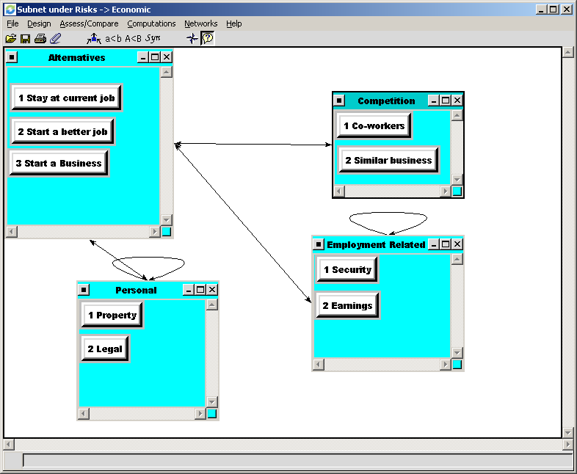

Exhibit 14: Sensitivity Analysis for BOCR Model
