Decision Making in a Complex in a Complex Environment

Final Project: Alternative Fuels in the Automotive World

By: Nick McClelland

Introduction
For this paper, the Analytical Network Process (ANP) was used in SuperDecisions software to help determine the best alternative fuels for cars of the future. The model used is a decision model and analyzes the benefits, opportunities, costs, and risks associated with each of the alternative fuel choices. There are a variety of alternative fuel sources that have been the subject of intense research, largely due to the fact that our auto industry, among many other industries, relies heavily on fossil fuels that will eventually run out. When these fossil fuels run out, the world will need to be ready to transition or already have transitioned to alternative fuels. Another reason to pursue alternative fuels is that our current source of fuel is also a harmful pollutant that not only contributes to global warming, but also the destruction of our ozone, as well respiratory sicknesses. This model attempts to analyze what alternative fuel source is the best option to incorporate into the automotive industry. The alternatives used in this model were: Biodiesel, Electricity, Ethanol, and Hydrogen/Fuel Cell.
Background
Alternative fuels are increasingly becoming a top priority among the majority of the world due to the dwindling amount of fossil fuels left to fuel our current automotive industry and many other industries. Currently, research being done in alternative fuels in the automotive industry largely revolves around hydrogen/fuel cell powered cars, electric cars such as any car made by Tesla, Biodiesel engines, and engines that run on ethanol.
Hydrogen/fuel cell powered cars run off energy created when a fuel cell converts the chemicals hydrogen and oxygen into water. Through this process, electricity is then created and used to power the vehicle. Fuel cells have many benefits associated with them, such as that they do not give off any greenhouse gases and eliminates pollution. The only bi-product of using a fuel cell is water. Fuel cells also have a higher efficiency than diesel or gas engines, they are extremely quiet, and unlike batteries of today, they never go dead. Although fuel cells have a plethora of benefits associated with them, there are also a fair share of cons too. For example, reforming an industry such as the automotive industry is extremely challenging and would have a significant toll on the environment. The transportation of the main ingredient in fuel cells, hydrogen, is also difficult to transport and store. The driving range of fuel cell powered vehicles is also shorter than most cars, and the size of the fuel cells are typically larger than today’s engines or batteries, which is not ideal for small-car companies such as Fiat.
Electric cars are currently the most popular commercially-available alternative fuel sourced cars. The biggest name in the electric car world is the carmaker, Tesla. Tesla makes cars that rely solely on electricity to power their vehicles by using a large battery that runs along the bottom of the car. Some benefits of electric vehicles is that they cost less to refuel since electricity is cheaper than gas. They have a lower maintenance cost due to having fewer moving parts when compared to engines used in typical gas-powered cars. The vehicle themselves are extremely quite when driving and give off significantly less emissions than cars today, however producing the components for the car does give off emissions and can cause more harm to the future of electric cars than good if production techniques are not improved.
The third alternative used in the model is a biodiesel engine. Biodiesel vehicles rely on various sources to produce enough energy to run a car. These sources of fuel are typically vegetable oils, soybean oils, or animal fats blended with alcohol to create the fuel required to power a vehicle. Biodiesel is a renewable fuel source that can already be used on older diesel cars, so for some users of this fuel the transition from gas to biodiesel would be seamless. Furthermore, vegetable oils can easily be obtained from most restaurants for free so biodiesel is also a very cheap fuel source. Although the fuel to power biodiesel cars is cheap, for newer diesel car or cars that can’t run on diesel, the required conversion necessary to run on biodiesel is expensive and is not a simple conversion.
The last alternative fuel source that was analyzed is ethanol. Ethanol powered cars run on a blend of ethanol and gasoline. Ethanol is great for reducing the demand for oil from other countries, has lower emissions than cars on the road today, and existing cars can currently run on a blend of 10% ethanol and 90% gasoline. Currently, roughly 10 million cars today are able to run off a blend of 85% ethanol and 15% gasoline. Although ethanol is useful for reducing the demand for oil, it still relies on oil to an extent which is not ideal. Ethanol also has a direct effect on food prices around the world. Since ethanol is made from the fermentation of inputs such as grains, the price of those inputs will increase as well. Lastly, an industry transition to ethanol fueled cars would result in a 25% lower fuel economy.
Methodology and Framework
As mentioned previously, the Analytical Network Process was put to use via SuperDecisions software. The model used assigns weights to four separate categories: Benefits, opportunities, costs, and risks (BOCR) to come to a decision on the best alternative fuel source for the future of the automotive industry. Benefits are the positive factors that the alternatives would bring to auto industry. Opportunities are benefits that the alternatives may allow in the future, such as technological advancements in other industries. Costs are the negative factors associated to each alternative while risks are possible risks for the future, for example the risk that driver safety may decline with the implementation of a new fuel source.
The Model
To establish ratings scales and evaluate the importance of Benefits, Costs, Risks, and Opportunities of this model, the four merits of BOCR were rated on a scale comprised of five different intensities. Figure 1 displays the design of the model and Table 1 shows the priority ratings for each of the BOCR merits.
Figure 1
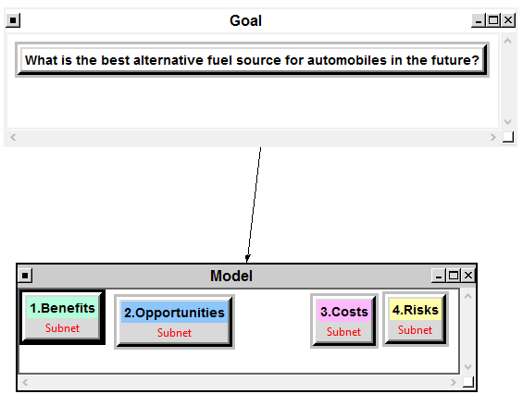

Table 1: Priority Ratings for the Merits- Benefits, Opportunities, Costs, and Risks
 | Benefits | Opportunities | Costs | Risks
Hydrogen/Fuel Cell | Excellent | Excellent | Above Average | Above Average
Electricity | Above Average | Average | Average | Below Average
Biodiesel | Average | Average | Excellent | Below Average
Ethanol | Below Average | Average | Average | Average
Priorities | .524 | .169 | .201 | .106

BOCR Network
The overall BOCR network hierarchy design for this model can be seen in Figure 2. The top level of the model is the goal cluster which contains a single node, the goal node. The goal node is then connected to the four BOCR merits: Benefits, Opportunities, Costs, and Risks. Each BOCR merit then has its own subnet of criteria related to the merit.

Figure 2: BOCR Network
Goal
Risks
Costs
Opportunities
Benefits

Economic
Consumer Reaction
Economic
Environmental
Job Availability
Auto Industry Disruption
Driver Safety
Implementation
Resource Availability
Technological Advancement
Energy Usage Reduction
Environmental
Social

Each set of criteria for each merit in the BOCR model also has a set of sub-criteria. Table 2 contains the definitions of the control criteria and sub-criteria for the Benefits model. Table 3 contains the definitions for the Opportunities model. Table 4 has the definitions for the Costs model while Table 5 has the definitions for the Risks model.
Table 2: Definitions for Benefits Model
Control Criteria | Sub-criteria | Description
Economic | Consumer Availability  Cost to Implement  Cost to sustain | Economic infrastructure of USA  How cheap it is to implement new fuel source  How cheap it is to sustain the fuel source
Social | Brand Recognition  Social Status | Popularity of specific car brands  Social standing
Environmental | Low Emissions | How much are emissions reduced
 | Energy | Energy efficiency of new fuel source

Table 3: Definitions for Opportunities Model
Control Criteria | Sub-criteria | Description
Environmental | Pollution | How much pollution can be reduced
Energy Usage Reduction | Reduced Energy Consumption | How much energy can be conserved with new fuel source
Technological Advancement | Fuel Tech Usage In Other Industries | The ability for the new fuel source to advance other industries

Table 4: Definitions for Costs Model
Control Criteria | Sub-criteria | Description
Economic | Legislation  Infrastructure  Profitability  Job Availability | Cost of legislation required for new fuel source  Cost of restructuring of industry infrastructure  The ability to retain profits from new fuel source  Amount of available jobs for people
Resource Availability | Patents  Physical Materials | Cost of obtaining the patents to implement new fuel source  Cost of obtaining necessary physical materials
Implementation | Cost to Implement | Cost of implementing new fuel system and fueling stations
Table 5: Definitions for Risks Model
Control Criteria | Sub-criteria | Description
Consumer Reaction | Public reception | How enthusiastic the public is for new fuel source
Driver Safety | Safety of Driver | How safe is the driver when using the new fuel source
Auto Industry Disruption  Job Availability | Decreased Sales  Decreased Production  Decreased Profit Margins  Decrease in Auto-Industry Jobs | How much might sales decrease  How much may production of vehicles be reduced  How much may profit margins be reduced  How much may job availability be reduced

High Priority Covering Criteria Selection
The priorities of the control criteria and sub-criteria in the four merits (Benefits, Opportunities, Costs, and Risks) were obtained from pairwise comparisons. The results can be seen below in Table 6.
Table 6: Criteria and their priorities
Merit |  | Criteria | Sub-criteria | Local Priorities | Global Priorities
Benefit |  | Economic | Consumer Availability | 0.67 | .0456
0.37218 |  | 0.183 | Cost to Implement | 0.11 | .0075
 |  |  | Cost to Sustain | 0.222 | .015
 |  | Social | Brand Recognition | 0.263 | .0074
 |  | 0.0752 | Social Status | 0.079 | .0022
 |  |  | Car Ownership | 0.659 | .0184
 |  | Environmental | Low Emissions | 0.800 | .221
 |  | 0.741 | Energy | 0.200 | .0552
Opportunities |  | Environmental  .676 | Pollution | 1.0 | .252
0.37218 |  | Energy Usage Reduction  .174 | Reduced Energy Consumption | 1.0 | .065
 |  | Technological Advancement .0749 | Fuel Tech Usage In Other Industries | 0.0749 | .028
Costs |  | Economic | Legislation | 0.502 | .019
0.15006 |  | 0.258 | Job Availability  Infrastructure | 0.1781  .09420 | .007  .004
 |  |  | Profitability | 0.225 | .009
 |  | Resource Availability | Patents | 0.25 | .004
 |  | 0.10473 | Physical Materials | 0.75 | .012
 |  | Implementation | Cost to Implement | 1.0 | .096
 |  | 0.637
Risks  .10558 |  | Consumer Reaction  .60922 | Public Reception | 1.0 | .064
 |  | Driver Safety  .08671 | Safety of Driver | 1.0 | .009
 |  | Auto Industry Disruption | Decreased Sales | .34455 | .008
 |  | 0.22176 | Decreased Production | .10852 | .003
 |  |  | Decreased Profit Margins | .54693 | .012
 |  | Job Availability  .08231 | Decrease in Auto-Industry Jobs | 1.0 | .009

Synthesized Results from SuperDecisions program
With the use of the SuperDecisions software, the overall synthesized results were obtained from the model. The results were made with respect to the Benefits, Opportunities, Costs, and Risks that each of the alternatives have to offer. The results are illustrated below in Tables 7 – 10. In Table 11, the final results of the whole model are displayed.

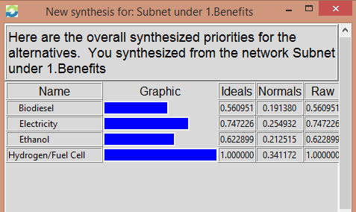
Table 7: Results of Benefits Model with Additive Formula (the multiplicative formula has same results)

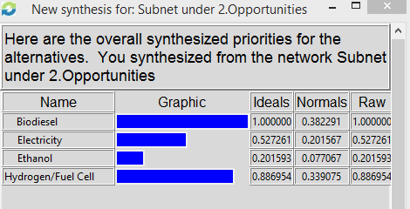
Table 8: Results of Opportunities Model (the multiplicative formula has same results)

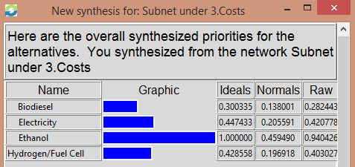
Table 9: Results of Costs Model

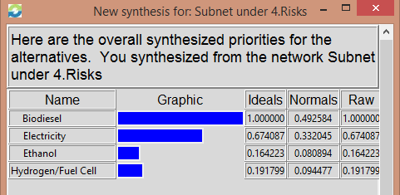
Table 10: Results of Risks Model (the multiplicative formula has same results)

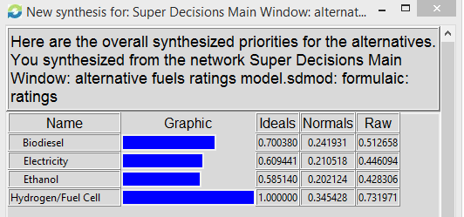
Table 11a: Final Results of the Whole Model with Additive Formula

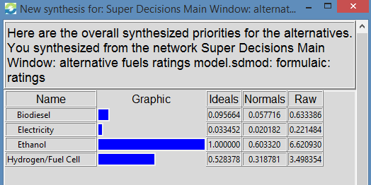
11b: Final Results of the Whole Model with Multiplicative Formula

Sensitivity Analysis
Below are Figures 2 – 5 which show the sensitivity analysis of the model when using the additive formula. Sensitivity analysis was done on the Benefits, Opportunities, Costs, and Risk merits. According to the results below, hydrogen/fuel cells is the best choice in all the analyses, however the spot for the second best alternative is a bit more competitive, particularly in the Opportunities and Risks nodes. For the opportunities node, biodiesel is the second best alternative available, however that changes. As time goes on, the opportunities of electric-powered vehicles outweigh the opportunities that biodiesel engines have to offer. For the risks node, the electric vehicles and ethanol powered vehicles are very comparable at the beginning, but as time goes on, electricity proves to have fewer risks associated with it when compared to that of a vehicle that runs off ethanol.

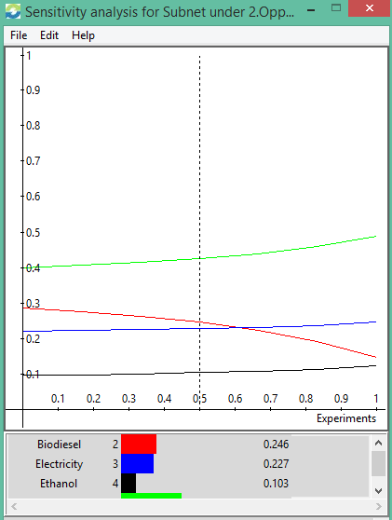
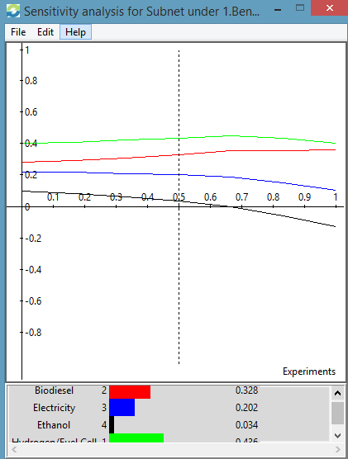
Figure 2: Sensitivity Analysis for Benefits Figure 3: Sensitivity Analysis for Opportunities

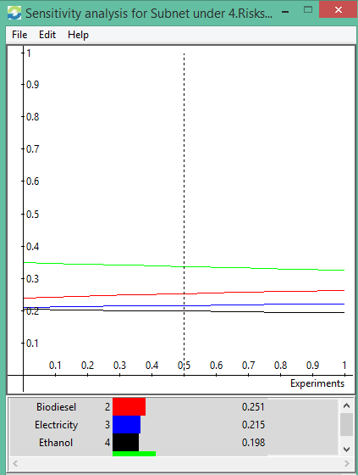
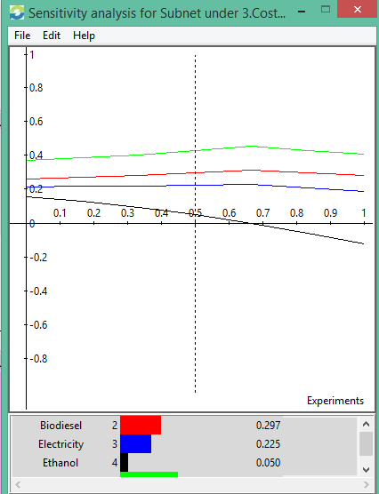
Figure 4: Sensitivity Analysis for Costs Figure 5: Sensitivity Analysis for Risks

Conclusion
From the model results, the best option with regards to the future of alternative fuels in the automotive industry is the hydrogen/fuel cell option when using the additive formula. When using the multiplicative formula, the best alternative is ethanol. Both of these choices seem logical to me. The short-term decision of ethanol is logical sense it requires the least amount of effort to switch to and many cars can already run on ethanol blends. The choice of hydrogen/fuel cell technology is fairly consistent with the real-world decision that the automotive industry has chosen. Currently electric cars are the most popular commercially available alternative fuel vehicle, however there are fuel cell powered cars available for purchase, and there is an abundance of research being carried out to advance hydrogen/fuel cell technology. I believe that as time goes on, the automotive industry will move towards fuel cell technology as the technology improves. Although the model used here indicates that Hydrogen/Fuel Cell alternative fuel is the best alternative, reality may not hold true to my model as time goes on. The reason that this may be is that pursuing alternative fuels is a complicated process with an abundance of factors that can sway a decision many ways. My model could be improved by adding more criteria for each merit and doing more comparisons. The more comparisons that are being made consistently, then the more accurate my model should become. I also could include more alternatives to my model such as hybrid vehicles or vehicles that run off of compressed gas. With the addition of more alternatives, more comparisons can be made and more criteria can be created to make the model as accurate as possible.
Tesla is currently leading the way with alternative fuels by releasing electric powered vehicles for purchase. Although electric vehicles are rising in popularity, it has yet to be seen whether or not electric vehicles are the future of the auto industry. If my model is any indication, electric vehicles may not be the future of cars powered by alternative fuels, but only time will tell.
Sources
Works Cited
"Hydrogen Fuel Cells Pros and Cons." Hydrogen Fuel Cells Pros and Cons. N.p., n.d. Web. 21 Apr. 2015.
Mello, Tara B. "The Pros and Cons of Electric Cars | Bankrate.com." The Pros and Cons of Electric Cars | Bankrate.com. N.p., 22 Apr. 2014. Web. 21 Apr. 2015.
Nice, Karem. "How Fuel Cells Work - HowStuffWorks." HowStuffWorks. N.p., n.d. Web. 21 Apr. 2015.
"Pros and Cons of Alternative Fuels | Consumer Reports." Pros and Cons of Alternative Fuels | Consumer Reports. N.p., Feb. 2014. Web. 21 Apr. 2015.

