Marcellus Shale Drilling
Decision Model for State of Pennsylvania
Christopher Gill, B. Alex Huber, Joshua Shaffer

Marcellus Shale-Overview
The Marcellus Shale formation is the largest unconventional natural gas reserve in the world, containing at least 489 trillion cubic feet of recoverable reserves. The Marcellus Shale formation is located throughout the Allegheny Plateau region of the northern Appalachian region of the United States. This includes southern New York, eastern Ohio, most of West Virginia and northern and western Pennsylvania. According to geology.com, the Marcellus Shale formation lies 5,000’-9,000’ below the surface of 60% of the land mass of Pennsylvania. The amount of drilling in the state of Pennsylvania has increased rapidly in the past few years. Economic output in Pennsylvania related to Marcellus Shale drilling increased from $2.3 billion in 2008 to $3.8 billion in 2009. State tax revenues related to drilling increased from $240 million in 2008 to $400 million in 2009. The increase in drilling volume can be attributed to depletion of conventional natural gas reserves. Another reason is the fact that natural gas produces fewer greenhouse gas emissions than coal. An economy-wide shift to lower greenhouse gas emissions thus makes natural gas more attractive.
The Impact
The increase in drilling has brought a few major environmental concerns to the forefront. To capture natural gas, underground shale formations are fractured by injecting a complex mix of fluids and chemicals under high pressure. This process is commonly referred to as “fracking”. One major risk associated with fracking is the potential for drinking water contamination caused by the fluids and chemicals used. In addition there is some concern that toxic air emissions near gas wells could occur. There are also concerns regarding wildlife habitats, hazards from trucking operations, damage to roads, and complications with handling of waste water produced by the fracking process. Some communities have also expressed concern for explosions of wells or gas lines in residential areas or near schools. However, many professionals in the natural gas industry believe that few of these fears are realistic based on experience.
In addition to the impacts imparted on the environment, there is potential for economic growth. Drilling could open opportunities of employment in local communities. The employment increase will generate local revenues from spending within these communities. The added jobs will contribute to Pennsylvania’s taxable incomes.
A similar endeavor in Texas has left local communities in a prosperous state. The Barnett Shale formation has been tapped there, however, their situation varies from that of Pennsylvania’s. In Texas, shale drilling has been a great source of local revenue from taxes. These have contributed to a higher quality of life to the affected communities by benefiting school districts, county governments, and municipal governments. However, Pennsylvania is currently unable to generate local tax revenues since natural gas is not subject to local taxation. Pennsylvania is the only state in the US with mineral wealth that does not impose a severance tax to compensate residents for the removal of nonrenewable resources. The impact of imposing such a tax is currently being debated in Pennsylvania. Those not in favor of such a tax fear that it would discourage drilling, since the cost of the tax would be difficult to pass on to consumers. The 14 states with greater natural gas production than Pennsylvania all have severance taxes and have experienced drilling growth of 5.2% per year on average.
From the aforementioned, our strategic criteria was selected and encompasses Economic, Environmental, and Social aspects.
The Objective
Through the Complex Analytical Network Process, we hope to arrive at a conclusion for the state of Pennsylvania concerning the Marcellus Shale formation. In this type of analysis we use Benefits, Opportunities, Costs and Risks for to evaluate each salutation (or alternative).
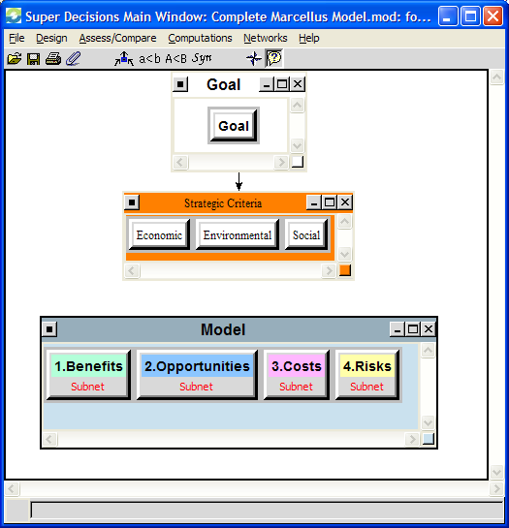
Figure 01: Complex ANP Overview
Three options have been selected as suitable alternatives. In this case, the alternatives present themselves as:
- No Drilling – no large scale increase in drilling currently occurring in PA
- Drilling with regulation but without taxation
- Drilling with regulation and taxation – includes imposing a new severance tax comparable to those used in other states with mineral wealth
Where regulation is referred to as the policies protecting social rights and the environment. It is clear that the extent to which these policies will apply have significant impacts on local communities and drilling industry. The ideal solution would enable companies to drill with limited environmental risk imparted on the community.
The BOCR nodes help us to produce the most valuable outcome. However, we cannot say that the BOCR merits are weighted equally. For instance, it is in our interest to protect the environment while remaining financially stable. We first decided to analyze the decision from the perspective of the state. To distribute the perceived values, a ratings model has been applied to appropriately determine the magnitude of each merits’ influence in the decision. We categorize the value of each BOCR merit for the corresponding three control criteria. The ratings selected for the synthesis are depicted below.
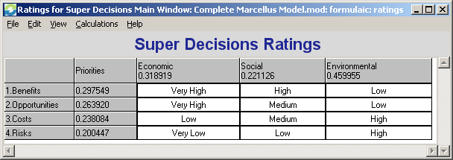
Figure 02: ANP Synthesis Ratings

The Network
The model integrates a complex structure of decision criteria and pair wise comparisons. For the first subnet of each BOCR merit node, we have chosen “Environmental”, “Economic”, and “Sociopolitical” to describe groups of our control criteria. See the figure below for a representation of the primary subnet for Benefits node.

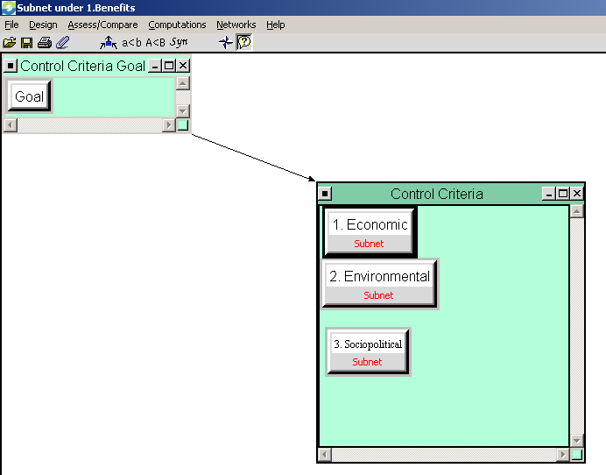
Figure 03: Example view of subnet structure
Within these groups, we have constructed networks to prioritize the value of each alternative. The full network summary to the third level is given in the following table. The table depicts the priorities associated with each criteria. Additionally, a “Global Priorities” field denotes the relative influence on the model prior to the influence of “Ratings” or “Sensitivity.”

GOAL: Determine what policy Marcellus Shale Drilling should be conducted by.
Social
Economic
Environmental
Strategic Criteria
BENEFITS
Social
- Energy Independence
- Improve quality of life
- Increase in social responsibility
- New Roads/Infrastructure
- Protection policies and assurances
Environmental
- Reformation in drilling techniques
- Decrease in 'dirty' fossil fuel dependence
Economic
- Decrease in Energy Cost
- Increase in shareholder value
- New Jobs
- Tax Revenue
OPPORTUNITIES
Social
- Energy Independence
- Higher Standard of Living
- Reformed Leadership
Environmental
- Improved drilling methods
- Increased Use of Cleaner Energy
- Policy Improvements
Economic
- Energy Cost Control
- Increase industrial growth and technology Effect on US budget
- Profitable mineral rights
- Regional Employment Growth Reduction of bureaucracy
COSTS
Social
- Earmarks/deficit increase
- Increased Lawsuits
- Infrastructure Wear +Tear
- Local Economy Collapse
Environmental
- Catastrophic Event
- Damaged Aquifers
- Deforestation/Landscape Impact
- Increased Water Use
Economic
- Cost of regulation
- Cost/energy to drill
- Decrease property value
- Increased Rural Cost of Living
- Infrastructure cost
- Lost opportunity
RISKS
Social
- Excessive Policy
- Industrialization of Rural Areas
- Political Shift
- Public Affairs/Protests
Environmental
- Contaminated Drinking Water
- Gas Leaks
- Increased Gas Consumption
- Well Explosions
Economic
- Local Economy Collapse
- Lost Potential Revenue

No Drilling
Drilling, w/ Regulation but No Tax
Drilling w/ Tax + Regulation
Alternatives

The Results
A synthesis was executed for each of the BOCR merit nodes. The results are depicted in the following table.
Benefits Synthesis  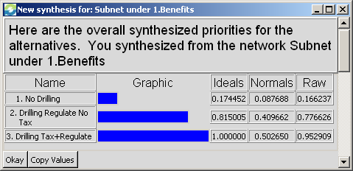 | Opportunities Synthesis  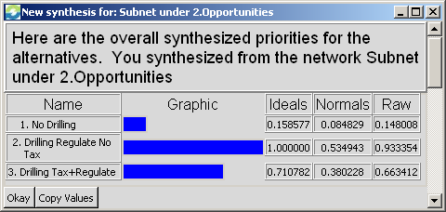
Costs Synthesis  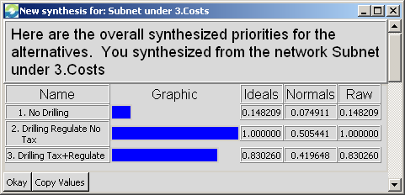 | Risks Synthesis  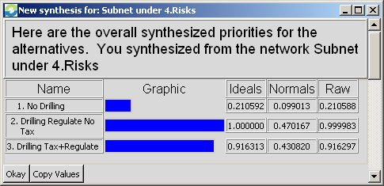

Overall Model Synthesis – Additive 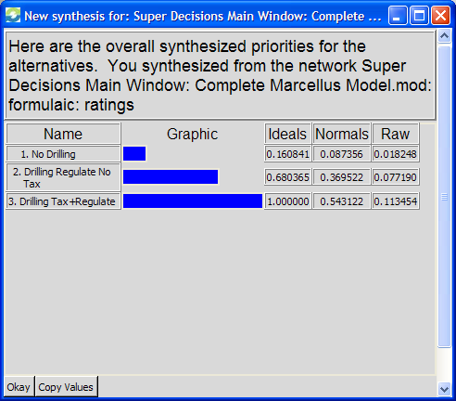 | Overall Model Synthesis – Multiplicative 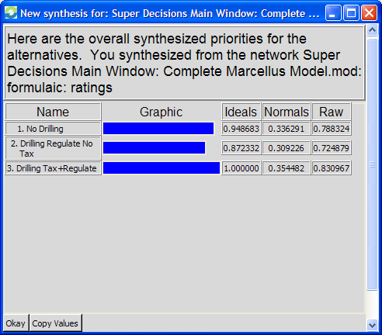
For the whole model synthesis, both the additive (negative) and multiplicative methods indicate that drilling with an added severance tax is the preferred alternative. This was the preferred alternative in the Benefits node and was lower in both costs and risks than drilling without severance tax. No drilling had the lowest benefits and opportunities but also had the lowest costs and risks. The final conclusion of the model then depends on the priority weighting of those four factors.

Sensitivity Analyses
Benefits  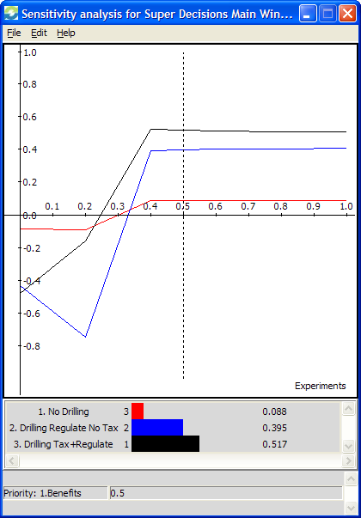 | Opportunities  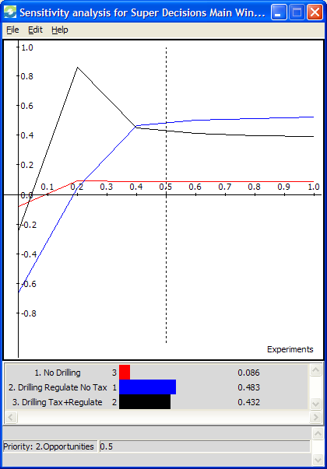 | Costs  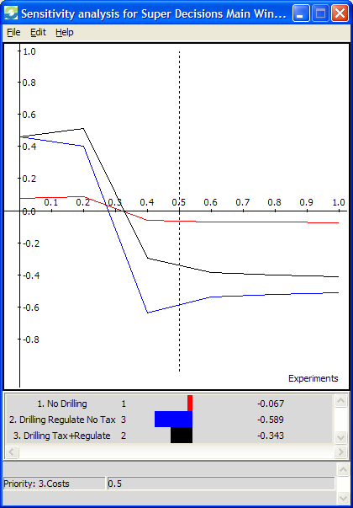 | Risks  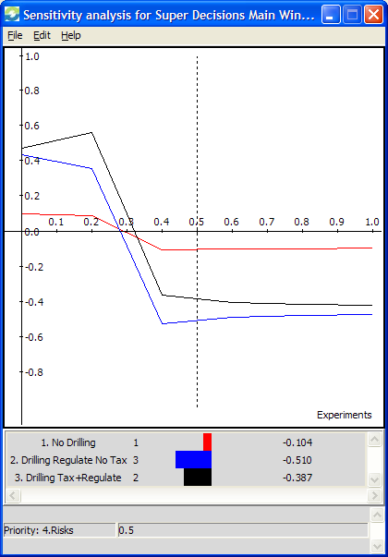
Figure 04: BOCR Model Sensitivity Analysis with respect to each merit
When analyzing final goal selection, both of the increased drilling options vary significantly with changes in priority of benefits, opportunities, costs and risks. With very low emphasis on benefits, no drilling is the preferred option but as benefits become more heavily weighted it becomes the least attractive choice. High emphasis on costs or risks would lead to selection of no drilling as the preferred alternative as well.

Economic  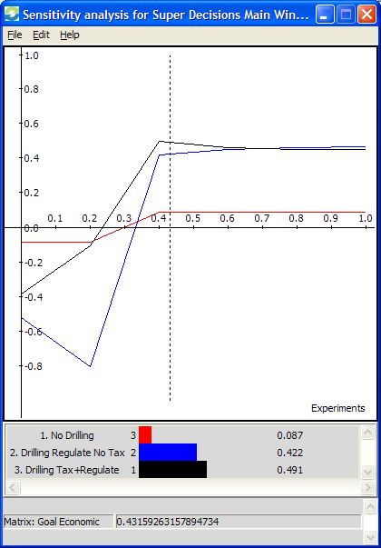 | Social  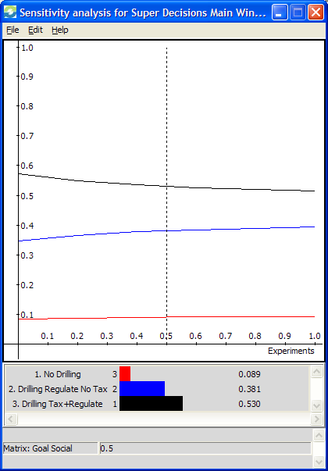 | Environmental  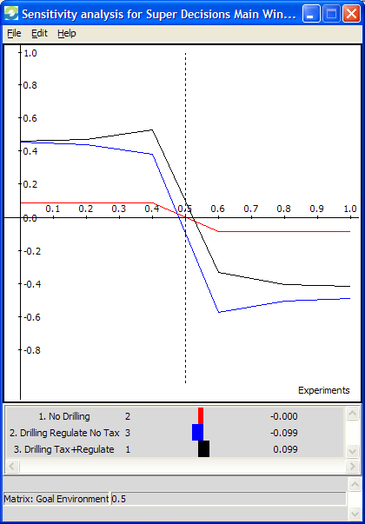
Figure 05: Overall Model Sensitivity Analysis with respect to each Strategic Criteria
When economic benefits are weighted heavily as the preferred strategic criteria, drilling with no severance tax overtakes drilling with tax as the preferred alternative. Similarly, as environmental concerns become more important the choice of no additional drilling becomes the preferred alternative. However, there is very little sensitivity in the model to preference toward social benefits. Drilling with a severance tax is the preferred option regardless of the importance of social impacts.

