Chronic Illness and Hospital Admissions

By Orrin Cooper and Brian Turcsanyi

Decision Making in a Complex Environment

October 13, 2008

Abstract
Healthcare costs are projected to rise as the population ages. The largest portion of healthcare costs are those associated with unnecessary hospital visits from poorly managed chronic illnesses. Congestive heart Failure (CHF), Chronic Obstructive Pulmonary Disease (COPD), and Diabetes, are the top three illnesses that lead to hospital readmissions for Baby Boomers. To decide which illness offers the greatest opportunity for improved disease management and healthcare cost reduction they are rated against return on investment (ROI), sustainability, intervention spread, and the existing treatment gap. From our findings, COPD appears to be the ideal chronic illness to target.
Contents
Introduction 3
Methodology & Data 4
Strategic Criteria 4
Model Assumptions 5
Alternatives 5
Main Model 6
Benefits 6
Benefits -> Economical Subnet 7
Benefits -> Social Subnet 8
Benefits -> Political Subnet 9
Costs 10
Costs -> Economical Subnet 11
Costs -> Social Subnet 11
Costs -> Political Subnet 11
Opportunities 12
Opportunities-> Economical Subnet 13
Opportunities-> Social Subnet 14
Opportunities-> Political Subnet 15
Risks 16
Risks-> Economical Subnet 17
Risks-> Social Subnet 18
Risks-> Political Subnet 19
Analysis 20
Sensitivity Analysis 22
Summary and Conclusion 24
Future Research and Applications 24

Introduction
Healthcare spending continues to rise at the fastest rate in our history. In 2007, total national health expenditures were $2.3 trillion, or $7600 per person. U.S. health care spending is expected to increase at similar levels for the next decade reaching $4.2 Trillion in 2016, or 20 percent of the GDP. The largest segment of those costs is from hospital care. Hospital care represents over one-third of total health care spending, both in Pennsylvania and nationally.
The best opportunity to reduce the growth in health care costs is by reducing unnecessary hospitalizations by managing chronic diseases better. The 45-64 population age range, commonly referred to as the Baby Boomers, have the highest readmission rates out of the population with chronic disease. The top five conditions are Congestive Heart Failure (CHF), Pneumonia, Chronic Obstructive Pulmonary Disorder (COPD), Long-Term Diabetes Complications, and Asthma. For our project, we wanted to know if there was an advantage to choosing a specific chronic disease to start with. In Eastern Pennsylvania, there is underway a large Diabetes intervention. In Southwestern Pennsylvania, there is a COPD intervention underway. However, CHF has the largest amount of hospital admission rates. Our goal was to see what illness was the best opportunity for an intervention to reduce healthcare costs.

Methodology & Data
A preventable hospital readmissions in our case is defined as a another hospital admission within 30 days. The purpose of reducing these visits is not to limit access to care or prevent those who need care from getting it but to reduce the cost from the additional waste of visits. These admissions could have been prevented if adequate care/education was provided on the first visit. These can be targeted by providing an intervention to change the care plan or introduce new protocols. We have identified these strategic criteria as what would make a good intervention to rate

Strategic Criteria
To determine what makes a successful intervention, we’ve decided upon these criterions.
- Return on investment (ROI) – This is the business case as to why you’re undertaking a particular intervention. Interventions reduce cost or waste. In our example we’re looking to reduce to cost from readmissions.
- Spread/Duplicate – This is the potential of the intervention to be used in other hospitals regionally and nationally. Health care has pockets of quality islands were systems are efficient and safe but spreading the lessons and experience to other places to build quality improvements in those new areas is difficult. A good intervention will have defined protocols that can be used as a starting point for new interventions.
- Sustainability – This is the likelihood that changes for the better in a system will stay in place and continue to improve. Healthcare, just like other organizations, needs to have a strong culture to reinforce good behaviors otherwise systems breakdown and will lose the gains they have made.
- Treatment Gap – This is an observation regarding the current condition of treatment. Is there room for improvement and how much? In this case, management of care that does a poor job of addressing patient needs would be better than on that does a good job for most patients.

Model Assumptions
While a treatment gap exists in the management of these conditions, the actual cost of implementing these changes is relatively small in comparison to the money that could be saved. There is also very little risk involved in trying these interventions. The current health care system already provides a baseline of care and do not harm patients. The changes of the intervention are proven to improve outcomes. The changes from the intervention are better coordination between the many stakeholders and processes to manage chronic illnesses.

Alternatives
The alternatives chosen are a reflection of the current initiatives under way by the Governor’s Office of Health Care Reform (GOHCR) in Pennsylvania. In Eastern Pennsylvania, diabetes is the targeted chronic illness; in Southwest Pennsylvania COPD is the targeted illness. We choose to add CHF because CHF had the highest rates of readmission for the largest portion of the demographic.

Main Model
The main model pictured below with our strategic criteria, ROI, Spread/Duplicate, Sustainability, Treatment Gap and the BOCR criteria.

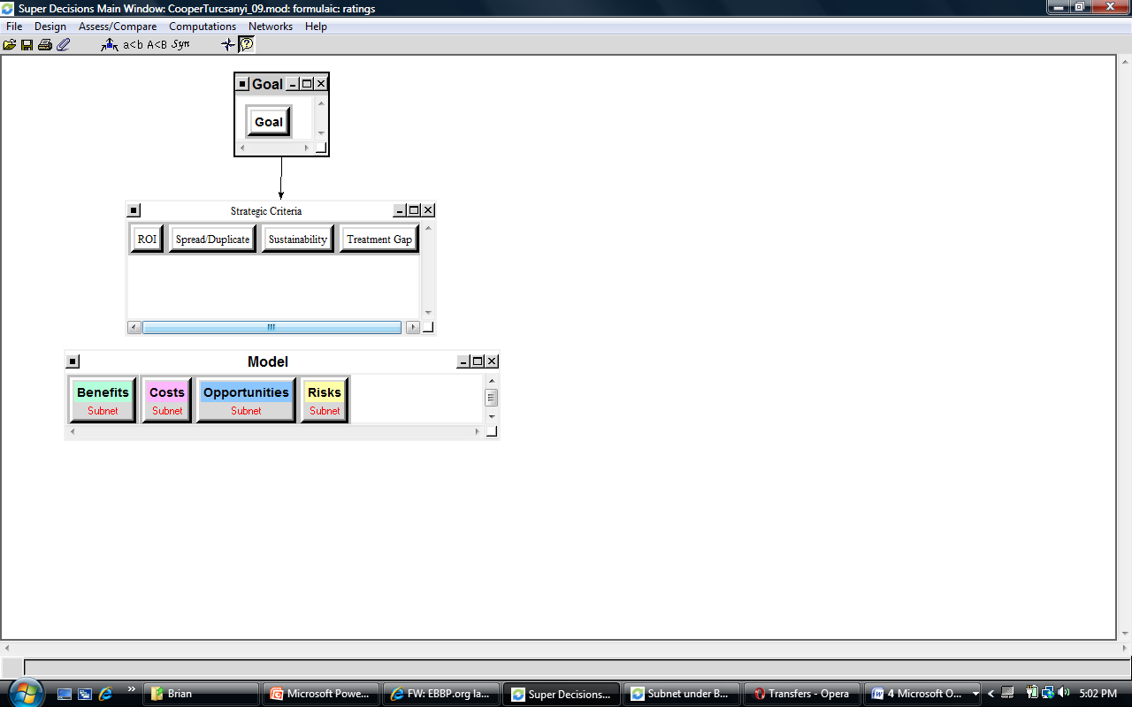

Benefits
In the Benefits subnet, our control criteria of Economic, Social, and Political.

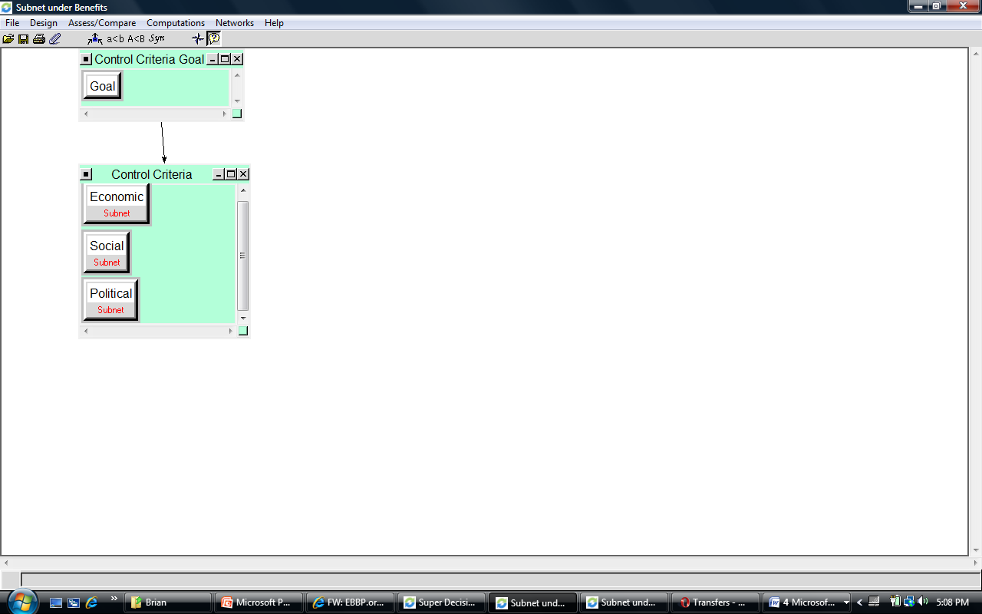

Benefits -> Economical Subnet
This subnet has two clusters named Actions and Actors.

Cluster: Actors
- Care manager – The care manager supports the patient. They provide coordination of visits to specialists, weekly checks to see how the patient is managing, provide training and education for the patient to better manage their chronic illnesses.
- Doctor – The physician that works with the patient.
- Patient – The person with the chronic illness.
- Support Network - This is the group of family and friends of the patient.

Cluster: Actions
- Care Manager Follow-up – Care managers provide weekly home visits or monthly telephone calls to see how the patient is doing
- Diet – Eating right is important for good health. For diabetes and CHF, eating the right types of food is critically important, more so than those that suffer from COPD
- Exercise – Regular exercise is another important aspect of maintaining good health.
- Medication – Medication is used to alleviate some of the symptoms of chronic illnesses.
- Patient Staff Interaction – This is how engaged the patient is with their healthcare providers in making decisions.

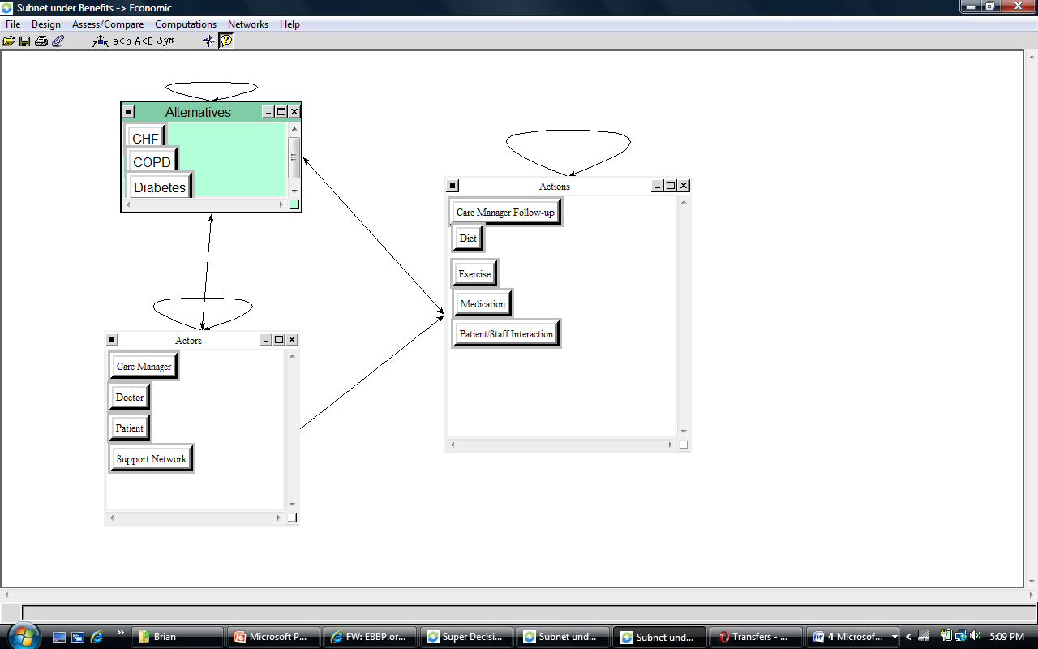

Benefits -> Social Subnet
This subnet has three clusters, Image, Actions, and Actors

Cluster – Image
- Public Good – This is raising the awareness of these chronic illnesses in the public’s mind.

Cluster – Actors
- Care Manager
- Patient
- Physicians
- Support Group

Cluster – Actions
- Productivity – Better management of chronic Illness helps the patient become more productive in their life and reduces the burden on the patients’ support groups as well make the other healthcare professionals more productive because they’re not wasting resources for unnecessary hospital visits.

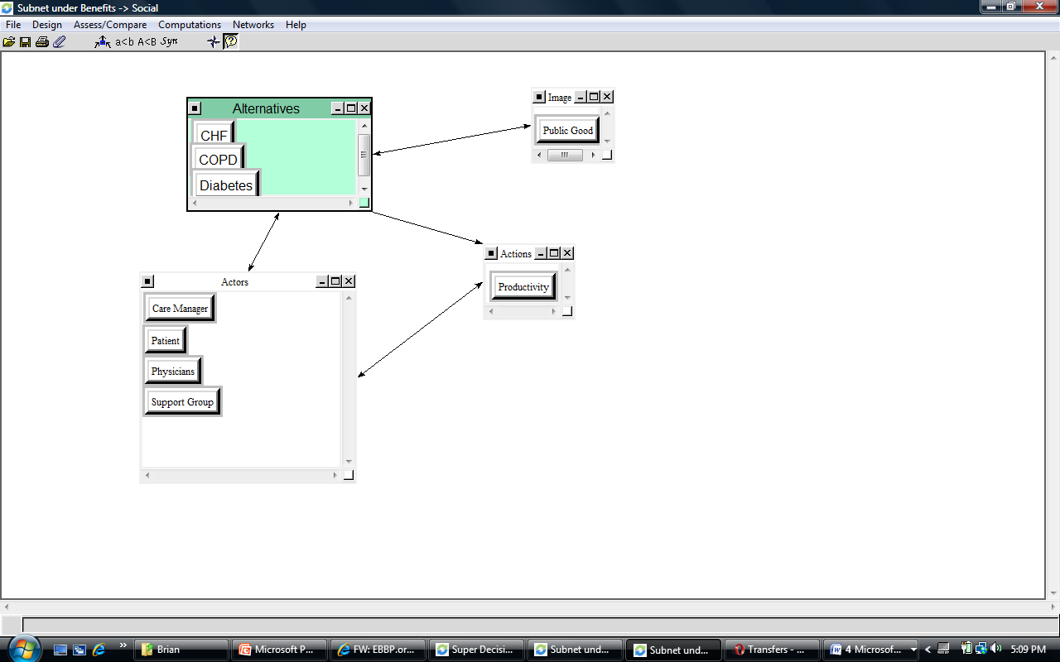

Benefits -> Political Subnet

This subnet has Actions and Actors clusters

Cluster: Actors
- Associations – These are the associations that are associated with the Chronic Illnesses such as the American Heart Association, the American Diabetes Association, and the American Lung Association. The Heart and Diabetes associations have a much stronger impact on their diseases than the Lung Association which primary deals with Lung Cancer and Smoking.
- Lobbies – Special interest groups that push their own legislative agenda.
- Politicians – People who create legislation

Cluster: Actions
- Legislation – Create new guidelines or reimbursement levels for particular chronic illnesses
- Never Events – Patient safety events that are ‘never’ supposed to happen in a hospital (e.g. amputation of the wrong limb). Hospitals are not reimbursed for these events so there is a strong incentive for hospitals to change processes to ensure these events never happen to patients.

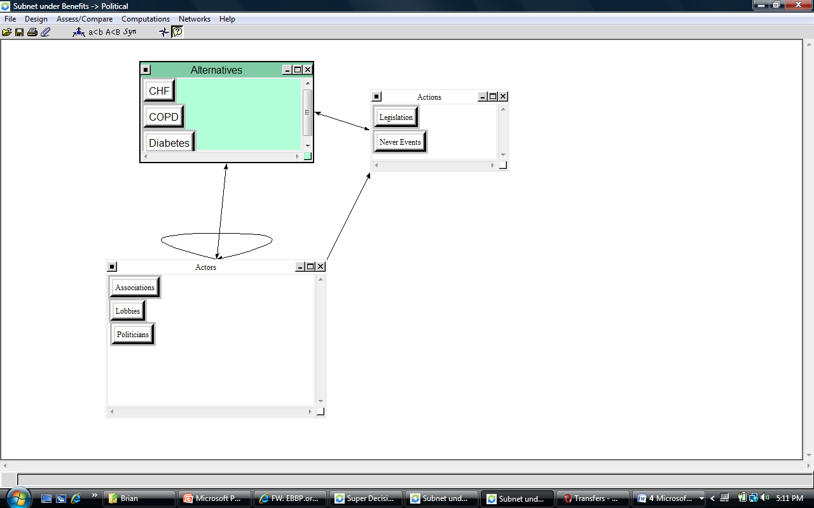

Costs
In the Costs subnet, our control criteria of Economic, Social, and Political.

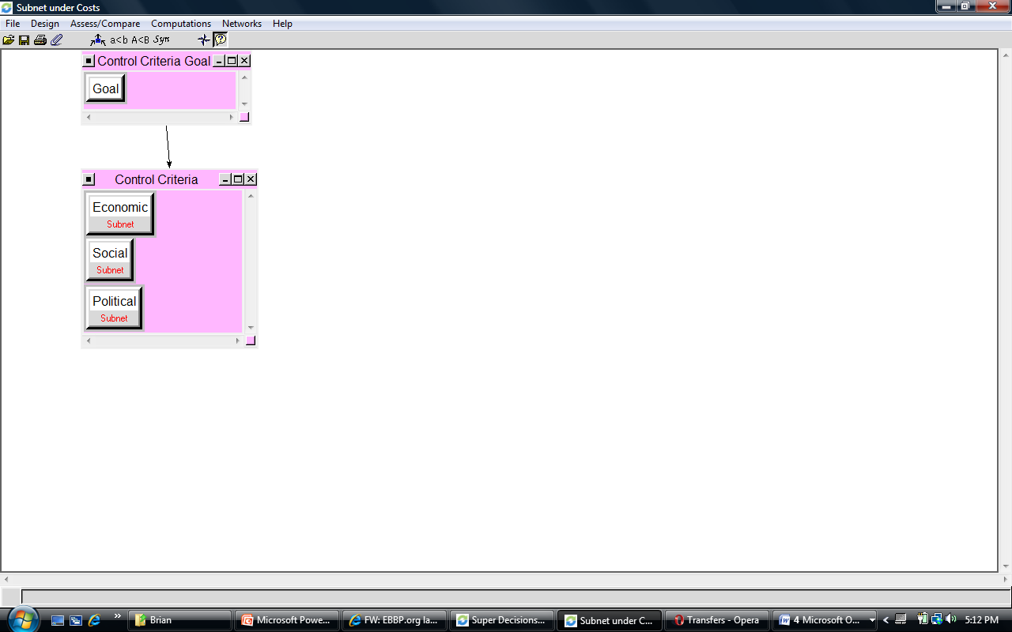

Costs -> Economical Subnet
This subnet has Actors and Actions clusters

Cluster – Actions
- Cost of Changing System – This is the cost of changing the system to a more patient centered system.
- Culture – This is the cost of changing the culture from a top down authoritative system where the physician is alone at the top to a more healthcare team approach.
- IT – This is the cost of building out the Information Technology infrastructure to support the integration of medical information for the patient, physician, and ancillary services.
- Training/Hiring – This is the cost of hiring care managers and training healthcare workersin new processes.

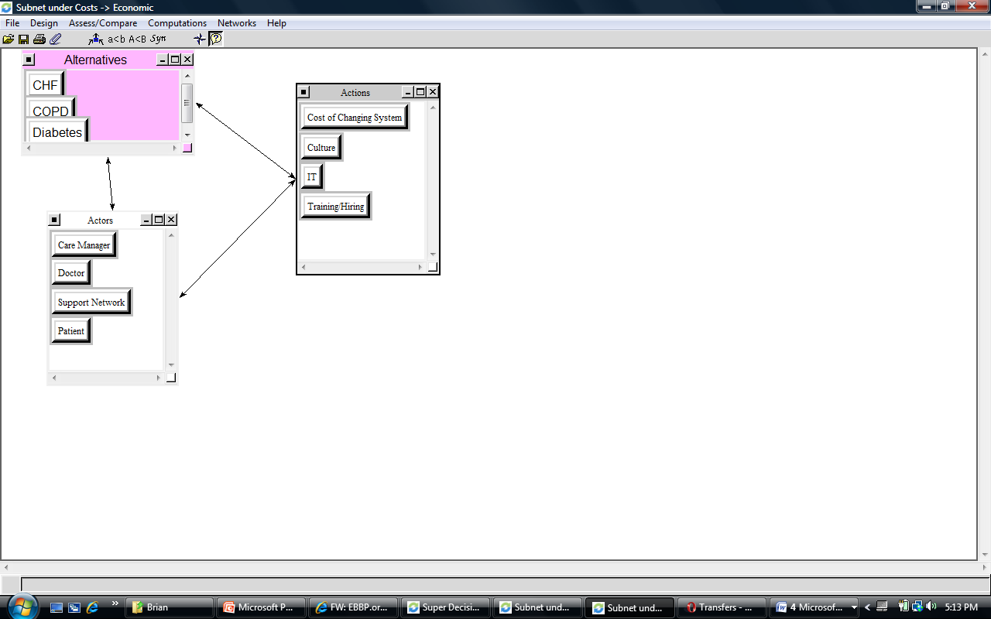

Costs -> Social Subnet
As discussed in the assumptions section, we felt that there were no social costs to choosing an alternative.

Costs -> Political Subnet
As discussed in the assumptions section, we felt that there were no political costs to choosing an alternative

Opportunities
In the Opportunities subnet, our control criteria of Economic, Social, and Political.

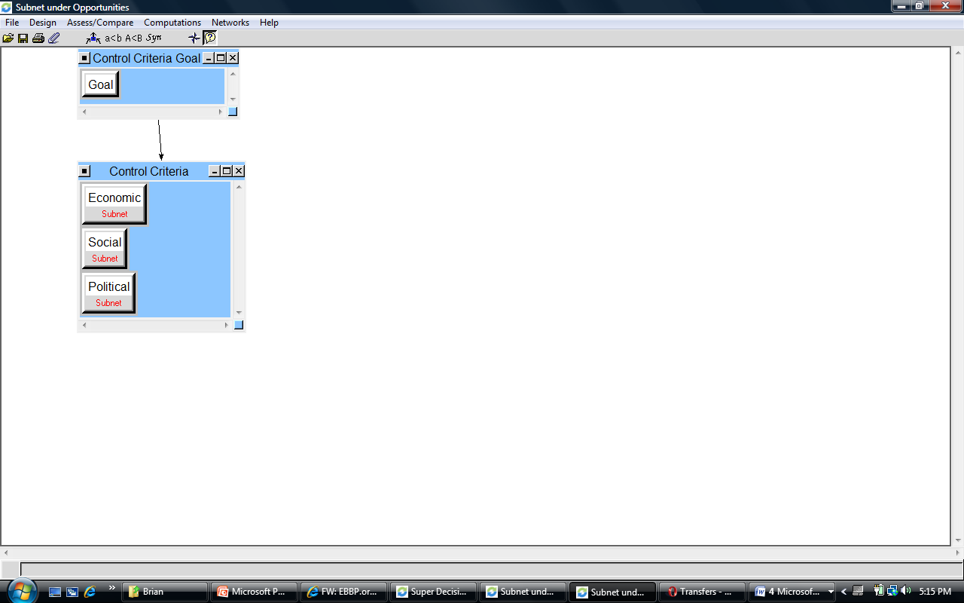

Opportunities-> Economical Subnet
This subnet has Actors and Actions clusters

Cluster – Actions
- Higher Reimbursements – If the changes are successful, insurances companies may offer higher reimbursement rates to healthcare providers to incentive them to switch to a better way to care for patients
- Productivity- Productivity will likely be greater if the intervention is successful.

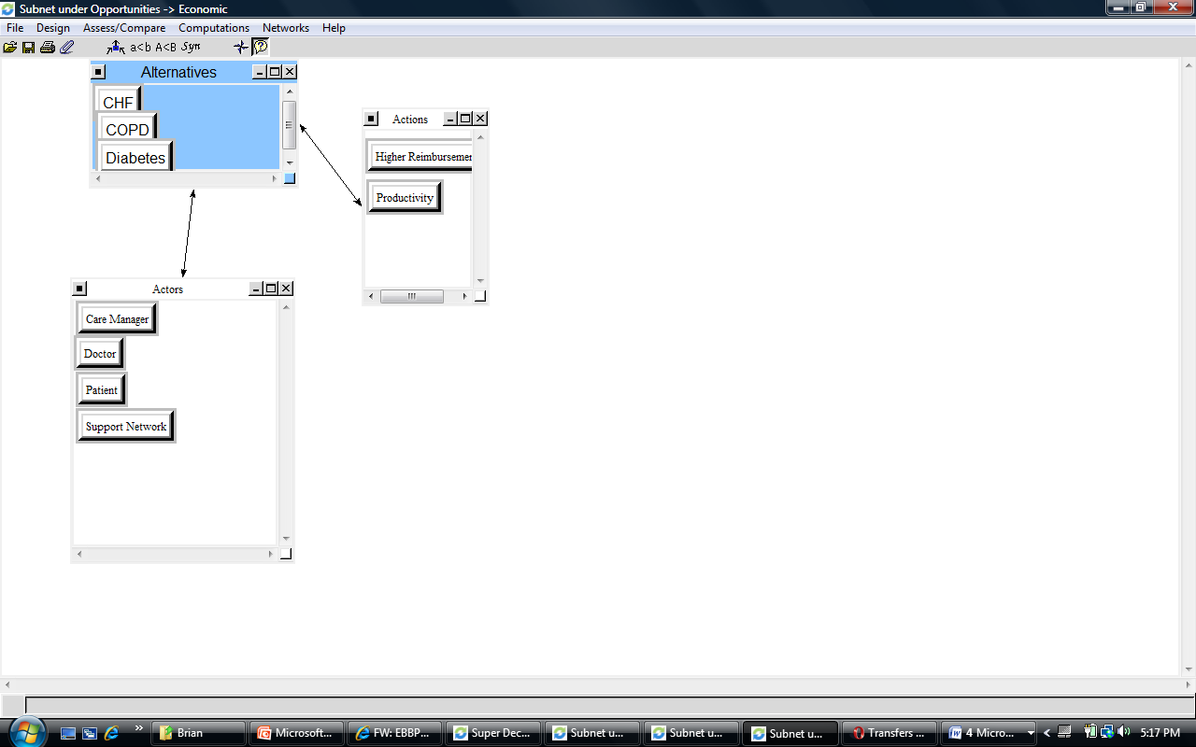

Opportunities-> Social Subnet
This subnet has Actors and Actions clusters

Cluster - Actions
- Health – The opportunity of increased health for patients.
- Relationships – Stronger relationships between health care providers and patients.

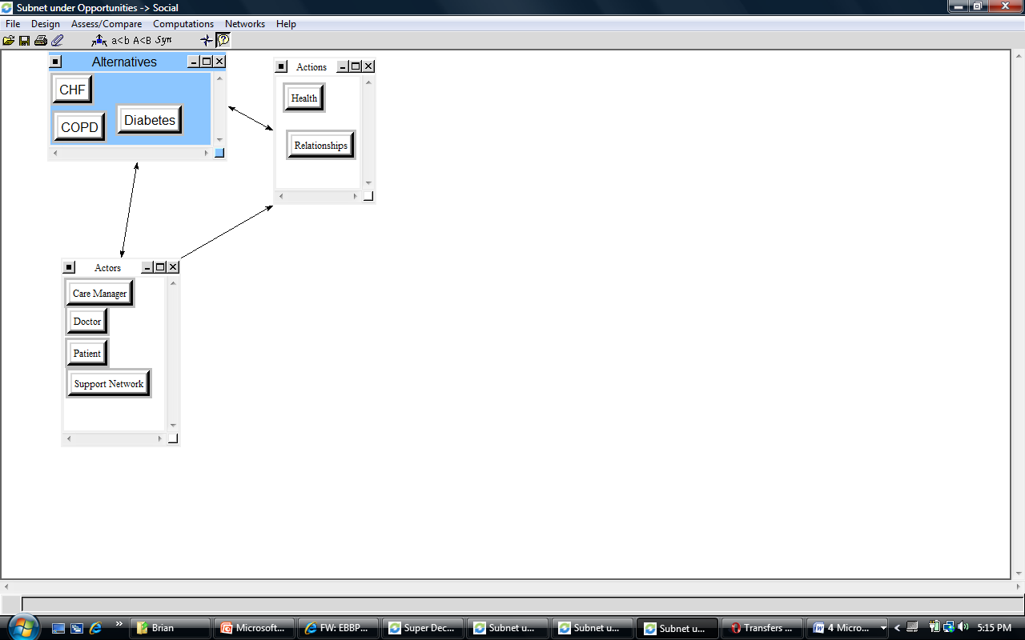

Opportunities-> Political Subnet
This subnet has Actors and Actions clusters

Cluster – Actions
- Goodwill – An opportunity for politicians and associations to garner goodwill for their community if the interventions are successful.

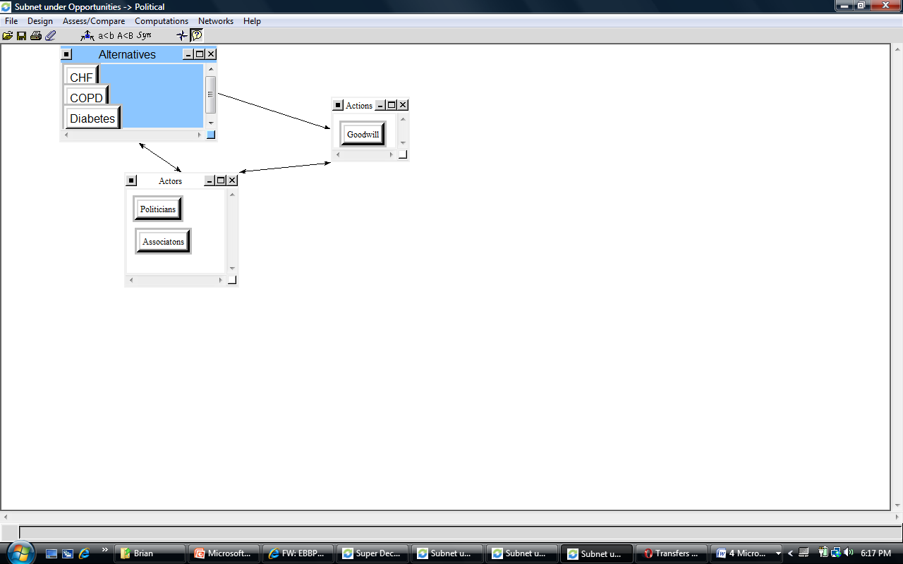

Risks
In the Risks subnet, our control criteria of Economic, Social, and Political.

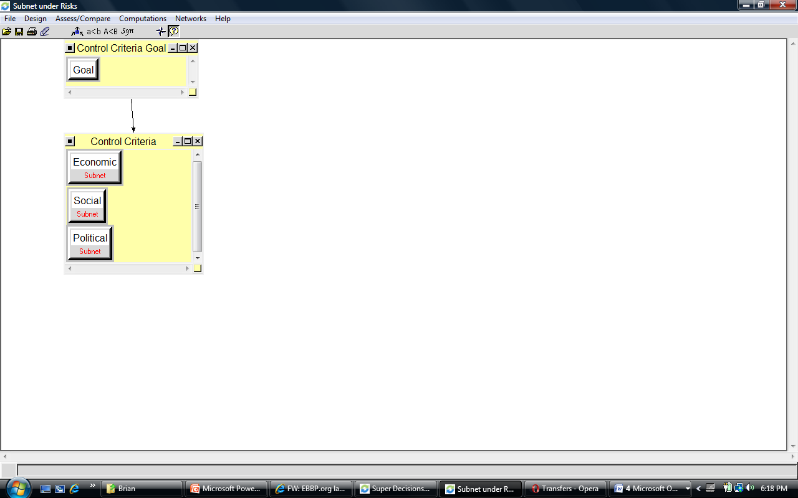

Risks-> Economical Subnet
This subnet has Actors and Actions clusters

Cluster - Actions
- Intervention Failure – This is the risk of intervention failing. We would lose the cost of hiring and training personnel.
- Malpractice – While the procedures in the intervention are not harmful, there always remains a risk of malpractice.
- Perception – The chance that changes of the intervention will negatively impact reimbursement rates.

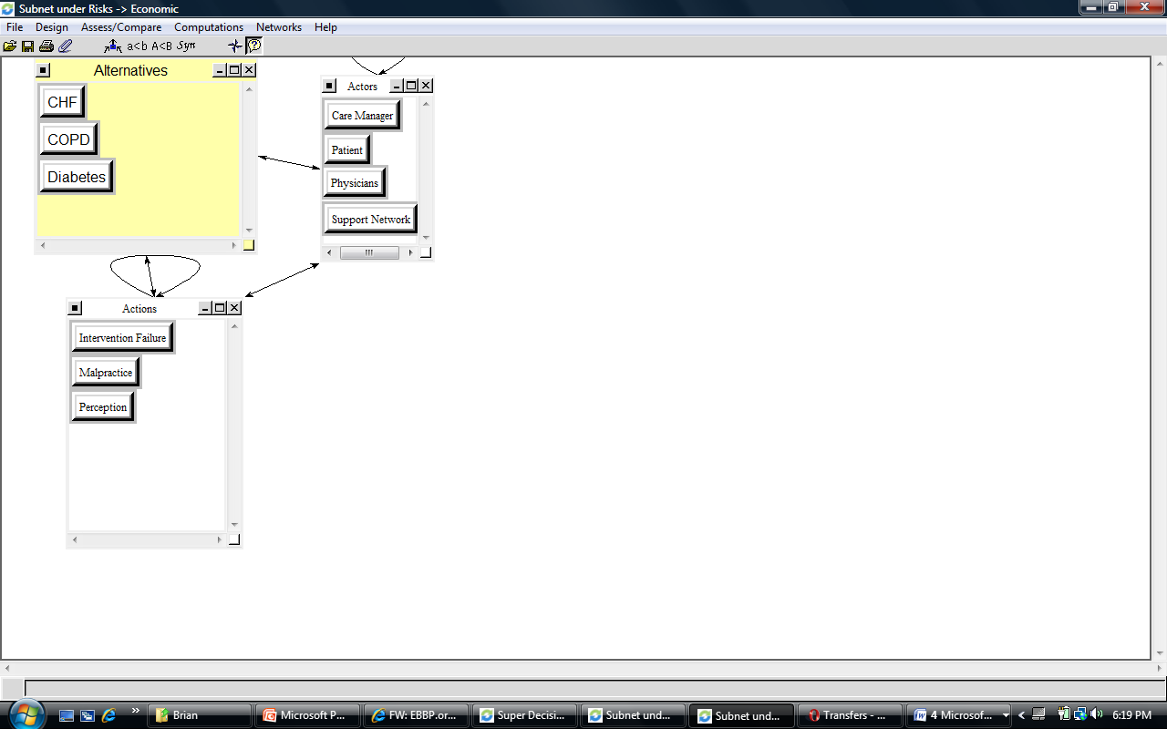

Risks-> Social Subnet
This subnet has Actors and Actions clusters

Cluster – Actions
- Perception – The chance that the patient may look negatively to the changes being made to the healthcare system. Patients view low cost as low quality.

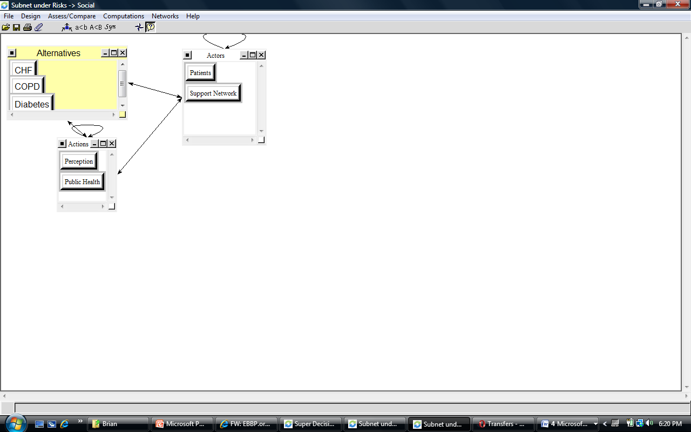

Risks-> Political Subnet
This subnet has Actors and Actions clusters

Cluster - Actions
- Misperception – This is the risk that the voters assume that lobbies are making decisions on the public’s health care.
- Failure – The risk that chronic illness intervention will fail and cast a negative light on lobbies and associations.

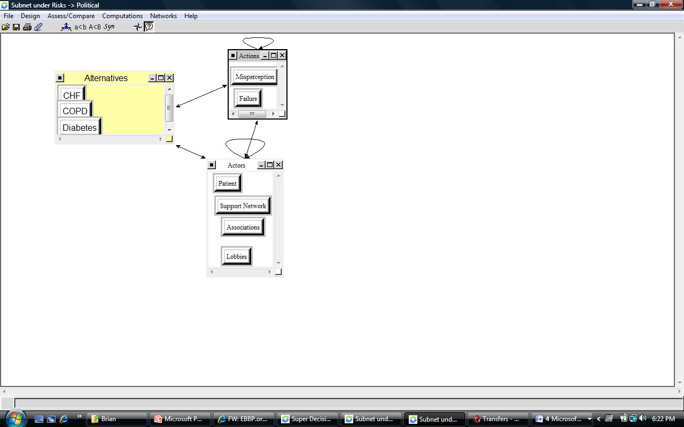

Analysis
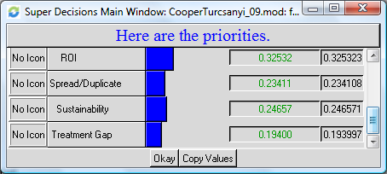The Super or Strategic Criteria Matrix is used to rate priorities for the BOCRs. We filled this matrix with the comparisons of how COPD satisfied each BOCR for the strategic criteria 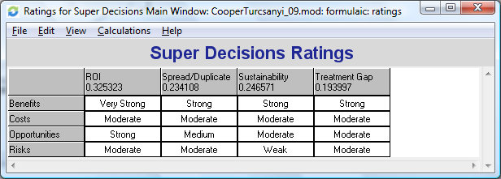which were Return on Investment (ROI), the ability to spread or duplicate the program that is implemented, the Sustainability of the intervention, and the ability to avoid a Treatment Gap when the program is implement. The ROI criteria is in line with the overall goal of decreasing costs and also opening beds for more profitable treatments which would increase the ROI. The Benefits and Opportunities are tremendous; a moderate amount of costs and risks also exist. The benefits from being able to spread the program would provide increased rewards and in the overall picture would be nice but the other comparisons were moderate because savings would be realized regardless of if other hospitals could use the program. We felt CHF would be very sustainable and not a present a large problem in treatment gaps while having moderate costs, opportunities and risks.
Criteria Weighting
Super Criteria Matrix

We synthesized our model with the strategic criteria and compared the results of our model under the additive and multiplicative formulas. While each formula considers the Benefits, Opportunities, Costs, and Risks the main difference we were interested in was the short versus long term results of our decision. We were interested in the results from each formula; however, the multiplicative is generally a better fit because it avoids errors that can occur when the values divided are close to zero and it also looks that the long term results. In our case the results were the same. In line with the benefits of the multiplicative formula there is a greater gap between Diabetes and CHF than in the additive formula results.
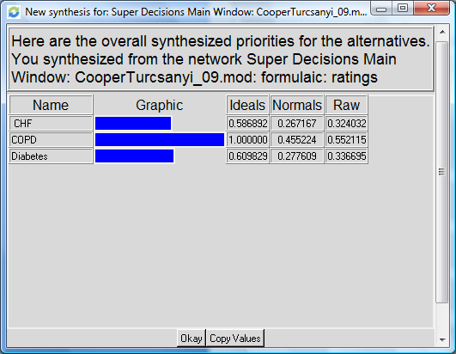
Result Based on Additive Formula
Decision Results Using:
Multiplicative Formula

Decision Results Using:
Additive Formula

After the pairwise comparisons were completed, the model was synthesized, and the strategic criteria were added and synthesized into the model, we took a closer look at why COPD was the best decision. We were also interested in how Diabetes had come out on top of CHF through the model. Our ANP model brought out a richness that lead to further investigation through sensitivity analysis.

Sensitivity Analysis
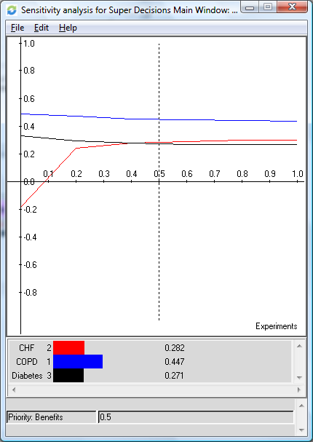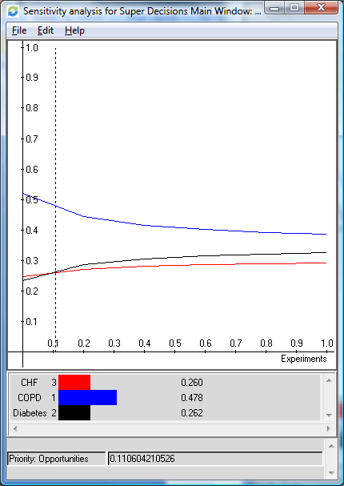
Sensitivity Graph
Opportunities
Sensitivity Graph
Benefits
COPD came out on top without intersecting the other alternatives for almost every top level network and subcriteria. Two examples are given above which show how COPD is clearly on top; and while in some of the sensitivity plots the alternatives never intersect, in both graphs there is an intersection point where the tables turn between CHF and Diabetes. COPD came out on top because it is one of the most costly illnesses to treat and readmissions are easier to prevent by following the regimens given by doctors than Diabetes. The stiff competition between CHF and Diabetes was unexpected, we expected Diabetes to come in dead last in the overall model. The results are a good example of the richness that an ANP model can provide. Had we not included Diabetes this difference would not have come to our attention. Originally, the only reason Diabetes was included was because of the amount of public attention it receives. Diabetes is a hot topic and we felt that by not addressing it in our model the overall credibility of the model would be at risk if we were to present the model to a group outside of the classroom. By including Diabetes and completing the pairwise comparisons we saw that Diabetes not only receives a great deal of public attention but also merits to be given as much attention as cardio pulmonary diseases.
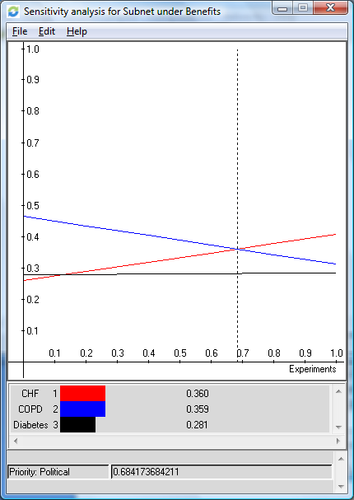The following chart demonstrates the sensitivity analysis for political benefits which was an exception where COPD was not always on top. Were the weights adjusted to approximately .67, the top performer then becomes CHF. Political benefits are not necessarily tied directly to the number of lives or dollars saved, nor to quality of life issues for the patients. The political benefits are more concerned with positive publicity and the public’s perception of what makes the biggest difference. The common layman’s perception of public interest will have little to no knowledge about health care costs for chronic illness, the infection rates, and other important criteria relevant to the decision. The layman’s opinions may be based on whether a close friend has the disease, whether anything is being done at all (simply hearing that government leaders are working to solve health care issues may be enough), or what disease receives the most publicity which may be related to the size of outside organizations or health associations like the American Diabetics Association. The preceding factors explain how political benefits is an atypical subnet within the model. The reader may also wonder why this comparison did not affect the overall model decision. First and foremost, a single comparison among the many does not hold much influence; in fact it has been recommended when developing the model if there are criteria which while important only represent a marginal portion of the overall model to exclude them from the model. The other reason is that in the model we weighted the economic and social criteria significantly higher than political because we felt the life altering decision should not be based on future campaign hopes.
Sensitivity Graph
Benefits-Political

Summary and Conclusion
Healthcare costs will only continue to rise as the baby boomer population ages. Officials in the state of Pennsylvania are considering a worthwhile topic as they decide which diseases to focus treatment options on. Reducing preventable readmissions will reduce healthcare costs, open beds for other patients, and increase hospital profits. In the ANP model we looked at COPD, CHF, and Diabetes. The illnesses were compared among the Benefits, Opportunities, Risks, and Costs that each action or actor could incur. The comparisons were made through the pairwise comparison process, strategic criteria were added and the model was synthesized with the multiplicative formula. We conducted the sensitivity analysis to see how strongly the suggested result had faired throughout the model.
COPD is the chronic illness to focus an intervention program on to provide the highest return on investment. After comparing many pairwise comparisons and evaluating the sensitivity of the decisions we have increased confidence in our decision and a method to validate our decision process. Starting with COPD is our final recommendation.

Future Research and Applications
The model has direct application to the current decisions about which chronic illness to focus the intervention work on. As mentioned previously the results go against what might be considered the most important chronic illness to address. Presenting this model to government leaders and hospital administrators has the potential to help them make a better decision which is not based solely on which illness gets the most public attention.
While the model is considered to be a complete and accurate representation of the alternatives and multiple levels of criteria that impact the decision, it is not an exhaustive model. Based on the results at this point we do not believe the overall results would change; however, the spread between the alternatives would change if the model were redesigned. We will list two areas where if the model were used again it could be improved.
Originally as we built the model we wanted to keep a clear and consistent pattern throughout the model to ensure that the relevant criteria were addressed and the comparison made in a reliable fashion. We concluded that the consistency would improve our comparisons and avoid duplication or confusion among the subcriteria. During the comparison process we felt as though the rigid structure did not benefit the comparison process enough to be worth the trade off of having a more flexible model structure. The dynamic nature of the network comparisons provided the reliability we sought and also would have enriched our model had the framework been more flexible to allow for additional clusters and nodes. The suggestions listed above are not meant to be a complete list of critiques, rather to list a few areas that with a little more experience the authors believe the model could be improved.

Poisal, J.A., et al, Health Spending Projections Through 2016: Modest Changes Obscure Part D’s Impact. Health Affairs (21 February 2007): W242-253.

