Marcellus Shale Drilling

Ian Black
Matt Bright

INTRODUCTION

Marcellus shale drilling has become very important to the natural gas industry in Pennsylvania. The natural gas industry through Marcellus shale drilling has become a strong force in our local economy and can be attributed to job and wealth creation. The state of Pennsylvania has passed legislation legalizing fracking and imposing some taxes on the drilling companies and well sites. Ultimately, local municipalities have the legislative power to decide if they will allow drilling on public land and/or local residents to execute land and mineral rights lease agreements with the drilling companies. As more national gas and drilling companies enter the market, each municipality must ultimately decide whether to permit or ban fracking for natural gas. The following map illustrates the geographic scope of Marcellus Shale drilling activity:

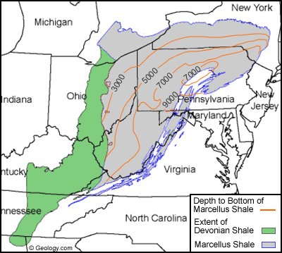
http://geology.com/articles/marcellus-shale.shtml

There are many short term and long term implications arising from each municipality’s decision whether to allow or prohibit drilling activity. A thorough analysis of the related Benefits, Opportunities, Costs and Risks must be completed in order to assess and chose the appropriate legislative action. In order to make this decision, a complex BOCR Model and Ratings Model was completed with the SuperDecisions software.

Ratings Model
The Ratings model was set up in the following fashion:
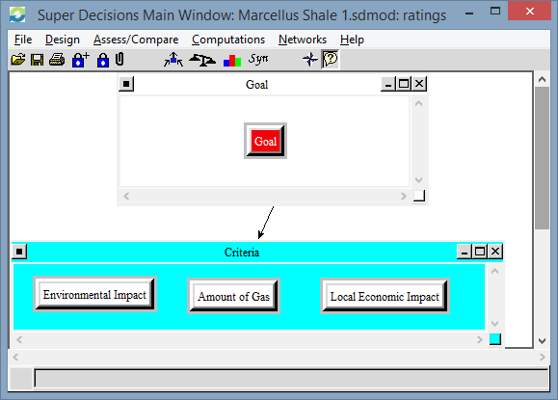

Three criteria, including Environmental Impact, Amount of Gas, and Local Economic Impact were included. The ratings model decisions are below:

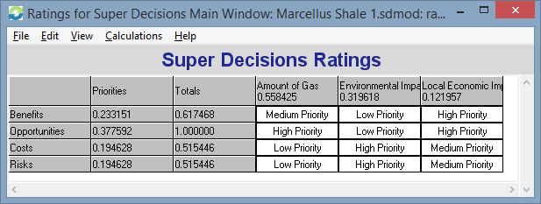

Each criteria was rated through priority (Low Priority, Medium Priority and High Priority) for each Benefit, Opportunity, Cost and Risk. “Amount of Gas” and “Local Economic Impact” have higher priorities for Benefits and Opportunities, while “Environmental Impact” has the highest priority for Costs and Risks. A simplification of the decision whether to drill for natural gas essentially is tied to economic benefits/opportunities, while the potential for environmental harm is the primary source of costs/risks.
BOCR Setup

The entire model is arranged in the following fashion: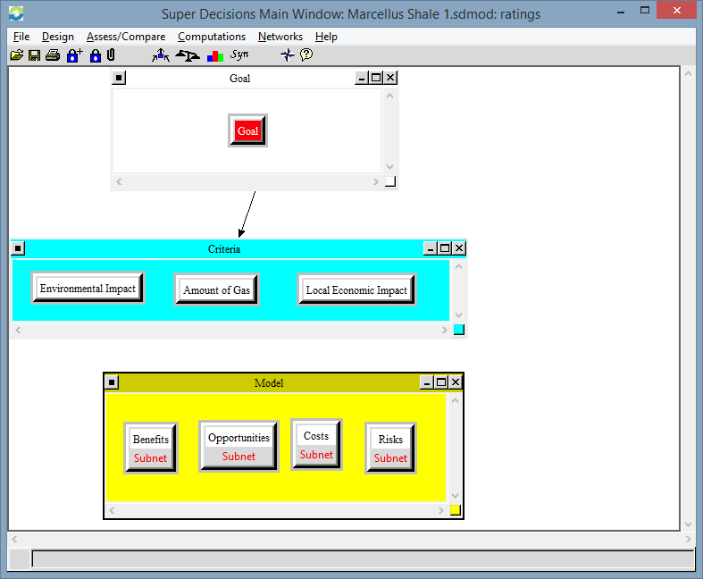

Benefits Subnet
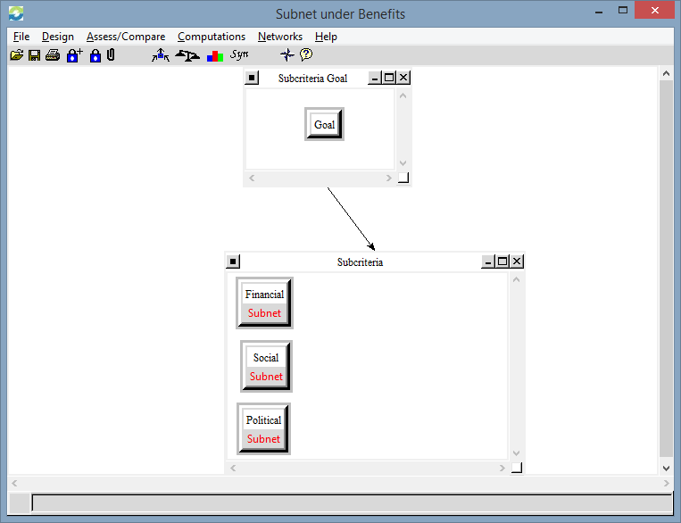

The subcriteria “Financial”, “Social” and “Political” were established for each subnet of Benefits, Opportunities, Costs and Risks. The Alternatives for each subcriteria essentially pose the question whether to “Drill for Shale Gas” or “Don’t Drill for Shale Gas”. Financial, Social and Political subnets were prioritized in the following fashion:

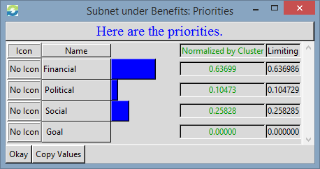

Benefits: Financial Subnet
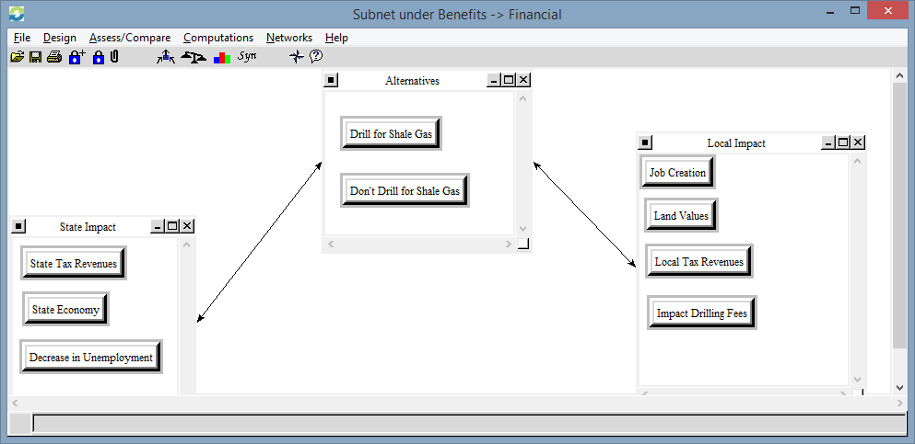

For Financial Benefits, both local and state impact was assessed for the alternatives. There are a mix of unique and overlapping financial benefits at both the state and local level associated with Marcellus Shale fracking and drilling. Pairwise comparisons were completed for each. The synthesized results are:
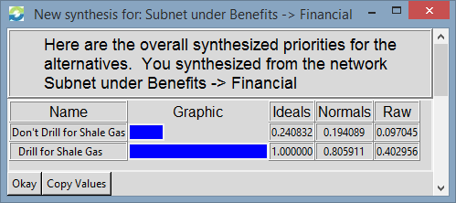

Benefits: Social Subnet
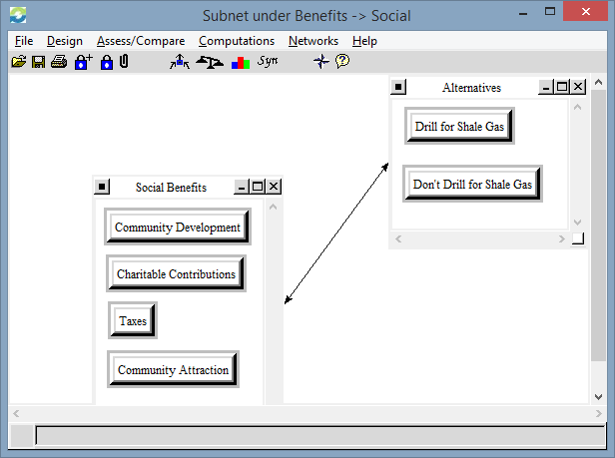

Several social benefits were considered and pairwise comparisons were completed. The synthesized results are as follows:

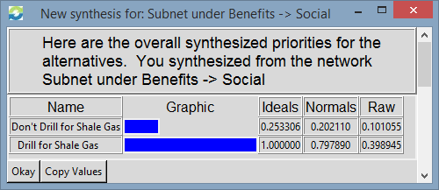

Benefits: Political Subnet
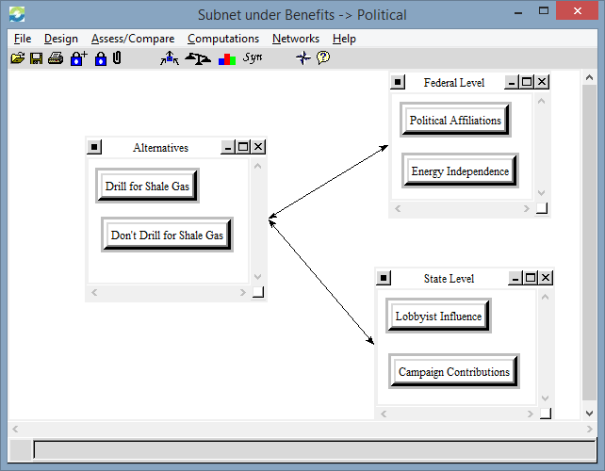

We considered political benefits on both the State and Federal level, as the regulation, taxation and political associations tied with the decision to drill or not spans beyond a local to a national level. Our synthesized results are as follows:
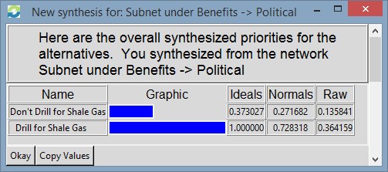

Opportunities Subnet
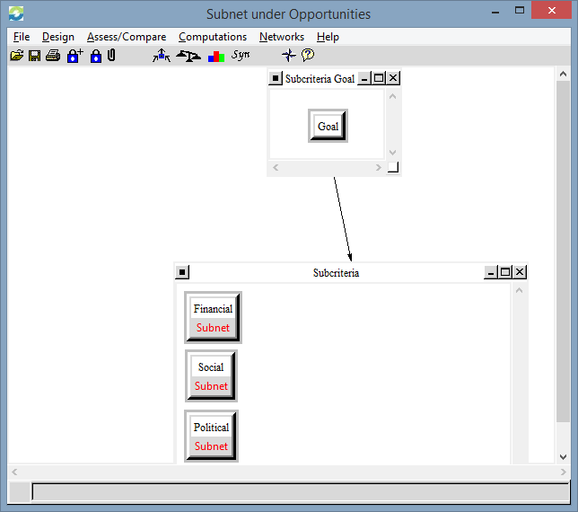

Similar to Benefits, the Opportunities Subnet includes Financial, Social and Political Subnets. The subnets were prioritized in the following fashion:
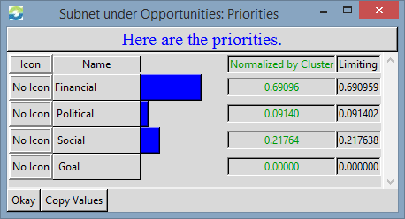

Opportunities: Financial Subnet
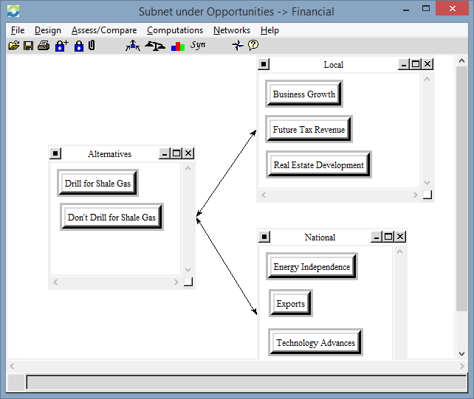

Similar to Benefits, the financial opportunities associated with the decision to drill is categorized on both a local and a national level. The synthesized results are:

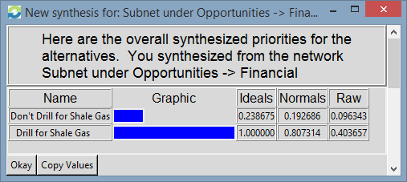

Opportunities: Social
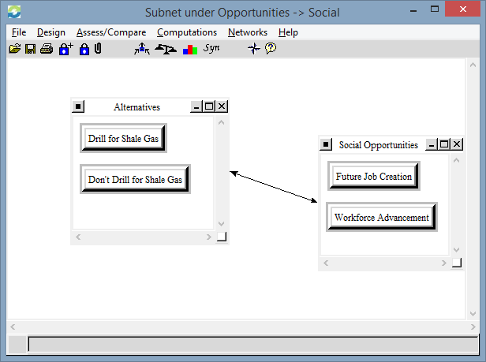

The synthesized results are:
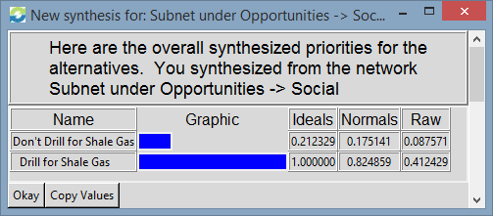

Opportunities: Political

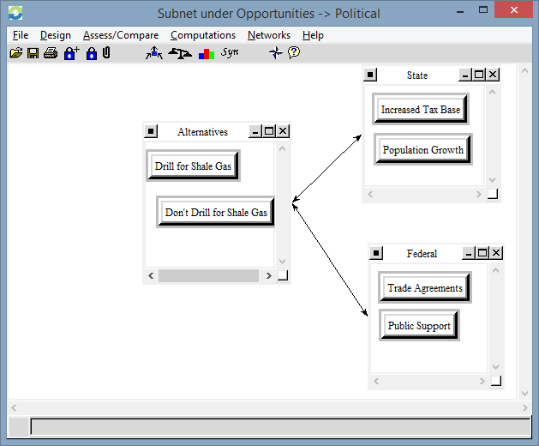

As illustrated above, political opportunities are considered on both a State and Federal level. The synthesized results are:

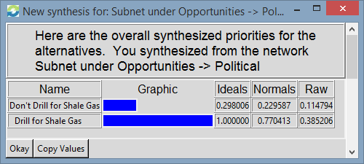

Costs Subnet
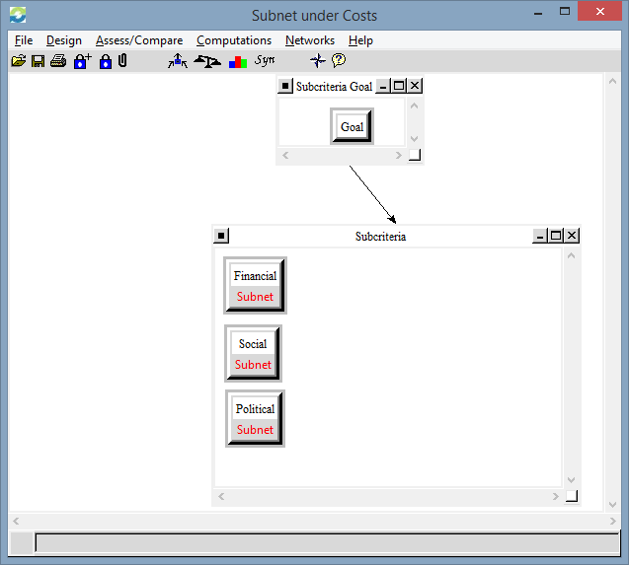

Financial, Social and Political subnets were all included for the Cost Subnet.

Costs: Financial Subnet
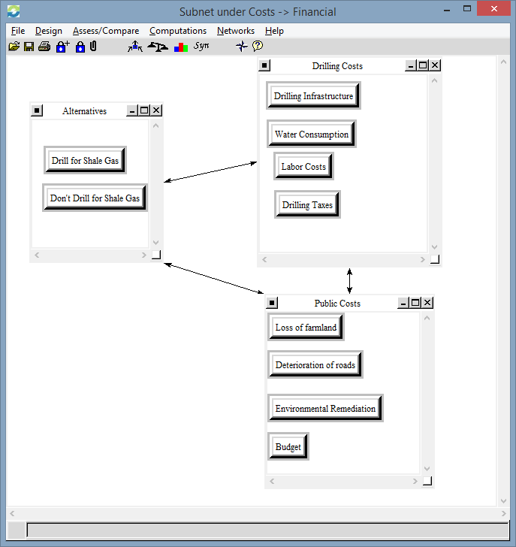

As illustrated above, there are costs associated with the drillers themselves along with public costs from the impact of drilling activities. Pairwise comparisons were made in respect to the alternatives. In addition, pairwise comparisons were made between “Water Consumption” and “Environmental Remediation” along with “Drilling Infrastructure” and “Deterioration of Roads” as these cost categories affect each other. The synthesized results are as follows:

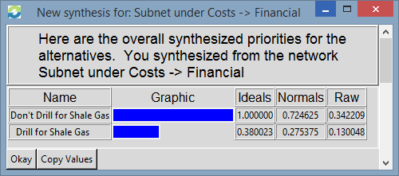
As evidenced in the synthesized results, the Financial Subset under Costs produced a desirable outcome of “Don’t Drill for Shale Gas”. In comparison to the Benefits and Opportunities subnets, which all had indicated “Drill for Gas”, the costs of fracking result in a “Don’t Drill for Shale Gas” decision.

Costs: Social Subnet
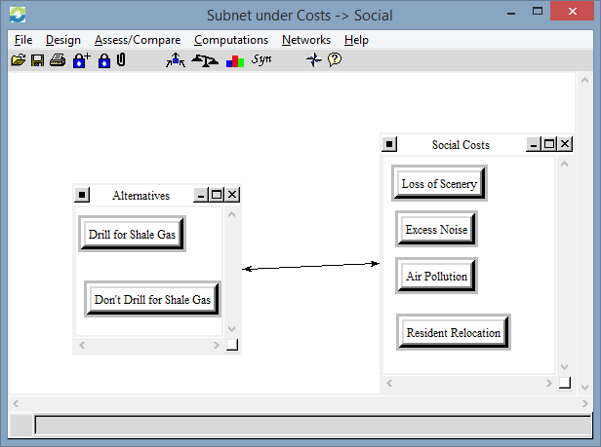

Four different social costs were pairwise compared to the alternatives. The synthesized results are as follows:

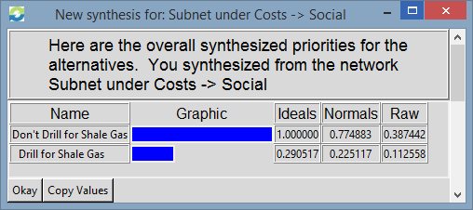

Costs: Political

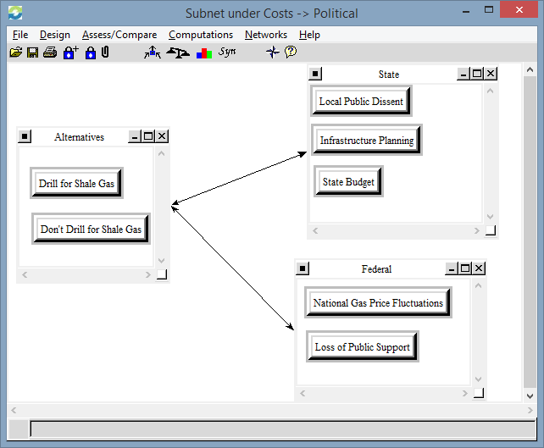

Like the previous sections, Political influencers are organized on a state and a federal level. The synthesized results are as follows:

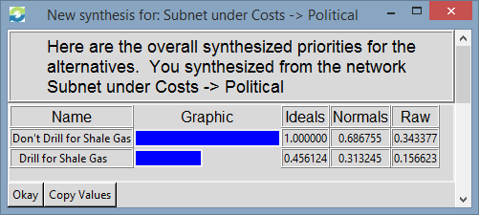

Risks Subnet

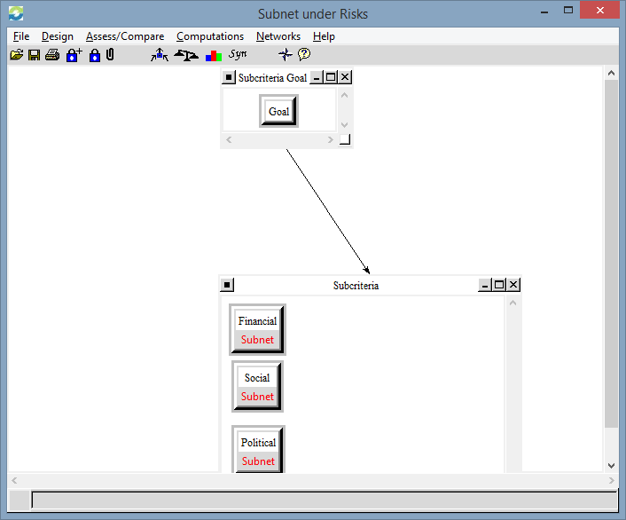

Like the previous subnets, Financial, Social and Political subnets were considered, and were weighted in the following fashion:

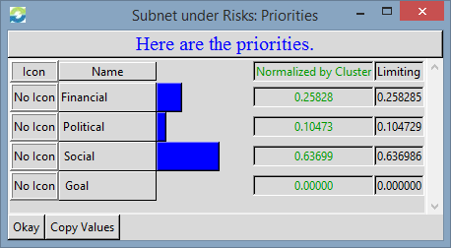

Risks: Financial
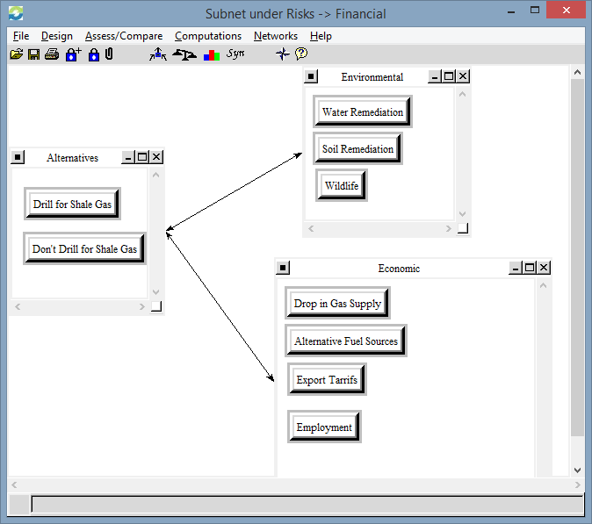

Financial risks include both environmental remediation costs along with economic costs. Each was pairwise compared with the two alternatives, and the following synthesized results were achieved:

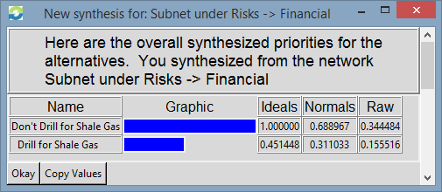

Risks: Social
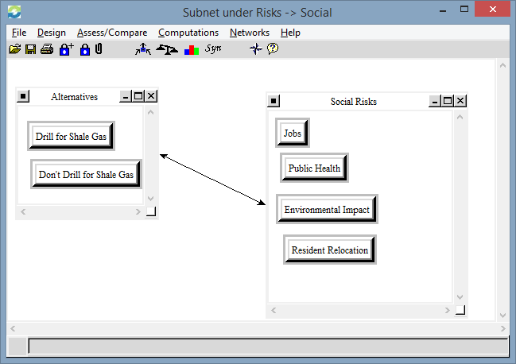

Social risks including Jobs, Public Health, Environmental Impact and Resident Relocation were considered. The synthesized results are as follows:

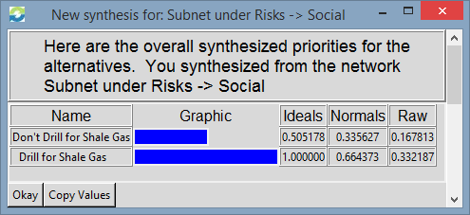

Risks: Political
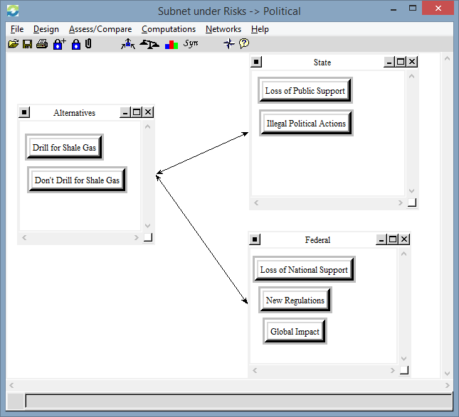

Once again, political implications are categorized on both a state and federal level. The synthesized results are as follows:

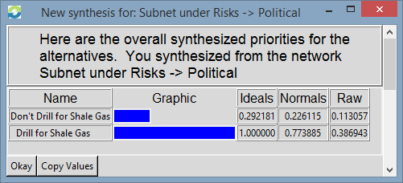

Model Results

After completing all comparisons in the model, we were able to utilize the data to generate the best possible alternative to the decisions on whether or not to drill for Marcellus Shale gas.

The following charts are each sensitivity analysis for the BOCR model:

Benefits
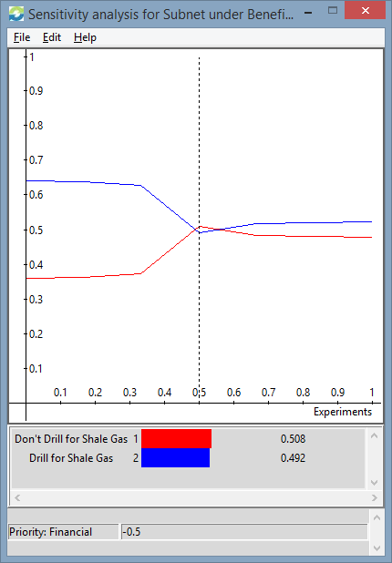

Opportunities
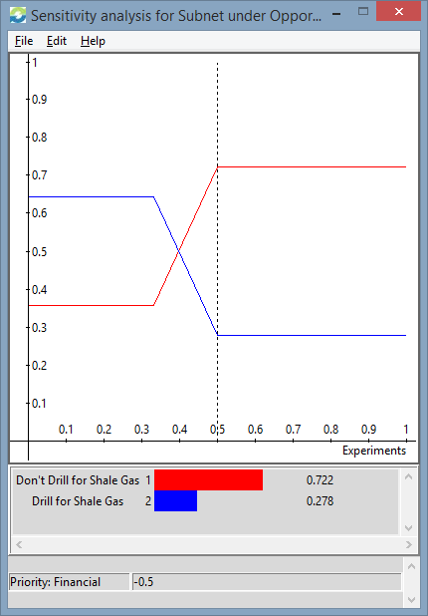
Costs
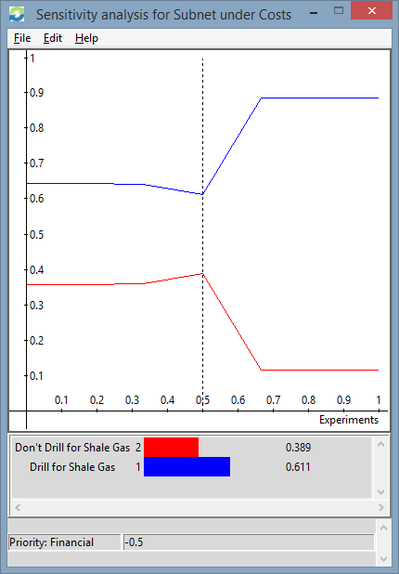

Risks
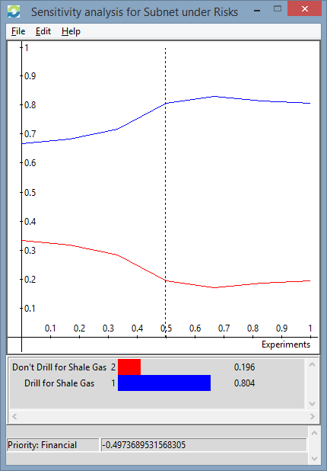
The following priorities were assigned to each BOCR subnet:

Priorities
Benefits | 0.233151
Opportunities | 0.377592
Costs | 0.194628
Risks | 0.194628
Total | 1.00000

Taking the synthesized results from each subnet of the BOCR model, the following results are shown:

 | Benefits | Opportunities | Costs | Risks
Don't Drill for Shale Gas | 0.257899 | 0.238364 | 1 | 0.610676
Drill for Shale Gas | 1 | 1 | 0.340428 | 0.858317

As evidenced in this chart, the Benefits and Opportunities of drill for shale gas far outweigh the alternative of not drilling for shale gas. The model favors not drilling for shale gas as it relates to the various cost categories we established. Lastly, the risks we established in the model slightly favor drilling for shale gas. The financial, social and political risks for drilling for shale gas outweigh not drilling.

The overall synthesized results of the model are:

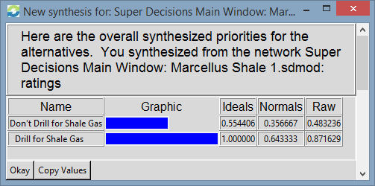

The model chooses “Drill for Shale Gas” over “Don’t Drill for Shale Gas” with an ideal of 1.0 to 0.554, normalized results of 0.643 to 0.356 and a Raw Score of 0.873 to 0.483, respectively. Applying the bB+oO-cC-rR equation yields the following results:

bB+oO-cC-rR
Don’t Drill for Shale Gas | -0.163348899
Drill for Shale Gas | 0.377433658

Once again, the equation yields a result that suggests to Drill for Shale Gas. Lastly, the BxO/CxR equation results in:

BxO/CxR
Don’t Drill for Shale Gas | 0.100665225
Drill for Shale Gas | 3.42237041

Once again, the alternative “Drill for Shale Gas” is the clear choice.

There have been numerous studies and surveys conducted to assess the overall public opinion of hydraulic fracturing for natural gas. The most recent survey from the PEW Research Center suggests that fracking (ie drilling for natural gas) is supported by 48% of people while 38% oppose fracking. A summary of the survey findings, including a breakdown of various demographics, is highlighted below.

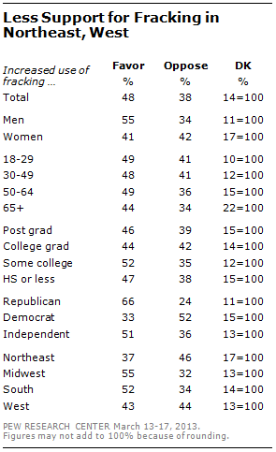

The BOCR model we created resulted in a decision to drill for natural gas. The financial and social benefits and opportunities outweigh the environmental and infrastructure costs associated with hydraulic fracking.

