Should the University of Pittsburgh Build a Parking Lot at Schenley Park
An Analytical Network Process Model
Domonick Cook

Table of Contents
Introduction 3
Methodology 4
Alternatives 5
Costs 7
Economic 7
Political 8
Social 8
Opportunities 9
Economic 9
Political 9
Social 10
Risks 10
Economic 10
Political 10
Benefits 11
Economic 11
Political 11
Social 12
The ANP Model 13
Results 14
Subnetwork Results 17
Benefits Subnetwork 17
Costs Subnetwork 18
Risks Sub network 18
Opportunities Sub network 18
Alternative Methods of Comparison 18
Sensitivity Analysis 19
Conclusion 20

Introduction

Schenley Plaza is a 4.5-acre communal area located at Forbes Avenue and Schenley Drive in Pittsburgh’s Oakland Section. The Plaza features restaurants, food kiosks, public meeting spaces, a carousel, multiple gardens and the 1-acre “Emerald Lawn.” Schenley Plaza is built on what used to be known as a deep gully called St. Pierre’s Ravine. In 1913, the entire gully included the Bellefield Bridge, which carried Bigelow Boulevard toward Schenley Park, was filled in. In 1949, Schenley Plaza was converted into a parking lot to accommodate both university students and fans at Forbes Field. In 2004, the Pittsburgh Parks Conservancy undertook a major renovation project to restore the Plaza back to its once glorious gateway to Schenley Park. This renovation transformed the long-standing parking lot into the Schenley Plaza that we know today.
Now, students, faculty and staff face a difficult time finding parking at the University. The only options are to park in one of the school’s few parking garages, which are always occupied by hospital visitors and are rather expensive, or to park down in Panther Hollow. Panther Hollow is a ways away from the center of campus and far from a convenient location. One must plan on getting to campus very early if they intend on making it to class on time. Additionally, people in this lot often park haphazardly as they try to cram as many cars into the lot as possible. People also have the option of parking along the street and paying the Pittsburgh Parking Authority up to $2 an hour. Every on street parking section allows you to park for different amounts of time, so in some instances you will find yourself running out to pay the meter ever 2 hours. If you slip up by just a minute, odds are you will be greeted by a $30 parking ticket. On street parking was not as big of an issue until last year. In 2011 and 2012, there were a lot of free on street spaces that did not have meters. Last year however, the parking authority installed electronic meters all over Oakland, leaving it virtually impossible to find anywhere with free parking.
A parking lot at Schenley Plaza could offer students, faculty and staff an affordable and convenient parking location. However, it would take out what little bit of grass we have at this concrete campus. Schenley Plaza is used for all sorts of different events, students lay out on the lawn when the weather is nice, and it just provides us with something aesthetic to look at. By constructing a parking lot over the Plaza the University may see a backlash from students, environmentalists and the whole community. This could have a negative impact on the number of applications the school receives and on its overall public perception. The goal of this project was to compare the benefits of more convenient parking for students and an increase in parking revenues for the university, against the costs and risks associated with destroying the only thing on campus that resembles grass.

Methodology
To evaluate this complex decision I will employ the use of the Analytical Network (ANP) Model, developed by Professor Thomas Saaty, in conjunction with his Superdecisions software. The ANP Model requires us to develop a list of alternatives, which are potential solutions to our proposed problem, and criteria by which to weigh the alternatives. The standard ANP criteria are Benefits, Opportunities, Costs and Risks (BOCR.) Within each of these criteria will be sub criteria specific to the question at hand.

Alternatives
The purpose of this project is to analyze what would be the best option for building a parking lot at the Schenley Park location The three alternatives are as follows:
- Surface Parking Lot: An above ground parking lot that would occupy the 1-acre lawn at Schenley Plaza. The lot would feature 168 8’6” parking spaces, with two-way traffic lanes spanning 24” across. This would not affect the restaurant caroseul or food kiosks in the Plaza.
- Underground Parking: An underground two story garage similar to the garage at Sennott Square. It would be a total of 100,000 sq. ft. A parking garage running at normal efficiency requires 325 total sq. feet of space per parking stall (this includes lanes, entrances and all other necessary area to maintain the garage.) This would leave space for a total of 307 parking stalls.
- Don’t Build a Lot: Leave everything as it is.

Parking Space Dimensions
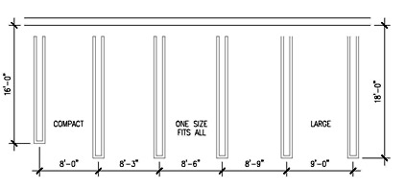
Parking Lane Dimensions
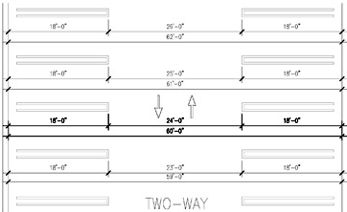
* Diagrams taken from www.timhaahs.com
Each option has its advantages and disadvantages and they will be further discussed in the following sections of this report.

Costs

Economic

The first aspect to focus on is the cost of each alternative. Benefits mean nothing unless we have costs to relate them to. Not building the lot would not cost the university anything. They would miss out on potential revenue but there will be no costs incurred. On the contrary it will cost students more time and money as they are forced to park in more inconvenient and expensive locations. To build a surface parking lot that would cover the entire 1 acre of grass at Schenley Plaza would cost approximately $672,000 and take close to 3 months to complete. An underground parking structure would cost $7.9 million to build using union workers, and a total time of approximately two years. During this time it would be assumed that Schenley Plaza would be off limits until the construction project was completed.
Projected Costs for Underground Project
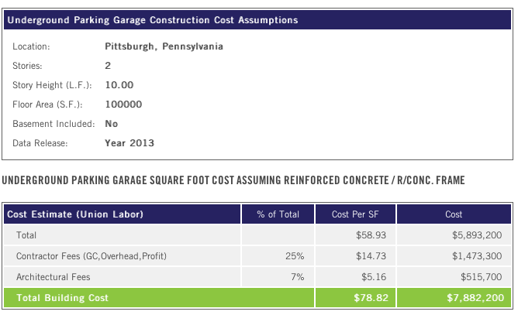
*taken from reedconstructiondata.com
Lastly, there would be an increase in taxes. The school would have to pay a 50% parking tax on their revenue and there may be an increase in property tax for the alterations made to the property.

Political

The Political costs associated with not building the lot again are zero. For building the lot above ground there will most certainly be a strong backlash from lobbyists and environmentalists. There are plenty of people who fought hard to have the old parking lot removed and to have the area re-beautified. Tearing up grass and putting the parking lot back in would definitely enrage this segment. It may also anger the municipality as it would be taking money away from the Pittsburgh Parking Authority by offering an alternative to their on street parking. Similarly building the lot underground could anger the local government. The environmentalists and lobbyists may not be as angry about it, however there may be some sort of nature that is damaged by the underground construction.

Social

The school would almost certainly see a social backlash from the students, surrounding community and the city if they were to get rid of the Emerald Lawn. If they were to build a surface lot it would do away with one of the only areas where students can congregate and sit on grass to read or throw a football. A central parking lot would also be an eyesore. This may lead to lower enrollment, which in turn would cause economic costs. An underground parking lot could be a good alternative as the school would be able to rebuild the lawn on top of the lot. Students may still be upset that the lawn would be off limits for a few years. To fully understand the reach of impact I randomly sampled 100 students walking past Schenley Plaza and 49 said they would not want a parking lot at all, 32 said they would want an underground lot and 19 said that they would prefer a surface lot.

Opportunities

Economic

All opportunities would remain the same if the lot was not built. Building an above ground lot may create opportunities for growth in the local economy. People that are driving through Oakland that would not normally stop to shop or eat may do so now because there is a big parking lot right on Forbes Avenue. The above ground plan purposely did not include the parts of the plaza where the food kiosks were so that they could take part in this potential opportunity. The underground lot would do this to a lesser extent. People may not be as willing to pull over and park if they have to take a ticket and go into a garage. It loses a little of its convenience factor if it becomes more of a process.

Political

I did not think there would be any political opportunities from any decisions made.

Social

Turning down the project may make the school look better in the public’s eyes, however that all depends on how the general public perceives this idea. There are some social opportunities that may come from building the lot. While in the costs there was a potential to drive away applicants, there may actually be a chance to attract more commuter students and more faculty. People who may have been turned off by the University’s lack of parking may now reconsider their decision because they know they would have a cheap parking alternative. This would apply equally for surface and below ground parking.

Risks

Economic

An economic risk to not building the parking lot is missing out on the potential to collect parking revenue. If the university were to build the parking lot above ground there are risks of agitating donors and possibly losing future funding. If it were to build a lot underground there are environmental risks as well as risks of complications associated with such a large project. There could be delays and stalls that would throw off any original cost benefit analysis or predictions.

Political

There are no political risks associated with not building the lot. Building the lot above ground may affect state funding as they have gone against the wishes of the parks commission and against the efforts that the state has made to beautify this area. Similarly, but to a lessor extent, these same political risks could be associated with building the lot underground.

Benefits

Economic

There are no economic benefits associated with not building a parking lot. If the university were to build a parking lot with would be able to charge students for parking. If they were to charge $5 per spot just as Panther Hollow does, if every spot was full each day they would make $840 per day. Considering the lot will only be busy during school sessions $840 a day for 34 weeks is about $200,000 per year. This would be about a 30% return on investment per year. Additionally, the students and faculty parking in the lot would see the economic benefit of saving money. If it were to build the underground lot and charged rates similar to Soldiers and Sailors parking garage on Fifth Avenue, the average rate would be $8 and the daily total if all 307 spots were filled would be $2456. This makes for a yearly total of $584,528 about a 7% return per year but with more long term potential to make money.

Political

The political benefits on not building the lot are the converse of the political costs. Certain lobbyists may applaud the decision not to build a lot. This would however require the decision itself to become a matter of public debate. If things were just to go on as normal with no lot built there would be no reason why environmentalists would applaud the school. There are very minimal political benefits associated with building an above ground lot. The state may applaud the school for making money and saving the students money at the same time, however this is unlikely. There is some potential political benefit from building an underground lot, especially if they are able to build an eco-friendly lot. This would be seen as an extra measure to conserve the environment while implementing a functional and necessary parking garage.

Social

The social benefits from not building the lot are that people would be able to continue to use the grassy area as they have done for the past 9 years. If the lot were to be built above ground it would mean more parking options and more convenient parking. Students and staff would not have to worry as much about rushing to class or being late because they could park at a central location and presumably have a short walk to where they needed to go. Similarly building a lot underground will allow students and staff to park closer to classes, however it will take them longer to do so, since parking underground is a slightly more involved process that parking in a surface spot. On the other hand the university could restore lawn above the garage and maintain the social benefit of allowing students to congregate there.
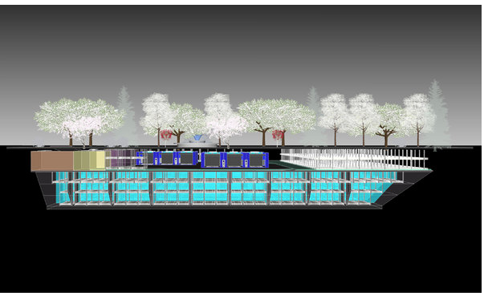

The ANP Model

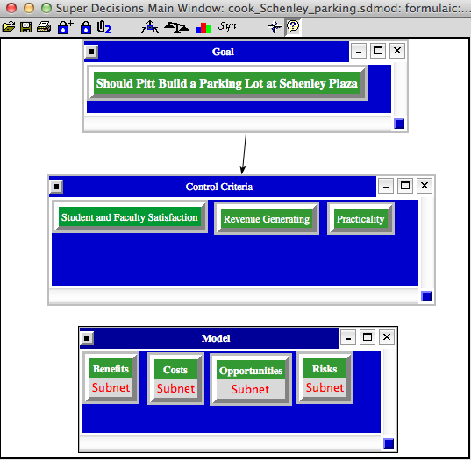

I constructed the ANP model weighing Benefits Costs Risks and Opportunities in relation to the control criteria of Student and Faculty Satisfaction, Practicality, and Revenue Generation. Each of these criteria contained its own sub network with additional clusters and nodes. Two of these sub networks are shown below.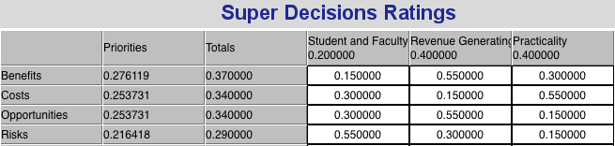
Benefits Sub network Opportunities Sub Network
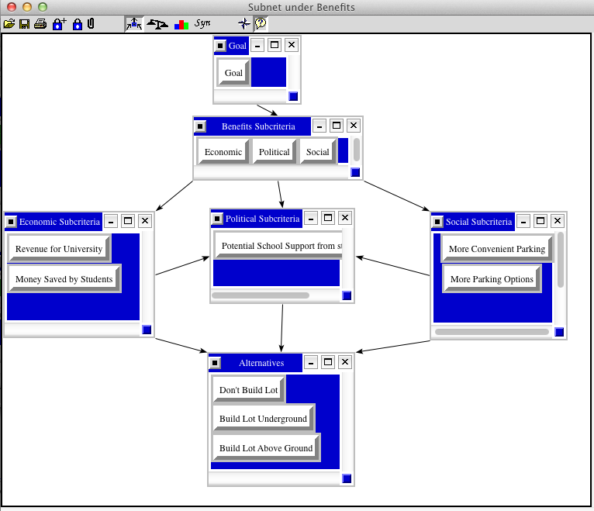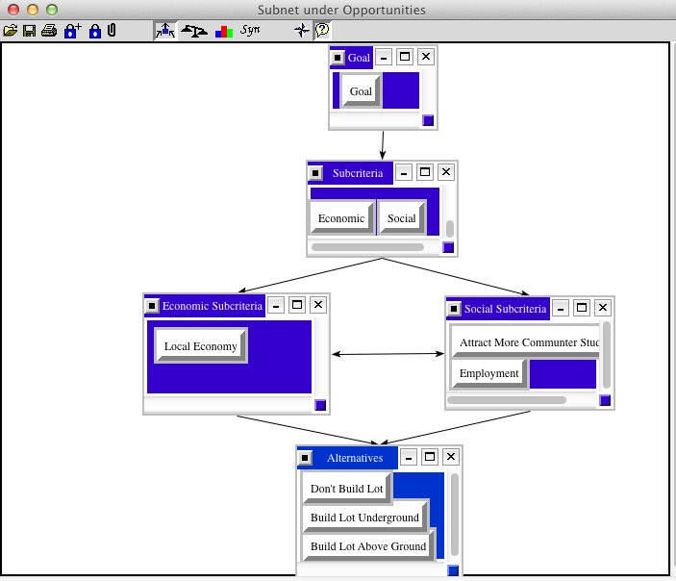
Within these sub networks comparisons were made to rate the importance of each cluster versus others, as well as how the criteria aligns with each of the alternatives. By conducting these comparisons for each sub network, I was able to come up with a test result and an answer to our question of how to address the parking lot issue.

Results

The synthesized full model tells us that the best option would be to build the parking lot underground. There are three ways to represent this data. One is by showing the normalized amount which shows all alternatives as a percentage of 1. The other way is by the idealized amount, which sets the best alternative as 1 and shows the other alternatives proportional amounts. And finally we can look purely at the Total Score of each. This graph shows the Total amounts, and represents the Normal and Ideal amounts numerically.
Alternative Comparison Results
Short Term Best Option
(Additive)

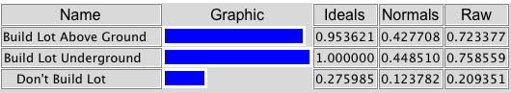
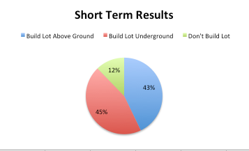
In the short term building the lot above ground and underground are very similarly ranked. Not building the lot at all is not a close third but still remains a relevant option. It is surprising that the above ground lot would not be a better option in the short run since it would be able to start accomodating cars much quicker than the underground lot could.

Long Term Best Option
(Multiplicative)
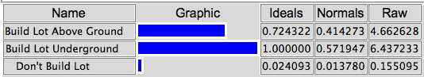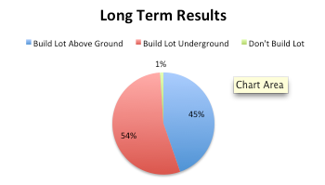
Here building the lot underground has taken away mot of the points from not building the lot at all. Given the long term projections of making money down the line against not making any money at all this should come as no surprise. The option to build the lot above ground is still a strong second with 42%.

Subnetwork Results

As depicted by these graphs representing the normalized data from each of the main criteria, building an underground garage was not the best option in every subnetwork.
Subnetwork Amounts Based on Multiplicative
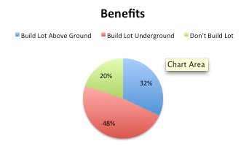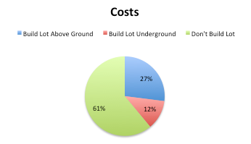
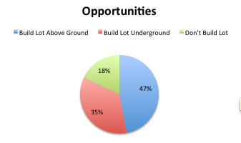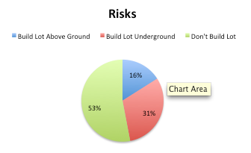

Benefits Subnetwork

Building the lot underground also came up as the best alternative based solely on an analysis of the benefits. The sheer number of spots that the underground lot provided along with the potential for long term economic profit by the university is most likely the reason for this outcome.

Costs Subnetwork

For the costs subnetwork I had to rank things based on which would cost more, then use the invert function because leaving these ratings as is would value the more costly decisions higher than the less costly decisions. Here, since not building a garage resulted in zero economic costs, and economic costs were heavily weighted, not building a garage came up as the number one option.

Risks Sub network

Similarly to the costs sub network I had to employ the invert function on a lot of the comparisons to get an accurate perception of what the most desired option would be. Again here, not building the lot came up as the top choice, however this was not a highly weighted category.

Opportunities Sub network

Building the lot above ground had the highest opportunity score. This was largely based on the fact that an above ground lot is more convenient and therefor would provide students with a better chance to get to class on time. Additionally, it would provide opportunities for local businesses to sell to people who usually would not travel into Oakland fore lack of sufficient parking.

Alternative Methods of Comparison

The comparisons used in the results above were based off of the Additive Probabilistic formula. If I were to switch the formula to the Additive Negative the results would look like this:

Additive Negative Results

Here not building the lot shows up in the negative. Also you will see that building the lot above ground becomes a less viable option. In all three formulas building the underground lot is the best alternative.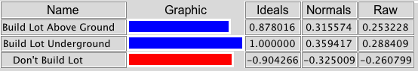

Sensitivity Analysis

Alternative relative outcomes don’t intersect within the span of 0-1, however the alternative “Don’t Build the Lot” and “Build Lot Above Ground” approach each other as we move towards 1. The option to Build the Lot Below Ground stays stable across the whole spectrum.
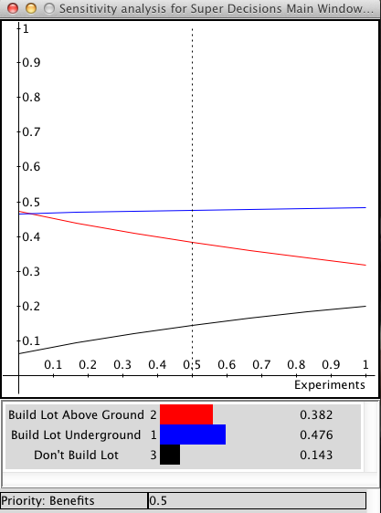
The sensitivity analysis for all sub networks except for costs remain stable across the full spectrum.
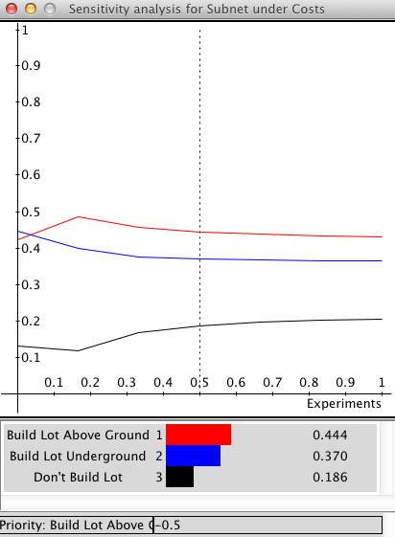
If you look at the graph above, at 0 Building Lot Above Ground is lower than Building Lot Underground, however as you approach 0.1 the two cross over. The alternatives all change directions again around 1.75.

Conclusion
After thorough analysis we see that the best option for the school would be to build a parking lot underground at Schenley Park. While this would put the park out of use for a few years while construction is completed it will have significant long-term benefits for the university. In each variation of analysis building a lot underground was still the number one alternative.
While the economic costs are initially very steep at $7.9 million the school will be able to collect approximately $584,528 in additional revenue each year. Barring it doesn’t raise parking rates the entire parking lot will be paid off in 13.5 years and will provide for steady years of profit. Additionally, we do not have to sacrifice the much-needed grassy area on campus. Students desperately need a place on campus where they can congregate and enjoy the outdoors. Students and faculty alike use this grassy area to read, relax, and participate in social events.
This would also provide a great parking alternative for commuting students and faculty. The drive in would be much less stressful knowing that there is an easily accessible and convenient parking lot right at a central location of the campus. While an above ground lot would facilitate this same outcome it would do so at expense of the grass lawn.
This option will appease most protestors and environmentalists. If the school could somehow find a way to incorporate some sort of environmentally friendly or green developments into the garage itself it would go a long way to show the progress the University has made in supporting environmental sustainability. Unless there is some sort of environmental aspect that will be disturbed by undermining this area, I cannot foresee any problems.
Unfortunately, the school is not actually considering this as an idea at this time. It is just something that I found interesting because I commute to school and have trouble finding parking every day. As a student I cannot afford to pay $20 a day to park on the street while I have class all day. I would fully support the schools decision to build a parking garage under Schenley Plaza as it is an economically, environmentally, and socially sound idea.

http://en.wikipedia.org/wiki/Schenley_Plaza
168 is the maximum amount of parking spaces that would fit on one acre of land with sufficient space for two way traffic lanes.
These are average dimensions for a “one size fits all” sized parking space, and for standard two-way lanes in parking lots. See http://www.timhaahs.com/index.php/site/dbdetail/3_what_is_the_level_of_service_los_approach_to_parking_geometrics/
http://www.ehow.com/how_6500293_calculate-square-feet-parking-spaces.html#ixzz2hcvqQQdf
It costs on average $4000 per space to complete a parking lot from start to finish. See http://www.northwestern.edu/newscenter/stories/2006/01/parking.html
http://articles.washingtonpost.com/2011-10-23/local/35279548_1_spaces-surface-lots-underground-construction-projects
http://www.reedconstructiondata.com/rsmeans/models/underground-garage/
City of Pittsburgh City Code, Title Two Article VII, Chapter 253, §206
This data may be slightly skewed because 63 of the students surveyed lived on campus and 37 of them were commuters.

