Pittsburgh Public Transportation
How Should Pittsburgh Port Authority Prepare for the Future?

Heather Snyder
&
Steven Strasser

Joseph M. Katz Graduate School of Business
University of Pittsburgh
Spring 2012

Background
When Heather Snyder tore her Achilles tendon in February and required surgery, she was prohibited from driving. This created a major issue about how she would get to and from class. Normally, she would drive myself but clearly, this was no longer an option. After relying far too heavily on her best friend (and partner for this project) Steven Strasser, she decided it was time to take advantage of the public transportation system in town. After doing research She ultimately found out that there was no direct bus from her house on the North Side to Mervis Hall. Transferring buses downtown would be incredibly difficult given the fact she was in a cast and required crutches. After getting tired of chauffeuring her around, team “Steather” (Steve and Heather) decided to do our final project for this class on the Pittsburgh Port Authority and which direction it is headed. With all the budget cuts made lately, public transportation has undoubtedly become a heated topic in Pittsburgh. Routes are continuously being changed and re-routed. And, as I found out the hard way, routes are even being eliminated.

The Pittsburgh Port Authority is struggling to meet its financial obligations. In 2001, the labor union agreed to take cuts of nearly $19 million as an attempt to keep routes from being eliminated. The Pittsburgh Port Authority used $45 million as a way to combat short falls in its budget. Unfortunately, nearly 30 bus routes stilled had to be eliminated and 37 routes were reduced in frequency. In August, Governor Corbett’s Transportation Funding Advisory Commission outlined innovative mechanisms to fund Pennsylvania’s roads, bridges and public transportation systems. As of April 2012, none of these measures have been implemented. The Pittsburgh Port Authority says that if nothing happens by the end of 2012, the transit authority will face a $64 million operating deficit beginning July 1, 2012. There is absolutely no way that Steve will continue to drive me around town, therefore, a decision needs to be made and implemented before more service cuts are made.

There have been a lot of ideas floating around on how to fix the Pittsburgh Port Authority’s financial problems. One idea is to expand the current T train system to allow more suburban commuters to take advantage of public transportation. The theory here is that more riders would mean more revenues. However, expanding the T train system would need a significant amount of capital for construction costs and take a substantial amount of time to complete. Another option is to upgrade all the buses in the city to more fuel efficient vehicles that run off natural gas. The buses could either be swapped out completely or just retrofitted to have engines that run solely on natural gas. This option allows the costs to be spread out over a longer period of time and would most likely not require additional funding. When comparing these two plans, we need to consider more than just costs. The alternatives are listed below as we walk through our modeling process and ultimately come to a decisive conclusion.

Alternatives
We analyzed this problem using three alternatives:
1. Upgrade the Buses
2. Expand the T Train System
3. Do Not Make Changes

Alternative #1: Upgrade the Buses

This alternative would upgrade/replace the current buses gas engines with natural gas engines over a longer period of time. This alternative would decrease the energy costs for the bus system, with low disturbances to the current bus system.

Alternative #2: Expand the T train System
This alternative would serve more commuters than the current system, which would increase revenue to the Pittsburgh Port Authority. This alternative has the greatest potential for future growth allowing for future expansions of the T train system.

Alternative #3: Do Not Make Changes
This alternative would essentially maintain the ‘status quo.’ If the Pittsburgh Port Authority utilized this alternative, it would continue to cut routes and modify service to cut costs while it waited for the economy to recover.

Our Model
We used the BOCR model to analyze this problem. Each subnet of Benefits, Opportunities, Costs and Risks were divided into the following categories: Economical, Environmental, and Social. These categories each were given unique conditions which influence the choice of alternatives.
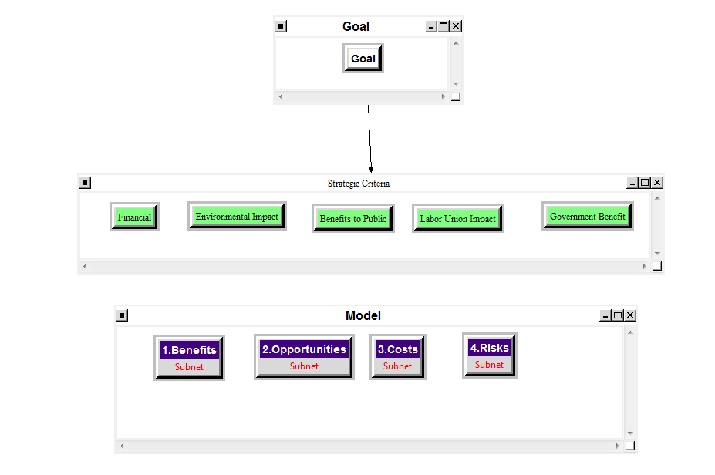

Benefits
Economic Subnet:
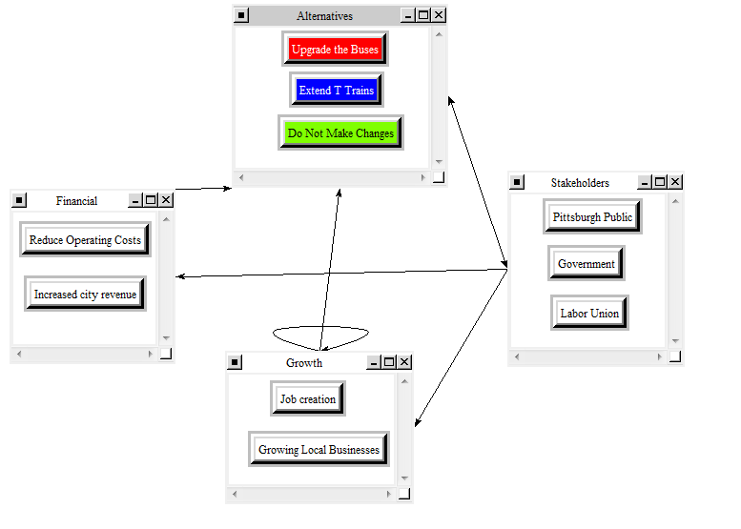

Environment Subnet:
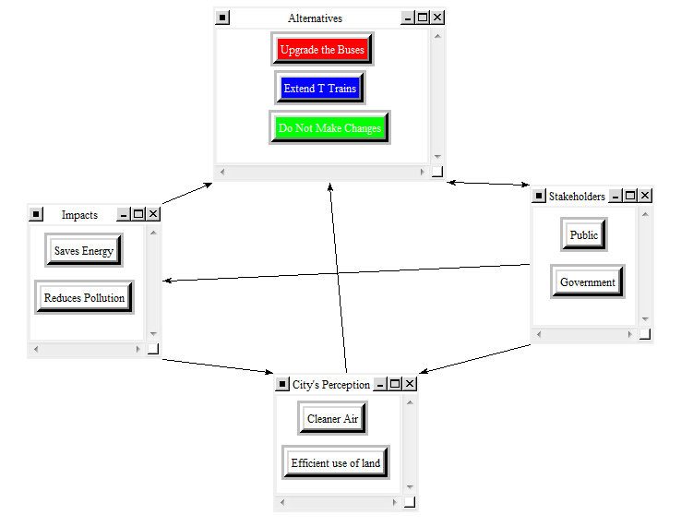

Social Subnet:

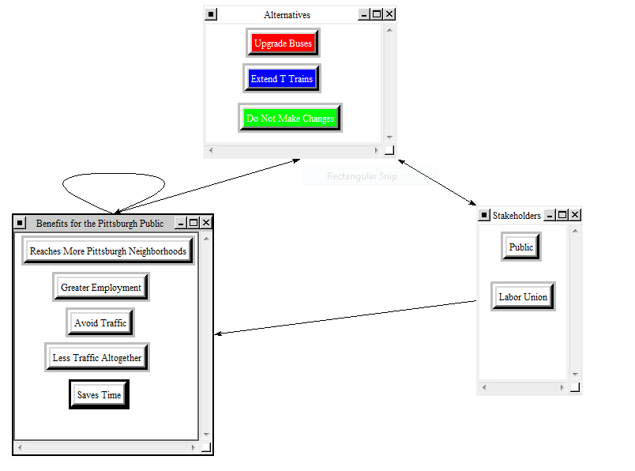

Benefits Results:
After synthesizing all the benefits categories we just formed, the results are shown below:

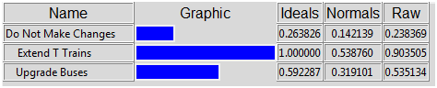

Benefits Sensitivity:
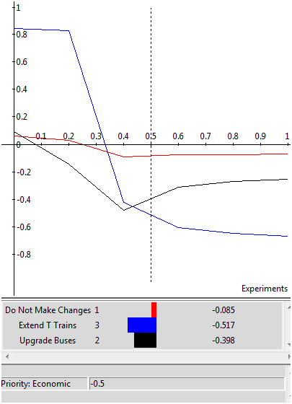

Opportunities
Economic Subnet:

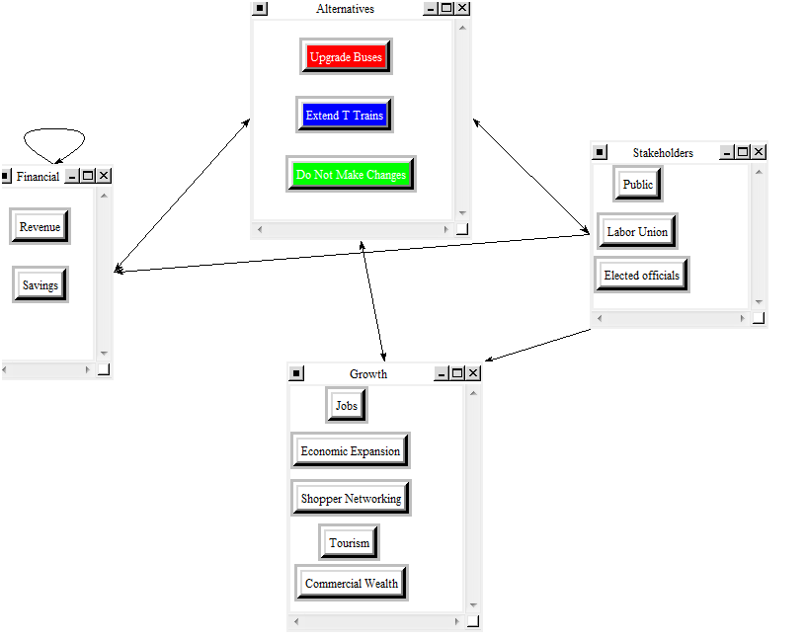

Environmental Subnet:
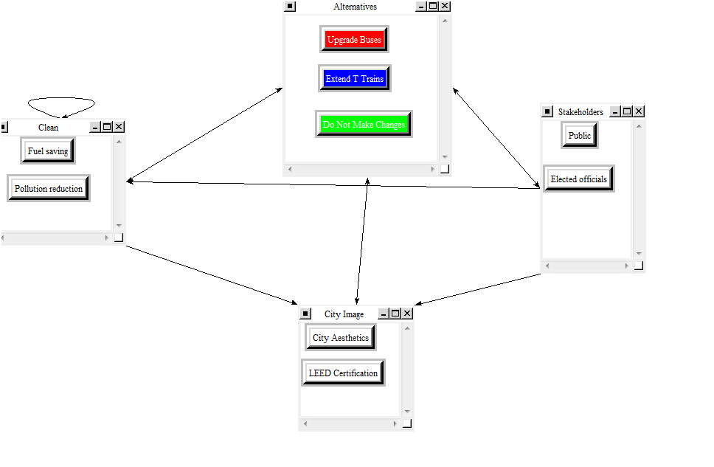

Social Subset:
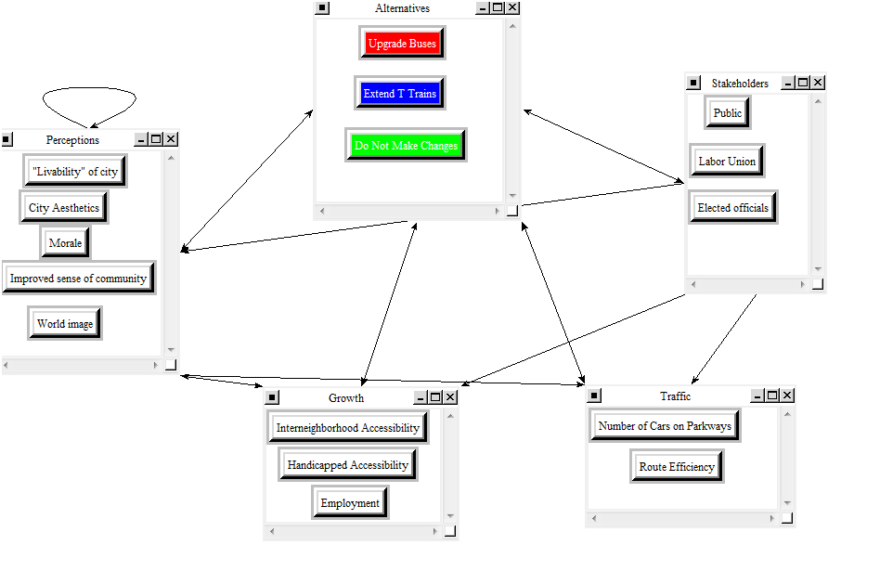

Opportunities Results:
The results after synthesizing all the opportunities categories are shown below:
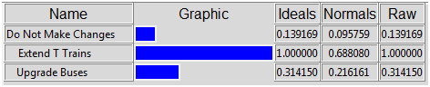

Opportunities Sensitivity:
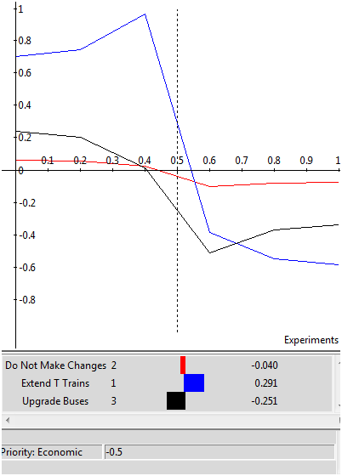

Costs
Economic Subset:
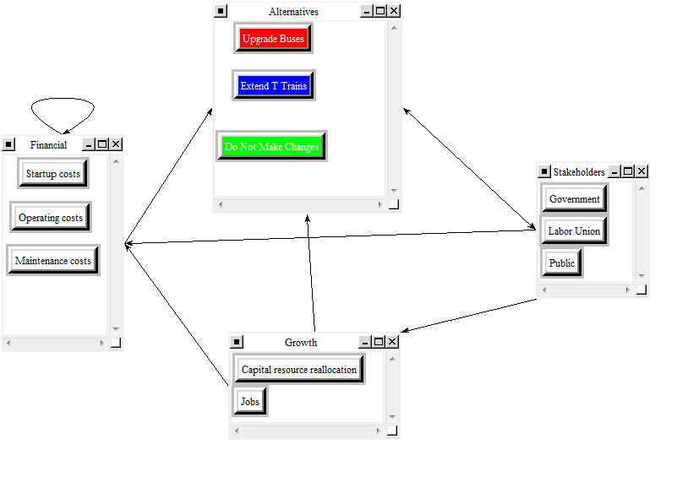

Environmental Impact Subnet
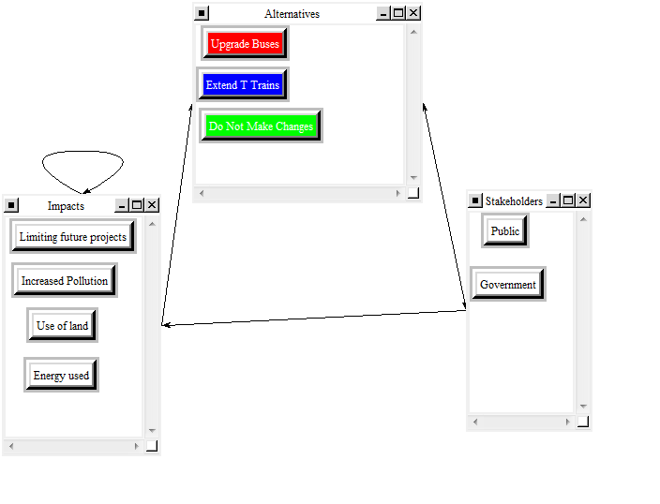

Social Subnet
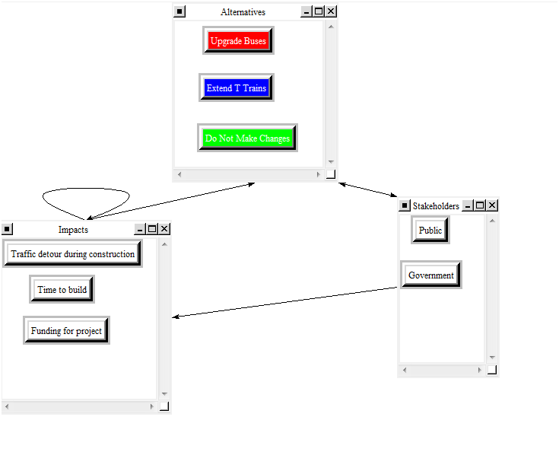

Costs Results:
The results after synthesizing all the costs categories are shown below:
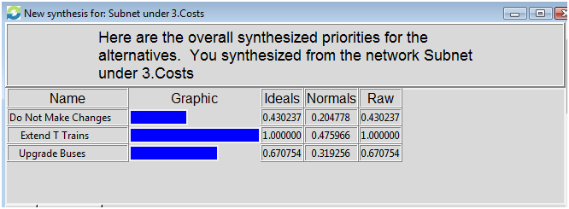

Costs Sensitivity
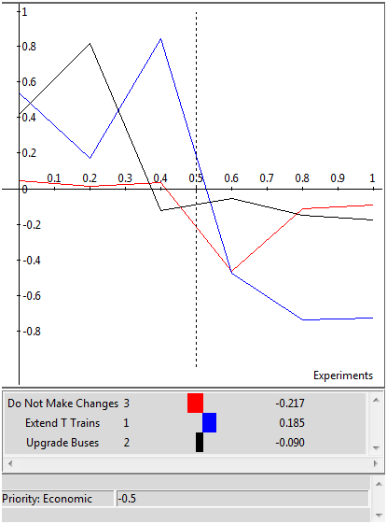

Risks
Economic Subnet:
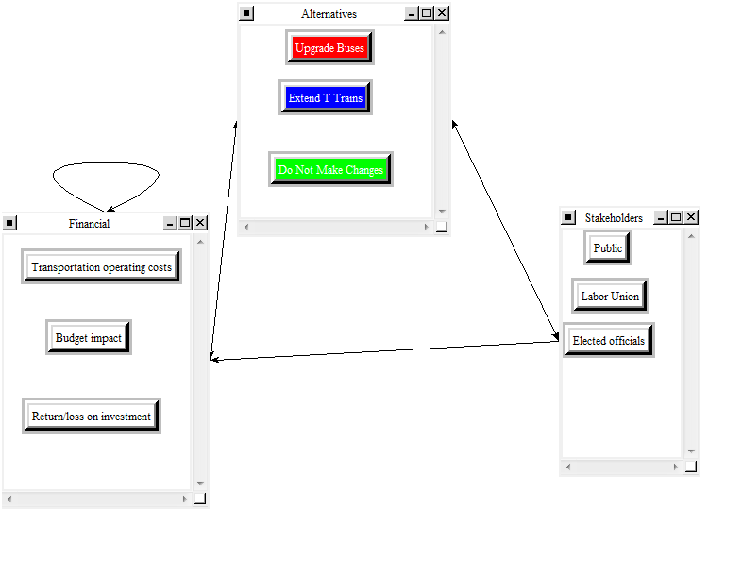

Environmental Subnet:
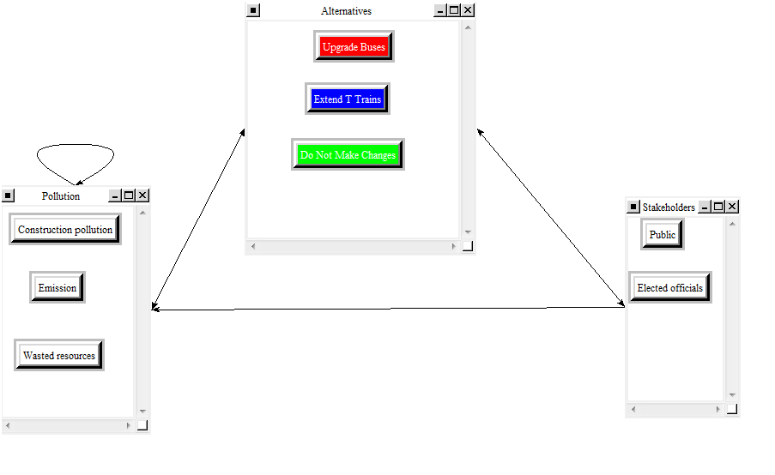

Social Subnet:
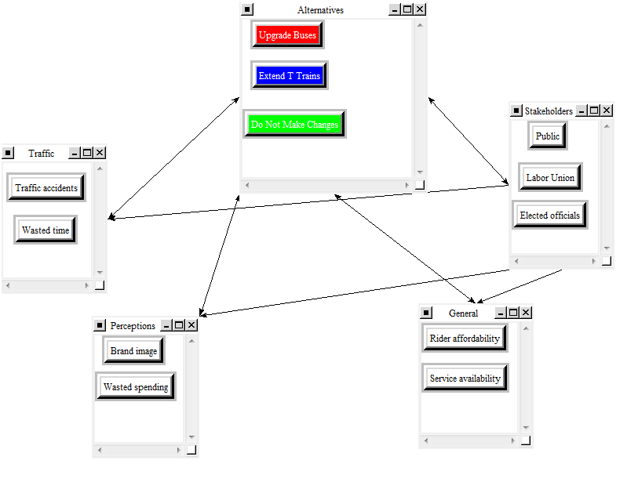
Risks Results:
The results after synthesizing all the risks categories are shown below:
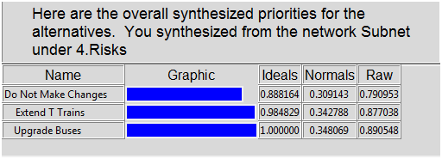

Risks Sensitivity:
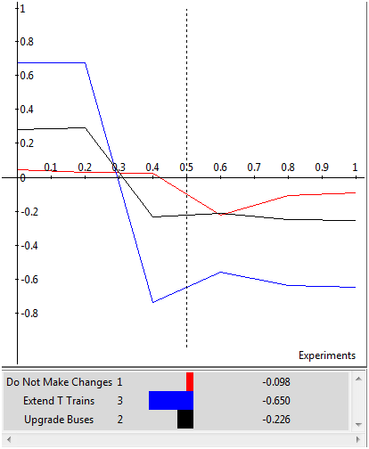

Strategic Criteria
We analyzed the alternatives using a total of five strategic criteria. We believed these would determine the best solution to the public transportation issue that is occurring in Pittsburgh. We used the ratings model to rate the best alternative from each subnet against the strategic criteria we chose. Below is the ratings table that we created.
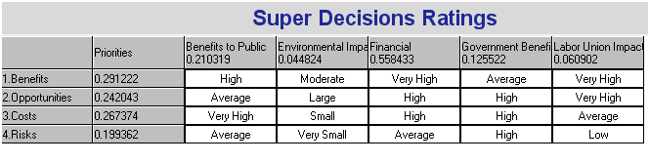
Since funding for the Pittsburgh Port Authority’s public transportation system is so unstable, we decided that the most important strategic criteria was the financial portion at 56%. The second most important strategic criteria are the ‘Benefits to the Public’ at 21%.
Findings
From our synthesis we found that expanding the T train is the best alternative. Our sensitivity analysis of the benefits and opportunities we used in our model always indicates that expanding the T train system would be the best alternative. However, if the cost rises beyond about 0.33 in regard to priority, “Do Not Make Changes” would become the best alternative for the Pittsburgh Port Authority to utilize as a long term solution. When the priority of risk, rises to about 0.6, all of the alternatives become equal and no alternative becomes significantly more of a priority than the other two alternatives. If the Pittsburgh Port Authority can finance the alternative of “Extend T Trains” we still believe, based on our model, this will be the best option in the short term, as well as the long term.

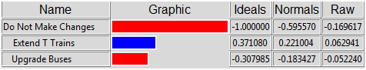

References
Public Transit 4 Pittsburgh. (March 2011). Retrieved October 6, 2011. http://publictransit4pittsburgh.wordpress.com/

Pittsburgh’s key roadways ear dubious ranking – Pittsburgh Tribune-Review. (February 2010). Retrieved October 6, 2011. http://www.pittsburghlive.com/x/pittsburghtrib/news/cityregion/s_668672.html

Port Authority Rider Report. (October 2011). Retrieved October 18, 2011. www.portauthority.org/riderreport/MessageFromCEO.aspx?spid=309

