UNIVERSITY OF pITTSBURGh
BQOM 2521: Decision Making in a Complex Environment
“Regardless of the Legal Definitions, Should UPMC be Considered Taxable or Tax-Exempt?”
From the Perspective of a Pittsburgh Community Member
Naveed Ismail and Mitchell Woll
4/23/2013

Introduction

UPMC has become a controversial company in the Pittsburgh area. The system operates several hospitals within the city and several more throughout western Pennsylvania. They employ roughly 55,000 individuals and are consistently rated the best hospital in Pittsburgh and among the top ten in the whole country. However, many Pittsburghers feel that healthcare giant is not paying its fair due. This is because UPMC is a non-profit organization. They do not have stockholders and, therefore, do not pay out profits to them. They meet all the legal requirements to hold status as a tax-exempt corporation; however, many feel that some of their practices are not in keeping with their charitable mission.

Many point to UPMC’s large annual profits, high-paid executives, swanky headquarters, frequent hospital acquisitions, and expensive advertising as chief amongst their complaints. They see the growth and the success of the company and feel it’s unfair that they do not pay the same taxes that others are expected to. Additionally, the rising cost of healthcare nationally has made many question whether or not UPMC’s profits are justifiable at all. When they see the struggle of community members to afford treatment and see that the CEO of UPMC is paid almost $6 million dollars a year, they see injustice. Furthermore, UPMC has made controversial decisions to shut down community hospitals such as the one formally located in Braddock. Many feel that UPMC destroyed a community resource all for the sake of improving the bottom line. What’s more, some feel bombarded by UPMC’s unfairness when they see UPMC billboards all over the city, hear their commercials on the radio, watch their ads during a Steelers game, and see their name sprawled high above the city’s skyline. This sense of injustice and unfairness has permeated Pittsburgh to the highest levels, with Mayor Luke Ravenstahl recently bringing a suit against UPMC challenging their tax-exempt status.

However, some recognize UPMC as an asset to Pittsburgh, offering the aforementioned jobs and world-class healthcare. They recognize that UPMC turns a profit so it can keep its facilities top-notch. The new Children’s Hospital and UPMC East are testaments to this commitment. Also, they see the high salaries as justifiable when they consider the success that retaining and rewarding top-talent has had for the company. They also feel that UPMC brings a great deal of prestige and wealth to Pittsburgh. Plus, they feel that UPMC contributes generously to the community and offers charitable care to the low-income community. All in all, they see more good than bad done by UPMC and feel that their tax-exempt status makes much of this possible.

For our project, we have tried to weigh these various opinions and facts to make a decision from the viewpoint of a Pittsburgh citizen. To do so, we tried to come up with all of the effects the change of the tax-status would have on three separate entities: UPMC, the local government filing the lawsuit, and most importantly, the Pittsburgh community itself. To suit the model, the effects would be broken down into four categories: Costs, Benefits, Opportunities, and Risks. Our Costs and Benefits were those that were clearly defined and would absolutely occur; whereas, the Opportunities and Costs were those effects that we thought could or would happen depending on the tax status. At the end of the day, there were only two statuses UPMC could hold: Taxable or Tax-Exempt. With that in mind, we used these as our two alternatives for the question we were trying to answer. When we came up with the question, it started simply as “Should UPMC be taxable or tax-exempt?”, but the more we thought about it, the more we refined our question for the purposes of doing this analysis. Some people may argue that by definition, UPMC is a non-profit, and hence should be tax-exempt by law, so we wanted to take that factor out of the question. We also did not want our benefits, costs, opportunities, and risks of UPMC being tax-exempt to just be “status quo” since that is their present status. In order to take a more objective viewpoint, we stepped back and thought about the question as if UPMC was taxable currently, what the effects would be to switch, and if it was tax-exempt currently, what the effects would be to switch. Based on that line of thought, we framed our question as follows: All else equal and regardless of the legal definitions, should UPMC be considered taxable or tax-exempt? This question is asked from the perspective of a City of Pittsburgh community member, taking into account the respective implications on the community, local government, and UPMC itself.

Alternatives

As mentioned in the introduction we are thinking about this situation from outside of the reality where UPMC is already tax-exempt and are instead thinking of it where there are only two outcomes in our scenario where both come with new and unique Costs, Benefits, Risks and Opportunities.

- Taxable: UPMC must pay taxes to the City of Pittsburgh.
- Tax-Exempt: UPMC operates free from certain taxes that other businesses would have to pay.

From a community member’s point of view, both alternitives have something to offer. The strong motivation for seeing a taxable UPMC would be building a strong Pittsburgh economy and establishing fairness in UPMC’s model. In the case of being tax-exempt the community would benefit from the increase in jobs and charitable care not having to pay taxes would offer.

Strategic Criteria

We established five strategic criteria we felt would encompass all factors most important when considering this issue from the viewpoint of a Pittsburgh community member.

- Fairness: The community’s perception of inequity and impropriety of a non-profit making such large profits and not paying taxes.
- Strong Economy: The community wants their community and city to prosper.
- Community Benefits: The community wants benefits in the form of government programs and charitable contributions.
- Jobs: The community wants plentiful and stable jobs for Pittsburgh.
- Cost of Healthcare: The community wants affordable healthcare.

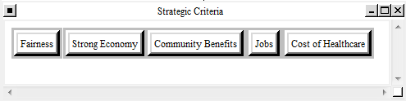

BOCR

We put together a chart (see below) that laid out the Costs, Benefits, Opportunities, and Risks from a Taxable and Tax-Exempt perspective.

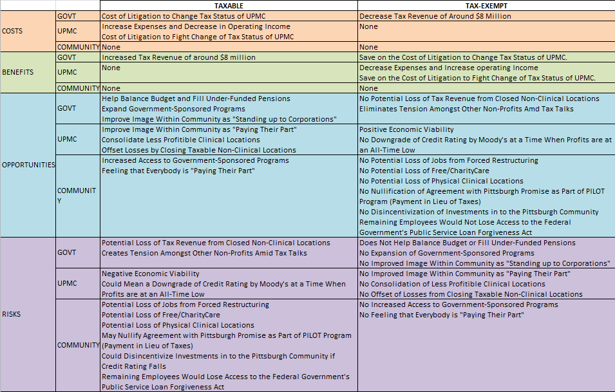

Ratings

The strategic criteria are rated based Benefits, Opportunities, Costs, and Risks. For our decision we actually had far more opportunities and risks than we did defined benefits and costs. As a result, our opportunities are our highest priority. Among the strategic criteria, we felt that a community member would feel that community benefits would be most important, while fairness and cost of healthcare, which both are least importance in this context.

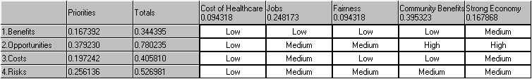

Networks

Benefits

The Benefits criteria assess what we deemed to be definite, determined positive outcomes to a decision. We felt that the Government and UPMC had the only benefits.

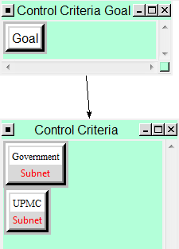

Government

Economic: These factors represented fiscal benefits that would come from the alternatives. Choosing “Taxable” would mean that annual revenue would increase by an estimated $8 million. Choosing “Tax-Exempt”, however, would mean that the government would benefit from saving on costly litigation.

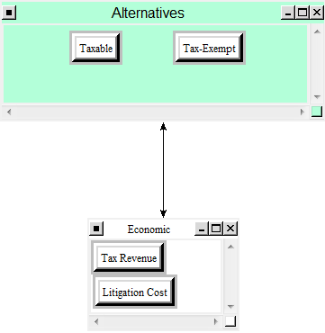

UPMC

Economic: Again, these factors represent the fiscal benefits for UPMC. UPMC’s benefit from being “Tax-Exempt” would be an increased operating income and decreased expenses. Also, they would save on litigation costs. They do not benefit from a “Taxable” scenario.

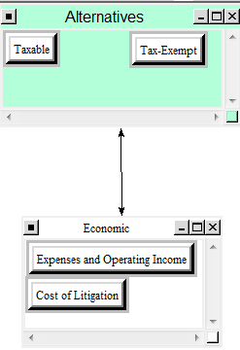

Costs

The Costs criteria assess what we deemed to be definite, determined negative outcomes to a decision. We felt that the Government and UPMC had the only costs.

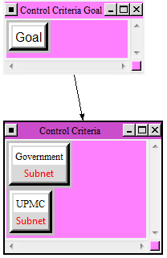

Government

Economic: These factors represented fiscal costs that would come from the alternatives. Choosing “Tax-Exempt” would mean that annual revenue would not increase by an estimated $8 million. Choosing “Tax” would mean that the government would lose money costly litigation.

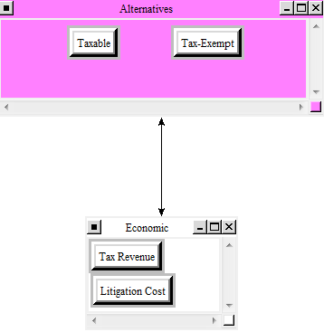

UPMC

Economic: These factors represent the fiscal costs for UPMC. UPMC’s cost from being “Taxable” would be a decreased operating income and increased expenses. Plus, they would lose money on litigation costs. There are no costs from a “Tax-Exempt” scenario.

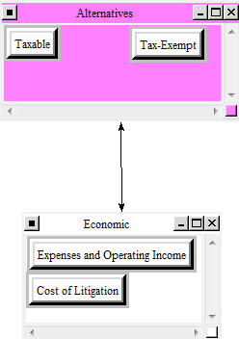

Opportunities

The Opportunities criteria represent what we feel are potential or likely positive results to choosing one of the alternatives. The government, UPMC, and the Pittsburgh community all have potential opportunities associated with them.

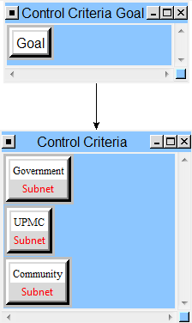

Government

Economic: These factors represent the fiscal opportunities for the government we see between the two alternatives. Choosing “Taxable” could help to balance the city’s budget. A balanced budget could also contribute to fill government worker pensions, as well as, increasing the funding for government programs (this also helps the government’s image within the community). Choosing “Tax-Exempt” status could result in lost tax revenue from UPMC closing non-clinical locations.

Image: These factors represent the government’s opportunities to improve its image. If “Taxable” is chosen the government could have a better image within the community for having stood up to a corporation which is perceived as greedy and unfair. Also, if government programs, such as bus lines, are expanded the community will think more of the government. But, if the “Tax-Exempt” status was chosen, the government could be seen as easing the tension that has arisen in other non-profits (including universities and other hospitals) now fearing a change to their status.

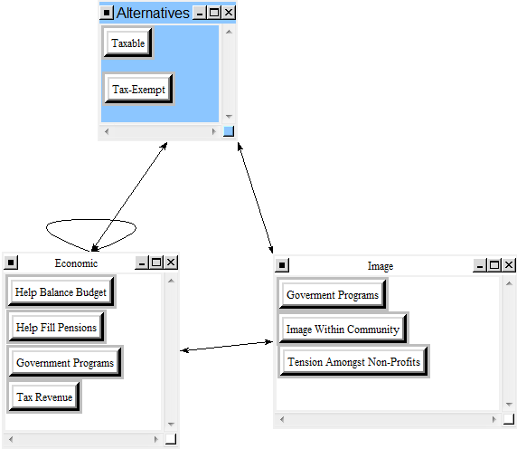

UPMC

Economic: These factors represent the fiscal opportunities for UPMC that we see between the two alternatives. Choosing “Tax-Exempt” could result in improved economic viability for the company; which would affect the image of the company as financially sound and result in a high credit rating. If “Taxable” were chosen, UPMC might have to consolidate hospitals or close non-clinical locations in order to remain financially strong. These are being treated as opportunities because UPMC might find it better to run fewer facilities and be more efficient.

Image: These factors represent UPMC’s opportunities to improve its image. UPMC could be seen as being more fair and reasonable by the community if it had “Taxable” status. But, if they had “Tax-Exempt” status they are more likely to have greater revenue and therefore maintain an image of economic strength and earn a high credit rating. Furthermore, having high rated businesses in Pittsburgh improves the image of the city as a whole.

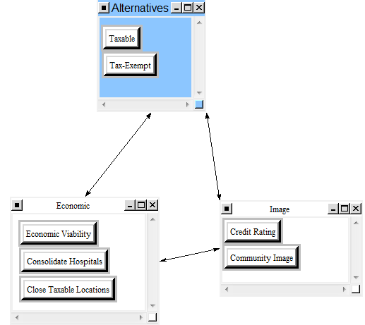

Community

Economic: These factors represent the fiscal opportunities for the community that we see between the two alternatives. Choosing “Tax-Exempt” could mean more facilities would stay open and therefore, there will be more jobs for community members. These jobs also offer access for employees to the Loan Forgiveness Act. Also, being “Tax-Exempt” could mean a higher credit rating which would keep investors and businesses eager to operate and spend in the Pittsburgh community.

Access: These factors represent the community’s opportunities to increase access to certain locations and programs. Choosing “Tax-Exempt” would mean more hospitals could stay open (thus affecting charity care provided by the hospitals). Also, the Loan Forgiveness Act is a government program only available to employees of a non-profit company. Choosing “Taxable”, however, could provide more access to government-funded programs.

Charity: These factors represent the community’s opportunities for charitable programs. Choosing “Tax-Exempt” could allow UPMC to provide more charitable care to the needy and underserved communities within Pittsburgh. Also, UPMC is part of the PILOT (Payment In Lieu Of Taxes) Program which has non-profit businesses pay into the Pittsburgh Promise Program instead of paying taxes. This program provides financial, collegiate support up to $40,000 per student for those who live in Pittsburgh, go to Pittsburgh public schools, and then attend a Pittsburgh university. Without UPMC’s contribution, this charity could be severely under-funded.

Image: Choosing “Taxable” would improve the community’s image of the government and UPMC by ensuring fairness and justice even for large corporations.

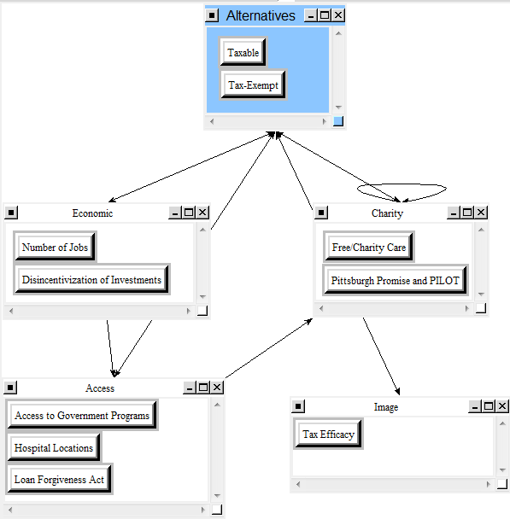

Risks

The Risks criteria represent what we feel are potential or likely negative results to choosing one of the alternatives. The government, UPMC, and the Pittsburgh community all have potential risks associated with them.

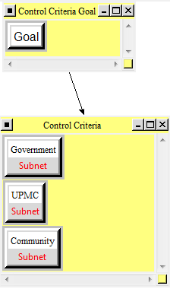

Government

Economic: These factors represent the fiscal risks for the government we see between the two alternatives. Choosing “Tax-Exempt” could not help to balance the city’s budget. Without a balanced budget, the government could struggle to fill worker pensions and decrease the funding for government programs (this also damages the government’s image within the community). Choosing “Taxable” status could result in increased tax revenue from UPMC keeping open its non-clinical locations.

Image: These factors represent the government’s risks to its image. If “Tax-Exempt” is chosen the government could have a worse image within the community for not having stood up to a corporation which is perceived as greedy and unfair. Also, if government programs, such as bus lines, are cut, the community will think less of the government. If the “Taxable” status was chosen, the government could be seen as worsening the tension that has arisen in other non-profits (including universities and other hospitals) now fearing a change to their status.

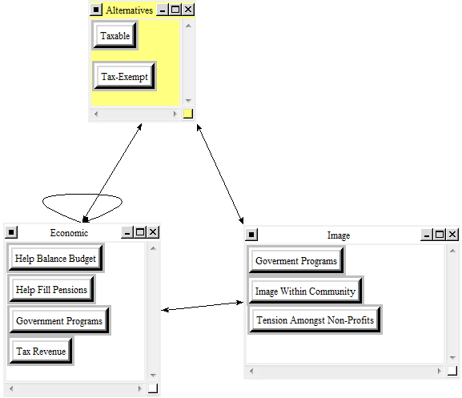

UPMC

Economic: These factors represent the fiscal risks for UPMC that we see between the two alternatives. Choosing “Taxable” could result in damaged economic viability for the company; which would affect the image of the company as financially sound and result in a lower credit rating. If “Tax-Exempt” were chosen, UPMC might not have to consolidate hospitals or close non-clinical locations in order to remain financially strong.

Image: These factors represent UPMC’s risks to its image. UPMC could be seen as being unfair and unreasonable by the community if it had “Tax-Exempt” status. But, if they had “Taxable” status they are less likely to have high revenue and might not maintain an image of economic strength and earn a high credit rating. Having low rated businesses in Pittsburgh worsens the image of the city as a whole.

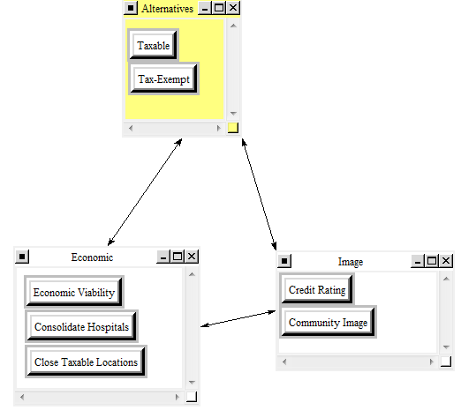

Community

Economic: These factors represent the fiscal risks for the community that we see between the two alternatives. Choosing “Taxable” could mean fewer facilities would stay open and therefore, there will be fewer jobs for community members. Without these jobs, there is no access for employees to the Loan Forgiveness Act. Also, being “Taxable” could mean a lower credit rating which could make investors and businesses wary of operating and spending in the Pittsburgh community.

Access: These factors represent the community’s risks to access to certain locations and programs. Choosing “Taxable” would mean fewer hospitals could stay open (thus affecting charity care provided by the hospitals). Also, the Loan Forgiveness Act is a government program only available to employees of a non-profit company. Choosing “Tax-Exempt”, however, could provide less access to government-funded programs.

Charity: These factors represent the community’s risks to charitable programs. Choosing “Taxable” could force UPMC to provide less charitable care to the needy and underserved communities within Pittsburgh. Also, UPMC is part of the PILOT (Payment In Lieu Of Taxes) Program which has non-profit businesses pay into the Pittsburgh Promise Program instead of paying taxes. This program provides financial, collegiate support up to $40,000 per student for those who live in Pittsburgh, go to Pittsburgh public schools, and then attend a Pittsburgh university. UPMC’s contribution, may keep this charity from being under-funded.

Image: Choosing “Tax-Exempt” would damage the community’s image of the government and UPMC by allowing them to feel that fairness and justice for large corporations do not exist.

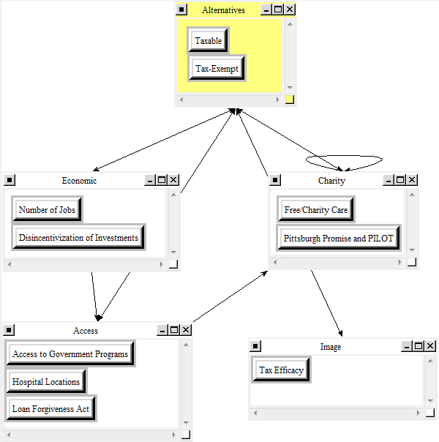

Results

Our results ended up being very close, with the results split in half for “Taxable” versus “Tax-Exempt”.

- Benefits favored “Taxable”
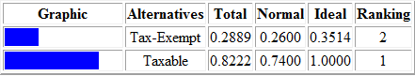

- Opportunities favored “Tax-Exempt”
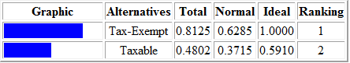

- Costs favored “Tax-Exempt”


- Risks favored “Taxable”



Ultimately, this resulted in our final additive result being narrowly in favor of “Tax-Exempt” status.

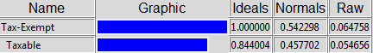

However, this result shows the best alternative in the long-run. Our results showed that the “Taxable” status wins in the short-run according to the multiplicative findings.

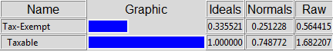

But, we believe strongly that the long-term result is the more important outcome in this situation. A “Tax-Exempt” UPMC will be better for the people of Pittsburgh in the years to come.

Sanity

The sanity check was a success, with all applicable comparisons made.

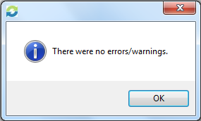

Sensitivity
The sensitivity analyses were also close but ultimately favored “Tax-Exempt” status. Below is a shot of our graph for Opportunities which had the highest priority for us. The graph shows that at .24 both alternatives are equal. From there on though, the results favor “Tax-Exempt”. The dotted line is set at roughly .38, the priority we assigned opportunities.

