Decision Making
Final Project Model
Outbound Enrollment Verification Calls
Kelly Aber
10/17/2011

Contents
Introduction 2
Decision Model 2
Top Level Network 2
Alternatives 2
Goals & Criteria 3
BOCR Network 3
Benefits 3
Opportunities 5
Costs 6
Risks 8
Model Synthesis 12
Additive Model 12
Multiplicative Model 13
Rating Model 13

Introduction
Medicare Advantage plans, such UPMC Health Plan, are required to adhere to a strict enrollment regulations as set forth and governed by The Centers for Medicaid and Medicare Services (CMS). Failure to adhere to those regulations can result in civil penalties and enrollment sanctions. The Medicare Advantage market is very competitive, especially here in South Western Pennsylvania, making compliance even more important.
Much like standard Employer Group Plans, Medicare enrollees can enroll into a new plan during the Annual Enrollment Period (AEP). As a result, Medicare Advantage plans are often faced with a significant seasonal fluctuation in their enrollment volumes, posing a substantial risk in maintaining ongoing compliance. CMS requires enrollments are processed within 7 days of the organization receiving the enrollment request; and so, most plans must hire temporary staff members, employ a flexible workforce, or some other agile staffing model to manage this volume of work while maintaining compliance.
In 2010, CMS introduced a new requirement. Medicare Advantage plans are now required to conduct outbound enrollment verification calls to new enrollees to verify their intent to enroll. Calls must be completed within 15 days of receiving the application and require up to three attempts to reach the new enroll (within 15 days from receipt of the application). This 15 day timeframe includes the seven day window for processing the application, so if an application is not processed until day 7, an organization only has 8 days remaining to complete the outbound verification process. This additional requirement, while certainly in the member’s best interest, can be operationally burdensome to organizations. As such an organization, we chose to outsource the outbound verification call process during the 2011 AEP (November 15 – December 31, 2010).

Decision Model

Top Level Network

Alternatives
After the 2010 AEP timeframe, UPMC Health Plan chose to move the outbound verification call process back in house. We believed we were capable of managing the smaller volume of enrollment effectively, provide a higher level of quality service to our members, maintain better control of our compliance, and, of course, reduce costs, as existing staff would be able to manage the significantly smaller volume of calls. As we approached the 2011 AEP season, we were again faced with a decision to make: Maintain operations in house with temporary staff members (Do Not Outsource), outsource to our existing vendor (Use Existing Outsource Company), or contract with a new organization (Use New Company A).
We currently have an existing relationship with both vendors, and as such are generally familiar with their organization and capabilities; however, only one of the vendors has conducted the outbound enrollment verification calls for us. The other vendor (Use New Company A) has performed a variety of customer service activities in the past and we feel they are a formidable opponent of our existing vendor in determining who could complete these calls, if the decision is to outsource.

Goals & Criteria
And, so the goal of this model is to answer the question “Determine if outbound verification calls should be kept in house or outsourced. And, if outsourced, to whom?” The strategic criteria used to evaluate this decision were:
- Financial – Cost is an essential point of reference when making business decisions. The cost of outsourcing, or not outsourcing, is a critical criterion.
- Company – Generally referencing the organization for whom will be making the calls. Reputable organizations are a must, given the compliance risk associated with the outsourced activity. If UPMC decides to outsource, they must be confident the organization will be able to follow through and achieve the desired outcomes. In addition, the organization must have a strong focus on quality service and a robust quality assurance program. Our organization prides ourselves on the service we provide our members and we expect nothing less from a vendor. Both Service Quality and Quality Assurance Program are identified as Company Criteria.
- Compliance – Critically essential to any Medicare Advantage organization. Given the penalties and the market conditions, it is imperative the final decision results in compliance with all state and federal requirements. Compliance is further broken into Regulatory Compliance, referring to the standard procedural requirements as defined by CMS, and Transparency; essential to proving compliance.
- Operations – Refers to the general operations of the organization or outsourced vendor. Efficiencies, process controls, and management oversight are just a few such important factors when considering the overall operations of an organization.

Priorities
The priorities for the model are outlined in the screen shot below. Compliance and Transparency are heavily weighted, given their impact on our ability to conduct business moving forward. Financial and Operational are ranked next.
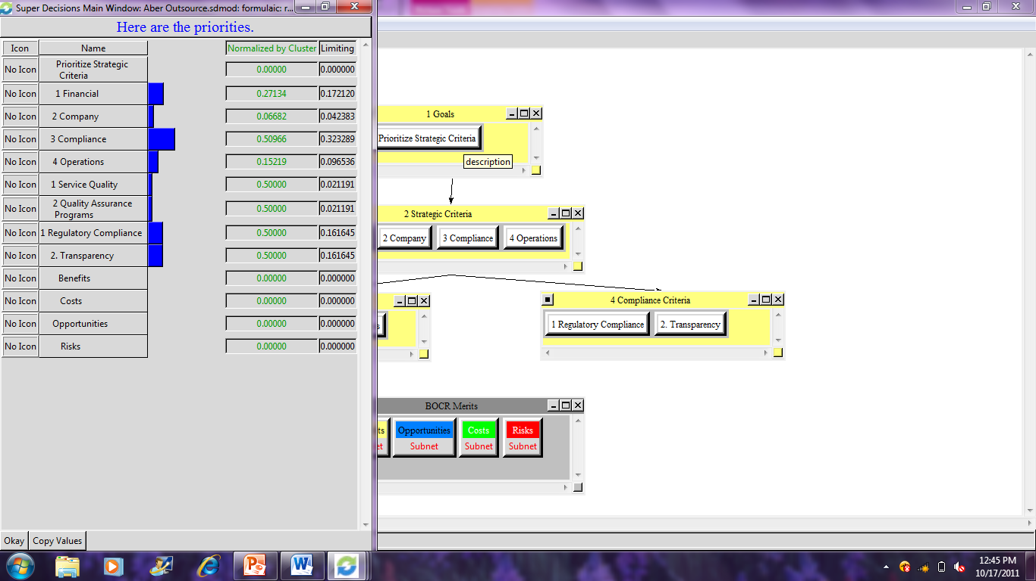

BOCR Network

Benefits
Economic SubNet:
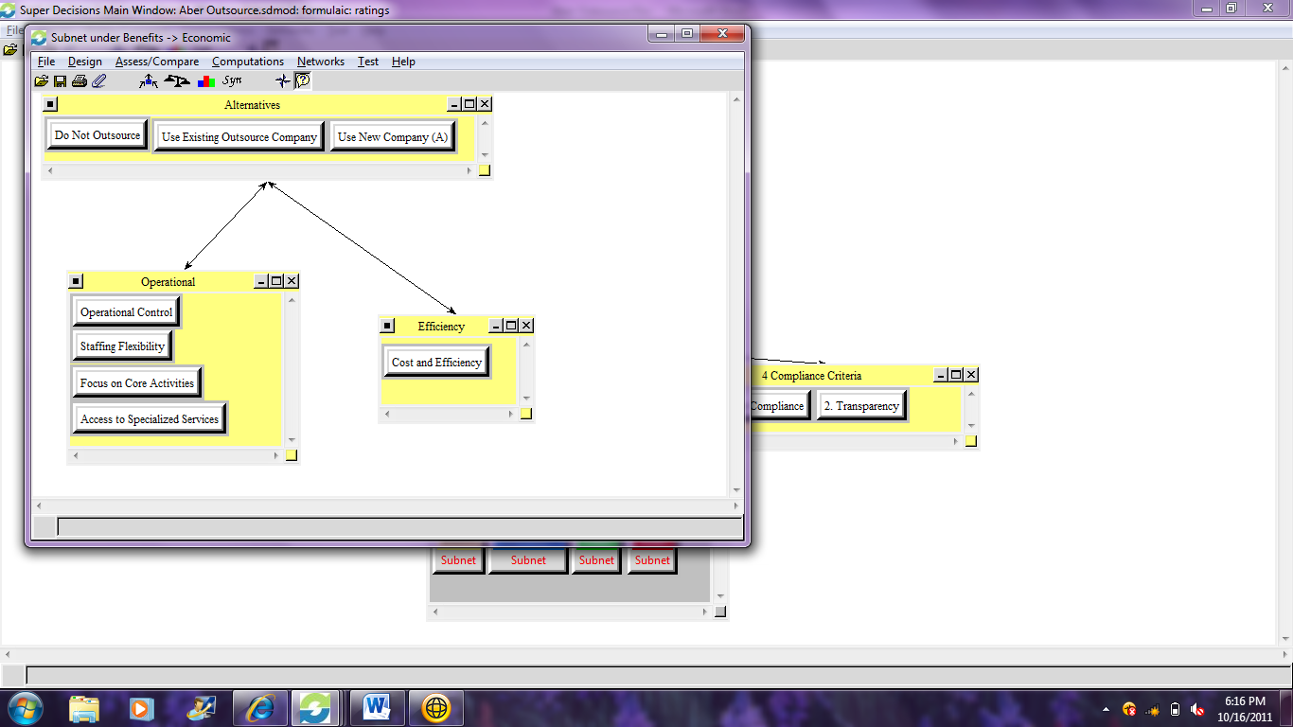
- Operational nodes include Operational Control, Staffing Flexibility, Focus on Core Activities, and Access to Specialized Services. While maintaining operations in house offers the highest level of operational control, it may be more desirable to outsource certain control activities to ensure success. Due to volume fluctuations, staffing flexibility is a benefit of outsourcing. Maintaining operations in house may dilute the core activities of enrollment processing and Member Services, as the outbound enrollment verification call is often considered an activity occurring post-enrollment, but pre-membership. Outsourcing would enable Enrollment and Member Services departments to focus on its core activities of processing enrollment transactions and providing service to active members. Organizations can often leverage their operations through the technology, knowledge, or other services offered by an outsourcer.
- Efficiency cluster combines the cost and production efficiencies (assuming they are linked). Outsourcing may enable scale of economy, better use of staffing, and in generally, be more cost-effective than maintaining operations in house, specifically during low enrollment timeframes. Of course, the activities may also be better served in house.

Political SubNet:
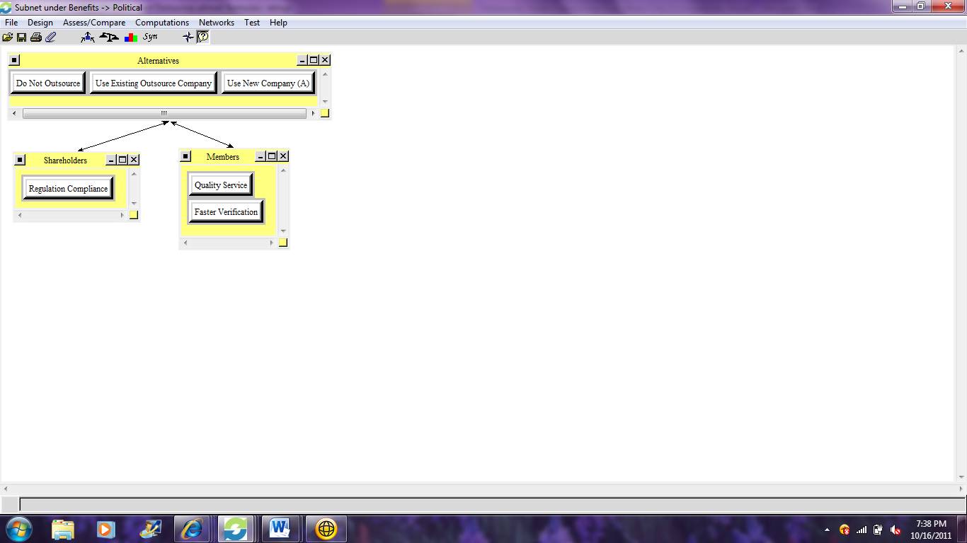
- The Shareholder cluster contains one benefit node: Regulation Compliance. Clearly, achieving compliance with vast and confusing regulations is clearly a benefit to all shareholders.
- The Members cluster contains Quality Service and Faster Verification as its two benefits. Providing a high level of quality service while completing the verification calls as early in the process are benefits to the members and can increase customer satisfaction.

Opportunities
Economic SubNet:
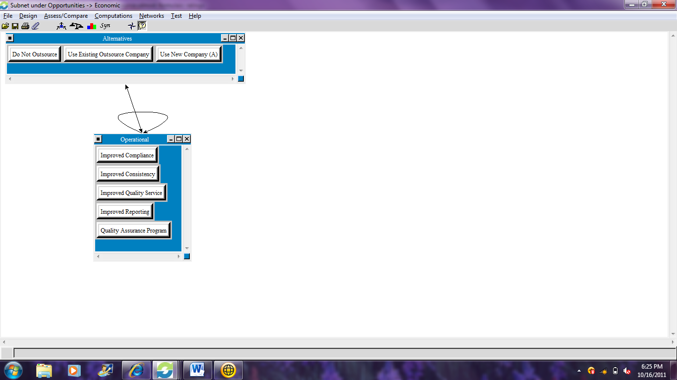
- The Operational nodes include Improved Compliance, Improved Consistency, Improved Quality Service, Improved Reporting, and Quality Assurance Program. Each of these opportunities is rather self-explanatory. As 2010 was the first season for outbound enrollment verification calls, many organizations around the country are working hard to identify the best possible way to manage this process and are often learning from their mistakes. Also, given low enrollment volumes outside of AEP, the learning curve for staff internally has been longer. Calls are sporadic and reporting trends and opportunities are difficult.

Costs
Economic SubNet:
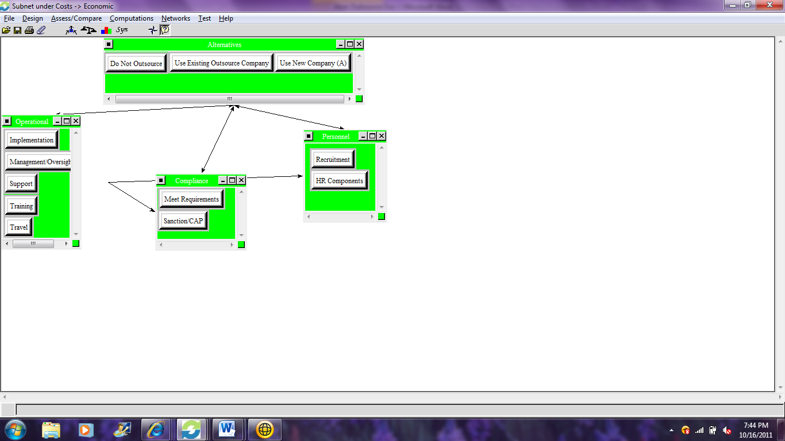
- The Operational cluster includes Implementation, Management Oversight, Support, Training, and Travel. Each of these refers to operational costs each of the alternatives have. While most are self-explanatory, Support refers to post-implementation support.
- The Compliance cluster includes two nodes: Meet Requirements and Sanction/CAP. Each of these have an associated cost. Certainly meeting the regulatory requirements have a cost associated with the operations (refer to other cluster) and failing to achieve compliance can result in either a sanction or corrective action plan required by CMS; each bearing an associated cost.

Social Subnet:
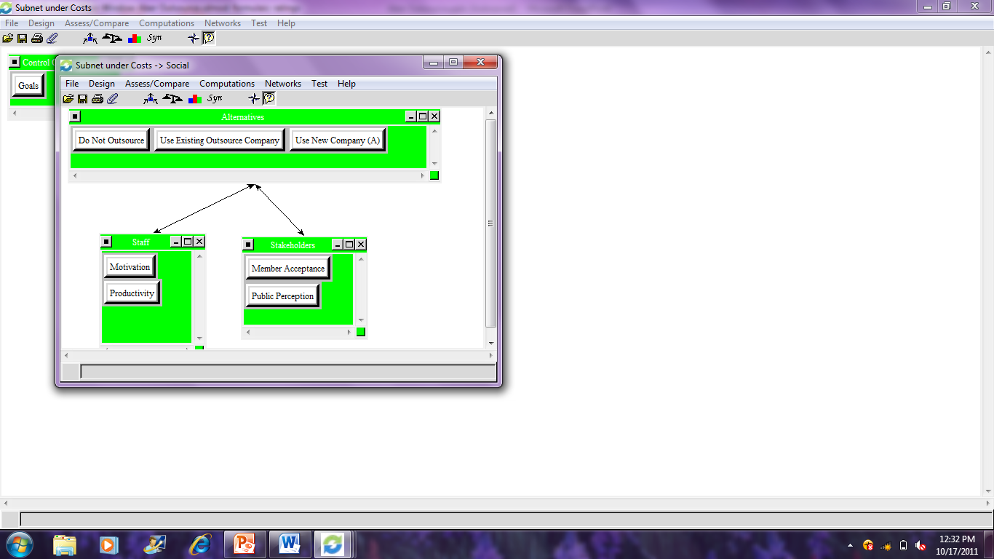
- The Staff cluster contains Motivation and Productivity. Motivated staff perform differently than unmotivated staff and there is a cost associated with that.
- The Stakeholder cluster contains Member Acceptance and Public Perception nodes. There is a potential intangible cost associated with both of these. Keeping the operations in house or using a local outsourcing company can be more accepting to members, and of course to the public. Non-local vendors can impact customer satisfaction and the brand image of “local”

Risks
Economic SubNet:
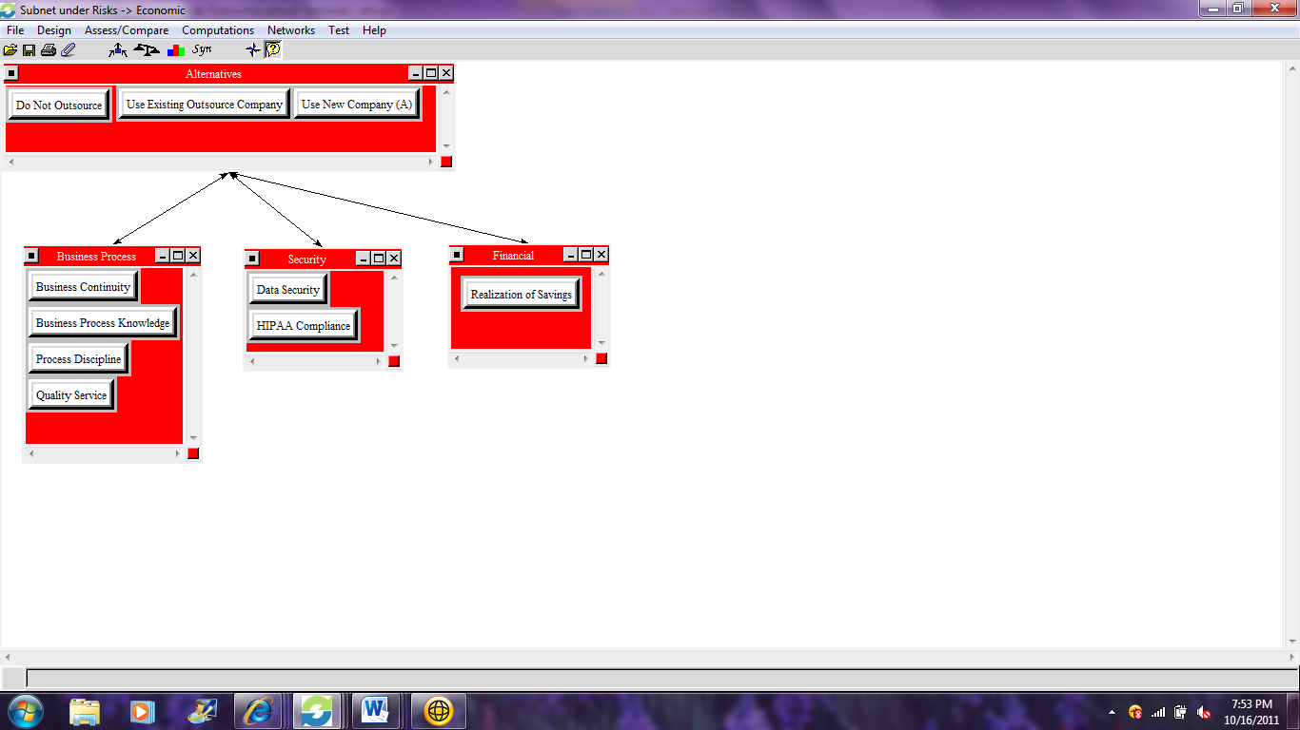
- The Business Process cluster contains four nodes: Business Continuity, Business Process Knowledge, Process Discipline, and Quality Service. Given the compliance requirements, business continuity is critical. There is a risk that business process knowledge, perhaps proprietary, could be lost and or shared unintentionally. The Process Discipline node accounts for the risk of adhering to the business process, as defined by management to ensure compliance.
- The Security cluster contains Data Security and HIPAA Compliance. If an outsource vendor is selected, it will be critical for data to be shared to enable operations and that data must be kept safe. HIPAA compliance is a standard security concern in the Health Care Industry.
- The Financial cluster contains one node: Realization of Savings. If an outsource vendor is chosen, there is a risk that the savings associated with outsourcing, when weighed with the benefits, will not be realized.

Geographic SubNet:
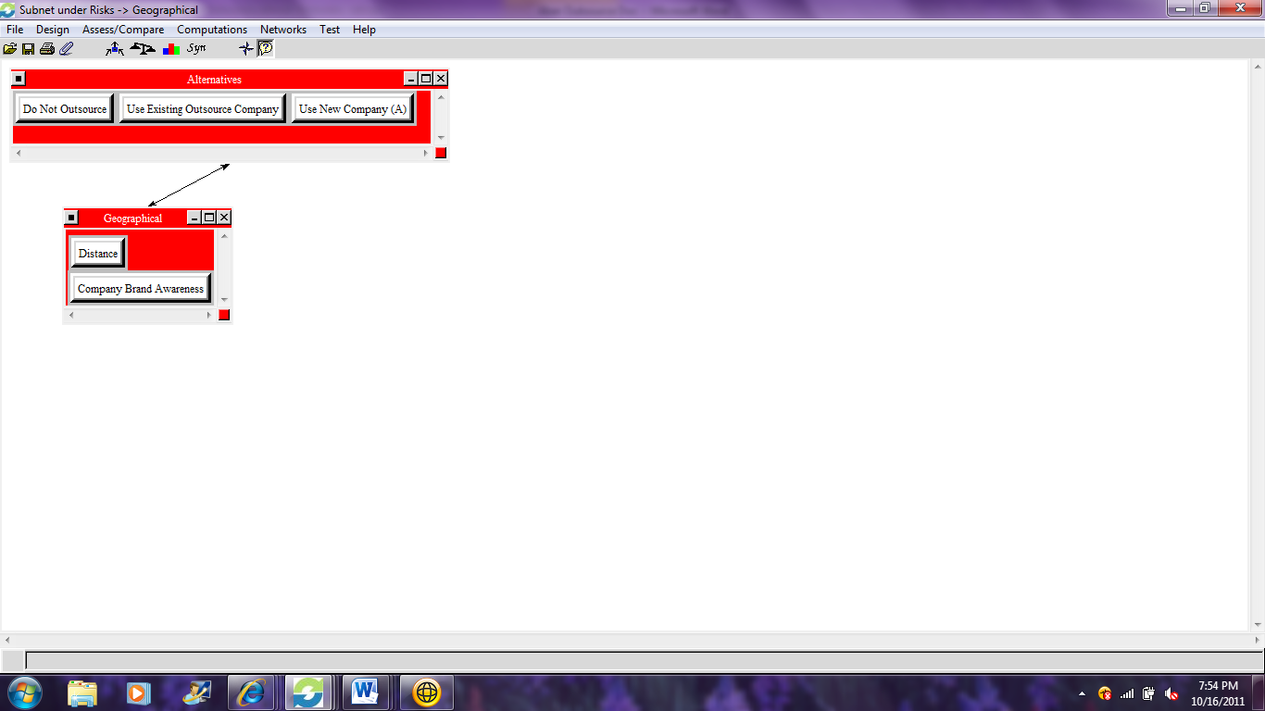
- The Geographical cluster contains two nodes: Distance and Company Brand Awareness. As one of the potential outsourced companies is not local, communicating through this distance can be a risk. It will not be as easy to set up operations and communicate regularly with a vendor when hundreds of miles of distance separate the two organizations. Also, due the geographical distance, the outsource company will need to be educated regarding the home organization, since it is a regional Health Care plan.

Regulatory Compliance SubNet:
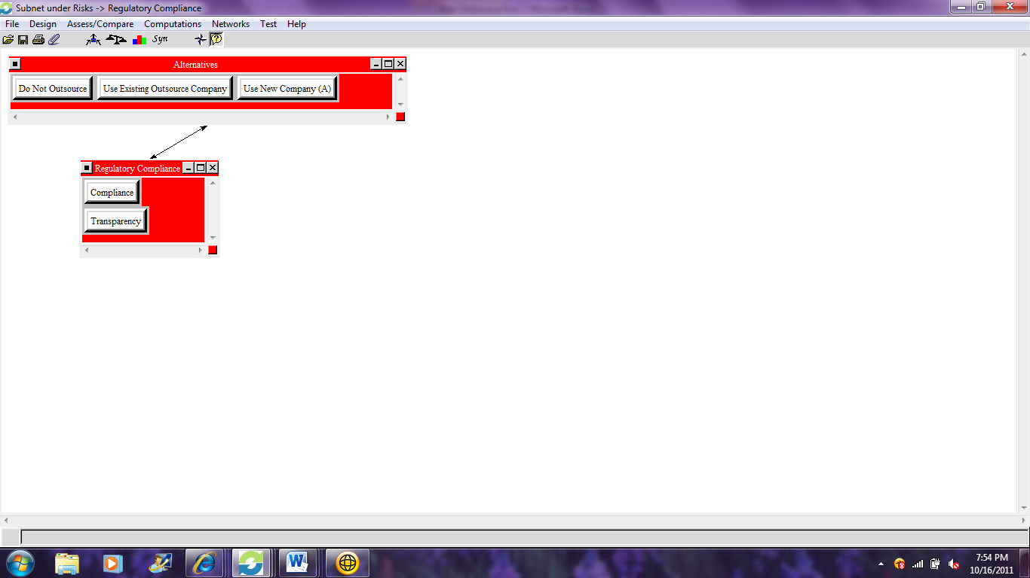
- The Regulatory Compliance cluster has two nodes: Compliance and Transparency. Compliance refers to the risk associated with conducting operations that meet CMS requirements and Transparency refers to the reporting, recording, and other activities that can easily be produced to prove compliance, if audited.

Social SubNet:
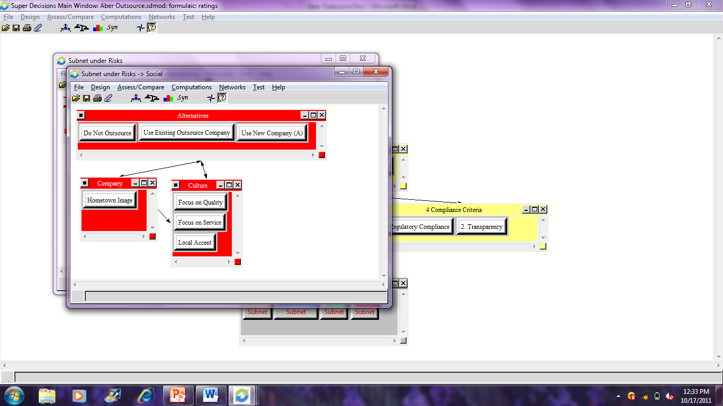
- The Company cluster contains Hometown Image. UPMC has a strong hometown image and it is important to maintain that message.
- The Culture of the organization conducting the outbound enrollment verification calls poses a intangible risk. These are evaluated in the Culture cluster; nodes Focus on Quality, Focus on Service, and Local Accent.

BOCR Priorities
For this model, the BOCR priorities were set as follows. While certainly cost and risks are important to our final decision, I believed the benefits and opportunities to be gained were slightly more important. The challenges in keeping the process in house are quite significant, and so, we needed to consider which outsource organization would be able to provide the highest amount of benefits.
Benefits | 0.269044
Opportunities | 0.269044
Costs | 0.230956
Risks | 0.230956

Model Synthesis
The model synthesis indicates the best solution is to utilize the New Company A; however, the alternative of maintaining operations in house (Do Not Outsource) are very close. This is not surprising to me. Maintaining operations in house was our initial decision, but we did decide to use the new company. Currently, this outsourcing is on a trial basis and we will continually review their performance and determine a long term solution.
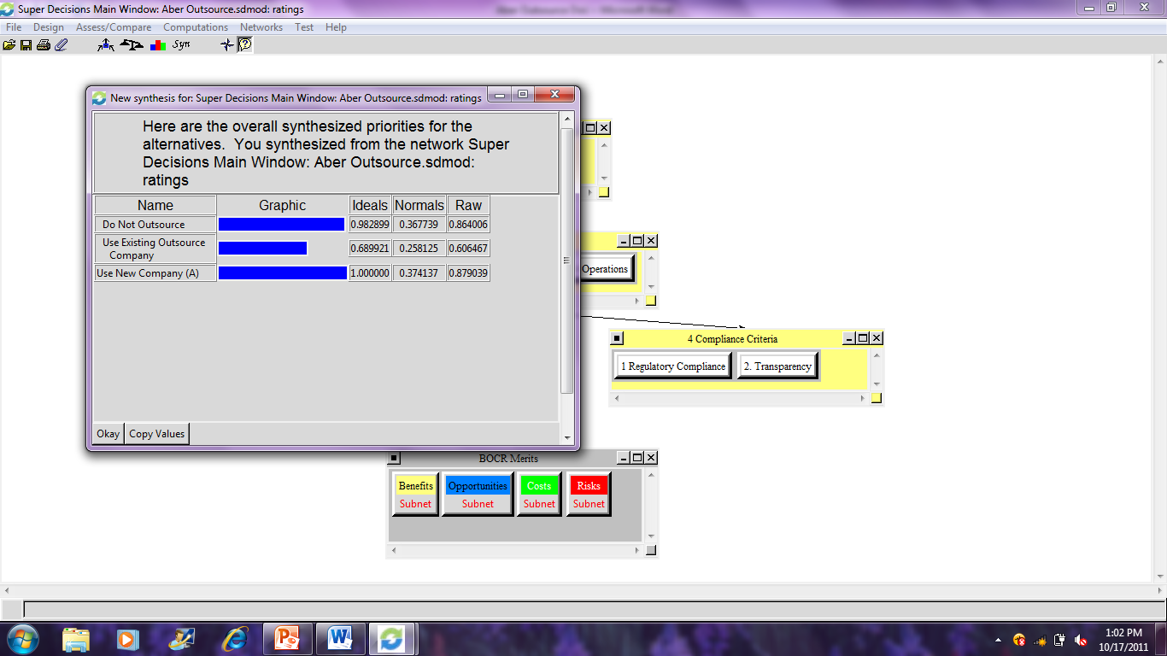

Rating Model
A rating model was also created, to rate the benefits, costs, opportunities, and risks with respect to Financial, Company, Compliance, Operations, Service Quality, Quality Assurance, Regulatory Compliance, and Transparency.
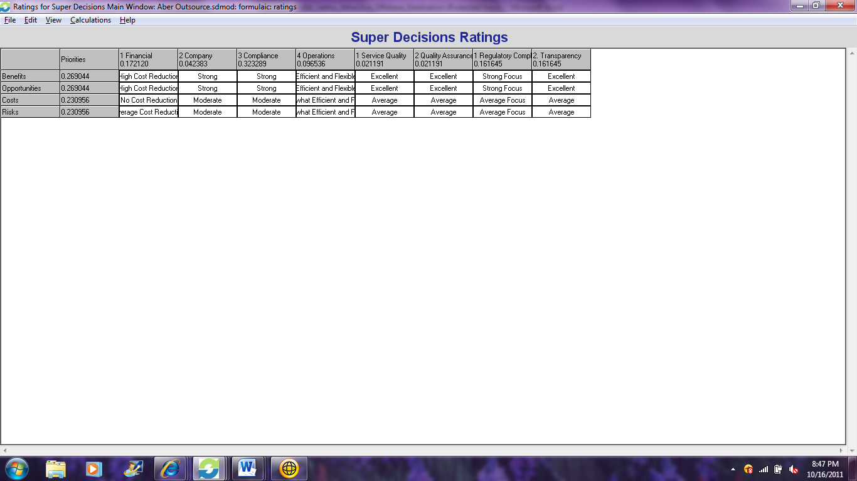

Sensitivity Analyses

Benefits Sensitivity
As the benefits become more important to the decision, you can see the alternative of using the new outsource company becomes more apparent:


Opportunities Sensitivity
The sensitivity analysis for the Opportunities mirror Benefits, in that as they become more important to the decision, using the New Company becomes the prevalent solution:
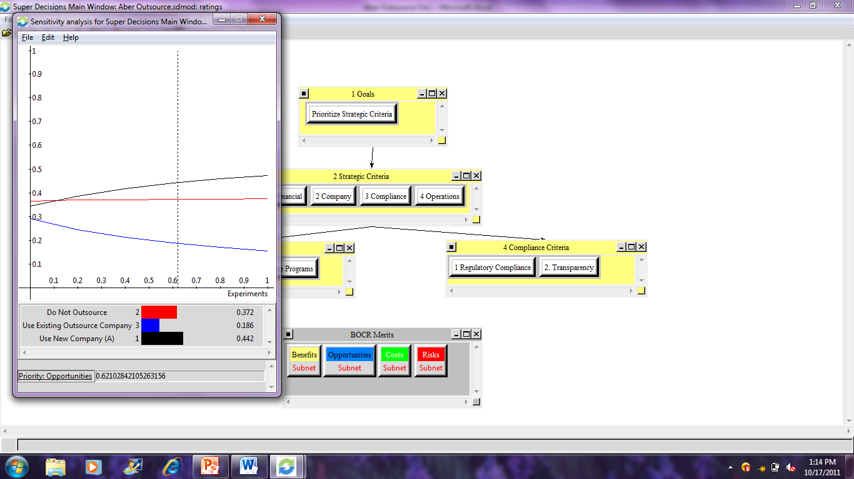

Cost Sensitivity
As costs become more important, it is easy to understand why using the existing outsource company becomes the decision. The existing outsource company is actually cheaper than the new company, however, the benefits of using the new company outweigh those costs:
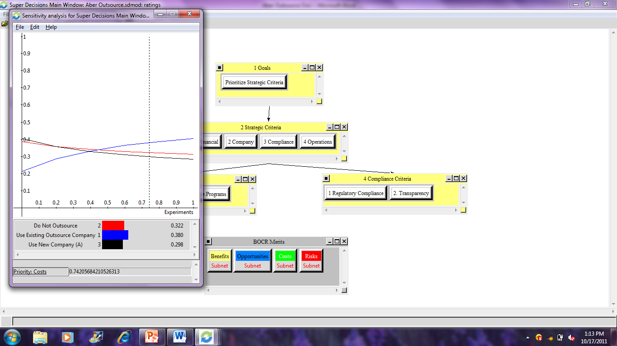

Risk Sensitivity
As the risks become greater, again, it is easy to understand while maintaining operations in house becomes the decision. This alternative offers the highest level of operational control over the outcomes:
