Should the City of Pittsburgh and Allegheny
County, PA Governments Merge?

BQOM 2521 - Decision Making in a Complex Environment
Spring 2005
The Katz Graduate School of Business

Matt Harnett
Tom Jarzab
Dan Lucarelli

April 13, 2005

Table of Contents

Introduction and Background. 1
Alternatives. 3
Strategic Criteria. 5
BOCR. 5
The Model. 10
Results. 11
Sensitivity Analysis. 15
Conclusions. 21

Appendices

AHP Model Description A
AHP Graphical Model B
Strategic Criteria: 1
Benefits subnet: 2
Economic Subnet: 3
Political Subnet: 3
Social Subnet: 4
Technological Subnet: 4
Opportunities Subnet: 5
Economic Subnet: 6
Political Subnet: 6
Social Subnet: 7
Costs Subnet: 8
Economic Subnet: 9
Political Subnet: 9
Social Subnet: 10
Technological Subnet: 10
Risks Subnet: 11
Economic Subnet: 12
Political Subnet: 12
Social Subnet: 13
Technological Subnet: 13

Introduction and Background.

Many corporate and several political leaders in Allegheny County, Pennsylvania are proposing the idea of a city-county government merger. The Pittsburgh Post-Gazette reported on September 16, 2003 that the Allegheny Conference on Community Development, a regional think tank, recommended that Pittsburgh city government merge with Allegheny County government. Additionally, they recommended that some overlapping services be merged to ameliorate impending financial distress. Then county executive, Jim Roddey, and Pittsburgh mayor, Tom Murphy, both endorsed the plan. The local legislature, however, was less enthusiastic about a full city-county merger, but did support the merging of overlapping city and county services such as the purchasing of supplies and the provision of police services. The debate over this merger is not a new one to the people of Allegheny County. In fact, it is a natural emergent characteristic of the Commonwealth, its people and the founding values upon which it was created.

William Penn, Father of Pennsylvania, not only developed the geographic area that is called Pennsylvania, but he also fostered the pioneering, independent spirit that Pennsylvanians live by even to this day. Penn envisioned Pennsylvania as the bastion of religious tolerance and individual liberty for people fleeing religious intolerance in Europe. A natural component of such individualism was the establishment of governing units with limited powers. The “smaller government” concept led to the development of Pennsylvania’s township system where the townships provide services to their respective communities while the larger and more encompassing county government takes a secondary role. Penn called his vision of Pennsylvania his “Holy Experiment.” His unique vision conceived the Commonwealth of Pennsylvania and within it, the city of Philadelphia – the birthplace of the Declaration of Independence, the seed that would maturate into the United States of America.

Penn’s plan for smaller, more independent government systems within Pennsylvania has today created an interesting situation in Allegheny County which is located in the southwestern region of Pennsylvania and contains Pittsburgh along with numerous smaller municipalities. Allegheny County was founded in 1788. At that time it consisted of just seven (7) townships. Today there are 130 local municipalities. Most of the 130 municipalities were created primarily during the Industrial Revolution as a direct outgrowth of the people’s need for individually tailored services to achieve their various business, farm, or residential community goals. The laws of Pennsylvania made the formation of these communities an easy matter. Therefore, whenever a group of citizens or businessmen wanted to create a community that catered to their needs, they found a receptive legal environment in which to do so. This method worked extremely well; it created the industrial powerhouse that built America during the 19th and 20th Centuries.

Consequently, for almost 140 years, the people of southwestern Pennsylvania divided their communities and governments according to local utilitarian benefit. In addition to the splits, however, there were also instances of communities merging in order to take advantage of economies of scale. The result was a myriad of municipal splittings and mergings among various communities. The community mergers were not always acceptable to the citizenry. Some of the initiatives to merge were so acrimonious that laws were eventually created that made it very difficult for two or more communities to unite. The intent of these laws was to stem the potential for a “hostile” community takeover.

Today, however, such exuberant community creations have given Allegheny County the arguably dubious reputation of having the most municipalities per capita in the nation. Each of these areas has its own unique heritage, municipal or city government and system of operations. Naturally, the still-independent-minded residents of these smaller Pennsylvania municipalities are proud of their communities and have a healthy amount of skepticism when it comes to any potential influence from larger forms of government. On the other hand, due to a declining industrial economy in the United States, some of these communities are currently facing complex problems. For example, some economically disadvantaged communities which formerly were home to huge industrial sites now have difficulty providing their citizens with basic services. Additionally, inefficient taxing systems, political factions and competition for funding and services make it difficult for communities in southwest Pennsylvania to compete economically with other areas of the country.

Alternatives.

This purpose of this project is to analyze the potential alternatives in the current proposal to merge the city and county governments within Allegheny County. Four high-level alternatives will be considered.

- Full Merger – All government entities including the city of Pittsburgh, Allegheny County and local municipalities are merged into one government entity called Allegheny, County, Pennsylvania

- Morph City to County – The city of Pittsburgh and Allegheny County become one entity called Metro Pittsburgh. All services, leadership and political offices coalesce into the Allegheny County equivalent, leaving the County of Allegheny leadership and services structure

- Merge Services Only – Redundant services from among all government entities are merged throughout Allegheny County; This is a full expansion to merge all services that began with the 911 Centers merge

- Do Nothing – This is the current Status Quo within the City and County

The first merger alternative would be to enact a full merger by combining all of Allegheny County’s local township governments, as well as the city of Pittsburgh, into one government entity. This merger would resemble a more complex version of the uniting of Pittsburgh and Allegheny County governments, because in this alternative, the small municipalities would be dissolved as well. The localized political power and the services of the small communities would be eliminated through the merger and all governmental authority and responsibility for services would be at the county level.

The second alternative to merging city and county governments would involve incorporating the city of Pittsburgh directly into Allegheny County. Allegheny County would “swallow” the city of Pittsburgh and the resulting entity would be known as Metro Pittsburgh. Metro Pittsburgh would take Pittsburgh from its current rank as the 54th largest city in the United States to the 7th largest. It would be larger in terms of population than Boston, Dallas, and San Francisco to name a few. The merger would occur in two ways. First, one office would be created uniting Pittsburgh and Allegheny County where now there two. For example, two human resource departments become one human resource department, and two information services departments become one information services department. Furthermore, the respective political positions would be consolidated into singular positions. There would no longer be a Pittsburgh mayor and a county executive. There would just be one mayor. Crucial for this alternative, however, is that the small municipal governments would not be eliminated. Municipalities could still elect town councils, collect taxes and maintain a police force, for example.

The third alternative would be to merge only those services where there is duplication of effort. In this scenario, the city of Pittsburgh would remain as it is now – a politically separate entity. However, it would coordinate public services with the county. Some examples to merging just services would be joint economic development initiatives, facility and vehicle maintenance, public works, purchasing supplies and providing road repair and maintenance. As of the publication of this project, some consolidation of services has already been implemented. The city and county 911 centers have been merged into one entity. Also, the two bodies now purchase and maintain mobile phone service together. However, the majority of potentially merged services as those mentioned above have not been consolidated.

It is important to note that in all of the above alternatives the judicial system and local school districts remain intact. The judicial system is already maintained at the State level. School districts would remain a local governing body.

Finally, the ANP analysis considers the option that no merger will occur. In this case Allegheny County would remain in status quo with the possibility of merger left only as an open question.

Methodology

The methodology used for the analysis of the four alternatives is the Analytical Network Process (ANP) as developed by Professor Thomas Saaty. Superdecisions, the software developed to process ANP analysis models, will be used to process all the criteria related to the alternatives.

Strategic Criteria.

The analysis identified the following strategic criteria and how they important to framing the City-County merger issue.

Criteria | Description
Efficiency | Economies of scale
National Competitiveness | Professional strength
Political Influence | Federal Clout  Sophistication of politicians
Regional Growth | Corporate appeal  Coordinated growth initiatives

BOCR.

The following tables delineate the Benefits, Opportunities, Costs and Risks (BOCR) that were identified for the analysis. The BOCR represents the merits of the issue from which criteria and sub-criteria are then compared.

BENEFITS

ECONOMIC | Criteria | Description
Efficiencies | Economies of scale | Efficiencies are created through consolidation of redundant governmental offices and services
 | Operating costs | Operating costs across the county can be shared
 | Planning | More efficient and coordinated planning
 | Purchasing power | Shared purchasing increases volume and reduces costs
Taxes | Revenue
 | Centralized claims | The number of claims an individual tax payer has will go from three (3) to one (1)  Taxing authority will be centralized and economies of scale realized
Employment | Corporate | Fortune 1000 representation  Professional sophistication
 | Immigration | More job opportunities and metropolitan environment will attract low-cost immigrant workers
 | Jobs | Appeal to corporations will create better, higher-paying jobs
POLITICAL
National | Clout | Larger census numbers will make Pittsburgh the largest and most politically important city in Pennsylvania
 | Political Sophistication | Political sophistication will increase due to more interaction with other political bodies as a result of larger city status
 | Reputation | Pittsburgh will become renowned for merger innovation
Regional | Less favoritism | Elimination of local politicians will reduce corruption
SOCIAL
Community | Jobs | Jobs increase citizens’ self-esteem
 | Less Crime
 | Sense of Community | Job creation helps build communities and their identity
Social Services | Access to federal funding | Larger census numbers increases amount of and access to federal funding for social programs
TECHNOLOGY
Cost Savings | 911 Center
 | Purchasing Power
Coordination | Central database | Central database of information and statistics increases the flow of information

OPPORTUNITIES

ECONOMIC | Criteria | Description
Regional Growth | Coordination of infrastructure | Coordination of infrastructure building
 | Coordination of planning and zoning | Coordination of planning and zoning
 | Federal funding | Increased federal funding
 | Corporate appeal | Fortune 1000 attracted to area  simplified tax structure  fewer barriers to entry
POLITICAL
Regional | Influence on school districts | Community at large will have greater influence on individual school districts
National | Clout | More national political clout
 | Federal funding | Increased federal funding
 | Reputation | Merger will attract attention to our area
 | Sophistication | Better political sophistication
SOCIAL
Reputation | City ranking | Seventh largest city status will bring notoriety to Pittsburgh
 | Entertainment
 | Ethnic diversity | Job opportunites and metro area attract greater diversity
 | Limelight | Merger generates national coverage
 | Quality of life | More opportunities in employement and entertainment create a better standard of living  “Most livable city”
Social Services | Diversification of services | Broad based services created through better coordination for a more dynamic and diverse community
 | Flow of Information | Information about services is distributed throughout the region
 | Police Coverage | Better, more coordination police coverage

COSTS

ECONOMIC | Criteria | Description
Implementation | Analysis | Costs associated with performing an analysis on how to execute merger
 | Lobbying | Costs associated with lobbying to execute merger
 | Merging offices | Costs associated with physically merging city and county offices
 | Merging services | Costs associated with merging city and county services
 | Tax reform | Cost of tax reform
 | Educating public | Cost of educating public  New services availability  Using new services
Taxes | Revenue lost from jobs | Jobs will be lost due to consolidation and therefore tax revenue from those jobs will also be lost
 | Revenue lost for municipalities | Some tax structure may be lost for some municpalitise
Other | Bureaucracy | Larger government will create more levels of bureaucracy
 | Higher wage government jobs | Higher paying government jobs will be lost through consolidation
POLITICAL
Local | Lost clout | Political power is diminished or eliminated at the township level
 | Lost control politics and taxes | Municipalities loose political power and direct influence on tax structure
 | Loss of representation | Citizens loose immediate representation at the municipal level
SOCIAL
Community | Jobs loss | Government job losses lead to community despair
 | Loss of representation | Loss of community representation at the local level

RISKS

ECONOMIC | Criteria | Description
Jobs | Government job loss | Governmental job loss through consolidation
 | Services job loss | Public services job loss through consolidation
Other | Diminished services for some | More distributed services may decrease services for some
 | Failure | Merger may fail or be a disaster
 | Higher taxes for some | May create higher tax structure for some
 | Loss of federal funding (earmark) | Some areas will loose their designated federally “earmarked” funding due to consolidated census numbers
 | Real estate drop | Real estate drop due to increased crime and homelessness
POLITICAL
Local | Loss of politicians | Loss of local representation
 | Loss of representation
 | Government has to grow too much | The size of government grow beyond control
SOCIAL
Regional | All eggs in one basket | Too much invested in merger
 | Loss of regional diversification | Loss of distinct neighborhoods and social areas
 | Mixing populations | Mixed population bring social unrest
 | Standardizations of payrolls across government jobs | Acrimony created by the stratification of job levels and pay across newly merged government positions
 | Loss of sense of community | Larger metropolitan size results in small communities loosing their heritage and identity
Community | More crime | More crime as new populations move in
 | More homelessness | Consolidation of government creates more human suffering and creates homelessness
 | Public outcry | Sectors of the public are furious over consolidation
TECHNOLOGY | Integration Failure | The technology fails

The Model.

The AHP model is organized as a classic Benefits, Opportunities, Costs and Risks decision model with four alternatives:

- Full Merger – All government entities including the city of Pittsburgh, Allegheny County and local municipalities are merged into one government entity called Allegheny, County, Pennsylvania

- Morph City to County – The city of Pittsburgh and Allegheny County become one entity called Metro Pittsburgh. All services, leadership and political offices coalesce into the Allegheny County equivalent, leaving the County of Allegheny leadership and services structure

- Merge Services Only – Redundant services from among all government entities are merged throughout Allegheny County; This is a full expansion to merge all services that began with the 911 Centers merge

- Do Nothing – This is the current Status Quo within the City and County

Within each subnet, factors affecting the control criteria (e.g. factors for Benefits -> Economic include Purchasing Power and Revenue) were determined, grouped into clusters and pairwise compared. In addition, the ‘nodes’ were pairwise compared to determine the weighting for each cluster within a subnet model. Two subnets – Benefits -> Economic and Opportunities -> Economic are displayed below. All subnets for the model are listed in Appendix ‘B’.
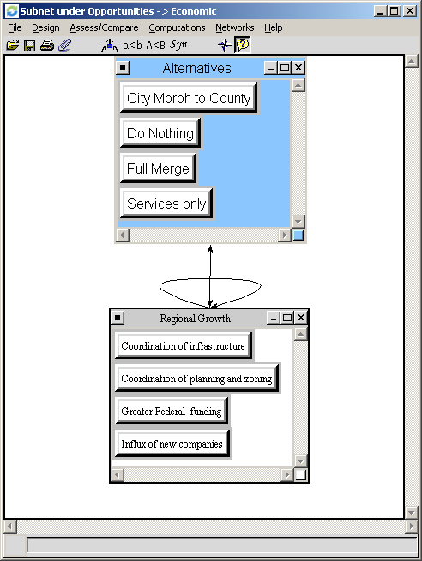
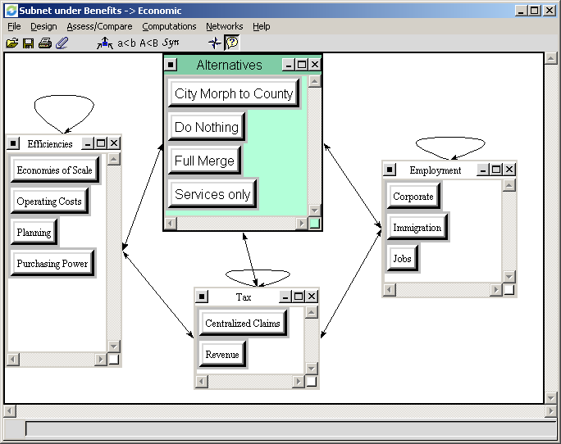

Results.

Overall, the fully synthesized model supports a full merge of Allegheny County and the City of Pittsburgh. All four control criteria: Benefits, Opportunities, Costs, and Risks, rank ‘Full Merge’ highest. The rankings for the full model and each control criteria are:

Note that ‘Services Merge’ is strongly in second place – a full 10% higher than the other two alternatives. This alternative may provide many of the benefits without associated risks of a full merger – e.g. the political and social risks the model values. Merging services may give region leaders wins without corresponding costs or risks.

When the second level rankings are examined (the controlling criteria of Benefits, Opportunities, Costs, and Risks), rankings remain consistent with the overall rankings: A full merge of city and county governments is the highest ranked alternative in all four controlling criteria.

Overall priorities for each of the subnets (Benefits, Opportunities, Costs, and Risks) are listed below.

Switching the formula to additive negative provided the following results. The rankings are best seen in a bar format since thee of the alternatives produce negative values.

Synthesis using the additive formula still supports Full Merger. Services only remains in second place. However, Do Nothing and City Morph to County switch positions. Do Nothing is ranked third and City Morph to County is fourth.

Sensitivity Analysis.

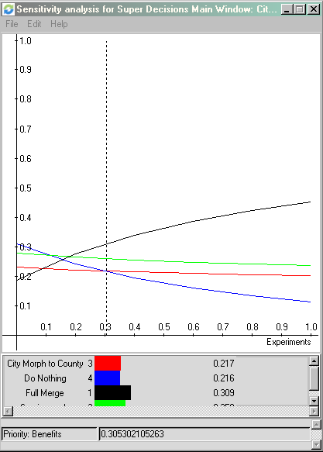

Alternative relative outcomes are stable with a priority for benefits above .305. However, the priority values become more extreme for Full Merger and Do Nothing.
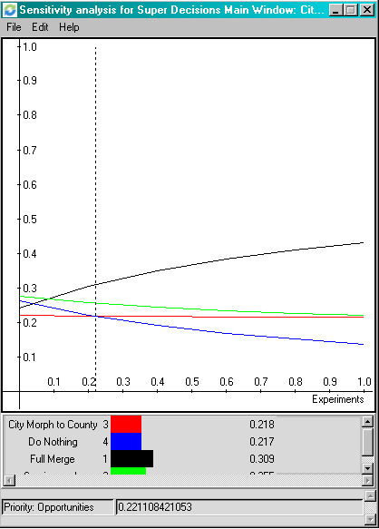

Opportunity sensitivity analysis shows stable relative alternative results when weighted above at least .221. Again, the Full Merger and Do Nothing priorities become more extreme. Interestingly, the City Morph to County and Services only almost converge.
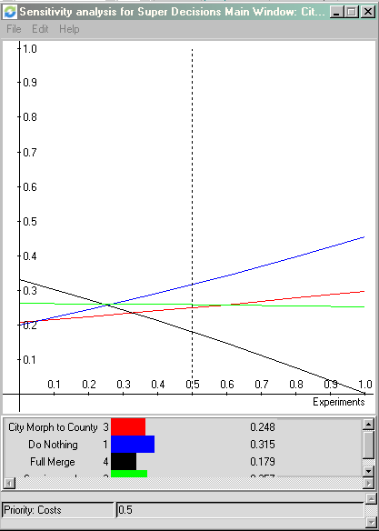

The outcome of the alternatives changes dramatically when as costs are weighed more heavily. Support for the Full Merger approaches zero and Do Nothing goes to first position. However, support for City Morph to County actually approaches second place and support for Services Only ends up in third place.
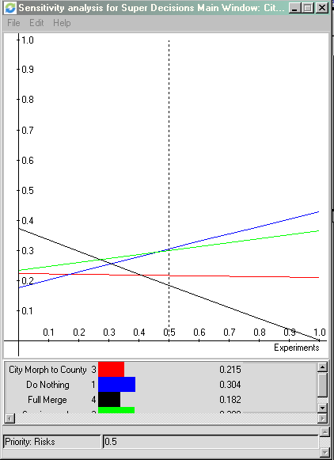

If risks are weighed heavily, the results nearly reverse. However, the relative outcome for merging Services Only remain in second place lending credence to the conclusion that if Allegheny County is very risk averse, then they should only merge services or do nothing at all.

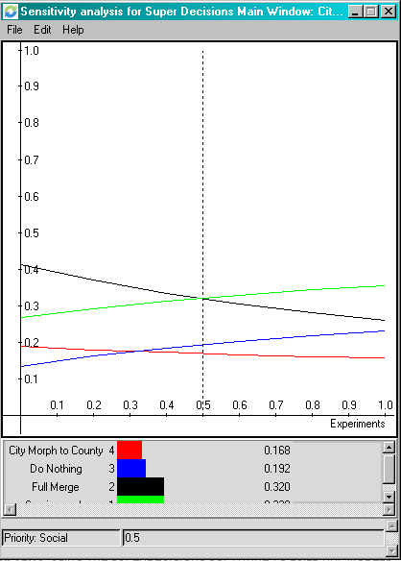

The following sensitivity to Social Benefits was uncovered. As the social benefits criteria are weighed more heavily, changes to the alterative ranking are as follows. First, the alternatives Do Nothing and City Morph to County switch for 3rd and 4th place. And Services Only leaps to the top as the best alternative in place of Full Merger.

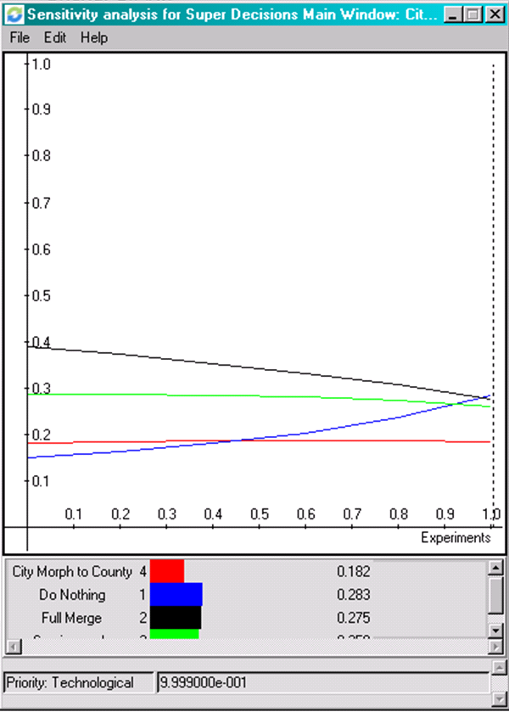

There is only one occurrence in the sensitivity analysis in which one of the alternatives actually leaps from the least desirable to the most desirable as one of the factors is weighed more heavily. It is when Technological Risks are weighted to the absolute extreme. Theoretically, this condition represents a total technical disaster making the merger impossible to execute.

Conclusions.

The model provides a realistic and meaningful perspective of the City-County merger issue in Allegheny County. It supports an alternative that is best for the region, but also demonstrates sensitivity that reflects the actual political climate in which the issue is being debated.

According to a full synthesis of the model, the best alternative is to proceed with the Full Merger. This result is in line with our expectations because of the tremendous economic and political benefits realized with a full merger. Allegheny County would become more nationally competitive and have substantially more political influence by becoming the seventh largest city in the United States. For these reasons, it is an intuitively pleasing outcome and we believe best for the region.

However, we do not believe this result is how Allegheny County will actually proceed in the short-run given the current political climate. Because of the significantly political and social risks, there will be little support for a full merger. The citizens of Allegheny County and the City of Pittsburgh will not want to relinquish local control vis-à-vis the municipality-level governing body and leadership.

The AHP model demonstrates this very accurately when performing the sensitivity analysis. For example, when conducting a sensitivity analysis on the “costs” priority, Full Merger drops dramatically, relative to the other three alternatives, as experiments increase. This “nose-dive” represents the will of the people.

The full merger remains as a theoretically best alternative. But, the model also reflects the reality based on intuition on what is likely to happen and the current actions local governments are already taking to merge some services. It is likely that the current initiative to merge services will continue with City-County merger possibly being considered in the more distant future. Meanwhile, the full merger will remain a best alternative, but remain only theoretical.

It is important to note that Services Only remains stable throughout the sensitivity analysis. Furthermore, in our first synthesis, it came in second position and was more than 10% higher than the third and fourth alternatives. Within the community at large, there is little resistance politically or socially from merging services - and the synthesis and sensitivity analysis support this. If only services are merged, the citizenry of Allegheny County will support the increased efficiencies while continuing to enjoy local political power and maintaining their community identities. Merging services does not socially affects citizens.

Given the realities of the situation, it makes most sense to merge services. This alternative shows the most stability of the two highest ranking priorities (Full Merge and Merge Services) during sensitivity, was ranked second in the synthesis and has a 10% + lead over the 3rd and 4th alternatives. The ‘Services Only” alternative also intuitively matches what is happening in reality, does not have the social and political risks of a full merge, and will likely not be resisted by the people like a full merge (according to sensitivity test and what we know about humans in reality). The “Services Only” also makes sense to us personally.

* * * *

AHP Model Description

AHP Graphical Model

Strategic Criteria:

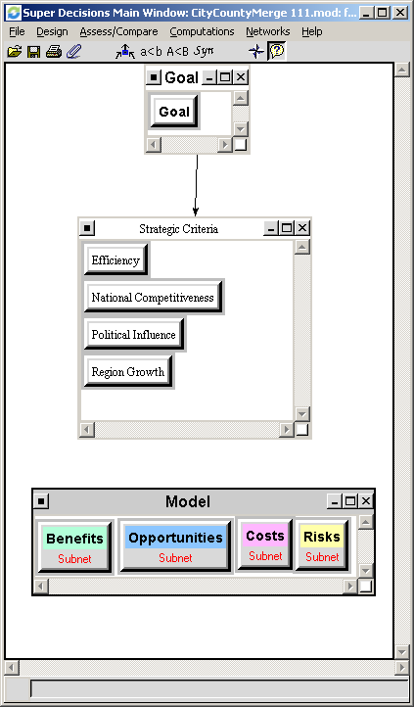

Benefits subnet:

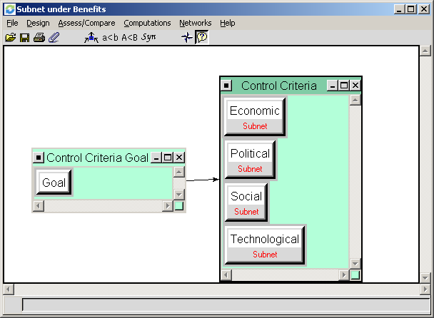

Economic Subnet:

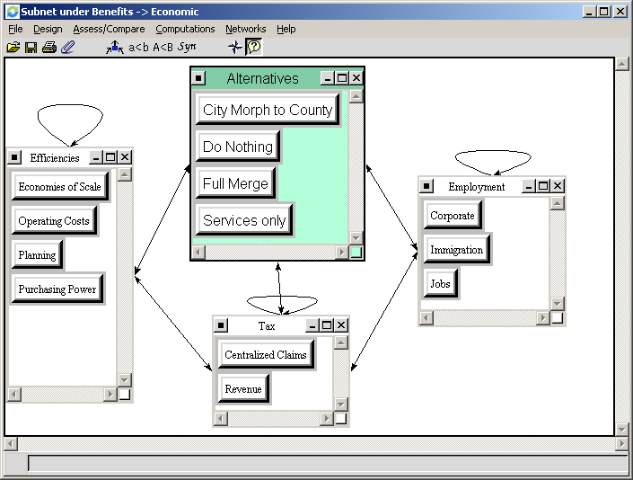

Political Subnet:

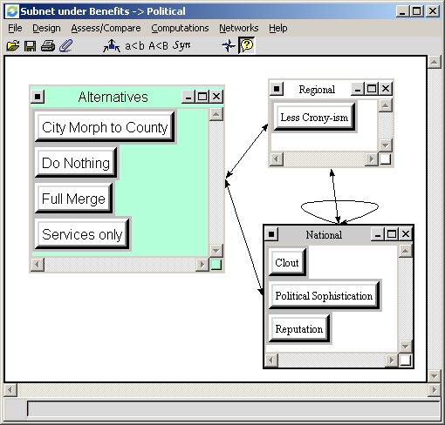

Social Subnet:

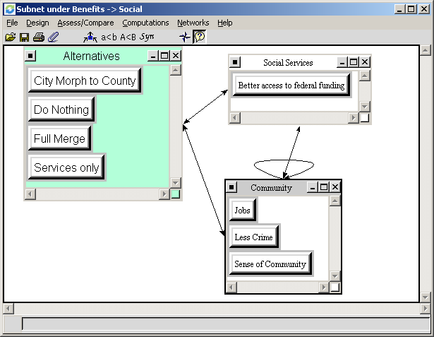

Technological Subnet:

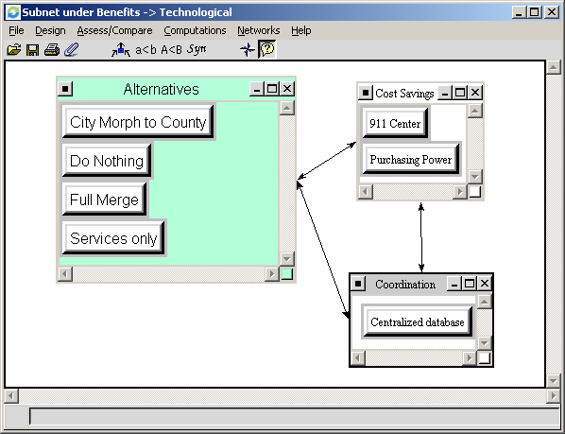

Opportunities Subnet:

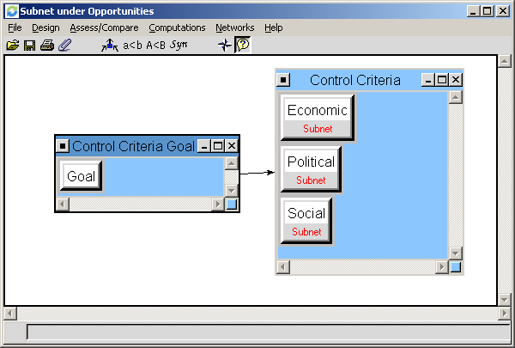

Economic Subnet:

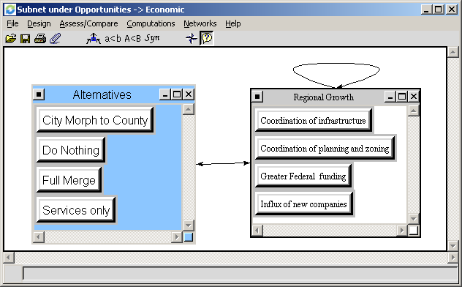

Political Subnet:

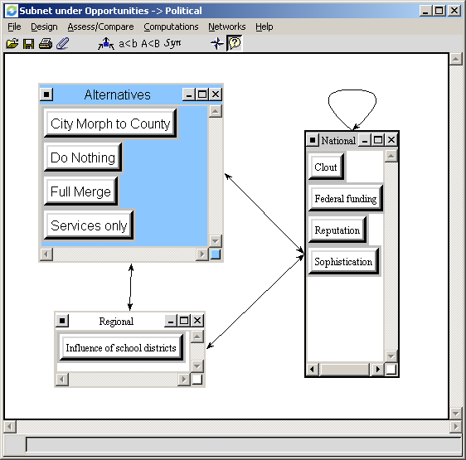

Social Subnet:

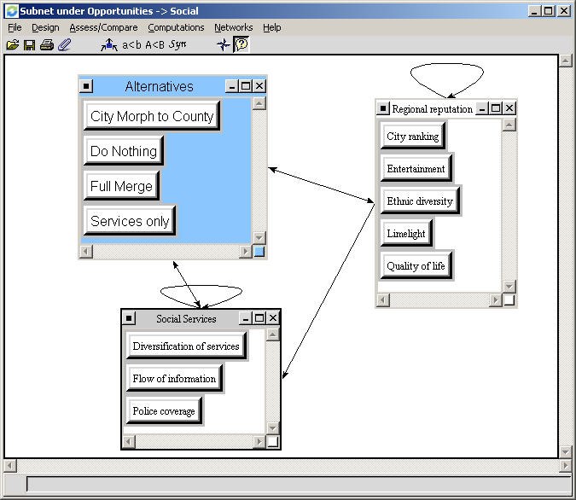

Costs Subnet:

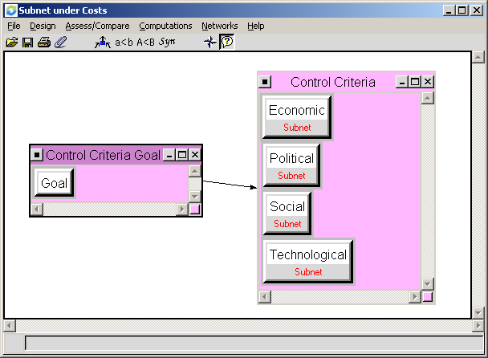

Economic Subnet:

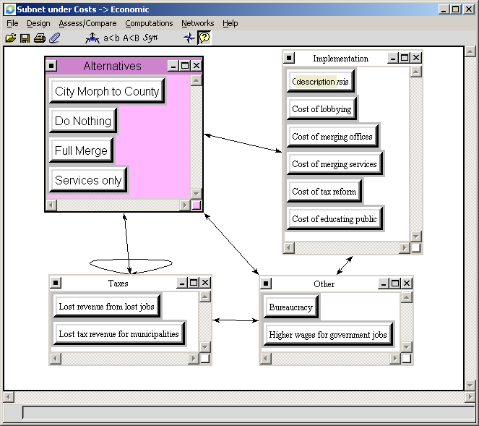

Political Subnet:

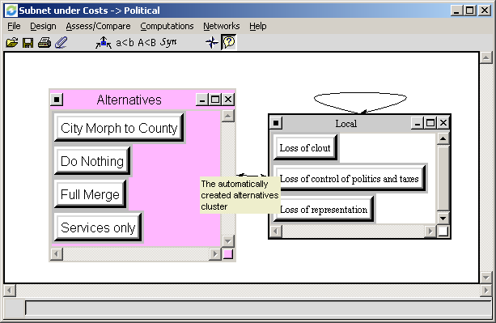

Social Subnet:

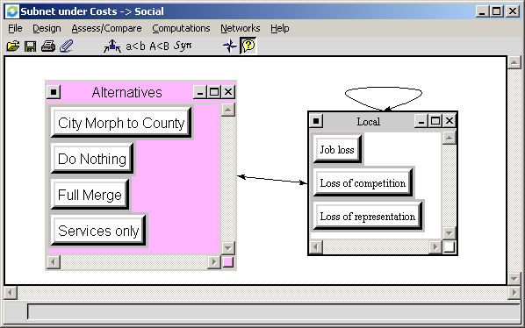

Technological Subnet:

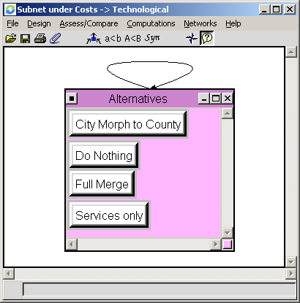

Risks Subnet:

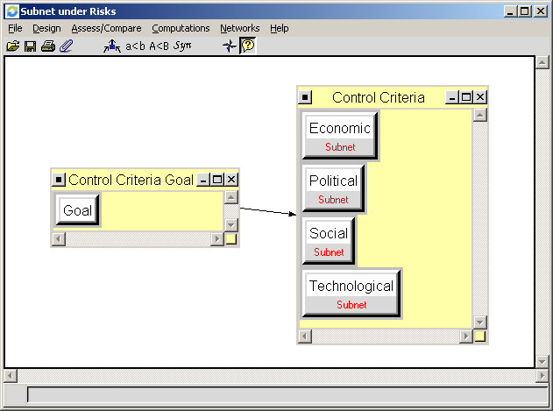

Economic Subnet:

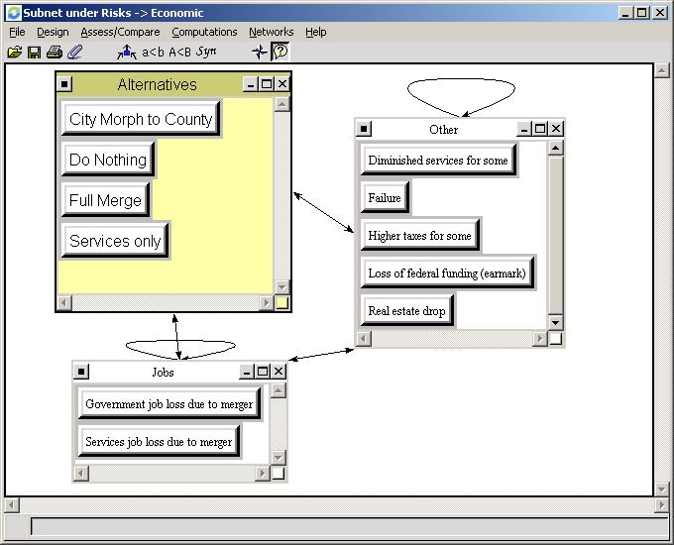

Political Subnet:

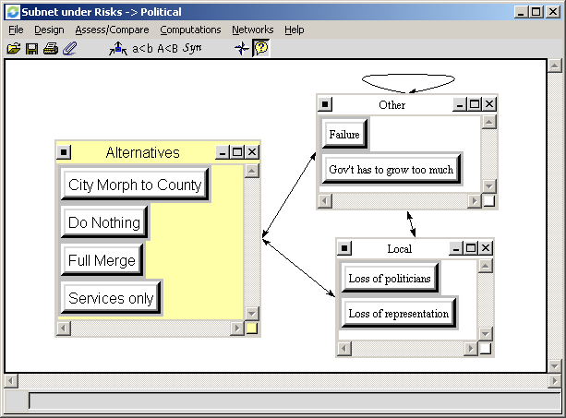

Social Subnet:

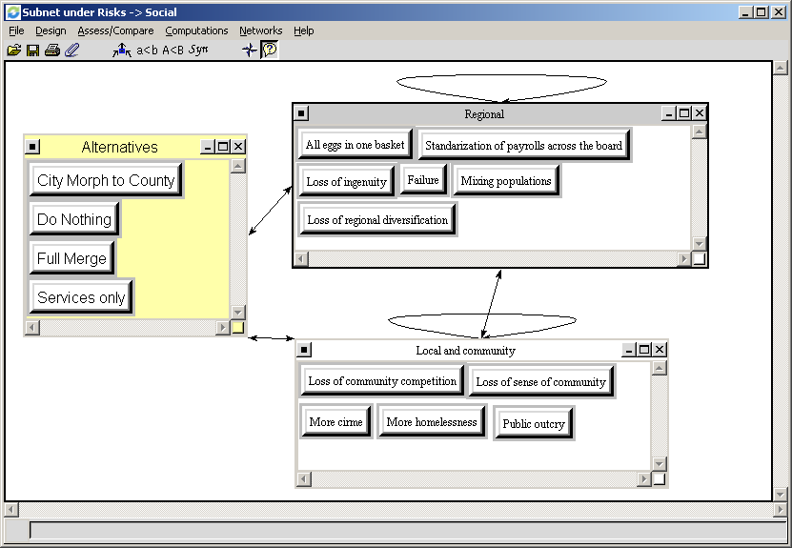

Technological Subnet:

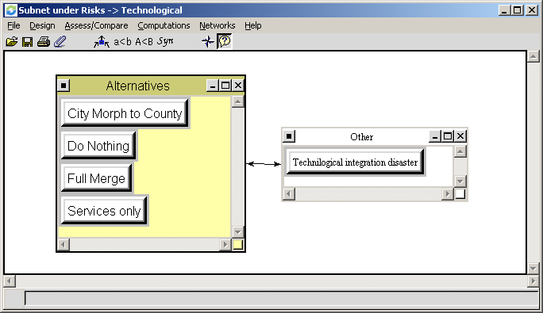

* * * * *

BENEFITS

ECONOMIC (.311) | Criteria | Local  Priority | Global  Priority
Efficiencies | Economies of scale | 0.148 | 0.015
 | Operating costs | 0.336 | 0.034
 | Planning | 0.225 | 0.023
 | Purchasing power | 0.291 | 0.029
Taxes | Revenue | 0.840 | 0.084
 | Centralized claims | 0.160 | 0.016
Employment | Corporate | 0.193 | 0.019
 | Immigration | 0.089 | 0.009
 | Jobs | 0.717 | 0.072
POLITICAL (.439)
National | Clout | 0.319 | 0.045
 | Political Sophistication | 0.174 | 0.025
 | Reputation | 0.242 | 0.034
Regional | Less favoritism | 0.265 | 0.038
SOCIAL (.146)
Community | Jobs | 0.220 | 0.010
 | Less Crime | 0.326 | 0.015
 | Sense of Community | 0.223 | 0.011
Social Services | Access to federal funding | 0.231 | 0.011
TECHNOLOGY (.104)
Cost Savings | 911 Center | 0.964 | 0.032
 | Purchasing Power | 0.035 | 0.001
Coordination | Central database | 1.0 | 0.034

OPPORTUNITIES (.199)

ECONOMIC (.594) | Criteria | Local  Priority | Global  Priority
Regional Growth | Coordination of infrastructure | 0.207 | 0.024
 | Coordination of planning and zoning | 0.188 | 0.022
 | Federal funding | 0.329 | 0.038
 | Corporate appeal | 0.275 | 0.032
POLITICAL (.249)
Regional | Influence on school districts | 0.227 | 0.011
National | Clout | 0.275 | 0.014
 | Federal funding | 0.224 | 0.011
 | Reputation | 0.101 | 0.005
 | Sophistication | 0.173 | 0.009
SOCIAL (.157)
Reputation | City ranking | 0.259 | 0.008
 | Entertainment | 0.150 | 0.005
 | Ethnic diversity | 0.148 | 0.005
 | Limelight | 0.185 | 0.006
 | Quality of life | 0.259 | 0.008
Social Services | Diversification of services | 0.447 | 0.014
 | Flow of Information | 0.103 | 0.003
 | Police Coverage | 0.450 | 0.014

COSTS (.192)

ECONOMIC (.276) | Criteria | Local  Priority | Global  Priority
Implementation | Analysis | 0.168 | 0.009
 | Lobbying | 0.177 | 0.009
 | Merging offices | 0.148 | 0.008
 | Merging services | 0.147 | 0.008
 | Tax reform | 0.149 | 0.008
 | Educating public | 0.211 | 0.011
Taxes | Revenue lost from jobs | 0.539 | 0.029
 | Revenue lost for municipalities | 0.461 | 0.024
Other | Bureaucracy | 0.526 | 0.028
 | Higher wage government jobs | 0.474 | 0.025
POLITICAL (.483)
Local | Lost clout | 0.329 | 0.031
 | Lost control politics and taxes | 0.318 | 0.029
 | Loss of representation | 0.353 | 0.033
SOCIAL (.141)
Community | Jobs loss | 0.409 | 0.011
 | Loss of competition | 0.221 | 0.006
 | Loss of representation | 0.371 | 0.010
TECHNOLOGY
(.101)

RISKS (.286)

ECONOMIC (.276) | Criteria | Local  Priority | Global  Priority
Jobs | Government job loss | 0.609 | 0.048
 | Services job loss | 0.391 | 0.031
Other | Diminished services for some | 0.087 | 0.007
 | Failure | 0.306 | 0.024
 | Higher taxes for some | 0.062 | 0.005
 | Loss of federal funding (earmark) | 0.505 | 0.040
 | Real estate drop | 0.039 | 0.003
POLITICAL
(.483)
Local | Loss of politicians | 0.312 | 0.043
 | Loss of representation | 0.688 | 0.095
Other | Failure | 0.711 | 0.098
 | Government has to grow too much | 0.289 | 0.040
SOCIAL (.141)
Regional | All eggs in one basket | 0.184 | 0.007
 | Failure | 0.079 | 0.003
 | Loss of ingenuity | 0.106 | 0.004
 | Loss of regional diversification | 0.104 | 0.004
 | Mixing populations | 0.483 | 0.019
 | Standardizations of payrolls across government jobs | 0.044 | 0.002
Community | Loss of community competition | 0.203 | 0.008
 | Loss of sense of community | 0.253 | 0.010
 | More crime | 0.236 | 0.010
 | More homelessness | 0.177 | 0.007
 | Public outcry | 0.131 | 0.005
TECHNOLOGY (.101)
 | Integration Failure | 0.500 | 0.014

