April 24, 2012
Drug Offenses – Jail or Alternative Punishment?
BQOM 2521 - Spring 2012
Chris Drummond and Kevin Rohner

Abstract
This project looks at two alternatives for dealing with non-violent drug offenses in the United States; jail based punishment or alternative punishments. The US currently jails many individuals for non-violent drug offenses; this has a large price in terms of financial costs to taxpayers, loss of freedom to prisoners, associated emotional and family losses to relatives, and overall societal losses. There are alternative punishments for non-violent drug offenders which could more effectively rehabilitate drug offenders that could be utilized in lieu of incarceration. This paper looks at the benefits, opportunities, costs, and risks of using jail or alternative punishment for non-violent drug offenses, and criteria that influence the decision in order to discover a preferred method. The results of this modeling is that it would be preferable for society to use alternative punishment rather than incarceration to address these offenses.
Introduction
Background
Changes in attitude, technology, education, and finance have slowly eroded the stance that prison cells are the best place for all convicted criminals. The Unites States has the highest incarceration rate in the world, currently around 0.7% of the adult US population is in either a federal or state prison, or a county jail. Additionally, around 2.4% of the adult US population is under some other form of correctional supervision. This is a total of around 3.1% of the US population. Since 1980 the prison population has quadrupled, and as of 2000, it was estimated that 22% of prisoners were non-violent drug offenders. As a result of these numbers, the U.S. has recently been facing a large challenge in figuring out a way to deal with the overcrowding of prisons. This, coupled with a huge increase in the cost to house an inmate (which can run from $25,000 to $45,000 per year), has led to more people thinking that alternative means of punishment other than prison should be considered. Using incarceration as a form of punishment or rehabilitation is a very costly option to society as a whole; in addition to the costs of housing prisoners, there is also the lost production that incarcerated individuals could otherwise provide. Alternative sentencing is slowly making its way into many local jurisdictions as a way of dealing with low level, non-violent crimes. One of the areas where alternative sentencing and rehabilitation may be preferable to imprisonment is in drug offenses. Though the media is full of stories about violence caused by drugs, both here and abroad; take for example the drug wars in Mexico, the majority of drug related offenses are not violent. Furthermore, using incarceration as a means of punishment or rehabilitation has not been as effective as other methods for non-violent drug offenders.
Alternative punishment is aimed at trying to help people get out of the life they are currently in and give them the tools to be successful without the use of drugs and alcohol that may have gotten them into the legal system. Part of the alternative punishment is education and part of it is tooling. Alternative punishment could look like counseling, community service, job training, job placement, etc. These rehabilitation methods can often be delivered at a lower cost than prison, and can be more effective in changing behavior of offenders. In addition, these methods can allow the offenders to remain productive members of society as opposed to becoming reliant on the state for everything. Such methods however have some resistance, as politicians are often reluctant to be “soft on crime” and may not wish to rewrite laws to send offenders from prison to less harsh but perhaps more effective alternative punishments.

The Decision
This analysis will focus on deciding if alternative punishment is a reasonable and preferred alternative to continuing to jail people for non-violent drug offenses. Our null hypothesis will be to continue to jail offenders and our alternative hypothesis will be to utilize alternative punishments for non-violent drug offenses.
Methodology
Using the Super Decision software, we setup our BOCR model for our analysis. The top level of our model shows the strategic criteria we’ve chosen for this decision, as well as the Benefits, Opportunities, Costs, and Risks (BOCR) subnets, and is shown below:
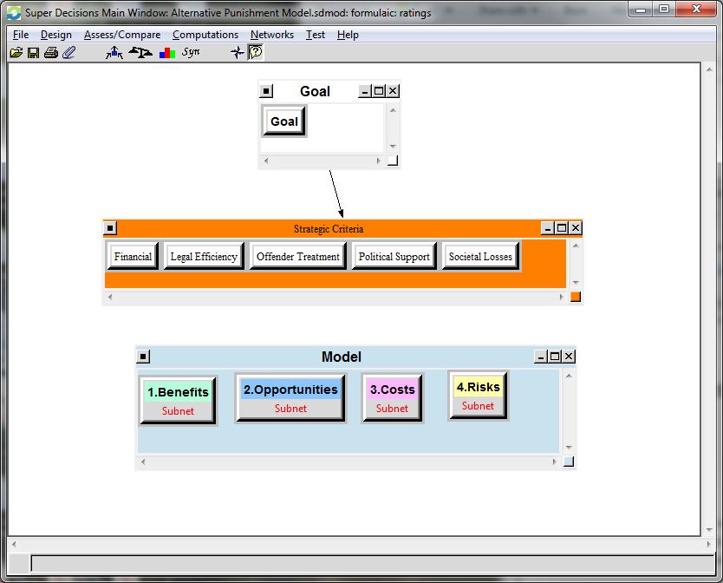
Strategic Criteria
The model includes 5 strategic criteria we’ve chosen to help make this decision, using the BOCR subnet models. The strategic criteria are described below:
- Financial – The costs of jail or alternative methods of dealing with drug offenders.
- Legal Efficiency – The efficiency of the legal system in meting out incarceration or alternative punishment. This includes the amount of time and effort that could be transferred to other legal problems.
- Offender Treatment – The effectiveness of jailing or alternative punishment for changing behavior in offenders.
- Political Support – The amount of support from politicians for jailing or pursuing alternative methods.
- Societal Losses – The losses that society incurs, not just in the cost of administering incarceration or alternative methods, but the foregone productivity and participation in society by offenders under each possibility.
These criteria were then evaluated using a pairwise comparison with respect to picking a goal, whether jailing or alternative punishments were more effective, as shown below:
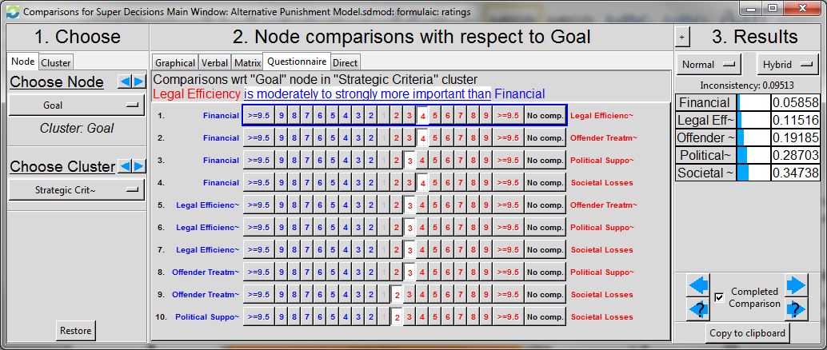
BOCR Model Criteria
Our BOCR model was then created with a 4 subnets, or separate decision model, for Benefits, Opportunities, Costs, and Risks. These subnets were created using several control criteria and sub-criteria. This allowed each of these four models to produce discrete decision weights, which were then used by the overall model to derive final decision weighting. An outline of the model as well as descriptions of each node is found below:
- Benefits
  - Economic
    - Decrease Jail Holding Costs – Decreasing the financial outlay of the U.S. for prison costs as a result of housing fewer prisoners. Also, there is less pressure to build additional prison capacity.
    - Lower Prosecution Costs – Prosecution costs for cases involving incarceration are higher than costs for cases with alternative resolutions. In addition, in cases where a public defender is used, the government must pay for defense counsel as well, and there are generally higher costs for cases involving incarceration.
    - Ability to Outsource Counseling – Ability to take counseling and training off the hands of the U.S. government and outsource it to specialists, which can result in cost savings.
    - More Productive Tax Spending – Ability to spend more prison resources on more violent offenders, and on alternative punishments which are generally more effective for less violent drug offenders.
  - Political
    - Fewer Addictions – More effective punishment / rehabilitation should lower the rate of drug addictions, and the number of drug offenses.
    - Lower Incarceration Rate – Alternative punishments and fewer drug offenses can lower the incarceration rate.
    - Tough on Crime Perception – Harsher punishment can enhance a candidate’s reputation for being tough on crime.
  - Societal
    - More Focused Treatments – More focused treatment of individuals that will hopefully lead to better success.
    - Improved Quality of Life – Allow drug offenders to deal with addictions, and not be incarcerated, both of which will achieve higher quality of life for them, their families, and society in general.
    - Increase in Social Responsibility – Treat drug addictions with effective methods that encourage offenders to become more socially responsible rather than simply incarcerating and not treating addictions.
    - Creation of New Jobs – Create new jobs in the offender treatment markets, as well as having more individuals as participating members of society, requiring and providing goods and services that create jobs.

- Opportunities
  - Economic
    - Decrease Long Term Costs – Decreasing the future financial burden of the U.S. for prison costs due to less inmates.
    - Free Up Jail Cells – Jail cells can be freed up for more violent offenders instead of outsourcing jailing to private jailing companies.
    - Outsource Infrastructure – Ability to take counseling and training off the hands of the U.S. government and outsource it to specialists.
    - Decrease Court Costs – Ability to decrease the amount of court time taken to prosecute lower level offenses.
  - Political
    - Create Difference in Election Year – Create an exciting change that will help differentiate a candidate in the November 2012 elections.
    - Help Political Party – Ability to use this change to help promote that candidate’s party.
    - Create Political Change in Congress – Allow for change in mindset of thinking in Washington D.C. that might lend itself to alternative ways of thinking in other areas of Congress.
  - Societal
    - Job Creation – Create new jobs in the offender treatment markets.
    - Better Treatment – More focused treatment of individuals that will hopefully lead to better success.
    - Change of view on drugs – Begin to change the view on drugs in the U.S. which might help mature the stance on drug use and hence create a more educated public which will decrease usage.
    - Better conviction rate on larger crimes – Will allow prosecutors to spend more time on more violent offenses to get more convictions where more needed.

- Costs
  - Economic
    - Costs of Regulation – The costs of creating regulations for and administrating both incarceration and alternative punishment.
    - Costs of Program Creation – The costs of creating new, more focused alternative punishment methods for drug offenses.
    - Repeat Offenders – The escalating costs of dealing with repeat offenders, for both incarceration and alternative punishment.
  - Political
    - Political “Suicide” – The costs for politicians, which could result in them being voted out because of a perception that they’re “soft on crime” by legislating alternative punishment, or taking an unpopular stand in their communities for a less harsh stand on drug offense punishment.
    - Congressional Time – The time that congress researches, debates, and implements laws to address this issue.
    - Opportunity Cost of Creation – The issues that government does not address while it is addressing the creation of new alternative punishments for drug offenses.
  - Societal
    - Ineffective Treatment – Incarceration alone without targeting addiction is ineffective at treating drug addictions. Also, some violent individuals may receive a lighter punishment if they are given alternative punishment in lieu of jail time.
    - Possible Injustice – More offenses that result in incarceration increase the amount of wrongful convictions of innocent people.
    - Increase Drug Use – Incarceration without targeting addiction may increase drug use, as drug offenders have a lower likelihood of rehabilitation after jail and may be more likely to abuse drugs.
    - Decreased Government Jobs – Fewer prisoners to house and deal with can reduce the correctional workforce.

- Risks
  - Economic
    - Increase Cost for Repeat Offenders – With little trials in this area, there could be more repeat offenders which could lead to more costs to put them through the system again.
    - Uncertainty of Long Term Costs – With little trials, there is some risk to the long term cost of this program and outsourcing some or all of it.
  - Political
    - Unfavorable to Majority Voters – Majority of voters may not agree with this point of view and hence could hurt re-election chances.
    - Utilize Larger Amounts of Congressional Time – This will take a lot of time to get through Congress.
    - Bad Timing in Election Year – With politicians focusing on re-elections, poor policy could get put in place and/or may not be possible due to lack of willingness to change before an election.
  - Societal
    - Incorrect Policy – Creating an ineffective policy.
    - Increased New Offenders – Increase in new offenders due to what is perceived to be more lenient punishments.
    - Increased Repeat Offenders - Increase in repeat offenders due to what is perceived to be more lenient punishments.
    - Ineffective Treatments – Linked with Incorrect policy and lack of trials, treatments may not be effective.
The subnet models look similar to the overall model, as an example, here is a screenshot of the Benefits submodel:
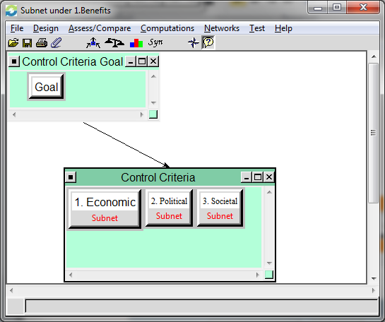
The Benefits, Economic subnet model is shown below:
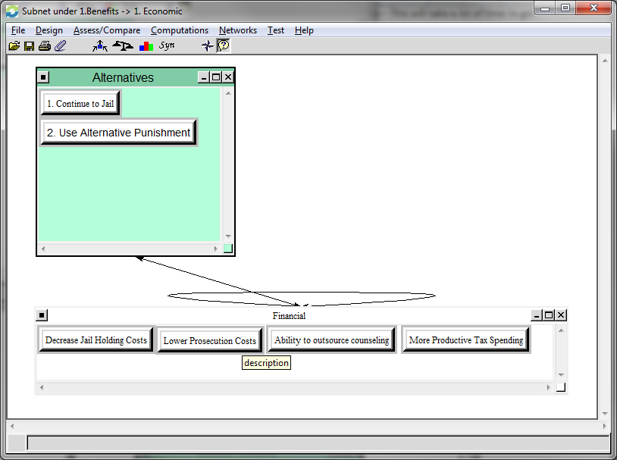
The above two screenshots show the nested models for Benefits, Economic control criteria. Similar models were developed for all of the BOCR control criteria.
Establishing Strategic Criteria against BOCR
After the BOCR subnet models were created and the strategic criteria comparisons were done, priorities had to be assigned for the BOCR models against the strategic criteria. A rating scale was created for the BOCR models and applied to the strategic criteria, each was judged to be one of the following: Very High, High, Medium, Low, or Very Low. The ratings table below shows the results of this step:
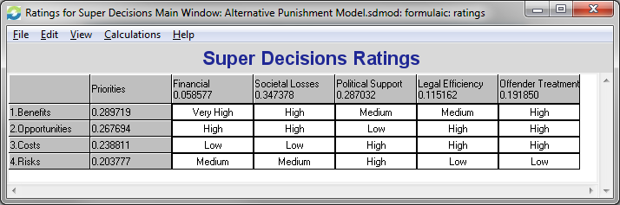
BOCR Subnet Results
After the model was created each subnetwork model is synthesized, and then these results are incorporated into the full model to develop the synthesized priorities for the overall model. The synthesized results for each BOCR subnet model are shown below:
Benefits Synthesized Priorities: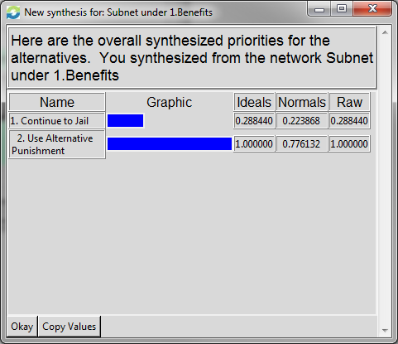
Opportunities Synthesized Priorities: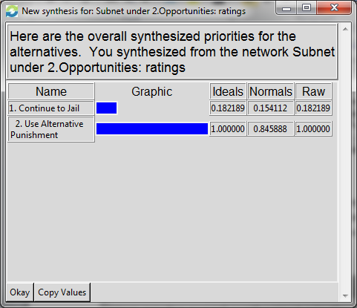
Costs Synthesized Priorities :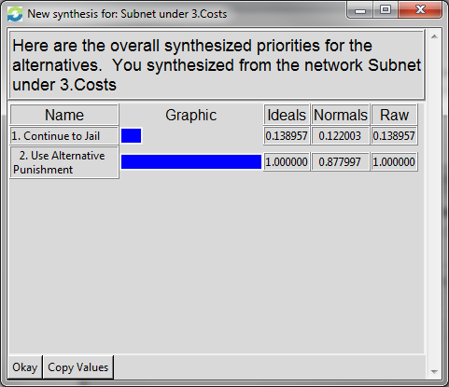
Risks Synthesized Priorities: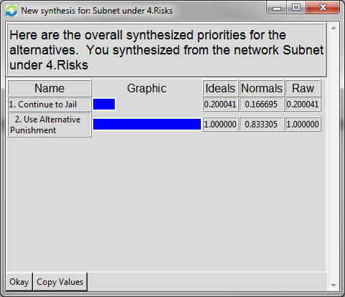
Full Model Results
After each of the BOCR synthesized priorities have been found, these numbers are used by the full model to find the overall priorities for the alternatives, and is shown below: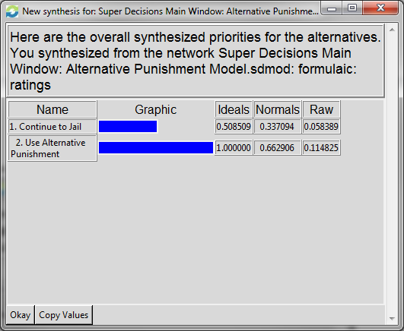
The full model synthesis shows that the best alternative for dealing with drug offenses in the US is to utilize alternative punishment in lieu of jailing as a means of punishment / rehabilitation. According to the model, it is nearly twice as preferred as jailing.
Analysis
An analysis of the model results indicates that the model is relatively consistent. For all four of the BOCR subnets, as well as the overall model, alternative punishment has the highest priority. The priorities for each subnet and the overall model are summarized in the table below:
 | Benefits | Opportunities | Costs | Risks | Overall
Jail | 22.4% | 15.4% | 12.2% | 16.7% | 33.7%
Alternative Punishment | 77.6% | 84.6% | 87.8% | 83.3% | 66.3%

Sensitivity with respect to Benefits: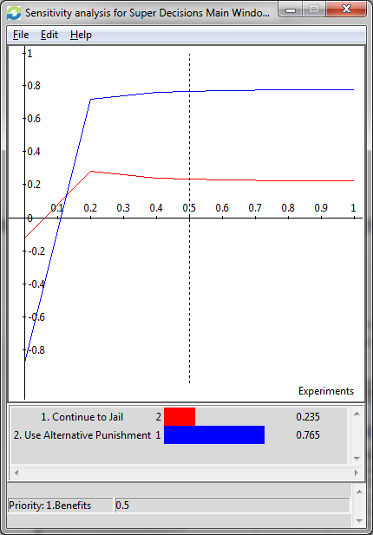
Sensitivity with respect to Opportunities: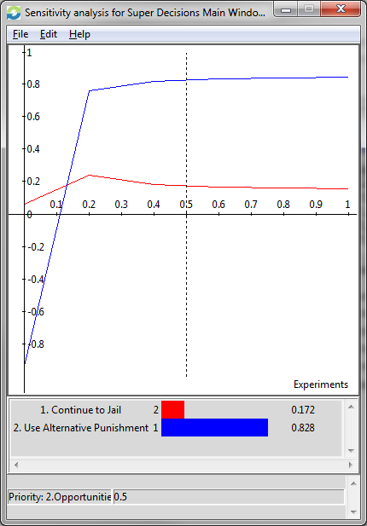
Sensitivity with respect to Costs: 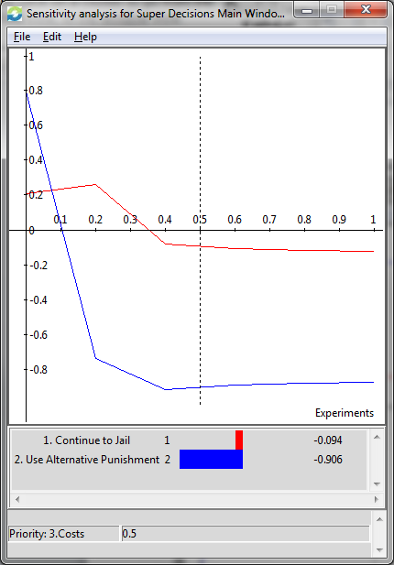
Sensitivity with respect to Risks: 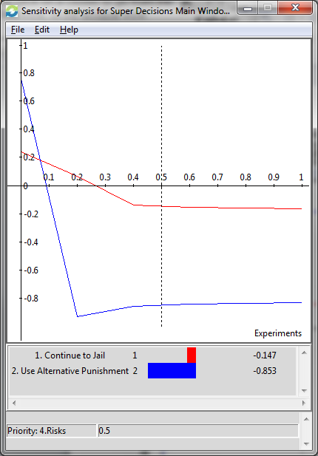
It is interesting that the jail option was ranked higher in the overall model than in any of the individual models, even though alternative punishment still had a priority that was twice as high as jail in the overall model. This was the most interesting outcome from the analysis and deserves further discussion. The ratings table for the strategic criteria shows how important each of the BOCR categories are relative to each other, as well as how important the strategic criteria are in the overall analysis. It is shown again below:
As can be seen in the table, the 2nd highest priority strategic criterion is political support. The single largest criterion that jail fares better than alternative punishment in is political support. This is also one of the most important criterion in the overall scenario, as any action to change from a jail based drug offense strategy to an alternative punishment / rehabilitation strategy will require significant political support. Because the level of importance of political support is not incorporated into the subnet models, but only at the whole model level, this effect does not appear in any of the subnet priorities, and only appears in the overall model synthesis.
Conclusion
The model shows that the best decision is to pursue alternative punishment / rehabilitation for non-violent drug offenders rather than incarceration. This conclusion makes sense, as this would help treat the source of the problem rather than simply impose a punishment on the offenders. In addition, this model shows that there are higher costs involved in jailing non-violent drug offenders than in rehabilitating them, both from a taxpayer cost outlay point of view as well as from a societal loss of production viewpoint. The model suggests that political support for such a course of action is the biggest hurdle to pursuing this though. The unwillingness of politicians to appear “soft on crime” or to suggest a less harsh response to drug offenses seems to be the driving factor in the national policy still favoring jail time over alternative punishments.
Future Research
This project has shown that in general, alternative punishments would be preferable to jail time for drug offenses. However, the project was very broadly defined in terms of non-violent drug offenses and alternative punishments. For further research, it would be interesting to further break down both the drug offenses and alternative punishments into different categories. Non-violent drug offenses could be sorted according to the five schedules of narcotics described in the Controlled Substances Act, by prescription vs. non-prescription drugs, and/or by drug usage or distribution. Alternative punishments could be sorted into counseling, halfway houses, probation, etc. This would help to determine which alternative punishments would be best suited to which types of drug offenses.

