Should the United States Continue the War on Drugs?

University of Pittsburgh
Joseph M. Katz Graduate School of Business

Anees Udyawar (anu8@pitt.edu)
Evgeny Kostromskoy (evk13@pitt.edu)

April 26, 2016



Table of Contents

Abstract………………………………………………………………………………………........ 3

Introduction……………………………………………………………………………………...... 3

Methodology…................................................................................................................................ 6

Model Setup and Data………......................................................................................................... 8

Analysis…….................................................................................................................................. 18

Sensitivity Analysis.………………………................................................................................ 19

Summary and Conclusion………………………………………………………………………. 21

Bibliography…………………………………………………………………………………….. 22

Abstract

For this project, we investigated in what manner should the Unites States tackle the illicit drug epidemic (marijuana, cocaine, heroin, etc.…) in this country. The alternatives that we put forth were: Continue the War on Drugs, Terminate the War on Drugs, or Legalize the Drugs. Initially, we hypothesized that continuing the War on Drugs would be the most prudent choice to fight this problem. However, through the use of the analytical network process (ANP), this particular alternative was not the best choice once we setup and ran the BOCR (benefits, opportunities, costs, and risks) model to investigate the other two alternatives. Our control criteria were economic, social, and political impacts, and our strategic criteria were crime level, graduation rates, lifestyles, employment prospective, and peaceful communities. Our BOCR model and decision criteria lead to the judgment that Legalization of Drugs was the best option to resolve the drug problem in this country.

Introduction

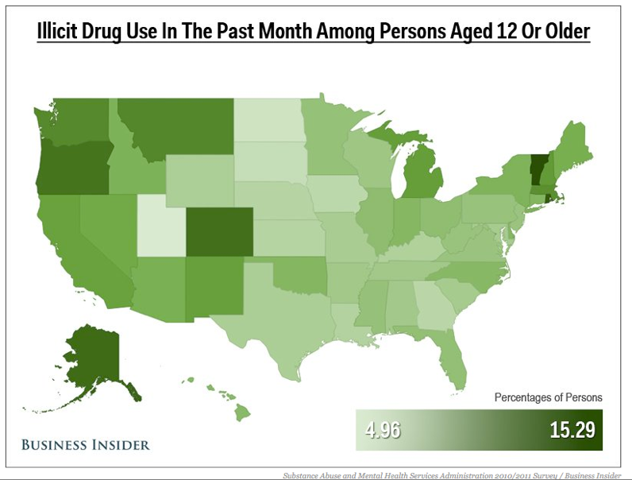
In 1971 president Nixon launched “war on drugs”. More than four decades later there is still lack of significant achievements. Annual cost estimated at over $40 billion. “War on drugs” increased the number of incarcerated Americans over the years. The cost is $25,251 per inmate person, however government spend $10,591 per student in public education in the US. In 2014, an estimated 27.0 million Americans aged 12 or older were current (past month) illicit drug users, meaning that they had used an illicit drug during the month prior to the survey interview (see Figure). “War on drugs” has boosted the prices of illicit substances, and made cartels more powerful.

Illicit Drugs can be categorized as Marijuana, Prescription Drugs, Cocaine, Hallucinogens, Heroin, and Inhalants. Marijuana is the most popular of all the illicit drugs and has increased drastically since 2007 (see figure). The use of other drugs than marijuana has stabilized over the past decade [References 1 and 2] national with the exception of Pennsylvania. Therefore, the question setup is how does America cut down on drug use, should it continue it war on drugs, terminate the drug wars, or legalize drugs.

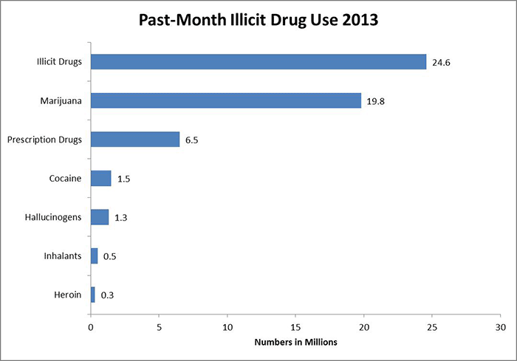
There are several countries who have shown success with legalization of drugs. Portugal decriminalized all drug use in 2001; thus, instead of jail time, drug users face fines and community service. Portugal’s drug use among adults and youth drooped every since the 2001 law. Also HIV is less common, and overdose rate is lower than every other country in the European Union. In 2009 Mexico also took a similar step by decriminalizing the possession of small amounts of heroin, cocaine, marijuana, LSD, and methamphetamine. Also, in Colombia and Peru, cocaine possession and cultivation is legal. Other countries have similar laws against certain drugs, such as in Germany and Switzerland, cocaine for medical use is permitted, as well as in U.K., Hong Kong, and Singapore. Similarly, Heroine is permitted for medical purposes in Canada, Hong Kong, Netherlands, and the U.K. [Reference 3].

However, there are other opposing arguments why Marijuana and other drugs should not be legalized. These include damage to health and increase in mental illness, endanger public safety, for instance person who is impaired cannot driving properly under the influence of drugs. Drugs will jeopardize more young people than others as they can be easily be influenced to try drugs and then get addicted. Other argument is that legalization will lead to new “Big Tobacco” where big for-profit corporation will market the drugs to younger generations to increase sales and profits and create a lifetime cliental [Reference 4].

Both the authors, Anees Udyawar and Evgeny Kostromskoy live in Pittsburgh but were raised on foreign soil, most notably in India and Russia respectively. Therefore, we bring in our unique experiences and cultural background when investigating this problem. It is our strong desire that our work herein will eventually help reduce drug problems not only in Pittsburgh, but also nationally. In a study done by University of Pittsburgh Graduate School of Public, it notes that in a 35-year period, Pennsylvania has experienced a 14-fold increase in drug overdoses. In 1979, there were 134 overdose deaths in the commonwealth, representing a rate of two per 100,000 residents. In 2014, there were 2,458, a rate of 29 per 100,000. In Pennsylvania, which has a higher rate of fatal overdoses than the national average, more men are dying as a result, but the rate among women aged 35-44 is growing the most dramatically. Among men, there are stark differences in the ages at which blacks and whites die from overdoses; the rate for white men peaked in the 25-44 age group but at 45-65 for black men [References 5 and 6]. Therefore, the goal of this project is determine which alternative (i.e. Continue War on Drugs, Terminate War on Drugs or Legalize Drugs) will provide the best solution to reduce the drug epidemic in the United States.

Methodology

Our research in the fight on drugs identified three key alternatives that were pertinent to this investigation:

- Continue the War on Drugs
- Terminate the War on Drugs
- Legalize Drugs

The above alternatives are setup to be simplistic in decision-making process in regards to how the country needs to analyze the current drug problem. Should the USA continue to spend financial, political, and human resources to continue fighting a problem that is growing each year? Or instead, should the country minimize or stop any other additional funding to fight the war on drugs, and let the country arrive at an equilibrium state, if feasible. Lastly, should we legalize drugs such as several other countries that have taken a similar route to arrive at a stable and good success. Each alternative has its own advantages and disadvantages that we will investigate in this study.

Our model considered various strategic criteria that encompasses economical, social and political factors (control criteria). The strategic criteria are as follows:

- Peaceful Communities
- Crime Level
- Graduation Rates
- Lifestyles
- Employment Prospective

In our model, we applied the analytical network process with inner and outer dependences among the clusters and nodes in the Super Decision Software Model [References 7 and 8]. We investigated the problem from the benefits, opportunities, costs and risks (BOCR) point of view. Within the sub models for Economic, Social, and Political control criteria we made pairwise judgments amongst the various nodes and clusters.

Within the economic criteria we covered various financial factors such as revenue, taxations, including impacts on large drug companies and small local farmers. We also considered the legal and financial impacts from worker lawsuits, judicial laws and governances. Also considered were resources expended for correctional facilities (i.e. jails), police, and prosecutorial systems.

With respect to the social impacts, we considered lifestyle and community factors such as education, medical benefits, addiction, and emotional stresses. Also, we investigated the impact of racial stereotyping of certain demographics (such as African-Americans and Mexicans) by the general pubic and law-enforcers. Also, we considered how drugs may cause homelessness and lead to child and domestic abuse. Also, we considered drug experimentation by youth and adolescents which lead to school dropout and increased unemployment. Also, our overall social cost was to consider how does the Unites States lead a social revolution and portray itself to the rest of the world as leaders in reducing the drug addiction and abuse problem.
We also consider the political factors on our alternatives such as foreign policies, breaking up the drug cartels, and the reputation of the country as viewed by the other nations. Also important were trade impacts by other countries due to our foreign and national policies on drugs, for instant some countries would not trade with us if we have a big drug problem within our country. Also in our model, we investigated the impacts of political scandals and bribes with drug kingpins and cartels, in this case legalization of drugs would reduce these issues. Lastly, we looked at the national perspective of how government would take care of its citizens based on the three different alternatives.

Model Setup and Data

Model Overview and Strategic Criteria

In the Super Decision software, we have setup up our model as shown below. We used economic, social, and political as our control criteria in our model. We also used these as control criteria consistently throughout the benefits, opportunities, costs, and risks.

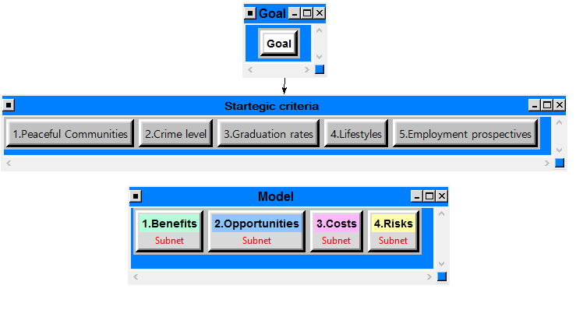
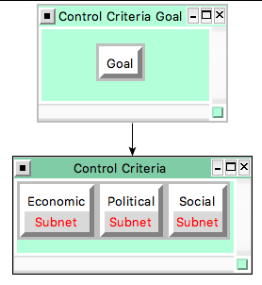
Benefits
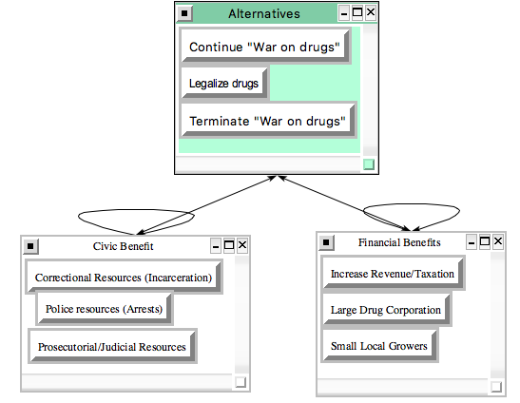
Economic Control Criterion:

The interdependencies between the three alternatives, continue war on drugs, terminate war on drugs, and legalize drugs have the following implications:

- Increase revenue/taxation
- Large Drug corporations
- Small Local Growers
- Correctional resources
- Police resources
- Prosecutorial resources

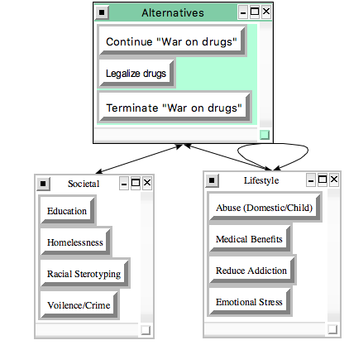
Social Control Criterion:

For the social criteria, we investigated the following factors

- Impact on Education
- Increase on Violence/Crime Rate
- Homelessness
- Racial Stereotyping for minorities
- Increase in Abuse (domestic and children)
- Any benefits of medical use
- Addiction impacts
- Changes in emotional stress

Political Control Criterion:

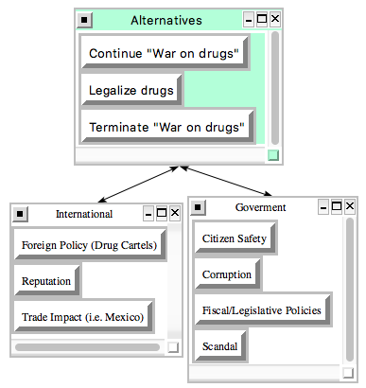
For the political implications, we investigated the following:

- Impact on Foreign policy based on interaction with drug cartels
- Reputation of the country as viewed by national and international audiences
- Trade impact due to restriction or fiscal and legislative policies
- Corruption within the government
- Public citizen safety
- Government scandal

Benefits Pairwise Comparison Results

The synthesized pairwise results for the Benefits sub model is shown below. It demonstrates that legalization of drugs has the greatest benefit, followed by continuing the war on drugs, and then terminating the drug wars.

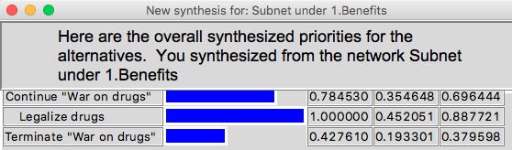
Opportunities

Economic Control Criterion:

For economic opportunities we identified main stakeholders, who might affect a decision making, and their perspectives in financial opportunities.

The stakeholders are:

- Democratic party
- Republican party
- Society (population of the US)
- State governments
- Foreign governments

Also, some stakeholders are influenced by other. Described parties have different perspectives in financial opportunities:

- Cost reduction
- Investments (in social programs)
- New businesses
- Revenue increase

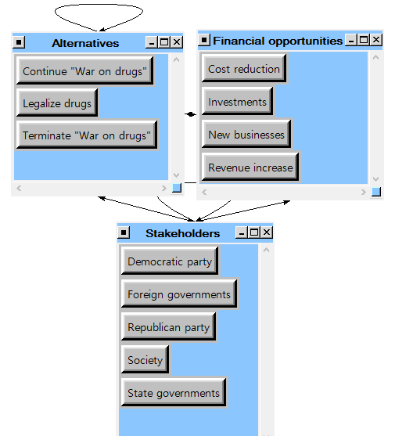

Social Control Criterion:

Social opportunities are also dependent on different stakeholder’s perspective. The social opportunities are divided into communities and societal. They are represented by following criteria:

- Less dropouts (from schools)
- Less inmates (in US jails)
- Less segregation (cultural and racial)
- Less crime
- Less police abuse
- Safer neighborhoods

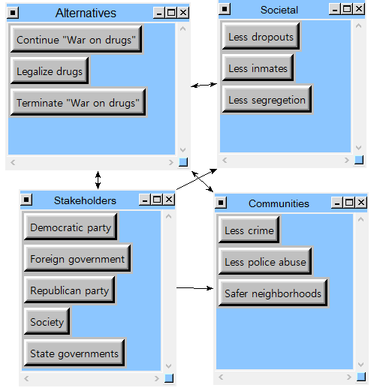

Political Control Criterion:

Political opportunities for the US government are represented by following criteria:

- Global influence (global power)
- Elections
- Political image.

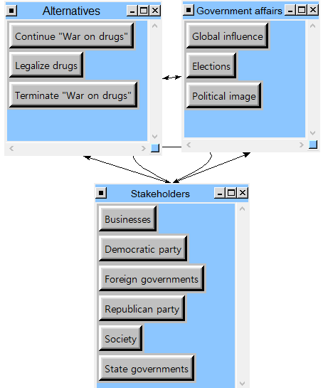

Opportunities Pairwise Comparison Results

The synthesized pairwise results for the Opportunities sub model is shown below. It demonstrates that legalization of drugs is associated with the greatest opportunities, followed equally by continuing the war on drugs, and terminating the drug wars.

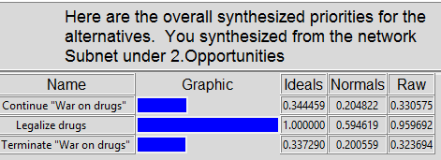

Costs

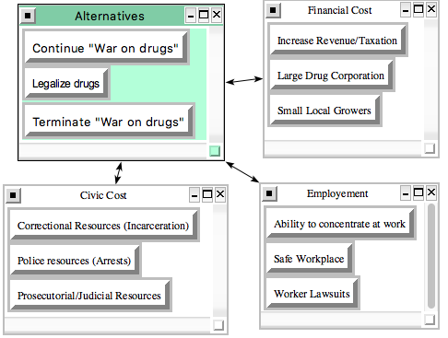
Economic Control Criterion:

The economic control criteria for the Costs sub-model are as follows:

- Can drug use affect the concentration at work
- Is the workplace safe with drugs
- Increase in worker lawsuits due to drugs
- Revenue/Taxation impacts
- Large Drug corporation versus small local growers
- Increase in jails
- Change in police resources
- Judicial system impacts

Social Control Criterion:
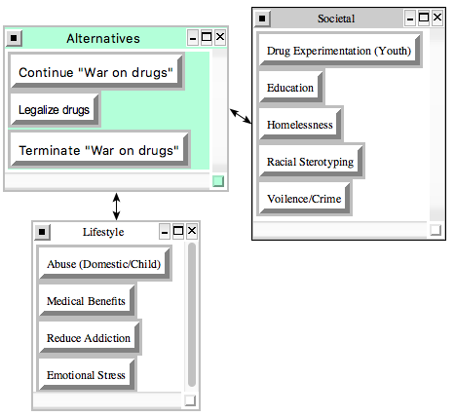

The social costs associated with this model are as follows:

- Drug experimentation by youth and adolescents in high school
- Impact on education
- Increase in homelessness
- Racial stereotyping of minority drugs
- Increase in violence crimes
- Changes in addiction
- Abuse of children and domestic partners
- Emotion stresses
- Medical benefits provided by legalization of drugs

Political Control Criterion:

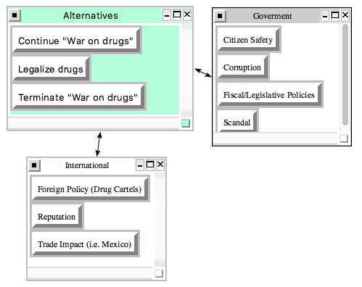
The political cost implications are as follows:

- Reputation
- Foreign Policy due to drug cartels operating within and outside the country
- Trade impact with other countries due to drug problems
- Citizen safety with use of drugs and government policies
- Government corruption and scandal
- Fiscal and legislative policy costs

Costs Pairwise Comparison Results

The synthesized pairwise results for the Costs sub model is shown below. It demonstrates that Terminate the War on drugs has the greatest cost, followed by legalizing drugs and continuing the war on drugs. However, all three alternatives have high costs associated with them.

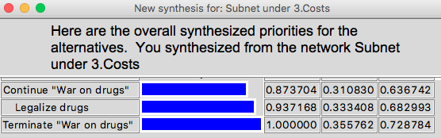

Risks

Economic Control Criterion:

Economical risks evaluated from the position of different stakeholders, which were described above. Another criterion is financial risks:

- Cost increase (higher spending)
- Global trade (World Trade Organization relationship)
- Growth (economical)
- Lost revenue

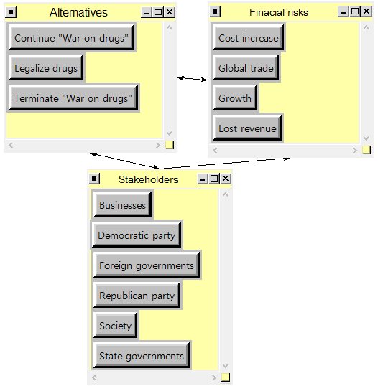

Social Control Criterion:

Social risks are mainly associated with the following factors:

- Drug users increase
- Increase in school dropouts
- Social segregation
- Unemployment
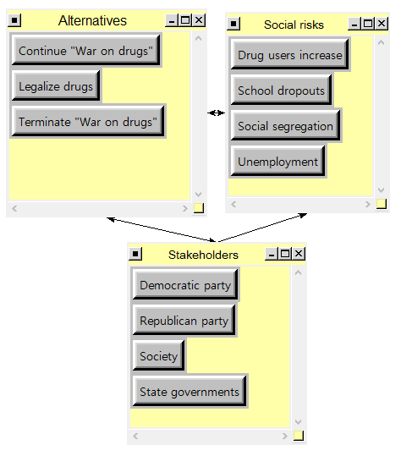

Political Control Criterion:

Political risks for the US government associated with different stakeholders and following factors:

- Impeachment
- International political isolation
- Re-election
- Revoked visa-free entrance

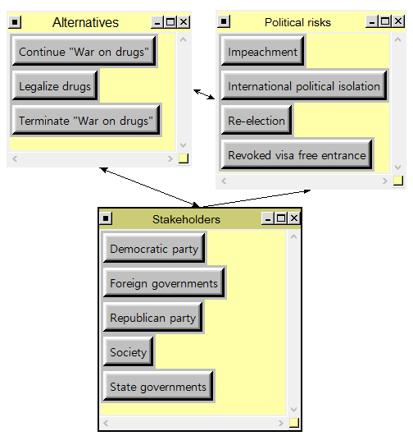

Risks Pairwise Comparison Results

The synthesized pairwise results for the Risks sub model is shown below. It demonstrates that Terminating the War on drugs has the greatest risk, followed by legalizing drugs and continuing the war on drugs.

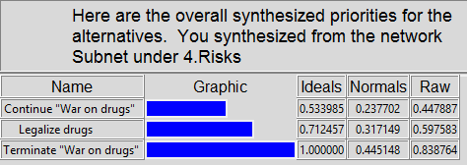

Analysis

In the ratings model between the strategic criteria and BOCR options, we assigned the highest priorities to Crime Level, followed by Peaceful Communities, and Graduation Rates. For the Benefits and Opportunities the best options are Legalization of Drugs, while the most costly and riskiest option is Terminate the War on Drugs. We then evaluated these alternatives based on the various ratings that were given for each of the strategic criteria.

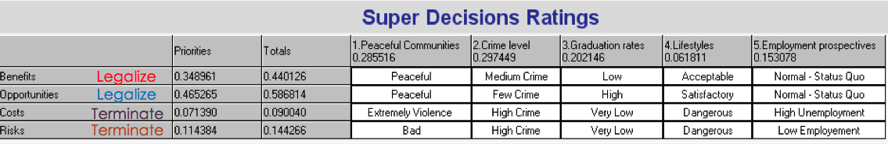

Multiplicative (Short Term)

The multiplicative formula is best for short-term results. The graph below demonstrates that Legalizing Drugs is the best option. The worst option is to stop the War on Drugs.

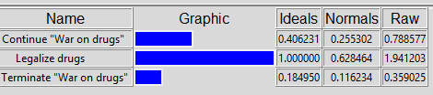

Additive Negative (Long Term)

The additive negative formula is best for long-term results. The graphic below also indicates that Legalizing Drugs is the best options. The worst option is to stop the War on Drugs.

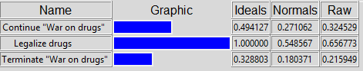

Thus, both the additive and Multiplicative solutions demonstrate that the best options is to ahead and legalize the drugs, while the worst option is do nothing and just terminate the war on drugs.
Sensitivity Analysis

Benefits

The priority of benefits in our model is 0.3489. If the priority increases or decreases, the alternative “Legalize drugs” will still be the most preferred solution.

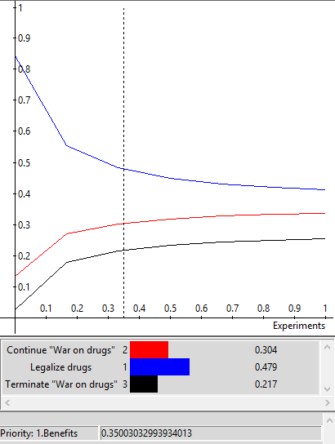

Opportunities

The priority of Opportunities in our model is 0.4652. Preferred solution is “Legalize drugs”. Changes in the value of opportunities priority does not change the best alternative.
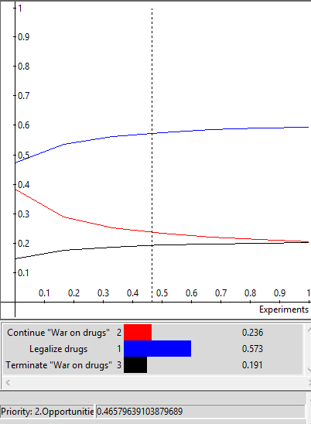

Cost

The priority of the cost is 0.071 in our model. The best alternative with this value is “Legalize drugs”. If the priority of Costs increase above 60%, the best solution will switch to “Terminate”. In this case Costs will outweigh benefits and opportunities for “Legalize drugs” alternative.

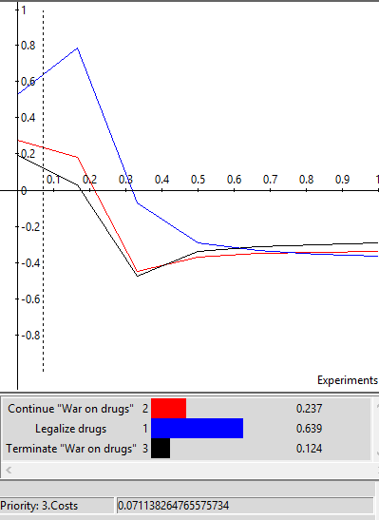

Risks

The priority of the Risks is 0.1143 in our model. The preferred alternative for this situation is “Legalize drugs”, but if the priority goes over 56%, “Continue” becomes the best alternative. Risks start to outweigh benefits and opportunities, because legalization has higher risk.
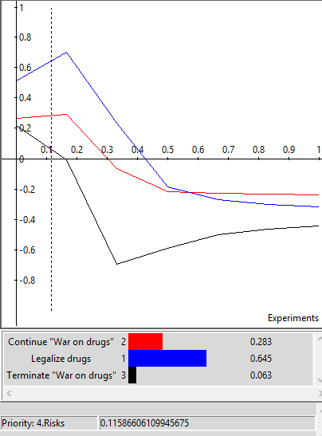

Summary and Conclusions

The choice on how the USA should tackle the drug problem includes the consideration of three key alternatives: continue war on drug, terminate the war on drugs, or legalizing drugs. We consider several strategic criteria such as peaceful communities, crime level, employment opportunities, lifestyle considerations and high school graduation rates. In coming to our decision we also considered three control criteria: economic, social and political. For the economic considerations we evaluate how our choices will impact changes in revenue and taxation, changes in judicial, correctional, and law-enforcement resources. We also investigated economic benefits for large corporations versus small local growers of drugs.

For social impacts we considered, education, homelessness, medical benefits, addiction, racial stereotyping, emotional stresses, and changes in community violence and crime rates. For political impacts we investigated how government will evolve to incorporate one of the three alternatives. For instance, will government scandals and corruption be impacted with continued war on drugs, or how will the public safety be impacted with legalization of drugs. We also considered changes to fiscal and legislative policies, and impacts on global trade and USA reputation amongst international allies and enemies.

Based on the analytical process model (ANP) and with the use of the BOCR modeling, we recognized that legalization of drugs gives the best short and long term results. Whereas terminating any drug wars will be the costliest and riskiest option. If USA chooses legalization of drugs, then there are several other countries that we can model our decision upon. Furthermore, USA should also look at the lesson learned from these countries when we go ahead with several changes to our laws and policies. The government should work with the public and large corporations to setup guidelines and criteria once legalization is chosen, or else big companies may opt to setup their goals and profits at the risk of the public health and safety. The authors of this report would feel that legalization of drugs would be advantageous to the country in reducing the drug problems based by the USA; however, the communities must try to play a vital role to go about changing our laws slowly or else we will jeopardize the future of our nation by drug epidemic among youth and adults.

Bibliography

- Engel, Pamela., Lubin, Guis., Nudelman, Mike., “15 Maps that Show how Americans Use Drugs.” Sept 26, 2013. http://www.businessinsider.com/15-maps-that-show-how-americans-use-drugs-2013-9

- National Institute on Drug Abuse, Drug Facts: Nationwide Trends. https://www.drugabuse.gov/publications/drugfacts/nationwide-trends, June 2015.

- Townes, Carimah. “Irish Government to Decriminalize Heroine, Cocaine, and Marijuana.” Nov 4, 2015. http://thinkprogress.org/justice/2015/11/04/3718843/ireland-drug-decriminalization/

- New Health Advisor, “Why Marijuana Should Not be Legalized.” 2014. http://www.newhealthadvisor.com/Why-Marijuana-Should-Not-Be-Legalized.html

- Pittsburgh Post-Gazette, “Drugged Society: Pitts’s study sheds light on a horrifying scourge.” March 14, 2016. http://www.post-gazette.com/opinion/editorials/2016/03/14/Drugged-society-Pitt-s-study-sheds-light-on-a-horrifying-scourge/stories/201603310034

- Get Smart about Drugs, an Online Resource for Parents, Educators and Caregivers. http://getsmartpittsburgh.com/problem/problem Retrieved April 24, 2016.

- Saaty, Thomas, and Peniwati, Kirti. “Group Decision Making: Drawing out and Reconciling Differences.” RWS Publications: 2012. ISBN: 1-888603-08-9.

- Saaty, Thomas and Vargas, Luis. “A Dictionary of Complex Decision Using the Analytic Network Process,” The Encyclicon Volume 3. RWS Publications: 2011. ISBN: 1-888603-11-9.

