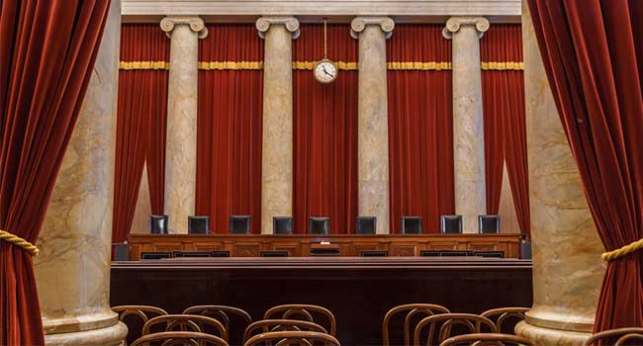

Decision Making in Politics
When Should Senate Republicans Vote on the Supreme Court Nominee?

Adrian Markocic
BQOM 2521
30 September 2020

Table of Contents
Abstract 3
Introduction 3
Methodology 4
Vote Prior to the Presidential Election…………………………………………………………………………………………………4
Vote During the Lame Duck Period………………………………………………………………………………………………………4
Vote After the Inauguration…………………………………………………………………………………………………………………4
Data 5
Benefits Example Subnet 5
Opportunities Example Subnet 6
Costs Example Subnet 7
Risks Example Subnet 8
Analysis 9
Overall Synthesis 10
Sensitivity 11
Benefits Sensitivity 11
Opportunities Sensitivity 12
Costs Sensitivity 13
Risks Sensitivity 14
Conclusion 15

Abstract
The purpose of this project is to evaluate when Senate Republicans should hold a vote on President Trump’s Supreme Court Nominee. The decision to vote on a nominee at this point so near to the election is fraught with potential tripwires and the goal of this paper is to determine if and when the vote should be held. Through this analysis SuperDecisiosn will be utilized to synthesize when the Republican Senate should vote on the nominee. The SuperDecisiosns Model that will be created will look at three choices: (1) Vote prior to the election; (2) Vote during the Lame Duck period; or (3) Vote after the Inauguration.

Introduction
With the recent death of Ruth Bader Ginsburg the Republican controlled Senate has an opportunity to expand the number of conservative Supreme Court Justices to six although the decision to vote on a nominee could come at potential risk given that this is an election year. Not only is the Presidency up for grabs but so are 35 of the seats in the Senate and all of the seats in the House of Representatives. With the House firmly in control of the Democratic Party it is unlikely that any decision will result in party turnover though the Senate is a different situation altogether. Of the 35 Senate races 23 are held by members of the Republican party and Senate Democrats only need to win 3 of these seats (or 4 if the Democratic party does not win the White House) to control the Senate.
Resultingly the decision to vote for a Supreme Court nominee at this point in the election season will have direct impacts on the way voters view the candidates and more importantly any decision has the ability to energize voters in a way which could end up in an outcome different from what current political polls show.
The Supreme Court has the extraordinary power to shape every facet of life and the question of whether to solidify a solid Republican majority for years to come is a serious one. The lifetime nature of a Supreme Court appointment can extend the governing philosophy of a party for generations and there are potential merits in losing Senate seats-short term loss-for an extra justice with a lifetime appointment.
The risk associated with such a move is great, not only because of the potential to lose Senate races, but also because appointing a nominee with minimal support could cause public backlash and diminish favorability at a time when public opinion of politicians is at a near all-time low. Consequently the decision to vote on a nominee will have short and long-term impacts and consequences.

Methodology
I proposed three alternative options to be used in the decision-making method:
(1) Vote prior to the Presidential election
(2) Vote during the Lame Duck period, after the Presidential Election, but before the Presidential Inauguration
(3) Wait to hold a vote until after the Presidential Inauguration
These alternatives were measured against the control criteria of economic, social and financial conditions on a Benefit, Opportunity, Cost and Risk (BOCR) model.
- Vote Prior to the Presidential Election
In this model the Senate would attempt to hold a vote before Election Day. Holding an early vote could catalyze certain voting blocs of the Republican Party who may have been reluctant to support a very controversial President and provide potential downstream support for other Republican candidates running for either election or re-election.
- Vote During the Lame Duck Period
The short time in which the Senate needs to hold hearings and run through procedural activities may prevent the vote on a nominee. Additionally, if it is impossible to obtain 51 votes prior to the election, the Senate may need to wait until this time period to obtain the additional votes. Vulnerable Senators who are up for re-election may be reluctant to vote on a nominee if they feel that they do not have the support of their constituents at home. Similarly, Senators who feel that the election will be going against the party as a whole may choose to wait until this period to push a vote as there is little recourse for short-term punishment from the voting electorate.
- Vote After the Inauguration
There has been substantial public outrage against the Republican Party not only for nominating a candidate who is the complete polar opposite of Ruth Bader Ginsburg but for also violating the so-called McConnell rule which was used to block President Obama’s nomination of Merrick Garland. Under this rule the Senate should not vote on a nominee in an election year as the vote should be left to the incoming Senators. This rule was quickly caveated by Sen. McConnell who said that the rule did not apply when the Senate and Presidency was controlled by both parties. Waiting to vote until after the election would help to diffuse the political animosity and aid a return to civility in the Senate which was the more formal of the houses but has recently been beset by the same partisanship and rancor as the House of Representatives.

Data
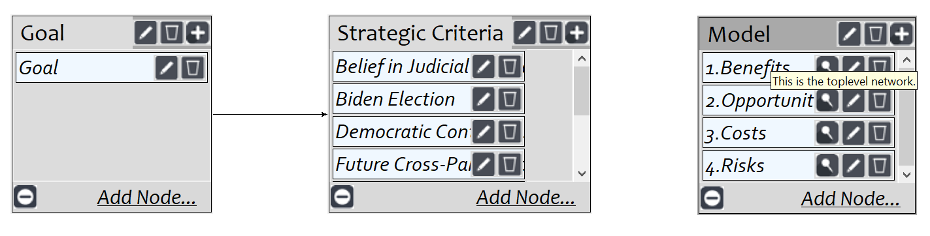
In the BOCR model, alternatives were measured against the strategic criteria of
- President Trump’s reelection
- Vice-President Biden’s election
- Democratic Control of the Senate
- Republican Control of the Senate
- Belief in Judicial Neutrality
- Public Trust of Politicians
- Future Cross-Party Cooperation
- Political Retribution
By factoring in these criteria, the model could decide on the best decision for the Republican Senate considering the multitude of factors which will be impacted. Where possible polling data was utilized to approximate the strength of candidates against one another as was data regarding the number of each state’s electors in the Electoral College. Assumptions were made where data was not available.
Benefits Example Subnet
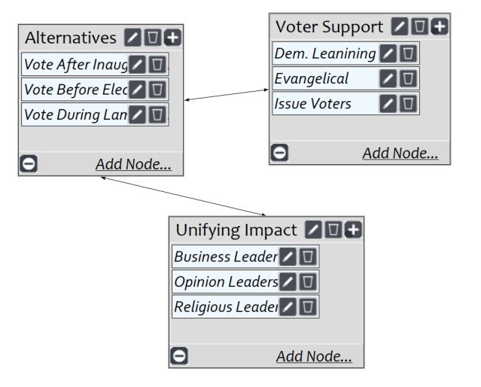
As shown by the chart above the greatest benefit to Senate Republicans would be from voting prior the election. With benefits constituting short-term positive impacts the decision to hold a vote would catalyze voter support from groups who may be reluctant to vote for any number of reasons ranging from opposition to the President to distrust of issue leaders (ie. Jerry Falwell) whose support of the Republican party that those voters may no longer value. The catalyzing effect that an early vote could have combined with the knowledge of the impact that a conservative Supreme Court Justice would have makes an early vote the best option. Alternatively, voting during the Lame Duck period was the next best decision for the same reasons as voting prior to the election, while holding a vote after the election was the last choice. The short-term gains of this last proposition are nearly non-existent thus its reflection as the last of the choices.
Opportunities Example Subnet
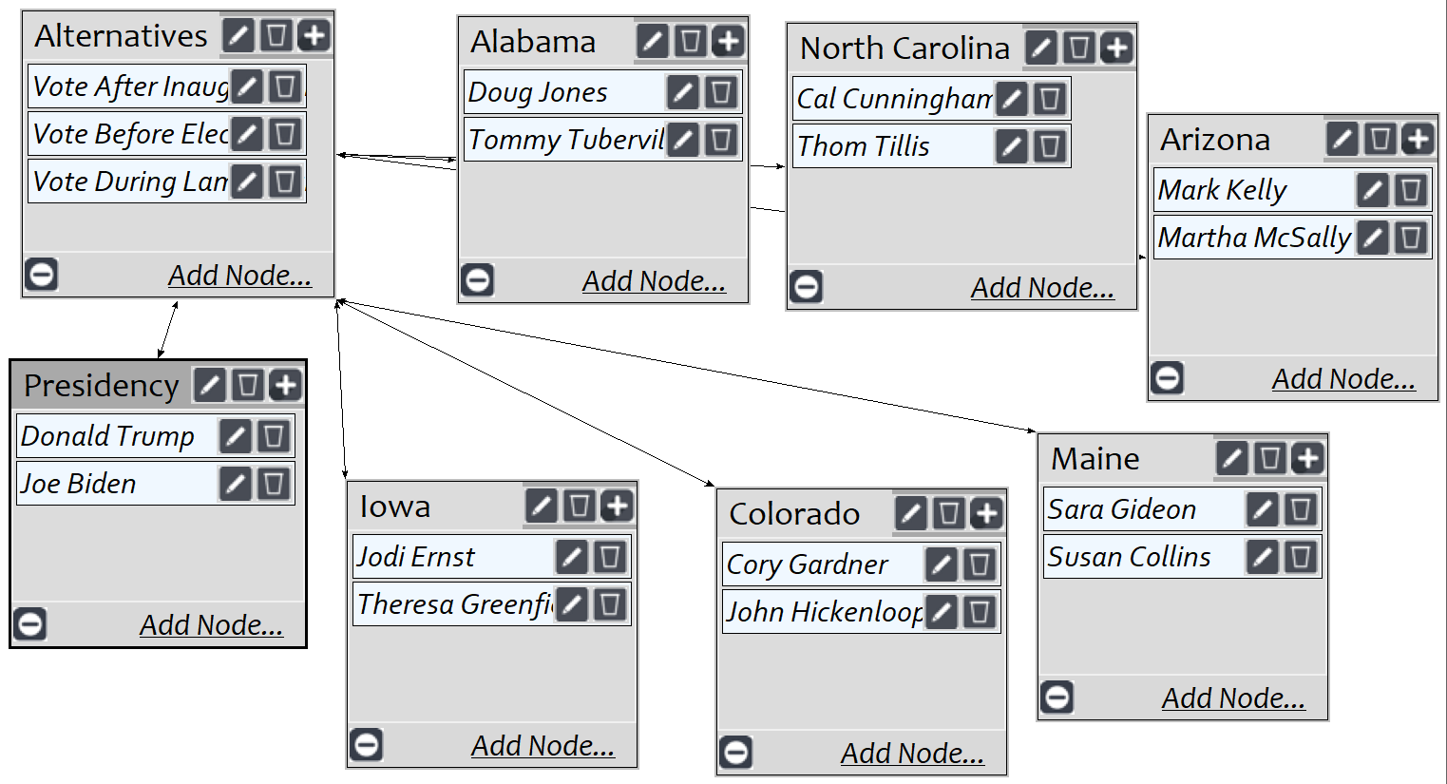
The top priority for the Opportunities subnet was also voting prior to the election. On the political front there are six Senatorial races that are close and the decision to vote early has an impact on each of these. In a race such as Maine’s the incumbent Susan Collins (R) has announced that she does not think that a vote should be held until after the inauguration. As a result of race’s like this the alternative of holding a vote after inauguration comes in the second position. In other races like Alabama Tommy Tuberville (R) is running against the incumbent, Doug Jones (D), and though he cannot vote he gains from the decision to vote prior to the election potentially boosting Senate Republicans chances to hold onto the Senate. With Senate Republicans holding a slim majority Senators are forced to make a decision whether they choose to hold onto their seat or make a political statement by voting and losing. Long-term opportunities such as a conservative agenda carry less weight because voting has passed and as we have seen voters have a short memory.
Costs Example Subnet
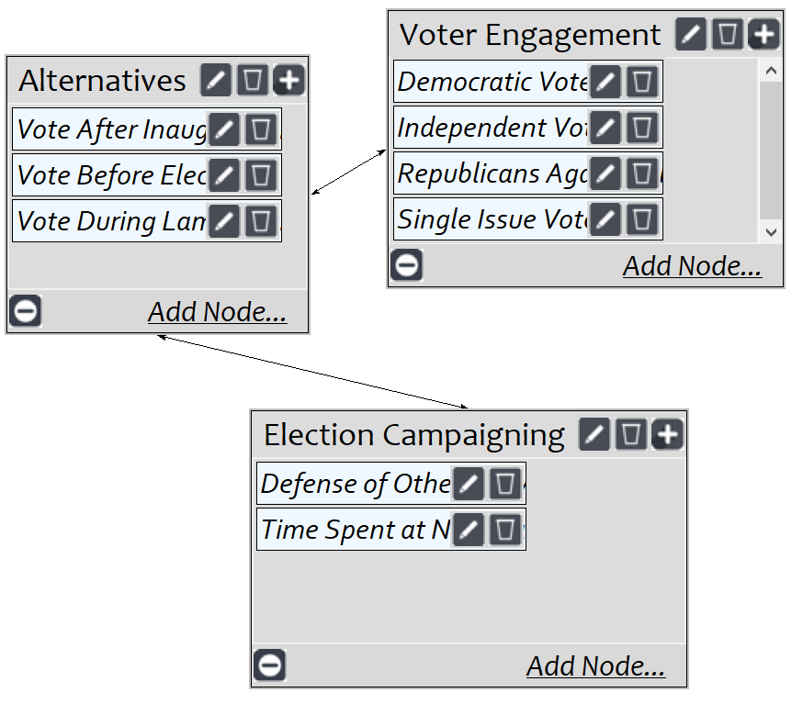
As noted early on the decision to vote can have substantial costs. Just as an early vote could catalyze Republican support it can have similar effects on Democratic support. In fact, the death of Ruth Bader Ginsburg brought in $150 million dollars of campaign donations within 72 hours of the announcement of her death. These sums combined with the cash advantage held by both Vice President Joe Biden and the Democratic National Committee provides Democrats to blanket the media with both pro-Democrat and anti-Republican messaging. This same action forces Republicans to spend money on defensive ads and the Republicans have nearly twice the seats to defend in this election cycle doubling the problem. The alternative with the greatest cost to Republicans is voting after the Inauguration. By waiting to vote Republicans run the risk of losing power in both the Senate and Presidency. Conversely, voting before the Election eliminates that risk while voting during the Lame Duck period increases it, due to the social impacts of voting during a time when the party knows it is out of power, and the action is perceived as a thumb in the eye to the voting public.
Risks Example Subnet
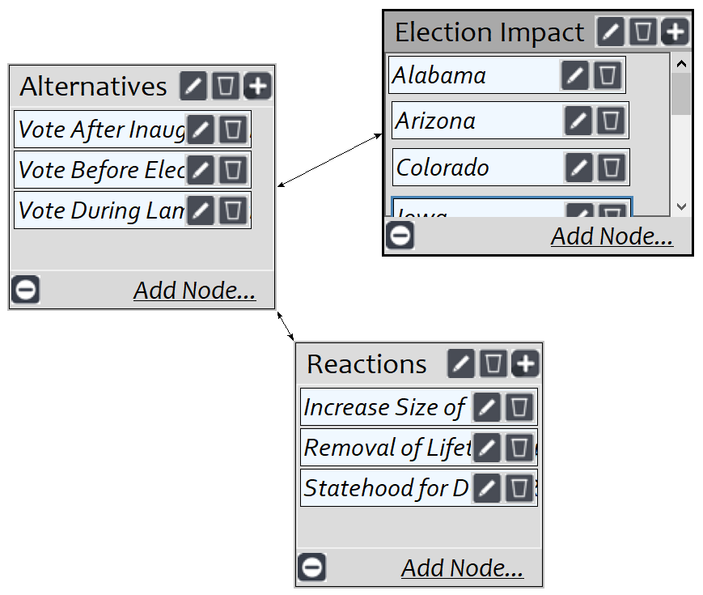
The greatest long-term risk to the Republican Senate is voting during the Lame Duck period. As noted in the preceding section, voting during this period is seen as a rebuke of the electorate’s decision and as a not so pleasant parting gift. Additionally the risk of political retribution with this decision is substantial with the Democratic party looking at potential options of granting, either or both, DC or Puerto Rico statehood, both of which are solidly Democrat, increasing the size of the court to neutralize the conservative majority, or limiting the terms of Justices to force retirements of the most senior justices who are conservatives. Additional risks involve the loss of multiple Senate seats and by way of the losses of those seats, potential loss of the Presidency if voters vote in straight-line opposition to the Republican party. The least risky alternative is to wait until after the Inauguration to vote as this decreases the level of anger and helps to calm a very partisan country.

Analysis
The data from each of the subnets was aggregated and analyzed for each of the alternatives. The table below shows a summary of the BOCR priorities, the alternatives identified as (1) Vote After Inauguration, (2) Vote Before Election, and (3) Vote During Lame Duck. All subnets were synthesized and ideal vectors were taken from each and in the ratings tab, each of the BOCR were assigned a weight.

Overall Synthesis
The long-term and short-term alternatives were synthesized in SuperDecisions and both agreed that priority should be given to voting before the election. The secondary choice was to hold the vote post Inauguration followed by voting during the lame duck period.
Additive Long-Term
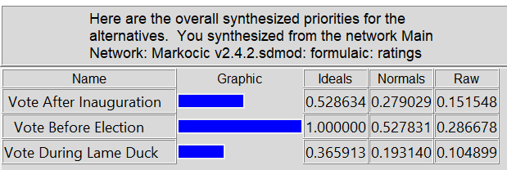

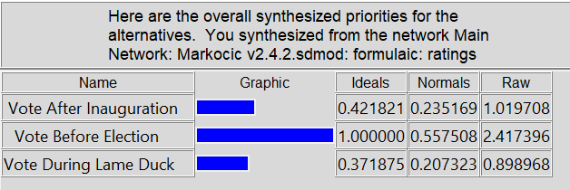
Multiplicative Short-Term

The ratings model is shown below identifying how each of the control criteria was ranked with respect to the Strategic Criteria.
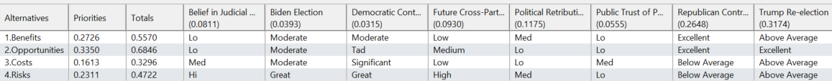

Sensitivity
Benefits Sensitivity
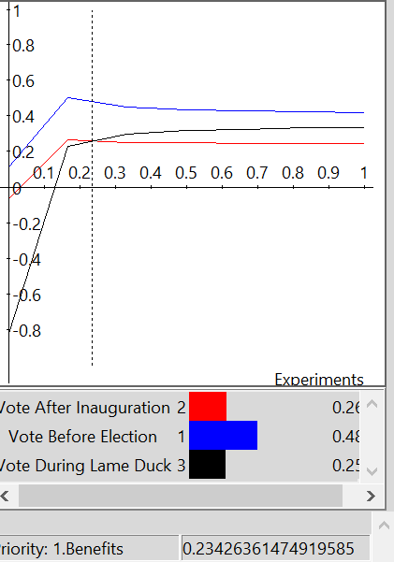

Looking at the Benefits Sensitivity voting prior to the election consistently provides the greatest benefit to Senate Republicans. Voting after the Inauguration provides a benefit until the 25-26% range at which point a rank reversal gives voting during the Lame Duck period greater weight. This latter rank reversal is most likely attributed to voters for whom the Supreme Court may not be as large of an issue at the outset but whose minds are changed when faced with the potential of a Republican loss.

Opportunities Sensitivity
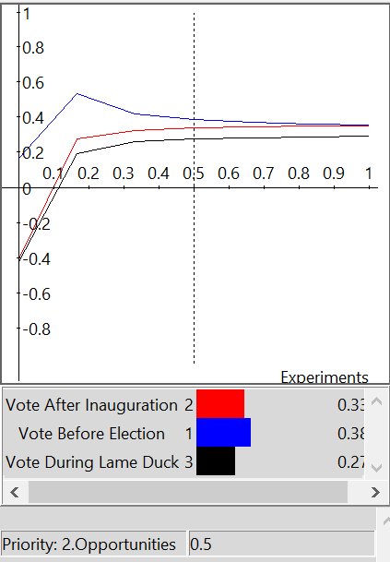
Holding a vote on the Supreme Court nominee prior to the election presents the greatest benefit regardless of the priority weighting. Voting after the Inauguration holds greater weight than voting during the Lame Duck period most likely due to closely contested Senatorial elections. The threat of a potential loss of Senate seats requires candidates to commit to an early decision or other alternatives.

Cost Sensitivity
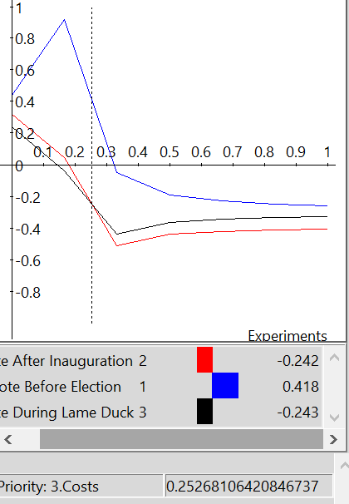
Holding a vote on the Supreme Court nominee prior to the election carries the biggest cost. When the priority of the decision goes from 24 to 25% taking a vote during the Lame Duck period becomes a better option over waiting until after the Inauguration. The potential of increased democratic turnout makes choosing waiting until after the Inauguration the least costly decision.

Risk Sensitivity
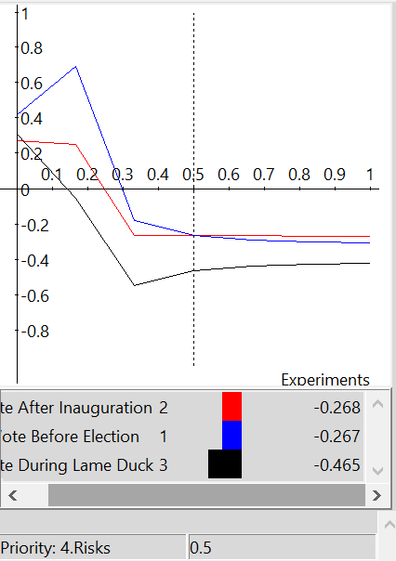
The greatest risk to Senate Republicans is taking a vote up until the point that the priority of the risk exceeds 50% at which point the risk shifts to voting after the Inauguration. The risk up until that point is associated with the loss of Senate seats. Long-term consequences exist attributed to casting a vote when there has been a shift in the public’s voting (ie. electing Democrats) at which point the risk shifts to voting in the Lame Duck period.

Conclusion
As described in the preceding model the Opportunities and Benefits collectively outweigh the Costs and Risks. The potential to boost voter turnout in a hotly contested election makes the Republican Senate’s decision to vote prior to the Election a winning decision. This combined with the potential of creating a long-term conservative majority on the Supreme Court mitigates the potential risk of the Democrats picking up the necessary seats to gain control of the Senate while potential threats posed by Senate Democrats may be more threats than reality.

