Chinese Alternatives in North Korea Nuclear Weapon Issue

Jingyi Li and Desheng Li

Abstract
The purpose of our project is to determine the best alternatives for China regards to the North Korean nuclear weapon program issue. As we learned in class, it is important to understand the strategic goals and objectives of the negotiating party. China has been playing a crucial role in maintaining peace on Korean Peninsula. China and North Korea have been good relations for few decades until Kim Jong-un being elected as the supreme leader of North Korea. North Korea has performed 6 nuclear test in 2017 which urged Chinese government to change the policy to North Korea. We are using the BOCR method to compare the possible alternatives, guided by strategic and control criteria, to find out the best solution. Our project report analyzes the North Korean nuclear issue from Chinese perspective and focuses on the best outcomes and strategic decisions for Chinese government given the alternatives of:
1. Military and/or covert action
2. Increasing sanction
3. Supporting the North Korean governments economically
4. Global alignment and cooperation of people and governments
5. No action

Introduction/Background

China is North Korea’s most important trading partner and main source of food and energy. It has helped sustain Kim Jong-un’s regime, and has historically opposed harsh international sanctions on North Korea in the hope of avoiding regime collapse and a refugee influx across their 870-mile border. Pyongyang’s nuclear tests and ongoing missile launches have complicated its relationship with Beijing, which has continued to advocate for the resumption of the Six Party Talks, the multilateral framework aimed at denuclearizing North Korea. A purge of top North Korean officials since its young leader came to power and the assassination of Kim Jong-nam, Kim Jong-un’s exiled half- brother, in Malaysia also spurred concern from China about the stability and direction of North Korean leadership. Yet China’s policies have done little to deter its neighbor’s nuclear ambitions.

With tensions escalating rapidly again on the Korean peninsula, the attention of the world invariably has returned to the question of whether or not the solution to the crisis lies in China. After months of continuing missile tests by North Korea despite sanctions and global condemnation, Kim Jong-un’s regime claims to have tested a hydrogen bomb and once again launched an intercontinental ballistic missile over Japan. North Korea’s march toward wielding a nuclear arsenal against its neighbors and far off enemies, like the United States, is nearing completion. For Xi Jinping and the Chinese Communist Party (CCP), North Korea’s obstinate drive toward becoming a nuclear force has dealt Beijing a critical challenge at a moment when the party would prefer to focus on other matters seen as essential to its rise as a regional and world power.

Hope and frustration leveled at Xi and the People’s Republic of China (PRC) stems in part from two assumptions. The first is the general conviction that North Korea is a rogue state so reckless and its leader, Kim, so maniacal that it is not driven by rational interests or goals, a point contested by more nuanced and historically informed perspectives. The second assumption is that the PRC’s leverage over Pyongyang is considerable enough to force Kim to avert course. True enough, China is North Korea’s top ally and trading partner, responsible for supplying the country with the majority of its fossil fuels and much needed food. It is also true that Beijing has played a prominent role through its seat on the Security Council in undermining efforts at the United Nations to sanction North Korea in the past.

For our project, we will focus on the alternatives such as giving a military of covert action, increasing sanction, supporting the North Korea economically or just doing nothing. The decision will base on the factors such as the economic condition of the country, the social welfare impact and the political impacts.

Methodology
Alternatives include the following:
1. Military and/or covert action
2. Increasing sanction
3. Supporting the North Korea economically
4. Global alignment and cooperation of people and governments
5. No action

Increasing sanction
The idea behind the UN sanctions and China’s blockade on selected imports is that by starving North Korea of money, its leader will be unable to continue with his nuclear weapons programme.

Supporting North Korea economically
One of the reason that make Kim keep developing nuclear weapon is because the feeling of insecure or the feeling of being isolated from the world. If the China give North Korea some economic help, the North Korea might be willing to listen to the Chinese government and stop developing the nuclear weapons.

Global alignment and cooperation of people and governments

Each sub-network is based upon control criteria in which declared options are evaluated.
The control criteria are the following:
Benefits:
Economic – The business/trade benefits can be achieved.
Social – The social welfare benefits that can be achieved.
Political – The political benefits that can be achieved.

Benefit-Economic decision subnet
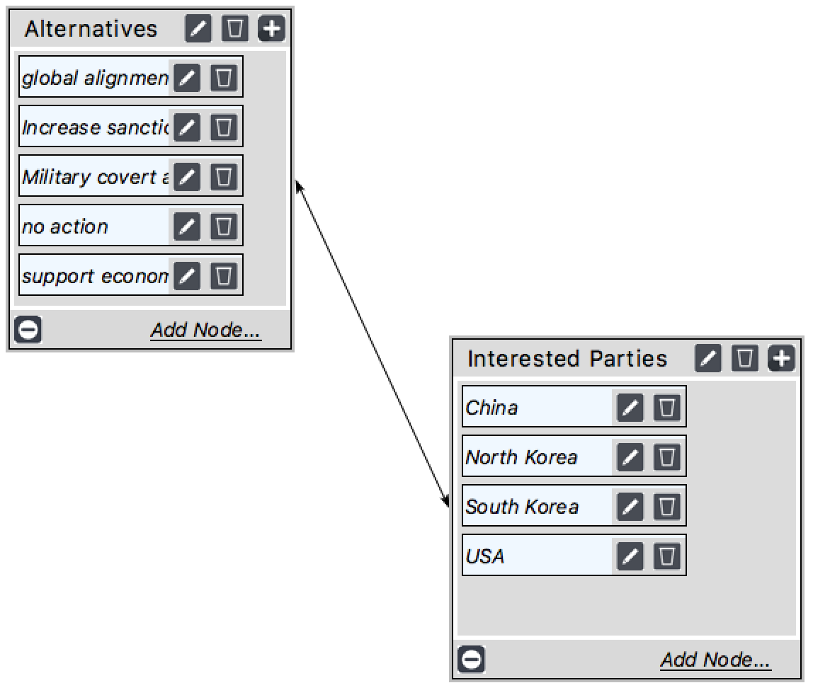

Interested Parties
- China: 0.68
- North Korea: 0.18
- South Korea: 0.05
- USA: 0.09

The numbers means how much interested of these countries matter to China. We do not consider other countries like Japan and Russia because we do not think the number would over 0.01.

Benefit-Political Decision Subnet
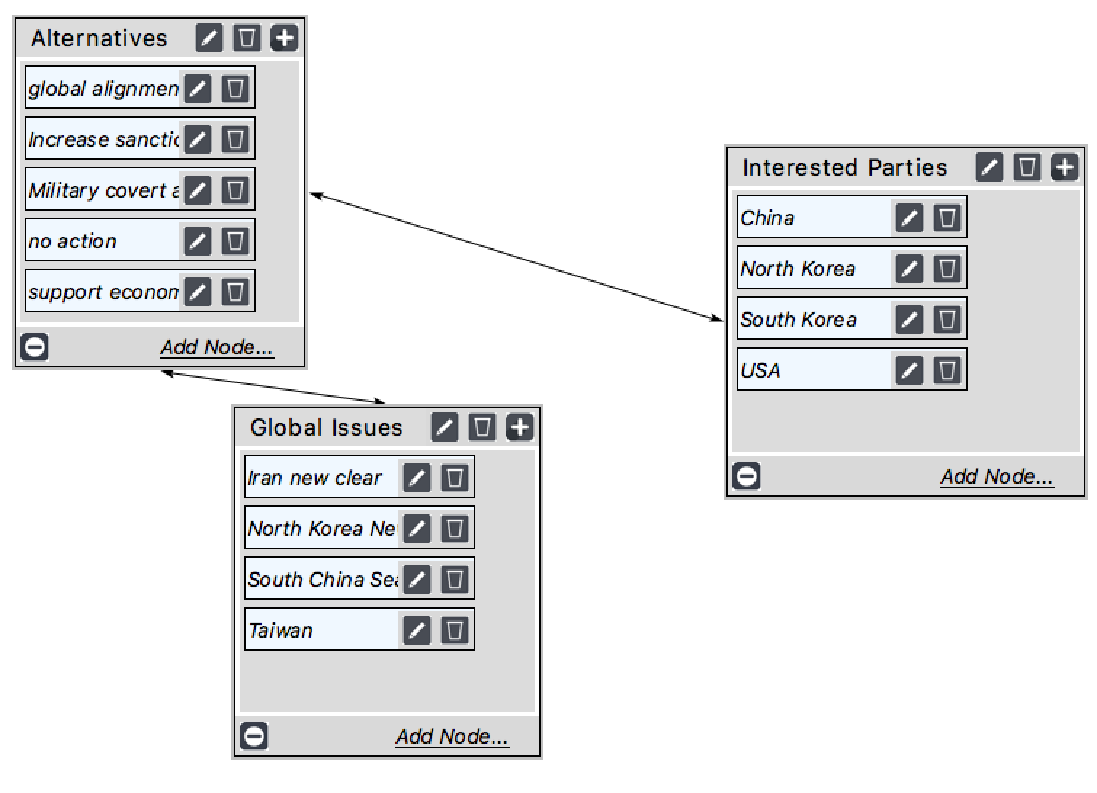
Global Issues:
- Iran new clear: 0.04
- North Korean new clear: 0.07
- South China Sea: 0.25
- Taiwan: 0.64
Interested Parties:
- China: 0.47
- North Korea: 0.18
- South Korea: 0.09
- USA: 0.3

These numbers are same as Benefit Economic part. Taiwan and South China Sea issue are the most important political issues for Chinese government.

Benefit-Social Decision Subnet
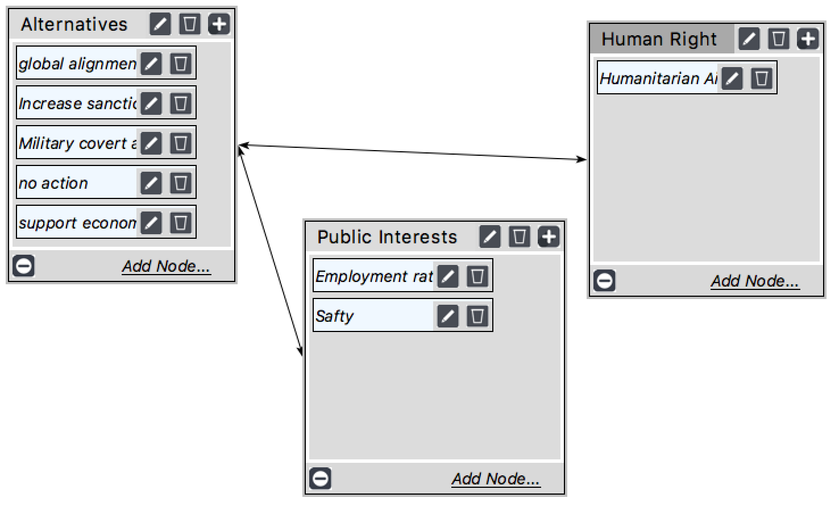

Public Interests:
- Employment rate: 0.2
- Safety: 0.8

Benefit Synthesize
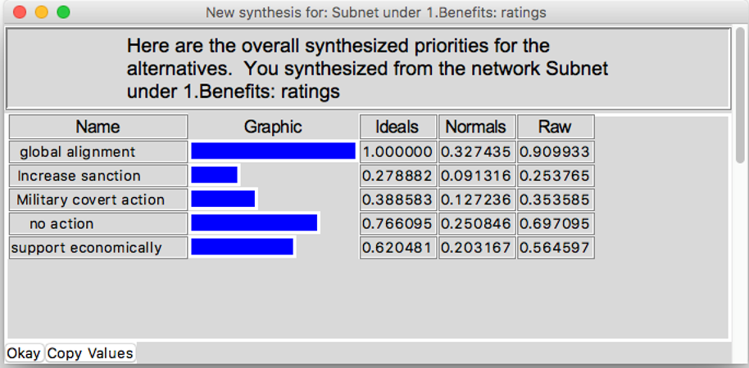

Opportunities:
Economic – The business/trade opportunities that can be achieved.
Social – The social welfare opportunities that can be achieved.
Political – The political opportunities that can be achieved.

Opportunities-Economic Decision Subnet
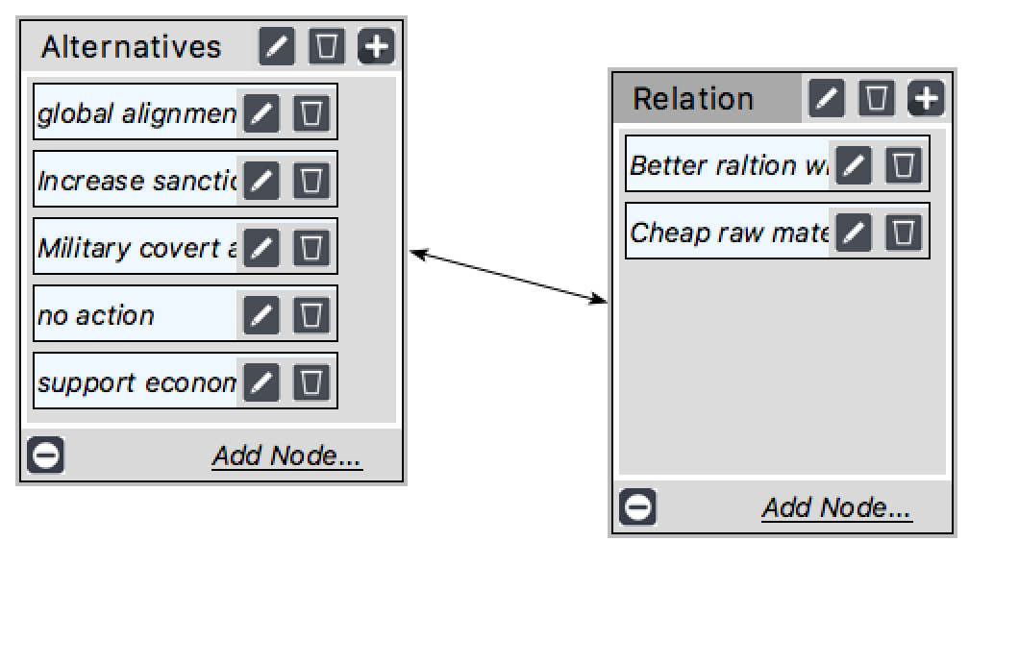
Relation
- Better relation with US: 0.25
- Cheap raw material from North Korea: 0.75

Opportunity-Political Decision Subnet
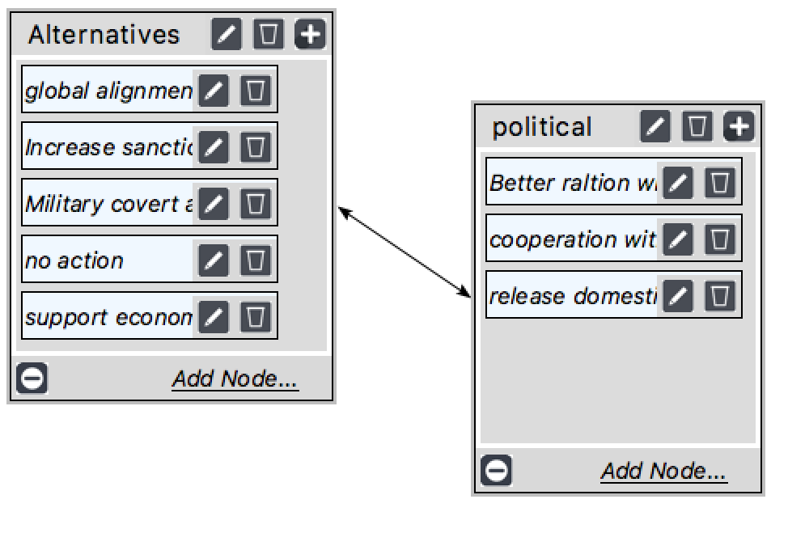
Political:
- Better relation with US: 0.43
- Cooperation with neighbor countries: 0.14
- Release domestic issue: 0.42
Opportunity Synthesize
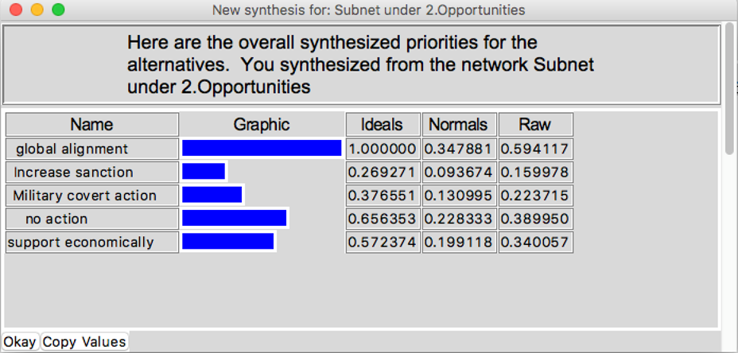

Costs:
Economic – The negative business/trade impacts.
Social – The negative social welfare impacts.
Political – The negative political impacts.
Environmental - The negative environmental impacts.

Cost-Economic Decision Subnet
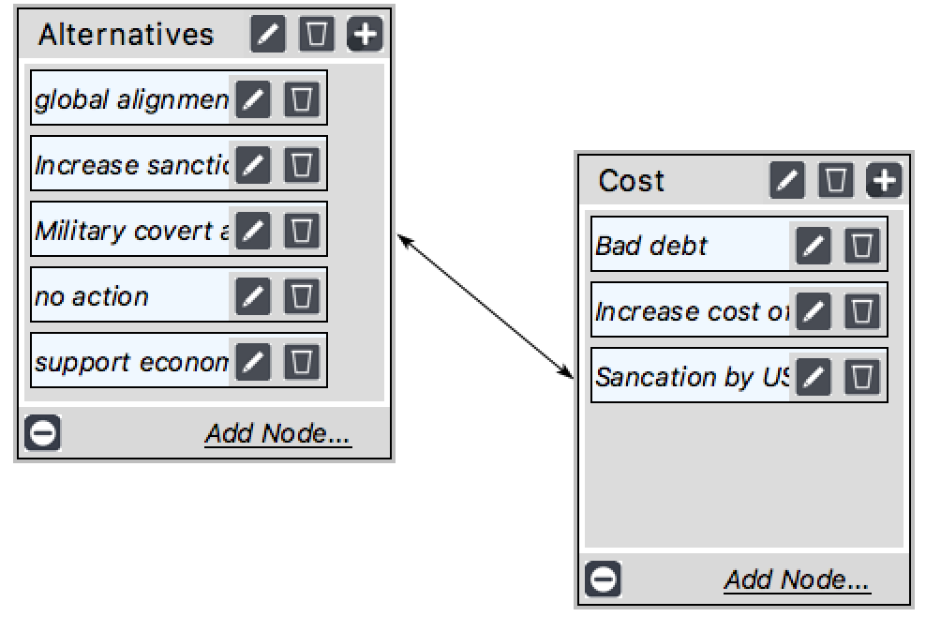
Cost:
- Bad debt: 0.12
- Increase cost of raw material: 0.32
- Snaction by US: 0.56

Cost-Environmental Decision Subnet
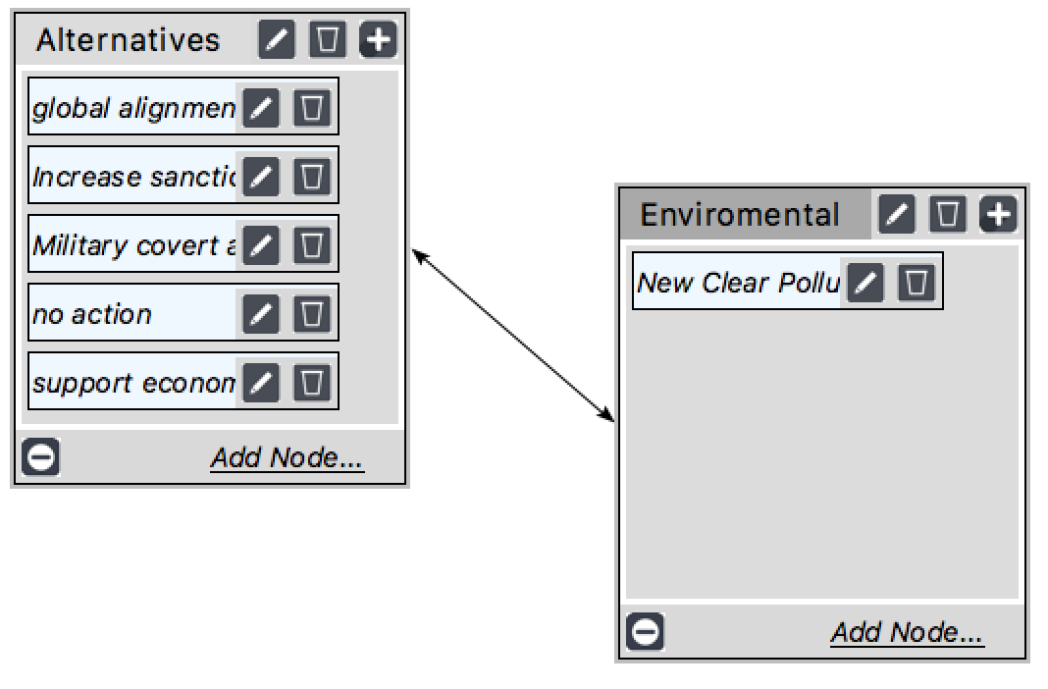

Cost-Political Decision Subnet
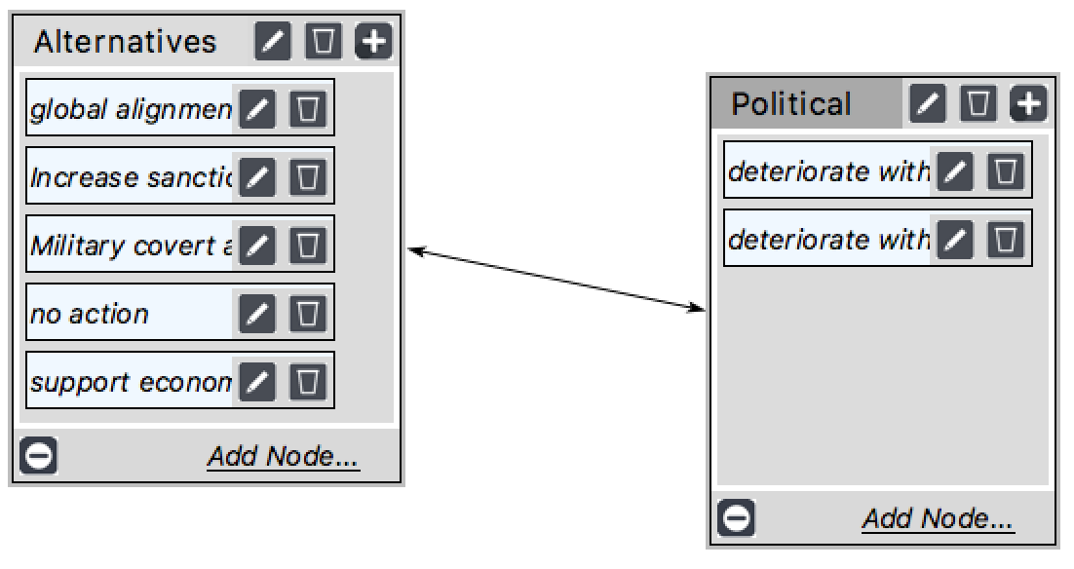
Political
- Deteriorate with UN: 0.75
- Deteriorate with US: 0.25

Cost-Social Decision Subnet
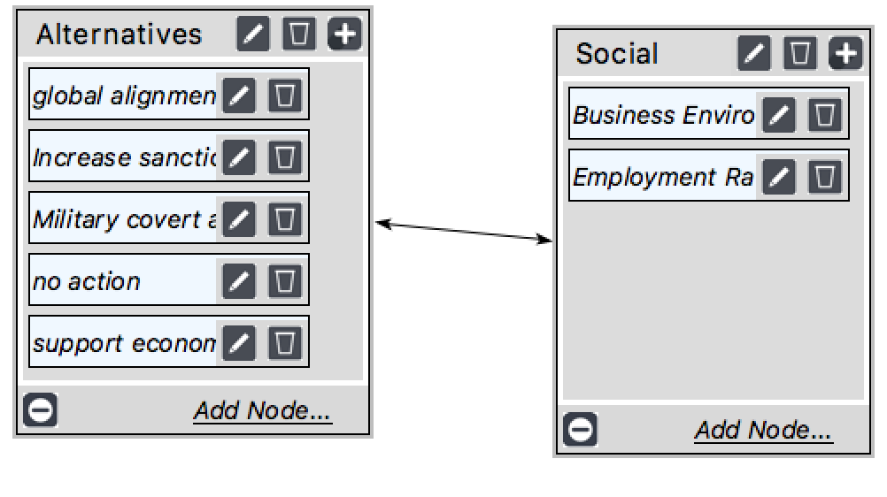
Social
- Business Environment: 0.75
- Employment Rate: 0.25

Cost Synthesize
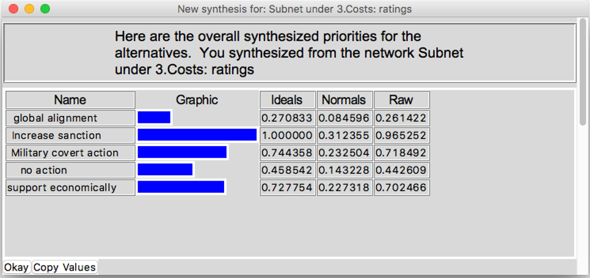

Risks:
Economic – The long-term negative business/trade impacts.
Social – The long-term negative social welfare impacts.
Political – The long-term negative political impacts.
Environmental - The long term negative environmental impacts.

Risk-Economic Decision Subnet
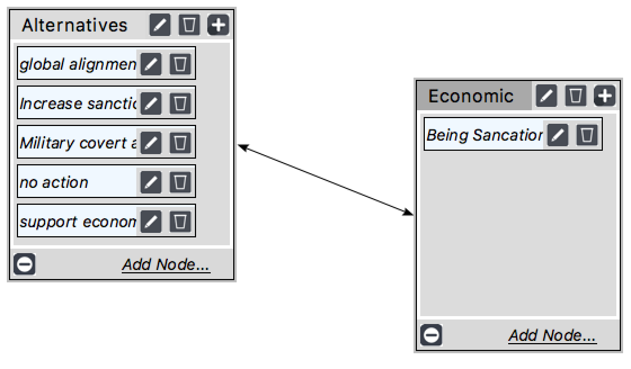

Risk-Environmental Decision Subnet
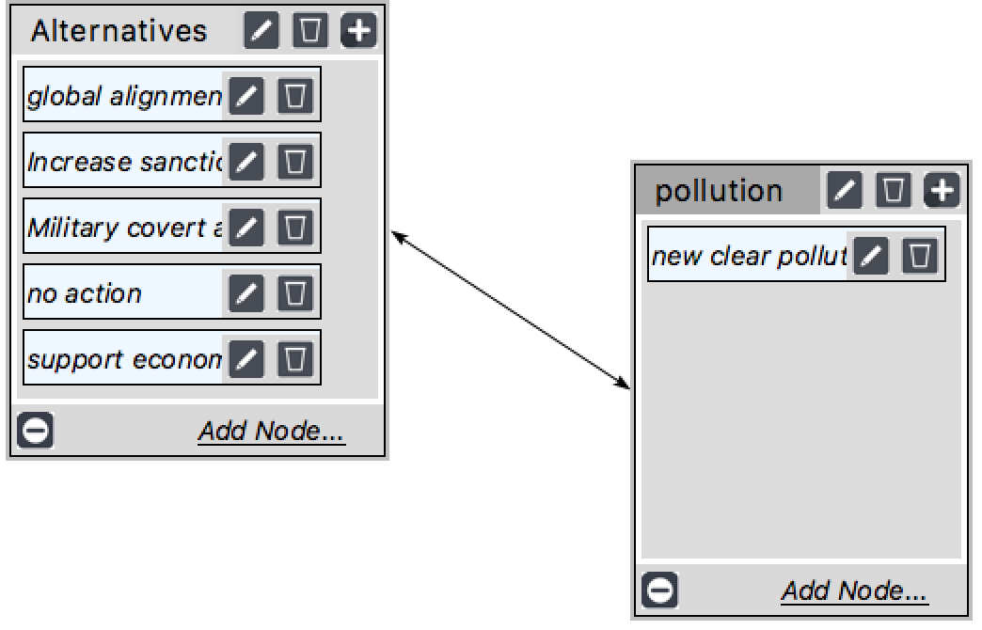

Risk-Political Decision Subnet
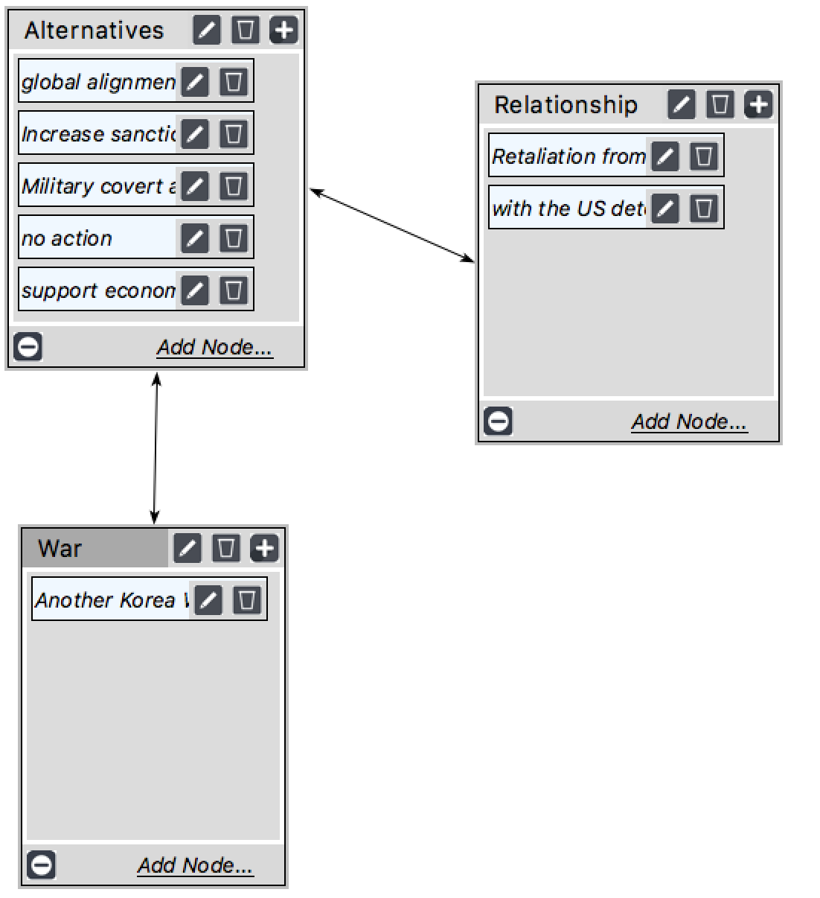
Relation:
- Retaliation from North Korea: 0.2
- Deteriorate with US: 0.8

Risk-Social Decision Subnet
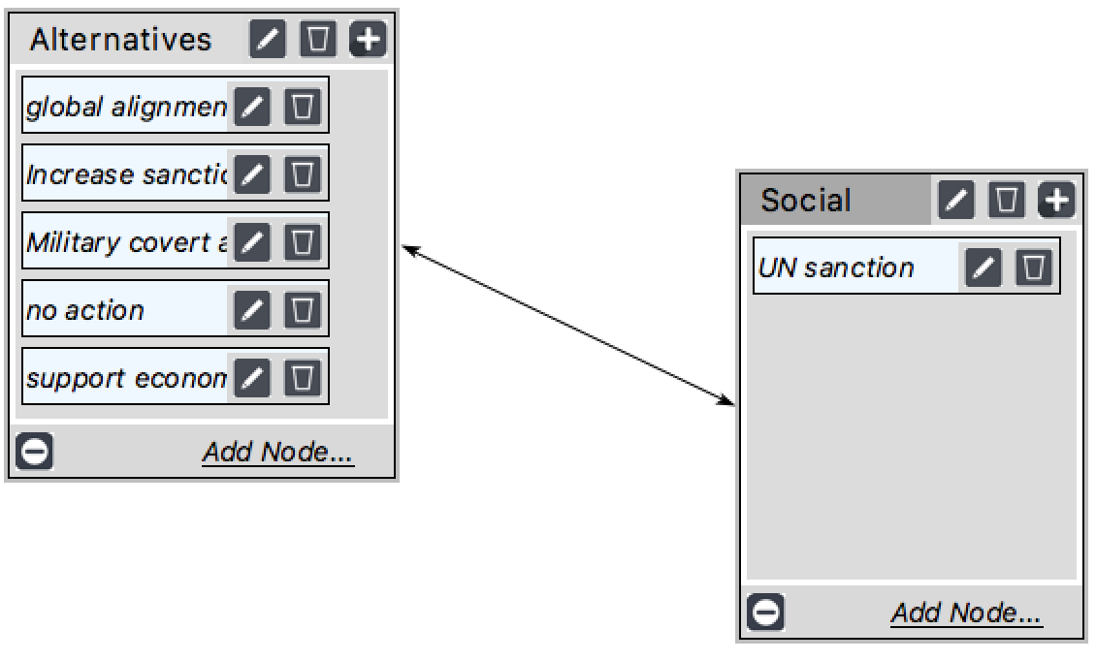

Risk Synthesize
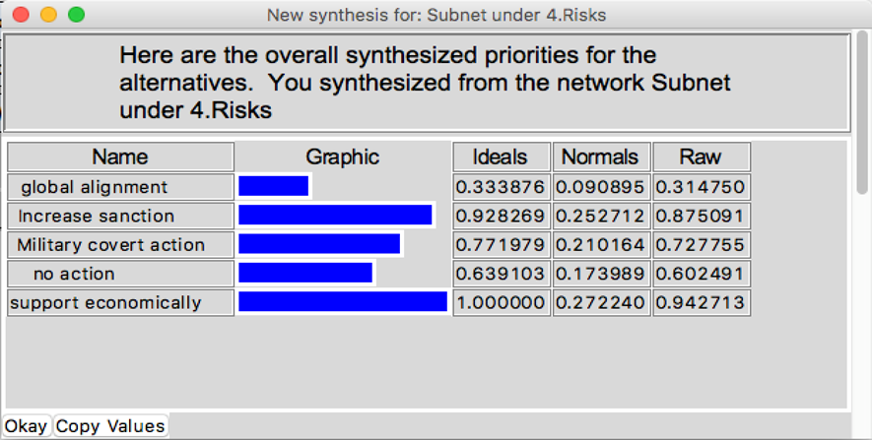

Whole model Synthesize
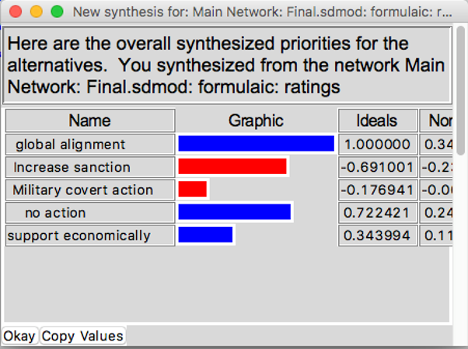

Sensitivity - Benefit
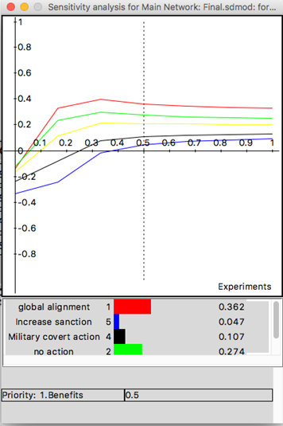

Sensitivity - Opportunity
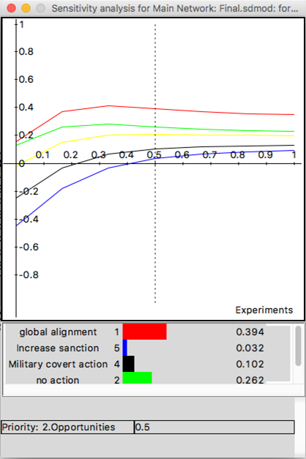

Sensitivity - Cost
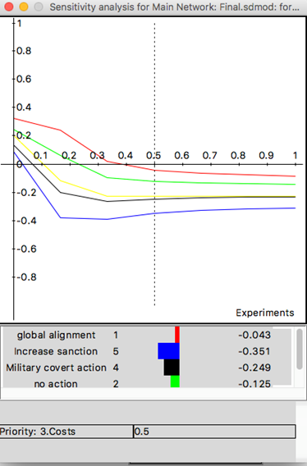

Sensitivity - Risk
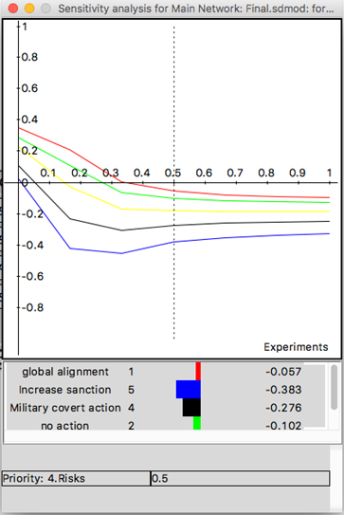

Strategic criteria is based upon the top overarching priorities that need to be kept in mind.
The strategic criteria evaluated is the following:
Economic
- Economic status of the country (especially the economic stability of the Chinese 3 northeast province
- Trade between China and North Korea
Social
- Ability to meet basic needs
- Human rights
Political
- Global Perspective of safety
- Relationship between United States and United Nation
Environmental
- New clear pollution

The BOCR model was then rated according to scale of five ratings: very high, high, medium, and low.

Conclusion

The final best option from the model are global alignment and cooperation of people and governments and no action. It interprets the potential benefits, opportunities, costs and risks of China’s action for the North new clear weapon issue.
Increase sanction and military and/or covert action have highly costs and risks.
When pairwise compare the criteria, standing on Chinese government’s point of view and Chinese people’s point of view turn out a very different result. Addition to that, ranking the interested parties is difficult to do because it is hard to find out every country’s domestic and oversea vested interested.

