Introduction and Methodology

Global warming is the observed rise in the average temperature of the Earth’s climate systems. Scientific evidence shows that the climate system is warming due factors related to greenhouse gas emissions and general human activity. 2016 was recently record as begin the hottest year and 2017 is following the same tend. The warming has triggered many changes to the Earth’s climate and extreme weather such as heat waves and droughts are the primary way most people experience climate change. Climate change has impacted the strength and severity of extreme weather events. These changes last for an extended period and future impacts are difficult to predict. Over the last 50 years, the US has experienced prolonged periods of excessively high temperature, heavy rain and drought.

In 2016, there were 15 weather and climate events that caused losses exceeding $1 billion across the United States. These events include droughts, wildfires, 4 inland flood events, 8 severe storm events and tropical cyclone events. The 4 inland flood events are a notable record because they clustered near Louisiana and Texas between March and August. They caused significant damages that approached $15 billion and further highlight the impacts of climate change. Collectively the 15 events led to 138 fatalities and caused $46 billion in total, direct costs. This total is the second highest annual number of U.S billion-dollar disasters, it falls behind the 16 events that occurred in 2011. The trend continues upward as the impacts of Hurricane Harvey and Irma on Texas and Florida become known.

Actions need to be taken to protect the U.S. infrastructure and people from the negative side effects of climate change. The BOCR model was created to present potential alternative solutions that can protect the US against the effects of climate change. Alternatives either directly impact aspects related to securing the U.S. infrastructure or they provide solutions that involve addressing the issue of climate change at core. All stakeholders were considered in the decision making behind this model. Stakeholders include government officials and agencies, general public, special interest groups and etc.

Goal
Effects due to climate change and global warming are becoming an significant threat to U.S. security and national wellbeing, this model suggests actions the U.S. should take in order to migrate and/or eliminate risks associated with unpredictable changing climate.

Question: How should the US manage the effects of climate change?

Alternative Overview
- Fortify infrastructure – This option manages the risk associated to weather related climate events like hurricanes, floods, earthquakes and other extreme weather. Investing infrastructure projects include:
  - Fortifying the structural support for buildings and bridges
  - Investing eruption resistance roads
  - Improving the quality of building materials

- Government Grants for Sustainable Technology Innovations – Provides grant money to innovative technology that supports suitable practices. Technology like solar panels, electric cars and alternative “green” energy sources.

- Tax penalties for organizations that pollute excessively – Carbon footprint threshold set by climate related research. Organizations above the threshold will be charged a penalty, no charge occurs when threshold not met.

- National climate change educational campaign – Launch an educational program that informs and encourages civilizations to adopt alternative behavior. This behavior will focus on sustainable lifestyle and promote actions to that minimize waste.

- Do nothing

Strategic Criteria

Criteria | Description
Awareness | Informing the public about potential dangers related to climate change
Public Health and Safety | Safety of the public and environment
Political and social benefit | Number of political/social groups involved
Resource management | Effectiveness in usage of current and future resource issue
Impact on lifestyle | Attractive of the alternative being adopted

BOCR Model - Summary

BENEFIT  - Improved public safety and preparedness with future weather conditions  - Sustaining nonrenewable resources for future communities  - Contribution across local and national organizations | OPPORTUNITIES  - Minimize or eliminate the impact of future severe weather  - Creation of novel and innovative technology  - Economic opportunity to create jobs and business markets
COST  - Financial impact related to cost of infrastructure  - Loss of unsustainable industries  - Difficulty with changing public opinion  - Political tension with passing legislation | RISKS  - Alternatives may not be effective at combating climate change  - Worsening weather conductions  - Complete public backlash against measures

Detailed BOCR

BENEFITS  Economics  - Market  - Development of new markets  - Creation of new jobs  - Financial  - Increase tax earnings  - Reduced utility/infrastructure costs  Social  - General Public  - Improved public health  - Benefits to farmers  - Improved education  Environmental  - Climates  - Reduction in severe weather  - Mild temperature/climate  - Resources  - Improved sustainability  - Reduce usage of unstainable  - Wilderness conservation | OPPORTUNITIES  Economics  - Market  - Development of new market  - Creation of new jobs  - Financial  - Increase tax earning  - Reduced utility/infrastructure costs  Social  - General Public  - Household income  - National security  - Redistribution of wealth  Environmental  - Climates  - Reduction in severe weather  - Mild temperature  - Resources  - Improved sustainability  - Reduce usage of unstainable  - Wilderness conservation
COST  Economics  - Market  - Job/Markets loses  - Financial  - Increase in taxes  - Increased cost of infrastructure  Social  - General Public  - Changing public opinion  - Education support  Political  - Government  - Regulations and restriction  - Laws and enforcements  - Programs | RISKS  Economics  - Market  - No market growth  - Financial  - Plateau in tax benefits  - Cost exceeds benefits  Social  - General Public  - Public backlash  - No adaption  Political  - Government  - Bipartisanship difficulty  - State vs. Federal conflict  Environmental  - Climates  - Minimal impact  - Alternatives worst

Benefits
Additive (Long Term)  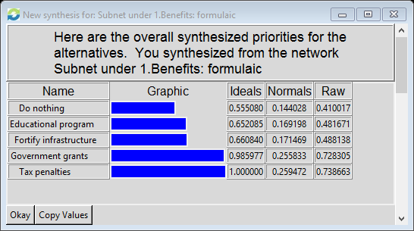 | Multiplicative (Short Term)  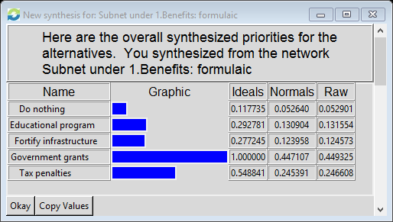

In terms of Benefits, tax penalties and government grants are equally viable solutions in the when looking at the long-term output of the data. These two opinions are closely related when you look at some of the risks attributed to their implementation. Both would require some government intervention to functional solution for climate. This decision changes when you look at the short-term solution. Government grants become more of feasible solution when looking in the short term. There would be less regulatory hurdles when implementing so it makes sense for the short-term to apply this measure. This short-term solution of government grant is an investment into the future and can be very beneficial if a new innovative technology gets developed in the short time period.

Opportunities
Additive (Long Term)  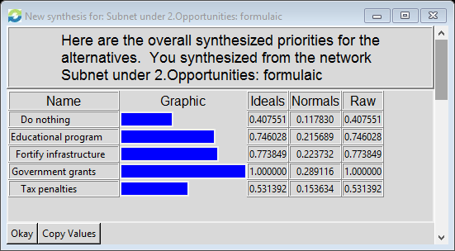 | Multiplicative (Short Term)  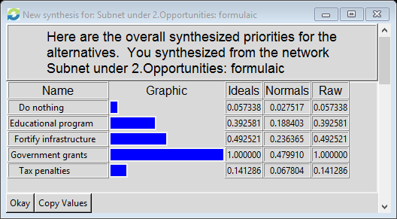

In terms of Opportunities, government grants are viable for both long-term and short-term results. This makes sense because government grants can be used to fund variety of projects. The diversification in funding potential makes this solution the best opinion for the great risk of award. Some projects many fail but the hope is to fund at least one to two projects that can significantly impact the severe weather issues. Both fortify infrastructure and education program rank second and third respectfully in the output for opportunities. These opinions would in comparison to tax penalties and doing nothing have more opportunity attributed to them. Education programs and infrastructure investments can have long term success and would be easily implemented on the short term.

Costs
Additive (Long Term)  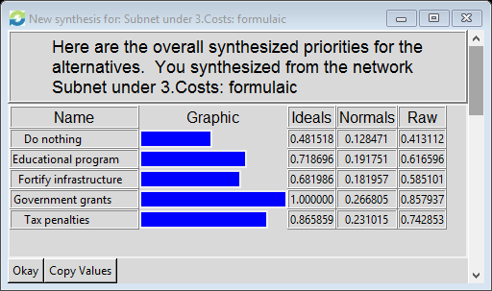 | Multiplicative (Short Term)  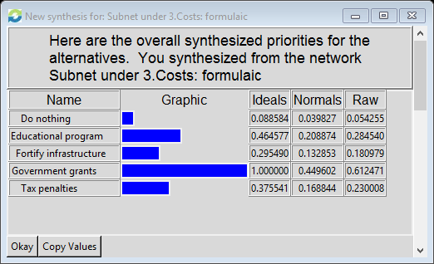
In terms of Costs, government grants are the costliest when looking at long-term and short-term results. In order for government grants to succeed there has to be a large invested so that project opinions can be completely diversified. It makes sense that it would be the costliest of the opinions. In the long term, tax penalties ranked second and this is due to the potential government and/or regulatory hurdles. It would take a lot of effort to implement a tax policy that is fair and with this there is significant cost to do so. Also in the short term, the education program solution would require a heavy initial investment in order to get programming approved and ready for implementation.

Risks
Additive (Long Term)  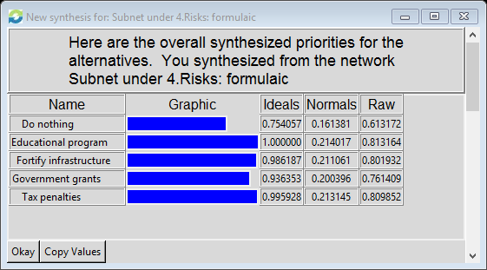 | Multiplicative (Short Term)  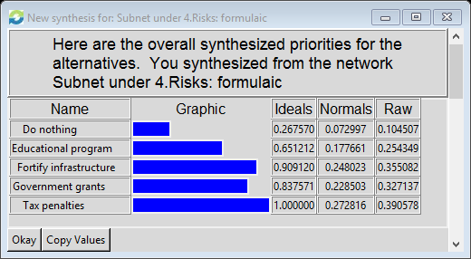

The riskiest long-term solutions are relatively tied between education program, fortify infrastructure and government grants. All three have significant risk related to overall cost of the solution, the success vs failure of the program and government and/or regulatory hurdles required to be successful with the program. Overall, when looking at all the solution there is a lot of risk implementing any solution since the science been climate change is not fully realized. Factors related to actual cause are still debatable items among the scientific community.

Rate Model
Additive (Long Term)  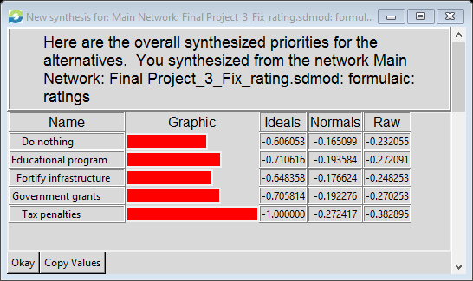 | Multiplicative (Short Term)  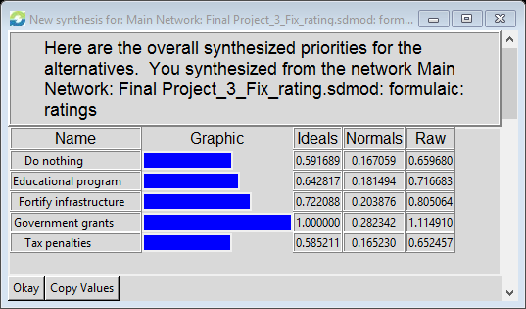

In looking at the short-term output of the of the rating model, government grants is the best choice for solution in this case. Government grants have score significantly well in the BOCR model. It was ranked with tax penalties in the benefits and opportunities subnets. But there is differently concern with the risk and cost associated with government grants. In the long-term all solutions are not feasible from the output of the rating model. Do nothing is the most viable solution in the long-term because it has the lowest raw, normal and ideal score.



I performed a rating based upon how important the strategic criteria impacted the BOCR model. In terms of benefits, the health and safety strategic criteria would most be impacted. Awareness doesn’t really have any significant impact on cost or risks because increasing awareness about a topic is low risk and generally free. In contract, in terms of opportunities awareness is above average because low and cost are good measure for optimal opportunity.

Sensitivity Analysis
Awareness | 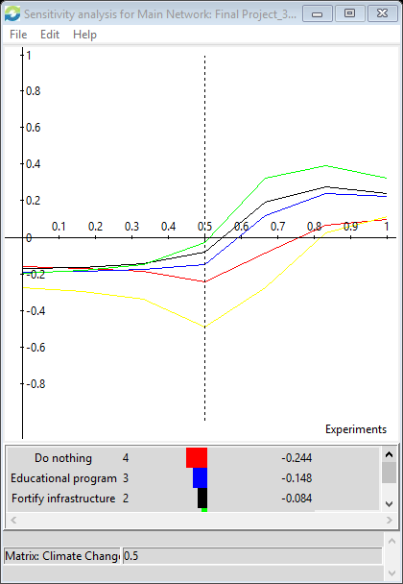
Public health and safety | 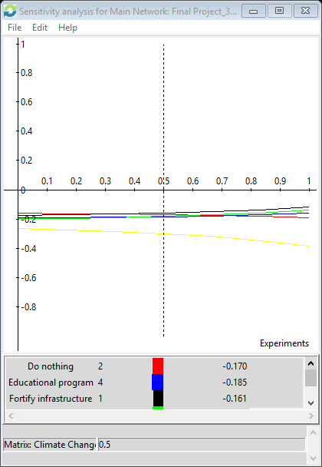
Impact on Lifestyle | 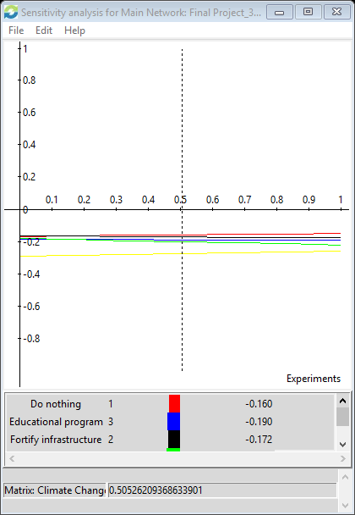
Political and Social Benefit | 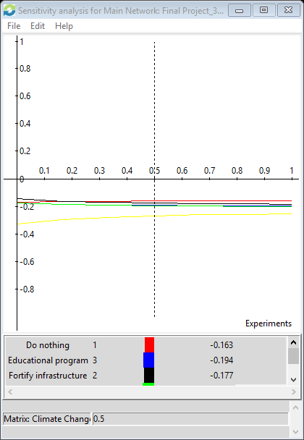
Resource Management | 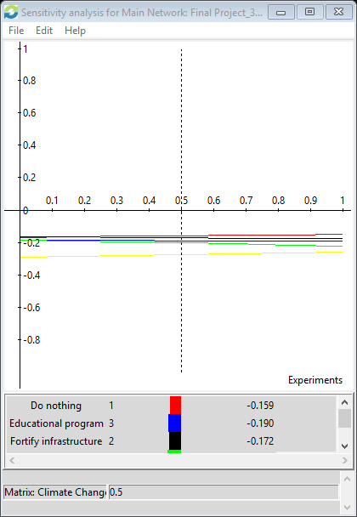

The sensitivity for awareness is the most significant due to the shape of the curve. Government grants is the leading curve on the top with no intersection between other curves. Simply confirms that government grants the best solution for the problems.

Conclusion
Climate change and global warming are still relatively unknown fields of science. A lot of the facts are still up for debate in terms of what actually causes climate change and global warming. As a result in terms of long term solutions, there is still debate over what will be a good direction for the U.S. to go when looking to the future. Ultimately, for the short-term investing efforts in government grants would be best at remedying he issues with managing climate change and the side effect of severe weather. My personal decision would have placed considerable investments in fortifying infrastructure because this solves the immediate issue involving the destruction of infrastructure because of the weather. But I can see why the model determined government grants as the most viable solution. Government grants have a strong chance of being successful if invest are made diversely across an array of projects.

Recommendations for next model
If I were to redo this model, I would pick a differ topic. There are a lot of uncertainties with climate change and the data that supports climate change claims. Also in terms of creating the models, I would have had more self-loops but I initially felt they were unnecessary for this model. All of my subnets could stand only and the subnets of those nets could also stand alone. In the economic subnet some factors like job creation and market growth could have been self-looped because they stronger relate.

https://earthobservatory.nasa.gov/Features/GlobalWarming/page2.php

http://nca2014.globalchange.gov/highlights/report-findings/extreme-weather

