BOCR for 2020 Presidential Election

By: Nicholas Fiano

TAble of
Contents
ABstract 2
Introduction 3

Methodology 4

Model Structure 6

Data 7

Analysis 14

Sensitivity 15

Conclusion 17

ABstract:

The year 2020 has been nothing short of unpredictable. A novel virus spread rapidly across the globe leaving thousands dead and economies in ruins. People have been confined to their homes most of the year with very little outside interaction. On top of all of the chaos, there is a United States Presidential election. This could be one of the most pivotal elections in the history of the country. The Republican incumbent, Donald Trump, is a real estate giant who’s seen a strong economy during his term, but has also witnessed the collapse of that very same economy due to the lack of preparation for the COVID-19 epidemic. The challenger, Democrat Joe Biden has previously seen two terms in the White House as Vice President to Barrack Obama and boasts nearly 40 years of political experience with a desire for change. In my model, I will examine the benefits, opportunities, costs, and risks that each candidate poses. My results will be based on how they stand on major political issues and ultimately will predict which candidate will be sworn in as the next president of the United States.

Introduction:

The political climate in the United States has been set ablaze by a year like none other. A pandemic has sidelined our powerhouse economy, riots and protest have descended upon our streets searching for justice , and wildfires have made the west coast states look apocalyptic. During all of the chaos there’s a presidential election set to occur on November 4th, 2020. This may be one of the most important Presidential elections the country has ever witnessed. America is at a crossroads. The incumbent Donald Trump is a conservative stalwart who is expanding Reagan-era conservativism into all aspects of government. He has appointed 2 supreme court justices, removed America from the Paris Climate Agreement, and has restructured trade deals that have been a staple of US foreign policy for years. Yet, he has enjoyed a robust economy and has created an extremely loyal base to help secure his re-election.
The democratic candidate is very familiar to American families. Joe Biden served as the Vice President to Barrack Obama for 8 years, and before that had spent nearly 40 years in Washington DC. He is a moderate democrat who will look to regulate the economy, reverse the decision to pull out of the Paris Climate Agreement, and will seek to expand the Affordable care act to ensure every American has access to healthcare. He is the more progressive candidate between the two, but his policies could come at an economic cost.
Each of the candidates will appeal to different factions of Americans based on their socioeconomic status, age range, and potential military status. However, both nominee’s come with various risks and costs which could be felt through the financial markets, social programs, or foreign policy. The purpose of my model is examine how each of the candidates policy will affect different sub-populations of Americans and how that could potentially influence the results of the 2020 Presidential election.

Methodology:
For the election, there are two possible alternatives:
- Donald Trump
- Joe Biden
Strategic Criteria:
- Public Health Policy
- Economic performance,
- International Relations
- Social Policy
Donald Trump:
Trump is the current sitting Republican President. His economic policy has created more income for corporations and he’s lowered taxes on the rich. His economic policy proved successful for most of his initial term until the COVID-19 pandemic struck and the world markets slowed to a halt. He has been extremely conservative on social policy, holding traditional Republican views on such issues as abortion, LBGTQ rights, and gun control. He is typically seen as the preferential candidate of military members, blue-collar workers, and religious conservatives.
Joe Biden:
Joe Biden is the democratic challenger. Biden is a moderate democratic candidate who will look to regulate the economy, aim to re-establish the affordable care act, and arrange for the United States to re-join the Paris climate agreement. He is viewed as the more progressive candidate. One of the concerns surrounding Mr. Biden are questions about his overall health heading into the election. Despite those concerns he’s seen as a candidate of change is typically favored by younger Americans, minorities, and white- collar college educated Americans.

Model Structure:
The BOCR model utilized 4 sub-networks that are comprised of Benefits, Opportunity, Costs, and Risks. Each subnetwork is comprised of several decision factors that are connected to the two alternative choices as well as the stakeholders in each of those networks. The strategic criteria serve as the top level criteria which are public Health Policy, Economic performance, International Relations, and Social Policy. The bottom level factors of each of my subnetworks are all the same: Economic, International, and Social. Each of the stakeholders group differed slightly, based on the policy chosen. Each of these subnetworks had pairwise comparisons made, which prioritized each of the decision factors according to candidate and stakeholder. Furthermore, each of the clusters were prioritized against each other. This is repeated for each subnetwork under Benefits, Opportunity, Costs, and Risks. Once all of the pairwise comparisons and prioritizations are made, the results for each specific network can be examined.

Data:

  - Benefits Subnetwork Results:
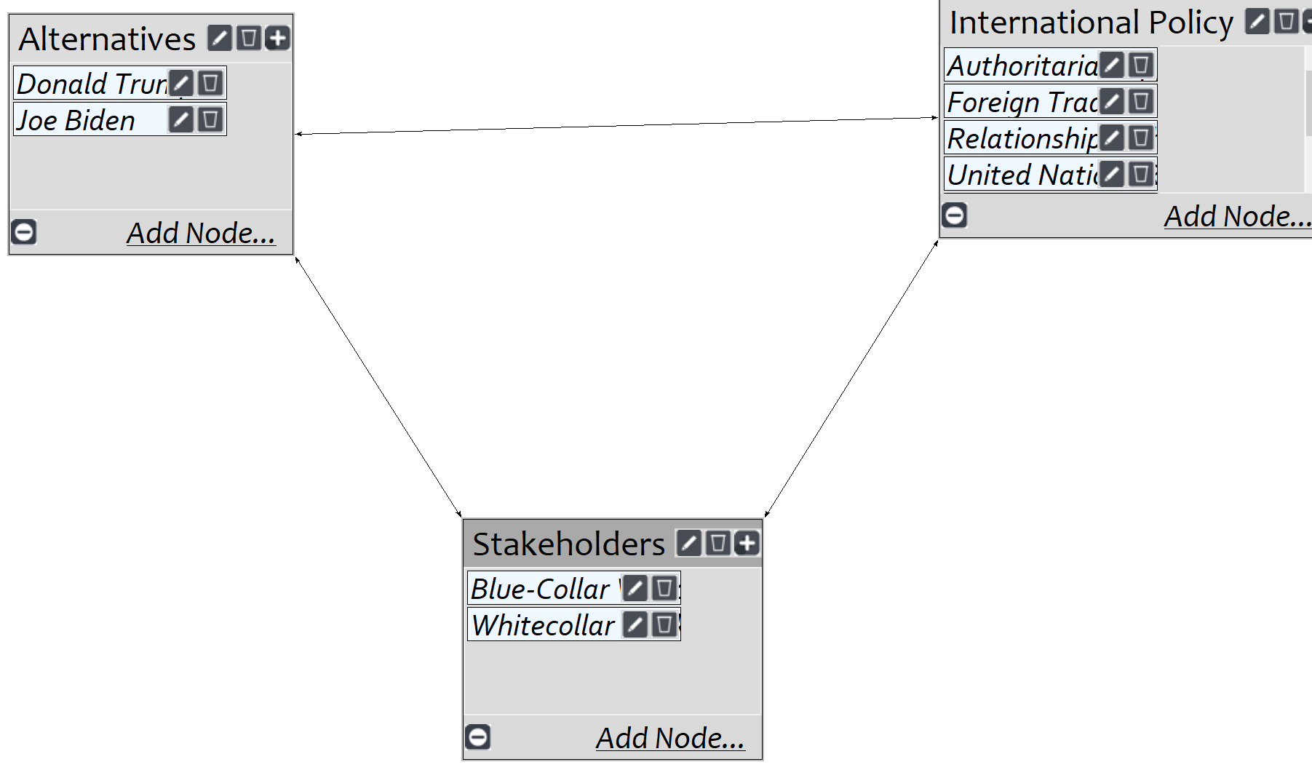
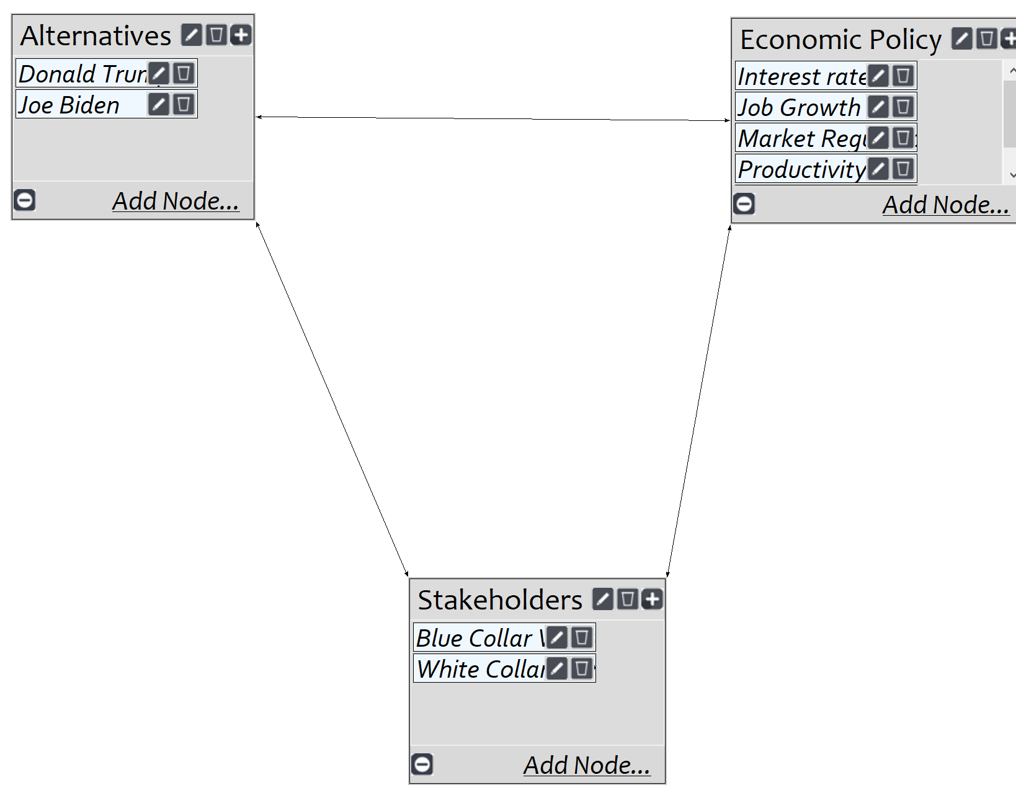
. International Benefits
. Economic Benefits

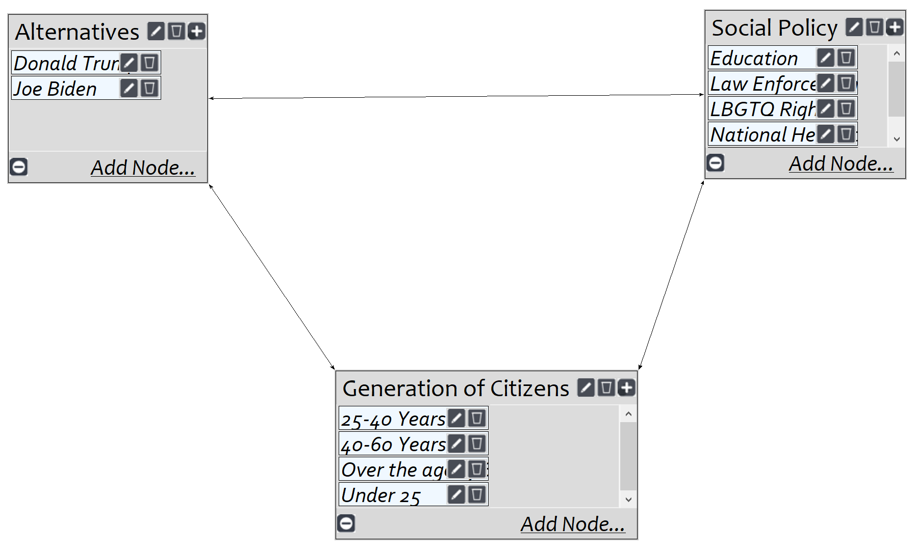
Social Benefits

The results of the benefits subnetwork slightly favors Biden. Each of the subnetworks: Economic, International, and Social’s prioritization can be observed above their designation. This shows how much each subnetwork influences the final calculation. The value associated with each subnetwork shows the prioritization of the stakeholders, alternatives, and the policy itself.
I think that this is an accurate representation of how the voters will approach each candidates policy specified in the model. The biggest discrepancy is rightly observed in social policy. This is where the two candidates differ the most, but with the recent events transpiring in the world I think the candidate that has a more progressive view on social justice, public health, and civil rights will be heavily favored in this election and that is indeed Joe Biden.

Opportunities Subnetwork Results:
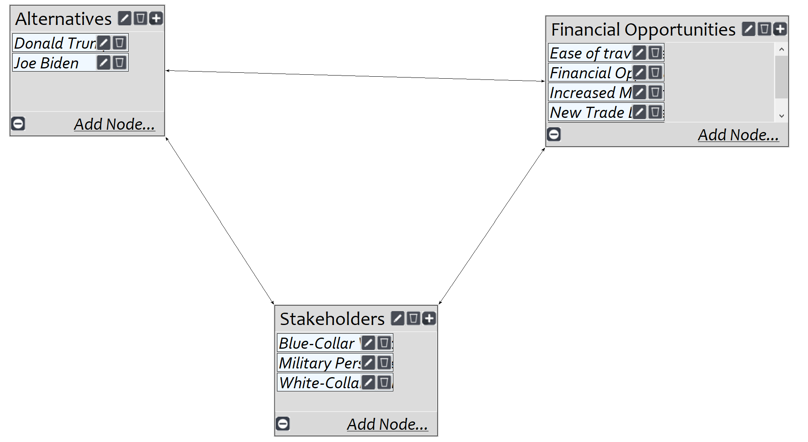
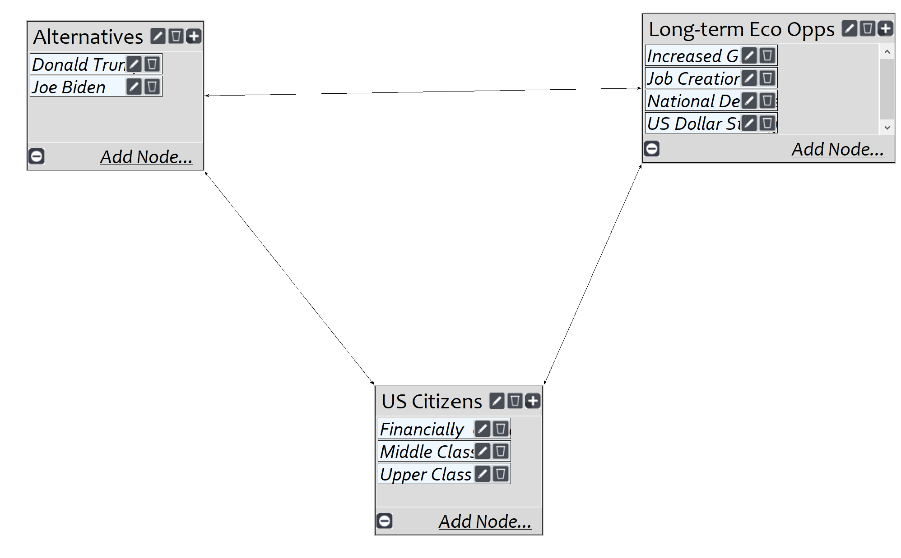
International
Economic
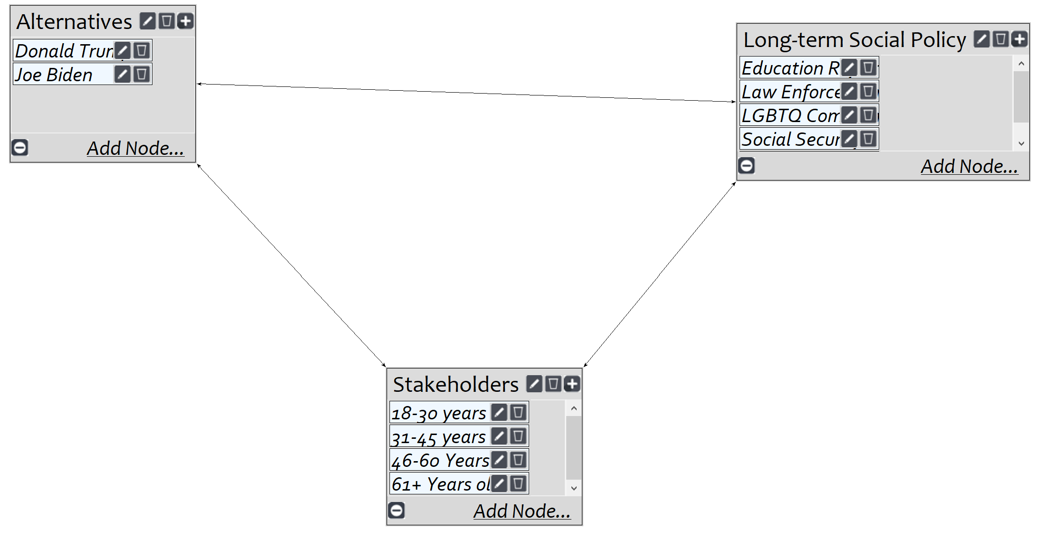
Social

The results for opportunities were a bit more lopsided in favor of Joe Biden. However, I think that this is accurate assessment. 8 years of extreme conservative policy could have an adverse social impact, but you could also see a trickle-down effect that could hurt our economy.
The stakeholder who would have a long term gain from a Trump presidency are military members as they would receive more funding and an increased recruiting effort. The vast majority of Americans would benefit from Bidens forward looking social policies as more people from historically fringed social groups would be able to prosper with more rights which, ultimately, lead to more economic opportunity. It’s also fair to speculate that Biden will solidify our relationship with the European Union and World Health Organization, which will help restore past alliances. The long term benefit of a Biden presidency could potentially help boost America’s image throughout the world.

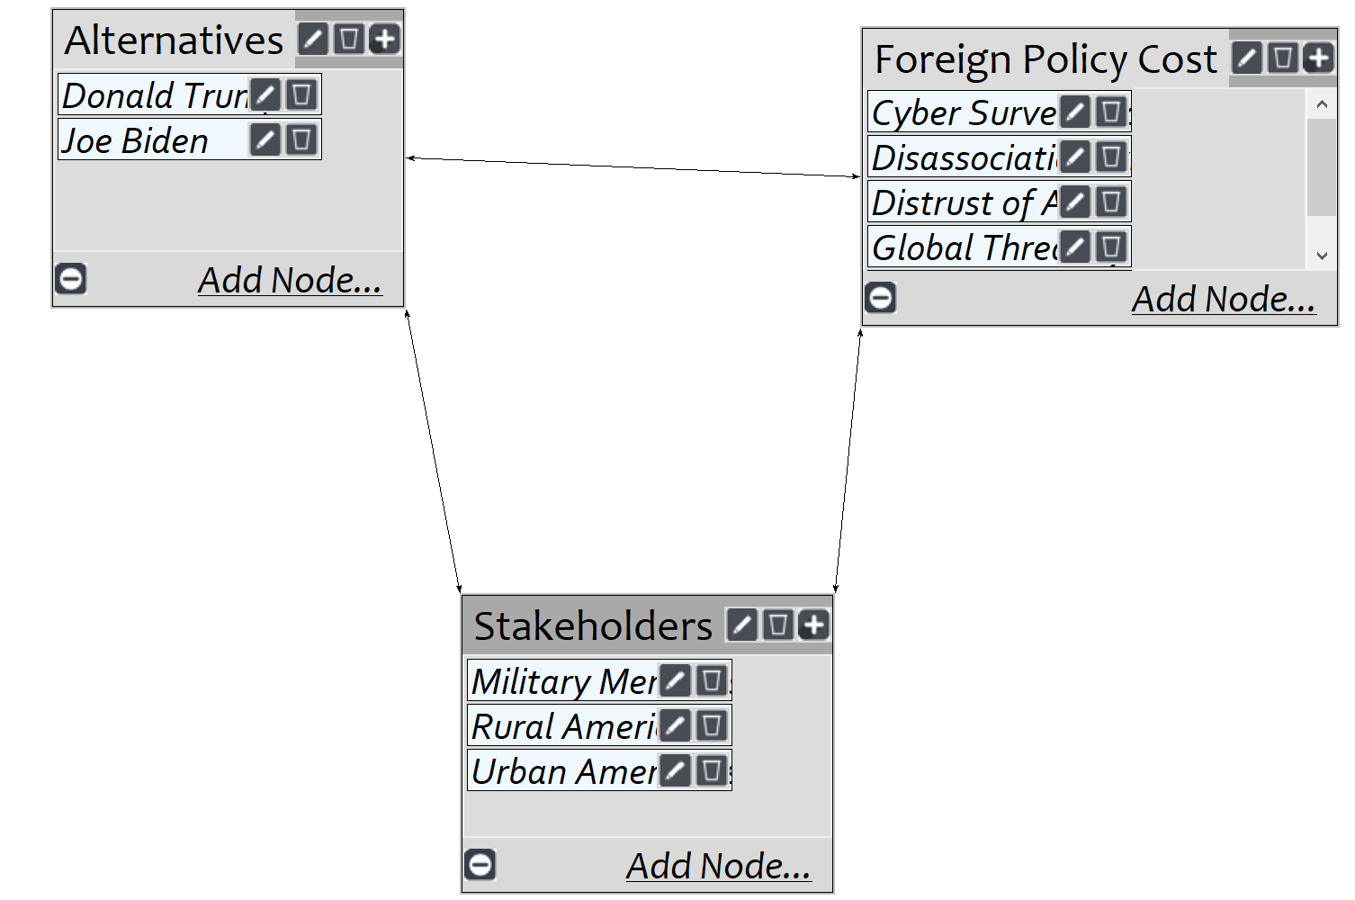
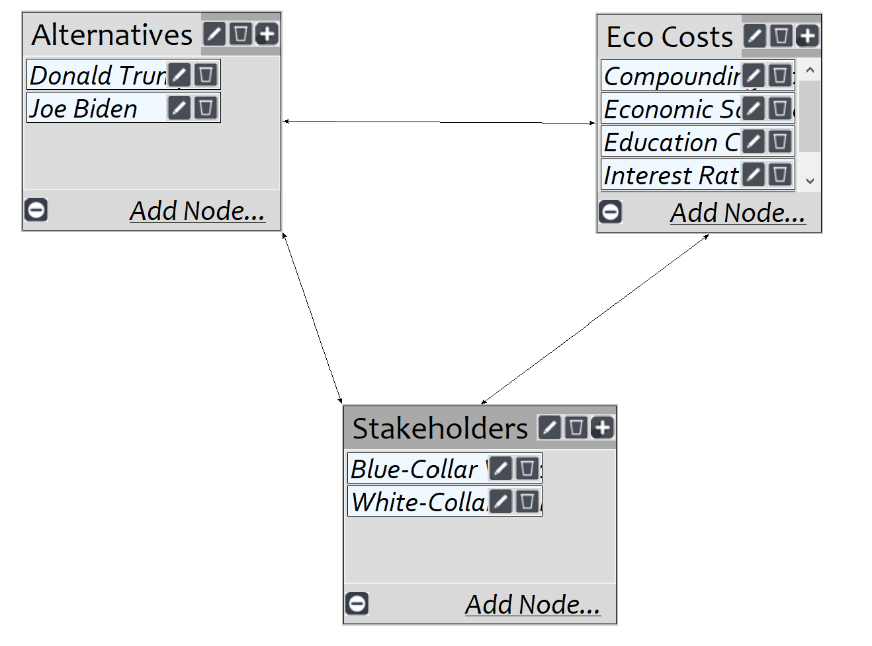
Costs Subnetwork Results:
International
Economic
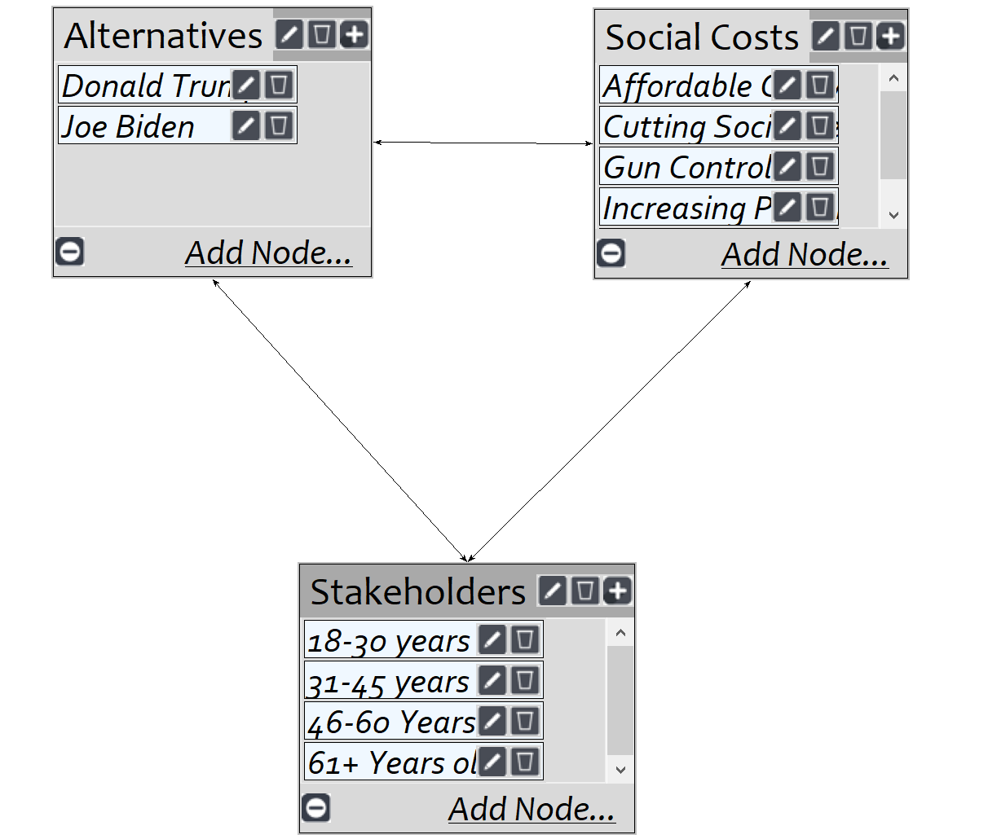
Social

The results for costs were interesting, but seemingly accurate. There is a higher cost to a Biden presidency. He will reconstruct the Affordable care act, make education free for kids who have a household income under $125,000 a year, and will improve public health policy. All of those policies will cost the tax payers more money so I think that it makes sense that his economic cost is higher. Trump having a higher international cost is due to the fact that he will increase our international military presence, which could cause tensions between other global super powers. His policies have also distanced us from our allies which could result in permanently severed ties. Biden’s progressive agenda will cost the American tax payer more than Trumps conservative policy would.
Risks Subnetwork Results:
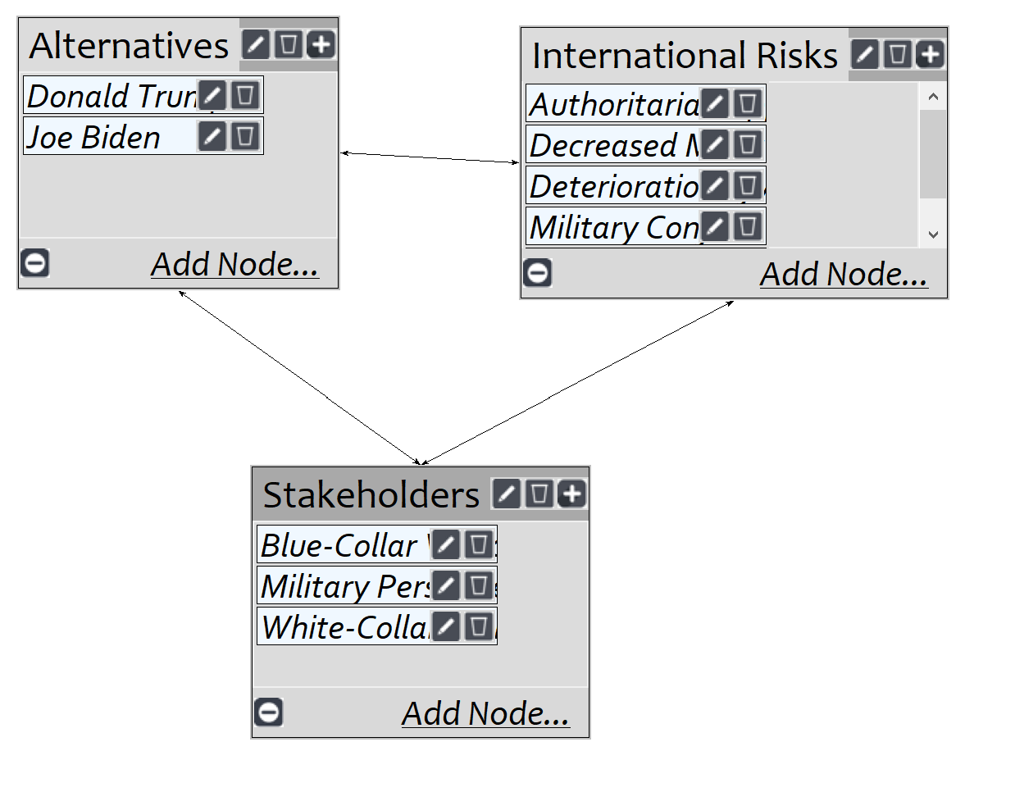
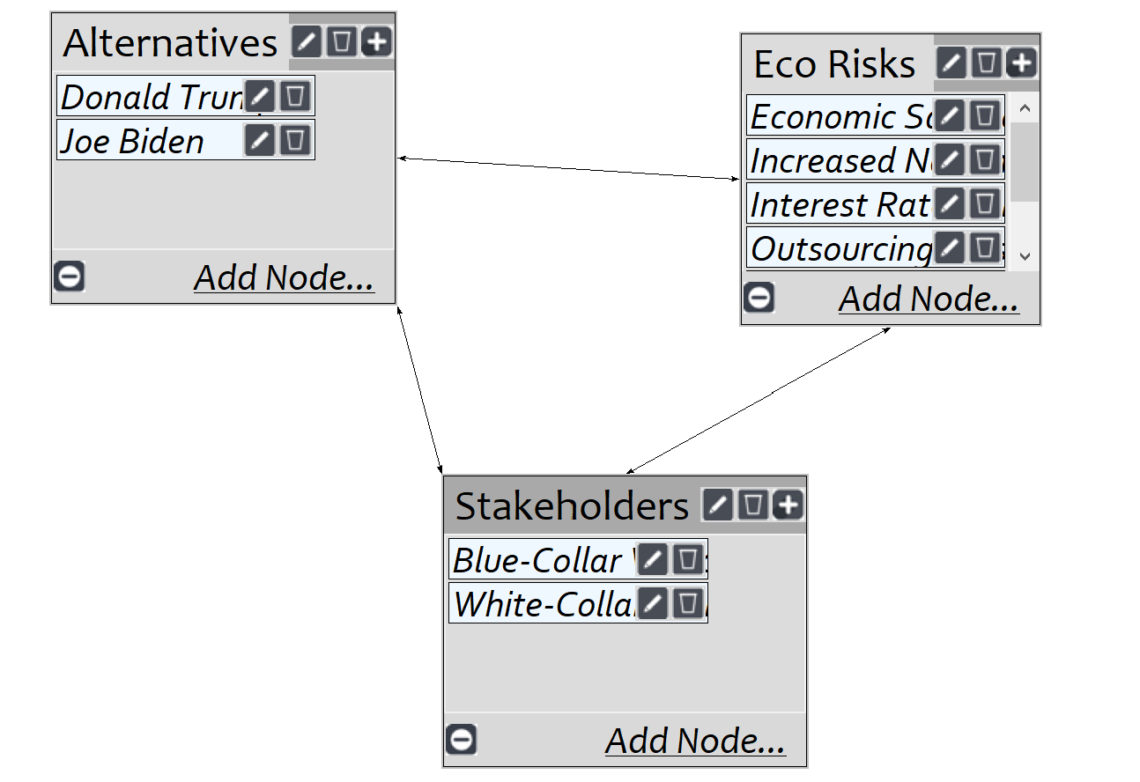
International
Economic

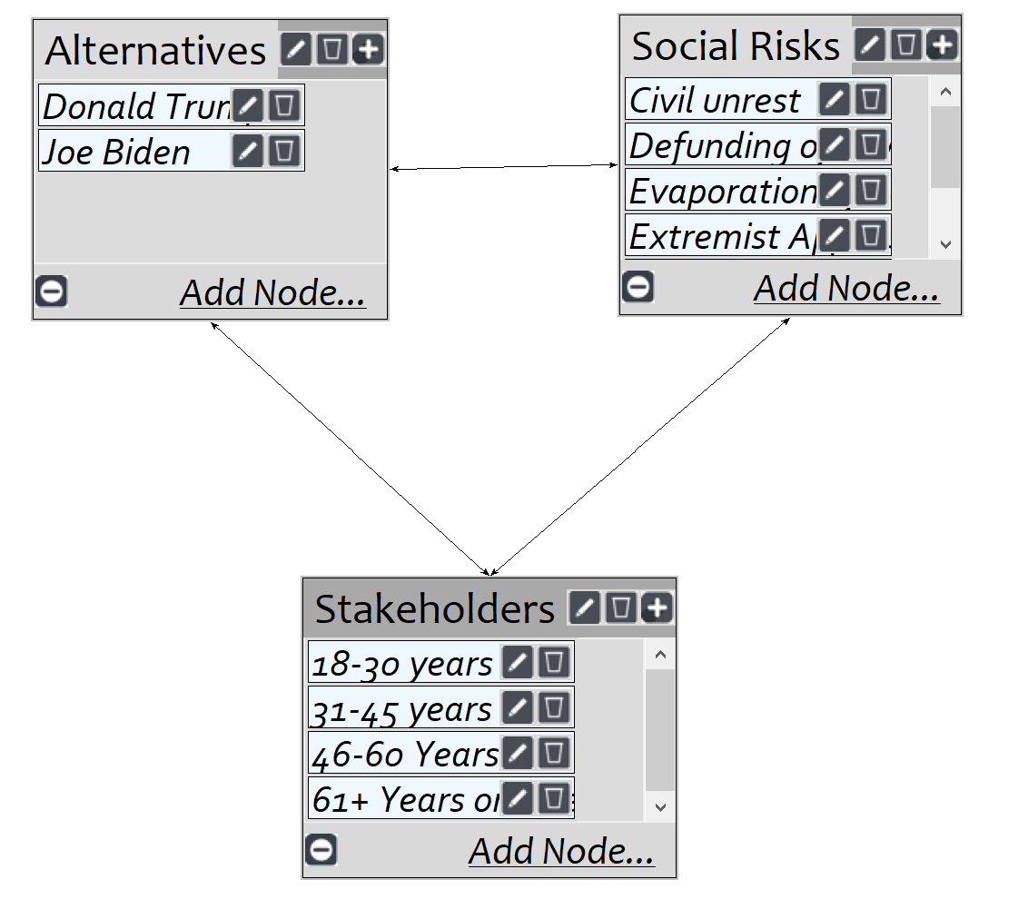

Social

I think that the results of the risks portion of the model align with all of the other results. The risks of a Trump reelection are very high compared to a Biden presidency.
The long term international and economic risks influenced this result most. Trumps constant tweeting and unpredictable behaviors could negatively impact the financial markets and his personal volatility may sever alliances or push the country to the brink of international conflict. Biden does have a larger social risk associated with him as there could be civil unrest due to his more progressive agenda. However, the long term risk that Trump poses are much more significant than Bidens.

Analysis:
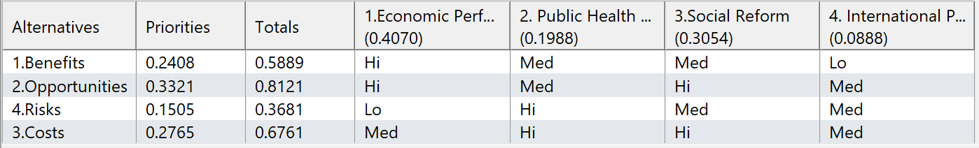
The final analysis is done using a ratings model. The criteria for the model will the strategic criteria referenced earlier, which are Health Policy, Economic performance, International Relations, and Social Policy. The alternatives for the model are labeled “1. Benefits, 2. Opportunities,3. Costs, and 4. Risks”. The candidate that had the highest final rating for each of the subnetworks are serving as the alternatives which will be reflected in the prioritization of the ratings table.
Once the ratings table is configured, each of the strategic criteria will be prioritized against each of the alternatives. The candidates stance on each of the strategic criteria will be ranked either Hi, Med, or Lo. The final results of the ratings table are pictured below.

Using the results of my model and ratings table, I was able to calculate the long and short term benefits of each candidate using two different calculations. For the short term calculation, I utilized the multiplicative formula, which can be seen below.

Based on the calculation, Joe Biden is by far the best short-term option for President, which corresponds to the results of the lower level criteria, which overwhelmingly favored Biden.
The long term calculation utilized the additive formula, which uses the results of the rating table. This calculation also proved that Biden is the unquestioned best long term option with a large discrepancy between him and Trump. Again, this accurately reflects each of the subnetworks calculated in my model.

Sensitivity:
The sensitivity analysis in my model are based around policy and how changes in prioritization of a policy may result in the a ranking reversal between the candidates. For example, if there was a greater emphasis on public health policy over economic performance the choice of president may change and vice versa, if public health prioritization was lowered other factors may gain a greater priority thus changing the candidate. A sensitivity analysis was performed for each Benefits, Opportunities, Costs, and Risks, below are the results.

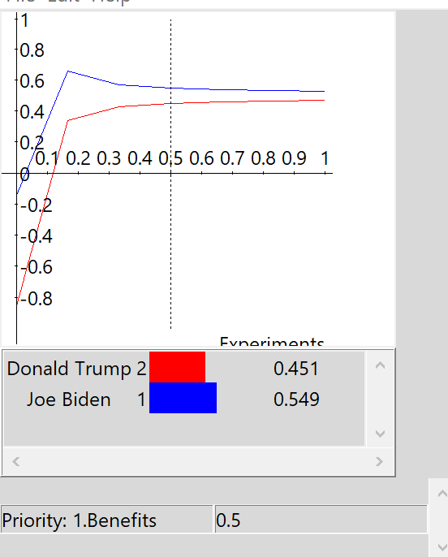
The sensitivity graph on the left shows the benefits sensitivity graph. As the prioritization on benefits increases, Joe Biden is still the ideal candidate, however the margin does narrow as the graph approached 1.

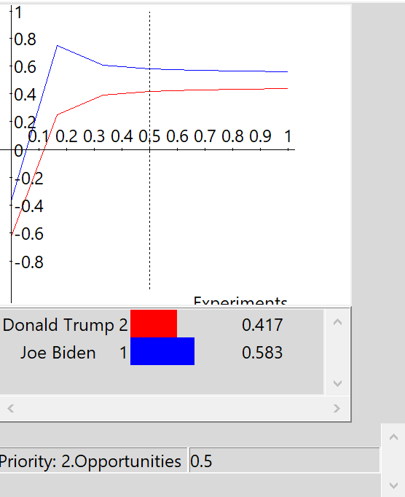
Again for opportunities, the graph closely resembles benefits and there is no rank reversal although it the gap narrows as the priority nears 1, with Biden still being the best choice.

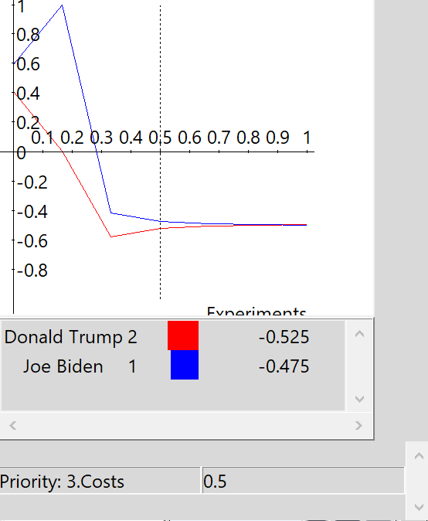
Costs sensitivity does show a ranking reversal. As costs priority is lowered, Biden is associated with a higher cost, while Trump’s cost is lower. However, as cost becomes a higher priority the discrepancy between the candidates is virtually non-existent.

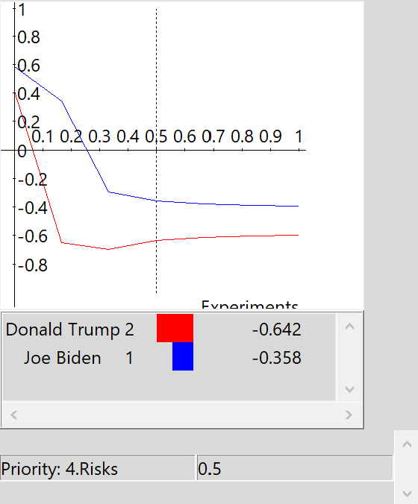
Much like Benefits and Opportunity, there is a large discrepancy between the candidates pertaining to risks. Donald Trump has the largest amount of risk from point 0-1 on the graph with no rank reversal.

Conclusions:
Based on the benefits, opportunities, costs, and risks, I think my model accurately chooses the best presidential candidate- Joe Biden. Each subnetwork accurately depicts how voters will likely align on social, economic, and international issues. Ultimately, I think there is one major flaw in predicting how certain groups of people, or stakeholders, will vote and that is the blinding bias that certain groups of Americans have for their political party. My results are based on reasonable assumptions about how the stakeholders would choose the candidate that would serve them the best in both the short and long term based on their job or age group.
Ultimately, I think that most of the economic benefits and opportunities Trump would provide are derailed by his conservative social policy. The economic benefits he provides will ultimately be offset by younger Americans desire for change. I also think that Biden’s education policy will send more young Americans to college, which could create a positive long term economic outlook.
The United States seems to be ready for change and I think that change will be catalyzed by a new president getting elected on November 4th. Both parties are to blame for the lack of preparation for the global pandemic, but I think that Donald’s trump utter neglect of the issue will be the ultimate reason why he loses in 2020. My model accounts for this and the economic turmoil that ensued because of the pandemic, which is why the social and economic sub criteria had such a large priority. I believe most Americans will share this sentiment and we will see a very close election, but ultimately see Joe Biden become the next president of the United States.

Background Material:
https://www.washingtonpost.com/elections/2020/trump-policies-vs-biden-policies/
https://www.cfr.org/election2020/candidate-tracker

